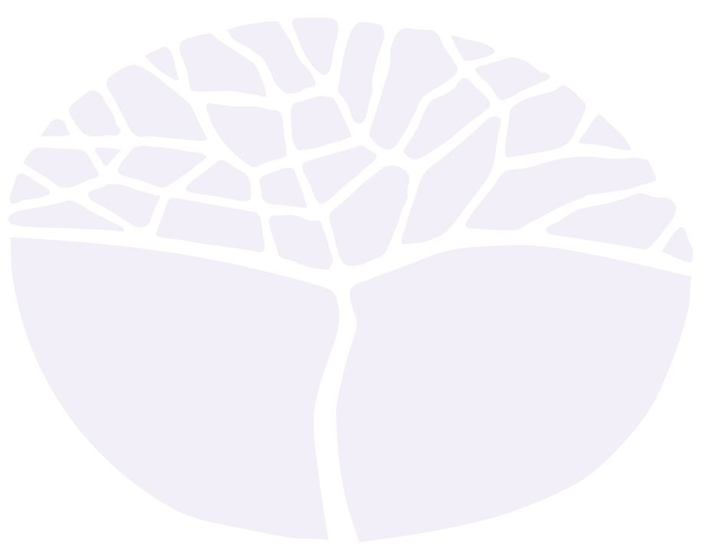
Human Biology

General course
Marking key for the Externally set task
Sample 2016

Copyright
© School Curriculum and Standards Authority, 2014
This document – apart from any third party copyright material contained in it – may be freely copied, or communicated on an intranet, for
non-commercial purposes in educational institutions, provided that the School Curriculum and Standards Authority is acknowledged as the copyright owner, and that the Authority’s moral rights are not infringed.
Copying or communication for any other purpose can be done only within the terms of the Copyright Act 1968 or with prior written permission of the School Curriculum and Standards Authority. Copying or communication of any third party copyright material can be done only within the terms of the Copyright Act 1968 or with permission of the copyright owners.
Any content in this document that has been derived from the Australian Curriculum may be used under the terms of the Creative Commons Attribution-NonCommercial 3.0 Australia licence
Disclaimer
Any resources such as texts, websites and so on that may be referred to in this document are provided as examples of resources that teachers can use to support their learning programs. Their inclusion does not imply that they are mandatory or that they are the only resources relevant to the course.

Human Biology

Externally set task – marking key
1(a) Write an hypothesis for this experiment. (1 mark)
Description | Marks
Distraction increases reaction time  Or any reasonable hypothesis showing relationship between independent and dependent variables | 1
Total | 1

(b) i What is the independent variable? (1 mark)
Description | Marks
Distraction | 1
Total | 1

ii What is the dependent variable? (1 mark)
Description | Marks
Reaction time | 1
Total | 1

iii List three (3) variables that Lucy and Phillip kept the same. (3 marks)
Description | Marks
Any 3  Ruler used  Height dropped  Method of timing  Similar environmental conditions  Type of distraction | 1–3
Total | 3

(c) Write a step-by-step method describing how this experiment could be conducted, including equipment required. (10 marks)
Description | Marks
Equipment: ruler, stopwatch, test subject, form of distraction | 1–3
Steps of method include:  Any 3  Variables to be kept the same (controlled) are mentioned in steps: distance dropped from hand, timer, environmental conditions, lighting, time period tested, etc. | 1–3
Method of measuring dependent variable  Implementation of independent variable | 1–2
Recording of data in the table | 1
Repeat trials | 1
Total | 10

(d) Complete calculating the averages in the table. (2 marks)
Description | Marks
Braxton  Average reaction time with distraction = 0.38 + 0.28 + 0.22 = 0.293  3 | 1
Rohan  Average reaction time without distraction = 0.22 + 0.18 + 0.18 = 0.193  3 | 1
Total | 2

(e) Draw a graph showing the average results from the table. Put the students on the x-axis and the reaction time on the y-axis. (6 marks)
Description | Marks
Correctly draws columns | 1
Labels axes with correct name and unit | 1–2
Uses a suitable scale | 1
Title appropriate, with both variables included | 1
Key | 1
Total | 6

(f) How could this experiment be improved to increase the reliability of the results? (2 marks)
Description | Marks
Conduct more trials | 1
Increase number of students used | 1
Total | 2

(g) What could Lucy and Phillip do to investigate the difference between a visual distraction and a noise distraction? (2 marks)
Description | Marks
Conduct trials which use sound as a distraction only and no vision | 1
Conduct trials which uses visual distraction only and no sound | 1
Total | 2

- Describe how the nervous system assists reactions. (5 marks)
Description | Marks
Stimulus received from receptor
Sends message to brain | 1
Brain processes information | 1
Sends message back to effector | 1
Muscles cause reaction | 1
Total | 5

- Explain the difference between a reaction and a reflex action. (2 marks)
Description | Marks
Any 2  Reflex arc is quicker than reaction  Brain involved in reaction and not in reflex  Reflex is involuntary | 1–2
Total | 2

- Describe the nervous pathway of a reflex arc. (5 marks)
Description | Marks
Receptor sensory nerve interneuron motor nerve effector | 1–5
Total | 5

