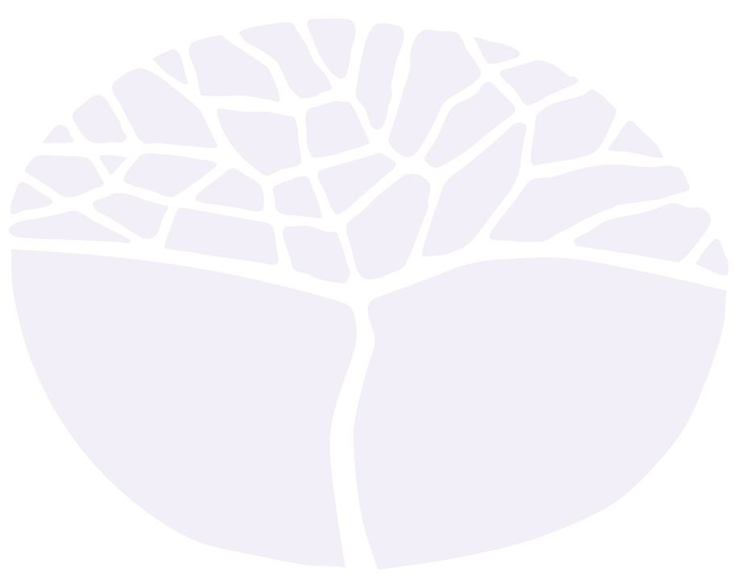
Visual Arts

Preliminary course
Year 11 and Year 12 syllabus

IMPORTANT INFORMATION
Users of this syllabus are responsible for checking its currency.
Syllabuses are formally reviewed by the School Curriculum and Standards Authority on a cyclical basis, typically every five years.
Copyright
© School Curriculum and Standards Authority, 2013.
This document – apart from any third party copyright material contained in it – may be freely copied, or communicated on an intranet, for non-commercial purposes in educational institutions, provided that the School Curriculum and Standards Authority is acknowledged as the copyright owner, and that the Authority’s moral rights are not infringed.
Copying or communication for any other purpose can be done only within the terms of the Copyright Act 1968 or with prior written permission of the School Curriculum and Standards Authority. Copying or communication of any third party copyright material can be done only within the terms of the Copyright Act 1968 or with permission of the copyright owners.
Any content in this document that has been derived from the Australian Curriculum may be used under the terms of the Creative Commons Attribution-NonCommercial 3.0 Australia licence

Content

Introduction to the Preliminary courses 1
Rationale for the Visual Arts Preliminary Course 2
Aims 2
Organisation 3
Structure of the syllabus 3
Organisation of content 3
Representation of the general capabilities 4
Representation of cross-curriculum priorities 5
Unit 1 – Discovery 6
Unit description 6
Unit outcomes 6
Unit content 6
Unit 2 – Expression 8
Unit description 8
Unit outcomes 8
Unit content 8
Unit 3 – Observation 10
Unit description 10
Unit outcomes 10
Unit content 10
Unit 4 – Manipulation 12
Unit description 12
Unit outcomes 12
Unit content 12
School-based assessment 14

Introduction to the Preliminary courses
Preliminary courses provide a relevant option for students who cannot access the ATAR or General course content with adjustment and/or disability provisions, or who are unable to progress directly to training from school, or who require modified and /or independent education plans. Preliminary courses are designed for students who have been identified as having a recognised disability under the Disability Discrimination Act 1992, and who meet the above criteria.
The Preliminary courses are:
- Business Management and Enterprise
- English
- Food Science and Technology
- Health and Physical Education
- Materials Design and Technology
- Mathematics
- Religion and Life
- Visual Arts.
Preliminary courses provide opportunities for practical and well-supported learning to help students develop skills required for them to be successful upon leaving school. They acknowledge the broad scope of abilities of students with special needs and the need for adapted approaches to teaching and learning.
Preliminary courses may form all or part of a program of study. Schools will make decisions about the content to be taught in each course on the basis that it meets individual student needs, goals and priorities.

Rationale for the Visual Arts Preliminary Course
The Visual Arts Preliminary units encompass the broad areas of art and craft. Students have opportunities to express their imagination and engage in the making and presentation of artworks.
The Visual Arts course encourages students to develop problem-solving skills together with thinking. Students engage in art making processes in traditional and new media areas. This involves exploring materials, techniques, processes, and emerging technologies, with art forms, such as sculpture, painting, drawing, printmaking, collage, ceramics and multimedia.
Students respond to and evaluate their own works and the works of others. The Visual Arts Preliminary course aims to contribute to a sense of enjoyment, engagement and fulfilment in students’ everyday lives.

Aims
The Visual Arts Preliminary course aims to develop students’:
- development and communication of art ideas
- use of creative techniques, processes and technologies to make artworks
- respond to own artworks and the artworks of others.

Organisation

Structure of the syllabus
This Year 11 and Year 12 syllabus is divided into four units.

Unit 1 – Discovery
Students experience a range of media and develop a basic understanding of the visual arts. They participate in activities that enable them to gain a tactile experience of visual art and to explore a variety of art forms.

Unit 2 – Expression
Students use a range of media and techniques to express personal ideas and feelings through art making. They participate in activities that enable them to react to visual art and recognise a variety of art forms.

Unit 3 – Observation
Students use a range of media and techniques to express personal ideas and observations. They participate in activities using a range of media and expression that enable them to respond to visual art and recognise a variety of art forms.

Unit 4 – Manipulation
Students experience a range of media and develop an understanding of the visual arts. They participate in activities that enable them to gain a tactile experience of visual art and explore a variety of art forms to produce an outcome.
Each unit includes:
- a unit description – a short description of the focus of the unit
- unit outcomes – a set of statements describing the learning expected as a result of studying the unit
- unit content – the content to be taught and learned.

Organisation of content
This course consists of a combined Year 11 and Year 12 syllabus. The syllabus is divided into four units. Each unit is designed to be delivered over a semester; however the pace of delivery will reflect the abilities of the students.
The unit content is separated into the two areas within Visual Arts: Art Making and Art Interpretation focusing both on the production of artwork and the response to artworks.

Representation of the general capabilities
The general capabilities encompass the knowledge, skills, behaviours and dispositions that will assist students to live and work successfully in the twenty-first century. Teachers may find opportunities to incorporate the capabilities into the teaching and learning program for the Visual Arts Preliminary Course. The general capabilities are not assessed unless they are identified within the specified unit content.

Literacy
The general capabilities may be explicitly taught or may be an inherent part of a particular learning area; for example, the visual arts rely on multi literacies: oral, visual, kinetic, text based and digital literacy, all of which are fundamental to learning, communicating, creating and responding.
Numeracy
An ability to apply numerical concepts, such as space, scale, proportion, depth, ratio and pattern, is the foundation of all composing and creating in the visual arts.
Information and communication technology capability
The information and communication technology (ICT) capability enables students to use digital tools and environments to represent their ideas and artworks. They use digital technologies to locate, access, select and evaluate information, work collaboratively, share and exchange information, and communicate with a variety of audiences.
Critical and creative thinking
The visual arts are dependent on the development of creative and critical thinking. In creating artworks, students draw on their curiosity, imagination and thinking skills to pose questions and explore ideas. They consider possibilities and processes and make choices that assist them to take risks and express their ideas creatively.

Personal and social capability
Learning in the visual arts promotes self-discipline, initiative, confidence, empathy and adaptability as students work individually and collaboratively. As art makers they acquire facility with tools, media, skills and techniques, and they develop and apply personal abilities, such as self-discipline and goal setting.
Ethical understanding
Ethical understanding is developed and applied in the visual arts when students encounter or create artworks that require ethical consideration, such as artworks that are controversial that involve a moral dilemma, or present a biased point of view. They actively engage in ethical decision making when reflecting on their own and the artworks of others.

Intercultural understanding
Intercultural understanding in the visual arts assists students to explore new ideas, media and practices from diverse local, national, regional and global cultural contexts. Students are encouraged to demonstrate open-mindedness to perspectives that differ from their own, and to appreciate the diversity of cultures and contexts in which artists and audiences live.

Representation of cross-curriculum priorities
The cross-curriculum priorities address contemporary issues which students face in a globalised world. Teachers may find opportunities to incorporate the priorities into the teaching and learning program for the Visual Arts Preliminary course. The cross-curriculum priorities are not assessed unless they are identified within the specified unit content.

Aboriginal and Torres Strait Islander histories and cultures
The study of Aboriginal and Torres Strait Islander histories and cultures enriches understanding of the diversity of art making practices in Australia, and develops appreciation of the need to respond to artworks in ways that are culturally sensitive and responsible.
Many Australian Indigenous artists affirm connection with Country/Place, people and culture through their visual arts making. Study of the visual arts created by Aboriginal and Torres Strait Island artists exposes students to a view of the Australian landscape that is unique, expressive and personal.
Other Australian Indigenous and Torres Strait Island artists offer a more contemporary view of Australian society. Many of these artists are part of the wider community of Australian artists, and their artworks are as various and individual as other contemporary Australian artists.
Asia and Australia's engagement with Asia
Asia, and Australia’s engagement with Asia, provides rich, engaging and diverse contexts in which to investigate making and responding to visual artworks, which has arisen from the rich and diverse cultures, belief systems and traditions of the peoples of the Asian region.

Sustainability
Sustainability provides engaging and thought-provoking contexts in which to explore the nature of art making and responding, and enables the investigation of the interrelated nature of social, economic and ecological systems.

Unit 1 – Discovery

Unit description
The focus for this unit is discovery. Students experience a range of media and processes in the visual arts. They participate in activities that enable them to gain a tactile experience of visual art and explore some of the art forms.
Students observe and experiment with media and processes to create individual and group artworks. They follow guidelines that focus and direct artistic activity. Students experience the process of continual exploration when developing artworks. Exploration is used to open up artistic expression, creating results that students can compare with similar works by their peers.

Unit outcomes
By the end of this unit, students will:
- develop art ideas to create artworks
- explore art media and techniques to make artworks
- respond to artworks
- reflect on their art experiences
- present artworks.

Unit content
This unit includes the knowledge, understandings and skills described below.

Art making

Inquiry
- collation of ideas for design; for example, brainstorming or mind mapping
- mark making for initial drawings/sketches: for example, different mark- making media, such as pencils, crayons, markers, brushes, fingers
- materials; for example, painting with different size brushes or with twigs or bamboo nibs; paint using different amounts of liquid medium, or on different weights and absorbency of paper
- visual arts process in making artworks; for example, rolling out clay, impressing a clay surface with textured objects, and glazing a clay surface with liquid copper carbonate using sponges

Visual language
- visual elements (line, shape, colour and/or texture) to create artworks; for example, making patterns with textured stamps, or making a series of pinch pots, or making a monoprint using printmaking ink and simple torn stencils

Art forms, media, techniques and influences
- engage in colour mixing techniques
- media and techniques in selected art forms; for example, applying paint with a brush or coiling with clay
- materials and techniques; for example drawing with light, using large gestures to suggest an emotion
- experience techniques, subject matter or approaches by other artists or teachers when making own artworks

Art practice
- processes and techniques used to create artworks
- produce artworks
- safe work practices
- respect own and the artworks of others
- display finished artworks

Art interpretation

Art responses
- reflect on own artworks and personal accomplishments
- respond to artworks; for example, identify lines, shape, colour
- personal response/reaction to artworks
- meaning and purpose in artworks; for example, appreciate what artworks may be about

Unit 2 – Expression

Unit description
The focus for this unit is expression. Students explore ways to use media and techniques to express personal ideas and feelings.
Students apply media and techniques in the development of artworks. Students will be introduced to visual language and skills appropriate to selected art forms. They will look at a range of artworks and gain some first-hand experience of art making.
This unit will allow students to develop confidence and competence using a range of media.

Unit outcomes
By the end of this unit, students will:
- develop art ideas to create artworks
- use art media and techniques to present personal expression in artworks
- respond to artworks
- reflect on their art experiences
- present artworks.

Unit content
This unit includes the knowledge, understandings and skills described below.

Art making

Inquiry
- collation of ideas for design; for example, brainstorming, collage or mind mapping
- initial drawings to express themselves; use of drawing as a means of expression
- materials to develop artworks; for example, bending wire to create a sculpture armature
- steps and processes to create artworks

Visual language
- visual language to create artworks; for example, using contrasting colours
- visual language (elements and principles of art) to represent experiences and express feelings; for example, using line to capture movement

Art forms, media, techniques and influences
- colour mixing techniques to produce an outcome
- variety of media to produce artworks; for example, textured surfaces for rubbings or prints
- handle media and demonstrated techniques; for example, the use of crayon and wax resist techniques
- adopt processes associated with specific art forms; for example, making more than one print from a plate
- exposure to artists and their work when producing artworks; for example, the textural paint qualities of Starry Night by Vincent Van Gogh

Art practice
- processes and techniques used to create artworks
- produce artworks
- safe work practices
- respect own and the artworks of others
- display finished artworks

Art interpretation

Arts responses
- reflect on individual and/or group evaluation of artworks
- respond to artworks with basic visual language; for example, line, colour, texture and/or shape
- meaning and purpose in artworks; for example, respond to the narrative in artworks

Unit 3 – Observation

Unit description
The focus for this unit is observation. Students use media and techniques to express personal ideas and observations using a range of media and experiences to demonstrate an understanding of the visual arts.
Students apply media and techniques in the development of artworks. Students will utilise visual language and skills appropriate to selected art forms. They will look at a range of artworks and gain some first-hand experience of art making.
Students will experience a different range of media and techniques from Unit 1 and Unit 2 to develop an understanding of the visual arts.
This unit will allow students to develop confidence and competence, using a range of media.

Unit outcomes
By the end of this unit, students will:
- develop art ideas to create artworks
- use art media and techniques to present personal observation in artworks
- respond to artworks
- reflect on their art experiences
- present artworks.

Unit content
This unit includes the knowledge, understandings and skills described below.

Art making

Inquiry
- collation of ideas for design; for example, brainstorming, collage and mind mapping
- initial drawings as a means of inquiry and observation
- materials to develop artworks; for example, making a collage of landscape using found objects for printmaking
- experience techniques and processes to create artworks

Visual language
- experiment with visual language to create artworks; for example, using line to create visual movement
- visual language (elements and principles of art) to represent experiences and intention; for example the use of red hue to represent the emotion of anger

Art forms, media, techniques and influences
- colour mixing techniques to produce an outcome
- use a variety of media to produce artworks; for example, acrylic paint on canvas/MDF board, or watercolour on paper
- media and demonstrated techniques; for example, blending and colour mixing
- techniques and processes associated with specific art forms; for example, wedging the clay to remove air bubbles
- respond to artists and their work when producing artworks; for example, Eduard Munch’s use of colour in The Scream

Art practice
- techniques and processes to create artworks
- demonstration to produce artworks
- safe work practices
- respect own and others’ artworks
- display finished artworks, for example decision making as a group regarding how final artworks are displayed

Art interpretation

Art responses
- reflect on individual and/or group evaluation of artworks
- respond to artworks referring to basic visual language, for example line, colour, shape, form, texture and/or tone
- meaning and purpose in artworks, for example respond to the narrative in artworks.

Unit 4 – Manipulation

Unit description
The focus for this unit is manipulation. Students will participate in activities that enable them to gain a tactile experience of visual art, and explore a variety of art forms to produce resolved artworks.
Students apply media and techniques in the development of artworks. Students will use visual language and skills appropriate to selected art forms. They will look at a range of artworks and gain some first-hand experience of art making.
This unit will allow students to develop confidence and competence in using a range of media.

Unit outcomes
By the end of this unit, students will:
- develop art ideas to create artworks
- manipulate art media and techniques to present personal ideas in artworks
- respond to artworks
- reflect on their art experiences
- present artworks.

Unit content
This unit includes the knowledge, understandings and skills described below.

Art making

Inquiry
- collation of ideas for design; for example, brainstorming, collage or mind mapping
- drawing as a means of inquiry
- ways of using materials to develop artworks; for example, manipulate clay for ceramics
- experience techniques and processes to create artworks

Visual language
- visual language to create artworks; for example, using repeated shapes to create a pattern.
- visual language (elements and principles of art) to represent experiences and intention; for example, using colour to represent an emotion

Art forms, media, techniques and influences
- colour mixing techniques to produce artworks
- experience a variety of media; for example, embossing textured surfaces into clay
- media and demonstrated techniques; for example, pinch pot or slab building
- processes associated with specific art forms; for example, stretching the paper for water colour painting
- exposure to artists and their work when producing artworks; for example, the smooth curved three dimensional form of Henry Moore’s Reclining Figure

Art practice
- techniques and processes to create artworks
- produce an artwork
- safe work practices
- respect own and the artworks of others
- display finished artworks; for example, decision making as a group regarding how the final artworks are displayed

Art interpretation

Art responses
- reflect on individual and/or group evaluation of artworks
- respond to artworks referring to basic visual language; for example, line, colour, shape, texture and/or form
- meaning and purpose in artworks; for example, responding to the narrative in artworks.

School-based assessment
Approaches to assessment should support teachers to identify, broaden and deepen their understanding of what students can do, and assist teachers to determine the educational priorities for each student.
The unit content forms the basis of a teaching, learning and assessment program. The content points in each unit form the basis of teaching and learning opportunities for students, and also provide examples of assessable activities on which teachers can make informed judgements.
Teachers are required to develop an assessment outline for each unit.
The assessment outline must:
- include a set of assessment tasks
- include a general description of each task
- indicate the unit content to be assessed
- include the approximate timing of each task (for example, the week the task is conducted, or the issue and submission dates for a task).
To cater for individual needs and student capabilities, a range of assessment tasks will be developed by the teacher, appropriate for a student’s expected ways of learning.
The assessment tasks will provide opportunities for teachers and students to reflect on progress towards individual learning goals. Teachers make decisions about each student’s readiness to progress to the next level of proficiency on his or her individual learning goals using a range of assessment tools.
Tools for the collection of evidence to support student progress towards individual learning goals may include:
- observation rubrics
- oral and/or written tasks, or any combination of oral and written tasks
- work experience feedback and/or reports.
Decisions about whether it is appropriate to offer adjustments to students in course work and assessment tasks are the responsibility of the school.

Unit completion
Schools report on each student’s learning progress for a unit in Preliminary courses as either completed or not completed.
To be deemed to have completed the course, the school determines whether a student meets the following criteria:
- completion of the education and assessment program for the unit (unless the school accepts that there are exceptional and justifiable circumstances)
- evidence of progress in demonstrating the unit outcomes, including sufficient attendance and engagement, either independently or with support.
The WACE Manual contains essential information on principles, policies and procedures for school-based assessment that needs to be read in conjunction with this syllabus.

