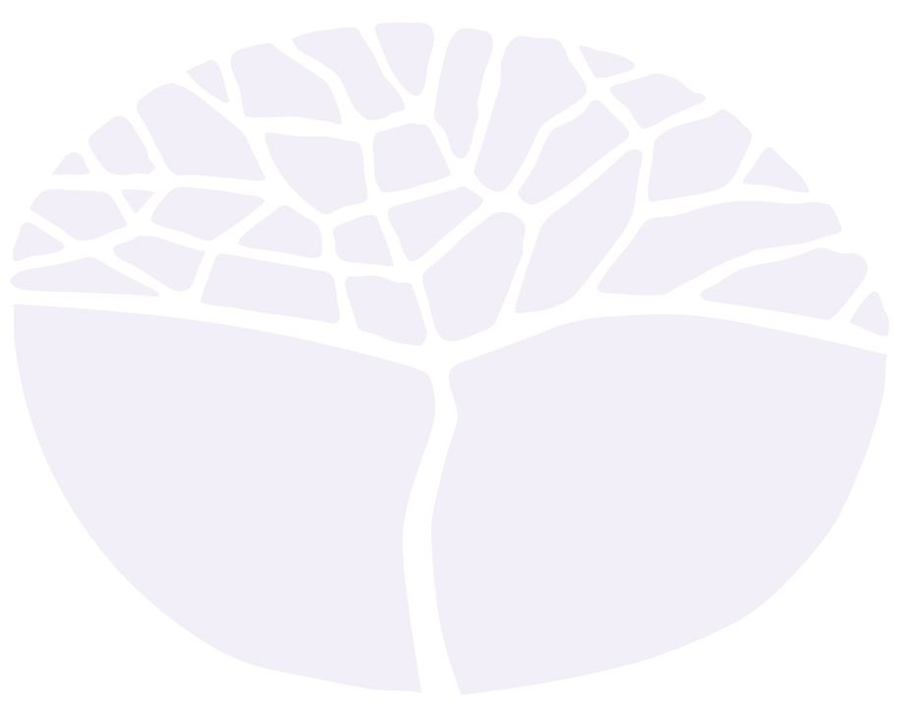
Visual arts
General course

Externally set task
Sample 2016

Note: This Externally set task sample is based on the following content from Unit 3 of the General Year 12 syllabus.
Art making
Reflection
- reflect on and maintain documentation of the development of thinking and working practices
- describes the ideas, meaning and personal direction taken in art making (artist statement)
Art Interpretation
Visual analysis
- discuss artwork referring to visual language and using art terminology
Personal response
- structure responses giving reasons for opinions and interpretations about artworks
Social, cultural and historical contexts
- examine the subject matter of artwork, identifying the stylistic and technical aspects that locate it in a
particular time, place or culture

In future years, this information will be provided late in Term 3 of the year prior to the conduct of the
Externally set task. This will enable teachers to tailor their teaching and learning program to ensure that the content is delivered prior to the students undertaking the task in Term 2 of Year 12.

Copyright
© School Curriculum and Standards Authority, 2014
This document – apart from any third party copyright material contained in it – may be freely copied, or communicated on an intranet, for non-commercial purposes in educational institutions, provided that the School Curriculum and Standards Authority is acknowledged as the copyright owner, and that the Authority’s moral rights are not infringed.
Copying or communication for any other purpose can be done only within the terms of the Copyright Act 1968 or with prior written permission of the School Curriculum and Standards Authority. Copying or communication of any third party copyright material can be done only within the terms of the Copyright Act 1968 or with permission of the copyright owners.
Any content in this document that has been derived from the Australian Curriculum may be used under the terms of the Creative Commons Attribution-NonCommercial 3.0 Australia licence
Disclaimer
Any resources such as texts, websites and so on that may be referred to in this document are provided as examples of resources that teachers can use to support their learning programs. Their inclusion does not imply that they are mandatory or that they are the only resources relevant to the course.

Visual Arts

Externally set task
Working time for the task: 60 minutes
Total marks: 40 marks
Weighting: 15% of the school mark

- Visual Language (Source 1 and 2) (20 marks)
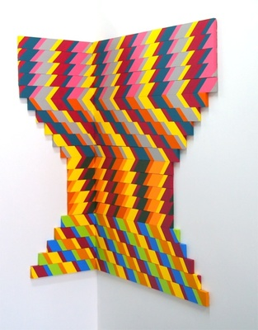
Source One
SOPHIA EGARCHOS, Levels #2, 2013
Acrylic paint on wood pine frame
140 x 140cm ©Sophia Egarchos/Licensed by Viscopy

(a) Refer to the painting, Levels #2, (2013) by Sophia Egarchos (Source 1).
Provide one (1) specific example of shape, colour, line, repetition and movement. Use art terminology to explain how they have contributed to the composition in the painting. (10 marks)
Shape
________________________________________________________________________________
________________________________________________________________________________
________________________________________________________________________________
________________________________________________________________________________
________________________________________________________________________________
________________________________________________________________________________
Colour
________________________________________________________________________________
________________________________________________________________________________
________________________________________________________________________________
________________________________________________________________________________
________________________________________________________________________________
________________________________________________________________________________
Line
________________________________________________________________________________
________________________________________________________________________________
________________________________________________________________________________
________________________________________________________________________________
________________________________________________________________________________
________________________________________________________________________________

Repetition
________________________________________________________________________________
________________________________________________________________________________
________________________________________________________________________________
________________________________________________________________________________
________________________________________________________________________________
________________________________________________________________________________
Movement
________________________________________________________________________________
________________________________________________________________________________
________________________________________________________________________________
________________________________________________________________________________
________________________________________________________________________________
________________________________________________________________________________

For copyright reasons the image of John Brack’s work
The New House cannot be reproduced in the online version
of this document, but may be viewed at www.artgallery.nsw.gov.au/collection/works/192.2013/

Source Two
John Brack 1953 The New House
Oil on canvas on hardboard
142.5 x 71.2cm

(b) Refer to the painting, The New House, (1953) by John Brack (Source 2).
Use art terminology, where applicable, to describe the compositional techniques used by the artist that contribute to your interpretation of the mood of the artwork. (10 marks)
________________________________________________________________________________
________________________________________________________________________________
________________________________________________________________________________
________________________________________________________________________________
________________________________________________________________________________
________________________________________________________________________________
________________________________________________________________________________
________________________________________________________________________________
________________________________________________________________________________
________________________________________________________________________________
________________________________________________________________________________
________________________________________________________________________________
________________________________________________________________________________
________________________________________________________________________________
________________________________________________________________________________
________________________________________________________________________________
________________________________________________________________________________
________________________________________________________________________________
________________________________________________________________________________
________________________________________________________________________________
________________________________________________________________________________
________________________________________________________________________________
________________________________________________________________________________
________________________________________________________________________________
________________________________________________________________________________
________________________________________________________________________________
________________________________________________________________________________
________________________________________________________________________________
________________________________________________________________________________
________________________________________________________________________________
- Reflection – Artist Statement
Use the provided headings to write your own artist statement. Discuss the intention behind your work and the process based on the theme INSPIRATION. Use art language to identify the materials used and the inspirations and artist influences when explaining your intention behind your work.
(20 marks)

(a) Use art terminology with examples to explain the key themes, ideas and/or questions explored in your work. (10 marks)
If relevant, include the following headings:
- cultural background and influences
- world events and relevant social and political issues of the time
- how your work acts conceptually in order to communicate the intention to the viewer.

________________________________________________________________________________
________________________________________________________________________________
________________________________________________________________________________
________________________________________________________________________________
________________________________________________________________________________
________________________________________________________________________________
________________________________________________________________________________
________________________________________________________________________________
________________________________________________________________________________
________________________________________________________________________________
________________________________________________________________________________
________________________________________________________________________________
________________________________________________________________________________
________________________________________________________________________________
________________________________________________________________________________
________________________________________________________________________________
________________________________________________________________________________
________________________________________________________________________________
________________________________________________________________________________
________________________________________________________________________________
________________________________________________________________________________
________________________________________________________________________________
________________________________________________________________________________
________________________________________________________________________________
________________________________________________________________________________
________________________________________________________________________________
________________________________________________________________________________
________________________________________________________________________________
________________________________________________________________________________
________________________________________________________________________________
________________________________________________________________________________
________________________________________________________________________________
________________________________________________________________________________
________________________________________________________________________________

(b) Make reference to artists that have influenced or inspired your work. (10 marks)
Your case study investigations should be influential in the development of your ideas and visual arts practice. Acknowledge artists by mentioning whether their work led you to:
- use particular subject matter, media, skills or processes
- develop conceptual strength and meaning in artworks produced
- resolve ideas for the presentation of final artworks.
________________________________________________________________________________
________________________________________________________________________________
________________________________________________________________________________
________________________________________________________________________________
________________________________________________________________________________
________________________________________________________________________________
________________________________________________________________________________
________________________________________________________________________________
________________________________________________________________________________
________________________________________________________________________________
________________________________________________________________________________
________________________________________________________________________________
________________________________________________________________________________
________________________________________________________________________________
________________________________________________________________________________
________________________________________________________________________________
________________________________________________________________________________
________________________________________________________________________________
________________________________________________________________________________
________________________________________________________________________________
________________________________________________________________________________
________________________________________________________________________________
________________________________________________________________________________
________________________________________________________________________________
________________________________________________________________________________
________________________________________________________________________________
________________________________________________________________________________
________________________________________________________________________________
________________________________________________________________________________
________________________________________________________________________________
________________________________________________________________________________

If sketch or diagrams required, identify which sections you are addressing.
Question No. _______________

Acknowledgements
Source One Egarchos, S. (2012). Levels #2 [Acrylic paint on wood pine frames; 50 x 100 cm] [Image]. Retrieved March, 2014, from http://sophiaegarchos.com/new-gallery/

Source Two Brack, J. (1953). The new house [Oil on canvas on hardboard; 142.5 x 71.2 cm frame] [Image]. Retrieved March, 2014, from www.artgallery.nsw.gov.au/collection/works/192.2013/

