Sample Assessment Tasks

Building and Construction

General Year 11

Copyright
© School Curriculum and Standards Authority, 2014
This document – apart from any third party copyright material contained in it – may be freely copied, or communicated on an intranet, for non-commercial purposes in educational institutions, provided that the School Curriculum and Standards Authority is acknowledged as the copyright owner, and that the Authority’s moral rights are not infringed.
Copying or communication for any other purpose can be done only within the terms of the Copyright Act 1968 or with prior written permission of the School Curriculum and Standards Authority. Copying or communication of any third party copyright material can be done only within the terms of the Copyright Act 1968 or with permission of the copyright owners.
Any content in this document that has been derived from the Australian Curriculum may be used under the terms of the Creative Commons Attribution-NonCommercial 3.0 Australia licence
Disclaimer
Any resources such as texts, websites and so on that may be referred to in this document are provided as examples of resources that teachers can use to support their learning programs. Their inclusion does not imply that they are mandatory or that they are the only resources relevant to the course.

Sample assessment task

Building and Construction – General Year 11

Task 3 – Unit 1
Assessment type: Design and Production

Residential backyard design project
Part A: Design a scale model of a residential backyard (25 marks)
You are to complete a design brief for the planning of a residential backyard.
Part B: Construct a scale model of a residential backyard design (10 marks)
You are to then construct a scale model.
Part C: Evaluate completed scale model of a residential backyard design (5 marks)
Finally, evaluate your scale model.

Conditions

Period allowed for completion of theory lessons and to complete this range of practical tasks:

4 to 6 weeks

Task weighting

Part A: Design 5%; Part B: Production 8%; Part C: Design 2% of the school mark for this pair of units
________________________________________________________________________________

What you need to do

Part A
- Take some pictures of your backyard (or someone else’s if you do not wish to use yours).
- Produce sketches (at least five) that illustrate particular characteristics of the backyard.
- Complete a scale drawing of your backyard.
- Examine the pictures that you have taken and the scale drawing that you have completed and produce a PMI table.
- Detail the changes that you will make utilising sketches.
- From the results of your PMI you are to decide upon changes that you would make to your backyard.
- You will be required to detail the changes that you are going to make and the reasons that you have chosen to make these changes.
- Select the appropriate materials to make the modifications that you have chosen to undertake. Detail the benefits of using these materials to yourself and the environment.
- Prepare a materials order/cutting list.

Part B
- You will be required to produce a scale model of your backyard showing the modifications made.
- Complete a materials costing list for your backyard.
Part C
- Evaluate the changes that you have made.
- Have your parents/guardian/carers evaluate the changes that you have made.

What needs to be submitted for assessment? | Due dates
Pictures, drawings and sketches of your backyard
Completed PMI
Completed detailed reasons for changes
Completed materials selection justification benefits and costing
Completed scale model and evaluation

Marking key for sample assessment task 3 – Unit 1

Residential backyard design project
Description | Marks
Part A: Design a scale model of a residential backyard /25
Pictures and sketches (minimum of five) | /6
- provides clear drawings with annotations and development  - clear drawings with some annotations  - clear drawings with no annotations | 5–6  3–4  1–2
Scale drawing; hand or instrument drawing /4
- conforms to appropriate scale drawings standards  - utilises appropriate drawing techniques, minor errors | 3–4  1–2
PMI /6
- provides detailed information and annotated sketches for the changes planned and the relevant reasons for these changes  - provides sketches with clear annotations for the changes and the main reasons for these changes  - provides general brief comments about plans and reasons for changes | 5–6  3–4  1–2
Materials selection documentation /4
- provides all relevant information in a clear and concise manner, detailing reasons for material selection  - provides relevant information in a clear manner, detailing some reasons for material selection | 3–4  1–2
Project materials order/cutting list /5
- provides relevant information in a detailed and complete order/cutting list  - uses correct terminology to provide a suitable materials order/cutting list  - presents list with missing or incomplete materials | 4–5  2–3  0–1
Part B: Construct a scale model of a residential backyard design /10
Completed project /10
- completes project to a very high standard of workmanship and finish  - completes project to a high standard of workmanship and finish  - completes project to a satisfactory standard of workmanship and finish | 8–10  5–7  1–4
Part C: Evaluate completed scale model of a residential backyard design /5
Project evaluation /5
- reflects on the design criteria and evaluates the changes made and materials used  - presents simple likes and dislikes comments | 3–5  1–2
Total marks | /40

Sample assessment task

Building and Construction – General Year 11

Task 5 – Unit 1
Assessment type: Production

Part A: Bricklaying and brick paving (66 marks)
Gain a theoretical understanding from lessons, then complete a range of practical tasks to experience and develop skills in building and construction processes.

Conditions

Period allowed for completion of theory lessons and to complete a range of practical tasks:

5 to 8 weeks

Task weighting

10% of the school mark for this pair of units __________________________________________________________________________________

Suggested time management
The practice for and production of these tasks will take place over a period of five weeks.

What you need to do
Using the information provided in Activity Sheet A1 attached, complete the following: calculating quantities, bricklaying and brick paving tasks.

Activity 1: Theory
Complete worksheets identifying and justifying material selection for the chosen situation.
- calculate materials quantities (10 marks)

Activity 2: Bricklaying
- site preparation
- construction of brick pyramid
- constructing a brick pier (36 marks)

Activity 3: Brick paving
- site preparation
- stretcher pattern (20 marks)

What needs to be submitted for assessment? | Due dates
Activity 1: Theory worksheets | five weeks from commencement date
Activity 2: Bricklaying
Activity 3: Brick paving

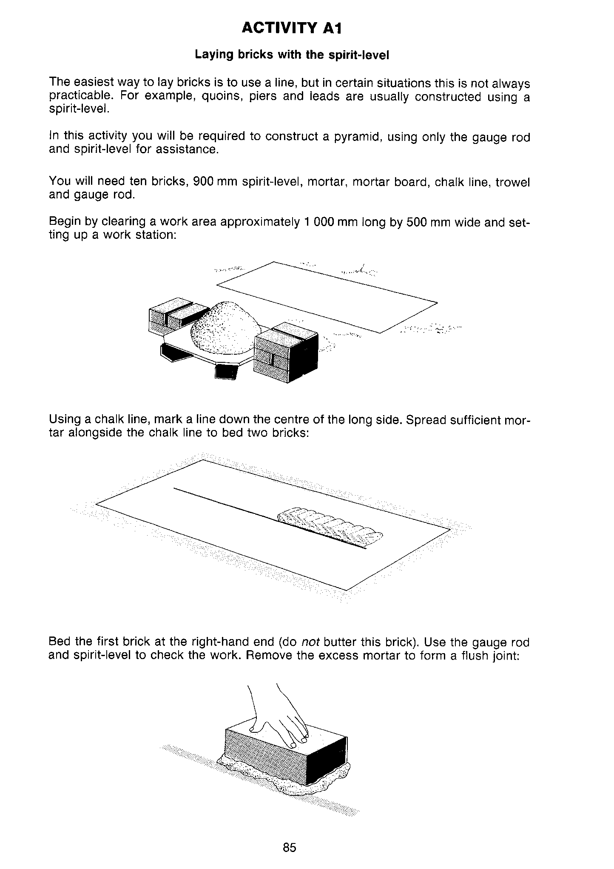
ACTIVITY SHEET A1
ACTIVITY SHEET A1

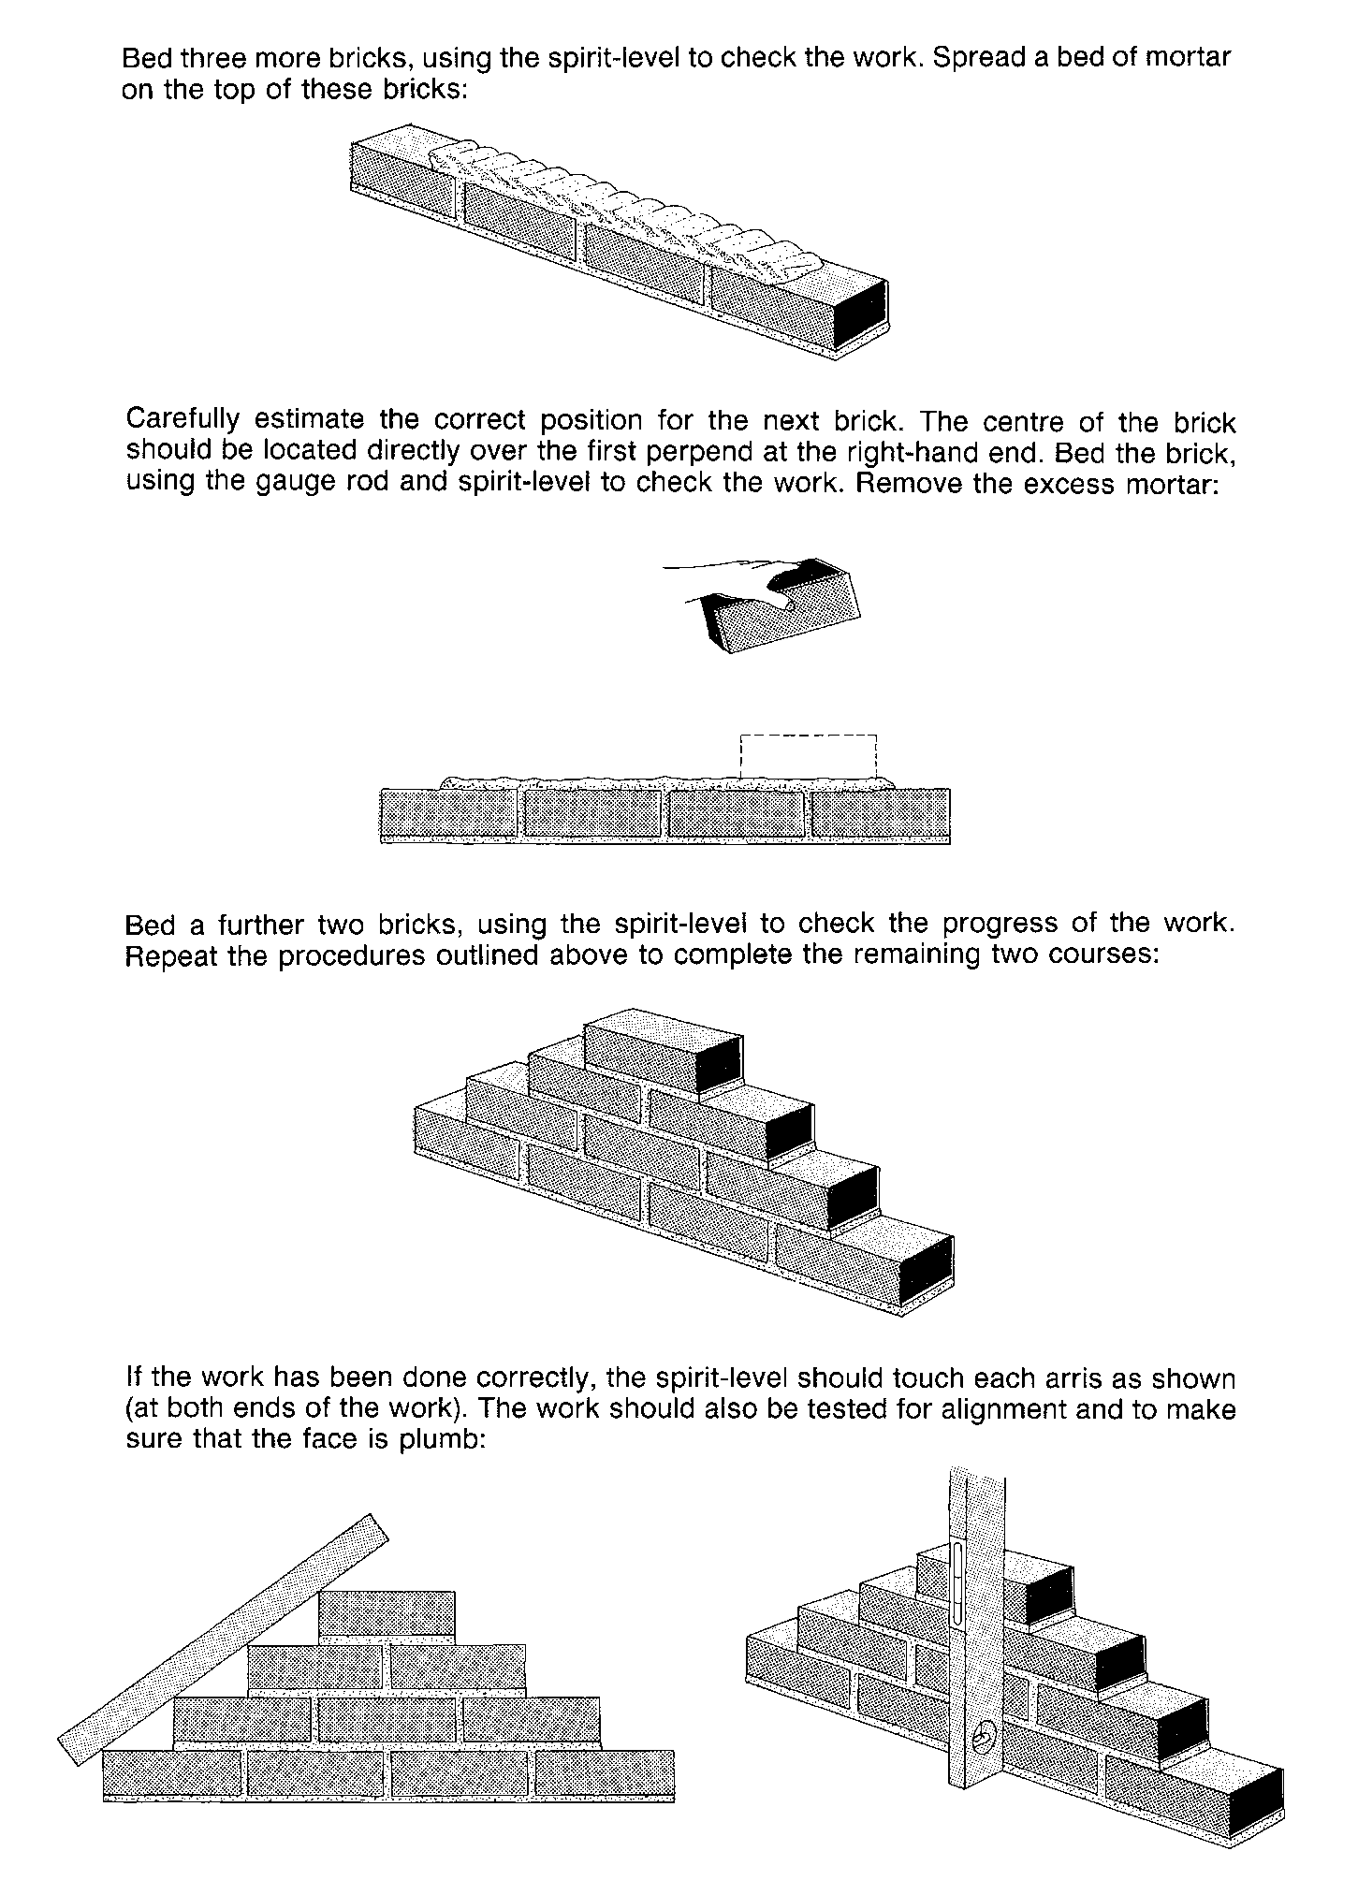
[From: Education Department of Western Australia, Curriculum Branch. (1987). Bricks and bricklaying.
East Perth, WA: Education Department of Western Australia, pp. 85–86]

Marking key for sample assessment task 5 – Unit 1

Part A – Activity 1: Theory worksheets
Description | Maximum possible mark | Allocated mark
Complete worksheets identifying and justifying material selection for the chosen situation.  - all worksheets completed, clear notes and correct entries  - all worksheets completed, notes have minor errors | 3–4  1–2 | /4
Calculating materials quantities  - all calculations completed, clearly set out and correct  - all calculations completed, some errors corrected  - calculations attempted, but require re-calculating or revision | 5–6  3–4  1–2 | /6
Total |  | /10

Part A – Activity 2: Bricklaying
Description | Maximum possible mark | Allocated mark
Site preparation  - cleanliness  - setting out  - preparedness | 1–2  1–2  1–2 | /6
Laying a course of bricks  - square  - level  - raking | 1–3  1–3  1–3 | /9
Construction of brick pier  - square  - level  - raking | 1–3  1–3  1–3 | /9
Occupational Safety and Health  - clothing  - tools/equipment  - procedural | 1–2  1–2  1–2 | /6
Work habits  - works independently  - use of materials  - tidiness | 1–2  1–2  1–2 | /6
Total |  | /36

Part A – Activity 3: Brick paving
Description | Maximum possible mark | Allocated mark
Site preparation  - cleanliness  - setting out  - preparedness | 1–2  1–2  1–2 | /6
Laying a course of paving bricks – stretcher pattern  - square  - flat  - compacted | 1–3  1–3  1–3 | /9
Work habits and Occupational Safety and Health  - correct PPE clothing  - correct use of tools/equipment  - correct procedure  - appropriate use of materials  - tidiness | 1  1  1  1  1 | /5
Sub total |  | /20
Combined total |  | /66

Sample assessment task

Building and Construction – General Year 11

Task 5 – Unit 1
Assessment type: Production

Part B: Construction exercises (identify materials and tiling) (55 marks)
Complete a range of practical and theoretical exercises incorporating a spectrum of construction materials processes and techniques.

Conditions

Period allowed for completion of theory lessons and to complete a range of practical tasks:

5 to 8 weeks

Task weighting

10% of the school mark for this pair of units __________________________________________________________________________________

What you need to do
You are to complete the following theory worksheets and practical exercises.
Construction knowledge and skills exercises
Activity 1: Wall tiling (20 marks)
Complete wall tiling task using specified area tools and equipment.

Activity 2: Floor tiling (20 marks)
Complete floor tiling task using specified area tools and equipment.

Activity 3: Construction materials (15 marks)
You are to complete the relevant worksheets that relate to the following points:
- present a materials identification sheet, showing mechanical properties of common building materials in terms of:
- hardness
- elasticity
- conductivity
- flexibility
- strength
- presentation of finishes; different types and their uses.

What needs to be submitted for assessment? | Due dates
Completed wall tiling
Completed floor tiling
Construction materials identification sheet

Marking key for sample assessment task 5 – Unit 1

Task 5 Part B – Construction exercises
Wall tiling | Maximum possible mark | Allocated mark
Site preparation  - cleanliness  - setting out  - preparedness | 1–2  1–2  1–2 | /6
Wall tiling process  - mixing of grout  - square  - level  - spacing  - grouting | 1–2  1–2  1–2  1–2  1–2 | / 10
Work habits and Occupational Safety and Health  - correct PPE clothing  - correct use of tools/equipment  - appropriate use of materials  - tidiness | 1  1  1  1 | /4
Total |  | / 20

Floor tiling | Maximum possible mark | Allocated mark
Site preparation  - cleanliness  - setting out  - preparedness | 1–2  1–2  1–2 | /6
Wall tiling process  - mixing of grout  - square  - level  - spacing  - grouting | 1–2  1–2  1–2  1–2  1–2 | / 10
Work habits and Occupational Safety and Health  - correct PPE clothing  - correct use of tools/equipment  - appropriate use of materials  - tidiness | 1  1  1  1 | /4
Total |  | / 20

Task 5 Part B – Construction exercises – Materials identification sheet
Description | Maximum possible mark | Allocated mark
Presented materials identification sheet  - completed worksheet listing common building materials, with correct, detailed listing of all mechanical properties for each material  - completed worksheet listing common building materials, with mechanical properties correctly listed for each material  - completed list of common building materials, with minor errors in the listing of mechanical properties  - partially finished worksheet of common building materials, with errors or missing mechanical properties  - incomplete worksheet missing information about the mechanical properties | 9–10  7–8  5–6  3–4  1–2 | /10
Presentation of finishes; different types and their uses  - all finishes listed, with clearly set out uses  - most finishes listed, but some errors in arrangement of details of uses  - list of finishes attempted, but require further arrangement of types and uses | 4–5  2–3  0–1 | /5
Total |  | / 15
Combined total |  | /55

Sample assessment task

Building and Construction – General Year 11

Task 5 – Unit 1
Assessment type: Production

Part C: Fabrication exercises (welding) (45 marks)
Complete a series of practical exercises in the three types of welding.
Present welds on a suitable display board.

Conditions

Period allowed for completion of theory lessons and to complete a range of practical tasks:

5 to 8 weeks

Task weighting

8% of the school mark for this pair of units __________________________________________________________________________________

What you need to do
You are to complete the following welding exercises. The exercises are to be presented on a suitable display board that you have constructed.

Arc welding
- beads
- butt weld
- ‘T’ weld

MIG welding
- beads
- butt weld
- ‘T’ weld

Gas welding
- beads
- butt weld
- flange weld

Present completed welds on a suitable display board.

What needs to be submitted for assessment? | Due dates
Completed welds on a suitable display board

Marking key for sample assessment task 5 – Unit 1

Part C – Fabrication exercises (welding)
Description | Maximum possible mark | Allocated mark
Correct and safe preparation of welding equipment  - correct safe set up of equipment  - personal protective equipment used  - correct setting of:  - oxy/acetylene gas pressures  - rod selection and amperage  - amperage and wire speed  - correct shut down | 1–3  1–3  1–3  1–3  1–3  1–3 | /18
Gas welding – good weld appearance, good weld penetration, and neat, even or consistent shape to weld and surrounding metal  - beads  - butt weld  - flange weld | 1–3  1–3  1–3 | /9
Arc welding – good weld appearance, good weld penetration, and neat, even or consistent shape to weld and surrounding metal  - beads  - butt weld  - ‘T’ weld | 1–3  1–3  1–3 | /9
MIG welding – good weld appearance, good weld penetration, and neat, even or consistent shape to weld and surrounding metal  - beads  - butt weld  - ‘T’ weld | 1–3  1–3  1–3 | /9
Total |  | /45

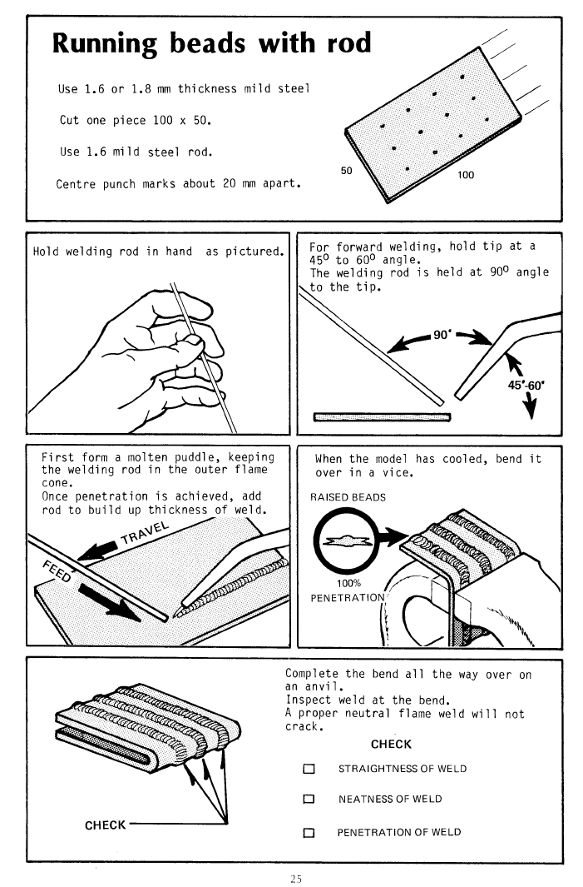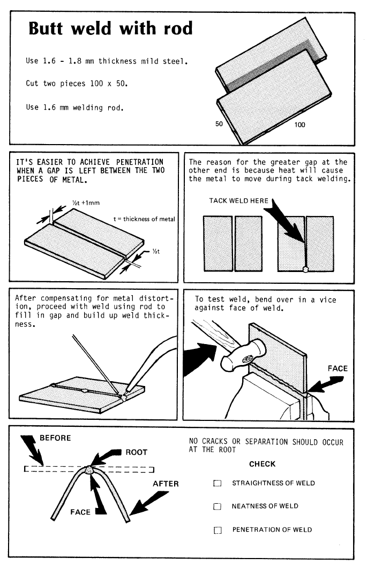
GAS WELDING
[From: Education Department of Western Australia, Curriculum Branch. (1983). Manual arts: Fusion welding. Perth: Education Department of Western Australia, p. 25]
[From: Education Department of Western Australia, Curriculum Branch. (1983). Manual arts: Fusion welding. Perth: Education Department of Western Australia, p. 27]
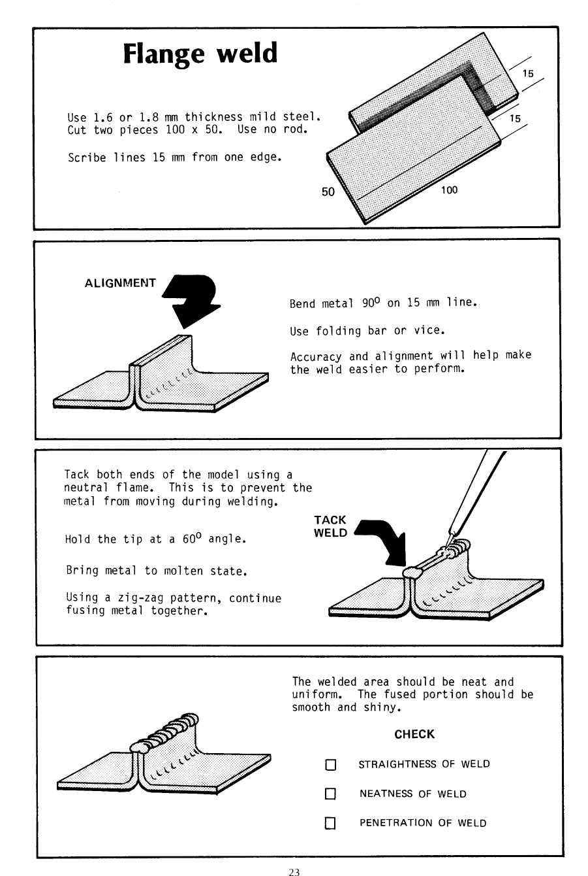
[From: Education Department of Western Australia, Curriculum Branch. (1983). Manual arts: Fusion welding. Perth: Education Department of Western Australia, p. 23]

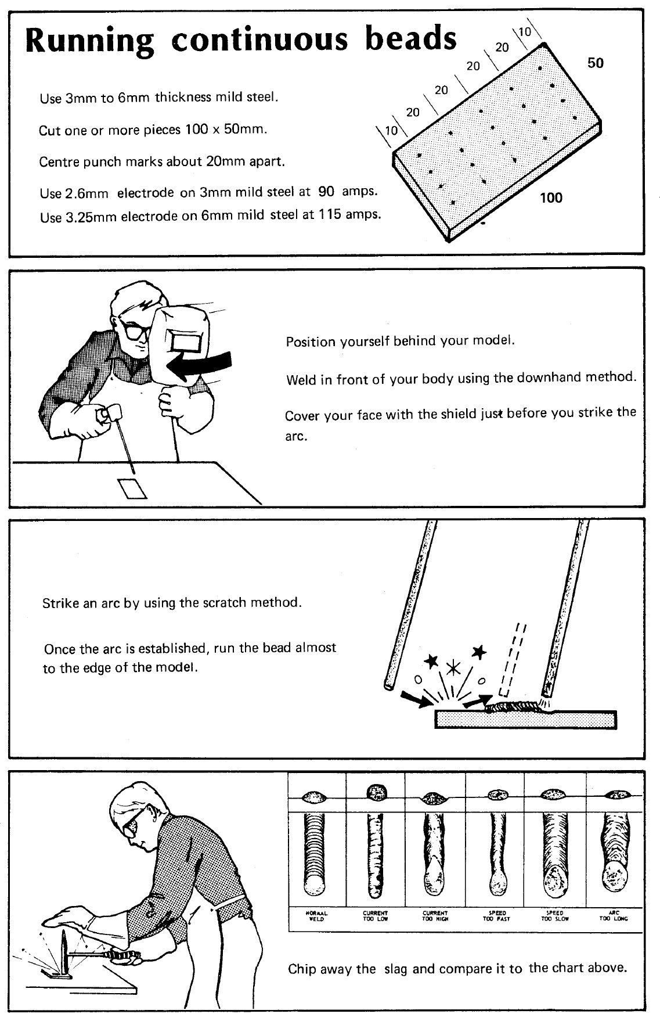
[From: Education Department of Western Australia, Curriculum Branch. (1984). Manual arts: Arc welding. Perth: Education Department of Western Australia, p. 30]
ARC WELDING
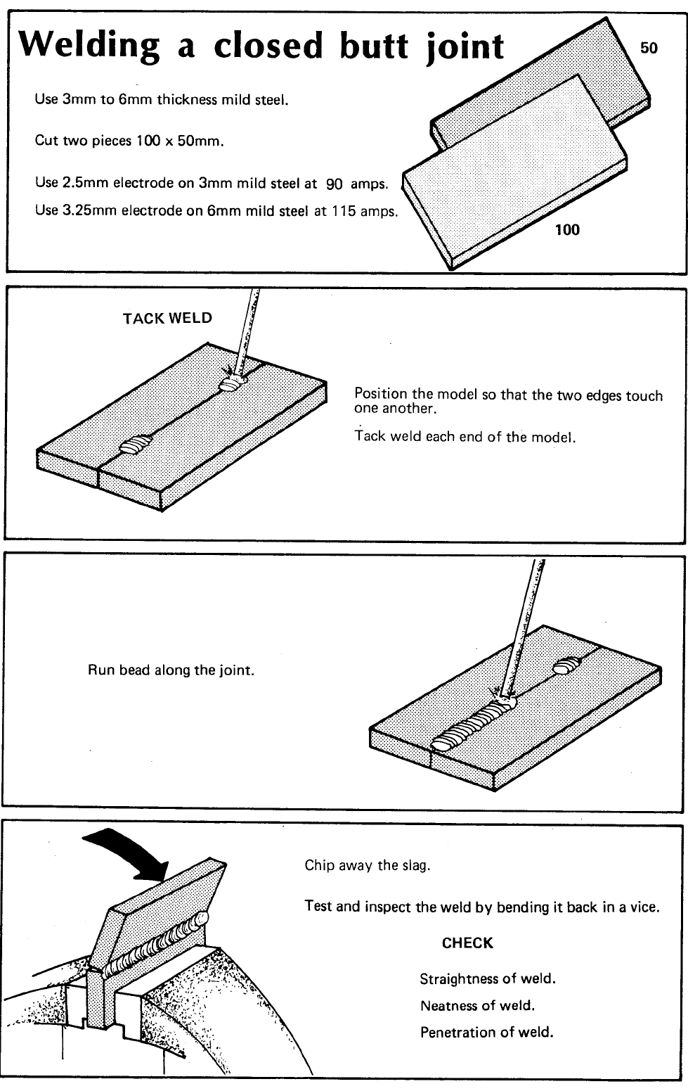
[From: Education Department of Western Australia, Curriculum Branch. (1984). Manual arts: Arc welding. Perth: Education Department of Western Australia, p. 34]
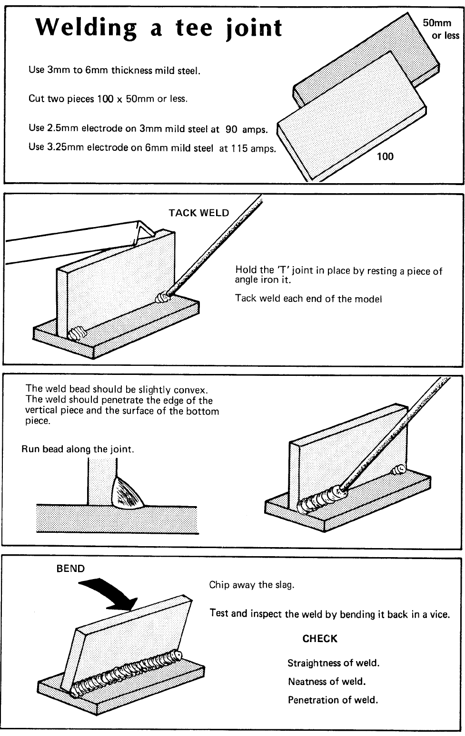
[From: Education Department of Western Australia, Curriculum Branch. (1984). Manual arts: Arc welding. Perth: Education Department of Western Australia, p. 37]
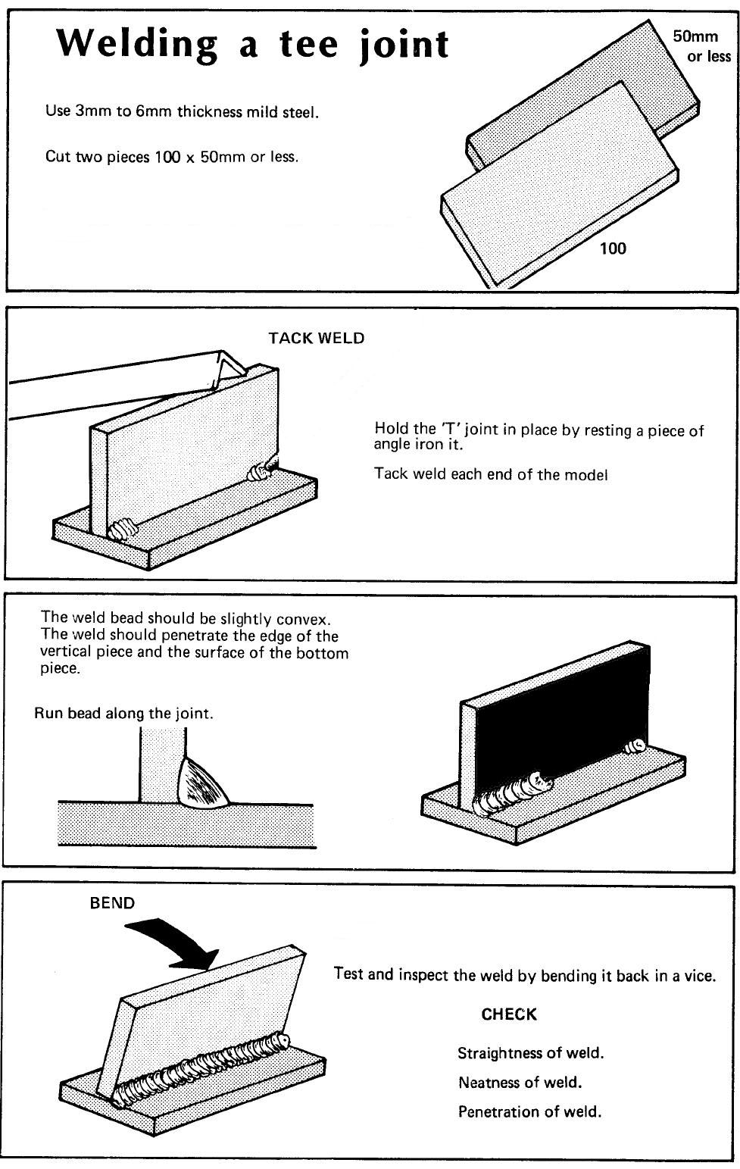
[From: Education Department of Western Australia, Curriculum Branch. (1984). Manual arts: Arc welding. Perth: Education Department of Western Australia, p. 37]
MIG WELDING
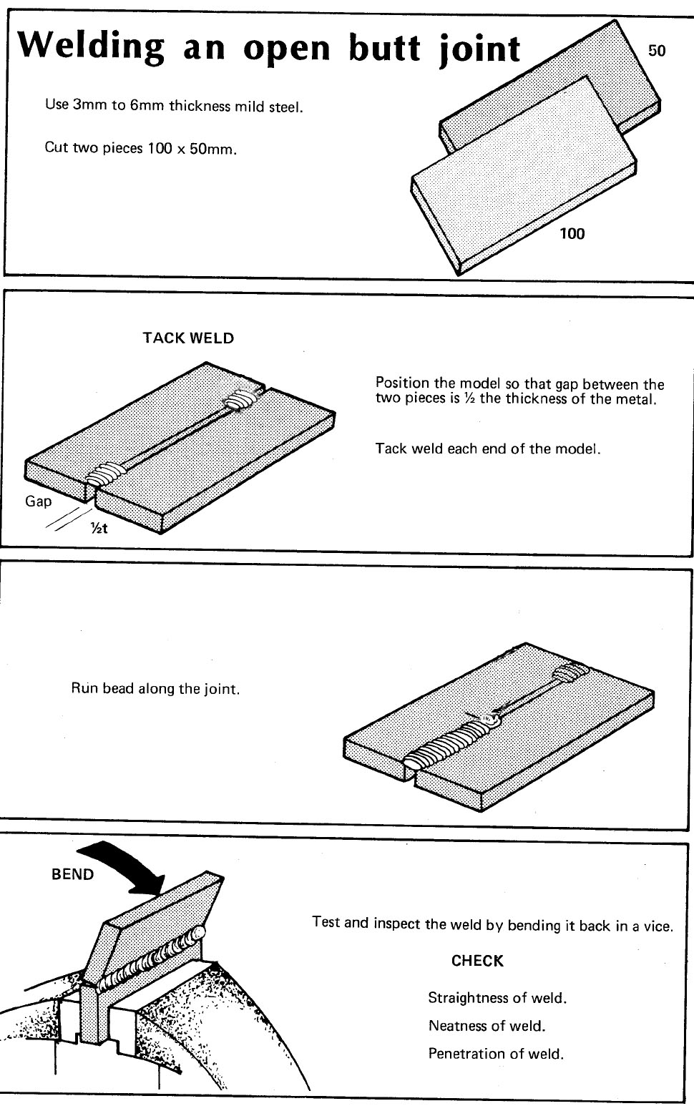
[From: Education Department of Western Australia, Curriculum Branch. (1984). Manual arts: Arc welding. Perth: Education Department of Western Australia, p. 35]

Sample assessment task

Building and Construction – General Year 11

Task 4 – Unit 1
Assessment type: Response

Environment and sustainability assignment (25 marks)
Research and compile notes on:
- sustainable practices in building and construction
- types of environmentally friendly alternatives in methods of building and construction

Conditions

Period allowed for completion of this task is two weeks

Task weighting

3% of the school mark for this pair of units
__________________________________________________________________________________

What you need to do:
In your groups, you are to research and compile notes on:
- sustainable practices in building and construction
  - define sustainable practices
  - locate and list methods of sustainable practices
- types of environmentally friendly alternatives in methods of building and construction
  - identify environmentally friendly alternatives
  - locate and list, giving a brief description and examples of each, of environmentally friendly alternatives in building and construction

Provide a list of references and sources of information.

What needs to be submitted for assessment? | Due dates
Completed assignment notes

Marking key for sample assessment task 4 – Unit 1

Research and compile notes on the definitions of sustainable practices. Identify methods of environmentally friendly alternatives in building and construction. | Maximum possible mark | Allocated mark
Definition of sustainable practices  - accurate detailed definition and correct use of terminology  - adequate definition with/without minor errors in use of terminology | 4–5  1–3 | /5
Documents listing methods of sustainable practices  - accurate detailed listing of methods and correct use of terminology  - minor/small errors or some details missing from list, uses general terminology correctly to explain methods  - terminology incorrect and/or critical information missing | 5–6  3–4  1–2 | /6
Identify and list different environmentally friendly alternatives in building and construction  - accurate identification of each type and correct descriptions, using appropriate terminology and common examples  - correct terminology in identifying each type but has minor errors in some descriptions  - some types identified and described in general terms, with errors in some descriptions  - incorrect use of terminology to identify and describe examples of only a few types | 10–12  7–9  4–6  1–3 | /12
- appropriate reference list  - limited or no reference list provided | 2  0–1 | /2
Total |  | /25

