Indonesian: Second Language
General course

Externally set task
Sample 2016

Note: This Externally set task sample is based on the following content from Unit 3 of the General Year 12 syllabus.

Learning contexts and topics
- The individual: Being teen, what does it mean?
Students reflect on what they do in their daily life and express their identity and what it means to be a teenager. They discuss moving into adulthood, coping with pressures, socialising and developing relationships.
- The Indonesian-speaking communities: Indonesian communities
Students explore the influence of culture on lifestyle in Indonesia through a study of music, film, and national and religious celebrations.

Text types and textual conventions
- advertisement, image, article

Linguistic resources
- vocabulary, phrases and expressions associated with the unit content
- grammar – adjectives, colloquial language, comparatives, conjunctions, phrases, prepositions, simple object focus, syntax of descriptive phrases, time indicators, verbs

Intercultural understandings
In future years, this information will be provided late in Term 3 of the year prior to the conduct of the Externally set task. This will enable teachers to tailor their teaching and learning program to ensure that the content is delivered prior to the students undertaking the task in Term 2 of Year 12.

Copyright
© School Curriculum and Standards Authority, 2014
This document – apart from any third party copyright material contained in it – may be freely copied, or communicated on an intranet, for non-commercial purposes in educational institutions, provided that the School Curriculum and Standards Authority is acknowledged as the copyright owner, and that the Authority’s moral rights are not infringed.
Copying or communication for any other purpose can be done only within the terms of the Copyright Act 1968 or with prior written permission of the School Curriculum and Standards Authority. Copying or communication of any third party copyright material can be done only within the terms of the Copyright Act 1968 or with permission of the copyright owners.
Any content in this document that has been derived from the Australian Curriculum may be used under the terms of the Creative Commons Attribution-NonCommercial 3.0 Australia licence
Disclaimer
Any resources such as texts, websites and so on that may be referred to in this document are provided as examples of resources that teachers can use to support their learning programs. Their inclusion does not imply that they are mandatory or that they are the only resources relevant to the course.

Indonesian: Second Language

Externally set task
Working time for the task: 60 minutes
Total marks: 42 marks
Weighting: 15% of the school mark for Units 3 and 4 of this course
Materials required for this task:
Special items: print dictionaries
one combined dictionary (Indonesian/English and English/Indonesian dictionary) or
two separate dictionaries (one English/Indonesian dictionary and one Indonesian/English dictionary). No electronic dictionaries are allowed.
Note: Dictionaries must not contain any notes or other marks.

Part 1 – Response: Viewing and reading (5%)
Text 1
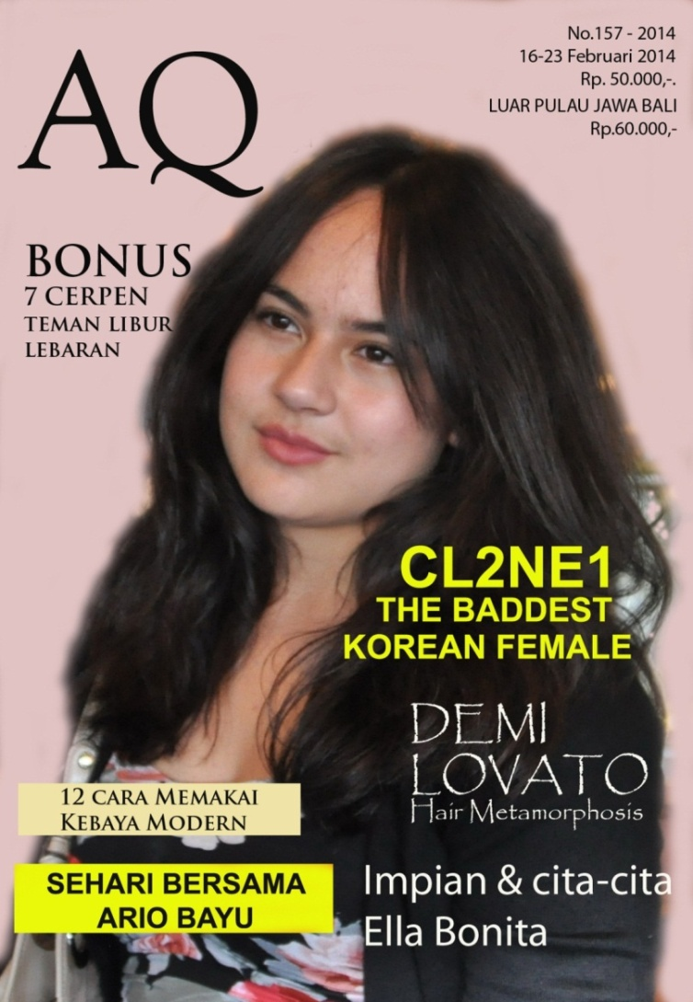

- Read the cover of AQ magazine and complete the following table to organise the main ideas conveyed in the text. Respond in English. (8 marks)
 | Description | Marks
Celebrities featured in this edition | - ______________________________________  - ______________________________________  - ______________________________________  - ______________________________________ | 4
Cost of the magazine | - ______________________________________  - ______________________________________ | 2
Event happening during the time of this edition | - ______________________________________ | 1
Style of fashion featured in this edition | - ______________________________________ | 1
- Who is the target audience for AQ magazine? Justify your answer by referring to the written language on the cover of the magazine. Give two (2) reasons. (3 marks)

____________________________________________________________________________________________________________________________________________________________________________________________________________________________________________________________________________________________________________________________________________________

Text 2
Read this article and respond to Questions 3, 4, 5, 6 and 7 in English.

Majalah Favorit Saya

OPINI 23 Februari 2014 | 20:17 Dibaca: 3240 Komentar 12 ♦ 3
Sejak saya masih kecil orang tua saya berlangganan majalah Bobo dan Kawanku untuk membangkitkan minat membaca anak-anaknya. Setelah duduk di kelas 6 SD, bapak melanggankan majalah HAI buat kami, tetapi isinya di”sensor” terlebih dahulu. Orang tua saya ingin memahami trend yang berlaku diantara kaum remaja pada waktu itu. Kadang-kadang ada majalah yang sama sekali terlarang untuk dibawa ke rumah karena isinya kurang baik menurut orang tua saya. Satu hal yang saya pelajari dari bapak adalah bahwa dia terlambat merubah pola hubungan bapak dan anak. Yaitu dari otoriter dan indoktrinasi menjadi diskusi yang seimbang berdasarkan logika.
Sampai sekarang belum ada majalah remaja pria yang isinya selengkap HAI. Kemarin saya membeli majalah HAI untuk anak saya karena saya temukan artikel menarik didalamnya. Artikel yang menarik buat saya adalah resensi tentang grup band yang sedang populer atau yang akan menyelenggarakan konsernya di Indonesia. Juga, selalu ada satu bagian dengan chord lagu barat/Indonesia. Rubrik lainnya yang masih mirip-mirip jaman saya dulu, adalah sekolah atau perguruan tinggi favorit dan tips untuk memasukinya. Juga rubrik curhat remaja pria yang membuka kesadaran betapa rawannya masa-masa remaja. Mereka membutuhkan perhatian orang tua sebagai tempat curhat sekaligus partner yang memahami perasaan anak-anaknya. Akhirnya saya melanggankan majalah HAI untuk anak-anak saya tanpa ‘sensor’ supaya kami bisa mendiskusikan hal remaja yang seimbang berdasarkan logika.
curhat (curahan hati)= outpouring of the heart/express feelings

- Answer True or False to the following statements (3 marks)
Statement | True/False

The writer’s parents encourage their children to read by subscribing to magazines.

The writer’s parents sometimes ban magazines because of the content.

The writer’s parents are not interested in teenage magazines.

- Describe the relationship between the writer and his father during his childhood. (2 marks)
________________________________________________________________________________
________________________________________________________________________________
________________________________________________________________________________

- List three (3) things that appear in HAI magazine. (3 marks)
________________________________________________________________________________
________________________________________________________________________________
________________________________________________________________________________
________________________________________________________________________________

- What did HAI make the writer become aware of, in relation to parent-child relationships?
(1 mark)
________________________________________________________________________________
________________________________________________________________________________

- Why did the writer buy HAI magazine and what did he decide to do after buying the magazine?
(2 marks)
________________________________________________________________________________
________________________________________________________________________________
________________________________________________________________________________
________________________________________________________________________________
________________________________________________________________________________

Part 2 – Written communication (10%)
- You are an Indonesian teenager and yesterday you were involved in a celebration of the religion you and your family embrace. Write a diary entry, recounting the experience and your feelings and opinions about the celebration. Write approximately 80–100 words in Indonesian.
(20 marks)
________________________________________________________________________________
________________________________________________________________________________
________________________________________________________________________________
________________________________________________________________________________
________________________________________________________________________________
________________________________________________________________________________
________________________________________________________________________________
________________________________________________________________________________
________________________________________________________________________________
________________________________________________________________________________
________________________________________________________________________________
________________________________________________________________________________
________________________________________________________________________________
________________________________________________________________________________
________________________________________________________________________________
________________________________________________________________________________
________________________________________________________________________________
________________________________________________________________________________
________________________________________________________________________________
________________________________________________________________________________
________________________________________________________________________________
________________________________________________________________________________
________________________________________________________________________________

