Modern History
General course

Externally set task Source Booklet
India 1919–1948 – a study of the end of the British Empire
Sample 2016

Copyright
© School Curriculum and Standards Authority, 2014
This document – apart from any third party copyright material contained in it – may be freely copied, or communicated on an intranet, for non-commercial purposes in educational institutions, provided that the School Curriculum and Standards Authority is acknowledged as the copyright owner, and that the Authority’s moral rights are not infringed.
Copying or communication for any other purpose can be done only within the terms of the Copyright Act 1968 or with prior written permission of the School Curriculum and Standards Authority. Copying or communication of any third party copyright material can be done only within the terms of the Copyright Act 1968 or with permission of the copyright owners.
Any content in this document that has been derived from the Australian Curriculum may be used under the terms of the Creative Commons Attribution-NonCommercial 3.0 Australia licence
Disclaimer
Any resources such as texts, websites and so on that may be referred to in this document are provided as examples of resources that teachers can use to support their learning programs. Their inclusion does not imply that they are mandatory or that they are the only resources relevant to the course.

Modern History

Externally set task Source Booklet

India 1919–1948 – a study of the end of the British Empire

Source 1

(extract from gandhi’s correspondence with the government 1942–1944.)
The accumulated experience of the past thirty years fills me with the greatest hope that in the adoption of nonviolence lies the future of India and the world. It is the most harmless and yet equally effective way of dealing with the political and economic wrongs of the downtrodden portion of humanity. I have known from early youth that nonviolence is not a cloistered¹ virtue to be practised by the individual for his peace and final salvation, but it is a rule of conduct for society if it is to live consistently with human dignity and make progress towards the attainment of peace for which it has been yearning for ages past.

1. cloistered secluded, private

Source 2
(Free India by LG Illingworth published in the Daily Mail May 23 1947. On May 23 1947, the British cabinet took the step of agreeing to Lord Louis Mountbatten's proposal for the partition of India into two states, one Moslem and the other Hindu.)

On 23 May 1947 the Daily Mail newspaper in London published a cartoon by L G Illingworth depicting the violence which would be provoked by the decision to partition India. Gandhi is shown in the middle apparently unaware of the civil unrest and violence around him. For copyright reasons the cartoon cannot be reproduced in the online version of this document, but may be viewed on the Google images website by entering the search terms LG Illingworth Free India.

Source 3
(Aftermath of communal rioting during the Partition of India 1947)

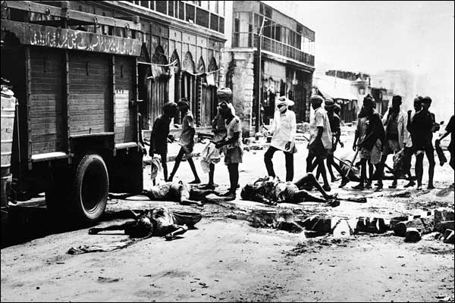

Source 4
(The National Archives [UK] has recorded the narratives of four Panjabi elders uprooted from their homeland during the Partition of British India in 1947. At least 18 million people were uprooted and one million died in the mass migration that followed. This is an extract from one of their stories.)

My name is Tilak Raj Betab. I was born in Lahore and was the tenth of my brothers and sisters. I lived in quite a big house, five Muslim houses were around us and one Hindu and one Sikh house. Our street was between the Shah Almi Gate and the Lahori Gate. It was the place where the riots started.
We were living in our house at the time of the first disturbances… There were certain people who wanted to make sure the rioting continued.
The first incident in Lahore was pre-planned for when a Hindu procession was going on. Some ringleaders/troublemakers organised that there will be an attack at a certain point. There was a procession around our area which was Chowk Mati. There were a lot of butchers there. They started stabbing and there was brick throwing from the rooftops.
I felt furious when I saw somebody carrying the dead bodies right in front of our house from the Chowk Mati area because by that time, the police had arrived. There was one man; he was carrying one body at a time. There were 12–14 people killed at that time by stabbing.

ACKNOWLEDGEMENTS

Source 1 Gandhi, M. (1942–1944). Gandhi's views on nonviolence (Gandhiji’s correspondence with the Government 1942–1944, Navajivan Publishing House). Retrieved December, 2013, from www.gandhi-manibhavan.org/gandhiphilosophy/philosophy_nonviolence_nonviolence.htm

Source 2 No image included

Source 3 Bourke-White, M. (1947). In pictures: India’s partition [Image] (Image 5). Retrieved December, 2013, from http://news.bbc.co.uk/2/shared/spl/hi/pop_ups/06/south_asia_india0s_partition/html/5.stm

Source 4 National Archives. (2010). Tilak Raj’s story. Retrieved January, 2014, from www.nationalarchives.gov.uk/panjab1947/raj.htm

