Sample Assessment Tasks

Chinese: Second Language

ATAR Year 12

Copyright
© School Curriculum and Standards Authority, 2015
This document – apart from any third party copyright material contained in it – may be freely copied, or communicated on an intranet, for non-commercial purposes in educational institutions, provided that the School Curriculum and Standards Authority is acknowledged as the copyright owner, and that the Authority’s moral rights are not infringed.
Copying or communication for any other purpose can be done only within the terms of the Copyright Act 1968 or with prior written permission of the School Curriculum and Standards Authority. Copying or communication of any third party copyright material can be done only within the terms of the Copyright Act 1968 or with permission of the copyright owners.
Any content in this document that has been derived from the Australian Curriculum may be used under the terms of the Creative Commons Attribution-NonCommercial 3.0 Australia licence
Disclaimer
Any resources such as texts, websites and so on that may be referred to in this document are provided as examples of resources that teachers can use to support their learning programs. Their inclusion does not imply that they are mandatory or that they are the only resources relevant to the course.

Sample assessment task

Chinese: Second Language – ATAR Year 12

Task 1 – Unit 3
Assessment type: Oral communication

Conditions

Time for the task: 3 minutes

A bilingual Chinese/English print dictionary can be used during the preparation time.

Task weighting

4.5% of the school mark for this pair of units

__________________________________________________________________________________

Celebrations and traditions (15 marks)
You will participate in a conversation with a speaker of Chinese who is interested in talking to you about Chinese celebrations, festivals and traditions.

Your conversation is scheduled for _____________________________________________________

Before the conversation takes place, you will be given the opportunity to:
- draft responses to the practice questions provided
- practise with a partner, asking and responding to questions related to the topic (using the practice questions provided).
While the practice questions form the basis of the conversation, not all of the practice questions will be asked, and your teacher may vary the way in which some questions are asked.
To help you during the conversation, remember to:
- listen for key words in the questions
- use oral clues, e.g. expression, tone, intonation, to assist interpretation
- ask for a question to be repeated if you don’t understand it.

Practice questions – Celebrations and traditions
In preparation for your conversation, you should consider the following questions
related to The Chinese-speaking communities: Celebrations and traditions.
Space has been provided for you to draft your responses to the questions.
© Microsoft
- Festivals
谈谈你认识的中国节日. 你觉得哪个节日最有意思？ 为什么？ Please talk about the Chinese festivals that you know about. Which do you think is the most interesting and why?
澳大利亚人过什么节日? What festivals do Australians celebrate?
在澳大利亚的中国人也庆祝那些节日吗？ 你怎么知道？ 有中国朋友吗？ Do Chinese people in Australia celebrate these festivals too? How do you know? Do you have Chinese friends?

- Mid-Autumn Festival
什么是中秋节? What is the Mid-Autumn Festival?
中国人怎样庆祝中秋节? How do Chinese people celebrate the Mid-Autumn Festival?

- Dragon Boat Festival
© Microsoft
什么是端午节? What is the Dragon Boat Festival?
中国人怎样庆祝端午节? How do Chinese people celebrate the Dragon Boat Festival?
屈原是谁？ Who is Qu Yuan?
© Microsoft
- Celebrations
你还参加过中国人的其他庆祝活动吗？比如婚礼、生日会什么的？ Have you participated in other celebrations, such as weddings or birthdays, within Chinese communities?
中国人的庆祝活动和澳大利亚人的有什么不同？ What differences are there between how Chinese and Australians celebrate?
中国人怎样庆祝春节? How do Chinese people celebrate the New Year?

- Food and gifts
谈谈中国人过节时喜欢吃的东西和喜欢送的礼物。 Talk about food Chinese people enjoy eating and the gifts they like to give during festivals.
谈谈澳大利亚人过节时喜欢吃的东西和喜欢送的礼物？ Talk about food Australians eat and gifts they usually give during festivals and celebrations.
© Microsoft

你吃过月饼吗？什么样的？味道怎么样. Have you ever eaten moon cakes? Did you like them? Describe the flavour.
你吃过粽子吗？喜欢吗？ Have you tried rice dumplings? Do you like them?

你知道中国人过生日吃什么? 他们也吃生日蛋糕吗？ What do Chinese people eat at birthday parties? Do they eat birthday cake?

寿面是什么？ 有什么特有的意思？你吃过吗？好不好吃？ What are birthday noodles?
What do they represent? Have you ever tried them? Are they good?

中国人还有什么庆祝活动和传统？ Are you aware of any other Chinese celebrations and traditions?

Marking key for sample assessment task 1 – Unit 3
Description | Marks
Comprehension /4
Comprehends all anticipated and familiar questions, including comments by the marker, and responds with little or no hesitation. Expresses the need for clarification or repetition when required. Needs minimal support from the marker | 4
Occasionally hesitates, but comprehends most simple and well-practised questions. Has difficulty when processing complex questions, even after repeating or rewording by the marker. Requires some support from the marker | 3
Comprehends only simple questions. Requires considerable support from the marker and has difficulty comprehending repeated or reworded questions. Lack of comprehension frequently results in inappropriate answers | 2
Shows little evidence of comprehension, resulting in partial answers and numerous silences. Leaves many questions unanswered, even after frequent repeating and rewording by the marker | 1
Does not show any evidence of comprehension | 0
Response (relevance and depth of information) /4
Responds in detail to all questions and comments made by the marker with relevant opinions, ideas and a range of information associated with the topic | 4
Responds to most questions and comments made by the marker with a fair range of opinions, ideas and information related to the topic | 3
Responds with a limited range of information related to questions and comments made by the marker | 2
Responds with very limited or frequently irrelevant information to questions and comments made by the marker | 1
Does not respond to questions and comments made by the marker, or responds in another language | 0
Language range (vocabulary and grammar) /3
Uses a good range of vocabulary, grammar and sentence structure. | 3
Uses a satisfactory range of vocabulary and grammar, relying predominantly on simple sentence structure. | 2
Uses set structures and basic vocabulary with repetition and reliance on non-Chinese sentence structure and vocabulary. | 1
Uses single words and short phrases with limited control, heavily influenced by another language. | 0
Language accuracy (grammar) /2
Applies rules of grammar with a high level of accuracy and consistency | 2
Applies rules of grammar with some inaccuracies | 1
Shows no application of rules of grammar | 0
Speech (flow, pronunciation and intonation) /2
Pronunciation is consistently clear and comprehensible with excellent intonation  Speaks with some spontaneity, but ‘think time’ may be required | 2
Pronunciation and intonation is acceptable  Some hesitation and/or repetition is evident | 1
Does not apply the rules of pronunciation and intonation | 0
Total | /15

Sample assessment task

Chinese: Second Language – ATAR Year 12

Task 4 – Unit 3
Assessment type: Response: Viewing and reading

Conditions

Time for the task: 45 minutes in class under test conditions

A bilingual Chinese/English print dictionary can be used for this task.

Task weighting

3.5% of the school mark for this pair of units

__________________________________________________________________________________

Celebrations and traditions and Communicating in a modern changing world (33 marks)
Read the three texts and answer the questions in English that follow each text.

Text 1 – Conversation (10 marks)

徐丽，下个星期五是中秋节。我想那天晚上搞一个聚会，你觉得怎么样？
Dawei

好呀！我也参加！在哪儿搞？是在你家吗？
Mei
在家里恐怕不太方便吧？我家比较小，可能坐不下。

Dawei
好像最近几年中国人过节，都喜欢跟家人朋友上饭馆吃饭庆祝。我觉得在家里自己做，比在饭馆吃便宜得多，也很方便。

Mei

还是去饭馆吧。在家里的话，要做很多准备，吃完了还要搞卫生，太麻烦了。去饭馆，大家可以多聊聊天，喝喝酒，唱唱卡拉OK什么的。
Dawei

那我们准备去哪个饭馆？几点去？
Mei
中国城有个饭馆叫“四季园”，很不错，价钱合适味道很好，我们六点半到那儿，怎么样？

Dawei
Mei

行！

1. What is the conversation about? (2 marks)
___________________________________________________________________________
___________________________________________________________________________

2. The speakers discuss whether to have the event at home or in a restaurant. In the table below, list two benefits for each venue. (4 marks)
Benefits
Home
Restaurant

3. According to the conversation, how have Chinese people celebrated festivals in recent years?
(4 marks)
____________________________________________________________________
____________________________________________________________________
____________________________________________________________________

Text 2 – Blog (11 marks)
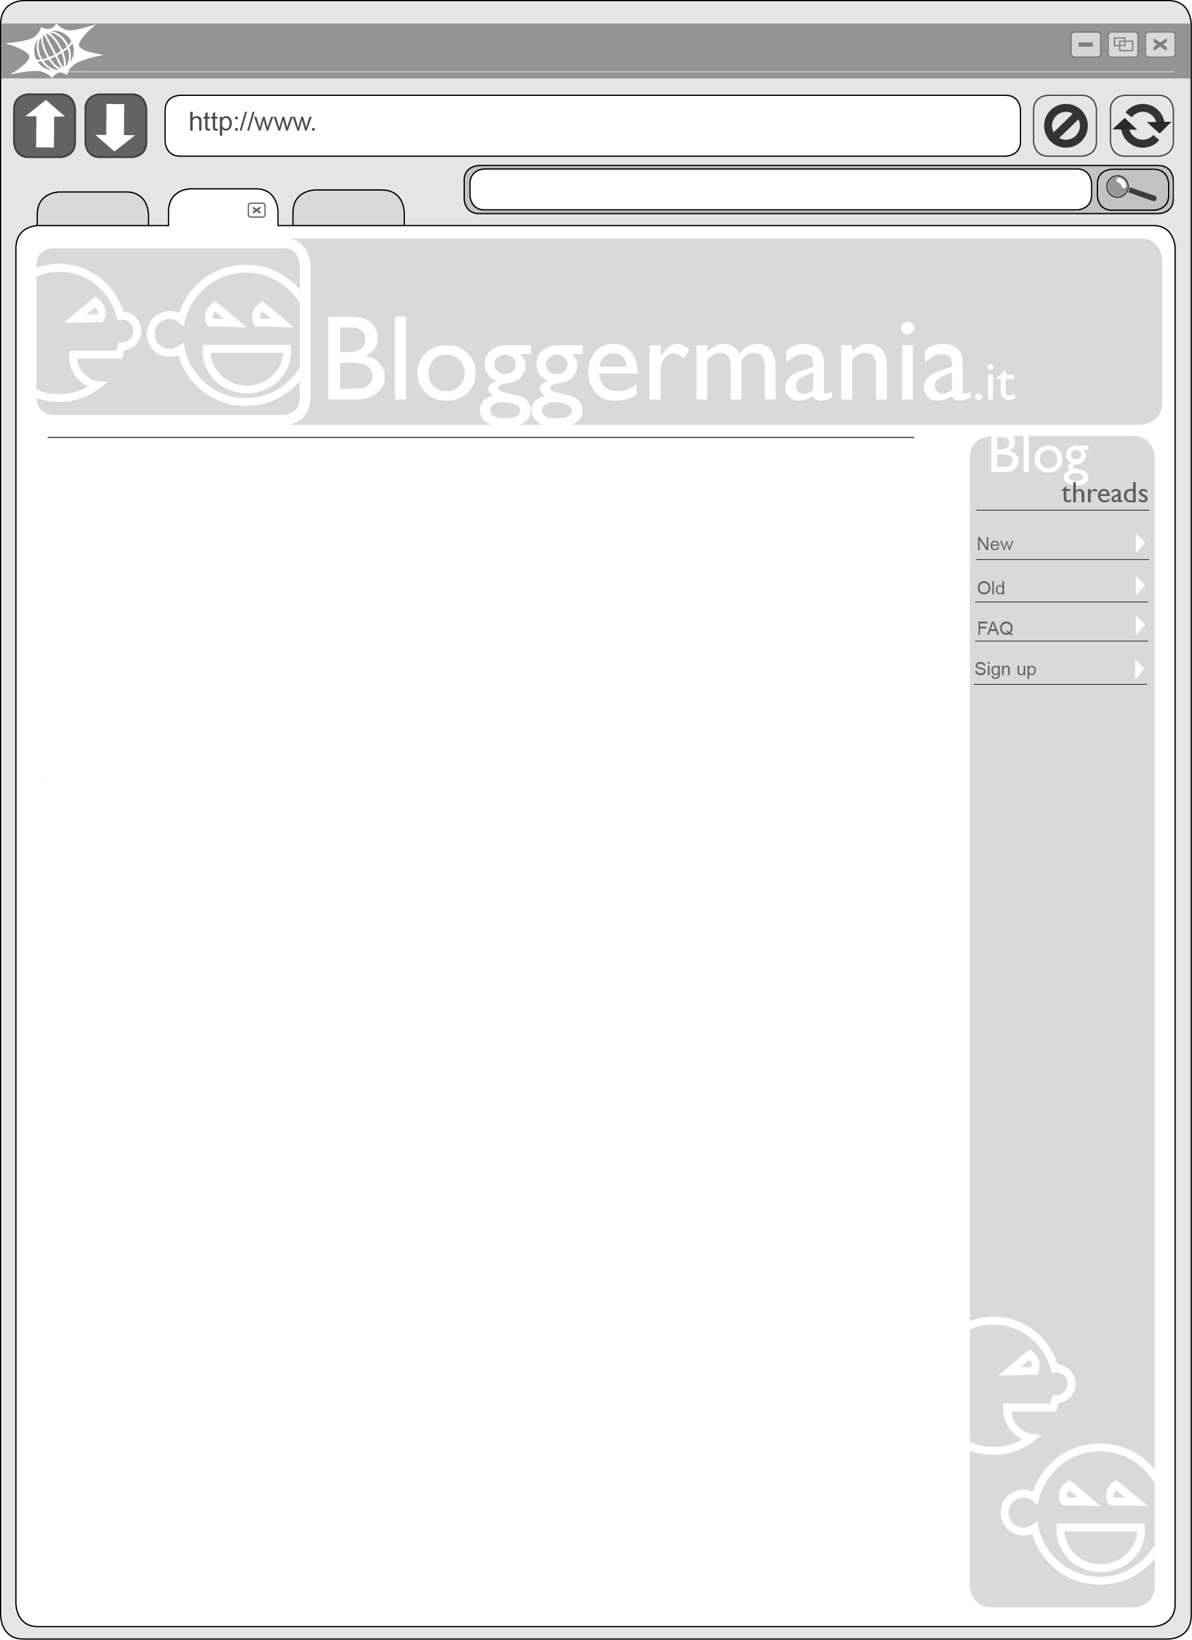
.cn
科技产品对你的日常生活的影响
现在的孩子们太依赖科技产品了
我的小孩一天到晚都在用手机打电话和听音乐。不用手机的时候，他们就在电脑上聊天、玩游戏什么的。我觉得这样不但浪费时间，而且让他们养成了依赖科技产品的习惯。
另外，很多科技产品让孩子们花太多时间待在家里，而不是做有益健康的户外活动，这样对他们的身体健康没有好处。
所以学校和家长应该加强管理孩子们对科技产品的使用。
一位着急的家长
科技产品让我的生活又方便又有趣。
电脑不仅对我的学习有帮助，而且帮我放松。我做作业的时候，经常用电脑上网找资料，学习有问题的时候，可以发电子邮件问朋友。功课压力太大的时候，我喜欢用手机一边听音乐一边玩游戏轻松一下，效果好极了！
很多家长认为我们过分依赖科技产品，但是我觉得科技产品是现代生活的一部分。作为年轻人，我们应该多和父母沟通，让他们理解这些。
一个希望被理解的中学生
7. Tick () which of the following statements are true and which are false. (4 marks)
 | True | False
The parent says his/her children are relying too much on technology.
The parent believes children today are watching too much television.
The parent says technology is bad for the health of children.
The student says children today use technology only for information.

8. What does the parent say about his/her children’s use of technology? (3 marks)
____________________________________________________________________
____________________________________________________________________
____________________________________________________________________
9. What does the student think about the use of technology? (4 marks)
____________________________________________________________________
____________________________________________________________________
____________________________________________________________________
Text 3 – Account (12 marks)
上网聊天
前几天网上有一个报道说70% 的中国学生都喜欢上网聊天。
看了这报道后，我想：我已经学了三年汉语了，为什么不上网和中国人聊聊天呢？这样也许能提高我的汉语水平，取得好成绩，父母也会很高兴。
我第一次访问中文聊天室， 便发现他们聊天的速度非常快，用的句子里也有很多我不懂的字。这已经让我觉得比较困难，更麻烦的是，我总是记不住他们的名字，分不清谁是谁，不知道应该怎么办。此外，聊天室里的人，看起来好像都是认识了很久的老朋友，他们会欢迎新人加入吗？
我最后还是打了“你好”两个字，等了很长时间，终于有一个人回答我：“你好， 你是谁？从哪儿来的？”我很高兴，就很快地回答说：“我是澳大利亚人，正在学汉语，想跟中国人聊天。多学点中国历史、文化、美食。”
这个人 现在是我最好的朋友，明年我打算去中国看他。

Glossary
Character | Pinyin | Meaning
报道 | bàodào | A report
访问 | fǎngwèn | To visit
10. According to the account, what do a lot of Chinese people do online these days? (2 marks)
_____________________________________________________________________
_____________________________________________________________________
11. What is the writer’s idea? (2 marks)
_____________________________________________________________________
_____________________________________________________________________
12. List three positives that could result from the idea? (3 marks)
- __________________________________________________________________
- __________________________________________________________________
- __________________________________________________________________
13. What difficulties did the writer have? Complete the following. (5 marks)
- The participants chat _______________________________________________.
- Didn’t know a lot of ______________________________________________________.
- Chinese ___________________________ are difficult to remember.
- Did not know who _______________________________________________________.
- The others already _______________________________________________________.

ACKNOWLEDGEMENTS

Text 2 Image: Supakitmod. (2013) Education by computer stock photo. Retrieved May, 2015, from www.freedigitalphotos.net/images/education-by-computer-photo-p212511

Marking key for sample assessment task 6 – Unit 3
Text 1 – Conversation | 10 marks
Question 1 | /2
- to discuss the (celebration) plans  - for the Chinese Mid-Autumn Festival | 1  1
Question 2 | /4
Home:  - cheaper  - more convenient | 1  1
Restaurant:  - less preparation  - don’t have to clean up | 1  1
Question 3 | /4
- they celebrate in restaurants where they will  - chat  - drink  - sing karaoke | 1  1  1  1
Text 2 – Blog | 11 marks
Question 7 | /4
True False  The parent says his/her children are relying too much on technology.  The parent believes children today are watching too much television.  The parent says technology is bad for the health of children.  The student says children today use technology only for information. | 1 mark each
Question 8 | /3
- they spend all day, all night  - either on phone  - or on computer | 1  1  1
Question 9 | /4
- convenient  - interesting  - helps them study  - and relax | 1  1  1  1
Text 3 – Account | 12 marks
Question 10 | /2
- 70% of Chinese students like to  - chat online | 1  1
Question 11 | /2
- he will go online to chat  - with Chinese people | 1  1
Question 12 | /3
- he can improve his Chinese  - improve his grades  - make his parents happy | 1  1  1
Question 13 | /5
- The participants chat too fast.  - Didn’t know a lot of characters  - Chinese names are difficult to remember.  - Did not know who was who  - The others already knew each other. | 1  1  1  1  1
Total | /33

Sample assessment task

Chinese: Second Language – ATAR Year 12

Task 9 – Unit 4
Assessment type: Response: Listening

Conditions

Time for the task: 60 minutes in class under test conditions

A bilingual Chinese/English print dictionary can be used.

Task weighting

5.25% of the school mark for this pair of units

__________________________________________________________________________________

Reflecting on my life and planning my future and The environment (39 marks)

Listen to the four texts and answer the questions in English.
Texts 1 and 2 are played twice.
As Texts 3 and 4 are longer, each is divided into two parts. Each will be played once in its entirety, and then each part will be played twice.
After the second reading of Texts 1 and 2, and of each part of Texts 3 and 4, there is a pause for you to complete your answers to the questions.
Text 1 – Conversation (10 marks)
A conversation between two students about recycling.
1. What four types of recycling bins are nearby? (4 marks)
- _________________________________________________________________________
- _________________________________________________________________________
- _________________________________________________________________________
- _________________________________________________________________________
2. Tick () which of the following statements are true and which are false. (4 marks)
 | True | False
The male speaker cannot recycle all the rubbish he wants to throw away.
The male speaker does not know much about recycling.
The female speaker thinks highly of the male speaker.
The male speaker thinks the task is quite easy.

3. What two things does the female speaker want everyone to do? (2 marks)
______________________________________________________________________
______________________________________________________________________
______________________________________________________________________
Text 2 – Message (10 marks)
David leaves a message for Teacher Zhang.
Glossary for Text 2
Character | Pinyin | Meaning
野生动物保护协会 | yěshēng dòngwù bǎohù xiéhuì | Wildlife Conservation Society
濒临灭绝 | bīnlín mièjué | To face extinction
长江巨鳖 | chángjiāng jù biē | Yangtze River giant soft shell turtle
4. Why did David ring Teacher Zhang? (2 marks)
______________________________________________________________________
______________________________________________________________________
5. Complete the details about the lecture mentioned in the telephone message. (4 marks)
Date
Time
Venue
Lecture topic
6. What information is given about the person giving the lecture? (4 marks)
______________________________________________________________________
______________________________________________________________________
______________________________________________________________________

Text 3 – Interview (12 marks)
Kate is being interviewed about her life.
Part 1
7. What is the topic discussed in the interview with Kate? (2 marks)
______________________________________________________________________
______________________________________________________________________

8. Why did Kate want to work? Tick () which of the following statements are true and which are false. (4 marks)
 | True | False
She wanted to help her parents.
She wanted to save money.
She wanted to gain independence.
She wanted to gain work experience.

Part 2
9. Kate talks about what she does in her free time. Complete the table with the missing information. (6 marks)
Day | Activity
 | study
 | play sport
Saturdays
Sundays

Text 4 – Conversation (7 marks)
Lanlan and Xiaoming discuss dating.
Part 1
10. What opinions do Lanlan’s parents have about high school students dating? (2 marks)
____________________________________________________________________________
____________________________________________________________________________
Part 2
11. What information is given about Xiaoming’s parents and their opinions? (5 marks)
____________________________________________________________________________
____________________________________________________________________________
____________________________________________________________________________
____________________________________________________________________________

Listening texts for sample assessment task 9 – Unit 4
Text 1 – Conversation
Female speaker: 你做什么呢？等一下，等一下！
Male speaker: 怎么了？
Female speaker: 你不能把那个纸袋放在垃圾箱里。
Male speaker: 为什么？这是垃圾，当然得放在垃圾箱里，不应该随便扔。
Female speaker: 这是纸袋，可以循环使用。你看，这里有几个回收箱：纸的，玻璃的，塑料的，金属的。这个是纸袋，应该放进纸的回收箱里。
Male speaker: 这个我当然知道，但是纸袋里有水果、瓶子和其他的垃圾。
Female speaker: 别这么懒吧！你应该先把瓶子放在玻璃的回收箱里，再把水果等垃圾放在垃圾箱里，最后把纸袋放在纸的回收箱里。
Male speaker: 这真的太麻烦了！
Female speaker: 那给我吧！我来做！我们每天制造太多垃圾了。如果大家都学会资源节约和回收，地球就会变得更美好。我们应该用实际行动来承担这份责任。
Male speaker: 好，好，好。我现在就去。
Text 2 – Message
喂，张老师，我是大卫呀。下星期二晚上七点在学校图书馆有一个环保演讲，我们请来了中国野生动物保护协会的李教授，给我们谈谈中国野生动物濒临灭绝的问题。李教授曾经参与长江巨鳖的保护工作。演讲完了，我们打算请李教授吃晚饭，希望您也一起来。好吧，下星期二见。
Text 3 – Interview
Part 1
Teacher: 现在越来越多年轻人一边学习一边打工。今天，我们谈谈这个问题。让我们欢迎凯特!
Kate: 谢谢老师！大家好!
Teacher： 听说你刚刚高中毕业了？恭喜恭喜！请跟我们谈谈你的学习和工作。
Kate： 谢谢。我从十五岁开始便一边工作一边学习。上十二年级的时候，虽然学校的功课越来越多，考试越来越难，我也越来越忙，但是我还忙得过来。
Teacher： 你的工作是什么？为什么开始打工？
Kate： 我在咖啡馆当服务员。我开始打工是为了要存钱，不用问父母要钱，希望可以过自由的生活。
Part 2
Teacher： 明白了。你不觉得太辛苦了吗？工作会影响你的成绩吗？
Kate： 不会啊，我只是周末工作，这样我星期一到星期五可以有时间学习和做运动。开始工作以前，我的成绩不错，工作以后也还可以，所以没问题。
Teacher： 那你现在的休闲生活跟以前有什么不同呢？

Kate： 周末我只是白天工作，星期六晚上是我的休闲时间，一般和朋友一起看电影，去餐馆吃饭，或者去朋友家聊聊天。星期天我和家人去教堂。我觉得我的学生生活过得很好。
Teacher： 谢谢你的参与。现在我们开始理解为什么学生喜欢工作。

Text 4 – Conversation
Part 1
Xiaoming: 喂，兰兰，我是小明，星期六晚上刘东生日晚会你能来吗？我们邀请了很多朋友。
Lanlan: 是吗？我很想来，可是不知道我爸爸妈妈会不会让我晚上出去。
Xiaoming: 为什么不让？
Lanlan: 是呀。他们不放心。我要是和一个男同学多打一个电话，他们就以为我有男朋友。
Xiaoming: 有男朋友又怎么样？
Lanlan: 他们说，中学生交男女朋友会影响学习，考大学最重要。

Part 2
Xiaoming: 我觉得你爸爸妈妈管孩子管得太严了。
Lanlan: 也不一定，我知道他们很爱我，是为我好，所以我没有意见。你爸爸妈妈呢？他们对你交女朋友有什么看法？
Xiaoming: 我爸爸妈妈认为青年交男女朋友很正常，和女朋友在一起要互相帮助和学习。有时周末去朋友家玩，只要他们知道我是去谁家去做什么，他们一般都会同意。
Lanlan: 你真幸运！我回家跟我爸爸妈妈说一下，明天告诉你。
Xiaoming: 没问题！明天见。

Marking key for sample assessment task 9 – Unit 4
Text 1 – Conversation |  | 10 marks
Question 1 |  | /4
Recycling bins for:  - paper  - glass  - plastic  - metal |  | 1  1  1  1
Question 2 |  | /4
 | True | False
The male speaker cannot recycle all rubbish he wants to throw away.
He does not know much about recycling.
The female speaker thinks highly of the male speaker.
The male speaker thinks the task is quite easy.

Question 3 |  | /2
- she wants everyone to practise resource conservation and  - recycling |  | 1  1
Text 2 – Message |  | 10 marks
Question 4 |  | /2
- to invite Teacher Zhang to a lecture and  - to dinner afterwards |  | 1  1
Question 5 |  | /4
Date Next Tuesday (1)  Time 7pm (1)  Venue The school's library (1)  Lecture topic China's endangered species (1) |  | 1 mark for each
Question 6 |  | /4
- Professor Li  - from Wildlife Conservation Society  - in China  - he took part in saving the Yangtze River giant soft shell turtles |  | 1  1  1  1
Text 3 – Interview |  | 12 marks
Part 1  Question 7 | /2
- Kate shares her experience of working  - while studying |  | 1  1
Question 8 |  | /4
True False  She wanted to help her parents.  She wanted to save money.  She wanted to gain independence.  She wanted to gain work experience. |  | 1 mark for each

Part 2  Question 9 | /6
- Mondays to  - Fridays  - goes to movies  - dines at the restaurants  - goes to friend's house to chat  - goes to church with her family |  | 1  1  1  1  1  1
Text 4 – Conversation |  | 7 marks
Part 1  Question 10 | /2
- high school students will not study well/be distracted from their studies if they start dating  - it is more important for high school students to focus on getting into universities |  | 1  1
Part 2  Question 11 | /5
- dating among teenagers is normal/acceptable  - boyfriends and girlfriends need to help and learn from each other  - Xiaoming is allowed to visit friends at their places during the weekends  - as long as he lets his parents know who he is visiting and  - what he will be doing |  | 1  1  1  1  1
Total |  | /39

Sample assessment task

Chinese: Second Language – ATAR Year 11

Task 12 – Unit 4
Assessment type: Written communication

Conditions

Time for the task: 45 minutes in class under test conditions

A bilingual Chinese/English print dictionary can be used.

Task weighting

5.25% of the school mark for this pair of units

__________________________________________________________________________________

Current issues (18 marks)
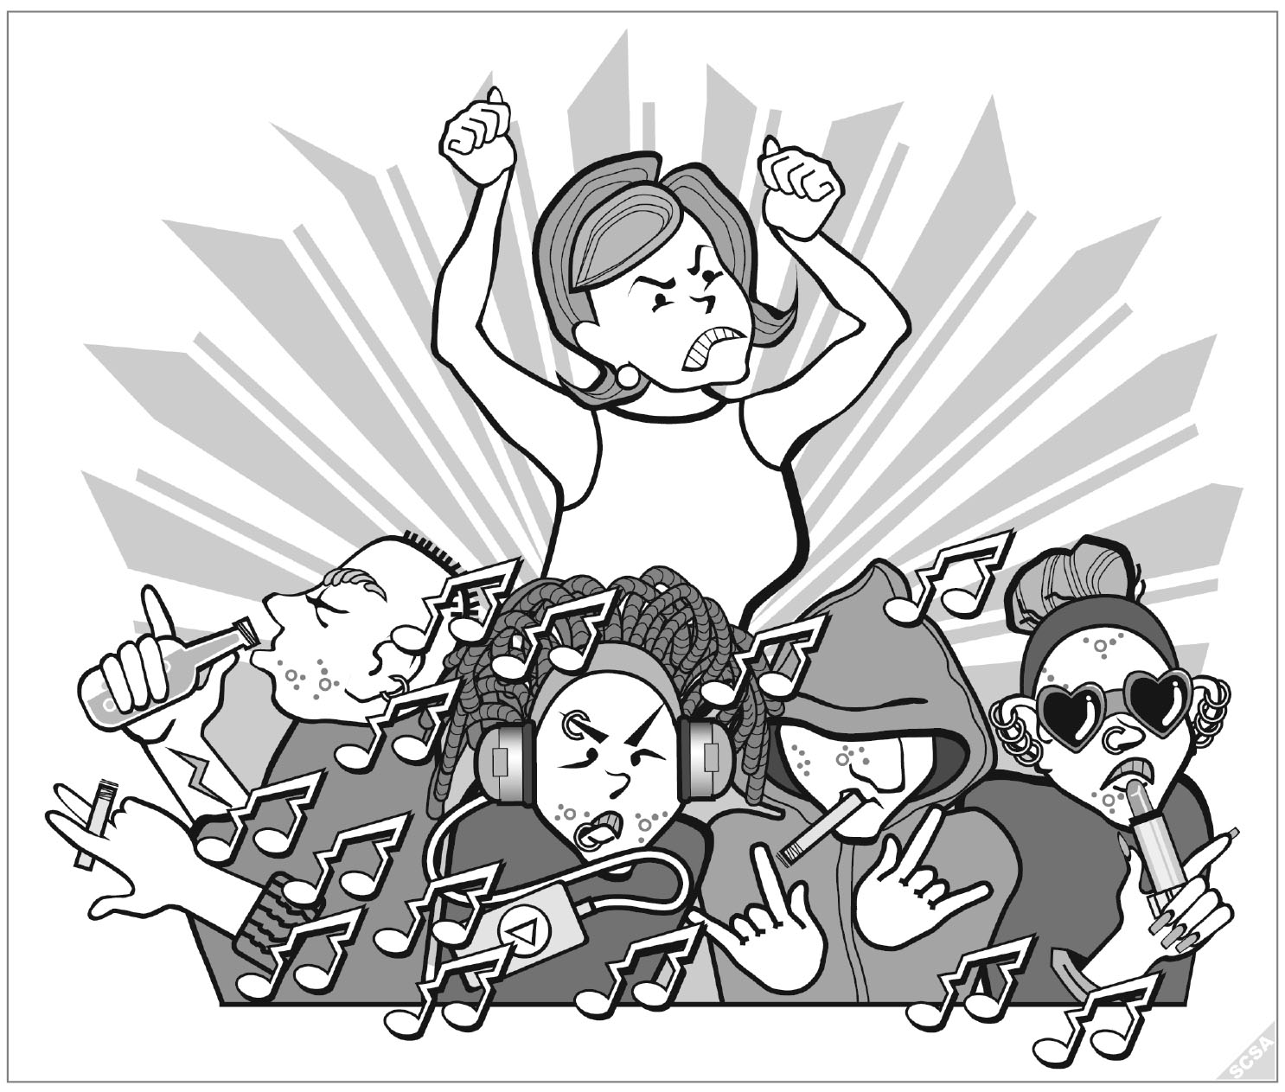
Write a blog about the current issues faced by teens at your school for an online student forum. Refer to at least two of the issues illustrated in the image above. Write approximately 120–150 Chinese characters. Use the template provided.
In your blog, include information, such as:
- why it is an issue
- who does the issue affect
- your personal experience
- how to deal with the issue.
.cn
______________________________________________________________
______________________________________________________________
______________________________________________________________
______________________________________________________________
______________________________________________________________
____________________________________________________________________________________________________________________________
______________________________________________________________
____________________________________________________________________________________________________________________________
______________________________________________________________
____________________________________________________________________________________________________________________________
______________________________________________________________
____________________________________________________________________________________________________________________________
______________________________________________________________
____________________________________________________________________________________________________________________________
______________________________________________________________
______________________________________________________________

Marking key for sample assessment task 12 – Unit 4
Description | Marks
Content and relevance /6
Provides a detailed blog related to at least two issues, reflected in the stimulus, faced by teens including,  - why it is an issue  - who does the issue affect  - your personal experience  - how to deal with the issue  Engages the audience and effectively supports information with well-developed examples | 6
Provides most of the content required by the question  Uses details and/or examples to elaborate | 5
Provides relevant content and covers a range of aspects of the question  Uses some details with elaboration | 4
Provides most of the content required by the question, but may be superficial with treatment of some content and in elaboration | 3
Provides content that is generally relevant, with minimal elaboration or detail  Relies on listing issues and some repetition | 2
Provides content that is very repetitive and often with little relevance to the question | 1
Response is unclear and content has little relevance to the question | 0
Linguistic resources (grammar) – range /4
Uses a good range of grammar and sentence structures appropriately | 4
Uses a good range of grammar and sentence structures, with occasional influence of syntax of another language | 3
Uses a range of grammar and sentence structures, with occasional influence of syntax of another language | 2
Uses basic and repetitive grammar and sentence structures with clear influence of syntax of another language | 1
Uses inadequate vocabulary, expressions, grammar and sentence structures | 0
Linguistic resources (vocabulary) – range /3
Uses contextually relevant vocabulary and a range of expressions. Includes contemporary, colloquial and specialised vocabulary, when required | 3
Uses a good range of vocabulary and characters appropriate to the question | 2
Uses basic and repetitive vocabulary and characters | 1
Insufficient command of basic vocabulary and characters | 0
Linguistic resources – accuracy /3
Uses language accurately and consistently  Occasionally omits words or makes errors in sentence structure and characters. Inaccuracies do not affect meaning or flow | 3
Uses language mostly accurately; however, errors interfere with the flow of a phrase or sentence and sometimes affect meaning | 2
Inaccuracies and incorrect choice of language impede meaning and flow  Inconsistent application of rules of grammar makes some parts of writing awkward | 1
No application of rules. Evidence of literal translations from English | 0
Text types – conventions and organisation /2
Writes a coherent and cohesive blog, sequencing information in an appropriate and logical manner.  Uses all the key conventions:  - title for the blog  - indentation for each paragraph  - appropriate register and tone | 2
Writes a basic and mainly cohesive blog and sequences most information  Uses some of the conventions of the text type | 1
Writes with a limited level of literacy, with minimal or no evidence of sequencing ideas  Does not observe the conventions of the text type | 0
Total | /18

