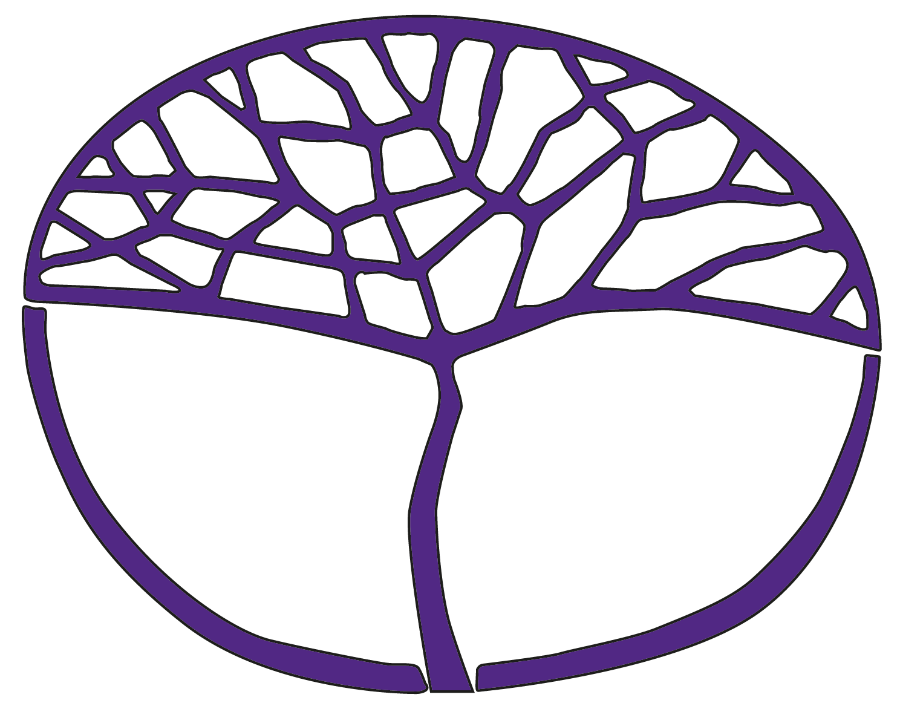**Sample Assessment Tasks**

Human Biology

General Year 11

**Copyright**

© School Curriculum and Standards Authority, 2014

This document – apart from any third party copyright material contained in it – may be freely copied, or communicated on an intranet, for non-commercial purposes in educational institutions, provided that the School Curriculum and Standards Authority is acknowledged as the copyright owner, and that the Authority’s moral rights are not infringed.

Copying or communication for any other purpose can be done only within the terms of the *Copyright Act 1968* or with prior written permission of the School Curriculum and Standards Authority. Copying or communication of any third party copyright material can be done only within the terms of the *Copyright Act 1968* or with permission of the copyright owners.

Any content in this document that has been derived from the Australian Curriculum may be used under the terms of the [Creative Commons Attribution-NonCommercial 3.0 Australia licence](http://creativecommons.org/licenses/by-nc/3.0/au/)

**Disclaimer**

Any resources such as texts, websites and so on that may be referred to in this document are provided as examples of resources that teachers can use to support their learning programs. Their inclusion does not imply that they are mandatory or that they are the only resources relevant to the course.

Sample assessment task

Human Biology – General Year 11

## Task 3 – Unit 1

**Assessment type:** Science Inquiry

**Conditions**

Period allowed for completion of the task:

* One lesson pre-dissection discussion
* One lesson conducting dissection
* One week to complete laboratory report write up and questions on dissection

**Task weighting:** 7% of the school mark for Units 1 and 2

________________________________________________________________________________________________________

**Task 3: Practical – Heart dissection (32 marks)**

Conduct a dissection of a sheep heart and write a scientific report about your dissection, as described below.

1. **Conduct dissection**

Follow the instructions to complete dissection.

Make diagrams and take photos of your dissection showing key parts of the process. Identify in your diagrams/photos key parts and components, for use in your report.

1. **Process, evaluate and communicate findings**

Complete report on dissection by answering the questions provided.

**Sheep heart dissection**

The heart is one of the most important organs in the body. It continually pumps blood around the body through our arteries, capillaries and veins. It supplies the cells of our body with necessary oxygen and nutrients for the cells to function properly.

In this dissection, you will be examining a sheep heart, looking closely at the heart chambers, valves and blood vessels. Use your notes and textbooks to answer the questions at the end of the dissection.

## Conduct dissection:

**Materials:**

|  |  |
| --- | --- |
| * sheep heart * dissecting kit – scalpel, scissors, probe, tweezers * dissecting board | * disposable gloves * 2 x red and 2 x blue pencils/straws * iPad/iPod/camera/mobile phone |

**Procedure:**

**Initial examination**

* Collect equipment listed above.
* Inspect the sheep heart and identify the left and right side of the heart. Remember the left side of the heart should be on your right side as you look at the heart.
* 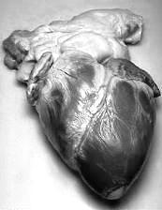Position your heart on the dissecting board matching the diagram.
* Locate the apex of the heart and measure the length of the heart from top to bottom.

Record the length: __________________

* Lay the heart with the apex closest to you and the groove with a blood vessel travelling diagonally from the right side of the wide part of the heart to a point just above and to the left of the apex.
* You should be able to locate some openings into the heart. These are the arteries and veins that carry blood to and from the lungs and to and from the body.
* The red pencils/straws are to represent oxygenated blood and the blue pencils/straws are to represent deoxygenated blood. Place the pencils/straws in the appropriate positions showing the pulmonary artery, pulmonary vein, aorta and vena cava.

**Photo 1:** Take a photo of your heart with pencils/straws inserted

**Dissecting the right atrium**

* Remove the pencils from the heart.
* Insert your probe into the superior vena cava. This should be on the right side of the top of the heart. This is the right atrium.
* Remove the probe and insert the dissecting scissors/scalpel and cut down through the heart until you reach the bottom of this chamber.
* Locate the valves that separate the atrium from the ventricles.

**Photo 2:** Take a photo of the valves

1. What is the purpose of these valves? (1 mark)

____________________________________________________________________________________________________________________________________________________________________

**Dissecting the right ventricle**

* Continue using your scissors/scalpel to cut down through the heart valve into the right ventricle.
* Locate the valves of the pulmonary artery and cut upward through this until you find the valves of the artery.

**Photo 3:** Take a photo of the valves

**Dissecting the left atrium and ventricle**

* Insert dissecting scissors/scalpel into the blood vessel located at the top of the heart. This is the pulmonary vein. Cut down through the wall of the atrium until you reach the apex.
* Open the left atrium and examine the valve that separates the atrium from the ventricle.
* Examine the ventricle, especially the walls.

1. What is different about the left ventricle compared with the right ventricle? (1 mark)

____________________________________________________________________________________________________________________________________________________________________

**Photo 4:** Take a photo of the walls of the ventricle.

* This is the end of the dissection. Dispose of the heart as instructed and place all dissecting equipment in the appropriate container.
* Wipe down bench with disinfectant and wash your hands.
* Complete the questions.

## Process, evaluate and communicate findings

**Questions:**

1. Label the following diagram of the heart. Using coloured pencils, colour parts of the diagram of the heart and use arrows to show the flow of deoxygenated blood (blue) and oxygenated blood (red) through the heart. (13 marks)

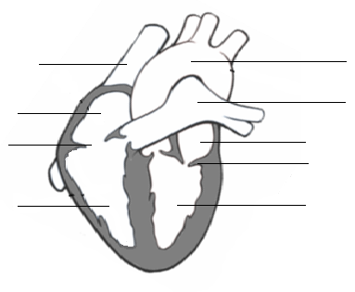

Place **photo 1** here (1 mark)

Photo 1

1. Where does the blood from the right atrium come from? (1 mark)

__________________________________________________________________________________

1. Where does the blood from the right ventricle go to? (1 mark)

__________________________________________________________________________________

1. Where does the blood from the left atrium come from? (1 mark)

__________________________________________________________________________________

1. Where does the blood from the left ventricle go to? (1 mark)

__________________________________________________________________________________

1. The heart is known as a double pump. Explain why it is known as a double pump. (3 marks)

____________________________________________________________________________________________________________________________________________________________________

1. Are there any valves in other parts of the circulatory system? If so, where? Paste a copy of the photos you took of the valves below. (2 marks)

__________________________________________________________________________________

__________________________________________________________________________________

__________________________________________________________________________________

__________________________________________________________________________________

Place **photo 2** here (1 mark) Place **photo 3** here (1 mark)

Photo 3

Photo 2

1. Compare the valves separating the right chambers of the heart with the valves separating the left chambers of the heart. (2 marks)

____________________________________________________________________________________________________________________________________________________________________

1. When comparing the walls of the ventricles, why is the wall of the left ventricle different from the wall of the right ventricle? (2 marks)

Place **photo 4** here (1 mark)

Photo 4

___________________________________________________

___________________________________________________

___________________________________________________

___________________________________________________

___________________________________________________

**ACKNOWLEDGEMENTS**

**Image under ‘Conduct dissection’**

Alexanderpiavas134 (n.d.). [Photograph of heart]. Retrieved June, 2014, from <http://commons.wikimedia.org/wiki/File:Humhrt2.jpg>

**Image under ‘Process, evaluate and communicate findings’**

Adapted from: Lynch, P. J. (2006). *Heart circulation simple diagram of heart chambers*.   
Retrieved June, 2014, from <http://commons.wikimedia.org/wiki/File:Heart_circulation_diagram.svg>

Used under Creative Commons [Attribution 2.5 Generic](http://creativecommons.org/licenses/by/2.5/deed.en) licence.

Marking key for sample assessment task 3

**Questions (32 marks)**

1. What is the purpose of these valves?

|  |  |
| --- | --- |
| **Description** | **Mark** |
| Keep blood flowing in one direction/stop backflow of blood | 1 |
| **Total** | **/1** |

1. What is different about the left ventricle compared with the right ventricle?

|  |  |
| --- | --- |
| **Description** | **Mark** |
| Left ventricle wall thicker than right | 1 |
| **Total** | **/1** |

1. Label the following diagram of the heart. Using coloured pencils, colour parts of the diagram of the heart and use arrows to show the flow of deoxygenated blood (blue) and oxygenated blood (red) through the heart.

|  |  |
| --- | --- |
| **Description** | **Mark** |
| One mark each correct  vena cava  right atrium  right heart valve  right ventricle  left atrium  left heart valve  left ventricle  aorta  pulmonary artery | 1–9 |
| * Correct colouring of oxygenated and deoxygenated blood heart chambers | 1–2 |
| * Correct direction of flow of blood | 1–2 |
| * Photo attached showing correct placement of coloured pencils | 1 |
| **Total** | **/14** |

[Image adapted from: Lynch, P., J. (2006). *Heart circulation simple diagram of heart chambers*. Retrieved June, 2014, from <http://commons.wikimedia.org/wiki/File:Heart_circulation_diagram.svg>

Used under Creative Commons [Attribution 2.5 Generic](http://creativecommons.org/licenses/by/2.5/deed.en) licence.]

1. Where does the blood from the right atrium come from?

|  |  |
| --- | --- |
| **Description** | **Mark** |
| Body | 1 |
| **Total** | **/1** |

1. Where does the blood from the right ventricle go to?

|  |  |
| --- | --- |
| **Description** | **Mark** |
| Lungs | 1 |
| **Total** | **/1** |

1. Where does the blood from the left atrium come from?

|  |  |
| --- | --- |
| **Description** | **Mark** |
| Lungs | 1 |
| **Total** | **/1** |

1. Where does the blood from the left ventricle go to?

|  |  |
| --- | --- |
| **Description** | **Mark** |
| Body | 1 |
| **Total** | **/1** |

1. The heart is known as a double pump. Explain why it is known as a double pump.

|  |  |
| --- | --- |
| **Description** | **Mark** |
| First pump – blood moves from atria to ventricles | 1 |
| Second pump – blood goes from ventricles to lungs and body | 1–2 |
| **Total** | **/3** |

1. Are there any valves in other parts of the circulatory system. If so where? Paste a copy of the photos you took of the valves below.

|  |  |
| --- | --- |
| **Description** | **Mark** |
| Yes, in the veins (and lymph vessels) | 1–2 |
| Mark for appropriate photo of two different valves – bicuspid, tricuspid valves | 1–2 |
| **Total** | **/4** |

1. Compare the valves separating the right chambers of the heart with the valves separating the left chambers of the heart.

|  |  |
| --- | --- |
| **Description** | **Mark** |
| Right valve has three flaps/cusps | 1 |
| Left valve has two flaps/cusps | 1 |
| **Total** | **/2** |

1. When comparing the walls of the ventricles, why is the wall of the left ventricle different from the wall of the right ventricle?

|  |  |
| --- | --- |
| **Description** | **Mark** |
| Left ventricle needs more strength to pump blood  further around body | 1–2 |
| Appropriate photo showing difference in thickness of ventricle walls | 1 |
| **Total** | **/3** |

Sample assessment task

Human Biology – General Year 11

## Task 10 – Unit 2

**Assessment type:** Extended response

**Conditions**

Time for the task:

Part 1: two lessons to research topic and complete notes

**Task weighting**

3% of the school mark for this pair of units

________________________________________________________________________________________________________

**Task 10: Research assignment – alcohol and smoking during pregnancy (47 marks)**

Increased understanding of the effects of smoking and consumption of alcohol during pregnancy on the unborn child has resulted in education campaigns highlighting risks.

Research the following and complete the worksheet provided.

* Find an advertisement addressing the risks of smoking during pregnancy and one that addresses drinking alcohol during pregnancy and complete the worksheet.
* Research what is in cigarette smoke.
* Research the effects of smoking on the unborn child and the risks to the pregnancy.
* Research the effects of drinking alcohol on the unborn child and risks to pregnancy.
* Use your research notes to complete the questions on the worksheet.

*Note: all research should be based on Australian medical information

## Anti-smoking and anti-drinking advertising

1. Complete the following table with information from the advertisements you researched. (14 marks)

|  |  |  |
| --- | --- | --- |
|  | Anti-smoking advert | Anti-drinking advert |
| Type of advert  (print, radio, TV) |  |  |
| Effects on unborn child |  |  |
| Effects on mother |  |  |
| Information to help mother |  |  |
| Impact of advertisement  (will it make a difference?) |  |  |

## Effects of smoking during pregnancy

2. How many different chemicals are found in cigarettes? List the **five (5)** most harmful ones. (6 marks)

__________________________________________________________________________________________________________________________________________________________________________

____________________________________________________________________________________________________________________________________________________________________________________________________________________________________________________________________________________________________________________________________________________

__________________________________________________________________________________________________________________________________________________________________________

3. How do the chemicals you listed above affect the body? (5 marks)

__________________________________________________________________________________________________________________________________________________________________________

____________________________________________________________________________________________________________________________________________________________________________________________________________________________________________________________________________________________________________________________________________________

__________________________________________________________________________________________________________________________________________________________________________

4. How do the risks of smoking during pregnancy affect the child when it is older? (6 marks)

__________________________________________________________________________________________________________________________________________________________________________

____________________________________________________________________________________________________________________________________________________________________________________________________________________________________________________________________________________________________________________________________________________

__________________________________________________________________________________________________________________________________________________________________________

__________________________________________________________________________________________________________________________________________________________________________

## Effects of drinking alcohol during pregnancy

5. What are Foetal Alcohol Syndrome (FAS) and Foetal Alcohol Spectrum Disorder (FASD) and what is   
the difference between the two? (10 marks)

________________________________________________________________________________________________________________________________________________________________________________________________________________________________________________________________________________________________________________________________________________________________________________________________________________________________________________________________________________________________________________________________________________________________________________________________________________________________________________________________________________________________________________________________________________________________________________________________________________________________________________________________________________________________________________________________________________________________________

6. List **three (3)** typical facial characteristics of a child born with FAS. (3 marks)

______________________________________________________________________________________________________________________________________________________________________________________________________________________________________________________________________________________________________________________________________________________________________________________________________

7. What are **three (3)** other potential risks from drinking alcohol during pregnancy? (3 marks)

______________________________________________________________________________________________________________________________________________________________________________________________________________________________________________________________________________________________________________________________________________________________________________________________________

Marking key for sample assessment task 10

1. Complete the following table with information from the advertisements you researched (14 marks)

|  |  |  |
| --- | --- | --- |
|  | Anti-smoking advert | Marks |
| Type of advert  (print, radio, TV) | No mark | 0 |
| Effects on unborn child | Any three points:   * retarded growth and development * increased risks of cleft palate * deprived of oxygen * stress on foetal heart * decreased development and functioning of placenta * normal development of brain and lungs affected by smoke * decreased foetal movement for an hour immediately after smoking * increased risk of death in infancy (SIDS) * low birth weight   Any other suitable effect on baby | 1–3 |
| Effects on mother | Any three points:   * high risk of ectopic pregnancy * increased chance of foetal death/stillbirth * increased chance of miscarriage * increased chance of problems with placenta – early detachment, placenta praevia * increased likelihood of premature rupture of membranes * increased likelihood of premature labour/birth   Any other suitable effect on mother | 1–3 |
| Information to help mother | * info/help line * support material such as DVD   Any other relevant information identified to help mother quit smoking | 1 |
| Impact of advertisement  (will it make a difference?) | no mark | 0 |
| **Total** | | **/7** |

|  |  |  |
| --- | --- | --- |
|  | Anti-drinking advert | Marks |
| Type of advert  (print, radio, TV) | No mark | 0 |
| Effects on unborn child | Any three points:   * damage to developing brain cells * harm to development of nervous system * leads to future problems with growth, learning and behaviour * under-nourished * changes to development of baby’s face leading to typical facial features of foetal alcohol syndrome (FAS) * abnormalities to heart and kidneys * death before birth   Any other suitable answer | 1–3 |
| Effects on mother | Any three points:   * injury from falling, accidents, violence, self-harm * motor vehicle or bicycle accidents * miscarriage from injury from accident/fall * malnutrition of mother from inappropriate eating or nausea/vomiting * blackouts * alcohol-related brain injury (after long-term use) * infertility (prior to conception)   Any other suitable answer | 1–3 |
| Information to help mother | * Info/help line * Support material such as DVD   Any other relevant information identified to help mother quit drinking | 1 |
| Impact of advertisement  (will it make a difference?) | No mark | 0 |
| **Total** | | **/7** |

2. How many different chemicals are found in cigarettes? List the **five (5)** most harmful chemicals.

|  |  |
| --- | --- |
| **Description** | **Marks** |
| 4000 + chemicals | 1 |
| Any five:   * Hydrogen cyanide * Carbon monoxide * Tar * Ammonia * Formaldehyde * Benzene * Metals – arsenic, cadmium, lead * Radioactive compounds – polonium-210 | 1–5 |
| **Total** | **/6** |

3. How do the chemicals you listed above affect the body?

|  |  |
| --- | --- |
| **Description** | **Mark** |
| Any five:   * Hydrogen cyanide, carbon monoxide and tar – associated with cardiovascular and lung disease * Ammonia and formaldehyde – cause respiratory problems * Metals, benzene and radioactive substances – cause cancer/carcinogenic   Any other suitable answer | 1–5 |
| **Total** | **/5** |

4. How do the risks of smoking during pregnancy affect the child when it is older?

|  |  |
| --- | --- |
| **Description** | **Mark** |
| Any three:   * Low birth weight and retarded growth and development at birth leads to child being smaller than other children of similar age * An increased risk of cleft palate may require surgery to correct and may lead to speech problems * Deprived of oxygen leads to delayed learning/inability to learn * Exposure to chemicals in cigarette smoke may lead to increased risk of childhood cancers * High blood pressure * Abnormal development of respiratory system may lead to asthma   Any other suitable explanation | 1–6 |
| **Total** | **/6** |

5. What are Foetal Alcohol Syndrome (FAS) and Foetal Alcohol Spectrum Disorder (FASD) and what is the difference between the two?

|  |  |
| --- | --- |
| **Description** | **Mark** |
| * FAS – when a baby/child has recognised mental and physical defects * associated with high alcohol consumption during pregnancy | 1–2 |
| * FASD – is the umbrella term used to describe the group of conditions that range in the severity of symptoms that can occur in people, whose mother drank alcohol during pregnancy, and have been diagnosed with some but not all the symptoms of FAS. Include – low birth weight, heart defects, distinctive facial features, behavioural problems and intellectual disability | 1–3 |
| * FAS has abnormal physical and mental growth during childhood, * has distinctive facial features among all individuals with FAS | 1–2 |
| * FASD can be: * partial FAS: child has some but not all features of FAS * alcohol-related, neuro-development disorder (ARND); children displaying problems with learning and behaviour, as a result of alcohol exposure * alcohol-related birth defects; children with abnormal development of organs like the heart and kidneys due to exposure to alcohol | 1–3 |
| **Total** | **/10** |

6. List **three (3)** typical facial characteristics of a child born with FAS.

|  |  |
| --- | --- |
| **Description** | **Mark** |
| Any three:   * smaller eye openings * flattened cheekbones * under-developed/indistinct philtrum (groove between mouth and nose) * thin upper lips * small faces and jaws   Any other suitable answer | 1–3 |
| **Total** | **/3** |

7. What are **three (3)** other potential risks from drinking alcohol during pregnancy?

|  |  |
| --- | --- |
| **Description** | **Mark** |
| Any three:   * alcohol poisoning, coma and death * injury to mother and/or baby associated with falls, accidents, violence and intentional  self-harm * motor vehicle or pedestrian accidents * reduced nutrition from nausea and vomiting * cirrhosis and liver failure of mother * sexual and reproductive problems (mother) * digestive problems   Any other suitable answer | 1–3 |
| **Total** | **/3** |

Sample assessment task

Human Biology – General Year 11

## Task 8 – Unit 2

**Assessment type:** test

**Conditions**

Time for the task: 60 minutes

**Task weighting**

6% of the school mark for this pair of units

________________________________________________________________________________________________________

**Task 8: Test – DNA, cells and reproductive systems**

**Part A: Multiple choice (15 marks)**

This section has 15 questions. Answer all questions on the multiple-choice answer sheet.

1. DNA is located in the nucleus. Where else in the cell is DNA found?
   1. ribosomes
   2. mitochondria
   3. golgi body
   4. centrioles
2. The function of the Vas deferens is to
   1. carry sperm to the urethra.
   2. produce spermatozoa.
   3. produce seminal fluid.
   4. pass out urine.
3. In meiosis, the chromosome number is halved in order to
   1. ensure the DNA is copied completely.
   2. maintain all the DNA in the daughter cells.
   3. ensure that errors in crossing-over can be corrected at fertilisation.
   4. maintain the correct chromosome number in offspring.
4. During mitosis, cells
   1. divide once to produce two identical cells.
   2. divide once to produce two new cells that show some variation.
   3. are able to unite with other cells that are produced.
   4. divide twice to produce four new cells.

The next three questions refer to the diagram below:



1. The structure that produces the ovum is
   1. A
   2. B
   3. C
   4. E
2. The Part B in the diagram is called the:
   1. ovary
   2. fallopian tube
   3. uterus
   4. vagina
3. Which of the following is **not** a function of the part labelled B?
   1. development of the placenta.
   2. development of the ova.
   3. where implantation of the fertilised egg occurs.
   4. growth and development of foetus.
4. Which of the following is **not correct** regarding formation of sperm?
   1. it begins before birth, then ceases until after puberty
   2. it occurs continually after puberty
   3. the process takes about 72 days
   4. one gamete results in four viable spermatozoa

Question 9 refers to the diagram below, which shows part of a DNA molecule.



1. The part of the DNA molecule in the shaded box labelled ‘A’ is a
   1. deoxyribose sugar.
   2. ribose sugar.
   3. peptide.
   4. nucleotide.
2. In human’s normal body cells contain 46 chromosomes. How many chromosomes are in the sex cells?
   1. 46
   2. 23
   3. 92
   4. 12
3. The function of the fallopian tubes is
   1. to carry the ovum from ovary to uterus.
   2. a place where the fertilised ovum can develop.
   3. to produce the ovum.
   4. to carry the sperm to the uterus.

The following three questions refer to the diagram below

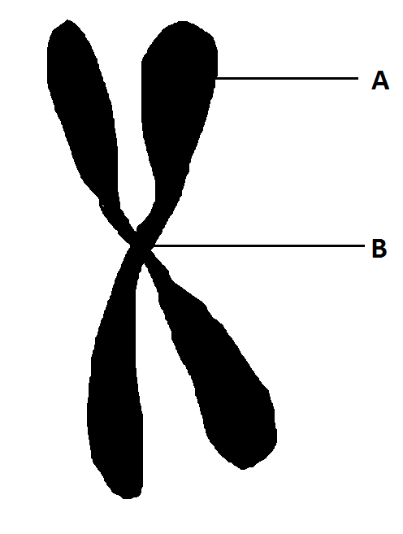

**C**

1. What is the name of structure C in the diagram?
   1. DNA
   2. nucleotide
   3. chromosome
   4. gene
2. What is the name of the part labelled **A**, on the diagram above?
   1. DNA
   2. centromere
   3. chromatid
   4. chromosome
3. The part labelled **B** on the diagram above is called
   1. DNA
   2. centromere
   3. chromatid
   4. chromosome
4. A woman, who has heavy scarring to her uterus and has had several miscarriages in the last few years, wants to have a baby. Which reproductive technology would be best suited to her?
   1. artificial insemination
   2. donor embryo
   3. in vitro fertilisation (IVF)
   4. surrogacy

**Part B: Short answer (43 marks)**

This section has **four (4)** questions. Answer all questions in the spaces provided.

1. The following parts of Question 16 refer to the diagram of the male reproductive system shown below.



* 1. Identify the structures labelled C and D. (2 marks)

Structure C: _______________________________________

Structure D: _______________________________________

* 1. State the function of the structures labelled C and D (2 marks)

Structure C: ______________________________________________________________________________

Structure D: ______________________________________________________________________________

* 1. Describe the pathway sperm need to travel from the testes of a man to reach an ovum in a woman. (9 marks)

____________________________________________________________________________________________________________________________________________________________________________________________________________________________________________________________________________________________________________________________________________________________________________________________________________________________________________________________________________________

1. The diagram below represents two cells and their chromosomes. One has been produced by the process of mitosis, while the other has been produced as a result of meiosis.

Chromosomes

* 1. In the space below, draw a diagram of the cells from which these two cells originated. Indicate chromosomes only: **do not** show organelles. (2 marks)

Original Cell: Meiosis Original Cell: Mitosis

* 1. Complete the following diagram which represents the process of fertilisation. (6 marks)

Name: ________________

Number of chromosomes: ________

Name: ________________

Number of chromosomes: ________

Name: ________________

Number of chromosomes: ________

1. (a) Briefly describe the events that occur through the three stages of labour. (4 marks)

First stage of labour: ___________________________________________________

___________________________________________________

Second stage of labour: ___________________________________________________

Third stage of labour: ___________________________________________________

1. The foetus can be affected by environmental factors which will have an influence on later development.

Give **two (2)** different factors which may affect an unborn child and briefly describe their influence on the unborn child. (6 marks)

Factor 1: ____________________

Description: ______________________________________________________________________________

______________________________________________________________________________

Factor 2: ____________________

Description: ______________________________________________________________________________

______________________________________________________________________________

1. There are occasions where conception cannot occur naturally and requires assistance for a viable pregnancy to occur. List and describe **two (2)** methods of assisted reproductive technology. (6 marks)

Method 1:

________________________________________________________________________________________________________________________________________________________________________________________________________________________________________________________________________________________________________________________

Method 2:

________________________________________________________________________________________________________________________________________________________________________________________________________________________________________________________________________________________________________________________

1. (a) Contraception can come in various forms. Give a method of contraception for each of the following types. (3 marks)

Hormonal: _________________________________________________________________

Barrier: _________________________________________________________________

Chemical: _________________________________________________________________

1. Name a sexually-transmitted disease that is caused by the following: (3 marks)

Bacteria: _________________________________________________________________

Virus: _________________________________________________________________

Parasite: _________________________________________________________________

**End of Test**

**ACKNOWLEDGEMENTS**

**Questions 5–7** Image adapted from: Miraceti. (2005).*File:Female reproductive system lateral.png*. Retrieved June, 2014, from <http://commons.wikimedia.org/wiki/File:Female_reproductive_system_lateral.png>

Used underCreative Commons [Attribution-Share Alike 3.0 Unported](http://creativecommons.org/licenses/by-sa/3.0/deed.en) licence.

**Question 16** Image from: Ningyou. (2006). *File:Male reproductive system.png*. Retrieved June, 2014, from <http://commons.wikimedia.org/wiki/File:Male_reproductive_system.png>

Used under Creative Commons [Attribution-Share Alike 3.0 Unported](http://creativecommons.org/licenses/by-sa/3.0/deed.en) licence.

Marking key for sample assessment task 8

**Part A: Multiple choice**

|  |  |
| --- | --- |
| Question | Answer |
| 1. | B |
| 2. | A |
| 3. | D |
| 4. | A |
| 5. | D |
| 6. | C |
| 7. | B |
| 8. | A |
| 9. | D |
| 10. | B |
| 11. | A |
| 12. | C |
| 13. | C |
| 14. | B |
| 15. | C |

**Part B: Short answer**

1. (a) Identify the structures labelled C and D.

|  |  |
| --- | --- |
| **Description** | **Marks** |
| C: Prostate gland | 1 |
| D: Epididymis | 1 |
| **Total** | **/2** |

1. State the functions for the structures labelled C and D.

|  |  |
| --- | --- |
| **Description** | **Marks** |
| C: Produces fluid to protect sperm/add to semen | 1 |
| D: Storage of sperm | 1 |
| **Total** | **/2** |

1. Describe the pathway sperm need to travel from the testes of a man to reach an ovum in a woman. Include glands that contribute to semen.

|  |  |
| --- | --- |
| **Description** | **Marks** |
| Testes 🡪 epididymis 🡪 Vas deferens 🡪 prostate gland and/or bulbo-urethral gland 🡪urethra | 1–5 |
| 🡪 vagina 🡪 cervix 🡪 uterus 🡪 fallopian tubes | 1–4 |
| **Total** | **/9** |

1. (a) In the space below, draw a diagram of the cells from which these two cells originated. Indicate chromosomes only: **do not** show organelles.

|  |  |
| --- | --- |
| **Description** | **Marks** |
| * Original Cell: Meiosis * Parent cell shows four chromosomes identical to diagram | 1–2 |
| * Original Cell: Mitosis * Cell shows four chromosomes for parent cell | 1–2 |
| **Total** | **/2** |

1. Complete the following diagram which represents the process of fertilisation.

|  |  |
| --- | --- |
| **Description** | **Marks** |
| One mark each correct:    Name: **SPERM**  Number of chromosomes: **23**  Name: **OVUM**  Number of chromosomes: **23**  Name: **ZYGOTE**  Number of chromosomes: **46** | 1–6 |
| **Total** | **/6** |

1. (a) Briefly describe the events that occur through the three stages of labour.

|  |  |
| --- | --- |
| **Description** | **Marks** |
| Stage 1: labour pains; contractions; dilation of cervix | 1–2 |
| Stage 2: birth of baby | 1 |
| Stage 3: delivery of placenta | 1 |
| **Total** | **/4** |

1. The foetus can be affected by environmental factors which will have an influence on later development.

Give **two** **(2)** different factors which may affect an unborn child and briefly describe their influence on the unborn child.

|  |  |
| --- | --- |
| **Description** | **Marks** |
| Any **TWO** factors |  |
| Alcohol | 1 |
| * Child may be born with foetal alcohol syndrome/foetal alcohol spectrum disorder * Lower than normal birth weight * Slow growth * Physical abnormalities | 1–2 |
| OR | |
| Smoking | 1 |
| * Lower than normal birth weight * Higher risk of respiratory problems * Higher risk of miscarriage * Premature labour * Higher risk of gastro-intestinal problems | 1–2 |
| OR | |
| Diet | 1 |
| * Lack of certain vitamins like folic acid can result in deformities like spina bifida * Bacteria like *Listeria* *monocytogenes* in food can cause death of unborn babies * Not enough food or food lacking in vitamins and minerals can lead to under-developed babies due to lack of nutrition | 1–2 |
| OR | |
| Infection | 1 |
| * Some viruses can cause death or birth defects * Rubella can cause blindness, deafness or heart malformations * Influenza may cause brain damage | 1–2 |
| OR | |
| Chemicals | 1 |
| * Teratogenic/disruption of normal development * Cause death * Cause malformation of limbs and organs | 1–2 |
| **Total** | **/6** |

1. There are occasions where conception cannot occur naturally and requires assistance for a viable pregnancy to occur. List and describe **two (2)** methods of assisted reproductive technology.

|  |  |
| --- | --- |
| **Description** | **Marks** |
| Any **TWO** | |
| In vitro fertilisation – embryo transfer (IVF–ET) | 1 |
| * Sperm and ovum are combined outside of mother’s uterus * Ovum placed back in the mother’s uterus once fertilised | 1–2 |
| OR | |
| Frozen embryo transfer (FET) | 1 |
| * Unused embryos from IVF are frozen and stored * Can be thawed and implanted to uterus when required | 1–2 |
| OR | |
| Gamete intrafallopian transfer (GIFT) | 1 |
| * An egg sperm mixture made from mother’s egg and father’s sperm * is placed in the fallopian tube of patient | 1–2 |
| OR | |
| Zygote intrafallopian transfer (ZIFT) | 1 |
| * Ovum fertilised by sperm in laboratory * Fertilised egg inserted into fallopian tube | 1–2 |
| **Total** | **/6** |

1. (a) Contraception can come in various forms. Give a method of contraception for each of the following types.

|  |  |
| --- | --- |
| **Description** | **Marks** |
| **Hormonal:** combined pill, mini pill, depo-provera, implanon | 1 |
| **Barrier:** condom, diaphragm, cervical cap, femidom (female condom) | 1 |
| **Chemical:** spermicide | 1 |
| **Total** | **/3** |

1. Name a sexually-transmitted disease that is caused by the following:

|  |  |
| --- | --- |
| **Description** | **Marks** |
| **Bacteria:** chlamydia, gonorrhea, syphilis | 1 |
| **Virus:** genital herpes, human immunodeficiency virus (HIV), hepatitis B, human papilloma virus (HPV) | 1 |
| **Parasite:** crabs, trichomoniasis (trich), scabies | 1 |
| **Total** | **/3** |