Modern History
General course

Externally set task Source Booklet
The Meiji Restoration 1853–1911
Sample 2016

Copyright
© School Curriculum and Standards Authority, 2014
This document – apart from any third party copyright material contained in it – may be freely copied, or communicated on an intranet, for non-commercial purposes in educational institutions, provided that the School Curriculum and Standards Authority is acknowledged as the copyright owner, and that the Authority’s moral rights are not infringed.
Copying or communication for any other purpose can be done only within the terms of the Copyright Act 1968 or with prior written permission of the School Curriculum and Standards Authority. Copying or communication of any third party copyright material can be done only within the terms of the Copyright Act 1968 or with permission of the copyright owners.
Any content in this document that has been derived from the Australian Curriculum may be used under the terms of the Creative Commons Attribution-NonCommercial 3.0 Australia licence
Disclaimer
Any resources such as texts, websites and so on that may be referred to in this document are provided as examples of resources that teachers can use to support their learning programs. Their inclusion does not imply that they are mandatory or that they are the only resources relevant to the course.

Modern History

Externally set task Source Booklet

The Meiji Restoration 1853–1911

Source 1
(The recollections of a Japanese historian who worked at the Shogun’s castle in Edo in 1853 at the time of Commodore Matthew Perry’s arrival.)
Fresh messages arrived one after the other, and the Shogun on receiving them was exceedingly troubled, and summoned all officials to a council … At first the affair seemed so sudden, so formidable¹, and so important that they were too alarmed to open their mouths, but in the end orders were issued to the great clans to keep a strict watch and ward on the seashore … as it was possible that these barbarian vessels … might proceed to acts of violence … The city of Edo and the surrounding villages were in great tumult;² in anticipation of the war that seemed imminent,³ the people carried their valuables and furniture in all directions to conceal them in the house of some friend living farther off.

1. formidable impressive, powerful or difficult
2. tumult a state of confusion, change or uncertainty
3. imminent coming or likely to happen very soon

Source 2
(Commodore Perry meets with Japanese officials. This is a woodcut from the time.)

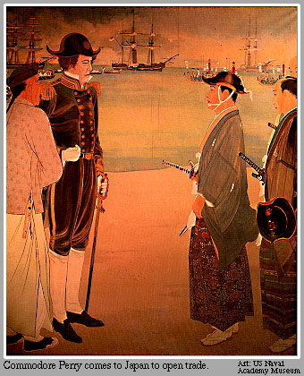

Source 3
(View of the Steam Engine at Tanakawa, Tokyo, Ichiyusei Kuniteru II (ja), 1870.)

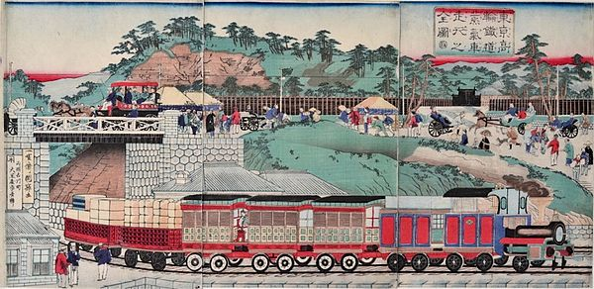

Source 4
(Basil Hall Chamberlain was a professor of Japanese at Tokyo Imperial University and one of the foremost British, active in Japan during the late 19th century.)
Industrialism has leapt into existence in this land which, only thirty years ago, was divided between an exclusive aristocracy and a humble peasantry, both extremely simple in their tastes. Now almost every town has its sheaf of smoke-stacks, fifteen hundred breaking the skyline in Osaka alone… Already the cotton mills threaten formidable rivalry to Lancashire. Not a month passes without seeing new manufactories of cement, carpets, soap, glass, umbrellas, hats, matches, watches, bicycles, smelting works, electrical works, steel foundries, machine shops of every sort.
Formerly, the Nakasendo was an old-world trail among the mountains, the last time we travelled along the new finely-graded carriage road, we were wakened every morning by the scream of the factory whistle… troops of girls coming in at five every morning and working straight on till eight at night –fifteen hours at a stretch!

ACKNOWLEDGEMENTS

Source 1 Japan 1853–1864, or Genji Yume Monogatari (Vol. 1; 1853). (E.M. Satow, Trans.). (1905). Tokyo: [s.n.], p. 2. Retrieved December, 2013, from https://archive.org/stream/japanorgenjiyum00satogoog#page/n0/mode/2up

Source 2 [Commodore Perry comes to Japan to open trade] [Image] (n.d.). Retrieved December, 2013, from
http://bookseller-association.blogspot.com.au/2010/04/are-black-ships-entering-japan.html
From collection of U.S. Naval Academy Museum

Source 3 Kuniteru, U. (1870). Tokyo Takanawa totsudo jokisha sagyo no zenzu [View of the Steam Engine at Tanakawa, Tokyo] [Image]. Retrieved December, 2013, from http://en.m.wikipedia.org/wiki/File:Ichiyusei_Kuniteru_II_(1870)_Tokyo_Takanawa_totsudo_jokisha_sagyo_no_zenzu.jpg

Source 4 Chamberlain, B.H. (1995). Things Japanese. In S. Fewster & T. Gorton, Japan: From shogun to superstate. South Yarra, Vic.: Taylor & Francis, p. 38. (Original work published 1898)

