Sample Assessment Tasks

Biology

General Year 12

Copyright
© School Curriculum and Standards Authority, 2015
This document – apart from any third party copyright material contained in it – may be freely copied, or communicated on an intranet, for non-commercial purposes in educational institutions, provided that the School Curriculum and Standards Authority is acknowledged as the copyright owner, and that the Authority’s moral rights are not infringed.
Copying or communication for any other purpose can be done only within the terms of the Copyright Act 1968 or with prior written permission of the School Curriculum and Standards Authority. Copying or communication of any third party copyright material can be done only within the terms of the Copyright Act 1968 or with permission of the copyright owners.
Any content in this document that has been derived from the Australian Curriculum may be used under the terms of the Creative Commons Attribution-NonCommercial 3.0 Australia licence
Disclaimer
Any resources such as texts, websites and so on that may be referred to in this document are provided as examples of resources that teachers can use to support their learning programs. Their inclusion does not imply that they are mandatory or that they are the only resources relevant to the course.

Sample assessment task

Biology – General Year 12

Task 1 — Unit 3
Assessment type: Science inquiry

Conditions

Period allowed for completion of the task: two weeks

Task weighting

7.5% of the school mark for this pair of units

__________________________________________________________________________________

Task 1: Reproduction in flowering plants

1. Gather flowers from six species of plants, including flowers with different mechanisms of pollination, e.g. wind, insects, birds. Choose flowers with ripe anthers.
(a) Make a sketch of each of the flowers and label the parts. (8 marks)
(b) Record any animal activity near the flowers when you collected them. (2 marks)

2. Make a pollen slide from each plant specimen. The technique is described below.
(a) Take a small cube of the pre-made pollen jelly (2–3 mm³) in a pair of tweezers and brush it back and forth over the ripe stamens of one type of flower. Look closely at the cube of pollen jelly; you should see that it is covered with fine dust.
(b) Place the pollen-coated jelly on a microscope slide and place a cover slip on top.
(c) Using a lighted match, warm the base of the microscope slide just enough so that the jelly begins to melt.
(d) Immediately remove the match and let the slide cool. The pollen grains will be firmly lodged within the jelly, between the microscope slide and the cover slip.
(e) Remove any soot from the bottom of the slide with a damp tissue.
(f) Label each slide from your six species with the following details:
- plant name (genus and species names, e.g. Eucalyptus erythrocorys)
- collector’s name
- date collected. (6 marks)

3. Using each of the slides you have made, study them under the microscope, then draw labelled diagrams of two or three typical pollen grains.
On your diagrams, clearly indicate:
- the scientific name of the plant from which the pollen was taken
- the magnification at which the pollen was observed under the microscope
- the dimensions of the pollen grains in micrometres
- any identifiable features (shape, texture, special features). (26 marks)

Question 4 should be done in class under test conditions.
4. (a) Summarise your information in a table. (11 marks)
(b) Compare pollen grains from flowers pollinated by different mechanisms and explain how these features are advantageous to the plant. (9 marks)

Marking key for sample assessment Task 1 — Unit 3

1. Gather flowers from six species of plants, including flowers with different mechanisms of pollination. Choose flowers with ripe anthers.
(a) Make a sketch of each of the flowers and label the parts.
Description | Marks
Flowers should include at least one of each type | 1
An appropriate sketch is made of each flower (sketch should be a reasonable size, single-line drawing with some shading allowed) | 1
Each sketch includes appropriate labels (1 mark for each of the following correctly identified across the six sketches): petals, sepals, stigma, style, ovary/receptacle, anther/stamen | 1–6
Total | /8

(b) Record any animal activity near the flowers when you collected them.
Description | Marks
- records names of animals where appropriate  - records number of animals/type of activity | 1–2
Total | /2

2. Label each slide from your six species with the following details:
- plant name (genus and species names, e.g. Eucalyptus erythrocorys)
- collector’s name
- date collected.
Description | Marks
Provides a slide for each of the six flowers with appropriate labelling – plant name, collector's name, date collected (1 mark per slide) | 1–6
Total | /6

3. Using each of the slides you have made, study them under the microscope, then draw labelled diagrams of two or three typical pollen grains. On your diagrams, clearly indicate:
- the scientific name of the plant from which the pollen was taken
- the magnification at which the pollen was observed under the microscope
- the dimensions of the pollen grains in micrometres
- any identifiable features (shape, texture, special features).
Description | Marks
Neat and accurate diagrams, drawn in pencil with scientific name | 1
Magnification at which the pollen was observed under the microscope | 1
Dimensions of the pollen grains in micrometres for each slide (six slides) | 1–6
Labels indicating any special and identifiable features (3 marks for each diagram)  - shape  - surface texture (rough, smooth, regular, irregular)  - special features (e.g. spikes, warts, net/web/tangle, ridges, wings, bladders, apertures, pores, furrows) | 1–18
Total | /26

4. (a) Summarise your information in a table.
Description | Marks
Constructs an appropriate table to record results, including:  - appropriate title  - column for plant name  - column for mechanism of pollination  - column for size of pollen grain  - column for each of the identifiable characteristics | 1–5
Accurately records data for each type of pollen (1 mark each) | 1–6
Total | /11
Answer could include, but is not limited to:
Title: Characteristics of pollen grains in plants pollinated by different mechanisms (the last three columns may be combined into one)
Plant name | Mechanism of pollination | Size of pollen grain (μm) | Shape | Texture | Special features

(b) Compare pollen grains from flowers pollinated by different mechanisms and explain how these features are advantageous to the plant.
Description | Marks
Makes comparisons of pollen grains and provides a detailed explanation of the advantage (3 marks per feature – 1 mark for the differences, 2 marks for the detailed explanation of the advantage)  - size/shape  - surface texture (rough, smooth, regular, irregular)  - special features (e.g. spikes, warts, net/web/tangle, ridges, wings, bladders, apertures, pores, furrows) | 7–9
Makes comparisons of pollen grains and briefly explains an advantage (2 marks per feature – 1 mark for the differences, 1 mark for the brief explanation of the advantage) | 4–6
Lists differences between pollen grains using the features examined (1 mark per feature) | 1–3
Total | /9

Sample assessment task

Biology – General Year 12

Task 7 — Unit 4
Assessment type: Test

Conditions

Time for the task: 60 minutes

Task weighting

8.75% of the school mark for this pair of units
__________________________________________________________________________________

Unit 4 – Ecosystems test

Multiple-choice (10 marks)

Answer all questions on the separate Multiple-choice Answer Sheet provided. Select one response for each question.

1. The correct order for the following ecological systems, from largest to smallest, is

(a) biosphere, ecosystem, community, population.

(b) ecosystem, biosphere, population, community.

(c) biosphere, ecosystem, population, community.

(d) ecosystem, biosphere, community, population.

2. The non-living factors in an ecosystem are termed

(a) biotic.

(b) abiotic.

(c) aerobic.

(d) anaerobic.

Questions 3 and 4 refer to the following food chain

GRASS → RABBIT → FOX → EAGLE

3. The original source of energy present in the body of the fox was

(a) the non-living matter in the environment.

(b) the grass.

(c) the rabbit.

(d) the sun.

4. Eventually, most of the energy obtained by the eagle is

(a) recycled.

(b) converted into tissue.

(c) lost in the form of heat.

(d) stored in decomposers.

Questions 5, 6 and 7 relate to the following diagram of a food pyramid, which has four trophic levels.

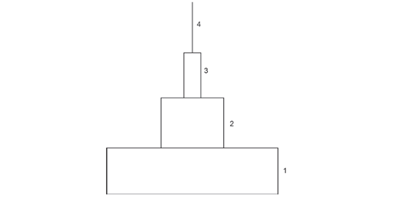

5. Which level in the food pyramid has the highest biomass?

(a) 1

(b) 2

(c) 3

(d) 4

6. In the food pyramid, carnivores occur at levels

(a) 1 and 2.

(b) 2, 3 and 4.

(c) 3 and 4.

(d) 1, 2 and 3.

7. Approximately what proportion of energy fixed in the bodies of the primary producers in the food pyramid will be available to the top order consumers?

(a) 1

(b) 0.1

(c) 0.01

(d) 0.001

8. Termites rely on micro-organisms in their digestive tract to digest the cellulose in the wood they eat. The termites absorb energy-rich products of the cellulose digestion for their own use and the micro-organisms obtain a ready supply of food from the termites. This relationship between termites and micro-organisms is an example of

(a) mutualism.

(b) collaboration.

(c) herbivory.

(d) parasitism.

9. In a parasitic relationship,

(a) the parasite is weakened but the host is unharmed.

(b) the parasite benefits while the host does not.

(c) each parasite has several hosts.

(d) the host inevitably dies as a result of the parasitism.

10. Five quadrats, each measuring one metre by one metre, were placed in an area of garden bed containing snails. The average number of snails in each quadrat was six. If the study area covered 50 square metres, what is the estimated number of snails in the study area?

(a) 6

(b) 25

(c) 300

(d) 1500

Short answer (42 marks)

Write your answers in the spaces provided.

11. The following diagram shows the carbon cycle.
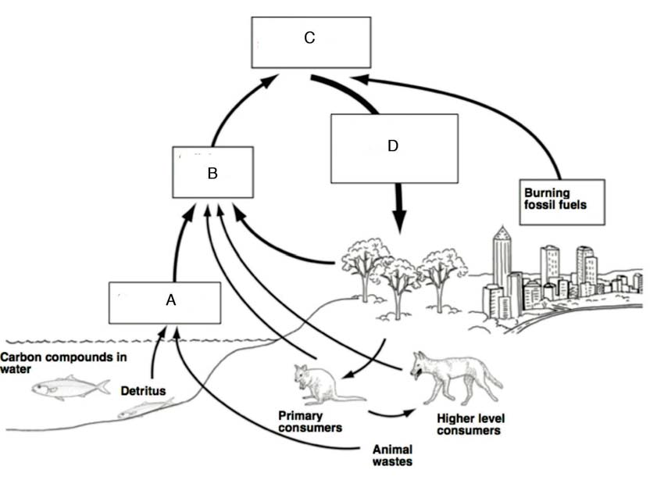
(a) Indicate which box or boxes (A, B, C or D) in the diagram represent each of the following: (4 marks)
(i) CO₂ in the atmosphere
(ii) CO₂ being absorbed for photosynthesis
(iii) CO₂ produced by cellular respiration ______

(b) Indicate whether each of the following statements is true or false by circling the correct answer. Give a reason for your answer.
(i) Food chains are simpler than food webs. (2 marks)
True/False
Reason
________
_______
(ii) Food chains recycle energy in ecological communities. (2 marks)
True/False
Reason
________
_______
(c) (i) What is the main difference between an autotroph and a decomposer?
(2 marks)
________
_______
(ii) What is the main difference between a herbivore and an omnivore? (2 marks)
________
_______
(d) Detritus is the organic debris formed from the decay of organisms.
(i) Provide two examples of detritivores (detritus feeders). (2 marks)
________
_______
(ii) Describe the role of detritivores in the carbon cycle. (2 marks)
________
_______

(e) Explain how human activity has changed the carbon cycle. (4 marks)
_______
_______
_______
_______
_______
_______

12. Blue-breasted fairy wrens, Malurus pulcherrimus, are small birds that live in the southwest of Western Australia. Long-term population studies have been conducted in a number of remnant vegetation patches near Wyalkatchem and in Eucalyptus wandoo woodland at Dryandra State Forest.
The blue-breasted fairy wrens were captured and colour banded for identification during the study period.
(a) (i) Suggest how the fairy wrens may have been captured. (1 mark)
________
_______
(ii) Describe two other methods that could be used to collect data about the breeding habits and dispersal of the fairy wrens. (2 marks)
________
_______
________
_______

Fairy wrens live in small family groups of about 2–5 adults, typically a male and female pair plus young male birds that help to raise the young. They are territorial and tend to occupy an area of approximately two hectares (60 000 square metres).
(b) Fifteen fairy wrens were present in a small reserve at the end of 2010. During 2011,
14 fairy wrens were born, eight died and two migrated out of the reserve. How many fairy wrens were in the reserve at the end of 2011? Show your working. (3 marks)
_______
_______
_______
_______
(c) The carrying capacity (K) of the land area is estimated to be 25 fairy wrens.
(i) What is meant by the term 'carrying capacity'? (1 mark)
________
_______
(ii) Twenty-two fairy wrens were present in the reserve at the beginning of 2013.
A nearby area of vegetation was cleared and a family group of five fairy wrens moved into the reserve. What is likely to happen to the population? Why? (2 marks)
________
_______
(iii) Explain why populations fluctuate around the carrying capacity of a land area.
(3 marks)
________
_______
________
_______

(d) Populations can be regulated by density-dependent or density-independent factors.
(i) Describe the main difference between a density-dependent and a density- independent factor in population regulation. (2 marks)
________
_______
________
_______
(ii) Give an example of a density-dependent factor. (1 mark)
________
_______
(iii) Give an example of a density-independent factor. (1 mark)
________
_______
(e) The following table shows the numbers of fairy wrens born into three populations of the fairy wrens in one year.
 | Population 1 | Population 2 | Population 3
Number of fairy wrens born | 5 | 4 | 6
Total number of fairy wrens present | 25 | 16 | 35

(i) Which population in the table has the highest birth rate? (1 mark)
________
_______
(ii) Indicate three ways in which the size of a population can increase when the birth rate is declining. (3 marks)
________
_______
_______

Extended response (12 marks)

Food webs are diagrams that show feeding relationships among organisms in a community. The table below gives information on the energy source of ten organisms in a coral reef community off the Western Australian coast. Use this information to construct a food web – do not draw the organisms. Make sure that your food web includes all of the organisms in the table.

Organism | Energy source
phytoplankton | photosynthesis
giant kelp | photosynthesis
bull kelp | photosynthesis
zooplankton | phytoplankton
dugong | giant kelp, bull kelp
sea urchin | giant kelp, bull kelp
abalone | giant kelp
manta ray | phytoplankton, zooplankton
whale shark | phytoplankton, zooplankton
tiger shark | abalone, manta ray, dugong

Marking key for sample assessment Task 7 — Unit 4
Multiple-choice (10 marks)
Question | Answer
1 | a
2 | b
3 | d
4 | c
5 | a
6 | c
7 | d
8 | a
9 | b
10 | c

Short answer (42 marks)
11. (a) Indicate which box or boxes (A, B, C or D) in the diagram represent each of the following:
(i) CO₂ in the atmosphere
(ii) CO₂ being absorbed for photosynthesis
(iii) CO₂ produced by cellular respiration
Description | Marks
(i) C or all of A, B, C and D | 1
(ii) D | 1
(iii) A and B | 1–2
Total | /4

(b) Indicate whether each of the following statements is true or false by circling the correct answer. Give a reason for your answer.
(i) Food chains are simpler than food webs.
Description | Marks
True | 1
A food web includes all the food chains in a food web. | 1
Total | /2

(ii) Food chains recycle energy in ecological communities.
Description | Marks
False | 1
Energy flows through food chains and is not recycled. | 1
Total | /2

(c) (i) What is the main difference between an autotroph and a decomposer?
Description | Marks
An autotroph uses solar/chemical energy to synthesise organic compounds. | 1
A decomposer obtains organic compounds from dead organisms/feeds on dead organisms. | 1
Total | /2

(ii) What is the main difference between a herbivore and an omnivore?
Description | Marks
A herbivore feeds exclusively on plant material. | 1
An omnivore feeds on both plant and animal material. | 1
Total | /2

(d) Detritus is the organic debris formed from the decay of organisms.
(i) Provide two examples of detritivores (detritus feeders).
Description | Marks
Two examples that are appropriate | 1–2
Total | /2
Answer could include, but is not limited to:
Examples may include:
- millipedes, woodlice, springtails, dung flies, dung beetles, slugs, snails, earthworms, worms, burying beetles, sea stars, sea cucumbers, crabs, polychaetes
Decomposers should not be accepted, e.g. bacteria, fungi, protists

(ii) Describe the role of detritivores in the carbon cycle.
Description | Marks
Ingest non-living organic matter | 1
Release carbon dioxide | 1
Total | /2

(e) Explain how human activity has changed the carbon cycle.
Description | Marks
- Burning of fossil fuels releases carbon dioxide into the atmosphere  - Carbon dioxide is being released far more rapidly than it is being removed | 1–2
- Clearing forests (deforestation) reduces the amount of photosynthesis  - Less carbon dioxide is removed from the atmosphere | 1–2
Total | /4

12. (a) (i) Suggest how the fairy wrens may have been captured.
Description | Marks
Nets are used to trap birds | 1
Total | /1

(ii) Describe two methods that could be used to collect data about the breeding habits and dispersal of the fairy wrens.
Description | Marks
Direct observation of birds (bird hides) | 1
Inspection of nests to count the eggs | 1
Total | /2

(b) Fifteen fairy wrens were present in a small reserve at the end of 2010. During 2011,
14 fairy wrens were born, eight died and two migrated out of the reserve. How many fairy wrens were in the reserve at the end of 2011? Show your working.
Description | Marks
15 + (14 - 8 - 2) | 1–2
19 fairy wrens present at the end of 2011 | 1
Total | /3

The carrying capacity (K) of the land area is estimated to be 25 fairy wrens.
(c) (i) What is meant by the term 'carrying capacity'?
Description | Marks
Maximum population size that can be supported or sustained by a given environment | 1
Total | /1

(ii) Twenty-two fairy wrens were present in the reserve at the beginning of 2013. A nearby area of vegetation was cleared and a family group of five fairy wrens moved into the reserve. What is likely to happen to the population? Why?
Description | Marks
22 + 5 = 27 fairy wrens. This exceeds the carrying capacity of the reserve. | 1
Either some of the fairy wrens will die or they will leave the area. | 1
Total | /2

(iii) Explain why populations fluctuate around the carrying capacity of a land area.
Description | Marks
Any three of the following:  - population growth ceases once the carrying capacity is reached  - population will increase slightly above the carrying capacity  - individuals die due to lack of resources  - population size will decrease and be below the carrying capacity | 1–3
Total | /3

(d) Populations can be regulated by density-dependent or density-independent factors.
(i) Describe the main difference between a density-dependent and a
density- independent factor in population regulation.
Description | Marks
Density-dependent factors are greater when population density is higher | 1
Density-independent factors may affect all individuals of a population equally | 1
Total | /2

(ii) Give an example of a density-dependent factor.
Description | Marks
Any one of the following:  - food supply  - disease  - parasites  - competition  - predation | 1
Total | /1

(iii) Give an example of a density-independent factor.
Description | Marks
Any one of the following:  - physical factors (rainfall, temperature, humidity, acidity, salinity)  - catastrophic events (flood, fire, drought, earthquake) | 1
Total | /1

(e) (i) Which population in the table has the highest birth rate?
Description | Marks
Population 2 (growth rate = 25%) | 1
Total | /1

(ii) Indicate three ways in which the size of a population can increase when the birth rate is declining.
Description | Marks
- decreased death rate  - decreased emigration  - increased immigration | 1–3
Total | /3

Extended response

Food webs are diagrams that show feeding relationships among organisms in a community. The table below gives information on the energy source of ten organisms in a coral reef community off the Western Australian coast. Use this information to construct a food web – do not draw the organisms. Make sure that your food web includes all of the organisms in the table.

Description | Marks
Phytoplankton with all arrows from it marked (to zooplankton, manta ray, whale shark) | 3
Giant kelp with all arrows from it marked (to abalone, dugong) | 2
Bull kelp with all arrows from it marked (to dugong, sea urchin) | 2
Zooplankton with all arrows from it marked (to manta ray, whale shark) | 2
Abalone with all arrows from it marked (to tiger shark) | 1
Dugong with all arrows from it marked (to tiger shark) | 1
Manta ray with all arrows from it marked (to tiger shark) | 1
Total | /12
Answer could include, but is not limited to:
giant kelp
bull kelp
phytoplankton
zooplankton
abalone
dugong
sea urchin
manta ray
whale shark
tiger shark

Sample assessment task

Biology – General Year 12

Task 8 — Unit 4
Assessment type: Extended response – Case study

Conditions

Period allowed for completion of the task: two weeks of research, e.g. jigsaw activity, and class discussion to formulate notes followed by a 60 minute in-class assessment. The three tables (maximum one page each) may be used during the assessment.

Task weighting

10% of the school mark for this pair of units

__________________________________________________________________________________

Threats to migratory species

There are significant threats to migratory species, such as birds, sharks, mammals and turtles, due to climate change, habitat loss and degradation, and over-harvesting. These threats cross international boundaries, affecting ecosystems worldwide. Conservation of migratory species requires both international co-operation and a co-ordinated response within Australia.

1. Research migratory species and, using the table provided, make notes on
- significant threats to migratory species (birds, sharks, mammals and turtles)
- national conservation activities in Australia, e.g. Environment Protection and Biodiversity Conservation Act 1999. Recovery Plans for selected species
- international agreements, partnerships and conventions, e.g. The East Asian-Australasian Flyway Partnership, Ramsar Convention on Wetlands, Convention on The Conservation
of Migratory Species of Wild Animals (CMS/Bonn Convention), China-Australia Migratory Bird Agreement (CAMBA), Japan-Australia Migratory Bird Agreement (JAMBA), Republic
of Korea-Australia Migratory Bird Agreement (ROKAMBA).

2. Complete the tables provided for one migratory species from each of the following groups:
- birds, e.g. Great Knot
- sharks, e.g. Great White Shark
- mammals, e.g. Southern Right Whale
- turtles, e.g. Hawksbill Turtle.

Threats to migratory species (Notes for in-class assessment)

Significant threats to migratory species

National conservation activities in Australia

International agreements, partnerships and conventions

Threats to migratory species (Notes for in-class assessment)
 | Sharks | Turtles

Common name

Scientific name

Status

Distribution (Australian and global)

Habitat

Diet

Life cycle

Migratory routes

Methods used to collect data
Threats to migratory species (Notes for in-class assessment)
 | Birds | Mammals

Common name

Scientific name

Status

Distribution (Australian and global)

Habitat

Diet

Life cycle

Migratory routes

Methods used to collect data
Name:
Threats to migratory species
In-class assessment
1. Use the following table to identify three significant threats to migratory species. For each threat, describe how this threat impacts on the survival of the species. Use specific examples of migratory animals. (12 marks)
Threat  (major threat or a more specific threat) | How this threat impacts  on the survival of the species | Example
1.
2.
3.

2. Complete the table to name and describe one action taken at a national level to protect sharks and mammals. Each action should be distinctly different. (6 marks)
Group | Action | Description
Sharks
Mammals

3. The East Asian-Australasian Flyway Partnership is an agreement between nations.
(a) On the map below indicate the extent of the East Asian-Australasian Flyway by shading in the following areas:
  - breeding areas
  - resting areas during the migration
  - non-breeding (wintering) areas. (6 marks)
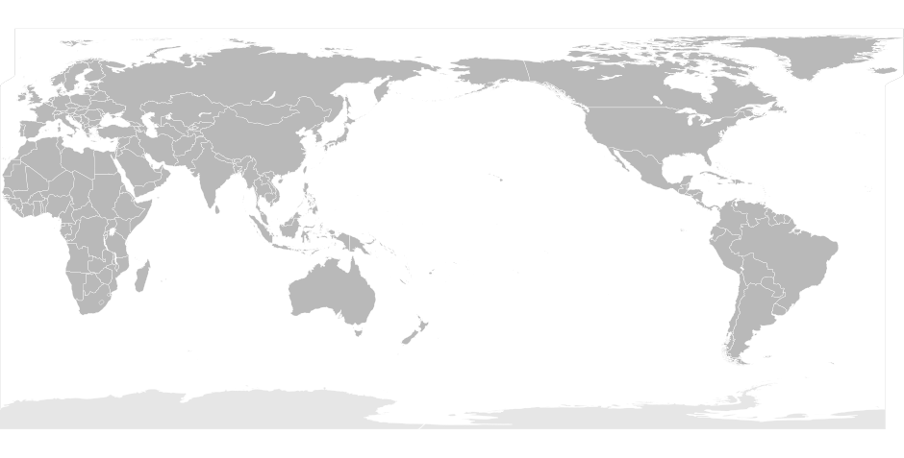
(b) Describe the reproductive cycle (age when first breeds, timing, clutch size, number of clutches, time to fledge, nesting sites) for a named species of bird. (6 marks)
Name of bird: _______________________________________
Reproductive cycle: ___________________________
_______
_______
_______
_______
_______

(c) Complete the following table to describe the habitat requirements and diet for the same species of bird. (4 marks)
 | Habitat | Diet
Breeding
season
Non-breeding
season

4. Describe one method used to collect data on turtle populations and migratory routes. Describe one advantage and one disadvantage of using this method to collect data. (6 marks)
Description
Method
Advantage
Disadvantage

Marking key for sample assessment Task 8 — Unit 4
1. Use the following table to identify three significant threats to migratory species. For each threat, describe how this threat impacts on the survival of the species. Use specific examples of migratory animals.
Description | Marks
Lists three significant threats to migratory species  - climate change  - habitat loss/degradation  - overharvesting  - other suitable example (may be a more explicit example of one of the above).  Threats should be distinctly different from each other, i.e. not more than one example of climate change/habitat loss/overharvesting. | 1–3
Clearly describes the impact of each threat in terms of a named example and area of impact (3 marks for each threat) | 7–9
Describes the impact of each threat and lists example (2 marks for each threat) | 4–6
Describes the impact of each threat in general terms without referring to an example/gives example without description (1 mark for each threat) | 1–3
Total | /12
Answer could include, but is not limited to:
Threat  (major threat or a more specific threat) | How this threat impacts  on the survival of the species | Example
Climate change (rising sea levels, habitat changes, sea temperature increase, acidification) | - habitat availability – changes to ocean currents and water temperature may affect migration, feeding and calving site selection  - food availability – changes to climate and oceanographic processes may lead to decreased productivity and different patterns of prey distribution and availability | Southern Right Whale
Habitat loss/degradation (urban and industrial development – oil rigs, pollution, human interference, introduced species) | - environmental pollution (oil contamination of intertidal mudflats)  - reduced river flow  - human disturbance (off-road vehicles/tourism) | Great Knot
Overharvesting (commercial and recreational fishing, hunting) | - unsustainable levels of harvesting for food and shell by indigenous communities in northern Australia and neighbouring countries (Indonesia, Malaysia, Thailand, Philippines, Cuba and the Solomon Islands) | Hawksbill Turtle

2. Complete the table to name and describe one action taken at a national level to protect sharks and mammals. Each action should be distinctly different.
Description | Marks
Name one action taken for sharks and one action taken for mammals, e.g. fishing regulations, legislation, recovery plan, research, monitoring and data collection, or habitat protection | 2
Describes the action taken in relation to the named shark and named mammal | 1–4
Total | /6
Answer could include, but is not limited to:
Group | Action | Description
Sharks | Fishing regulations | - bans/seasons/catch size  - reducing incidental/accidental catch  - licences
Mammals | Habitat use and needs | - identify habitat critical for survival, e.g. characteristics of important migratory pathways and aggregation areas  - protect habitat important to the survival of the species,  e.g. marine parks

Other Actions | Description
Legislation | - The Environment Protection and Biodiversity Conservation Act 1999  - lists status of species, e.g. endangered, vulnerable  - prevent commercial whaling in Australian waters
National recovery plan | - recovery plan for the species, e.g. Great White Shark, Southern Right Whale  - activities include assessment of recovery/monitoring/habitat identification/research/community education and awareness
Research/monitoring | - develop and implement research programs  - survey and collect data for the species  - reduce impact of commercial fishing/recreational fishing/trade in shark products/shark control activities/tourism
Community education | - community awareness  - targeted information, e.g. commercial fishing, recreational fishing

3. (a) On the map below indicate the extent of the East Asian-Australasian Flyway by shading in the following areas:
  - breeding areas
  - resting areas during the migration
  - non-breeding (wintering) areas.
Description | Marks
Shades map to indicate the extent of the East Asian-Australasian Flyway  - Arctic Circle  - East and South-east Asia  - Australia and New Zealand | 1–3
Breeding areas (B on map)  - Arctic circle/Siberia/Russia  Resting areas during the migration (R on map)  - Korea/China/Yellow Sea/Japan  Non-breeding/wintering areas (NB on map)  - Australia/New Zealand | 1–3
Total | /6
Map
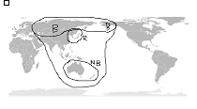

(b) Describe the reproductive cycle (age when first breeds, timing, clutch size, number of clutches, time to fledge, nesting sites) for a named species of bird.
Description | Marks
Names a migratory bird  - common name/scientific name, e.g. Great Knot | 1
Reproductive cycle  - breeding months/non-breeding months  - age when species first breeds  - clutch size/number of clutches  - incubation period/time to fledge  - description of nesting sites/nests | 1–5
Total | /6

(c) Complete the following table to describe the habitat requirements and diet for the same species of bird.
Description | Marks
Breeding season  - describes habitat  - describes diet | 1–2
Non-breeding season  - describes habitat  - describes diet | 1–2
Total | /4
Answer could include, but is not limited to:
e.g. Great Knot
 | Habitat | Diet
Breeding season | Alpine tundra with nests in exposed areas of broken rocks | Adults feed on berries and pine kernels; chicks feed on insect grubs and spiders
Non-breeding  season | Estuaries and intertidal mudflats | Bivalves, gastropods, crustaceans, annelids, echinoderms

4. Describe one method used to collect data of turtle populations and migratory routes. Describe one advantage and one disadvantage of using this method to collect data.
Description | Marks
- Describes one method used to collect data | 1–2
- Describes one advantage of using this method to collect data | 1–2
- Describes one disadvantage of using this method to collect data | 1–2
Total | /6
Answer could include, but is not limited to:
 | Description
Method | Flipper tagging  - tagged often during the nesting season  - turtles recaptured on return to natal beaches, in feeding grounds and other sites  OR  Satellite telemetry  - tracking device is attached to the turtle's shell  - a signal is detected by satellites (Argos system) when the turtle surfaces to breathe
Advantage | Flipper tagging  - provides valuable data on internesting interval, remigration interval, growth rates, reproductive output, population size and structure  OR  Satellite telemetry  - provides real-time data on movement behaviour, migration route and locations of habitats
Disadvantage | Flipper tagging  - may take years to recapture a turtle and longer to accumulate data in a database; tags often not returned by capturer  OR  Satellite telemetry  - usually only a small sample size; data collection limited to location at a particular time

ACKNOWLEDGEMENTS

Task 7 – Unit 4

Question 11 Diagram adapted from: Cale, B. (n.d.). Diagrammatic representation of the carbon cycle. Figure 17.5. In M. Calver, A. Lymbery, J. McComb & M. Bamford. (Eds). (2009). Environmental biology. Port Melbourne, Vic: Cambridge University Press, p. 400.

Task 8 – Unit 4

Question 3 Lokai_Profil. (2008). Australia centred world map [image] (public domain).
Retrieved March 10, 2015, from http://en.wikipedia.org/wiki/World_
map#mediaviewer/File:BlankMap-World-162E-flat.svg
Marking key
Task 8 – Unit 4

Question 3 Adapted image from: Lokai_Profil. (2008). Australia centred world map (public domain). Retrieved March 10, 2015, from http://en.wikipedia.org/wiki/World_ map#mediaviewer/File:BlankMap-World-162E-flat.svg

