
Glossary
DRAFT

DRAFT

Design ATAR
Acknowledgement of Country
Kaya. The School Curriculum and Standards Authority (the Authority) acknowledges that our offices are on Whadjuk Noongar boodjar and that we deliver our services on the country of many traditional custodians and language groups throughout Western Australia. The Authority acknowledges the traditional custodians throughout Western Australia and their continuing connection to land, waters and community. We offer our respect to Elders past and present.
Copyright
© School Curriculum and Standards Authority, 2022
This document – apart from any third party copyright material contained in it – may be freely copied, or communicated on an intranet, for non-commercial purposes in educational institutions, provided that the School Curriculum and Standards Authority is acknowledged as the copyright owner, and that the Authority’s moral rights are not infringed.
Copying or communication for any other purpose can be done only within the terms of the Copyright Act 1968 or with prior written permission of the School Curriculum and Standards Authority. Copying or communication of any third party copyright material can be done only within the terms of the Copyright Act 1968 or with permission of the copyright owners.
Any content in this document that has been derived from the Australian Curriculum may be used under the terms of the Creative Commons Attribution 4.0 International licence.
Disclaimer
Any resources such as texts, websites and so on that may be referred to in this document are provided as examples of resources that teachers can use to support their learning programs. Their inclusion does not imply that they are mandatory or that they are the only resources relevant to the course. Company names or the names of products referred to in this document are used for educational, non-commercial and descriptive purposes only. These names may be registered trademarks and the property of their respective owners.

Design ATAR – Glossary
This glossary is provided to enable a common understanding of the key terms in the ATAR Design course syllabuses.

Annotation
A succinct written note next to an image, diagram or visual that adds an explanation or makes comment.

Creative Design Thinking Strategies
Techniques used to generate a large quantity of ideas. The following strategies help prompt imaginative and unfiltered concepts that can build on past ideas and inform new ones:
- concept maps
- visual brainstorming
- forced associations
- Bloom's action verbs
- SCAMPER
- Six Thinking Hats® system
- synectic triggers, for example:
  - subtract
  - repeat
  - combine
  - add
  - transfer
  - empathise
  - animate
  - superimpose.

Critical Design Thinking Strategies
Techniques used to filter ideas and support decision making. The following strategies can help ensure the most suitable and effective design outcome is presented for implementation:
- PMI
- SWOT analysis
- compare and contrast
- persuasion map
- graphic organisers
- Six Thinking Hats® system.

Communication Strategies
Strategies and devices strategically used by a designer to engage or persuade a specified audience. These are often referred to as those that create an emotional response or grab attention to enhance the communication of a design solution. Such strategies include:
- shock tactics
- humour
- metaphor
- emotion.

Convergent Thinking
Incorporates critical design thinking strategies to apply judgement, logic and reasoning to filter and reduce the number of possible ideas developed during the Divergent Thinking phases. This is represented by the narrowing diamond shapes seen in the Double Diamond design process model. See Critical Design Thinking Strategies.

Demographic Characteristics
Used in conjunction with psychographic segmentation to identify and develop a complete target audience or end-user profile. Often based on statistical information using criteria such as age, gender or income, these factors are used by designers to influence and support design decisions, to ensure their designs meet the needs of the end user. The following demographic descriptors may be helpful when developing a target audience or end-user profile:
Singles | Students | Fit/healthy | Suburban resident
Seniors (60+) | Teenagers/adolescents | Frail/sickly/unwell | Rural resident
Elderly (75+) | Youth | Multicultural | Home owners
Retirees | School-leavers | Multilingual | Renters
Pensioners | Pre-teens (tweens) | Migrant background | Hospitality workers
Middle-aged (40+) | Children | Non-English-speaking background | Construction workers
Adults | School-aged children | Culturally diverse | Health professionals
Parents (mothers, fathers, grandparents) | Toddlers | Religiously affiliated | Sales professionals
Couples | Infants and babies | Politically affiliated | Finance professionals
Non-traditional families/couples | Families (young, new, established family) | Lives locally | Creative professionals
Young adults | Living with a disability | Urban resident | Emerging industry professionals

Design Brief
A document that clearly articulates what is expected by the designer as part of a design project. A comprehensive brief should reflect the information uncovered during the Discover phase and must address the following criteria:
- core design problem
- stakeholders
- target audience/end-user characteristics
- aim or purpose of the design
- constraints
- context of the design
- deliverables.

Design Conventions
The commonly understood rules or formal methods of communication relevant to a design field. Designers must be aware of the expectations required to articulate their design to various stakeholders such as professional printers, manufacturers, specialists, architects/engineers and the end user. This often requires specific file types/formats, layouts, scale drawings and/or diagrams to support the production of your intended design.

Design Life Cycle
The total environmental cost or impact of a design over its useful life. This may involve the analysis of emissions, pollutants and/or energy efficiency. Stages of the design life cycle include:
- pre-production, testing and use of prototypes
- acquisition of raw materials
- manufacture, processing and formulation
- distribution and transportation
- use, re-use and maintenance
- recycling and waste management.
Strategies for reducing the environmental impact of the design life cycle include:
- designing for reliability and durability
- making repair and maintenance easier and/or local
- adaptable, multi-functional or modular designs
- selecting low-impact resources and processes
- reducing resource consumption
- extending the lifespan of materials or parts
- making items easy to disassemble or break down
- designing for eco-efficiency if power is required.

Design Outcome
A creative response, consequence or end product that endeavours to meet the requirements of a design brief. After applying a design process, the design outcome should deliver practical outcomes for the end user and/or appeal to the specified target audience.

Design Problem
A design problem can be presented to a designer by a client or may begin with a designer’s initial idea or inspiration. By understanding the target audience and/or end user, designers must explore relevant needs, wants and opportunities, which are then used to drive the design process towards a desired outcome. The following strategies can help discover and identify design needs, problems or opportunities:
- design mindsets
- empathy mapping
- needfinding.

Design Proposal
A visual representation of the proposed design outcome/s in response to a design brief. The design proposal may be used to gain approval of clients and other stakeholders. It must outline what was specified in the design brief and communicate clearly and skilfully to best represent the proposed design outcome/s. Design proposals may include high fidelity drawings, plans, sections, elevations, photographs, perspectives and/or axonometrics, 2D and 3D renderings, CAD or scale models and other visual forms. In the Year 12 ATAR Design course, the design proposal must be submitted as a maximum of four A3 pages.

Design Thinking
An approach for identifying, redefining and solving problems. It is a way of thinking and working that includes a set of strategies and methods for testing concepts and ideas. Design Thinking encourages designers to focus on observing their target audience and developing empathy for users of their products and services.

Divergent Thinking
Incorporates creative thinking strategies, uninhibited by potential constraints and limitations, to generate as many possible solutions to a problem as possible. All ideas are welcome; none should be questioned or dismissed. This is represented by the expanding diamond shapes seen in the Double Diamond design process model. See Creative Design Thinking Strategies.

Double Diamond Model
A design process developed by the British Design Council. Consists of four phases that are iterative and non-linear. Students should use this model as a framework and be prepared to do things in a different order or retrace their steps to clarify or redefine problems as they occur. See Divergent Thinking and Convergent Thinking.
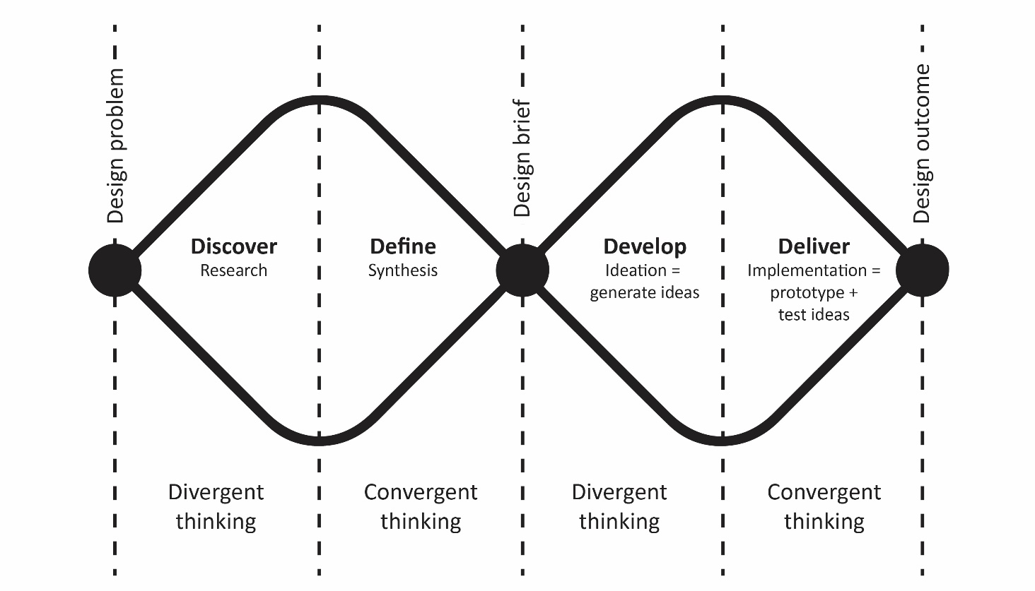
This iterative design process features 4 distinct phases and is based on the British Design Council’s Double Diamond model

Elements of Design
The basic components that are used to construct a design composition. There are seven design elements within the ATAR Design course: line, shape, tone, form, space, colour, texture.

Gestalt Principles of Perception
Gestalt psychology and the study of perception explains how and why people organise visual information into patterns and groups and how this influences their behaviour. Gestalt principles used in Design can assist how a design is visually presented to maximise the reaction of the intended audience.
- Figure/ground: the relationship between dominant and non-dominant elements in a composition when we perceive a visual image. The figure is the object you perceive. The ground is everything in the background. Figure/ground relationships can be inverted creating the illusion that objects appear to move forward or recede.
- Similarity: when elements are similar, they are perceived to be more related than elements that are dissimilar. Similarity helps us to organise and visually connect objects within a group. Objects may be similar based on shape, size, colour, materiality or orientation.
- Proximity: when elements are close together, they are perceived to be more related than things that are spaced further apart. The proximity of objects can override similarity and other factors that differentiate a group.
- Continuation: objects aligned in a linear or curved composition are perceived to have unity. We are more likely to perceive these objects as being connected, therefore leading our eye and directing our focus.
- Closure: within a complex arrangement of visual elements we tend to look for a single, recognisable pattern. We then perceive segmented components as complete or whole objects, even when we’re missing information.

High fidelity
The refined representation of a detailed design outcome. Designers use specialised materials and techniques to create realistic prototypes, digital or printed mock-ups, 3D renderings and/or models. High-fidelity processes allow all stakeholders to interact with and approve the colours, materials, form and functionality of a design before it goes into production. This takes place late in the design process, after other low-fidelity methods have been applied and tested.

Iterative Design Process
Involves a repeated cycle of prototyping, testing and refining ideas based on stakeholder feedback, to continually improve design outcomes. See Double Diamond Model.

Intellectual Property
The legal rights and protection of original ideas, products, services and processes. There are four categories of intellectual property (IP) within the ATAR Design course:
- Copyright: protects the rights that a person has over any newly created work, for example, original forms of writing, music or images that are not merely copied from another work. You don’t need to register for copyright in Australia. The moment an original expression of an idea is documented on paper or electronically it is automatically protected by copyright in Australia. Copyright protection is free and automatic under the Copyright Act 1968.
- Registered design: protects the overall visual appearance of new and distinctive products. This can be a combination of visual features, including shape, colour, configuration, pattern and ornamentation. To secure legal protection you must apply for both Registration and Certification which can last for up to 10 years.
- Patents: protects any device, substance, method or process that is new, inventive and useful. To secure legal protection you must apply for a patent based on specific criteria, and if granted can last for up to 20 years.
- Trademark: identifies a unique product or service, such as a business name or logo. It can protect a letter, number, word, phrase, sound, smell, shape, colour, logo, picture or any combination of these. To secure legal protection within Australia, you must apply for a trademark, and if accepted, it will last for 10 years initially and can be renewed indefinitely.

Linear Design Process
Comprised of defined steps in a specific sequence, designers proceed through each step, as they work towards developing a single solution.
Design brief → Research → Ideate → Develop → Refine → Produce
In contrast, an iterative design process, such as the Double Diamond model, involves repeated cycles of prototyping, testing and refining ideas to continually improve design outcomes. A linear design process has some limitations when compared to an iterative design process.
Linear design process
Narrow focus
Beginning with a defined and rigid design brief doesn’t allow for alternative viewpoints or flexibility, which may lead to a design that is not really what is needed
Limited options
Being constrained by a single starting point limits the number of possible solutions.
Inflexible and static
By working through the process sequentially, one step at a time, the designer finishes each step and then moves on. This does not allow the flexibility to address unforeseen issues that occur or to reflect and refine based on feedback.
Problems can’t be found
There is minimal opportunity for prototyping or user-testing, which is where problems can be identified.
Problems can’t be fixed
By continually moving on to the next step, a linear design process does not allow the designer to go back and fix problems. Problems are easier to ignore in order to meet deadlines.
Redo and repeat
If a significant flaw is identified late in the process, the designer may be required to start all over again. This is costly in time and budget.
Iterative design process
Open ended
By starting with a design need, problem or opportunity and exploring divergent thinking, designers spend time understanding exactly what is needed before constructing a detailed design brief.
Endless variations are possible
Through Design Thinking, multiple ideas are explored that can often be varied and unexpected.
Flexible and adaptable
By collaborating and seeking feedback from stakeholders regularly, ideas are never ‘set in stone’. Designers can go back and refine ideas at any point.
Problems are identified early
By creating low-fidelity prototypes, end-user and target audience testing can be conducted early and easily. Issues can then be identified and resolved before too much time is spent on one idea.
Problems are resolved
If needed, designs can be refined as a result of feedback and testing. Working in low-fidelity means changes can made be quickly.
Refine, test and refine again
As the design improves, designers move to high-fidelity processes, and the testing and refining continues until all stakeholders are satisfied.

Low fidelity
The raw presentation of initial concepts, design alternatives or schematic layouts. Designers use simple materials and techniques to quickly communicate their ideas in the form of sketches, annotated mock-ups, prototypes and/or models. These may be created via digital or non-digital methods. Low-fidelity methods allow designers to test multiple ideas, receive feedback and make iterations early in the design process, before investing too much time, skill or resources.

Occupational Safety and Health
It is the legal responsibility of all workplaces to protect the safety, health and welfare of employees, customers and the general public. Designers must understand how occupational safety and health (OSH) concepts impact design by considering the following:
- Ergonomics: ensuring designs are fit for the purpose and intended function by the end user. Anthropometrical data should be used to determine the optimum size, shape and form of a product, and to make it easier to use. By considering the end-user characteristics, designers are able to increase the quality, comfort and performance of a product or an environment. Ergonomics should be considered early in the design process to ensure the focus is on the end user and to help provide opportunities for innovation.
- Safe design: identifying potential hazards early in the design process to eliminate the risk of injury throughout the life of the design. Steps to achieving safe design may require designers to:
  - establish the risk context in relation to the design need or problem
  - identify potential hazards associated with early design ideas
  - analyse and evaluate risks inherent in design concepts
  - eliminate and control risks when refining design outcomes
  - conduct usability testing to assess the safety of design outcomes.

Principles of Design
The design principles describe how the design elements are applied to a composition. There are twelve design principles within the ATAR Design course: balance, contrast, emphasis, repetition, movement, scale, unity, variety, pattern, harmony, alignment, hierarchy.

Prototype
A sample, model, simulation or mock-up of a design concept that allows designers to test ideas and make iterations based on feedback received and/or issues discovered. Prototypes may use low-fidelity materials/techniques before progressing to more complex, high-fidelity methods as the design develops. See Low-fidelity and High-fidelity.

Psychographic segmentation
Used in conjunction with demographic characteristics to identify and develop a complete target audience or end-user profile. Often based on internal psychological characteristics such as personality, values and motivations, these factors are used by designers to influence and support design decisions. VALSTM is an example of one proprietary methodology used by marketers. The following psychographic descriptors may be helpful when developing a target audience or end-user profile:
Attitudes and values, lifestyle | Personality |  | Priorities and motivations | Social status
Family | Youthful | Mischievous | Heath/wellness | Professionals
Friendship | Outgoing | Loving/caring | Mindfulness/  mental health | Young professionals
Community | Carefree | Empathetic/  compassionate | Environmentally sustainable | Older professionals
Security/safety | Happy | Helpful | Modern/  contemporary | Tradespeople
Trust/loyalty | Social | Generous | Retro/historical | tradesmen
Creativity | Adventurous | Selfish | Digital | Qualified/highly qualified
Adventure | Quirky | Confident | Analogue | Manager
Innovation | Creative | Relaxed | Price/cost | Self-employed
Diversity | Eccentric | Focused | Safety | Unemployed/  jobseeker
Health | Independent | Conscientious | Size/scale/  proportion | Highly educated
Wealth | Dependent | Energetic/vibrant | quantity | Poorly educated
Success | Intellectual | Concerned/  worried | Local/location | Corporate
Nature/outdoors | Busy | Laid-back/relaxed | Popularity | Deprived
Travel | Optimistic | Chic/fashionable | Efficiency | Privileged
Professionalism | Pessimistic | Sophisticated | Range/options | Retired
Education/  intelligence | Sporty/athletic/  active | Unsophisticated | Brand recognition | Investor
Growth/  improvement | Experienced | Curious/intrigued | Availability/access | Budget-conscious
Spirituality | Worldly | Enthusiastic/keen/motivated | Service | Average income
Humour | Organised | Passionate | Quality | Student
Equality/equity | Sensible | Spontaneous | Convenience | Graduate
Review the VALS™ model | Assertive | Emotional | Rewards | Tertiary educated

Semiotics
The study of symbols, signs and images and how they are used to create meaning. Designers can apply semiotic concepts to influence, connect or communicate with an audience.
- Sign: Something that communicates meaning. The sign is the whole that results from the combination of the signifier and signified. Signs can be categorised within the following types:
  - Symbol: has no obvious resemblance between the signifier and the signified. The connection must be learned and only becomes associated with the concept it represents over time. Language and numbers are symbols. An example of a learned symbolic sign is a ‘Stop’ road sign, where the colour and shape alone are recognised and understood as an instruction.
  - Index: shows evidence of what is being represented. For example, an image of a paw print to indicate an animal.
  - Icon: has an obvious, physical resemblance to what is being signified. For example, the male and female pictograms used to indicate toilets. Can be photographic, illustrative or diagrammatic.
- Signifier: The form that the sign takes. Any material thing that signifies meaning: words on a page, a facial expression or object.
- Signified: The message or concept that the signifier communicates.

Stakeholders
The people, groups or individuals who have the power to influence or who have an interest in the outcome of a design project you are undertaking. Stakeholders may include a client or company executive, relevant government bodies or councils, local community members or the target audience/end-users. It is helpful to identify the various stakeholders affected by your design early in the design process so that you can collaborate or consult with them as required. Using a power vs interest grid to classify stakeholders (as exemplified in the diagram below) enables designers to plan the required level of engagement and understand how they are related to the design project.
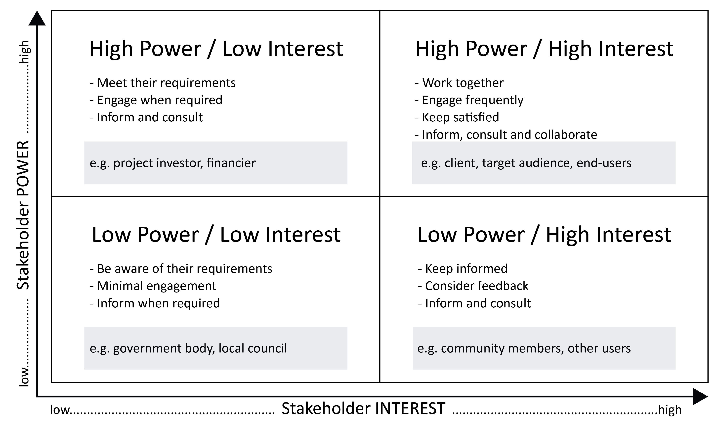
Standards of Design
Designers must refer to applicable regulations and legislation to ensure the safety, reliability, consistency and quality of their designs. At different times within the design process, designers may need to refer to the:
- Australian Standards® compiled by the Standards Australia organisation. They are written to establish the specifications, procedures and guidelines for ensuring that consumer products, services and systems are safe, consistent and reliable. Standards cover a range of environmental and construction concerns as well as specific material selection, testing and technical requirements.
- National Construction Code (NCC) produced by the Australian Building Codes Board. It sets the minimum required level for the safety, health, amenity, accessibility and sustainability of certain buildings.
- International standards published by the International Organization for Standardization (ISO). ISO standards are drafted by a global committee of experts, with representation from a variety of industries. The standards aim to ensure systems and products are designed with consideration for safety, consistency, accessibility and ease of use.

Typographic Styles
A classification system of typefaces based on their visual characteristics (also exemplified in the diagram below).
- Serif: a small shape or projection that appears at the beginning or end of a stroke on a letter.
- Sans serif: a typeface without serifs, from the French word ‘sans’ that means ‘without.’
- Script: a typeface with varied and often fluid strokes, simulating the form created by handwriting.
- Display: any typeface intended to be used in short bursts, rather than for blocks of text. Display fonts are often created only to be used at large point sizes, such as in headlines and titles.

Typographic Terminology
A specific language or set of terms that are commonly used when referring to designs with text (also exemplified in the diagram below).
- Ascender: an upward vertical stroke found in certain lowercase letters (such as k, b and d) that extend beyond the x-height.
- Descender: the downward vertical stroke in certain letters (such as y, p and g) that descend below the baseline.
- Baseline: the invisible line upon which a line of text rests.
- Cap line: (or cap height) refers to the height of a typeface’s flat capital letters measured from the baseline.
- Uppercase: the large or capital alphabetic characters used as the first letter in a sentence. Can also be applied to a whole word or sentence for emphasis.
- Lowercase: the smaller form of letters in a typeface.
- Leading: the vertical space between each line of type. It is measured from the baseline of one line of text to the baseline of the line above it. It should be adjusted to suit the context, interface and typeface being used.
- Kerning: the art of adjusting the spacing between letters to optimise the overall visual appeal and readability of a typeface.
- Typeface: a group of characters, letters and numbers that share the same design. For example, Arial, Helvetica and Times New Roman. A ‘font’ refers to variations of a typeface, like its size and weight. A font family is a group of related fonts.
- Character: a single element, such as a letter, numeral, or punctuation mark.
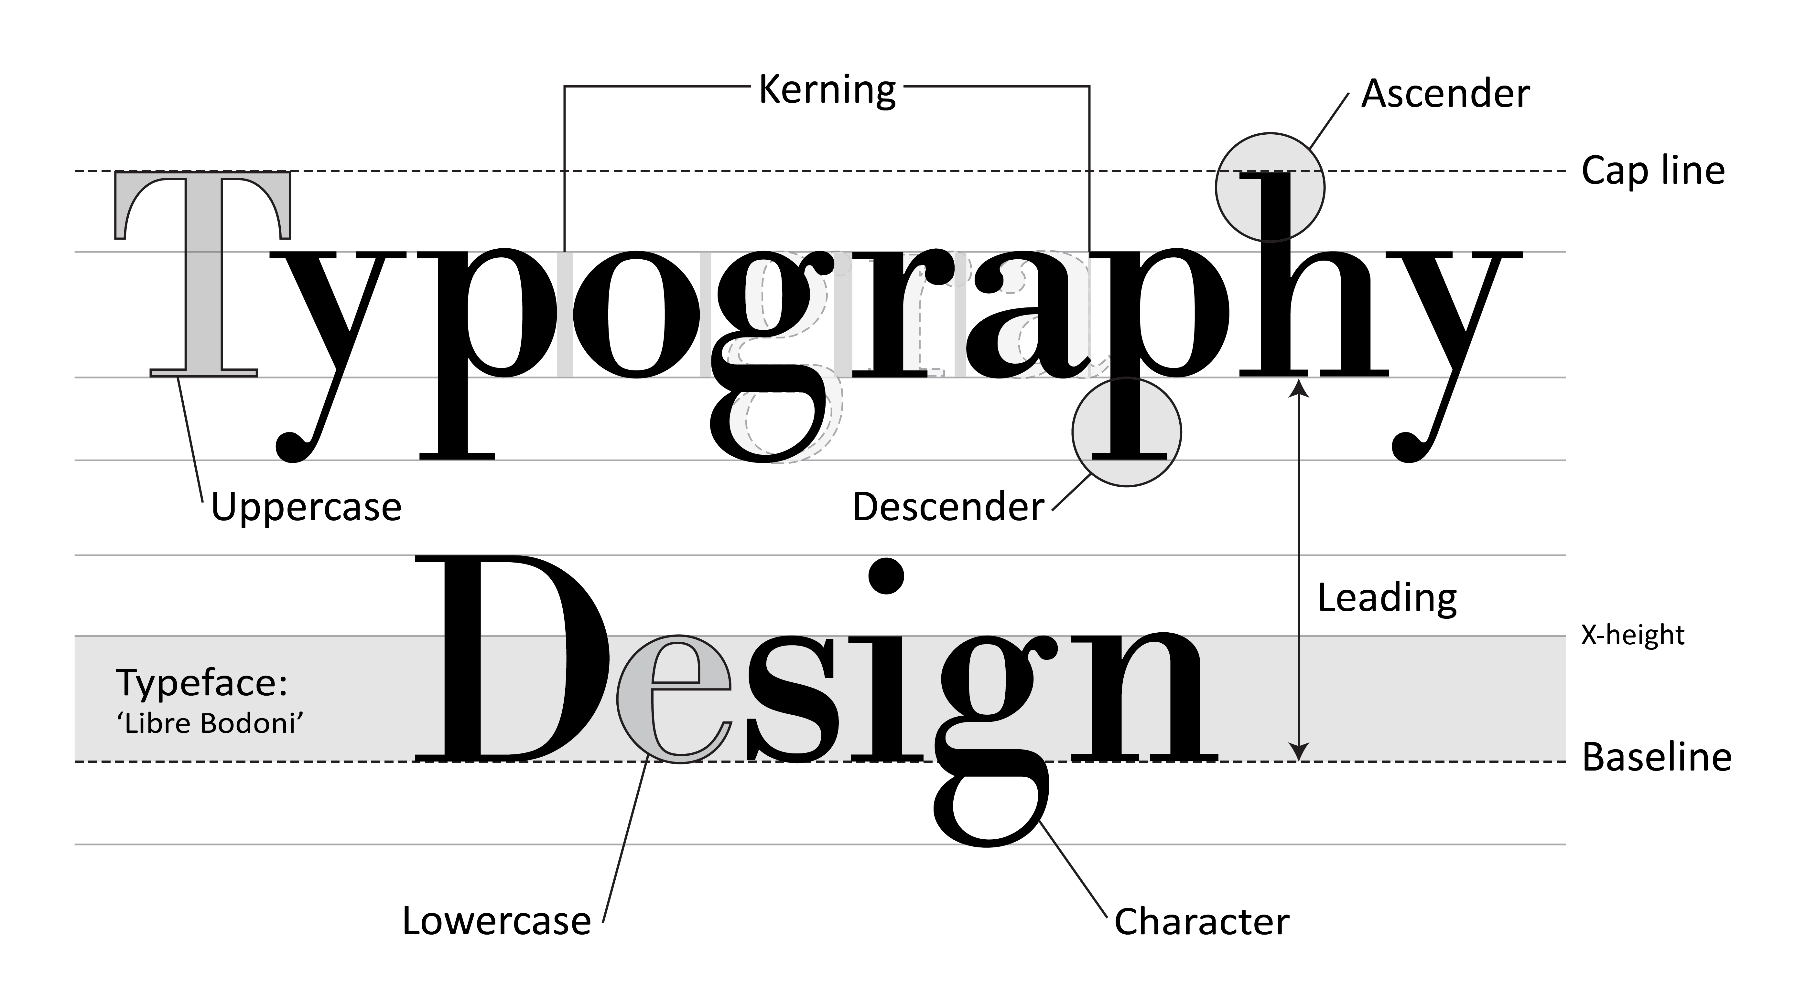

References
Design Life Cycle
Information from: Punekar, R.M., & Hemani, S. (n.d.). Life cycle design. D’source: Creating Digital-learning Environment for Design. Retrieved September, 2022, from https://www.dsource.in/course/systems-design-sustainability/life-cycle-design
Intellectual Property
Information from: IP Australia. (n.d.). Types of IP. Retrieved September, 2022, from https://www.ipaustralia.gov.au/understanding-ip/getting-started-ip/types-of-ip
Used under Creative Commons Attribution 4.0 International Licence.
Semiotics
Information from: Bradley, S. (2016). Icon, index, and symbol — Three categories of signs. Retrieved September, 2022, from https://vanseodesign.com/web-design/icon-index-symbol/
Standards of Design
Information from: International Organization for Standardization: (n.d.). ISO Standards. Retrieved September, 2022, from https://www.iso.org/standards.html
Information about National Construction Code from: Australian Building Codes Board (n.d.). General user. Retrieved September, 2022, from https://ncc.abcb.gov.au/homeowners
Used under Creative Commons Attribution 4.0 International licence
Information from: Standards Australia. (2019). Standardisation guide 003: standards and other publications (Standard 3.1). Retrieved September 2022, from https://www.standards.org.au/getmedia/d9da035d-2fbc-4417-98c1-aa9e85ef625d/SG-003-Standards-and-Other-Publications.pdf.aspx
Typography
Information from: Material Design. (n.d.). Understanding typography. Retrieved September, 2022, from https://material.io/design/typography/understanding-typography.html#type-properties

Acknowledgements
Double Diamond Model
Diagram adapted from: Design Council. (2019). [Double Diamond process]. Retrieved September, 2022, from https://www.designcouncil.org.uk/our-work/skills-learning/tools-frameworks/framework-for-innovation-design-councils-evolved-double-diamond/
Adapted from: Design Council. (2019). The process: using the Double Diamond. Retrieved September, 2022, from https://www.designcouncil.org.uk/our-work/skills-learning/tools-frameworks/framework-for-innovation-design-councils-evolved-double-diamond/

