Sample Assessment Tasks
Geography
General Year 12

Acknowledgement of Country
Kaya. The School Curriculum and Standards Authority (the Authority) acknowledges that our offices are on Whadjuk Noongar boodjar and that we deliver our services on the country of many traditional custodians and language groups throughout Western Australia. The Authority acknowledges the traditional custodians throughout Western Australia and their continuing connection to land, waters and community. We offer our respect to Elders past and present.
Copyright
© School Curriculum and Standards Authority, 2018
This document – apart from any third-party copyright material contained in it – may be freely copied, or communicated on an intranet, for non-commercial purposes in educational institutions, provided that the School Curriculum and Standards Authority (the Authority) is acknowledged as the copyright owner, and that the Authority’s moral rights are not infringed.
Copying or communication for any other purpose can be done only within the terms of the Copyright Act 1968 or with prior written permission of the Authority. Copying or communication of any third-party copyright material can be done only within the terms of the Copyright Act 1968 or with permission of the copyright owners.
Any content in this document that has been derived from the Australian Curriculum may be used under the terms of the Creative Commons Attribution 4.0 International licence.
Disclaimer
Any resources such as texts, websites and so on that may be referred to in this document are provided as examples of resources that teachers can use to support their learning programs. Their inclusion does not imply that they are mandatory or that they are the only resources relevant to the course. Teachers must exercise their professional judgement as to the appropriateness of any they may wish to use.

Sample assessment task

Geography – General Year 12

Task 1 – Unit 3
Assessment type: Fieldwork/practical skills
Conditions
Completed in class under test conditions
Time for the task: 50 minutes
Task weighting
10% of the school mark for this pair of units

Section One – Multiple-choice (10 marks)
Refer to the 2014 Stage 2 WACE Geography Examination Broadsheet.
Study Source 1 on the Broadsheet then answer Questions 1–8.
- Which of the following expresses correctly the scale of the Kununurra topographic map extract as a written statement?
  - 1 centimetre on the map represents 10 000 centimetres on the ground
  - 1:100 000
  - One centimetre on the map represents one kilometre on the ground
  - One centimetre equals one hundred thousand metres
- The physical feature located at GR 695537 is the
  - Packsaddle Plain.
  - Pump house.
  - Ord River Diversion Dam.
  - Ord River.
- The difference in height between the highest point on Mount Cecil and the Trig Station in
AR 7351 is
  - 250 m.
  - 106 m.
  - 210 m.
  - 206 m.
- Which of the following latitude and longitude coordinates best represents the drain located at
GR 680569?
  - 15°45´S 126°44´E
  - 126°43´E 15°47´S
  - 15°46´S 126°42´E
  - 15°46´E 126°41´S

- The distance by road between the gravel pit located along Easting 61 on Duncan Highway and the bridge at GR 700547 is closest to
  - 11.5 kilometres.
  - 10.5 kilometres.
  - 9 kilometres.
  - 8 kilometres.
- The area of Bandicoot Range, west of Kununurra town site, is approximately
  - 240 hectares.
  - 2200 hectares.
  - 23 hectares.
  - 0.21 hectares.
Note: there are 100 hectares in a square kilometre.
- The direction and bearing of Ivanhoe Crossing (GR 664653) to the quarry in AR 7154 is
  - NW 45°.
  - NNE 67°.
  - SE 225°.
  - SSE 158°.
- A plane departs from the Kununurra airport (GR 680557) and flies west at an average speed of
220 kilometres per hour. Approximately how long will it take to reach the western edge of the Kununurra topographic map extract (Easting 57)?
  - 3 minutes
  - 5 minutes
  - 7 minutes
  - 12 minutes
Refer to the information in Source 1 and Source 2 on the Broadsheet and then answer Questions 9
and 10.
- Identify the physical feature located at A on the aerial photograph.
  - Dunham River
  - Duncan Highway
  - Bandicoot Range
  - Mount Cecil
- What is the dominant type of vegetation at location D on the aerial photograph?
  - medium scrub
  - dense forest
  - scattered scrub
  - tropical rainforest

Section Two – Short answer (19 marks)
Refer to the information in Source 1 and Source 2 on the Broadsheet and then answer Questions
11–12.
- Identify one feature of the natural and cultural landscape on both sides of the Ord River evident
in the photograph in Source 2. (4 marks)
Western side: natural landscape | Ord River | Eastern side: natural landscape
Western side: cultural landscape |  | Eastern side: cultural landscape
- Describe two situation features of the town of Kununurra. (2 marks)
One:

Two:

- Construct an annotated sketch map using the coordinates and frame below to show the following features: (8 marks)
- Kununurra town site  - Ord River  - Airport | - Main supply channel  - Duncan Highway  - Title/Key/North point

59
57
55
53
 | 66 |  | 68 |  | 70 |  | 72
- Represent the scale of your sketch map from Question 15 as a ratio. (1 mark)

Study Source 5 below, then answer Questions 15 and 16.
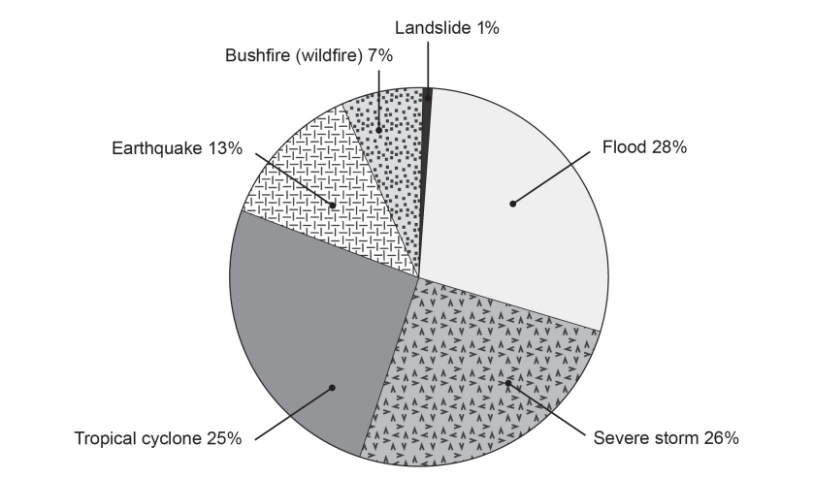
Source 5: Average Annual Cost of Natural Disasters by Type in Australia
- Refer to Source 5 and state one conclusion that can be drawn regarding the cost of geomorphic hazard/s. Include source data in your answer. (2 marks)

- Refer to Source 5 and state one conclusion that can be drawn when comparing the cost of hydrological hazard/s and atmospheric hazard/s. Include source data in your answer. (2 marks)

Total = 29 marks

Marking key for sample assessment task 1 – Unit 3
Section One – Multiple-choice (10 marks)
Question | Answer
1 | C
2 | D
3 | B
4 | C
5 | A
6 | B
7 | D
8 | A
9 | C
10 | A
Section Two – Short answer (19 marks)
- Identify one feature of the natural and cultural landscape on both sides of the Ord River evident in the photograph in Source 2. (4 marks)
Description | Marks
Western Side: Natural landscape – any one of  - Bandicoot Range/Hills  - Dunham River  - Packsaddle Creek. | 1
Western Side: Cultural landscape – any one of  - farmland/crops/irrigated cropland  - roads/Duncan Highway. | 1
Eastern Side: Natural landscape – any one of  - Mount Cecil  - Abney Hill  - Natural vegetation – medium scrubland. | 1
Eastern Side: Cultural landscape – any one of  - Kununurra townsite  - Kununurra-Parry Creek Road/Duncan Highway/roads  - airport  - farmland/crops/irrigated cropland. | 1
Total | /4

- Describe two situation features of the town of Kununurra. (2 marks)
Description | Marks
Identifies two situation features from the list below (but not limited to):  - latitude and longitude of Kununurra  - transport routes in relation to the location of Kununurra  - distance/direction from major landform features such as Mount Cecil, Bandicoot Range. | 2
Identifies only one situation feature. | 1
Total | /2
- Construct an annotated sketch map using the coordinates and frame below to show the following features: (8 marks)
- Kununurra town site  - Ord River  - Airport | - Main supply channel  - Duncan Highway  - appropriate title, key/legend, north point
Description | Marks
Correctly and accurately locates the five features. | 1–5  (1 mark each)
Includes all of the following map elements:  - appropriate title  - key/legend  - north point | 1–3  (1 mark each)
Total | /8
- Represent the scale of your sketch map from Question 14 as a ratio. (1 mark)
Description | Marks
Correctly represents the scale of the sketch map as 1:50 000. | 1
Total | /1
- Refer to Source 1 and state one conclusion that can be drawn regarding the cost of geomorphic hazard/s. Include source data in your answer. (2 marks)
Description | Marks
States accurately one conclusion that can be made regarding the cost of geomorphic hazard/s. | 1
Provides accurate source data to support conclusion. | 1
Total | /2
Answer may include:
Geomorphic hazards have the smallest average annual cost of all types of natural disasters. For example Landslides only comprise 1% and Earthquakes only 13%.
Combined, all types of geomorphic hazards have the lowest total amount of cost compared to hydrological and atmospheric hazards – with a total of only 14% of the total cost.
Landslides have the smallest cost of all types of hazards with only 1% of the cost.

- Refer to Source 5 and state one conclusion that can be drawn when comparing the cost of hydrological hazard/s and atmospheric hazard/s. Include source data in your answer. (2 marks)
Description | Marks
States accurately one conclusion that can be made regarding the cost of hydrological hazard/s and atmospheric hazard/s. | 1
Provides accurate source data to support conclusion. | 1
Total | /2
Answer may include:
A hydrological hazard is the highest cost disaster event with floods being 28% compared to atmospheric (severe storms) being the second at 26%.
In total, atmospheric hazards make up more of the total costs with 58% of the costs for natural hazards compared with 28% for hydrological.

Sample assessment task

Geography – General Year 12

Task 7 – Unit 4
Assessment type: Test
Conditions
Completed in class under test conditions
Time for the task: 40 minutes
Task weighting
5% of the school mark for this pair of units

Section One – Short response (16 marks)
- Describe the nature of the production of automobiles. (2 marks)

- Using the two graphs below, identify two major changes to the location and production of motor vehicles between 1950 and 2014. (4 marks)
Change 1:

Change 2:

or 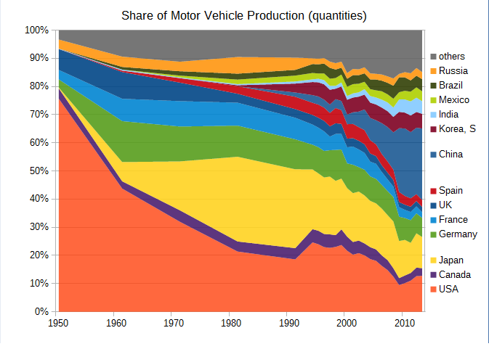
Masaqui. (2014, December 23). Share of motor vehicle production (quantities) [Graph]. Retrieved March, 2015, from http://commons.wikimedia.org/wiki/File:Motor_Vehicle_Production_Share_1950_2013.png. Used under the Creative Commons Attribution-Share Alike 4.0 International licence.
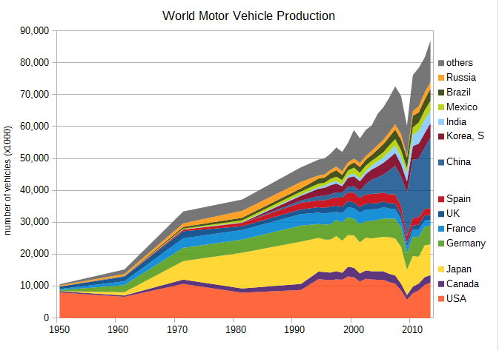
Masaqui. (2014, December 30). World motor vehicle production [Graph]. Retrieved March, 2015, from http://commons.wikimedia.org/wiki/File:Motor_Vehicle_Production_1950_2013_es.svg. Used under the Creative Commons Attribution-Share Alike 4.0 International licence.

- Identify one technological advancement in transport and/or telecommunications and explain how it has facilitated change in the spatial distribution of the production or consumption of automobiles. (4 marks)

- Over time, the spatial distribution of the production of automobiles has changed. Describe one way in which governments can facilitate change in the spatial distribution of the production of automobiles. Refer to specific examples in your answer. (2 marks)

- Describe one advantage and one disadvantage of the changes in the spatial distribution of the production of automobiles for people or places. Refer to specific examples in your answer.
(4 marks)
Advantage:

Disadvantage:

Section Two – Extended response (8 marks)
- Discuss the process of diffusion and the spatial distribution of automobiles. Refer to specific examples in your answer. (8 marks)

Total marks = 24 marks

Marking key for sample assessment task 7 – Unit 4
Section One – Short response
- Describe the nature of the production of automobiles.
Description | Marks
Describes the nature of the production of automobiles. | 2
Makes generalised statements about the production of automobiles. | 1
Total | /2
Answer may include:
The production of automobiles includes a wide range of companies and organisations which are all involved in the design, development, manufacture, marketing, and selling of motor vehicles. It is one of the world's most important economic sectors by revenue.
- Using the two graphs below, identify two major changes to the location and production of motor vehicles between 1950 and 2014.
Description (2 x 2) | Marks
Describes correctly a change and links it to a specific location. Quotes relevant and correct data from the graph/s. | 2
Describes correctly a change but may not link both to a specific location or provide any data from the graph. | 1
Total | /4
Answer may include:
To 1950: USA had produced more than 80% of motor vehicles. During the 1950s: UK, Germany and France restarted production.
In the 1960s: Japan started production and increased volume through the 1980s. US, Japan, Germany, France and UK had produced about 80% of motor vehicles through 1980s.
1990s: Korea became a volume producer. In 2004, Korea became No. 5, passing France.
2000s: China increased its production drastically and, in 2009, became the world’s largest-producing country.
2013: The share of China (25.4%), Korea, India, Brazil and Mexico rose to 43%, while the share of USA (12.7%), Japan, Germany, France and UK fell to 34%.

- Identify one technological advancement in transport and/or telecommunications and explain how it has facilitated change in the spatial distribution of the production or consumption of automobiles.
Description | Marks
Identifies one technological advancement in transport and/or telecommunications applicable to the automobile industry. | 1
Explains the way in which the technological advancement has facilitated change in the spatial distribution of automobile production or consumption. The relationship between cause and effect is evident, i.e. demonstrates how the change has caused the industry to expand geographically. | 3
Describes where the automobile industry has expanded geographically but is unable to link cause and effect. | 2
Makes a generalised statement about a change in the spatial distribution. | 1
Total | /4
- Over time, the spatial distribution of the production of automobiles has changed. Describe one way in which governments can facilitate change in the spatial distribution of the production of automobiles. Refer to specific examples in your answer.
Description | Marks
Describes one way in which governments can facilitate change in the spatial distribution of the production of automobiles. Refers to a specific relevant example to support the description. | 2
Makes a generalised statement about a way in which governments can facilitate change in the spatial distribution of the production of automobiles.  Makes limited reference to a relevant example. | 1
Total | /2
- Describe one advantage and one disadvantage of the changes in the spatial distribution of the production of automobiles for people or places. Refer to specific examples in your answer.
Description | Marks
Advantage  Describes one advantage of the changes in the spatial distribution of the production of automobiles for people or places. | 1
Refers to a specific example to support the advantage. | 1
Disadvantage  Describes one disadvantage of the changes in the spatial distribution of the production of automobiles for people or places. | 1
Refers to a specific example to support the disadvantage. | 1
Total | /4

Section Two – Extended response
- Discuss the process of diffusion and the spatial distribution of automobiles. Refer to specific examples in your answer.
Description | Marks
Discusses the process of diffusion and the spatial distribution of automobiles.  Shows the relationship between cause and effect, i.e. factors such as lower labour costs, mechanised assembly lines (automation), and proximity to major customers are used to account for the spatial distribution described.  Makes reference to specific examples and applies a range of appropriate supporting evidence (such as quotations, sources, statistics, data, maps, diagrams and/or sketches) to support the explanation. Applies relevant geographical terminology and concepts. | 7–8
Explains briefly the process of diffusion and the spatial distribution of automobiles.  Shows the general relationship between cause and effect.  Uses some specific examples and evidence to support the explanation.  Accurately uses geographical terminology and concepts. | 5–6
Describes the process of diffusion and the spatial distribution of automobiles.  Gives basic information about factors responsible for the distribution but the relationship between cause and effect is unclear.  Uses some examples, supporting evidence, geographical terminology and concepts to support the description. | 3–4
Makes generalised statements about the process of diffusion and the spatial distribution of automobiles.  Uses no relevant examples or supporting evidence to support the discussion. | 1–2
Total | /8

Sample assessment task

Geography – General Year 12

Task 9 – Unit 4
Assessment type: Geographical inquiry
Conditions
Period allowed for completion of the task: 4 weeks
Task weighting
15% of the school mark for this pair of units

Select one of the following music festivals and investigate how it has contributed to the diffusion of culture:
- Lollapalooza
- Serbia’s Exit Festival
- Roskilde Festival in Denmark
- Bonnaroo Music and Arts Festival
- Glastonbury Festival of Contemporary Performing Arts
- Sziget
- Rock al Parque.
For your chosen music festival, prepare a written report.
Syllabus content assessed in this inquiry:
- the process of diffusion of the element of culture and its spatial distribution
- the role played by technological advances in transport and/or telecommunications in the diffusion of the element of culture
- the role played by transnational institutions and/or corporations in the dispersion of the element of culture
- the role played by media and emerging technologies in the generation and dispersion of the element of culture
- the ways people embrace, adapt to, or resist the forces of international cultural integration
- the social, economic and environmental implications of the changes in the spatial distribution of the element of culture.
Part A: Geographical inquiry process (12 marks)
During the investigation, use your Geographical inquiry skills to:
- develop a plan for conducting your inquiry with clearly defined aims, using an appropriate framework (4 marks)
- select relevant information from a wide range of sources (2 marks)
- organise information and/or data into an appropriate note-making framework. (4 marks)
The inquiry notes must:
- be clear and ordered (headings can be used)
- cover all aspects of the inquiry
- use appropriate referencing techniques to acknowledge sources. The source of information for your research notes must be recorded following the school protocols. (2 marks)
The plan, inquiry notes and the bibliography are to be submitted at the same time as you present your findings.
Part B: Communicating findings (34 marks)
- Communicate your findings as a written report.
- Include clear and accurate answers to the following questions:
- describe the process of diffusion of the element of culture and its spatial distribution
- explain the role played by two of the following in the diffusion of the element of culture:
- technological advances in transport
- technological advances in telecommunications
- transnational institutions and/or corporations
- media
- emerging technologies
- describe the ways people embrace, adapt to, or resist the forces of international cultural integration
- discuss the social, economic and environmental implications of the changes in the spatial distribution of the element of culture.
- Use evidence from the information, data and maps to support the findings/conclusion.
- Use geographical terminology and concepts.

Part C: In-class reflection (19 marks)
Students are to complete the following 3-2-1 task in class under test conditions, after they have submitted the written report. Time: 30 minutes. No reference to any notes. The worksheet is not to be given to students in advance.
Reflection on what I have learned
The music festival I investigated:

Explain three facts you have learned about the diffusion and/or dispersion of the music festival.
(9 marks)

Describe two ways people and places have embraced, adapted to, or resisted the diffusion of the music festivals. (4 marks)

Explain one positive and one negative impact of the changes in the spatial distribution. Include evidence to support your explanation. (6 marks)

Marking key for sample assessment task 9 – Unit 4
Part A: Inquiry process
Description | Marks
Inquiry plan
Presents a clear well-organised plan for conducting the inquiry, which includes defined aims and appropriate methodology. | 4
Presents a simple organised plan for conducting the inquiry, which includes some defined aims and methodology. | 3
Presents a generalised brief plan for conducting the inquiry with limited defined aims and/or methodology. | 2
Presents some generalised brief statements about the inquiry process. | 1
Subtotal | /4
Selection of sources
Selects a wide range of relevant sources. | 2
Selects some relevant sources. | 1
Subtotal | /2
Note-making
Records notes in a well-organised manner, using an appropriate note-making framework. | 2
Records notes with limited organisation, using a simple format. | 1
Subtotal | /2
Selects and records relevant information that addresses all aspects of the inquiry. | 2
Selects and records some relevant information that addresses aspects of the inquiry. | 1
Subtotal | /2
Bibliography
Follows correct format according to the school protocols. | 2
Lists sources used. | 1
Subtotal | /2
Total Part A | /12

Part B: Communicates findings
Description | Marks
How and where the music festival has spread (including maps and diagrams)
Describes in detail how and where the music festival has spread to over time, from its place/region of origin to other places/regions in the world.  Includes maps and/or diagrams to support their answer. | 3–4
Makes generalised statements about how and where the music festival has spread to over time, from its place/region of origin to other places/regions in the world.  Includes maps and/or diagrams to support their answer. | 1–2
Subtotal | /4
Diffusion/spread of culture (2 x 6)
Explains the role of one factor contributing to the diffusion and/or dispersion of culture through the selected music festival.  Uses geographical terminology correctly to develop response.  Provides appropriate supporting evidence. | 5–6
Describes the role of one factor contributing to the diffusion and/or dispersion of culture through the selected music festival.  Uses some geographical terminology correctly to develop response.  Provides some appropriate supporting evidence. | 3–4
Makes generalised statements about one factor contributing to the diffusion and/or dispersion of culture through the selected music festival.  Makes limited use of evidence to support statements and generalisations. | 1–2
Subtotal | /12
Ways in which people and places have embraced, adapted to, or resisted the diffusion
Describes in detail all three responses to the diffusion of the selected music festival, i.e. embraced, adapted to, or resisted.  Uses relevant geographical terminology correctly to develop response.  Provides appropriate supporting evidence. | 5-6
Describes in brief all three responses to the diffusion of the selected music festival.  Uses some geographical terminology correctly to develop response.  Provides some appropriate supporting evidence. | 3–4
Makes generalised statements which may not consider all three responses to the diffusion of the selected music festival.  Makes limited use of geographical terminology and concepts. | 1–2
Subtotal | /6
The social, economic and environmental implications of the changes (3 x 4 marks)
Discusses one of the (i.e. social or economic or environmental) implications of the changes in the spatial distribution of the element of culture.  Refers to both the positive and negative implications (i.e. advantages and disadvantages).  Uses relevant geographical terminology correctly to develop response.  Provides appropriate supporting evidence. | 4
Explains the (i.e. social or economic or environmental) implications of the changes in the spatial distribution of the element of culture.  Refers to some positive and negative implications (i.e. advantages and disadvantages).  Uses some relevant geographical terminology correctly to develop response.  Provides some appropriate supporting evidence. | 3
Describes the (i.e. social or economic or environmental) implications of the changes in the spatial distribution of the element of culture.  Refers briefly to the positive or negative implications (i.e. advantages or disadvantages).  Uses some geographical terminology correctly to develop response.  Provides some supporting evidence. | 2
Makes generalised statements about the (i.e. social or economic or environmental) implications of the changes in the spatial distribution of the element of culture.  Uses limited geographical terminology. Makes limited use of evidence to support statements and generalisations. | 1
Subtotal | /12
Total Part B | /34

Part C: Reflection
Description | Marks
Three facts (3 x 3 marks)
Explains a fact about the diffusion and/or dispersion of the music festival, using relevant geographical terminology. | 3
Describes a fact about the diffusion and/or dispersion of the music festival, using some relevant geographical terminology. | 2
Makes a generalised statement about the selected music festival. | 1
Subtotal | /9
Describe two ways (2 x 2 marks)
Describes a way people and places have embraced, adapted to, or resisted the diffusion of the music festivals. | 2
Makes a generalised statement about a way people and places have embraced, adapted to, or resisted the diffusion of the music festivals. | 1
Subtotal | /4
One positive and one negative (2x3)
Explains one impact of the changes in the spatial distribution. Includes evidence to support the explanation. Uses geographical terminology. | 3
Describes briefly one impact of the changes in the spatial distribution, and refers to some evidence which may support the description.  Uses some geographical terminology. | 2
Makes a generalised statement with limited or irrelevant evidence about the impact of the change. | 1
Subtotal | /6
Total Part C | /19

Acknowledgements
Marking Key for sample assessment task 7 - Unit 4
Question 1 Answer Automotive Industry. (n.d.) Retrieved February, 2024, from https://en.wikipedia.org/wiki/Automotive_industry
Used under the Creative Commons Attribution-Share Alike 4.0 International licence.

