Physics
General course

Externally set task
Sample 2016

Note: This Externally set task sample is based on the following content from Unit 3 of the General Year 12 syllabus.
Science Inquiry Skills
- identify, research, construct and refine questions for investigation; propose hypotheses; and predict possible outcomes
- plan, select and use appropriate investigation methods, including preliminary trials, laboratory experimentation and controlling variables to collect reliable data
- organise and clearly represent data in tables and appropriate graphs to identify trends, patterns and relationships
- use appropriate SI units and symbols
- use evidence to make and justify conclusions
- evaluate conclusions by considering the quality of available evidence and make recommendations for improving experimental method
- communicate scientific ideas and information using appropriate scientific language, conventions and representations
Science as a Human Endeavour
- data used to describe motion can be collected using a range of technologies
- principles of physics can be applied to understand movement in sport
- the principles behind safety measures, such as crash barriers, seatbelts, crumple zones
- the effects of friction in everyday life
Science Understanding
- displacement, velocity, speed , distance, momentum
- acceleration is the rate of change of velocity
- solve simple problems using the equations:
- uniform motion in one dimension can be represented graphically
- forces and their effects, including pushes and pulls
- contact forces, including friction; and non-contact forces, including gravity
- forces have magnitude and direction
- free body diagrams show the forces acting on objects in one or two dimensions
- Newton’s First Law (also called the law of inertia)
- Newton’s Second Law explains the relationship between force and rate of change in momentum according to the equation
- Newton’s Second Law also relates force and acceleration according to the equation F = ma
- the relationships above can be used to explain behaviour of objects in practical situations
- Newton’s Third Law of motion
- the force of gravity causes objects close to the Earth to accelerate at the same rate
- distinguish between mass and weight. This will include applying the relationship:
In future years, this information will be provided late in Term 3 of the year prior to the conduct of the Externally set task. This will enable teachers to tailor their teaching and learning program to ensure that the content is delivered prior to the students undertaking the task in Term 2 of Year 12.

Copyright
© School Curriculum and Standards Authority, 2014
This document – apart from any third party copyright material contained in it – may be freely copied, or communicated on an intranet, for non-commercial purposes in educational institutions, provided that the School Curriculum and Standards Authority is acknowledged as the copyright owner, and that the Authority’s moral rights are not infringed.
Copying or communication for any other purpose can be done only within the terms of the Copyright Act 1968 or with prior written permission of the School Curriculum and Standards Authority. Copying or communication of any third party copyright material can be done only within the terms of the Copyright Act 1968 or with permission of the copyright owners.
Any content in this document that has been derived from the Australian Curriculum may be used under the terms of the Creative Commons Attribution-NonCommercial 3.0 Australia licence
Disclaimer
Any resources such as texts, websites and so on that may be referred to in this document are provided as examples of resources that teachers can use to support their learning programs. Their inclusion does not imply that they are mandatory or that they are the only resources relevant to the course.

Physics

Externally set task
Working time for the task: 60 minutes
Total marks: 42 marks
Weighting: 15% of the school mark
Materials required for this task:
Year 12 General Formulae and Data sheet
- Racing bikes are usually made from lightweight materials like aluminium or carbon fibre.
(16 marks)
- Use physics concepts to explain how this helps the cyclist ride faster. (2 marks)
________________________________________________________________________________
________________________________________________________________________________
________________________________________________________________________________
________________________________________________________________________________
- Cyclists try to decrease air resistance acting against them. Describe two ways they could do this.
(2 marks)
________________________________________________________________________________
________________________________________________________________________________
________________________________________________________________________________
________________________________________________________________________________
- Cyclists are required to wear a helmet to protect their head if they have an accident. Use physics principles to explain how the inner foam or gel layer of the helmet helps to protect the cyclist’s head from injury. (5 marks)
________________________________________________________________________________
________________________________________________________________________________
________________________________________________________________________________
________________________________________________________________________________
________________________________________________________________________________
________________________________________________________________________________
- The graph below shows a cyclist’s velocity during a ride which lasted one hour. During this ride, Katie the cyclist accelerated as she rode down a hill, rode at a steady speed for a while, stopped to have a drink, and braked suddenly to avoid a pedestrian.

Looking at the graph, answer the following questions.
- How long did Katie stop for a drink? (1 mark)
_____________________________________________________________________________
- At what time did Katie brake suddenly and stop? (1 mark)
_____________________________________________________________________________
- At what speed does Katie travel when she is cycling at a steady speed? (1 mark)
_____________________________________________________________________________
- Using the speed from (iii), calculate the distance Katie would cover in 5 minutes
(300 seconds). Show your working and express the answer in metres and also in kilometres
(4 marks)
_____________________________________________________________________________
_____________________________________________________________________________
_____________________________________________________________________________
- Sam and Jen are having a discussion about whose bicycle has the best brakes. They decide to do an investigation to find out more.
(26 marks)

- Design an experiment to test the braking power of a bicycle. You will need to write a step by step method of how the experiment will be carried out, and make a list of the equipment required.
Equipment (4 marks)

Method (4 marks)

- List four (4) variables which will need to be controlled during this investigation. (4 marks)
________________________________________________________________________________
________________________________________________________________________________
________________________________________________________________________________
________________________________________________________________________________
- Which variable is the dependent variable, or the one you will measure? (1 mark)
________________________________________________________________________________
________________________________________________________________________________
- Draw up a table to enter the results. (3 marks)

- Show the formula you would use to calculate the bike’s acceleration while it is braking, using the variable that you measured. No calculations are required. (1 mark)
________________________________________________________________________________
- Will the bike’s acceleration during braking be positive or negative? Explain. (2 marks)
________________________________________________________________________________
________________________________________________________________________________
- How will Sam and Jen decide which bike has the best brakes? (1 mark)
________________________________________________________________________________
________________________________________________________________________________

- Draw a diagram of all the forces acting on the bicycle while the brakes are being applied. Represent the forces using labelled arrows to show the direction of each force and indicate the relative sizes of the forces by the length of the arrows. (6 marks)

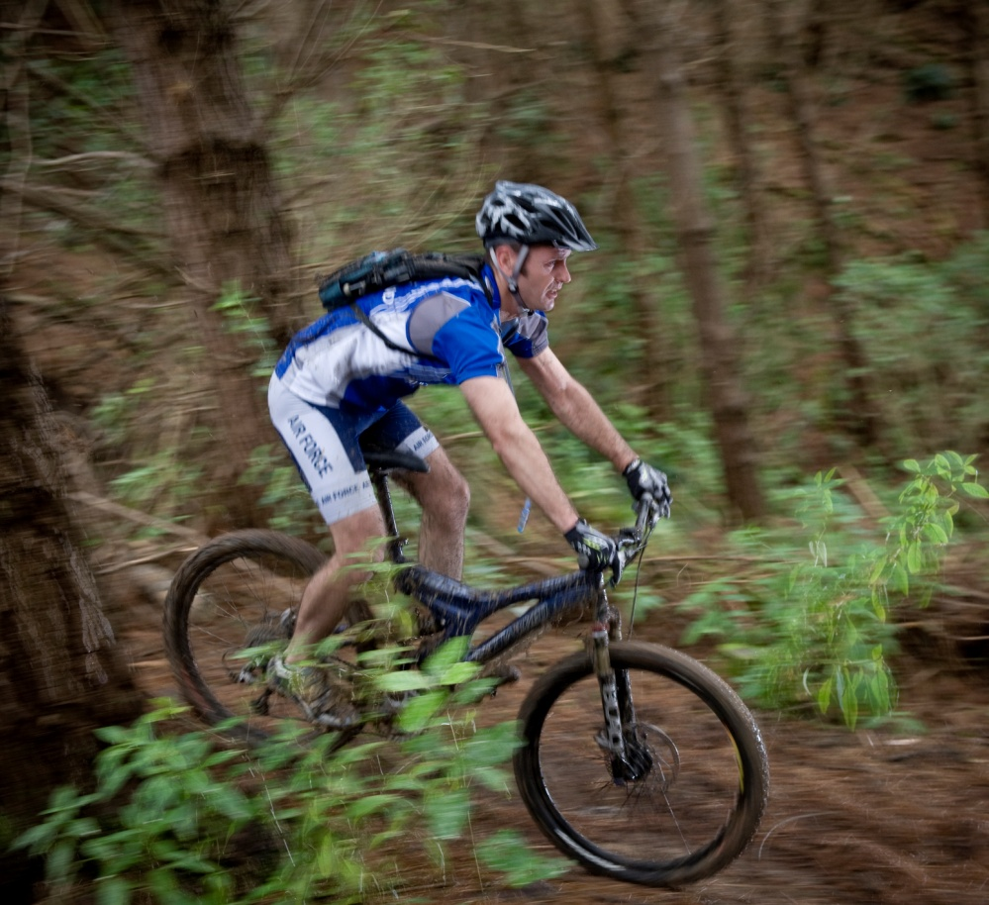

Acknowledgements
Question 1
Image: New Zealand Defence Force. (2011). File:20110825 OH H1013410 0091.JPG - Flickr - NZ Defence Force.jpg. Retrieved March, 2014, from http://en.wikipedia.org/wiki/File:20110825_OH_H1013410_0091.JPG_-_Flickr_-_NZ_Defence_Force.jpg
Used under Creative Commons Attribution 2.0 Generic licence.

