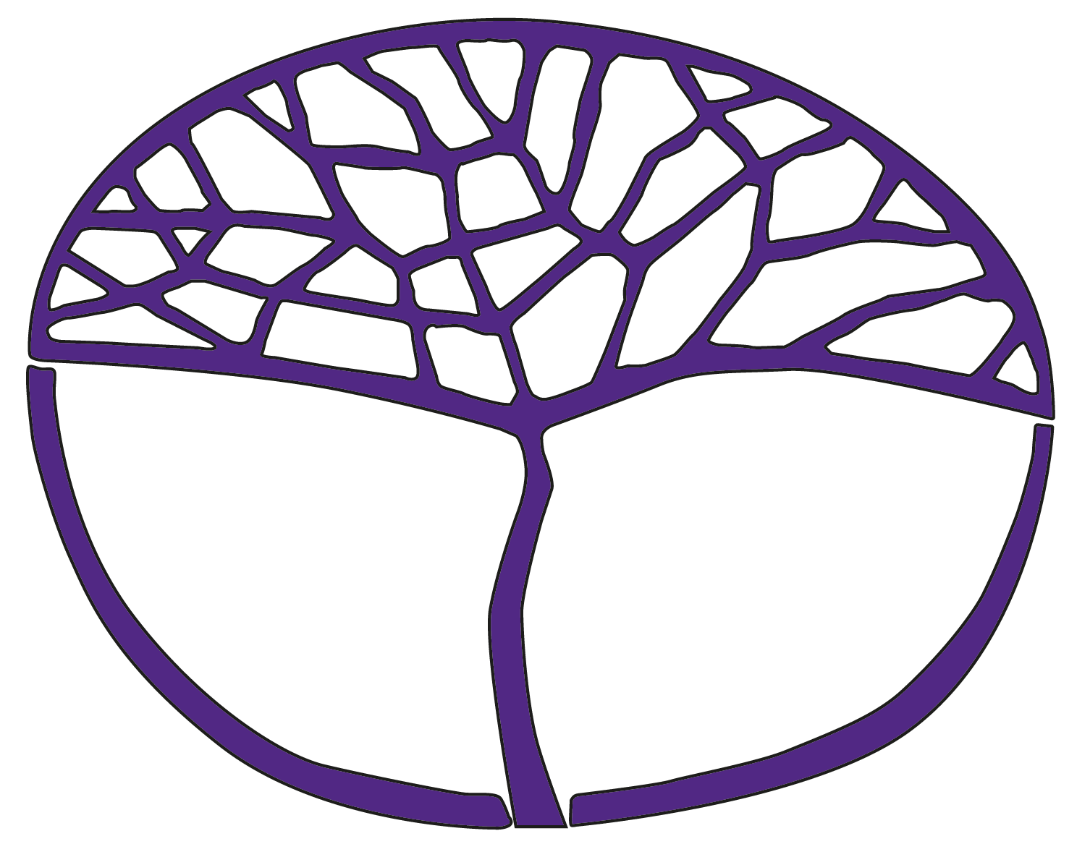Sample Assessment Outline

Dance

ATAR Year 11

**Acknowledgement of Country**

Kaya. The School Curriculum and Standards Authority (the Authority) acknowledges that our offices are on Whadjuk Noongar boodjar and that we deliver our services on the country of many traditional custodians and language groups throughout Western Australia. The Authority acknowledges the traditional custodians throughout Western Australia and their continuing connection to land, waters and community. We offer our respect to Elders past and present.

**Copyright**

© School Curriculum and Standards Authority, 2023

This document – apart from any third-party copyright material contained in it – may be freely copied, or communicated on an intranet, for non-commercial purposes in educational institutions, provided that the School Curriculum and Standards Authority (the Authority) is acknowledged as the copyright owner, and that the Authority’s moral rights are not infringed.

Copying or communication for any other purpose can be done only within the terms of the *Copyright Act 1968* or with prior written permission of the Authority. Copying or communication of any third-party copyright material can be done only within the terms of the *Copyright Act 1968* or with permission of the copyright owners.

Any content in this document that has been derived from the Australian Curriculum may be used under the terms of the [Creative Commons Attribution 4.0 International licence](https://creativecommons.org/licenses/by/4.0/).

**Disclaimer**

Any resources such as texts, websites and so on that may be referred to in this document are provided as examples of resources that teachers can use to support their learning programs. Their inclusion does not imply that they are mandatory or that they are the only resources relevant to the course. Teachers must exercise their professional judgement as to the appropriateness of any they may wish to use.

Sample assessment outline

Dance – ATAR Year 11

Unit 1 and Unit 2

|  |  |  |  |  |  |
| --- | --- | --- | --- | --- | --- |
| Assessment component | Assessment type (from syllabus) | Assessment type weighting (from syllabus) | Assessment task weighting | Week due | Assessment task |
| **Practical** | Performance/ production | 40% | 5% | Semester 1  Week 12 | **Task 1: Demonstration of technique and skills – popular dance**  Perform exercises and extended sequences in genre-specific technique:  • elevation, floor work, standing work, travelling, turning  • correct execution and control of technique and skills  • alignment and placement of body |
| 5% | Semester 2  Week 13 | **Task 2: Application of technique and skills – youth dance**  Apply genre-specific technique in a 2–3-minute teacher-choreographed dance:  •elevation, floor work, standing work, travelling, turning  • correct execution and control of technique and skills  • alignment and placement of body |
| 15% | Semester 1  Week 15 | **Task 3: Group choreography presentation**  Present evidence of choreographic processes and performance skills in a group dance work influenced by popular dance in genre of choice:  • selection and combination of elements of dance – body, dynamics, space, time (BDST) to convey ideas  • choreographic devices  • artistic interpretation, commitment, confidence, engagement, expression, focus, musicality, projection |
| 15% | Semester 2  Week 13 | **Task 4:** **Duo choreography**  (Note: students may opt to complete this assessment solo.)  Plan, create, rehearse and perform an original duo (or solo) that manipulates the elements of dance and uses choreographic devices and structure to reflect a choreographic idea influenced by youth dance in genre of choice:  • selection and combination of elements of dance – body, dynamics, space, time (BDST) to convey ideas |
|  | Examination | 20% | 5% | Semester 1  Week 16 | **Task 7a: Semester 1 practical examination** (modified)  Perform a teacher choreographed solo (TCS) in jazz and a structured improvisation task under examination conditions |
| 15% | Semester 2  Week 16 | **Task 8a: Semester 2 practical examination**  Perform one solo (P1S) (a solo performance of Task 4), the TCS in hip-hop and a structured improvisation task under examination conditions |
| **Written** | Examination | 15% | 5% | Semester 1  Week 16 | **Task 7b: Semester 1 written examination**  Answer questions that represent a sample of the syllabus content from Unit 1, using a modified examination design brief from the Year 12 syllabus |
| 10% | Semester 2  Week 16 | **Task 8b**: **Semester 2 written examination**  Answer questions that represent a sample of the syllabus content from Unit 1 and Unit 2, using a modified examination design brief from the Year 12 syllabus |
| Response | 25% | 12.5% | Semester 1  Week 8 | **Task 5: Case study – popular dance**  Complete an in-class timed response that draws on investigation of popular dance over time:  • background information  • related and relevant dance works – choreographic intent, elements of dance, choreographic devices, choreographic structures and design concepts |
| 12.5% | Semester 2  Week 8 | **Task 6: Case study** **– youth dance**  Complete in-class timed response that draws on investigations of youth communication through dance:  • background information  • related and relevant dance works – choreographic intent, elements of dance, choreographic devices, choreographic structures and design concepts |
| **Total** |  | **100%** | **100%** |  | |