
Sample assessment tasks

Marine and Maritime Studies

General Year 12

Copyright
© School Curriculum and Standards Authority, 2015
This document – apart from any third party copyright material contained in it – may be freely copied, or communicated on an intranet, for non-commercial purposes in educational institutions, provided that the School Curriculum and Standards Authority is acknowledged as the copyright owner, and that the Authority’s moral rights are not infringed.
Copying or communication for any other purpose can be done only within the terms of the Copyright Act 1968 or with prior written permission of the School Curriculum and Standards Authority. Copying or communication of any third party copyright material can be done only within the terms of the Copyright Act 1968 or with permission of the copyright owners.
Any content in this document that has been derived from the Australian Curriculum may be used under the terms of the Creative Commons Attribution-NonCommercial 3.0 Australia licence
Disclaimer
Any resources such as texts, websites and so on that may be referred to in this document are provided as examples of resources that teachers can use to support their learning programs. Their inclusion does not imply that they are mandatory or that they are the only resources relevant to the course.

Sample assessment task

Marine and Maritime Studies – General Year 12

Task 2 – Unit 3
Assessment type: Investigation

Conditions

Period allowed for completion of the task: two weeks

Task weighting

5% of the school mark for this pair of units

__________________________________________________________________________________

Measurement of biotic and abiotic factors in a marine ecosystem (25 marks)
All ecosystems have biotic and abiotic components. It is not possible to count all living and non-living things in an ecosystem but we can try to characterise them by counting their numbers in a transect. A transect is an area in which sample population counts of plants and animals can be taken. The size of the transect needs to be large enough to represent the biotic and abiotic factors of the ecosystem and this will vary depending on the ecosystem being studied.
In this activity, you will, in discussion with your teacher, choose a question about the relationship between biotic and abiotic factors of a marine ecosystem to investigate. You will need to write a hypothesis about the relationship and use the transect method, including a transect square, to collect data to test your hypothesis.
Some of the aspects to consider when planning data to collect are types of:
- abiotic data, including water temperature; sand temperature at various depths (if the ecosystem is a shoreline); air temperature at various heights above ground; wind direction and speed; light levels; whether it is sandy or rocky etc.
- biotic data, including number of different species present; number of different classes of species present; number of each species; whether you can identify adults and juveniles for a species present.

What you need to do
- As a class, brainstorm the type of biotic and abiotic data you think may need to be collected.
- Working with your group, and in discussion with your teacher, describe the question you will investigate.
- Working on your own, complete the questions in the Planning section of the activity sheet. Also design your results table at this stage. Show this to your teacher before moving to the next part.
- Working with your group, discuss your plan and amend, if necessary.
- Working with your group, construct your transect and collect your data.
- Working on your own, complete the questions in the Data processing and analysis and Evaluation sections of the activity sheet. Show this to your teacher before moving to the next part.
- Working with your group, discuss your answers to the Data processing and analysis and Evaluation questions and amend, if necessary.

Investigating biotic and abiotic factors in a marine ecosystem

Planning
- Describe the question relating the biotic and abiotic factors you will investigate. (2 marks)

______________________________________________________________________
______________________________________________________________________
______________________________________________________________________
______________________________________________________________________
______________________________________________________________________

- Write a hypothesis for the experiment. (2 marks)

Individual ideas
______________________________________________________________________
______________________________________________________________________
______________________________________________________________________
Any refinements after group discussion
______________________________________________________________________
______________________________________________________________________
______________________________________________________________________

- Predict what you think the result will be for your investigation. (1 mark)

______________________________________________________________________
______________________________________________________________________
______________________________________________________________________
______________________________________________________________________

- Plan and describe how you will collect your data. List the types of data you will collect and any equipment needed to collect it. (4 marks)

List of equipment and data to be collected

Individual ideas | Any refinements after group discussion

Description of how data will be collected

Individual ideas
______________________________________________________________________
______________________________________________________________________
______________________________________________________________________
______________________________________________________________________
______________________________________________________________________
______________________________________________________________________

Any refinements after group discussion
______________________________________________________________________
______________________________________________________________________
______________________________________________________________________
______________________________________________________________________
______________________________________________________________________
______________________________________________________________________

Results

- Design a suitable table to record your results. The table can be done in a spread sheet (and printed to take to the site where data is to be collected). Provide a description of the site where you are collecting data. Attach a picture of the site to your report. (9 marks)

Data processing and analysis

- Are there any patterns or trends in your data? (2 marks)

Individual ideas
______________________________________________________________________
______________________________________________________________________
______________________________________________________________________
______________________________________________________________________
______________________________________________________________________
______________________________________________________________________

Any refinements after group discussion
______________________________________________________________________
______________________________________________________________________
______________________________________________________________________
______________________________________________________________________
______________________________________________________________________
______________________________________________________________________

- Using science concepts, explain the patterns, trends or relationships you have identified in your data. (2 marks)

Individual ideas
______________________________________________________________________
______________________________________________________________________
______________________________________________________________________
______________________________________________________________________
______________________________________________________________________
______________________________________________________________________

Any refinements after group discussion
______________________________________________________________________
______________________________________________________________________
______________________________________________________________________
______________________________________________________________________
______________________________________________________________________
______________________________________________________________________

Evaluation

- Do the data support the hypothesis? Explain. (3 marks)

Individual ideas
______________________________________________________________________
______________________________________________________________________
______________________________________________________________________
______________________________________________________________________
______________________________________________________________________
______________________________________________________________________

Any refinements after group discussion
______________________________________________________________________
______________________________________________________________________
______________________________________________________________________
______________________________________________________________________
______________________________________________________________________
______________________________________________________________________

Marking key for sample assessment task 2 – Unit 3

- Describe the question relating the biotic and abiotic factors you will investigate.

Description | Marks
Question stated that relates biotic and abiotic factors in the chosen ecosystem | 1–2
Total | /2
Answer could include, but is not limited to:
Types of questions may include:
- relationships between population of a species and presence of a particular abiotic feature of the ecosystem
- relationships between number of different species and presence of a particular abiotic feature of the ecosystem
- relationships between genus (or family) and presence of a particular abiotic feature of the ecosystem
- organisms with similar adaptations present in the ecosystem when a particular abiotic feature is present in the ecosystem

- Write a hypothesis for the experiment.

Description | Marks
Hypothesis stated that relates dependent and independent variables | 1–2
Total | /2
Answer could include, but is not limited to:
Types of statement may include:
- higher population of a species when a particular abiotic feature is present in the ecosystem
- higher number of different species present when a particular abiotic feature is present in the ecosystem
- higher number of one genus (or family) and presence of a particular abiotic feature in the ecosystem

- Predict what you think the result will be for your investigation.

Description | Marks
Prediction related to hypothesis given | 1
Total | /1

- Plan and describe how you will collect your data. List the types of data you will collect and any equipment needed to collect it.

Description | Marks
Appropriate equipment listed | 1
Data to be collected listed | 1
Description of how data is to be collected | 1–2
Total | /4
Answer could include, but is not limited to:
Equipment may include (will vary depending on chosen ecosystem):
- transect (or rope to lay out as a transect)
- suitable clip board to lean on to write observations
- camera
Data to be collected may include:
- number of individuals of a species
- number and type of different species present
- number and type of genera present
- temperatures of water, sand, air, as appropriate
- light intensity
- wind speed and direction
- time of day data collected, time of year, geographical location

- Design a suitable table to record your results. The table can be done in a spread sheet (and printed to take to the site where data is to be collected). Provide a description of the site where you are collecting data. Attach a picture of the site to your report.

Description | Marks
Table has appropriate columns for the type of data to be collected | 1–2
Data entered appropriately to table | 1–2
Abiotic data, such as temperature, time of day etc. appropriately recorded | 1–2
Description of site provided | 1–2
Picture of site provided | 1
Total | /9

- Are there any patterns or trends in your data?

Description | Marks
Any patterns are described | 1–2
Total | /2
Answer could include, but is not limited to:
Patterns may include:
- higher population of a species associated with a particular abiotic feature
- higher number of a species associated with a particular abiotic feature
- higher population of a class (or genera etc.) associated with a particular abiotic feature
- higher prevalence of a particular type of adaptation in organisms associated with a particular abiotic feature

- Using science concepts, explain the patterns, trends or relationships you have identified in your data.

Description | Marks
Any patterns or trends are explained | 1–2
Total | /2
Answer could include, but is not limited to:
- higher population of a species associated with a particular abiotic feature may be due to the shelter provided by the abiotic feature
- higher number of species associated with a particular abiotic feature may be due to feature providing habitat and supporting an extensive food web
- higher prevalence of a particular type of adaptation in organisms due to the abiotic feature will be because the adaptation helps the organism survive under the prevalent conditions

- Do the data support the hypothesis? Explain.

Description | Marks
States whether the hypothesis is supported or not | 1
Relates data collected to hypothesis to explain whether it is supported or not | 1–2
Total | /3
Answer could include, but is not limited to:
- higher population of a species associated with a particular abiotic feature may be due to the shelter provided by the abiotic feature
- higher number of a species (or class or genera etc.) associated with a particular abiotic feature may be due to feature providing habitat and supporting an extensive food web
- higher prevalence of a particular type of adaptation in organisms due to the abiotic feature will be because the adaptation helps the organism survive under the prevalent conditions

Sample assessment task

Marine and Maritime Studies – General Year 12

Task 4 – Unit 3
Assessment type: Extended response

Conditions

Time for the task: two periods – group discussion component – one period; response questions – one period

Task weighting

5% of the school mark for this pair of units

__________________________________________________________________________________

Aquaculture in Western Australia (25 marks)
You will be provided with information about aquaculture in Western Australia from the
WA Government Department of Fisheries website (http://www.fish.wa.gov.au/Fishing-and-Aquaculture/Aquaculture/Pages/default.aspx) (http://www.fish.wa.gov.au/Documents/sofar/status_reports_of_the_fisheries_and_aquatic_resources_2013-14.pdf). You will work in groups to discuss guide questions about the aquaculture information provided.
During your group discussion, choose one person as a:
- facilitator for the discussion, who will be responsible for making sure everybody in the group has the opportunity to contribute their ideas
- recorder of your ideas
- spokesperson to report your ideas to the class.
After the group discussion, you will complete a set of questions on your own about aquaculture in Western Australia. You will be able to use the information from the website to help answer the questions.
Guide questions for group discussion
- What are some of the advantages of aquaculture?
- What are some of the possible problems that need to be managed? How does the Department of Fisheries intend to try to manage these issues to avoid them becoming problems?
- One of the issues to be managed in the aquaculture industry is biosecurity. What does biosecurity mean in the context of aquaculture?
- When writing about environmental impacts, the information for the Mid-west aquaculture zone uses the phrase ‘adaptive management controls’. What does this mean? As well, the Department of Fisheries indicate there will be environmental monitoring. What type of things would need to be monitored?

Aquaculture in Western Australia (25 marks)
- On the map provided below, mark in the Western Australian aquaculture regions. Label the regions with their names. (6 marks)

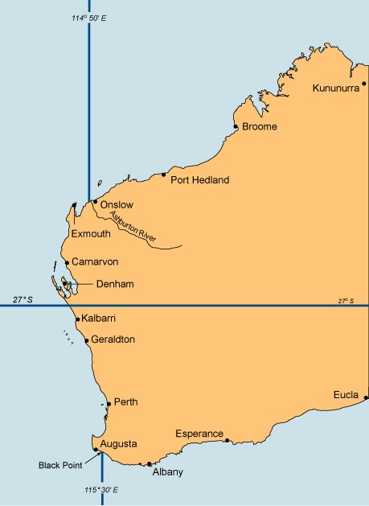

- Name four species that are farmed for commercial aquaculture in Western Australia.
(4 marks)
______________________________________________________________________
______________________________________________________________________

- Name two products of Western Australian commercial aquaculture that are not the marine organism itself. (2 marks)
______________________________________________________________________
______________________________________________________________________

- As part of its management of aquaculture in Western Australia, the Department of Fisheries requires operators to be licensed. Discuss how licensing is important to management of the aquaculture industry. (3 marks)
______________________________________________________________________
______________________________________________________________________
______________________________________________________________________
______________________________________________________________________

- What is a MEMP and what is its main purpose? (2 marks)
______________________________________________________________________
______________________________________________________________________
______________________________________________________________________
______________________________________________________________________

- What is an aquaculture zone? (1 mark)
______________________________________________________________________
______________________________________________________________________

- Name the species to be farmed in the Kimberley aquaculture zone. (1 mark)
______________________________________________________________________
______________________________________________________________________

- The Department of Fisheries information indicates that good water flow through sea-cages will give high productivity and low environmental impact. Explain why good water flow will have these effects. (2 marks)
______________________________________________________________________
______________________________________________________________________
______________________________________________________________________
______________________________________________________________________

- What work is currently being undertaken by the Department of Fisheries in the development of the Mid-west aquaculture zone? What is the purpose of this work? (2 marks)
______________________________________________________________________
______________________________________________________________________
______________________________________________________________________

- Why is the Mid-west aquaculture zone to be located in the Abrolhos Islands Fish Habitat Protection Area? (2 marks)
______________________________________________________________________
______________________________________________________________________
______________________________________________________________________

ACKNOWLEDGEMENTS

Map of Western Australia adapted from: Department of Fisheries. (2014). Sustainable fisheries management. Retrieved March, 2015, from www.fish.wa.gov.au/Sustainability-and-Environment/Sustainable-Fisheries/Pages/Sustainable-Fisheries-Management.aspx

Marking key for sample assessment task 4 – Unit 3
- On the map provided below, mark in the Western Australian aquaculture regions. Label the regions with their names.

Description | Marks
1 mark for each region marked on the map as below | 1–6
Total | /6

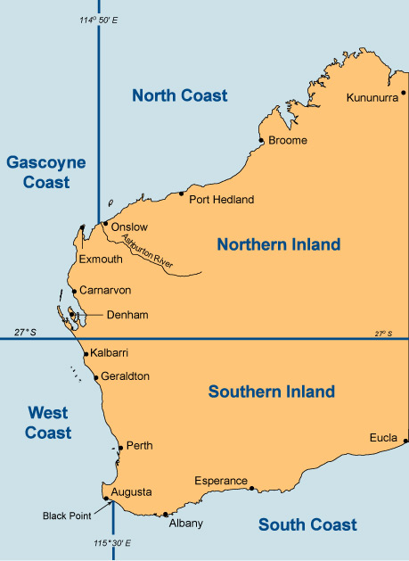

- Name four species that are farmed for commercial aquaculture in Western Australia.

Description | Marks
1 mark for each species | 1–4
Total | /4
Answer could include, but is not limited to:
barramundi, mussels, marron, oysters, abalone, silver perch, rainbow trout, yabbies and marine algae

- Name two products of Western Australian commercial aquaculture that are not the marine organism itself.

Description | Marks
1 mark for each product | 1–2
Total | /2
Answer could include, but is not limited to:
pearls, beta-carotene

- As part of its management of aquaculture in Western Australia, the Department of Fisheries requires operators to be licensed. Discuss how licensing is important to management of the aquaculture industry.

Description | Marks
Discussion shows recognition of a range of points about how licensing can contribute to sustainable management of aquaculture resources | 1–3
Total | /3
Answer could include, but is not limited to:
Discussion could include the following points:
- licensing provides an indication of the number of operators in an industry. This can contribute to ensuring appropriate supply of a product to the market
- licensing provides an indication of the number of operators in a location, so can reduce chances of damage to the natural environment that supports the industry
- licensing provides an indication of the type of organisms that an operator may wish to use in his/her operation and so alert authorities to biosecurity issues if it is a non-endemic species
- licensing provides an indication of the intended location of an operation so as to assess potential impact on other activities in the location

- What is a MEMP and what is its main purpose?

Description | Marks
Recognition of what the acronym stands for – Management and Environmental Monitoring Plan | 1
The purpose of a MEMP is to enable the Department to meet its responsibilities in respect of the environmental management of aquaculture in Western Australia. | 1
Total | /2

- What is an aquaculture zone?

Description | Marks
An aquaculture zone is a designated area of water selected for its suitability for a specific aquaculture sector. | 1
Total | /1

- Name the species to be farmed in the Kimberley aquaculture zone.

Description | Marks
barramundi | 1
Total | /1

- The Department of Fisheries information indicates that good water flow through sea-cages will give high productivity and low environmental impact. Explain why good water flow will have these effects.

Description | Marks
Good water flow through the sea-cages will give  - high productivity and  - low environmental impact | 1  1
Total | /2

- What work is currently being undertaken by the Department of Fisheries in the development of the Mid-west aquaculture zone? What is the purpose of this work?

Description | Marks
Environmental field work is being done to describe the state of the study area’s marine environment, including the coral habitats and sensitive species of fauna and flora | 1
The data from this field work will be used to assess the environment’s carrying capacity for ecologically sustainable finfish aquaculture | 1
Total | /2

- Why is the Mid-west aquaculture zone to be located in the Abrolhos Islands Fish Habitat Protection Area?

Description | Marks
The establishment of commercial marine finfish aquaculture projects within the zone is not expected to cause a significant environmental impact | 1
This is because the zone’s physical characteristics, in particular the high rates of water exchange, are likely to be sufficient to dilute nutrients and aid assimilation by the wider environment (all locations have adequate depth and good water circulation and are located away from areas of highest conservation value) | 1
Total | /2

Sample assessment task

Marine and Maritime Studies – General Year 12

Task 9 – Unit 4
Assessment type: Test

Conditions

Time for the task: 50 minutes

Task weighting

5% of the school mark for this pair of units

__________________________________________________________________________________

Test

Oceanography (35 marks)

Recommended time: 50 minutes

Write your answers in the space provided on the paper.

- (a) On the map below, show the complete pathway of an ocean current that significantly
impacts on the Western Australian marine environment. Give the name of the current.
(2 marks)
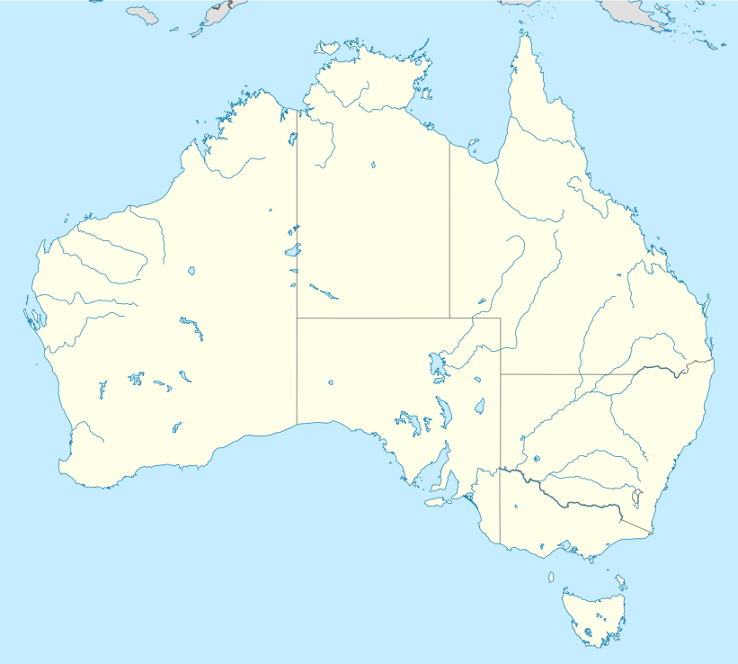

Name of current: ____________________________________
(b) Name three factors that contribute to this current’s flow. (3 marks)

Factor 1: ___________________________________________________________
Factor 2: ___________________________________________________________
Factor 3: ___________________________________________________________

This current is quite different from coastal currents along the southwest African coast (Benguela Current) and the Chile-Peru coast (the Humboldt Current). The Benguela and Humboldt Currents are cool, northward flowing currents, while this current along the Western Australian coast is a warm, southward flowing current.

(c) Identify three influences this current has on the marine ecosystem off the coast of Western Australia. (3 marks)

Influence 1: _________________________________________________________
__________________________________________________________________
Influence 2: _________________________________________________________
__________________________________________________________________
Influence 3: _________________________________________________________
__________________________________________________________________

- El Niño and La Niña events have impacts on Australian weather conditions. These events are triggered by changes in surface sea temperatures in regions of the Pacific Ocean.
(a) State the regions of the Pacific Ocean that are involved in creating El Niño and La Niña events. (2 marks)
__________________________________________________________________
__________________________________________________________________

(b) What surface sea temperature changes are associated with an El Niño event? (1 mark)
__________________________________________________________________

(c) State three effects of an El Niño event on climate conditions in Australia. (3 marks)
__________________________________________________________________
__________________________________________________________________
__________________________________________________________________
(d) El Niño events also affect the upwelling of nutrients from deep in the ocean. State how
El Niño events affect nutrient upwelling and explain how this can affect a marine ecosystem. (3 marks)
__________________________________________________________________
__________________________________________________________________
__________________________________________________________________
__________________________________________________________________

- Longshore currents are formed when a wave reaching a beach or coastline releases its energy to create a current. These currents are affected by the velocity and angle of a wave.
(a) Describe the conditions that lead to longshore currents with a high velocity. (3 marks)
__________________________________________________________________
__________________________________________________________________
__________________________________________________________________
__________________________________________________________________

(b) Describe the conditions that lead to longshore currents with a low velocity. (3 marks)
__________________________________________________________________
__________________________________________________________________
__________________________________________________________________
__________________________________________________________________

(c) On the diagram below, label the direction of the longshore current created by the waves, the direction of the swash, the direction of the backwash and the direction of longshore drift of the beach sand. (4 marks)
beach
waves

- The diagram below represents a section of beach where a port has been built. Label the diagram to show where there will be erosion and where sand will deposit. (4 marks)
waves
Port structures
beach

- (a) Two artificial reefs have been constructed in Western Australia. Name the locations of
these reefs. (2 marks)
Reef 1: ________________________________________________________
Reef 2: ________________________________________________________

(b) Artificial reefs are designed to provide a number of possible benefits. State two possible benefits of artificial reefs. (2 marks)
Benefit 1: ______________________________________________________
Benefit 2: ______________________________________________________

ACKNOWLEDGEMENTS

Map of Australia from: Mapsof.net. (n.d.). Australian location map. Retrieved March, 2015, from http://mapsof.net/map/australia-location-map

Used under Creative Commons Attribution-ShareAlike 1.0 licence.

Marking key for sample assessment task 9 – Unit 4

- (a) On the map below, show the complete pathway of an ocean current that significantly
impacts on the Western Australian marine environment. Give the name of the current.

Description | Marks
Current drawn on map from North West Cape along coast to the southern coast of Western Australia (extending as far as Tasmania) | 1
Name – Leeuwin Current | 1
Total | /2

(b) Name three factors that contribute to this current’s flow.

Description | Marks
Factors named | 1–3
Total | /3
Answer could include, but is not limited to:
Factors may include:
- water build up north of Australia
- El Niño and La Niña cycles (Southern oscillation index)
- pressure difference
- thermohaline forcing
- Indian Ocean dipole effects
- wind speed and direction

This current is quite different from coastal currents along the southwest African coast (Benguela Current) and the Chile-Peru coast (the Humboldt Current). The Benguela and Humboldt Currents are cool, northward flowing currents, while this current along the Western Australian coast is a warm, southward flowing current.

(c) Identify three influences this current has on the marine ecosystem off the coast of Western Australia.

Description | Marks
Three influences identified | 1–3
Total | /3
Answer could include, but is not limited to:
Influences may include:
- reduced upwelling of nutrients (or nutrient-poor waters)
- reduced populations of pelagic fish due to low-nutrient waters (as compared to currents like the Benguela and Humboldt)
- warmer water allows tropical marine organisms to survive further south than would otherwise be expected
- warmer water allows true corals to survive at the Abrolhos Islands (off Geraldton), making it the southernmost true coral reef system in the world
- settlement of lobster puerulus is closely linked with variations in the strength of the Leeuwin Current
- whitebait populations seem to be higher in the year following a stronger current

- El Niño and La Niña events have impacts on Australian weather conditions. These events are triggered by changes in surface sea temperatures in regions of the Pacific Ocean.

(a) State the regions of the Pacific Ocean that are involved in creating El Niño and La Niña
events.

Description | Marks
central and eastern equatorial Pacific Ocean | 1–2
Total | /2

(b) What surface sea temperature changes are associated with an El Niño event?

Description | Marks
El Niño is associated with extensive warming of sea surface temperatures | 1
Total | /1

(c) State three effects of an El Niño event on climate conditions in Australia.

Description | Marks
Effects stated | 1–3
Total | /3
Answer could include, but is not limited to:
Effects may include:
- drier conditions in Eastern States
- drought possibility increases in much of Australia
- hotter weather often occurs
- increased bushfire risk during summers
- drier winters

(d) El Niño events also affect the upwelling of nutrients from deep in the ocean. State how
El Niño events affect nutrient upwelling and explain how this can affect a marine ecosystem.

Description | Marks
Recognition that El Niño events reduce nutrient upwelling | 1
Recognition that phytoplankton living near the surface need these nutrients for survival, so reduced nutrient availability lowers their population | 1
Recognition that fish and mammals depend upon phytoplankton as the foundation of the marine food chain, so there is a flow-on effect up the food chain on the populations of other organisms | 1
Total | /3

- Longshore currents are formed when a wave reaching a beach or coastline releases its energy to create a current. These currents are affected by the velocity and angle of a wave.

(a) Describe the conditions that lead to longshore currents with a high velocity.

Description | Marks
Any three of the following:  - waves breaking at a more acute (steep) angle to the beach  - waves encounter a steeper beach slope  - the beach is very high  - high waves | 1–3
Total | /3

(b) Describe the conditions that lead to longshore currents with a low velocity.

Description | Marks
Any three of the following:  - waves breaking at a small angle to the beach  - waves encounter a gentler beach slope  - the beach is low  - low waves | 1–3
Total | /3

(c) On the diagram below, label the direction of the longshore current created by the waves, the
direction of the swash, the direction of the backwash and the direction of longshore drift of
the beach sand.
Longshore drift
Longshore current
beach
waves
swash
backwash

Description | Marks
Direction of the longshore current shown | 1
Direction of the swash shown | 1
Direction of the backwash shown | 1
Direction of the longshore drift shown | 1
Total | /4

- The diagram below represents a section of beach where a port has been built. Label the diagram to show where there will be erosion and where sand will deposit.

waves
Port structures
beach
deposition
erosion

Description | Marks
1 mark for each area of erosion | 1–2
1 mark for each area of deposition | 1–2
Total | /4

- (a) Two artificial reefs have been constructed in Western Australia. Name the locations of these reefs.

Description | Marks
Off the coast of Bunbury | 1
Off the coast of Dunsborough | 1
Total | /2

(b) Artificial reefs are designed to provide a number of possible benefits. State two possible
benefits of artificial reefs.

Description | Marks
Two appropriate reasons stated | 1–2
Total | /2
Answer could include, but is not limited to:
Reasons may include:
- provide habitat for marine life
- control erosion
- block ship passage
- improve surfing

Sample assessment task

Marine and Maritime Studies – General Year 12

Task 13 – Unit 4
Assessment type: Practical

Conditions

Time for the task: 15 minutes (per student)

Task is carried out under supervised conditions

Task weighting

5% of the school mark for this pair of units

__________________________________________________________________________________

Knot tying skills assessment (25 marks)
In this practical skills assessment, you will be required to tie five knots in front of an assessor under supervised conditions. The knots you will be assessed on are:
- reef knot
- bowline
- sheet bend
- clove hitch
- round turn and two half hitches.

For each knot, you are required to:
- tie the knot within the specified time period (1 mark)
- correctly set the knot (1 mark)
- correctly dress the knot (1 mark)
- describe the purpose of the knot (1 mark)
- give an example of how the knot could be used. (1 mark)

Marking key for sample assessment task 13 – Unit 4
Description | Marks
Reef knot  - tied in 40 seconds or less  - dressed correctly  - set correctly  - purpose of knot described e.g. used as a stopper knot  - example of use e.g. stop a rope end coming through a fairlead or eyehole | 1  1  1  1  1
Subtotal | /5
Bowline  - tied in 20 seconds or less  - dressed correctly  - set correctly  - purpose of knot described e.g. to form a fixed loop at the end of a rope  - example of use e.g. to fasten a halyard to the head of a sail; or to tie a jib sheet to a clew of a jib | 1  1  1  1  1
Subtotal | /5
Sheet bend  - tied in 20 seconds or less  - dressed correctly  - set correctly  - purpose of knot described e.g. to temporarily join two ropes of unequal or equal diameter together  - example of use e.g. search and rescue, making a longer line | 1  1  1  1  1
Subtotal | /5
Clove hitch  - tied in 20 seconds or less  - dressed correctly  - set correctly  - purpose of knot described e.g. to bind rope to a part of a ship or other object (usually cylindrical in structure)  - example of use e.g. hang fenders on the boat’s rails or lifelines, mooring a dinghy for short periods of time | 1  1  1  1  1
Subtotal | /5
Round turn and two half hitches  - tied in 20 seconds or less  - dressed correctly  - set correctly  - purpose of knot described e.g. to secure the end of a rope to a fixed object  - example of use e.g. attaching a mooring line to a dock post or ring | 1  1  1  1  1
Subtotal | /5
Final total | /25

