Sample Assessment Tasks

Mathematics Methods

ATAR Year 12

**Acknowledgement of Country**

Kaya. The School Curriculum and Standards Authority (the Authority) acknowledges that our offices are on Whadjuk Noongar boodjar and that we deliver our services on the country of many traditional custodians and language groups throughout Western Australia. The Authority acknowledges the traditional custodians throughout Western Australia and their continuing connection to land, waters and community. We offer our respect to Elders past and present.

**Copyright**© School Curriculum and Standards Authority, 2017

This document – apart from any third-party copyright material contained in it – may be freely copied, or communicated on an intranet, for non-commercial purposes in educational institutions, provided that the School Curriculum and Standards Authority (the Authority) is acknowledged as the copyright owner, and that the Authority’s moral rights are not infringed.

Copying or communication for any other purpose can be done only within the terms of the *Copyright Act 1968* or with prior written permission of the Authority. Copying or communication of any third-party copyright material can be done only within the terms of the *Copyright Act 1968* or with permission of the copyright owners.

Any content in this document that has been derived from the Australian Curriculum may be used under the terms of the [Creative Commons Attribution 4.0 International (CC BY)](https://creativecommons.org/licenses/by/4.0/) licence.

**Disclaimer**

Any resources such as texts, websites and so on that may be referred to in this document are provided as examples of resources that teachers can use to support their learning programs. Their inclusion does not imply that they are mandatory or that they are the only resources relevant to the course. Teachers must exercise their professional judgement as to the appropriateness of any they may wish to use.

Sample assessment task

Mathematics Methods – ATAR Year 12

Task 1 – Unit 3

**Assessment type** Investigation

**Conditions** The investigation will be completed over one week, with an authentication task at the end of this period. Students will be encouraged to work independently to complete the task and may use any appropriate technology.

Note: while the Authority provides sample assessment tasks for guidance, it is the expectation of the Authority that teachers will develop tasks customised to reflect their school’s context and the needs of the student cohort. This resource is available on a public website and use of the resource without modification may affect the integrity of the assessment.

**Task weighting** 10% of the school mark for this pair of units

An iterative process (50 marks)

Background information:

You are designing calculator software that requires you to implement a process that involves determining the roots of an equation. You know that many computers and calculators use a method of approximation and refinement to do this which involves a series of calculations called iterations to zero in on the solution. You need to research this process further.

The diagram below shows how this process projects successive tangent lines onto the x-axis, beginning with the first approximation ($x_{1}$) to find a closer approximation ($x_{2}$) to the true solution. The process is repeated ( $x_{3 }$ and so on), until a solution is found to an acceptable level of accuracy.

The iterative process uses the output of one iteration (calculating an approximation to the solution of $f(x) = 0$) as the input for the next consecutive iteration.

You are required to write a report that clearly communicates your research findings regarding the use of this method to find the root/s of a function. Use appropriate mathematical statements, through the mathematical thinking process, to support your work.

Your report should be no more than six one-sided A4 pages long and should include the following:

* an **introduction**, that clearly defines the purpose of the task, identifies key information, any assumptions made and an outline of your research strategy (6 marks)
* **evidence of the application of mathematical model and strategies**, including calculations and results using appropriate representations (graphs, tables, formulae etc.) (19 marks)
* your research communicated in a systematic and concise manner, including **analysis and interpretation** in the context of the problem and consideration of the reasonableness and limitations of the results (14 marks)
* use of correct mathematical conventions, symbols and terminology. (4 marks)

The format of the report may be written or digital.

Consider the following pointers to help with this task.

* Explain how this method can be developed into an algorithm to determine the next approximation for the iterative process.
* You may investigate the process through a variety of functions but must include:
  + the use of this algorithm to determine a root/s using at least three different types of functions encountered in this course
  + comparison results for different starting values, for each function you choose
  + consideration of the number of iterations needed to obtain a specific level of accuracy.
* Use diagrams and provide justification throughout your investigation:
  + Provide the conditions required for the process to have the best possible chance of working.
  + Explain the importance of the first approximation and provide a list of different situations, with appropriate examples and justification, in which the choice of the first approximation for this iterative process will not result in a required true solution.
  + Is there an example of a function in which there is **no** choice for the first approximation that will result in the process converging to the required true solution?

**Investigation authentication**

This is an activity designed to authenticate the research students have completed regarding the iteration process they have investigated.

**Conditions** Time for the task: 15 minutes

In class, calculator permitted

No notes

Question (7 marks)

Identify whether the iterative process researched can determine the root of the functions provided when each of following labelled points are chosen as the first approximation for the root. Explain the effect in each case.

|  |  |
| --- | --- |
| **Point** | Explanation of what will occur if the point is chosen as the first approximation for the root of the function |
| **A** |  |
| **B** |  |
| **C** |  |
| **D** |  |
| **E** |  |
| **F** |  |
| **G** |  |

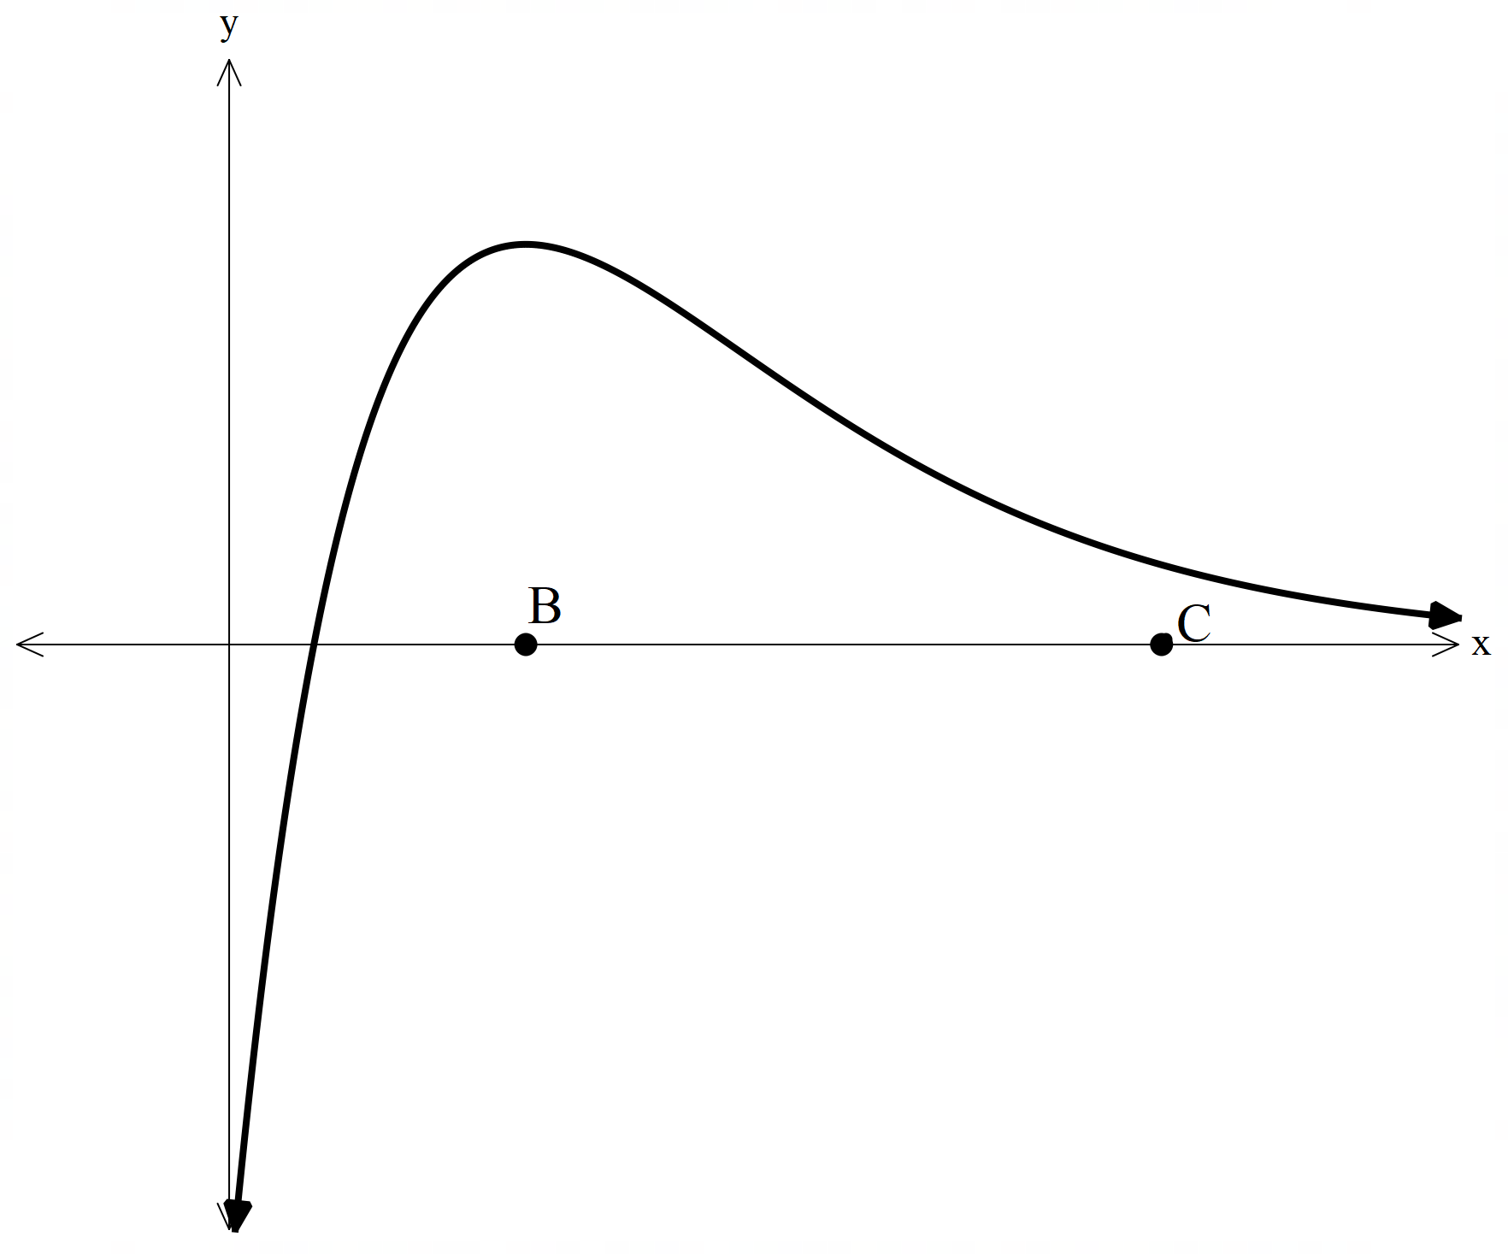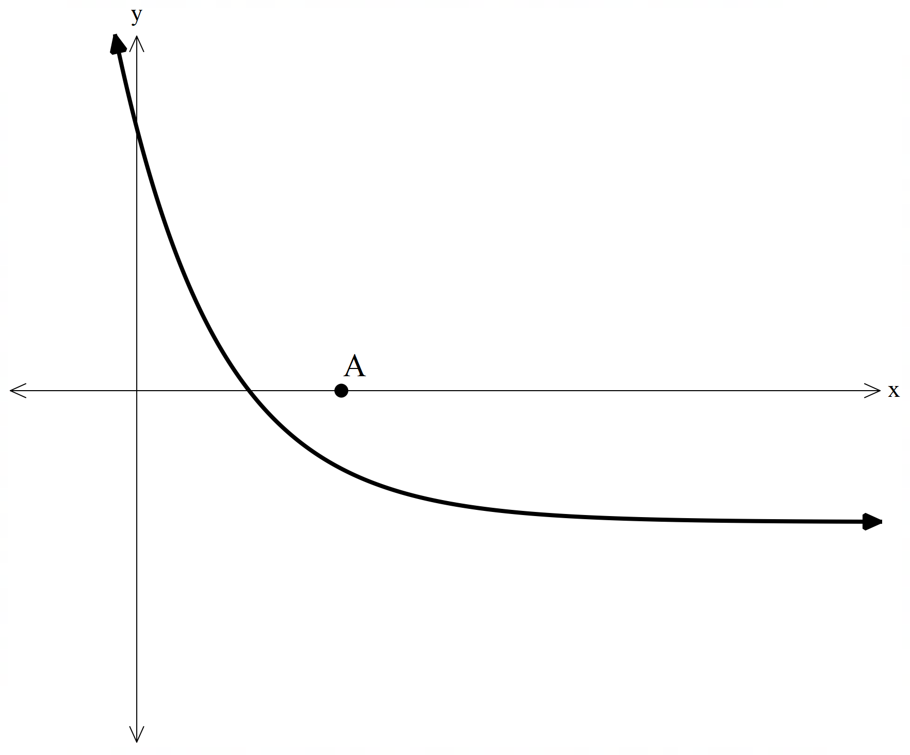

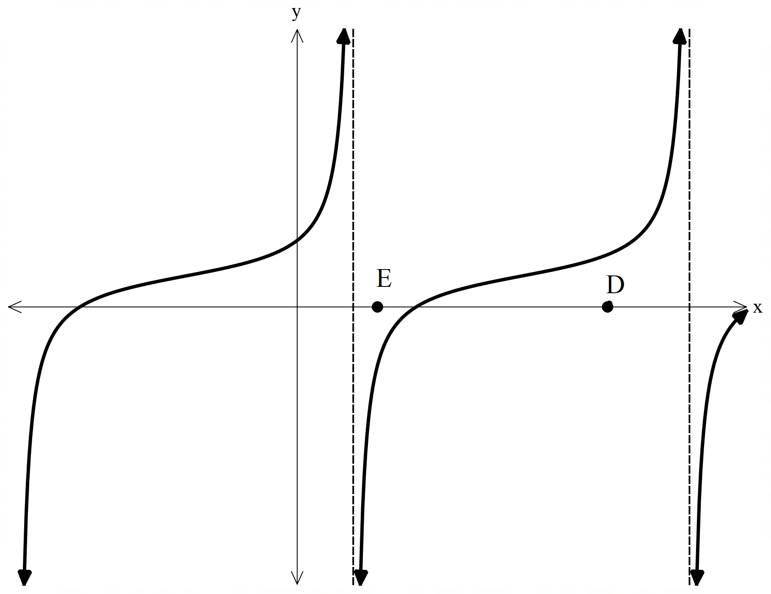

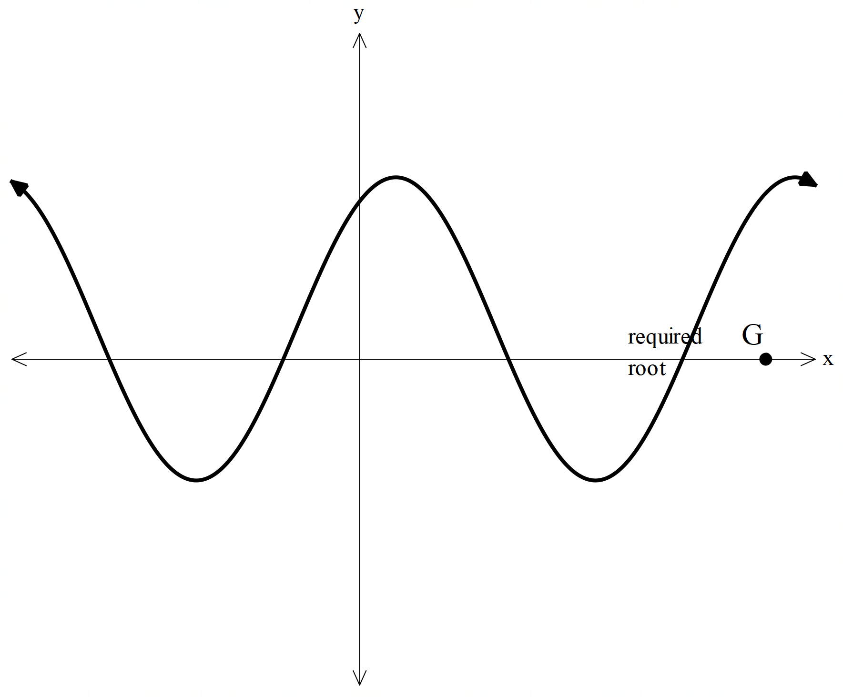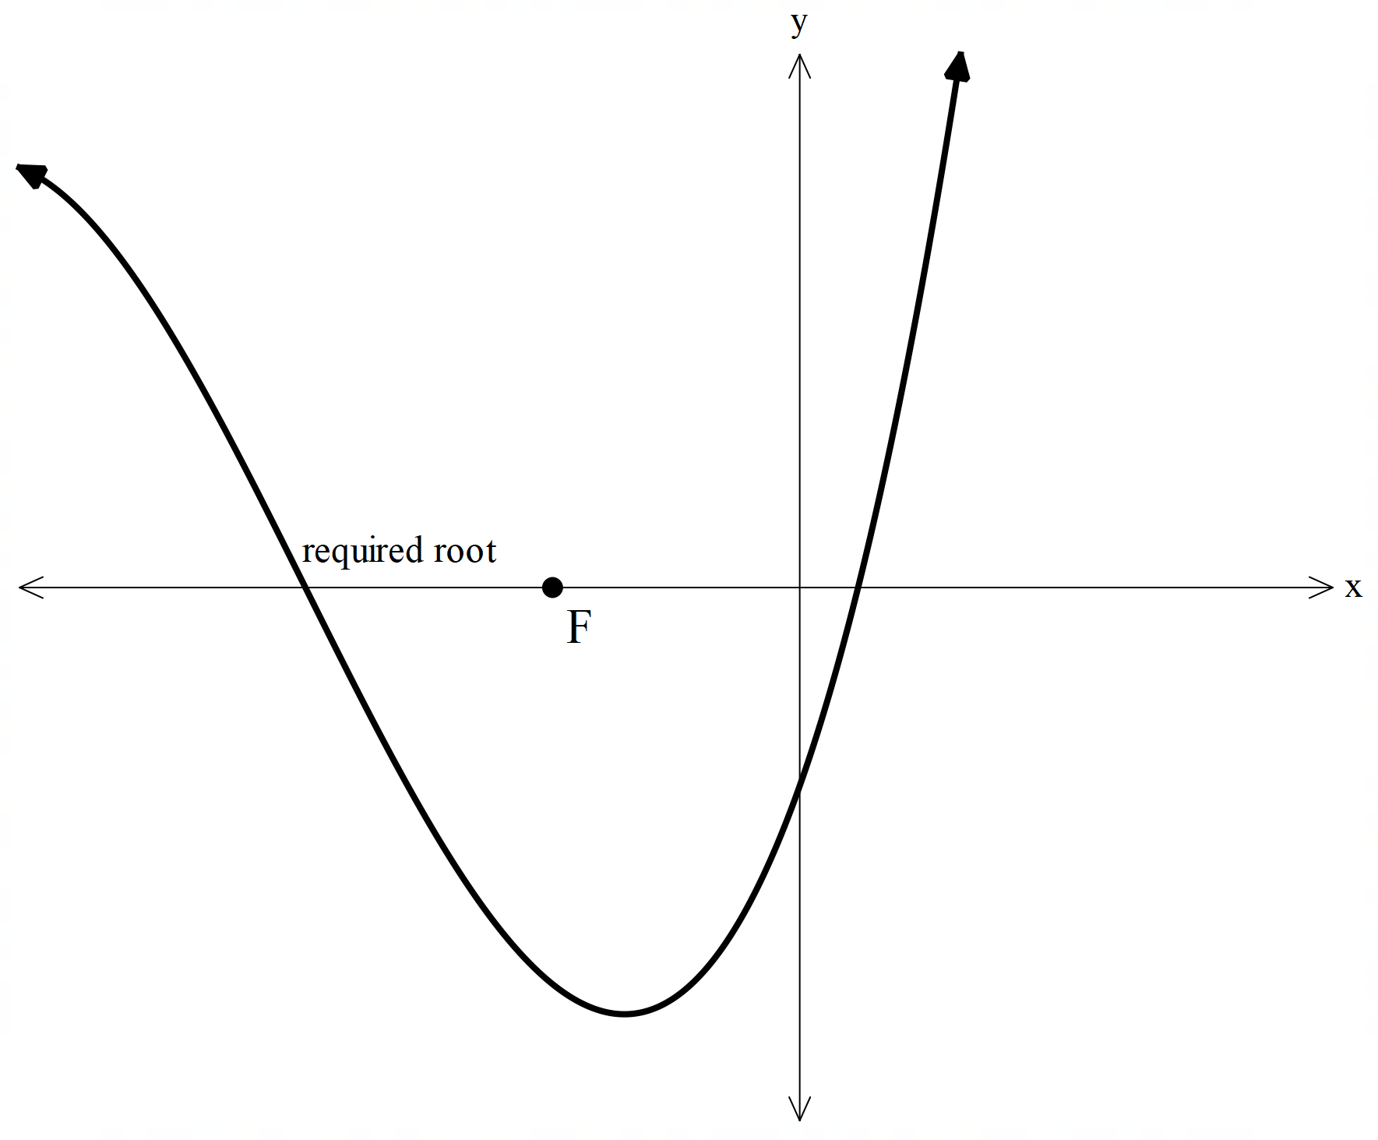

Marking key for sample assessment task 1 – Unit 3

This marking key may be adjusted based on the conditions of the task.

Introduction (6 marks)

|  |  |
| --- | --- |
| **Behaviours** | **Marks** |
| Succinctly writes a general introduction that accurately summarises all aspects of the investigation | 1–2 |
| Identifies and documents the iterative process | 1 |
| States three suitable functions to use | 1 |
| Identifies assumptions made, e.g. function does in fact have a root; function must be differentiable; function must be continuous | 2 |
| **Subtotal** | **/6** |

Application of the mathematical model and strategies (19 marks)

|  |  |
| --- | --- |
| **Behaviours** | **Marks** |
| Clearly identifies the need for the use of calculus | 1 |
| Shows research of the algorithm | 1 |
| Shows development of the algorithm using gradients and equation of a line | 2 |
| Shows accurate use of the algorithm to determine a root from each of the functions used | 6 |
| Shows different starting values and discusses the implications/differences | 6 |
| Specifies a level of accuracy and discusses/compares the number of iterations for this to be achieved | 3 |
| **Subtotal** | **/19** |

Analysis and interpretation (14 marks)

|  |  |
| --- | --- |
| **Behaviours** | **Marks** |
| Discusses the limitations of the process for at least four different cases by providing at least one example in which the method breaks down, such as   * starting value (or a successive value) meets stationary point * starting value (or a successive value) implies divergence * starting value produces loop/cycle * specific function that regardless of starting value, will not converge to solution | 8 |
| Provides mathematical justification for each limitation as listed above | 4 |
| Discusses the reasonableness of using the method with reference to assumptions made | 2 |
| **Subtotal** | **/14** |

Use of mathematical conventions, symbols and terminology (4 marks)

|  |  |
| --- | --- |
| **Behaviours** | **Marks** |
| Correctly labels and displays graphs/tables appropriately (sometimes = 1 mark, consistently = 2 marks) | 1–2 |
| Uses mathematical language throughout the investigation | 1 |
| Presents investigation in a systematic and concise way | 1 |
| **Subtotal** | **/4** |

Authentication question (7 marks)

|  |  |
| --- | --- |
| **Behaviours** | **Marks** |
| A: Identifies that when using iteration process with start point A, convergence to required solution will occur | 1 |
| B: Identifies that when using iteration process with start point B, no root can be obtained as tangent is horizontal | 1 |
| C: Identifies that when using iteration process with start point C, divergence will occur | 1 |
| D: Identifies that when using iteration process with start point D, convergence to required solution will occur | 1 |
| E: Identifies that when using iteration process with start point E, convergence to required solution will occur | 1 |
| F: Identifies that when using iteration process for start point F, loop or cycle will occur and hence root is unable to be determined | 1 |
| G: Identifies that when using iteration process with start point G, convergence to required solution will not occur and will jump to another root | 1 |
| **Subtotal** | **/7** |
| **Total** | **/50** |

Sample assessment task

Mathematics Methods – ATAR Year 12

Task 3

**Assessment type** Response

**Conditions** Total marks: 45 marks

* Section One – 23 marks
* Section Two – 22 marks

Time for the task: up to 50 minutes

In class, under test conditions

**Materials required** Section One: Calculator-free, standard writing equipment

Section Two: Calculator-assumed (calculator to be provided by the student)

**Other materials allowed** Drawing templates, one page of notes for Section Two

**Task weighting** 8% of the school mark for this pair of units

Section One: Calculator-free (23 marks)

Question 1 (6 marks)

(a) Evaluate  given that: (2 marks)

(b)  (4 marks)

Question 2 (9 marks)

A train is travelling on a straight track between two stations under the following conditions.

It starts from rest at station A and moves with acceleration

It then maintains its speed for 60 seconds such that

Finally, it slows to rest at a constant rate over 10 seconds such that $v\left(t\right)=148-2tms^{-1} \text{for }64≤t≤74 \text{seconds}$  
 and stops in station B.

1. Sketch the velocity versus time graph. (5 marks)
2. Calculate the total distance in metres between station A and station B. (4 marks)

Question 3 (3 marks)



Question 4 (5 marks)

Below is the sample space for the tossing of two dice and recording the numbers on the upper face of each die.

|  |  |  |  |  |  |  |
| --- | --- | --- | --- | --- | --- | --- |
|  | 1 | 2 | 3 | 4 | 5 | 6 |
| 1 | (1, 1) | (1, 2) | (1, 3) | (1, 4) | (1, 5) | (1, 6) |
| 2 | (2, 1) | (2, 2) | (2, 3) | (2, 4) | (2, 5) | (2, 6) |
| 3 | (3, 1) | (3, 2) | (3, 3) | (3, 4) | (3, 5) | (3, 6) |
| 4 | (4, 1) | (4, 2) | (4, 3) | (4, 4) | (4, 5) | (4, 6) |
| 5 | (5, 1) | (5, 2) | (5, 3) | (5, 4) | (5, 5) | (5, 6) |
| 6 | (6, 1) | (6, 2) | (6, 3) | (6, 4) | (6, 5) | (6, 6) |

One activity is to add the numbers in each pair and record how frequently these numbers came up. For example, $(3, 2)$ gives $3+2=5$.

1. Set up a discrete probability table for the possible outcomes of this activity and give the theoretical probabilities. (2 marks)
2. Draw a relative frequency diagram from the table. (3 marks)

**End of Section One**

Section Two: Calculator-assumed (22 marks)

Question 5 (3 marks)

A large container has developed a leak and is losing its liquid at a rate given by the equationif the leak is stopped after three hours, calculate, to the nearest millilitre, how much liquid is lost in that time.

Question 6 (5 marks)

1. Evaluate the integral $\int_{-3}^{3}{(x-3)x(x+3)dx}$ and explain the result. (2 marks)
2. Evaluate the area between the graphs $y_{1}=x\text{ and} y_{2}=(x+3)x(x-3).$ (3 marks)

Question 7 (5 marks)

An engineer is remotely monitoring the instruments from a test car travelling in a straight line on a track. At a given instant, she noticed that the acceleration of the car was a constant 4 ms-2 and   
5 seconds later she recorded the car was travelling with a velocity of 50 ms-1. Calculate the velocity equation of the car over this period and how far the car travelled in that time.

Question 8 (4 marks)

1. In Section One, Question 4 of this test, you were asked to set up a discrete probability table for the possible outcomes of the two dice activity and give the theoretical probabilities.

|  |  |  |  |  |  |  |
| --- | --- | --- | --- | --- | --- | --- |
|  | 1 | 2 | 3 | 4 | 5 | 6 |
| 1 | (1, 1) | (1, 2) | (1, 3) | (1, 4) | (1, 5) | (1, 6) |
| 2 | (2, 1) | (2, 2) | (2, 3) | (2, 4) | (2, 5) | (2, 6) |
| 3 | (3, 1) | (3, 2) | (3, 3) | (3, 4) | (3, 5) | (3, 6) |
| 4 | (4, 1) | (4, 2) | (4, 3) | (4, 4) | (4, 5) | (4, 6) |
| 5 | (5, 1) | (5, 2) | (5, 3) | (5, 4) | (5, 5) | (5, 6) |
| 6 | (6, 1) | (6, 2) | (6, 3) | (6, 4) | (6, 5) | (6, 6) |

Using the same table, calculate the mean and standard deviation for the distribution. (2 marks)

1. In a new activity, the totals from the two dice are tripled and five is added. Determine the new mean and standard deviation. (2 marks)

Question 9 (5 marks)

A carton contains 12 eggs, 5 of which are brown and 7 white. A chef selects 4 eggs at random, to use in an omelette.

1. Calculate the discrete probability distribution for *x* which represents the number of white eggs chosen, giving your answer in fraction form. (3 marks)

|  |  |  |  |  |  |
| --- | --- | --- | --- | --- | --- |
| *x* | 0 | 1 | 2 | 3 | 4 |
| Pr(X*=x*) |  |  |  |  |  |

1. Calculate the mean and standard deviation of the probability distribution. (2 marks)

**End of Section Two**

Solutions and marking key for Task 3

Section One: Calculator-free (23 marks)

Question 1 (6 marks)

(a) Evaluate  given that: (2 marks)

|  |  |
| --- | --- |
|  | |
| **Behaviours** | **Marks** |
| Calculates the derivative of the integral correctly  Applies the chain rule correctly | 1  1 |

(b)  (4 marks)

|  |  |
| --- | --- |
|  | |
| **Behaviours** | **Marks** |
| Partitions the algebraic fraction before integrating  Simplifies fractional indices when dividing  Simplifies fractions accurately when integrating  Shows adequate working with the substitution | 1  1  1  1 |

Question 2 (9 marks)

A train is travelling on a straight track between two stations under the following conditions.

It starts from rest at station A and moves with acceleration

It then maintains its speed for 60 seconds such that

Finally, it slows to rest at a constant rate over 10 seconds such that $v\left(t\right)=148-2tms^{-1} \text{for }64≤t≤74 \text{seconds}$ and stops in station B.

1. Sketch the velocity versus time graph. (5 marks)

|  |  |
| --- | --- |
|  | |
| **Behaviours** | **Marks** |
| Determines the first two velocity functions  Draws each section of the graph accurately | 2  3 |

1. Calculate the total distance in metres between station A and station B. (4 marks)

|  |  |
| --- | --- |
|  | |
| **Behaviours** | **Marks** |
| Uses the velocity functions/graphs to calculate the distance travelled for each leg  States the correct distance travelled | 3  1 |

Question 3 (3 marks)

$$\text{Explain why }\int_{2}^{5}{x\left(x-2\right)}\left(x-5\right)dx=\int_{0}^{3}{\left(x+2\right)}x\left(x-3\right)dx.$$

|  |  |
| --- | --- |
| The original graph has been translated two units to the left and the limits for the integral have also been translated two units to the left.  Hence, the area to be calculated in both cases is the same area enclosed by the function below the *x*-axis. | |
| **Behaviours** | **Marks** |
| States the graph has been translated to the left  States the limits have also been translated two units left  States the area is the same in both cases | 1  1  1 |

Question 4 [3.3.4] (5 marks)

1. Set up a discrete probability table for the possible outcomes of this activity and give the theoretical probabilities. (2 marks)

|  |  |  |  |  |  |  |  |  |  |  |  |  |  |  |  |  |  |  |  |  |  |  |  |  |  |  |  |  |  |  |  |  |  |  |  |  |  |
| --- | --- | --- | --- | --- | --- | --- | --- | --- | --- | --- | --- | --- | --- | --- | --- | --- | --- | --- | --- | --- | --- | --- | --- | --- | --- | --- | --- | --- | --- | --- | --- | --- | --- | --- | --- | --- | --- |
| |  |  |  |  |  |  |  |  |  |  |  |  | | --- | --- | --- | --- | --- | --- | --- | --- | --- | --- | --- | --- | | *x* | 2 | 3 | 4 | 5 | 6 | 7 | 8 | 9 | 10 | 11 | 12 | | P(*x)* |  |  |  |  |  |  |  |  |  |  |  | |  |  |  |  |  |  |  |  |  |  |  |  | | |
| **Behaviours** | **Marks** |
| Defines the set of variables correctly  Completes the probability values | 1  1 |

1. Draw a relative frequency diagram from the table. (3 marks)

|  |  |
| --- | --- |
|  | |
| **Behaviours** | **Marks** |
| Centres each class on 2, 3 … etc.  Sets an appropriate vertical and horizontal scale  Draws a good representation of the histogram | 1  1  1 |

Solutions and marking key for Task 3

Section Two: Calculator-assumed (22 marks)

Question 5 [3.2.18] (3 marks)

A large container has developed a leak and is losing its liquid at a rate given by the equationif the leak is stopped after three hours, calculate, to the nearest millilitre, how much liquid is lost in that time.

|  |  |  |
| --- | --- | --- |
|  |  | |
| **Behaviours** | | **Marks** |
| Sets up the correct integral  Sets up the correct limits  States the correct volume to the nearest millilitre | | 1  1  1 |

Question 6 [3.2.20] (5 marks)

1. $\text{Evaluate the integral }\int_{-3}^{3}{(x-3)x(x+3)dx}\text{ and explain the result.}$ (2 marks)

|  |  |  |
| --- | --- | --- |
| Since the graph is symmetrical about the origin, the area above the *x*-axis (+) equals the area below the  *x*-axis (–). Hence, these areas add to zero. |  | |
| **Behaviours** | | **Marks** |
| Uses symmetry to explain that the two areas are equal  States the areas are additive opposite in value | | 1  1 |

1. $\text{Evaluate the area between the graphs }y_{1}=x\text{ and }y_{2}=(x+3)x(x-3)$..(3 marks)

|  |  |  |  |
| --- | --- | --- | --- |
|  |  |  | |
| **Behaviours** | | | **Marks** |
| Uses the points of intersection to define integral limits  Uses the correct integrand  Gives the correct area | | | 1  1  1 |

Question 7 [3.2.9; 3.2.21] (5 marks)

An engineer is remotely monitoring the instruments from a test car travelling in a straight line on a track. At a given instant, she noticed that the acceleration of the car was a constant 4 ms-2 and   
5 seconds later she recorded the car was travelling with a velocity of 50 ms-1. Calculate the velocity equation of the car over this period and how far the car travelled in that time.

|  |  |
| --- | --- |
|  | |
| **Behaviours** | **Marks** |
| Calculates the correct constant of integration  Gives the correct velocity equation  Uses the integral of the velocity equation to calculate the distance travelled  Uses the correct limits  Calculates the correct distance | 1  1  1  1  1 |

Question 8 [3.3.5] [3.3.6] [3.3.7] (4 marks)

1. In Section One, Question 4 of this test, you were asked to set up a discrete probability table for the possible outcomes of the two-dice activity and give the theoretical probabilities.

Using the same table, calculate the mean and standard deviation for the distribution. (2 marks)

|  |  |  |
| --- | --- | --- |
|  | Mean = 7  Standard deviation = 2.4152 | |
| **Behaviours** | | **Marks** |
| Calculates the mean correctly  Calculates the standard deviation correctly | | 1  1 |

(b) In a new activity, the totals from the two dice are tripled and five is added. Determine the new mean and standard deviation. (2 marks)

|  |  |
| --- | --- |
| New mean: $7×3+5=26$ New standard deviation: $2.4152×3=7.2456$ | |
| **Behaviours** | **Marks** |
| Applies change of scale and origin to the mean to correctly determine a new value  Applies change of scale only to the standard deviation to correctly determine a new value | 1  1 |

Question 9 [3.3.1] (5 marks)

1. A carton contains 12 eggs, 5 of which are brown and 7 white. A chef selects 4 eggs at random, to use in an omelette. Calculate the discrete probability distribution for *x* which represents the number of white eggs chosen, giving your answer in fraction form. (3 marks)

|  |
| --- |
| P(4 white) = $\frac{\left({7 \atop 4}\right)}{\left({12 \atop 4}\right)}$ P(1 white) = $\frac{\left({7 \atop 1}\right)\left({5 \atop 3}\right)}{\left({12 \atop 4}\right)}$ P(3 white) = $\frac{\left({7 \atop 3}\right)\left({5 \atop 1}\right)}{\left({12 \atop 4}\right)}$ P(no white) = $\frac{\left({5 \atop 4}\right)}{\left({12 \atop 4}\right)}$ P(2 white) = |

|  |  |  |  |  |  |
| --- | --- | --- | --- | --- | --- |
| *x* | 0 | 1 | 2 | 3 | 4 |
| P(X = *x*) |  |  |  |  |  |

|  |  |
| --- | --- |
| **Behaviours** | **Marks** |
| Shows appropriate working for at least one value  Calculates the five values accurately | 1  2 |

1. Calculate the mean and standard deviation of the probability distribution. (2 marks)

|  |  |
| --- | --- |
| Mean = 2.3333  Standard deviation = 0.8409 | |
| **Behaviours** | **Marks** |
| Gives the correct mean  Gives the correct standard deviation | 1  1 |

**End of solutions**