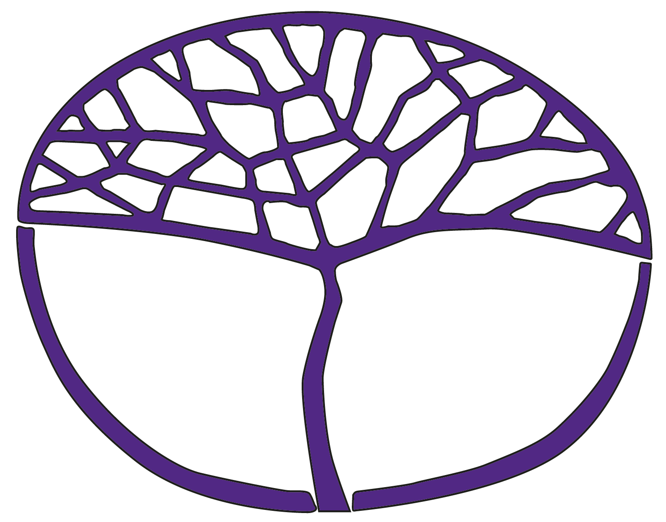
Sample Course Outline
Visual Arts
ATAR Year 11

Acknowledgement of Country
Kaya. The School Curriculum and Standards Authority (the Authority) acknowledges that our offices are on Whadjuk Noongar boodjar and that we deliver our services on the country of many traditional custodians and language groups throughout Western Australia. The Authority acknowledges the traditional custodians throughout Western Australia and their continuing connection to land, waters and community. We offer our respect to Elders past and present.
Copyright
© School Curriculum and Standards Authority, 2014
This document – apart from any third-party copyright material contained in it – may be freely copied, or communicated on an intranet, for non-commercial purposes in educational institutions, provided that the School Curriculum and Standards Authority (the Authority) is acknowledged as the copyright owner, and that the Authority’s moral rights are not infringed.
Copying or communication for any other purpose can be done only within the terms of the Copyright Act 1968 or with prior written permission of the Authority. Copying or communication of any third-party copyright material can be done only within the terms of the Copyright Act 1968 or with permission of the copyright owners.
Any content in this document that has been derived from the Australian Curriculum may be used under the terms of the Creative Commons Attribution 4.0 International licence.
Disclaimer
Any resources such as texts, websites and so on that may be referred to in this document are provided as examples of resources that teachers can use to support their learning programs. Their inclusion does not imply that they are mandatory or that they are the only resources relevant to the course. Teachers must exercise their professional judgement as to the appropriateness of any they may wish to use.

Sample course outline

Visual Arts – ATAR Year 11

Unit 1 and Unit 2

Semester 1, Unit 1 – Differences
Week | Key teaching points
1 | Unit focus: Differences  In this unit, the focus is differences. Students may, for example, consider differences arising from cultural diversity, place, gender, class and historical period. Differences relating to art forms, media and conventions may also provide a stimulus for exploration and expression.  Syllabus content  Inquiry  - explore approaches to drawing, including representational, expressive, decorative and symbolic methods to develop artwork  Key teaching points and tasks  Production Task 1: Part A – commence ‘Of the Animal’ body of work  Inquiry  - explore a range of media and techniques through observational drawings of people and animals  Syllabus content  Visual analysis  - use critical analysis frameworks to analyse each artwork from different points of view  - refer to visual language (elements and principles of art) and use art terminology to comment on artwork and discuss formal organisation (composition)  Personal response  - provide subjective and objective responses to artwork giving reasons for opinion  - support arguments and interpretations when responding to artwork  Key teaching points and tasks  - Analysis Task 2 – in-class seen image analysis short answer timed assessment, due Week 4. To prepare for Task 2, students should be familiar with four to six images from which two artworks will be selected for the assessment. Task 2 is modelled on Section One of the written examination.  - Investigation Task 3 – commence case study essay: Australian or international context due Week 9. Weeks 1–3 in class time, followed by six weeks independent work in own time.
2–4 | Syllabus content  Inquiry  - consider a variety of ways to develop and refine artwork  Visual language  - manipulate visual language (elements and principles of art) in the development and production of artwork  Art forms, media and techniques  - manipulate materials and explore techniques to develop and refine artwork  Art practice  - follow correct health and safety practices, respecting and acknowledging the work and rights of others  Key teaching points and tasks  - Production Task 1: Part A – continue ‘Of the Animal’ body of work  - Analysis Task 2 – in-class seen image analysis short answer timed assessment, due Week 4  Inquiry  - continue to explore approaches to drawing, including representational, expressive, decorative and symbolic methods to originate artwork/s  - organise and document the process of inquiry, including thinking and working practices  - demonstrate independent planning and time management  Syllabus content  Visual influence  - investigate others’ visual arts practice to make connections and inform the development and production of own artwork  Meaning and purpose  - identify formal, stylistic and technical elements which contribute to the function or messages in artwork  Social, cultural and historical contexts  - identify historical, social, political, religious and other contextual factors that have shaped the development and production of artwork or movements in different times and places  Key teaching points and tasks  - Investigation Task 3 – continue working on case study essay: Australian or international context, due Week 9  Visual analysis  - document notes using a given analysis framework to analyse selected artwork/s  - use visual language and art terminology to comment on the formal organisation (composition) of artwork  Personal response  - refer to artwork/s to support viewpoints or personal opinions  Syllabus content  Personal response  - provide subjective and objective response to artwork giving reasons for opinion  - support arguments and interpretations when responding to artwork  Key teaching points and tasks  - Analysis Task 2 – in-class seen image analysis short answer assessment, due Week 4
5–7 | Syllabus content  Inquiry  - organise work demonstrating independent planning and time management  - document the process of inquiry and thinking and working practices  Visual influence  - investigate others’ visual arts practice to make connections and inform the development and production of own artwork  Art practice  - follow correct health and safety practices, respecting and acknowledging the work and rights of others  Key teaching points and tasks  - Production Task 1: Part A – continue ‘Of the Animal’ body of work  Art practice  - select and manipulate materials, skills and/or processes to explore personal ideas  Syllabus content  Social, cultural and historical contexts  - identify historical, social, political, religious and other contextual factors that have shaped the development and production of artwork or movements in different times and places  Key teaching points and tasks  - Investigation Task 3 – continue working on case study essay: Australian or international context, due Week 9  - Analysis Task 4 – in-class short answer comparative seen image analysis timed assessment, due Week 8. Two seen images will be selected. Task 4 is modelled on Section Two of the written examination
8–12 | Syllabus content  Inquiry  - consider a variety of ways to develop and refine artwork  Art forms, media and techniques  - manipulate materials and explore techniques to develop and refine artwork  Art practice  - select, manipulate and discerningly apply materials, skills and processes to produce artwork in selected art forms  - follow correct health and safety practices, respecting and acknowledging the work and rights of others  - make informed and sensitive choices when developing and presenting artwork about different religious, cultural and social practices  Key teaching points and tasks  - Production Task 1: Part A – ‘Of the Animal’ body of work feedback, due Week 8  - Production Task 1: Part B – ‘Of the Animal’ resolved artwork, artist statement and body of work commencing Week 9, due Week 15, review each week  Inquiry  - organise work, demonstrating ongoing planning and time management  Visual language  - manipulate visual language in the development of design solutions to inform artwork  Visual influence  - investigate others’ visual art practice to make connections and inform the development, production and resolution of own artwork/s  Syllabus content  Meaning and purpose  - identify multiple meaning, values and beliefs communicated in artwork  - identify formal, stylistic and technical elements which contribute to the function or messages in artwork  Social, cultural and historical contexts  - identify historical, social, political, religious and other contextual factors that have shaped the development and production of artwork or movements in different times and places  Visual analysis  - use critical analysis frameworks to analyse artwork from different points of view  - compare and contrast subject matter, meaning and approaches between artwork  - refer to visual language (elements and principles of art) and use art terminology to comment on artwork and discuss formal organisation (composition)  Personal response  - provide subjective and objective response to artwork giving reasons for opinion  - support arguments and interpretations when responding to artwork  Key teaching points and tasks  - Investigation Task 3 – case study essay: Australian or international context, due Week 9  - Analysis Task 4 – in-class short answer seen comparative image analysis timed assessment, due Week 8. Two seen images will be selected. Task 4 is modelled on Section Two of the written examination.  Presentation  - determine alternative ways to present Production Task 1: Part B – ‘Of the Animal’ resolved artwork, artist statement by Week 15  Reflection  - reflect on the readiness of body of work for critique and exhibition  Visual analysis  - use critical analysis frameworks to analyse artwork/s
13 | Syllabus content  Reflection  - reflect on and maintain documentation of development of thinking and working practices  - acknowledge primary and/or secondary visual influence/s  Presentation  - organise, arrange and document thinking and working practices  Key teaching points and tasks  - Production Task 1 Part B – continue ‘Of the Animal’ studio production, review each week  Art forms, media and technique  - manipulate materials and explore techniques to resolve and refine artwork/s  Reflection  - prepare a draft artist’s statement that describes the ideas, meaning, influences and personal direction taken in art making
14–15 | Syllabus content  Presentation  - display selected artwork  Reflection  - provide an artist statement that describes the ideas, meaning, influences and personal direction taken in art making  - acknowledge primary and/or secondary visual influence/s  Key teaching points and tasks  - Production Task 1: Part B – presentation of resolved artwork due Week 15
Examination week | Key teaching points and tasks  - Semester 1 written examination Task 5

Semester 2, Unit 2 – Identities
Week | Key teaching points
1 | Unit focus: Identities  In this unit, the focus is identities. In working with this focus, students explore concepts or issues related to personal, social, cultural or gender identity. They become aware that self-expression distinguishes individuals as well as cultures. Students use a variety of stimulus materials and use a range of investigative approaches as starting points to create artwork. They develop a personal approach to the development of ideas and concepts, making informed choices about the materials, skills, techniques and processes used to resolve and present their artwork.  Syllabus content  Inquiry  - explore a variety of observational, conceptual, imaginative and expressive drawing approaches as starting points for developing artwork  Art forms, media and techniques  - explore, combine and manipulate materials and techniques to develop and produce artwork  - apply skills and techniques in the development of an individual style and innovative artwork  Key teaching points and tasks  - Production Task 6: ‘Alien/Alienation’  - discuss notion of alienation; for example, separation, isolation and fragmentation  Syllabus content  Visual language  - manipulate visual language to create innovative and personal visual solutions  Meaning and purpose  - identify formal, stylistic and technical elements which contribute to the function or meaning and message of an artwork  Social, cultural and historical contexts  - examine artwork that has been shaped or influenced by specific social, cultural or historical concerns  Key teaching points and tasks  - Investigation Task 8 – case study essay: Australian or international context, due Week 13
2–4 | Syllabus content  Art forms, media and techniques  - explore, combine and manipulate materials and techniques to develop and produce artwork  Art practice  - follow correct health and safety practices, respecting and acknowledging the work and rights of others  Presentation  - organise, document and present thinking and working practices  Key teaching points and tasks  - Production Task 6: ‘Alien/Alienation’  Inquiry  - continue to explore a variety of observational, conceptual, imaginative and/or expressive drawing approaches as starting points for originating artwork/s  - consider a variety of ways to develop ideas  - demonstrate independent planning and time management  Visual language  - manipulate visual language (elements and principles of art) to inform the inquiry process  Visual influence  - investigate visual inspirations/influences to make connections and inform inquiry process  Syllabus content  Visual analysis  - consolidate the use of critical analysis frameworks to analyse artwork from different points of view  - respond to unfamiliar artwork which challenge expectations and preconceived ideas (unseen image analysis)  - compare artwork referring to visual language (elements and principles of art) and use art terminology to discuss formal organisation (composition), meaning and artistic style  Personal response  - support interpretations, opinions and beliefs about artwork and their meaning  - consider alternative viewpoints and opinions when responding to artwork  Social, cultural and historical contexts  - examine a range of social, cultural, historical and other contextual factors that have influenced or impacted the development and production of artists, groups or movements over time  Key teaching points and tasks  - Investigation Task 8 – case study essay: Australian or international context, due Week 13  - Analysis Task 7 – in-class unseen image analysis short answer timed assessment, due Week 8
5–7 | Syllabus content  Meaning and purpose  - identify formal, stylistic and technical elements which contribute to the function or meaning and message of an artwork  Key teaching points and tasks  - Investigation Task 8 – commence case study Week 7, due Week 13  - Analysis Task 7 – in-class unseen image analysis short answer timed assessment due Week 8. Task 7 is modelled on Section One of the written examination  Visual analysis  - consolidate the use of critical analysis frameworks to analyse artwork/s  Syllabus content  Inquiry  - consider a variety of ways to develop and refine artwork  - document thinking and working practices when developing a body of work  Art practice  - investigate and refine skills to produce artwork which shows discernment in the application of materials and processes  - follow correct health and safety practices, respecting and acknowledging the work and rights of others  - make informed and sensitive choices when developing and presenting artwork about different religious, cultural and social practices  Key teaching points and tasks  - Production Task 6: ‘Alien/Alienation’  Inquiry  - explore a variety of drawing approaches to develop artwork
8–12 | Syllabus content  Inquiry  - investigate other methods of developing and producing artwork  Visual language  - explore, select and combine visual language (elements and principles of art) in the development and production of a body of work  - manipulate visual language to create innovative and personal visual solutions  Visual influence  - consider the relationship between form, style and expressive intent when developing and producing a body of work  Art forms, media and techniques  - selectively apply and refine media and techniques to communicate intended meaning, purpose or effects  Art practice  - investigate and refine skills to produce artwork which shows discernment in the application of materials and processes  Key teaching points and tasks  - Production Task 6: Part A – ‘Alien/Alienation’ body of work feedback, due Week 8  - Production Task 6: Part B – ‘Alien/Alienation’ commencing Week 9, review each week  Inquiry  - continue media and material experimentation based on unit focus  Visual influence  - investigate selected artist/s art practice to inform the development of ideas, production and resolution of own artwork/s  Syllabus content  Personal response  - support interpretations, opinions and beliefs about artwork and their meaning  - consider alternative viewpoints and opinions when responding to artwork  Key teaching points and tasks  - Investigation Task 8 – submit draft case study essay for feedback, due Week 11  Syllabus content  Visual analysis  - compare and contrast subject matter, meaning and approaches between artwork  - refer to visual language (elements and principles of art) and use art terminology to comment on artwork and discuss formal organisation (composition)  Personal response  - provide subjective and objective response to artwork giving reasons for opinion  - support arguments and interpretations when responding to artwork  Meaning and purpose  - discuss the meaning of artwork from different times and places making links to contextual factors that influence production and reading  - identify formal, stylistic and technical elements which contribute to the function or meaning and message of an artwork  Social, cultural and historical contexts  - examine a range of social, cultural, historical and other contextual factors that have influenced or impacted the development and production of artists, groups or movements over time  Key teaching points and tasks  - Analysis Task 9 – in-class comparative analysis of unseen images, due Week 12
13 | Syllabus content  Presentation  - organise, document and present thinking and working practices  Reflection  - reflect on and maintain documentation of the development of thinking and working practices  - provide an artist statement that describes the ideas, meaning, influences and personal direction taken in art making  - acknowledge primary and/or secondary visual influence/s  Key teaching points and tasks  - Production Task 6: Part B – ‘Alien/Alienation’  - draft artist statement  - reflect on the readiness of body of work for critique and exhibition  Syllabus content  Social, cultural and historical contexts  - examine artwork that has been shaped or influenced by specific social, cultural or historical concerns  Key teaching points and tasks  - Investigation Task 8 – final edited case study essay, due Week 13  Meaning and purpose  - identify formal, stylistic and/or technical elements which contribute to the function or meaning in selected artwork/s
14–15 | Syllabus content  Presentation  - display a body of work for critique and exhibition  Reflection  - provide an artist statement that describes the ideas, meaning, influences and personal direction taken in art making  - acknowledge primary and/or secondary visual influence/s  Key teaching points and tasks  - Production Task 6: Part A and Part B – ‘Alien/Alienation’ submit body of work and resolved artwork, due Week 15
Examination week | Key teaching points and tasks  - Semester 2 written examination Task 10

