Sample Assessment Tasks
Music
ATAR Year 11

Acknowledgement of Country
Kaya. The School Curriculum and Standards Authority (the Authority) acknowledges that our offices are on Whadjuk Noongar boodjar and that we deliver our services on the country of many traditional custodians and language groups throughout Western Australia. The Authority acknowledges the traditional custodians throughout Western Australia and their continuing connection to land, waters and community. We offer our respect to Elders past and present.
Copyright
© School Curriculum and Standards Authority, 2023
This document – apart from any third-party copyright material contained in it – may be freely copied, or communicated on an intranet, for non-commercial purposes in educational institutions, provided that the School Curriculum and Standards Authority (the Authority) is acknowledged as the copyright owner, and that the Authority’s moral rights are not infringed.
Copying or communication for any other purpose can be done only within the terms of the Copyright Act 1968 or with prior written permission of the Authority. Copying or communication of any third-party copyright material can be done only within the terms of the Copyright Act 1968 or with permission of the copyright owners.
Any content in this document that has been derived from the Australian Curriculum may be used under the terms of the Creative Commons Attribution 4.0 International licence.
Disclaimer
Any resources such as texts, websites and so on that may be referred to in this document are provided as examples of resources that teachers can use to support their learning programs. Their inclusion does not imply that they are mandatory or that they are the only resources relevant to the course. Teachers must exercise their professional judgement as to the appropriateness of any they may wish to use.

Content
Sample practical assessment tasks 1
Task 1 – Prepared repertoire 1
Marking key for Task 1 – Prepared repertoire 2
Task 1 – Composition portfolio 3
Marking key for Task 1 – Composition portfolio 4
Task 5 – Technical work 5
Marking key for Task 5 – Technical work 6
Task 5 – Performance (composition portfolio) 10
Marking key for Task 5 – Performance (composition portfolio) 11
Sample written assessment tasks 13
Task 3 – Music literacy 13
Marking key for Task 3 – Music literacy 18
Task 7 – Composition 22
Marking key for Task 7 – Composition 25
Task 8 – Music analysis 27
Marking key for Task 8 – Music analysis 33

Sample assessment tasks

Music – ATAR Year 11
Notes on the sample assessment tasks.
- These sample assessment tasks are provided to support the sample course outline, providing examples of how teachers may choose to assess the Year 11 Music ATAR course.
- Assessment tasks are numbered according to the sample assessment outline and sample course outline.
- Not all practical assessment options are exemplified in this document.
- A sample written examination for Year 12 is provided as a separate document on the music page of the School Curriculum and Standards Authority (the Authority) website. The Authority does not produce sample written examinations for Year 11 courses.
- Teachers should refer to the practical examination design brief in the syllabus, as well as the Practical examinations requirements document and marking keys (all available on the Music page of the Authority website) for guidelines on the Practical examinations.

Sample practical assessment tasks

Task 1 – Prepared repertoire
Assessment type: Prepared repertoire (performance)
Select one piece that you are preparing for the Semester 1 performance examination to present to the class. Assessment is of technique, style and expression appropriate to the selected repertoire and style.
Conditions: In-class performance assessment: Semester 1, Week 7
Task weighting: 10% of the school mark for this pair of units

Prepared repertoire ( marks)
You will be scheduled a time to perform one piece during class in Week 7 that you are preparing for the Semester 1 performance examination. The rest of the class will be the audience and there may be an additional marker in the room as well as your class teacher. The performance will be video recorded as part of the marking process and stored securely by the school as part of your assessment records.
In preparing for this assessment:
- consult with your instrumental/vocal teacher and/or classroom teacher regarding repertoire selection
- use the Music Performance Resource Package as a guide to the appropriate standard
- finalise your repertoire selection well in advance of your performance assessment
- prepare to perform with accompaniment (recorded or live) as appropriate to the repertoire. Discuss this requirement with your instrumental/vocal teacher and/or classroom teacher
- consider there will be at least one opportunity for performance practice in class with feedback from your teacher and fellow students. Seek out additional performance practice opportunities
- familiarise yourself with the marking key and self-assess your performance practice using the marking key criteria
- provide a copy of the music score to your teacher on the day of the assessment
- organise necessary equipment in advance to ensure a smooth performance
- check instrument settings, tuning etc. prior to the commencement of your performance
- consider appropriate performance etiquette for a formal performance.
Audience members are expected to always act in a respectful and supportive manner.
Remember, these are formal assessments and the video recordings will be retained by the school.
Following the assessment, analyse the video of your performance with your instrumental/vocal teacher and/or classroom teacher to inform future performances.

Marking key for Task 1 – Prepared repertoire
It is recommended that teachers use the current Music ATAR course practical (performance) examination marking key, available on the Music page of the Authority website (https://senior-secondary.scsa.wa.edu.au/syllabus-and-support-materials/arts/music), to mark student performances.
Note:
- this marking key is for the Year 12 external performance examination but may be used for Year 11 school-based assessment, with or without modification by the teacher
- Year 11 students should be marked according to a Year 11 standard of repertoire
- the Music: Practical (performance) marking template can be used to record individual student marks and teacher comments. This document is available on the Music page of the Authority website under ‘Support materials: Practical component’
- it is commonly accepted practice to either remove the ‘balance of program’ and ‘time requirements’ criteria, or all of the ‘program requirements’ criteria for non-examination performance assessments. The Music: Practical (performance) marking template includes a version with ‘balance of program’ and ‘time requirements’ removed.

Sample practical assessment tasks

Task 1 – Composition portfolio
Assessment type: Composition portfolio
Submit one work from the composition portfolio for marking by the classroom and/or composition teacher. Assessment is of the compositional process and the application of stylistic conventions appropriate to the chosen style or genre.
Conditions: Submission date: Semester 1, Week 7
Task weighting: 10% of the school mark for this pair of units

Composition portfolio ( marks)
Submit one music work (that you are preparing for the practical examination) as both a music score (printed or handwritten) and a recording of the work (live recording or software generated). An additional marker may be utilised as well as your class teacher.
In preparing for this assessment:
- consult with your composition teacher and/or classroom teacher regarding the selection of work to submit
- finalise your work selection well in advance of the due date to allow for refinement of the work
- consider this submission may be a substantial portion of an incomplete work, including a written plan to outline the intent for the finished work
- consider there will be at least one opportunity for feedback from your class teacher prior to submission. Seek out additional feedback opportunities
- familiarise yourself with the marking key and self-assess your work using the marking key criteria
- complete a ‘composition outline’ that must be no longer than one page, may be as short as you deem adequate, and must:
  - outline the inspiration behind the composition and explain the generation and development of ideas. This must be supported by evidence within the composition. Acknowledge the influence of any specific style/genre, composition and/or composer/arranger/performer, as relevant
  - cite use of, or reference correctly, another person’s work (musical, literary or otherwise)
  - write a brief musical analysis of the piece, addressing features such as form/structure, melody, harmonisation, instrumentation, accompaniment writing and/or stylistically appropriate orchestration/arranging techniques.

Marking key for Task 1 – Composition portfolio
It is recommended that teachers use the current Music ATAR course practical (composition portfolio) examination marking key, available on the music page of the Authority website (https://senior-secondary.scsa.wa.edu.au/syllabus-and-support-materials/arts/music), to mark student composition portfolio works.
Note:
- this marking key is for the Year 12 external composition portfolio examination but may be used for Year 11 school-based assessment, with or without modification by the teacher
- Year 11 students should be marked according to a Year 11 standard of composition
- the Music: Practical (composition) marking template can be used to record individual student marks and teacher comments. This document is available on the Music page of the Authority website under ‘Support materials: Practical component’
- it is commonly accepted practice to either remove the ‘time requirements and number of compositions’ and ‘balance of portfolio’ criteria, or all of the ‘composition portfolio requirements’ criteria for non-examination composition portfolio assessments. The Music: Practical (composition) marking template includes a version with all of the ‘composition portfolio requirements’ removed.

Sample practical assessment tasks

Task 5 – Technical work
Assessment type: Technical work (performance)
Present a selection of technical work (scales, other technical exercises, studies, orchestral excerpts etc., selected in consultation with, and approved by, the instrumental/vocal teacher) to the class, demonstrating skills and techniques appropriate to the chosen instrument/voice and style which support the development of repertoire. Assessment includes a sight-reading and/or improvisation component.
Conditions: Submission of list of technical work to class teacher: Semester 2, Week 5
In-class performance assessment: Semester 2, Week 6
Task weighting: 10% of the school mark for this pair of units

Technical work (performance) (48 marks)
Perform a selection of technical work, consisting of a minimum of 10 items, which may include a technical study and/or orchestra excerpt/s. Refer to the technical work support material outlined in the Music Performance Resource Package, and consider the scales, chord types, keys etc. required in the written component of the Year 11 ATAR Music syllabus.
Technical work should be selected in consultation with the instrumental/vocal teacher. A final list of technical work must be signed by the instrumental/vocal teacher and submitted to the class teacher one week prior to your assessment. You will be marked on accuracy, technique, musicianship, tone quality and control. A copy of the marking key will be provided for you as a checklist when practising.
INCLUDES ONE OR BOTH OF THE FOLLOWING TWO OPTIONS
Sight-reading: sight-read a given 8 to 16 bar excerpt, observing score markings and relevant performance conventions. You will be given two minutes to look at the excerpt provided, during which time you must not play/sing any notes or touch your instrument. You will then perform the extract, observing relevant performance conventions and score markings. You may choose to perform the excerpt a second time; in this case, the better of the two marks will count as your final mark.
Improvisation: play an improvised solo over a progression provided by your teacher. Use a recorded accompaniment, backing band or instrumentalist. You should demonstrate rhythmic accuracy and control, appropriate rhythmic feel, appropriate pitch selection, motivic development, melodic contour and appropriate expressive elements in the assessment. You may choose to perform the solo a second time; in this case, the better of the two marks will count as your final mark.

Marking key for Task 5 – Technical work
Note: this template may be used to collate marks from the marking keys below
Year 11 ATAR Music – Technical work marking template
10% of the school mark for this pair of units. Semester 2, Week 6
Name: _____________________________________ Instrument: _______________________
Technical work criteria | Marks | Sight-reading (SR) and/or* improvisation (I) criteria | Marks
Pitch | /6 | Rhythm (SR and I) | /5
Rhythm | /3 | Pitch and intonation (SR)  Pitch selection (I) | /5
Musicianship | /3 | Tone (SR)  Improvisation ideas (I) | /3
Tone | /4 | Expressive elements (SR and I) | /3
Subtotal | /16 | Subtotal | /16
*If including both sight-reading and improvisation, divide each mark by two for a total of 16 marks for sight-reading and improvisation combined. |  | TOTAL | /32

Technical work items | Notes
Overall comments

Technical work marking key | Marks
Pitch
Performs all scales/technical items with complete accuracy in pitch and intonation | 6
Performs scales/technical items with only very slight and infrequent errors or hesitations in pitch/intonation | 5
Performs scales/technical items competently, and recovers well from occasional errors or hesitations in pitch/intonation | 4
Performs scales/technical items competently; however, some errors and hesitations in pitch/intonation reduce the overall fluency | 3
Demonstrates limited competence in performing scales/technical items, with a number of errors and hesitations in pitch/intonation adversely affecting the fluency of presentation | 2
Demonstrates minimal competence in performing scales/technical items, with significant errors and hesitations in pitch/intonation greatly affecting the fluency of presentation | 1
Subtotal | /6
Rhythm
Demonstrates excellent control of tempo and accuracy of rhythm | 3
Demonstrates control of tempo and accuracy of rhythm, with some minor lapses | 2
Demonstrates some control of tempo and accuracy of rhythm, with some major lapses | 1
Subtotal | /3
Musicianship
Performs all scales/technical items with appropriate phrasing, articulation, dynamics and technique | 3
Performs scales/technical items with mostly appropriate phrasing, articulation, dynamics and technique | 2
Performs scales/technical items with generally ineffective phrasing, articulation, dynamics and technique | 1
Subtotal | /3
Tone
Performs with excellent tone quality and control across all registers and dynamic ranges | 4
Performs with proficient tone quality and control, recovering well from minor lapses | 3
Performs with inconsistent tone quality and control | 2
Performs with significant and frequent lapses in tone quality and control | 1
Subtotal | /4
Total | /16
AND
Sight-reading marking key | Marks
Rhythm
Performs with consistent tempo, rhythmic accuracy and control | 5
Performs with only very slight rhythmic lapses in rhythm and/or tempo | 4
Performs with competent rhythmic accuracy, demonstrating an ability to recover from minor inaccuracies in rhythm and/or tempo | 3
Performs with several rhythmic inaccuracies, yet manages to maintain a sense of metre | 2
Performs with many rhythmic errors, displaying an inconsistent pulse | 1
Subtotal | /5
Pitch and intonation
Performs with consistently excellent accurate pitch and intonation | 5
Performs with excellent pitch and intonation with only occasional slight lapses | 4
Performs with competent pitch and intonation, recovering well from minor lapses | 3
Performs with several inconsistencies in pitch and intonation, but manages to maintain a sense of tonality | 2
Performs with several errors in pitch and intonation, and little sense of tonality | 1
Subtotal | /5
Tone
Performs with excellent tone quality and control | 3
Performs with proficient tone quality and control, recovering well from minor lapses | 2
Performs with inconsistent tone quality and control | 1
Subtotal | /3
Expressive elements
Performs repertoire with sensitivity, musically and accurately interpreting dynamics, phrasing and bowings/articulation | 3
Performs repertoire with generally accurate interpretation of dynamics, phrasing and bowings/articulation | 2
Performs repertoire with little attention to and/or several errors in dynamics, phrasing, and bowings/articulation | 1
Subtotal | /3
Total | /16
AND/OR
Improvisation marking key | Marks
Rhythm
Performs with consistent tempo, rhythmic control and demonstration of appropriate rhythmic feel | 5
Performs with consistent tempo, rhythmic control and demonstration of appropriate rhythmic feel, recovering well from minor lapses in rhythm and/or tempo | 4
Performs with competent tempo and rhythmic control and appropriate rhythmic feel, demonstrating an ability to recover from minor lapses in rhythm and/or tempo | 3
Performs with several rhythmic lapses, yet manages to maintain a sense of metre. May demonstrate appropriate rhythmic feel | 2
Performs with many rhythmic lapses, an inconsistent pulse and a lack of appropriate rhythmic feel | 1
Subtotal | /5
Pitch selection
Demonstrates an excellent level of skill in the selection of pitch, appropriate for the given chord progression, including the use of guide tones/extensions where relevant | 5
Demonstrates a high level of skill in the selection of pitch, appropriate for the given chord progression, including the use of guide tones/extensions where relevant | 4
Demonstrates satisfactory selection of pitch that is mostly appropriate for the given chord progression | 3
Demonstrates inconsistency in selection of pitch that is sometimes appropriate for the given chord progression | 2
Demonstrates mostly inappropriate selection of pitch for the given chord progression | 1
Subtotal | /5
Improvisation ideas
Demonstrates excellent motivic development and melodic contour/shape | 3
Demonstrates mostly effective motivic development and melodic contour/shape | 2
Demonstrates limited evidence of motivic development and melodic contour/shape | 1
Subtotal | /3
Expressive elements (dynamics, tone etc.)
Manipulates appropriate expressive elements to greatly enhance the improvisation | 3
Employs appropriate expressive elements to enhance the improvisation | 2
Employs some expressive elements that are generally ineffective | 1
Subtotal | /3
Total | /16

Sample practical assessment tasks

Task 5 – Performance (composition portfolio)
Assessment type: Performance (composition portfolio)
Coordinate a live performance of a completed work from the composition portfolio. The composer should be involved, as appropriate to the work, as the solo performer, an ensemble member, or the ensemble director.
Conditions: Live performance: Semester 2, Week 6
Task weighting: 10% of the school mark for this pair of units

Performance (composition portfolio) (23 marks)
You will coordinate a live performance of a completed work from your composition portfolio. You must be involved, as appropriate to the work, as the solo performer, an ensemble member, and/or the ensemble director. An additional marker may be utilised as well as your class teacher. The performance will be video recorded as part of the marking process and stored securely by the school as part of your assessment records.
In preparing for this assessment:
- consult with your composition teacher and/or classroom teacher regarding the selection of work to be performed
- finalise your work selection well in advance of the performance date to allow for adequate rehearsal time
- consider there will be at least one opportunity for performance practice in class with feedback from your teacher and fellow students. Seek out additional performance practice opportunities
- familiarise yourself with the marking key and self-assess your performance practice using the marking key criteria
- submit a music score (printed or handwritten) to your class teacher on the performance day
- organise necessary equipment in advance to ensure a smooth performance
- check instrument settings, tuning etc. prior to the commencement of your performance.
Following the assessment, analyse/evaluate the video of your performance with your composition teacher and/or classroom teacher to inform future performance work.

Marking key for Task 5 – Performance (composition portfolio)
Description | Marks
Application of music elements (rhythm, pitch, form) and compositional devices
Demonstrates excellent skill in the selection and manipulation of music elements and compositional devices and their relationship within the works | 5
Demonstrates proficient skill in the selection and manipulation of music elements and compositional devices and their relationship within the works | 4
Demonstrates satisfactory skill in the selection and manipulation of music elements and compositional devices and their relationship within the works | 3
Demonstrates inconsistency in the selection and manipulation of music elements and compositional devices, and inconsistently applying these within the works | 2
Demonstrates limited skill in the selection and manipulation of music elements and compositional devices, and ineffectively applying these within the works | 1
Subtotal | /5
Creative process
Demonstrates excellent creativity and development when establishing and sustaining musical material/ideas | 5
Demonstrates proficient creativity and development when establishing and sustaining musical material/ideas | 4
Demonstrates satisfactory creativity and development when establishing and sustaining musical material/ideas | 3
Demonstrates inconsistent evidence of creativity and development of musical material/ideas | 2
Demonstrates limited evidence of creativity and development of musical material/ideas | 1
Subtotal | /5
Contextual application
Demonstrates excellent application of a range of stylistic conventions to create a highly effective representation of a style or genre | 5
Demonstrates proficient application of a range of stylistic conventions to create a contextually appropriate representation of a style or genre | 4
Demonstrates satisfactory application of a range of stylistic conventions, most of which are contextually appropriate to the chosen style or genre | 3
Demonstrates inconsistent application of stylistic conventions, most of which are contextually appropriate to the chosen style or genre | 2
Demonstrates limited application of stylistic conventions, some of which are contextually appropriate to the chosen style or genre | 1
Subtotal | /5
Orchestration and score presentation (timbre, texture, expressive devices)
Demonstrates proficient application of timbre, texture and expressive devices, producing a score with relevant scoring and notation conventions | 3
Demonstrates satisfactory application of timbre, texture and expressive devices, producing a score with some relevant scoring and notation conventions | 2
Demonstrates inconsistent application of timbre, texture and expressive devices, producing a score with some relevant scoring and notation conventions | 1
Subtotal | /3
Performance (the composer’s performance and/or direction)
Demonstrates excellent performance and/or direction skills in planning, rehearsing and staging the performance | 5
Demonstrates proficient performance and/or direction skills in planning, rehearsing and staging the performance | 4
Demonstrates satisfactory performance and/or direction skills in planning, rehearsing and staging the performance | 3
Demonstrates inconsistent performance and/or direction skills in planning, rehearsing and staging the performance | 2
Demonstrates limited skill performance and/or direction skills in planning, rehearsing and staging the performance | 1
Subtotal | /5
Total | /23

Sample written assessment tasks

Task 3 – Music literacy
Assessment type: Music literacy (written)
The assessment consists of questions requiring recognition, identification, analysis and notation, covering music literacy content from the Unit 1 syllabus, according to what has been covered in the course outline up to and including Week 10. Assessed content includes:
- scales
- intervals
- chords
- harmonic progressions
- rhythmic and melodic dictations
- score analysis.
Conditions: Formal in-class assessment: Semester 1, Week 11
Time for task: 50 minutes
Task weighting: 5% of the school mark for this pair of units

Music literacy (written) (51 marks)
Question 1: Scales (10 marks)
- Circle the prevailing scale type heard in each of the audio tracks below. (4 marks)
  - track 1: major pentatonic minor pentatonic major natural minor blues
  - track 2: major pentatonic minor pentatonic major natural minor blues
  - track 3: major pentatonic minor pentatonic major natural minor blues
  - track 4: major pentatonic minor pentatonic major natural minor blues
- Name the scale/mode (including scale type and tonic/home note) which most closely aligns to the melody below. (1 mark)
Scale/mode:
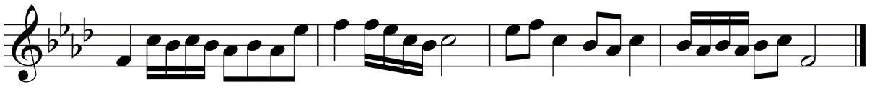
- Name the scale/mode (including scale type and tonic/home note) which most closely aligns to the harmonic progression given below. (1 mark)
Scale/mode:
| Eb | Eb | Eb | Eb |
| Ab | Ab | Eb | Eb |
| Bb | Ab | Eb | Eb |
- Write the following: (4 marks)
  - G major scale
  - The natural minor scale with the given key signature
Question 2: Chords (6 marks)
- Circle the chord type heard in each of the audio tracks below: (3 marks)
  - track 5: major minor dominant 7th
  - track 6: major minor dominant 7th
  - track 7: major minor dominant 7th
- Write the following chords as specified below: (3 marks)
C major
A flat dominant 7th
E minor

Question 3: Rhythmic dictation and harmonic progression (12 marks)
Listen to track 8 and examine the score below.
- Complete the rhythm notation as heard in the audio track (7 marks)
- Insert the four missing chords on the lines below the stave (4 marks)
- Define the given time signature: (1 mark)

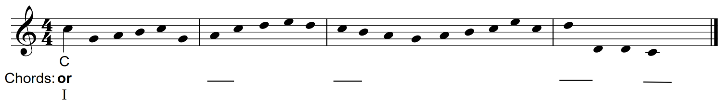
Question 4: Melodic dictations and intervals (12 marks)
Listen to track 9 and examine the score below.
- Name the intervals (by quality and number) as marked in the first bar. (3 marks)

- Complete the melody by writing the notation (including rhythm and pitch) on the score below.
(9 marks)

Question 5: Score analysis (11 marks)
Examine the score excerpt on the following page, listen to track 10 and answer the questions below.
Beethoven, L. Septet in E flat, third movement
Audio: https://open.spotify.com/track/47vHKjw4bECv1vBemmUoh7?si=a828b659d3314f38
Score: https://imslp.org/wiki/Special:ReverseLookup/1658
- Define the term anacrusis, and describe where this feature can be seen in the excerpt. (2 marks)
Definition:

Location in the excerpt:
- Explain how the dynamics symbols in the first eight bars should be interpreted by the players.
(2 marks)

- Name the overall key of the excerpt, the two chords that feature in bars 9–12, and the modulation that this combination of chords suggests. (3 marks)
Overall key of excerpt:
Chords: and
Modulation:
- Name the instruments used in this work. (4 marks)

Score excerpt for question 5
Beethoven, L. van. (First published1802). Septet in E flat, Opus 20. Franz Anton Hoffmeister. Retrieved November., 2022, from https://imslp.org/wiki/Special:ReverseLookup/1658
Used under Creative Commons Attribution-ShareAlike 4.0 licence.
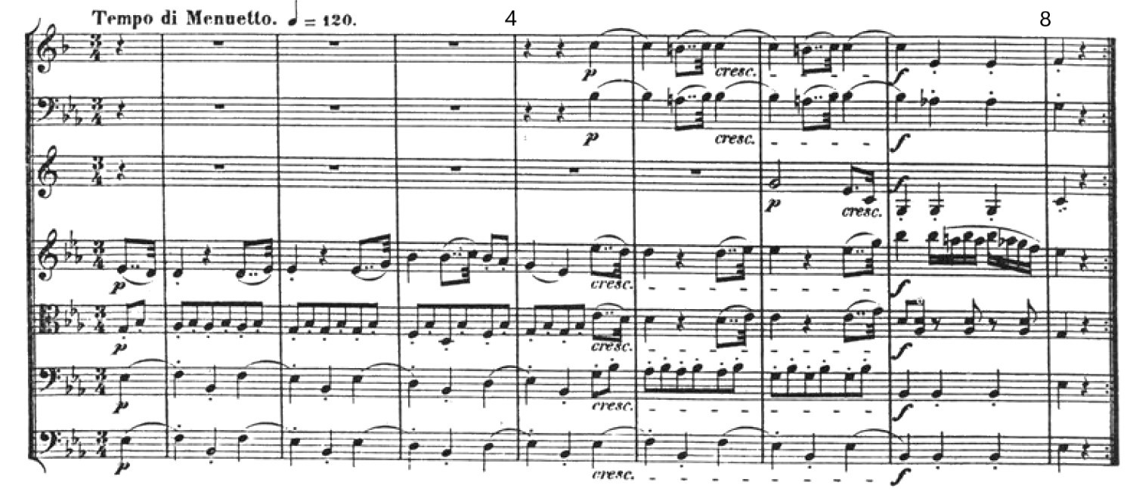
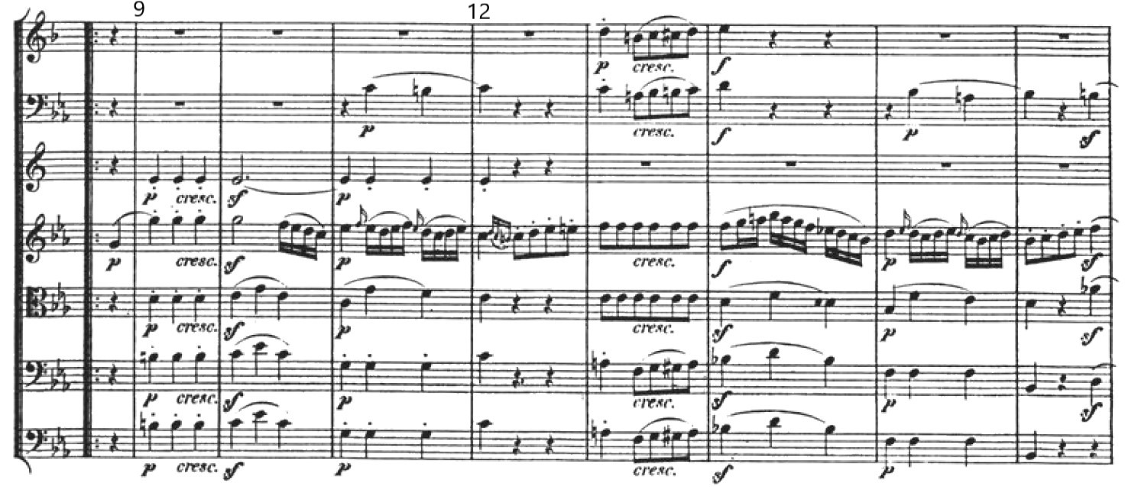
End of score excerpt

Marking key for Task 3 – Music literacy
Question 1: Scales (10 marks)
- Circle the prevailing scale type heard in each of the audio tracks below. (4 marks)
Description | Marks
One mark per correct answer | 1–4
Total | /4
- Name the scale/mode (including scale type and tonic/home note) which most closely aligns to the melody below. (1 mark)
Description | Marks
F minor pentatonic | 1
Total | /1
- Name the scale/mode (including scale type and tonic/home note) which most closely aligns to the harmonic progression given below. (1 mark)
Description | Marks
E flat blues (scale) | 1
Total | /1
- Write the following: (4 marks)
  - G major scale
  - The natural minor scale with the given key signature
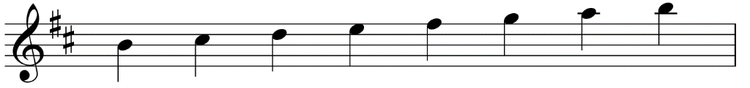
Description | Marks
Two marks for each correct scale  One mark for a scale containing one error  Accept any variation of the correct pitches (ascending/descending, any octave, any note value etc.) | 1–4
Total | /4

Question 2: Chords (6 marks)
- Circle the chord type heard in each of the audio tracks below: (3 marks)
Description | Marks
One mark for each correct response | 1–3
Total | /3
- Write the following chords as specified below: (3 marks)
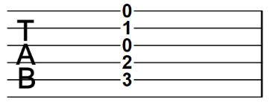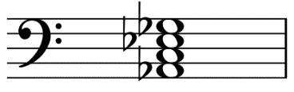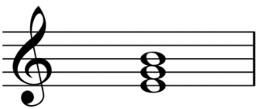
C major
A flat dominant 7th
E minor
Description | Marks
One mark for each correct response. (Accept correct variations.) | 1–3
Total | /3
Question 3: Rhythmic dictation and harmonic progression (12 marks)
- Complete the rhythm notation as heard in the audio track (7 marks)
Description | Marks
Rhythm
23 note values correct | 6
19–22 note values correct | 5
14–18 note values correct | 4
9–13 note values correct | 3
5–8 note values correct | 2
1–4 note values correct | 1
Subtotal | /6
Rhythmic grouping
All rhythmic grouping correct (for ) | 1
Subtotal | /1
Total | /7
- Insert the four missing chords on the lines below the stave (4 marks)
Description | Marks
Chords
1 mark per chord (as above) | 1–4
Total | /4

- Define the given time signature: (1 mark)
Description | Marks
Time signature
Definition: four crotchets/quarter notes per bar | 1
Total | /1
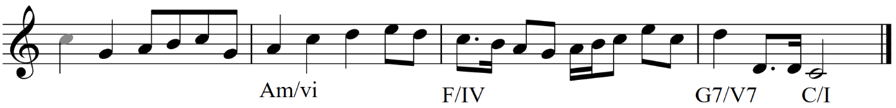
Question 4: Melodic dictations and intervals (12 marks)
- Name the intervals (by quality and number) as marked in the first bar. (3 marks)
Description | Marks
Intervals
One mark per correct interval (no half marks)
- perfect 5th | 1
- major 2nd | 1
- perfect 4th | 1
Total | /3
- Complete the melody by writing the notation (including rhythm and pitch) on the score below.
(9 marks)
Description | Marks
Pitch
15 pitches correct | 7
13–14 pitches correct | 6
11–12 pitches correct | 5
8–10 pitches correct | 4
5–7 pitches correct | 3
3–4 pitches correct | 2
1–2 pitches correct | 1
Subtotal | /7
Rhythm
All rhythm correct | 2
1–2 errors | 1
Subtotal | /2
Total | /9
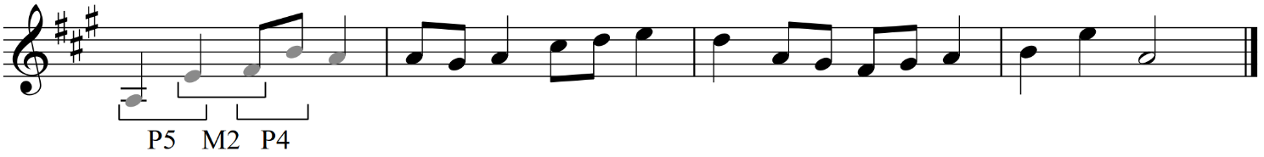
Question 5: Score analysis (11 marks)
- Define the term anacrusis, and describe where this feature can be seen in the excerpt. (2 marks)
Description | Marks
Definition: an incomplete bar at the beginning of a musical work or phrase. (The remaining value of this incomplete bar is accounted for in the final bar) | 1
Location: start of the excerpt. (Accept the start of the second system/B section/upbeat to bar 9) | 1
Total | /2
- Explain how the dynamics symbols in the first eight bars should be interpreted by the players.
(2 marks)
Description | Marks
Complete description: start soft, gradually get louder (from bar 4), finish loud | 2
Provides two out of three parts of the description above | 1
Total | /2
- Name the overall key of the excerpt, the two chords that feature in bars 9–12, and the modulation that this combination of chords suggests. (3 marks)
Description | Marks
Overall key: E flat major | 1
Chords: G major (or G7) and C minor (must have both for 1 mark) | 1
Modulation: to the relative minor | 1
Total | /3
- Name the instruments used in this work. (4 marks)
Clarinet (in B flat), bassoon, (French) horn (in F), violin, viola, cello, bass
Description | Marks
Correctly names all seven instruments | 4
Correctly names six instruments | 3
Correctly names four or five instruments | 2
Correctly names two or three instruments | 1
Total | /4

Sample written assessment tasks

Task 7 – Composition
Assessment type: Composition (written)
Submit two complete, original works:
- with a total duration of at least 90 seconds each
- with at least one work composed for a minimum of two instruments/parts/voices
- that have been developed and refined over time.
A selection of draft materials, recordings and other evidence of the creative and refinement processes are submitted, along with a short purpose statement and musical analysis. A score must be submitted and contain the necessary detail to prepare a performance.
Conditions: Assessment task issued to students: Semester 1, Week 10
Submission due date: Semester 2, Week 11. Submit handwritten, printed, or digital scores, as specified by the teacher. Audio tracks of the compositions may be included but are not required.
Time for task: some class time is allocated to developing and refining works. Students may need to dedicate some time, approximately 30 minutes, per week outside of class to this task. As there are approximately 15 weeks between the issue and submission of the task, students could spend approximately seven weeks on each of the two music works.
Task weighting: 10% of the school mark for this pair of units

Note: the sample task that follows allows for a good deal of student choice in setting the parameters for the compositions. Teachers may choose to provide additional scaffolding by modifying the task below, for example prescribing the required form, style or instrumentation.

Composition (written) (27 marks)
Composition task: Work one
Compose a work consisting of a melody and a simple accompaniment (e.g. guitar chord symbols or piano bass clef part). The finished work must have a duration of at least 90 seconds. In planning for work one:
- choose a particular purpose for the work (e.g. a film/video game score, an advertising jingle, a live performance)
- choose a music style the work will reflect. Depending on the purpose of the work, multiple styles may be appropriate
- consider the formal structure for the work. This may be chosen before composition begins, or evolve and change during the process
- present these ideas to your teacher for feedback before beginning the next phase.
In composing work one:
- experiment with melodic fragments and harmonic progressions, recording these in notation or audio form. Consider how the purpose of the work might guide musical choices like tonality, tempo, expressive devices or the balance of long and short notes in melodic ideas
- choose ideas from the experimental phase with which to build the work. Construct sections of the work and join them together according to the formal structure. As the work evolves, decisions made earlier can be modified or changed
- review the planning phase to determine if the developing work fits these parameters
- play and/or listen to the work often during composition, making adjustments to the melody and accompaniment
- save drafts of the work often to show the development of the work as required in the final submission.
In finalising work one:
- present the work to your teacher for feedback
- consider presenting the work to others for feedback, e.g. fellow students, a parent or a musician you know
- play and/or listen to the work with a critical ear
- consider all the feedback sources available and decide on any adjustments to the work based on this feedback
- check that the music score is neatly presented, contains adequate performance directions, a title for the work, and your name.
Composition task: Work two
Arrange work one for a quartet. The choice of instruments/voices for the quartet would ideally enable the class/school to perform the work. The finished work must have a duration of at least 90 seconds. In arranging the work:
- decide how the melody is allocated among the four parts
- explore various accompaniment patterns and combinations of instruments to expand the simple accompaniment from work one into a more complex accompaniment in the arrangement
- select and manipulate relevant musical elements and compositional devices in the arrangement, such as texture, timbre, ostinato/riff
- decide how to build upon or change aspects of work one, such as including key changes or additional sections (like an introduction), so that the arrangement looks and sounds significantly different from work one, rather than being a simple copy
- ensure each instrumental part demonstrates the relevant performance techniques specific to the instrument, e.g. bowing notations, guitar techniques.
In finalising work two:
- present the work to your teacher for feedback
- consider presenting the work to others for feedback, e.g. fellow students, a parent or a musician you know
- play and/or listen to the work with a critical ear
- organise a live performance of the work in class, where possible
- consider all the feedback sources available and decide on any adjustments to the work based on this feedback
- check that the music score is neatly presented, contains adequate performance directions, a title for the work and your name.
Final submission
In the final submission of the two works, include:
- a short statement specifying the purpose/intent of the compositions, the chosen music style/s and a brief musical analysis of the work according to the elements of music, including choices of instrumentation. This can focus on work two (the arrangement)
- the music score for both works in a format negotiated with the teacher (handwritten, printed, or digital). Audio/video recordings may be submitted if available, but are only used by markers to assist in interpreting the score
- a selection of draft materials, recordings and other evidence of the creative and refinement processes. This will vary but, as a guide, provide at least three separate pieces of evidence that show the works in different stages of development.

Marking key for Task 7 – Composition
Teachers may choose to mark each of the two student works individually and then decide on a final mark, or mark the two works as a single task.
Description | Marks
Application of music elements (rhythm, pitch, form)
Demonstrates excellent skill in the selection and manipulation of music elements and their relationship within the works | 8
Demonstrates proficient skill in the selection and manipulation of music elements and their relationship within the works | 6–7
Demonstrates satisfactory skill in the selection and manipulation of music elements and their relationship within the works | 4–5
Demonstrates inconsistency in the selection and manipulation of music elements and inconsistently applies these within the works | 2–3
Demonstrates limited skill in the selection and manipulation of music elements and ineffectively applies these within the works | 1
Subtotal | /8
Creative process
Demonstrates excellent creativity and development when establishing and sustaining musical material/ideas, including excellent skill in the selection and manipulation of compositional devices | 8
Demonstrates proficient creativity and development when establishing and sustaining musical material/ideas, including proficient skill in the selection and manipulation of compositional devices | 6–7
Demonstrates satisfactory creativity and development when establishing and sustaining musical material/ideas, including satisfactory skill in the selection and manipulation of compositional devices | 4–5
Demonstrates inconsistent evidence of creativity and development of musical material/ideas, including inconsistent skill in the selection and manipulation of compositional devices | 2–3
Demonstrates limited evidence of creativity and development of musical material/ideas, including limited skill in the selection and manipulation of compositional devices | 1
Subtotal | /8
Orchestration and score presentation (timbre, texture, expressive devices)
Demonstrates excellent application of timbre, texture and expressive devices, producing a score with relevant scoring and notation conventions | 4
Demonstrates proficient application of timbre, texture and expressive devices, producing a score with most relevant scoring and notation conventions | 3
Demonstrates satisfactory application of timbre, texture and expressive devices, producing a score with some relevant scoring and notation conventions | 2
Demonstrates inconsistent application of timbre, texture and expressive devices, producing a score with some relevant scoring and notation conventions | 1
Subtotal | /4
Stylistic conventions and task brief application
Demonstrates excellent application of the task brief, which may include stylistic conventions, meeting the stated purpose of the works, or specifications such as form, instrumentation etc. | 4
Demonstrates proficient application of the task brief, which may include stylistic conventions, meeting the stated purpose of the works, or specifications such as form, instrumentation etc. | 3
Demonstrates satisfactory application of the task brief, which may include stylistic conventions, meeting the stated purpose of the works, or specifications such as form, instrumentation etc. | 2
Demonstrates inconsistent application of the task brief, which may include stylistic conventions, meeting the stated purpose of the works, or specifications such as form, instrumentation etc. | 1
Subtotal | /4
Evidence of development and refinement process (draft materials, evidence of feedback)
Provides clear and detailed evidence of a methodical process/journey of development and refinement of compositions | 3
Provides evidence of a process/journey of development and refinement of compositions | 2
Provides some evidence of development and/or refinement processes | 1
Subtotal | /3
Total | /27

Sample written assessment tasks

Task 8 – Music analysis
Assessment type: Music analysis (written)
The assessment consists of visual and aural analysis of an unseen work/s and designated works from Unit 1 and/or Unit 2. Assessed content includes:
- identifying links to unit themes
- stylistic conventions
- contextual features
- use of music elements
- instrumentation
- orchestration.
Conditions: Formal in-class assessment: Semester 2, Week 13
Time for task: 50 minutes
Task weighting: 5% of the school mark for this pair of units

Music analysis (49 marks)
Question 1: Unseen score analysis (20 marks)
An American in Paris – George Gershwin
Score: Piano reduction by William Merrigan Daly, pages 1–2 (bars 1–56) https://www.musicnotes.com/sheetmusic/mtd.asp?ppn=MN0047109
Audio: Leonard Bernstein, Columbia Symphony Orchestra, 0:00–0:58 (Spotify) https://open.spotify.com/track/7tMaOTu32tb7G2Ieb9ULY8?si=63afda3271b54af1
- This work attempts to tell the story of the excitement of being in a big city as a visitor for the first time. How does the composer convey this narrative through manipulation of the elements of music and/or compositional devices? Make four specific points with reference to the score/audio to substantiate your answers. (4 marks)
One:

Two:

Three:

Four:

- Circle the term below that best describes this work. (1 mark)
Program Music Impressionism Musical Theatre Symphony
- Referring to the score, discuss three ways this work has been influenced by the jazz style.
(3 marks)
One:

Two:

Three:

- Name the instruments playing the main melodic material at the following bars. (4 marks)
Bar/s | Instrument
7
10
20
32

- In relation to the following musical terms, give a similarity and difference between this piece and your designated work Take the A Train. (8 marks)
 | Similarity | Difference
Timbre
Texture
Rhythm
Harmony

Question 2: Unseen score analysis (12 marks)
The Captain’s Tale – Paul Jarman
Score: pages 1–2
Audio and score available at http://www.pauljarman.com/composition/the-captains-tale/
- State the key of this excerpt, and explain why you have made this choice. (2 marks)
Key:
Reason for choice:

- Describe how this excerpt is structured. (1 mark)

- Describe the use of solo versus tutti sections in this excerpt. How does this support the narrative of this composition? (2 marks)

- Using bar numbers, identify and describe two examples of the use of rhythm, and how it has been used to support the narrative of this composition. (2 marks)
Bar number/s | Description
- Identify the chord seen in the piano part at bar 18. (1 mark)

- Both this composition and your designated work Die Moldau (Bedřich Smetana) have a narrative focused on water. Using references to compositional devices and elements, describe one way this is portrayed in each of these compositions. (4 marks)

Question 3: Designated work analysis (17 marks)
- Examine the score for Will You Love Me Tomorrow.
(i) Describe how syncopation is achieved in the first bar of the vocal part. (1 mark)

(ii) Circle the term below that describes the first chord in the treble clef line. (1 mark)
root position first inversion second inversion
- Examine the score for A Day in the Life.
(i) Describe the pitch movement of the bass part from bars 5–8. (1 mark)

(ii) How is this achieved in relation to the chord progression? (1 mark)

- Explain the similarities and differences with regard to form/structure in the works Will You Love Me Tomorrow and A Day in the Life. (4 marks)

- (i) List the instrumentation (including voices) of Will You Love Me Tomorrow. (2 marks)

(ii) Explain how the instrumentation in A Day in the Life differs from Will You Love Me Tomorrow.
(2 marks)

- Describe how the narrative in A Day in the Life is reflected through the composers’ application, combination and manipulation of music elements and concepts. (5 marks)

Marking key for Task 8 – Music analysis
Question 1: Unseen score analysis
An American in Paris – George Gershwin
- This work attempts to tell the story of the excitement of being in a big city as a visitor for the first time. How does the composer convey this narrative through manipulation of the elements of music and/or compositional devices? Make four specific points with reference to the score/audio to substantiate your answers. (4 marks)
Description | Marks
- semiquavers in bars 18, 20, 21, 22 etc. reflecting the pitter-patter of running feet  - taxi horn sounds in bars 38, 40, 41, 42, 43 etc.  - angular rhythms and cross rhythms which represent the hectic atmosphere in a big city  - polyphonic sections add to the cacophony  - bitonality (similar to Maurice Ravel; bars 40–43 etc.) to represent the two nationalities  Accept other relevant answers | 1–4
Total | /4
- Circle the term below that best describes this work. (1 mark)
Description | Marks
Program music | 1
Total | /1
- Referring to the score, discuss three ways this work has been influenced by the jazz style.
(3 marks)
Description | Marks
- use of jazz chords, e.g. Fmaj7 as tonic key in bars 1–7  - use of dominant 4 chord (bar 11)  - two-beat dance feel throughout  - cross rhythms, bars 25, 27, 32–35, 40–44, 48–52  - syncopation, bars 28–31, 36–39, 44–47, 52–55  - extended harmony, e.g. Gb6/9#11 in bar 21  - use of ‘blue’ notes, bars 1, 2, 3, 5, 6 etc.  Accept other relevant answers | 1–3
Total | /3

- Name the instruments playing the main melodic material at the following bars. (4 marks)
Bar/s | Instrument
7 | violin
10 | trombone
20 | trumpet
32 | xylophone
- In relation to the following musical terms, give a similarity and difference between this piece and your designated work Take the A Train. (8 marks)
 | Similarity | Difference
Timbre | Strong use of raucous brass sounds | Take the A Train is a Jazz Big Band line-up  Take the A Train has vocals  An American in Paris has a greater variety of timbre choices (instruments and colour)
Texture | Both have clear moments of homophony  Call and response between instruments | An American in Paris is often heavily polyphonic
Rhythm | Use of syncopation  Use of cross rhythms | An American in Paris is simple duple  An American in Paris has a two beat feel, while Take the A Train has walking bass
Harmony | Both in major key | An American in Paris has more dissonant chord changes and movement
Accept other relevant answers.

Question 2: Unseen score analysis
The Captain’s Tale – Paul Jarman
- State the key of this excerpt, and describe why you have made this choice. (2 marks)
Description | Marks
D minor (aeolian) | 1
Key signature, chordal movements in piano, common use of the C (flat 7) | 1
Total | /2
- Describe how this excerpt is structured. (1 mark)
Description | Marks
13 bars long – 8 bars for captain, 4 bars for response, 1 bar in between | 1
Total | /1
- Describe the use of solo versus tutti sections in this excerpt. How does this support the narrative of this composition? (2 marks)
Description | Marks
Solo is one person, tutti is a group of people | 1
Sounds like a rowdy gathering with a captain telling stories about escapades – this supports the lyrics telling the story | 1
Total | /2
- Using bar numbers, identify and describe two examples of the use of rhythm, and how it has been used to support the narrative of this composition. (2 marks)
Description | Marks
Any two of:  - B1 – the introduction is stride like in approach – sets up jaunty, dance like feeling  - B10, 12 etc. exaggerated semiquaver leading to next bar – lilting rhythms common in sea shanty  - B16 – exaggerated semiquaver to dotted crotchet rhythm – again sea shanty style  - B19 – s reflects spoken style rhythms  Accept other relevant answers | 1–2
Total | /2
- Identify the chord seen in the piano part at bar 18 (1 mark)
Description | Marks
D, 1st inversion | 1
Total | /1
- Both this composition and your designated work Die Moldau (Bedřich Smetana), have a narrative focused on water. Using references to compositional devices and elements, describe one way this is portrayed in each of these compositions. (4 marks)
Description | Marks
Die Moldau: river. Tells the story of a journey along the river. Each section of the river has a different story. Many possible answers. Accept any reasonable answer. One mark for specific narrative idea, one mark for relevant compositional device or musical element | 1–2
Captain’s Tale: sea. Sung song – bawdy sea shanty style, sung in unison with call and response. Rhythmic devices, simple repetitive phrases. All support this style | 1–2
Total | /4
Question 3: Designated work analysis
- Examine the score for Will You Love Me Tomorrow.
(i) Describe how syncopation is achieved in the first bar of the vocal part. (1 mark)
Description | Marks
Strong syllables are placed off the beat (i.e. ‘night’ and ‘mine’) | 1
Total | /1
(ii) Circle the term below that describes the first chord in the treble clef line. (1 mark)
root position first inversion second inversion
- Examine the score for A Day in the Life.
(i) Describe the pitch movement of the bass part from bars 5–8. (1 mark)
Description | Marks
Descending, mostly in steps | 1
Total | /1
(ii) How is this achieved in relation to the chord progression? (1 mark)
Description | Marks
The bass does not always play the root note of the chords in the progression | 1
Total | /1

- Explain the similarities and differences with regard to form/structure in the works Will You Love Me Tomorrow and A Day in the Life (4 marks)
Description | Marks
Similarities  - both include introduction  - neither include an obvious/typical chorus  Differences  - Will You Love Me Tomorrow is AABA form, A Day in the Life less standard form  - A Day in the Life includes orchestral transition (with similar part at the end)  Accept other relevant answers | 1–4
Total | /4
- (i) List the instrumentation (including voices) of Will You Love Me Tomorrow. (2 marks)
Description | Marks
Lists all of: guitars (rhythm and lead), bass, drums, lead vocal, backing vocals, strings | 2
One error or omission | 1
Total | /2
(ii) Explain how the instrumentation in A Day in the Life differs from Will You Love Me Tomorrow.
(2 marks)
Description | Marks
Any two of  - larger orchestra  - use of orchestra like a sound effect in the transitions  - includes piano  - includes alarm clock  Accept other relevant answers | 1–2
Total | /2
- Describe how the narrative in A Day in the Life is reflected through the composers’ application, combination and manipulation of music elements and concepts. (5 marks)
Description | Marks
Discusses accurately and in specific detail how the narrative is reflected through the composers’ application, combination and manipulation of music elements and concepts | 5
Discusses accurately and in some detail how the narrative is reflected through the composers’ application, combination and manipulation of music elements and concepts | 4
Provides general comment on how the narrative is reflected through the composers’ application, combination and manipulation of music elements and concepts or provides some relevant points with some inaccuracy evident | 3
Makes superficial comment on how the narrative is reflected through the composers’ application, combination and manipulation of music elements and concepts with some inaccuracy evident | 2
Makes superficial and/or mostly inaccurate comments about how the narrative is reflected through the composers’ application, combination and manipulation of music elements and concepts | 1
Total | /5

