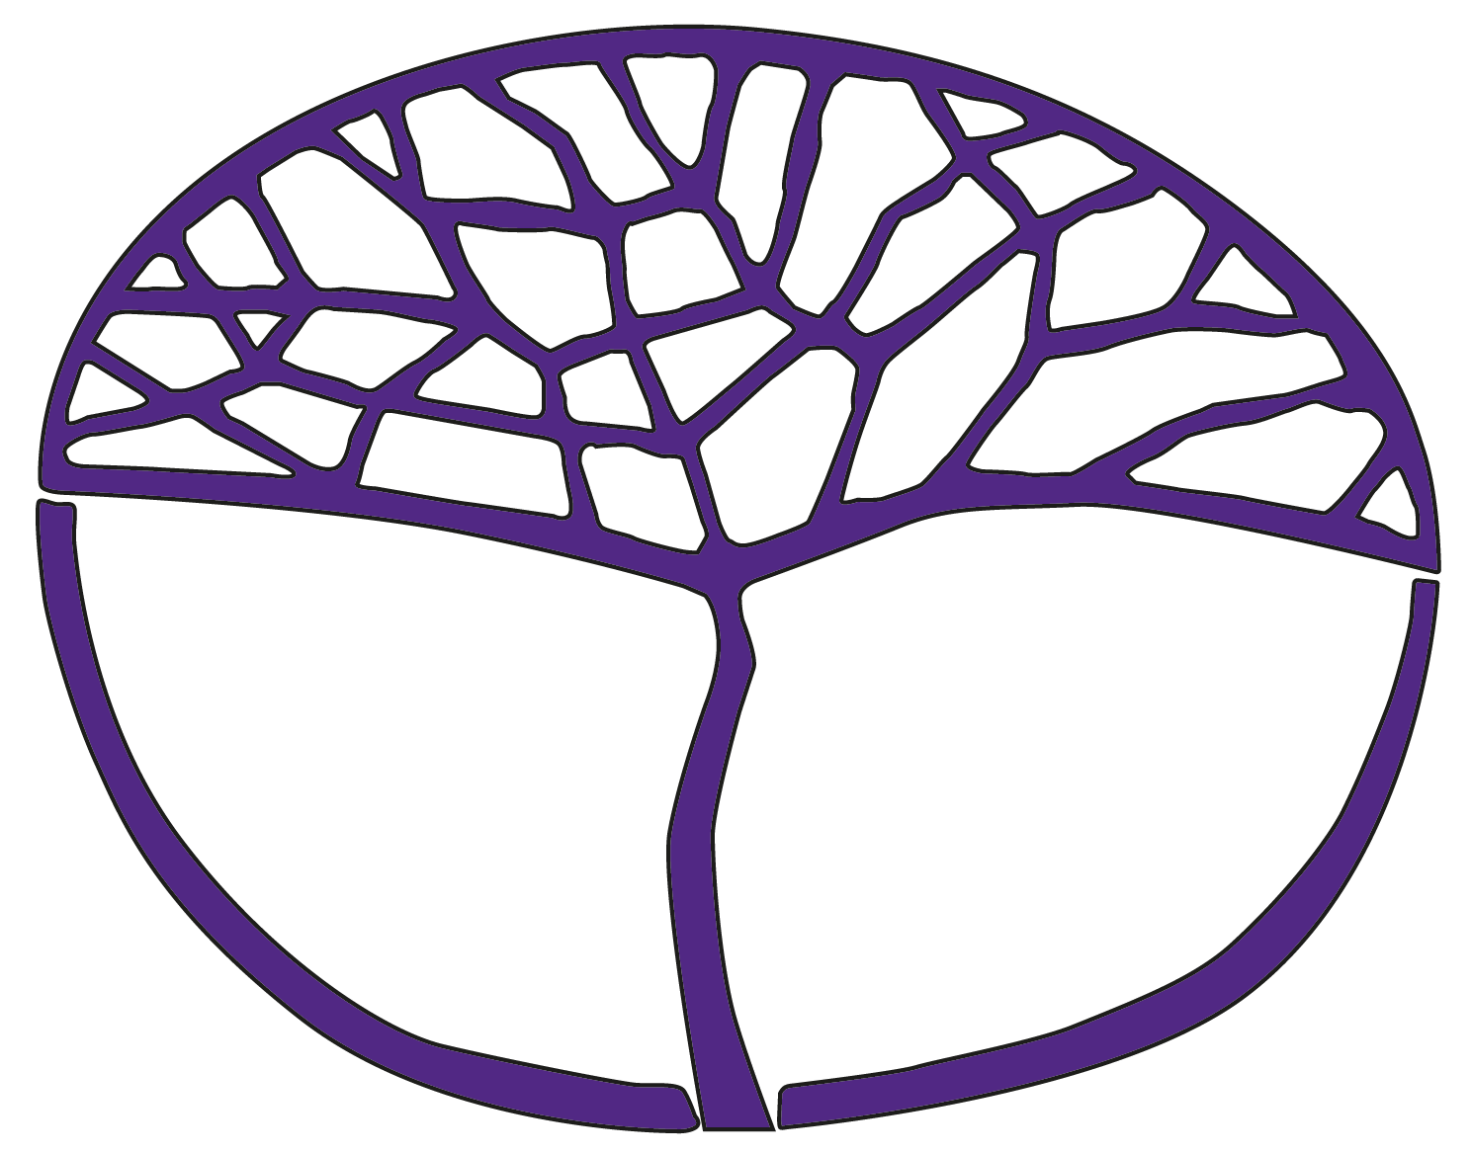Sample Assessment Outline

Philosophy and Ethics

ATAR Year 12

**Acknowledgement of Country**

Kaya. The School Curriculum and Standards Authority (the Authority) acknowledges that our offices are on Whadjuk Noongar boodjar and that we deliver our services on the country of many traditional custodians and language groups throughout Western Australia. The Authority acknowledges the traditional custodians throughout Western Australia and their continuing connection to land, waters and community. We offer our respect to Elders past and present.

**Copyright**

© School Curriculum and Standards Authority, 2023

This document – apart from any third-party copyright material contained in it – may be freely copied, or communicated on an intranet, for non-commercial purposes in educational institutions, provided that the School Curriculum and Standards Authority (the Authority) is acknowledged as the copyright owner, and that the Authority’s moral rights are not infringed.

Copying or communication for any other purpose can be done only within the terms of the *Copyright Act 1968* or with prior written permission of the Authority. Copying or communication of any third-party copyright material can be done only within the terms of the *Copyright Act 1968* or with permission of the copyright owners.

Any content in this document that has been derived from the Australian Curriculum may be used under the terms of the [Creative Commons Attribution 4.0 International licence](https://creativecommons.org/licenses/by/4.0/).

**Disclaimer**

Any resources such as texts, websites and so on that may be referred to in this document are provided as examples of resources that teachers can use to support their learning programs. Their inclusion does not imply that they are mandatory or that they are the only resources relevant to the course. Teachers must exercise their professional judgement as to the appropriateness of any they may wish to use

Sample assessment outline

Philosophy and Ethics – ATAR Year 12

Unit 3 and Unit 4

|  |  |  |  |  |
| --- | --- | --- | --- | --- |
| Assessment type | Assessment type weighting | Assessment  task  weighting | When | Assessment task |
| Critical reasoning | 20% | 10% | Semester 1  Week 3 | **Task 1:** Short answer test with questions focused on the structures of arguments, cogency, weasel words/phrases and informal fallacies |
| 10% | Semester 2  Week 2 | **Task 5:** Short answer test with questions focused on the structures of arguments, cogency, analytic/synthetic statements, complex sentences, conditionals and connectives and informal fallacies |
| Philosophical  analysis and evaluation | 20% | 10% | Semester 1  Week 6 | **Task 2:** Article/extract analysis and evaluation of an argument on governance and justice |
| 10% | Semester 2  Week 8 | **Task 6:** Community of inquiry dialogue on philosophy of religion and/or religious epistemology, including an analysis and evaluation |
| Construction of argument | 20% | 10% | Semester 1  Week 12 | **Task 3:** Answer one of the two questions on justice and society or ethical obligations; arguing for/against a statement |
| 10% | Semester 2  Week 11 | **Task 7:** Answer one of the three questions on philosophy of religion, religious epistemology or meaningful lives; arguing for/against a statement |
| Examination | 40% | 15% | Semester 1  Week 16 | **Task 4:** Semester 1 Examination – Three hours duration, using the examination design brief from the ATAR Year 12 syllabus |
| 25% | Semester 2  Week 16 | **Task 8:** Semester 2 Examination – Three hours duration, using the examination design brief from the ATAR Year 12 syllabus |
| **Total** | **100%** | **100%** |  |  |