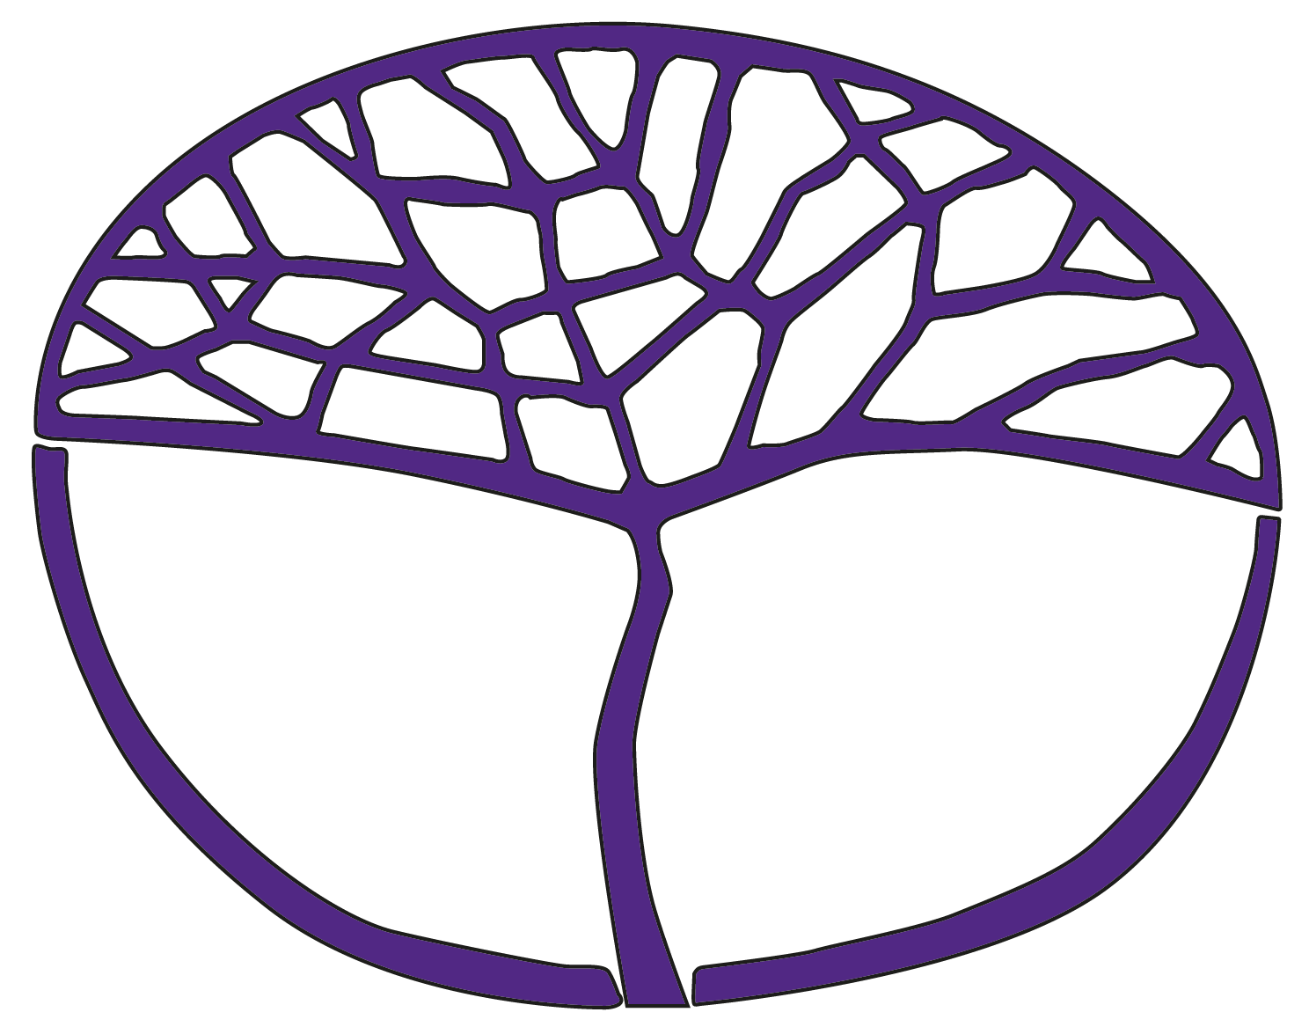Sample Assessment Outline

Humanities and Social Sciences in Action

General Year 12

**Acknowledgement of Country**

Kaya. The School Curriculum and Standards Authority (the Authority) acknowledges that our offices are on Whadjuk Noongar boodjar and that we deliver our services on the country of many traditional custodians and language groups throughout Western Australia. The Authority acknowledges the traditional custodians throughout Western Australia and their continuing connection to land, waters and community. We offer our respect to Elders past and present.

**Copyright**

© School Curriculum and Standards Authority, 2023

This document – apart from any third-party copyright material contained in it – may be freely copied, or communicated on an intranet, for non-commercial purposes in educational institutions, provided that the School Curriculum and Standards Authority (the Authority) is acknowledged as the copyright owner, and that the Authority’s moral rights are not infringed.

Copying or communication for any other purpose can be done only within the terms of the Copyright Act 1968 or with prior written permission of the Authority. Copying or communication of any third-party copyright material can be done only within the terms of the Copyright Act 1968 or with permission of the copyright owners.

Any content in this document that has been derived from the Australian Curriculum may be used under the terms of the [Creative Commons Attribution 4.0 International licence](https://creativecommons.org/licenses/by/4.0/).

**Disclaimer**

Any resources such as texts, websites and so on that may be referred to in this document are provided as examples of resources that teachers can use to support their learning programs. Their inclusion does not imply that they are mandatory or that they are the only resources relevant to the course. Teachers must exercise their professional judgement as to the appropriateness of any they may wish to use.

Sample assessment outline

Humanities and Social Sciences in Action – General Year 12

Unit 3 – People, planet, prosperity and Unit 4 – Disruptions

|  |  |  |  |  |
| --- | --- | --- | --- | --- |
| Assessment type  (from syllabus) | Assessment  type weighting  (from syllabus) | **Assessment  task  weighting** | Due date | Assessment task |
| **Social action investigation** | 20% | 20% | Issued:  Semester 1, Week 6  Submit:  Semester 1, Week 10 | **Assessment task 2: Social action investigation**  Part A: Evidence of research, including bibliography. Research based on content drawn from Focus area1.  Part B: Creation of an action plan and fast fashion information campaign to share with the school community.  Part C: In-class self-reflection written under test conditions. Students submit their inquiry notes and action plan prior to undertaking their in-class reflection. |
| **Commentary** | 30% | 10% | Issued:  Semester 1, Week 11  Submit:  Semester 1, Week 15 | Assessment task 3: Commentary  A summary of learning and reflections about climate change as the context for people, planet, prosperity, developed over the course of Focus area 2 – climate change. Students will complete four entries at various times during the teaching and learning program. |
| 10% | Issued:  Semester 2, Week 6  Submit:  Semester 2, Week 10 | Assessment task 6: Commentary  A summary of learning and reflections about the Australian Marriage Law Postal Survey, the School Strike 4 Climate protests and the #MeToo movement as examples of disruptions. Students will complete four entries at various times during the teaching and learning program and will focus on a comparison of the disruptive events. |
| 10% | Issued:  Semester 2, Week 11  Submit:  Semester 2, Week 15 | Assessment task 7: Commentary  A summary of learning and reflections about artificial intelligence as an example of a disruptive innovation, developed over the course of Focus area 2. Students will complete four entries at various times during the teaching and learning program. |
| **Response** | 35% | 15% | Semester 1, Week 5 | Assessment task 1: Response  A sectionalised, extended response based on the overview content from the syllabus about examples of government policies aimed at protecting the natural environment. |
| 20% | Semester 2, Week 5 | **Assessment task 5: Response**  Short answer response to stimulus based on the overview content from the syllabus about examples of disruptive innovations and elements of successful innovations. |
| **Externally set task** | 15% | 15% | Semester 1, Week 13 | **Assessment task 4: Externally set task**  A written task of 50 minutes duration developed by the School Curriculum and Standards Authority and administered by the school. |
| **Total** | **100%** | **100%** |  | |