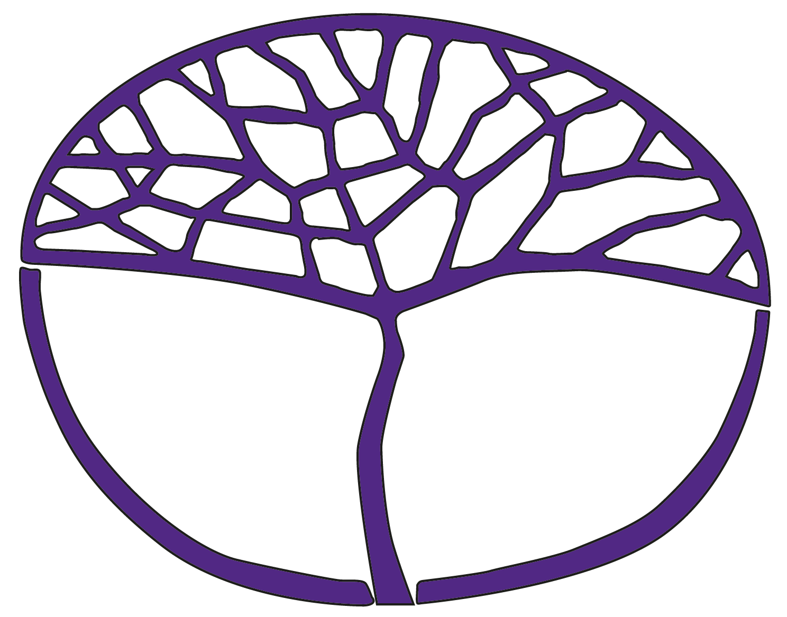
Sample Assessment Outline
Religion and Life
Foundation Year 12

Acknowledgement of Country
Kaya. The School Curriculum and Standards Authority (the Authority) acknowledges that our offices are on Whadjuk Noongar boodjar and that we deliver our services on the country of many traditional custodians and language groups throughout Western Australia. The Authority acknowledges the traditional custodians throughout Western Australia and their continuing connection to land, waters and community. We offer our respect to Elders past and present.
Copyright
© School Curriculum and Standards Authority, 2024
This document – apart from any third-party copyright material contained in it – may be freely copied, or communicated on an intranet, for non-commercial purposes in educational institutions, provided that the School Curriculum and Standards Authority (the Authority) is acknowledged as the copyright owner, and that the Authority’s moral rights are not infringed.
Copying or communication for any other purpose can be done only within the terms of the Copyright Act 1968 or with prior written permission of the Authority. Copying or communication of any third-party copyright material can be done only within the terms of the Copyright Act 1968 or with permission of the copyright owners.
Any content in this document that has been derived from the Australian Curriculum may be used under the terms of the Creative Commons Attribution 4.0 International licence.
Disclaimer
Any resources such as texts, websites and so on that may be referred to in this document are provided as examples of resources that teachers can use to support their learning programs. Their inclusion does not imply that they are mandatory or that they are the only resources relevant to the course. Teachers must exercise their professional judgement as to the appropriateness of any they may wish to use.

Sample assessment outline

Religion and Life – Foundation Year 12

Unit 3 and Unit 4
Assessment  type | Assessment  type weighting | Assessment  task  weighting | When/start and submission date | Assessment task
Investigation | 30% | 15% | Semester 1  Week 8–11 | Task 2: Digital presentation assessing the following content:  - an example from the past of the role religion played in society  - develop a range of questions to support an inquiry  - select appropriate and trustworthy sources to collect relevant information and/or data  - observe appropriate ethical protocols when conducting research  - support conclusions based on the use of evidence  - use suitable formats to communicate ideas or understandings for a set purpose and audience
Investigation | 30% | 15% | Semester 2  Week 6–11 | Task 6: Presentation based on the following content:  - how religion is reflected in the actions and beliefs of a religious group or organisation  - the work of a religious group or organisation in society, past or present  - develop a range of questions to support an inquiry  - select and use relevant information and/or data from source material  - consider how information and/or data found in source material relates to course understandings  - reflect on learning and identify new understandings  - support conclusions based on the use of evidence  - use suitable formats to communicate ideas or understandings for a set purpose and audience
Explanation | 30% | 15% | Semester 1  Week 15 | Task 4: Comprehension task assessing the following content:  - examples of the different ways in which a religion may respond to issues in society  - recognise and use subject-specific terminology  - reflect on learning and identify new understandings  - support conclusions based on the use of evidence
Explanation | 30% | 15% | Semester 2  Week 4 | Task 5: Multimedia task based on the following content:  - why people are motivated to become involved with the work of a religious group or organisation from the past or present  - recognise and use subject-specific terminology  - support conclusions based on the use of evidence  - reflect on learning and identify new understandings  - use suitable formats to communicate ideas or understandings for a set purpose and audience
Source Analysis | 25% | 12.5% | Semester 1  Week 4 | Task 1: Visual and/or written source/s used to assess the following content:  - how religion motivated a religious person from the past or present  - identify important information found in source material such as the origin, purpose, context or point of view of a source  - select and use relevant information and/or data from source material  - consider how information and/or data found in source material relates to course understandings  - support conclusions based on the use of evidence
Source Analysis | 25% | 12.5% | Semester 2  Week 14 | Task 7: Visual and/or written source/s used to assess the following content:  - compare views in society with a religious view about an issue from the past or present  - recognise and use subject-specific terminology  - identify important information found in source material such as the origin, purpose, context or point of view of a source  - select and use relevant information and/or data from source material  - support conclusions based on the use of evidence
Externally Set Task | 15% | 15% | Semester 1  Week 12 | Task 3: A task set by the School Curriculum and Standards Authority based on the following content from Unit 3 – <teacher to insert information provided by the Authority>
Total | 100% | 100%

