Media Production and Analysis ATAR course
practical (production) examination 2026

Production submission cover sheet
WA student number:
Production submission title:
Production theme:

Number your production roles (1–4) in order of specialisation to indicate your preference for mark allocation in Section Two.
Art direction
Cinematographer
Editor
Sound design
More marks will be awarded to the first and second preferences compared to the third and fourth preferences. Refer to the practical (production) marking key for more details.

Acknowledgements
Third-party material refers to any item within the practical (production) examination submission that was not created by the candidate, e.g. music, sound effects, images, stock footage, graphics, special effects, lookup tables (LUTs), and material created using generative artificial intelligence tools (AI).
All third-party materials must be acknowledged using the tables provided. An example within each table has been provided for your reference. Third-party material must be acknowledged and identified as work that was not created by the candidate. Include URLs and/or screen captures if third-party materials are used. All music must be acknowledged. Add additional table rows and pages if required. Any use of generative artificial intelligence tools must be acknowledged.
Internal and external assistance can be provided; however, the assistance must not be a substantial contribution to the student’s individual work and must not be excessively used within the production roles assessed in Section Two.
Internal assistance includes help from other Media Production and Analysis students.
External assistance is the help of a source outside the classroom. Examples include actors, family members and friends.
Note: do not name your parents, teacher or any school in this section. Use generic terminology,
e.g. ‘my teacher’ or ‘my father’, without using actual names.

Acknowledgement tables
(Delete the examples in italics in the tables below and include candidate information only.)
Software used (e.g. Adobe Premiere Pro)

Equipment used (e.g. Canon DSLR 5D Mark III)
Note: this information is requested here to remove the perceived need to include this information in the Practical (production) statement.
Acknowledgement of original music (e.g. All music is original and created by WA student number 12345678).

Third-party material used | Screen capture | URL
e.g. Idea inspiration from a poem | e.g. Text on screen in AV production at timecode 0:00:01:15 | e.g. www.poem.madeupurl.au
e.g. Map of Australia | 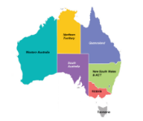  e.g.
e.g. Breaking news intro | 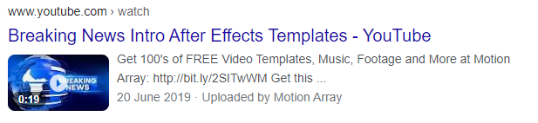 | e.g. https://www.youtube.com/​watch?v=lO3cDd4Yquw
- Tick the box if no third-party material was used.
AI used | Screen capture | URL
e.g. Scripting assistance used to get an idea started | 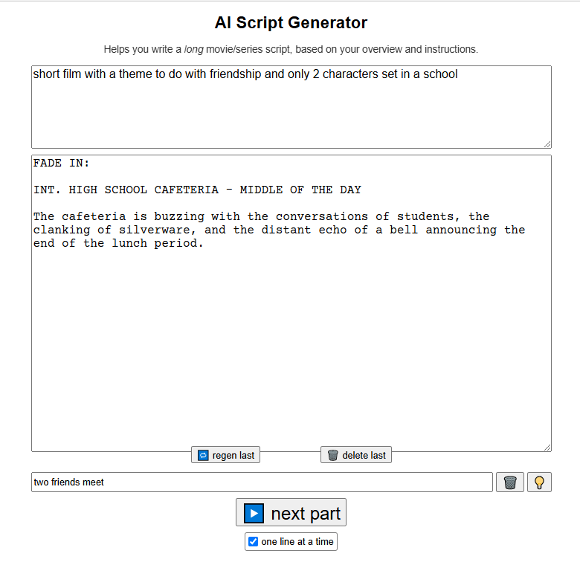
e.g. Inbuilt AI within editing software used to create a voiceover from my original text | 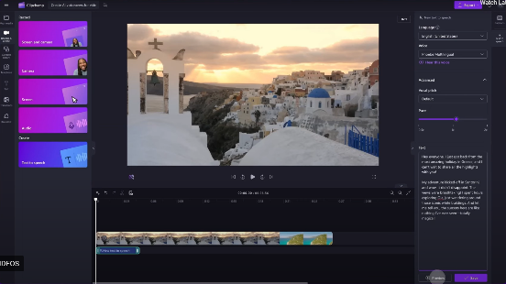
e.g. Animated sections of the film created using AI |  | www.fakeaianimationsoftwareURL.com
- Tick the box if no AI was used.
Internal or external assistance | Description of internal and/or external assistance used
e.g. Internal | e.g. My classmate provided sound recording assistance for the location shoot in Perth city to capture the audio with the boom mic while I operated the camera.
- Tick the box if no internal and/or external assistance was used.

