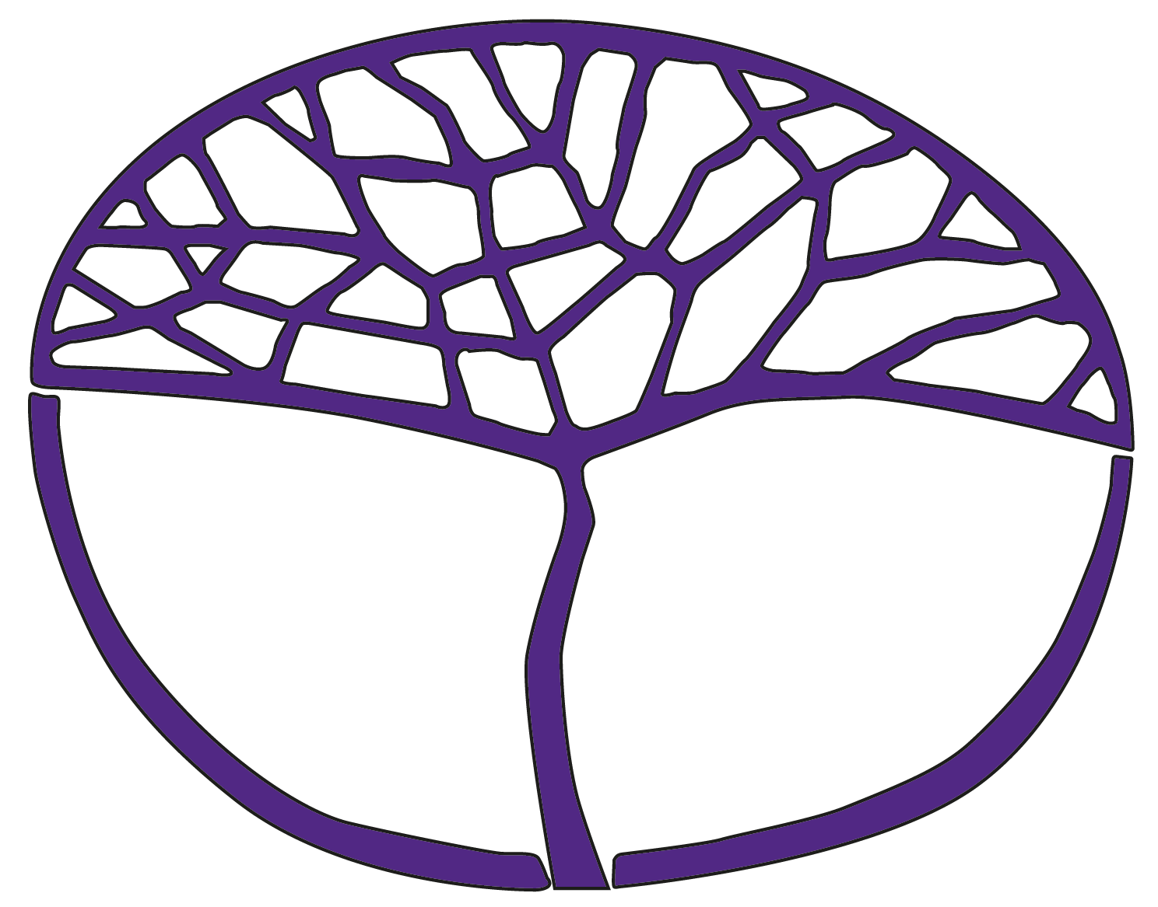
Structured improvisation information
Dance
ATAR Year 12

Acknowledgement of Country
Kaya. The School Curriculum and Standards Authority (the Authority) acknowledges that our offices are on Whadjuk Noongar boodjar and that we deliver our services on the country of many traditional custodians and language groups throughout Western Australia. The Authority acknowledges the traditional custodians throughout Western Australia and their continuing connection to land, waters and community. We offer our respect to Elders past and present.
Copyright
© School Curriculum and Standards Authority, 2026
This document – apart from any third-party copyright material contained in it – may be freely copied, or communicated on an intranet, for non-commercial purposes in educational institutions, provided that the School Curriculum and Standards Authority (the Authority) is acknowledged as the copyright owner, and that the Authority’s moral rights are not infringed.
Copying or communication for any other purpose can be done only within the terms of the Copyright Act 1968 or with prior written permission of the Authority. Copying or communication of any third-party copyright material can be done only within the terms of the Copyright Act 1968 or with permission of the copyright owners.
Any content in this document that has been derived from the Australian Curriculum may be used under the terms of the Creative Commons Attribution 4.0 International licence

Structured improvisation information
This document supports teachers and students to explore, create and practise structured improvisation tasks in preparation for the Dance ATAR Year 12 practical examination.
Figure 1. Creating a structured improvisation.
Elements of dance
Choose one or two
Structure
Choose one

Choreographic devices
Choose one or two
Original material
Choose one

- accumulation
- contrast
- embellishment
- fragmentation
- motif
- repetition
- retrograde
- body
- dynamics
- space
- time

- binary
- ternary
- rondo
- narrative
- Original Solo Choreography (OSC)
- Set Solo (SS)
- OSC and SS

Examples of how the improvisation could be structured are included below.
Example 1
Using the OSC:
- create a structured improvisation in a binary form
- manipulate the movement using the element of dance – space
- use the choreographic devices – accumulation and motif
- select a clear finishing position.
Example 2
Using movement from the OSC and SS:
- create a structured improvisation in a ternary form
- manipulate the movement using the element of dance – dynamics
- use the choreographic devices – fragmentation and repetition
- select a clear finishing position.
Example 3
Create a structured improvisation in two parts:
- in section one, manipulate movement from the OSC using the element of dance – body
- in section two, select a phrase from the SS and manipulate it using the choreographic device – contrast
- select a clear finishing position.

Example 4
Create a structured improvisation in three parts:
- in section one, manipulate movement from the OSC using the element of dance – body
- in section two, select a phrase from the SS and manipulate it using the choreographic device – retrograde
- in section three, use movement from the OSC and manipulate it using the choreographic device – accumulation
- select a clear finishing position.
Example 5
Using the SS:
- create a structured improvisation in a narrative form
- manipulate the movement using the element of dance – time and the choreographic device – embellishment
- select a clear finishing position.

