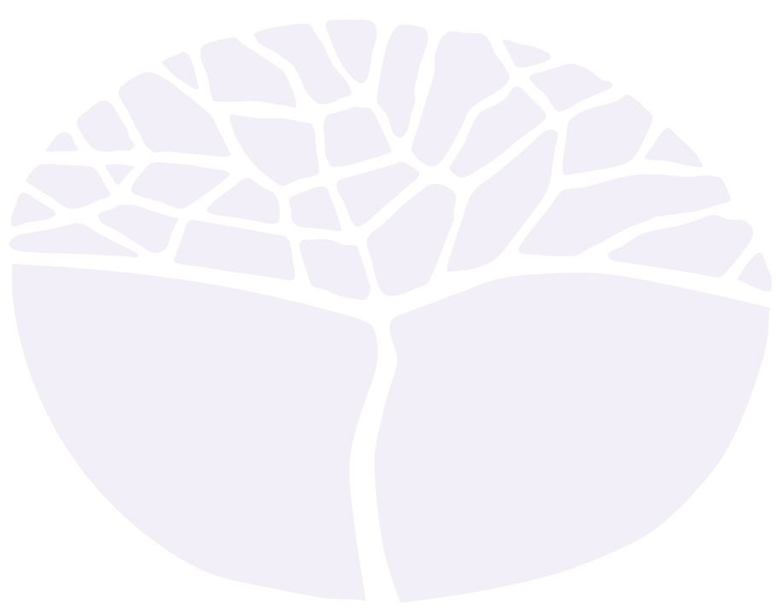
Ancient History
General course

Externally set task
Sample 2016

Note: This Externally set task sample is based on the following content from Unit 3 of the General Year 12 syllabus.
- Historical skills including:
- Chronology, terms and concepts
- Analysis and use of sources
- Explanation and communication
- Historical knowledge and understanding from one of the following electives:
- Old Kingdom Egypt, Dynasty 3–6 c. 2686–c. 2181 B.C.
- Egypt, Dynastic change, Dynasty 17–18 c. 1560–c. 1504 BC (the wars against the Hyksos to Amenhotep I) and Dynasty 18–19 (Ay to Rameses II) c. 1327–c. 1213 BC
- Emergence of the Greek City states in the archaic period to the fall of the Pisistratid Tyranny in Athens
c. 800 BC–512/11 BC
- The establishment of Rome from the beginning of the Republic to the end of the Punic Wars
c. 509–146 BC
- Rome, the Late Republic to the Lex Manilia c. 133–66 BC
- China from the time of the Warring States to the rise and fall of the Qin dynasty c. 475–c. 206 BC
In future years, this information will be provided late in Term 3 of the year prior to the conduct of the Externally set task. This will enable teachers to tailor their teaching and learning program to ensure that the content is delivered prior to the students undertaking the task in Term 2 of Year 12.

Copyright
© School Curriculum and Standards Authority, 2014
This document – apart from any third party copyright material contained in it – may be freely copied, or communicated on an intranet, for non-commercial purposes in educational institutions, provided that the School Curriculum and Standards Authority is acknowledged as the copyright owner, and that the Authority’s moral rights are not infringed.
Copying or communication for any other purpose can be done only within the terms of the Copyright Act 1968 or with prior written permission of the School Curriculum and Standards Authority. Copying or communication of any third party copyright material can be done only within the terms of the Copyright Act 1968 or with permission of the copyright owners.
Any content in this document that has been derived from the Australian Curriculum may be used under the terms of the Creative Commons Attribution-NonCommercial 3.0 Australia licence
Disclaimer
Any resources such as texts, websites and so on that may be referred to in this document are provided as examples of resources that teachers can use to support their learning programs. Their inclusion does not imply that they are mandatory or that they are the only resources relevant to the course.

Ancient History

Externally set task
Working time for the task: 60 minutes
Total marks: 25 marks
Weighting: 15% of the school mark
Materials required for this task:
A Source Booklet (which contains two sources for the elective which you have studied)

Use the two sources provided in the Source Booklet to answer the following questions.

- Tick one (1) of the following in (a) and (b) to best describe Source 1. (2 marks)

- ancient source
modern source

- written source
archaeological source
map/diagram
reconstruction

- Identify and briefly discuss the historical context of Source 1. You should consider the following where appropriate:
  - the relevant event/s
  - the significant person/people
  - the key idea/s depicted in the source. (4 marks)
________________________________________________________________________________
________________________________________________________________________________
________________________________________________________________________________
________________________________________________________________________________
________________________________________________________________________________
________________________________________________________________________________
________________________________________________________________________________
________________________________________________________________________________
________________________________________________________________________________
________________________________________________________________________________
________________________________________________________________________________
________________________________________________________________________________

- Identify and explain the message/s of Source 2. Provide evidence in your response. (4 marks)
________________________________________________________________________________
________________________________________________________________________________
________________________________________________________________________________
________________________________________________________________________________
________________________________________________________________________________
________________________________________________________________________________
________________________________________________________________________________
________________________________________________________________________________
________________________________________________________________________________
________________________________________________________________________________
________________________________________________________________________________
________________________________________________________________________________

- Outline and briefly explain the major changes occurring in the society which are depicted in Source 1 and Source 2. Provide evidence in your response. (6 marks)
________________________________________________________________________________
________________________________________________________________________________
________________________________________________________________________________
________________________________________________________________________________
________________________________________________________________________________
________________________________________________________________________________
________________________________________________________________________________
________________________________________________________________________________
________________________________________________________________________________
________________________________________________________________________________
________________________________________________________________________________
________________________________________________________________________________
________________________________________________________________________________
________________________________________________________________________________
________________________________________________________________________________
________________________________________________________________________________
________________________________________________________________________________
________________________________________________________________________________

- Discuss ‘change’ in this ancient society. (9 marks)
In developing your response you should:
- use the changes shown in both sources as your starting point
- identify and explain other major changes that occurred in the society
- illustrate the importance of the changes
________________________________________________________________________________
________________________________________________________________________________
________________________________________________________________________________
________________________________________________________________________________
________________________________________________________________________________
________________________________________________________________________________
________________________________________________________________________________
________________________________________________________________________________
________________________________________________________________________________
________________________________________________________________________________
________________________________________________________________________________
________________________________________________________________________________
________________________________________________________________________________
________________________________________________________________________________
________________________________________________________________________________
________________________________________________________________________________
________________________________________________________________________________
________________________________________________________________________________
________________________________________________________________________________
________________________________________________________________________________
________________________________________________________________________________
________________________________________________________________________________
________________________________________________________________________________
________________________________________________________________________________
________________________________________________________________________________
________________________________________________________________________________
________________________________________________________________________________
________________________________________________________________________________
________________________________________________________________________________
________________________________________________________________________________
________________________________________________________________________________

