
Sample Assessment Tasks
Mathematics Applications
ATAR Year 11

Acknowledgement of Country
Kaya. The School Curriculum and Standards Authority (the Authority) acknowledges that our offices are on Whadjuk Noongar boodjar and that we deliver our services on the country of many traditional custodians and language groups throughout Western Australia. The Authority acknowledges the traditional custodians throughout Western Australia and their continuing connection to land, waters and community. We offer our respect to Elders past and present.
Copyright
© School Curriculum and Standards Authority, 2018
This document – apart from any third-party copyright material contained in it – may be freely copied, or communicated on an intranet, for non-commercial purposes in educational institutions, provided that the School Curriculum and Standards Authority (the Authority) is acknowledged as the copyright owner, and that the Authority’s moral rights are not infringed.
Copying or communication for any other purpose can be done only within the terms of the Copyright Act 1968 or with prior written permission of the Authority. Copying or communication of any third-party copyright material can be done only within the terms of the Copyright Act 1968 or with permission of the copyright owners.
Any content in this document that has been derived from the Australian Curriculum may be used under the terms of the Creative Commons Attribution 4.0 International licence.
Disclaimer
Any resources, such as texts and websites, that may be referred to in this document are provided as examples of resources that teachers can use to support their learning programs. Their inclusion does not imply that they are mandated or that they are the only resources relevant to the course. Teachers must exercise their professional judgement as to the appropriateness of any resources they may wish to use.

Sample assessment task

Mathematics Applications – ATAR Year 11

Task 1 – Investigation 1
Assessment type: Investigation
Conditions
This investigation provides opportunity for students to demonstrate the use of the mathematical thinking process. The task may be completed in or out of class. Students may use any appropriate technology.
Note: while the School Curriculum and Standards Authority (the Authority) provides sample assessment tasks for guidance, it is the expectation of the Authority that teachers will develop tasks customised to reflect their school’s context and the needs of the student cohort.
Task weighting
8% of the school mark for this pair of units

How does your interest grow? (48 marks)
An investment sum gains interest each year. Your task is to investigate how long it will take for an investment amount to double in value?
Starting prompts:
- How long it will take for a fixed investment amount to double at 10% per annum simple interest/compound interest.
- Will the length of time change for different interest rates?
- Will the length of time change for different initial investments?
- Is there a quick method to estimate how long it will take for a simple interest investment to double in value?
- The ‘rule of 72’ is often used as a quick method to estimate how long it will take for a compound interest investment to double in value. Investigate how this rule works and discuss its accuracy.
- How will the ‘rule’ change if the interest is compounded twice a year? quarterly? monthly? daily?
Write an investigation report presenting your findings. As you write your report, take care to clearly communicate your findings using appropriate mathematical statements.
Your report should include the following.
- An introduction that clearly defines the purpose of the task, identifies key information, any assumptions made and an outline of your strategy. (9 marks)
- Evidence of the application of mathematical knowledge and strategies, including calculations and results using appropriate representations (graphs, tables, spreadsheets etc.). (18 marks)
- The findings communicated in a systematic and concise manner, including analysis and interpretation in the context of the problem and consideration of the reasonableness and limitations of the results. (21 marks)

Marking key for sample assessment Task 1 – Investigation 1
(Not to be distributed with the task)
Description | Marks available | Mark awarded
Introduction – identifies and organises relevant information
Succinctly writes a general introduction that summarises the aim of the investigation | 2
Includes at least two suitable assumptions relevant to the task, e.g. the interest rate does not vary for the duration of an investment, and no deposit or withdrawal is made | 2
Identifies the need to consider simple and compound interest | 1
Identifies that each parameter (investment amount and interest rate) will need to be varied | 2
Identifies that each parameter will need to be varied independently | 1
Recognises the need to systematically determine at least three values in order to look for patterns | 1
Subtotal | /9

Description | Marks available | Mark awarded
Application – chooses and applies mathematical knowledge and strategies
Correctly calculates the time for a fixed investment amount to double at 10% per annum simple interest | 1
Correctly calculates the time for the same fixed amount to double for at least two more rates of simple interest | 2
Calculates the time for an investment of at least two other amounts to double using simple interest | 2
Demonstrates the use of a suitable and clear method (formula, spreadsheet) to find the time for a simple interest investment to double (sometimes – 1, consistently – 2) | 2
Correctly calculates the time for a fixed investment amount to double at 10% per annum compound interest | 1
Correctly calculates the time for the same fixed amount to double for at least two more rates of compound interest | 2
Calculates the time for an investment of at least two other amounts to double using compound interest | 2
Demonstrates the use of a suitable and clear method (formula, spreadsheet) to find the time for a compound interest investment to double (sometimes – 1, consistently – 2) | 2
Compares the time taken for an investment to double to the ‘rule of 72’ | 1
Identifies a link between the time taken for an investment to double and the ‘rule of 72’ | 1
Calculates the time taken for an investment to double, using at least two other compounding periods (biannually, quarterly, monthly or daily) | 2
Subtotal | /18

Description | Marks available | Mark awarded
Findings – interprets and concludes
Compares and correctly concludes that the time taken to double any investment amount at a fixed interest rate per annum is the same (simple – 1, compound – 1) | 2
Clearly displays the time for an investment to double for at least three different rates of simple interest (using fixed investment amount) | 1
Makes some comparison between the time for an investment to double and the simple interest rate (using fixed investment amount) | 1
Defines a rule that relates the time for an investment to double to the simple interest rate | 1
Shows evidence of testing the rule | 1
Clearly displays the time for an investment to double for at least three different rates of compound interest (using fixed investment amount) | 1
Makes some comparison between the time for an investment to double and the compound interest rate (using fixed investment amount) | 1
Uses calculated values to compare and discuss the accuracy of the ‘rule of 72’ | 2
Relates the accuracy of the ‘rule of 72’ to high/low interest rates | 1
Indicates possible changes to the rule for different compounding periods | 1
Develops a new rule for time taken to double, using one other compounding period | 1
Demonstrates use of the new rule | 1
Discusses accuracy of the new rule and adjusts if necessary | 1
Summarises all findings in succinct and clear statement(s) | 1
Subtotal | /16

Description | Marks available | Mark awarded
Uses correct mathematical conventions, symbols and terminology
Correctly labels and appropriately displays graphs and tables  (sometimes – 1, consistently – 2) | 2
Uses mathematical language throughout the investigation (sometimes – 1, consistently – 2) | 2
Presents investigation in a systematic and concise way | 1
Subtotal | /5
Final total | /48
Note: this marking key may vary depending on the conditions under which the task is administered.

Sample assessment task

Mathematics Applications – ATAR Year 11

Task 2 – Test 1
Assessment type: Response
Content: Consumer arithmetic, Algebra and matrices (1.1.1 – 1.1.8, 1.2.1 – 1.2.7)
Conditions:
Time for the task: Up to 55 minutes, in class, under test conditions
Note: while the Authority provides sample assessment tasks for guidance, it is the expectation of the Authority that teachers will develop tasks customised to reflect their school’s context and the needs of the student cohort. This resource is available on a public website and use of the resource without modification may affect the integrity of the assessment.
Materials required:
Section One: Calculator-free Standard writing equipment
Section Two: Calculator-assumed Calculator (to be provided by the student)
Other materials allowed: Drawing templates, one A4 page of notes in Section Two
Marks available: 63 marks
Section One: Calculator-free 23 marks
Section Two: Calculator-assumed 40 marks
Task weighting: 6%

Questions (Task 2 – Test 1)
Section One: Calculator-free (23 marks)
Suggested time: 20 minutes
Question 1 (12 marks)
The Student Council at Sunset Coast College decided to sell daffodils to raise money for a local charity. The daffodils were sold in a small bunch of three flowers for $6 or a large bunch of eight flowers for $10. The number of small (S) and large (L) bunches of flowers sold to each class in Years 7, 8 and 9 is shown in the matrices X, Y and Z below.
S L
S L
S L
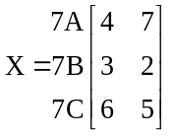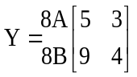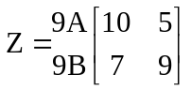
- Using the matrices above, calculate the following.
Where the operation is not possible, provide an explanation. (4 marks)
- Y + Z | - X + Y
- ZX | - 3X

- Use the matrices X, Y and Z to find the following and explain what information is shown in the resulting matrix. (8 marks)
- X 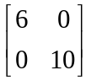 | - Z 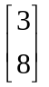
- Y pre-multiplied by 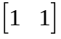 | - Y post-multiplied by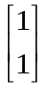

Question 2 (8 marks)
A section of a spreadsheet, provided below, shows the number of hours worked by three students during the course of a week. The students are paid time and a half on Saturdays and double time on Sundays.
 | A | B | C | D | E | F
1 | Name | Rate  ($/hour) | Weekday hours | Saturday hours | Sunday hours | Total pay
2 | Gen | 20 | 5 | 6 | 3.5
3 | Bri | 22 | 10 | 2 | 3
4 | Ala | 23.68 | 8 | 4 | 6
- Create a row and a column matrix and show how matrix multiplication could be used to determine how much Gen will earn in a week? (3 marks)
- Using cell references (e.g. A1 for row 1, column A), state the formula to calculate Ala’s total pay for one week. (2 marks)
- Bri receives a living away from home allowance of $75 per week. Her allowance is reduced by 50 cents for every dollar earned over $350. Assuming she works the same hours each week, determine by how much her allowance is reduced. (3 marks)
Question 3 (3 marks)
Chocolate Easter eggs are on special at a local supermarket.
The larger eggs (120 g each) are advertised at ‘Two for $4’ and the smaller ones (45 g) cost $1 each. Calculate the cost per gram of chocolate for each size. Determine which egg represents the better value for money.

Section Two: Calculator-assumed (40 marks)
Suggested time: 35 minutes
Question 4 (4 marks)
One formula for calculating the surface area (SA) of a person’s skin is given below.
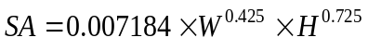 W = weight (kg), H = height (cm), SA = surface area (m²)
Sol is 80 kg in weight and 159 cm tall.
- Write an expression for calculating the surface area of Sol’s skin. (1 mark)
- Calculate the surface area of Sol’s skin, correct to four significant figures. (2 marks)
- Express the SA of Sol’s skin in cm², given that there are 10 000 cm² in 1 m². (1 mark)

Question 5 (9 marks)
Members of the school swim squad, Gino, Cara, Nick and Tina, each have Facebook accounts and can send messages to friends on their Facebook page. Gino is Facebook friends with Cara and Nick. Gino and Nick are also friends on a second Facebook account. Nick is also friends with Cara and Tina.
Assume no-one communicates with themselves.
- With each row representing a different person, create a labelled matrix (M) to represent the number of Facebook accounts each person has to communicate with each of the others.
(3 marks)
- Who can message only one person? (1 mark)
- Calculate the two-step communication matrix M². (2 marks)
- Identify the element m₄₃ of the matrix M². Explain the significance of this value. (2 marks)
- Training is cancelled on Friday. The swimmers all receive and pass on the notice. How many
two-step messages will Nick receive? (1 mark)

Question 6 (8 marks)
John has shares in two banks. He wants to find out which of the two banks in his portfolio of shares is the better performer, and he decides to use the P/E ratio to compare the two banks.
$$P/Eratio=\frac{Market price per share}{Annual earnings per share}$$
AAA Bank’s shares are currently $33.65 while ZZZ Bank’s shares are currently $32.055.
AAA Bank has annual earnings of 207.5 cents per share.
ZZZ Bank has annual earnings of 223.1 cents per share.
- Calculate the P/E ratio for each bank and make a recommendation as to which bank John should buy more of, if the P/E ratio was the only indicator to be used. Justify your recommendation.
(4 marks)
Dividends from both banks are paid twice a year and in the last year AAA Bank gave dividends of
82c and 84c per share.
- What percentage of its annual earnings does AAA Bank distribute to shareholders? (2 marks)
- ZZZ Bank paid an interim dividend of 66c per share. It has a policy of paying 65% of its annual earnings as dividends. What would you expect its final dividend payout to be? (2 marks)

Question 7 (6 marks)
Mary keeps records of her blood tests and some of the data are reproduced in the table below.
 | Blood test type |  |  |  | Risk
 | HDL | Chol. | LDL | PTRI | Risk
Ideal range | 1.1 to 3.5 | <5.5 | <3.5 | <1.5 | <3.5
Year
2009 | 1.4 | 5.7 | 3.8 | 1.1 | 4.1
2011 | 1.6 | 7.2 | 5 | 1.3
2012 | 1.3 | 5.2 | 3.4 | 1.1
2013 | 1.5 | 5.4 | 3.4 | 1
2014 | 1.7 | 4.9 | 2.8 | 0.8

- Circle all of Mary’s test results which are outside the ideal range of values. (2 marks)
- Mary knows that the ‘Risk’ value is found by dividing one variable by another, but cannot remember the rule and she used a ‘guess-and-check’ method to work it out.
State a general expression to calculate the ‘Risk’ value. (2 marks)
- Mary has been concerned about her risk level, and has monitored her diet and exercise in an attempt to reduce her score to the ideal range. Determine if Mary’s ‘Risk’ value is within the ‘ideal range’ in 2014. (2 marks)

Question 8 (7 marks)
Lucy has invented a new method for scoring points in the game of Tins. Each participant can score in any of four ways (M, S, T and G) and their scores are added to form a grand total.
They are as follows:
- 10 points for a match (M)
- 7 points for a set (S)
- 3 points for a touch (T)
- 1 point for each game (G).
The number of matches, sets, touches and games for 5 different players (P1, P2, P3, P4, P5) are provided in the matrix below.
M S T G
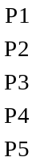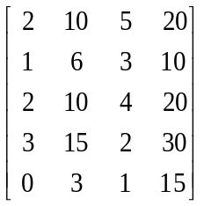
- Write the column matrix, with rows representing in order M, S, T and G, that represents the points for each way of scoring. (1 mark)
- Calculate the product of the matrix given above and the column matrix from 8(a). (2 marks)
- What is the total score for P1? Where in the matrix from 8(b) is this score located? (2 marks)
- Describe the data stored in the matrix generated in 8(b). (2 marks)

Question 9 (6 marks)
Three friends went on a trip overseas and brought back some unspent foreign currency which they need to exchange back to Australian dollars (AUD).
They have made a table showing the amounts of each currency they each have.
 | Bali (Indonesia) | Singapore | Hong Kong
Kate | 190 000 IDR | 200 SGD | 500 HKD
Guy | 175 000 IDR | 350 SGD | 250 HKD
Alex | 85 000 IDR | 75 SGD | 100 HKD
The exchange rates when they convert their money are as follows.
10 000 IDR (Indonesian rupiah) = 0.9700 AUD
1 SGD (Singapore dollars) = 0.8666 AUD
1 HKD (Hong Kong dollars) = 0.1410 AUD
- How many Australian dollars will Kate get for her Indonesian rupiah (assuming she pays no commission fees)? (1 mark)
- How many Australian dollars (to the nearest 10 cents) will Guy get for his Singapore dollars (assuming he pays no commission fees)? (1 mark)
- Using the same exchange rates as given in the table for Question 9, what is one Australian dollar worth (to the nearest cent) in Singapore dollars? (1 mark)
- Write a matrix operation to calculate the amount of Australian currency that each person will receive when their foreign currencies (as shown in the table for Question 9) are converted.
(3 marks)

Solutions and marking key for sample assessment task (Task 2 – Test 1)
Section One: Calculator-free (23 marks)
Question 1 (12 marks)
a) | Solution | Behaviours | Marks
i) | 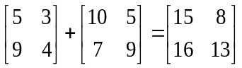 | Adds two matrices correctly | 1
ii) | Not possible as only matrices of the same size can be added | States not possible, with correct reasoning | 1
iii) | Not possible because the number of columns in Z does not equal the number of rows in X | States not possible, with correct reasoning | 1
iv) | 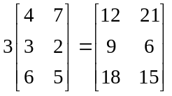 | Multiplies a matrix correctly by a scalar | 1

b) | Solution | Behaviours | Marks
i) | 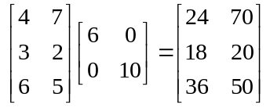  Matrix shows the total money received for the sale of small and large bunches in each Year 7 class | Multiplies two matrices correctly  Identifies each element as money totals for each class | 1  1
ii) | 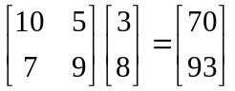  Matrix shows the total number of flowers required to make the bunches for each Year 9 class | Multiplies two matrices correctly  Identifies each element as total number of flowers for each class | 1  1
iii) | 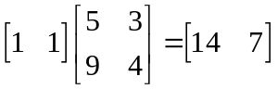  Matrix shows the total number of small bunches and the total number of large bunches sold to Year 8 | Pre-multiplies the matrix correctly  Identifies each element as total of each type of bunch for Year 8 | 1  1
iv) | 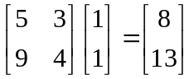  Matrix shows the total number of bunches sold to each Year 8 class | Post-multiplies the matrix correctly  Identifies each element as total number of bunches for each Year 8 class | 1  1

Question 2 (8 marks)
 | Solution | Behaviours | Marks
a) | 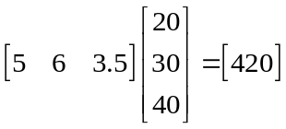  or  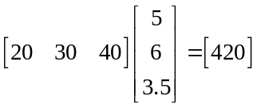  or  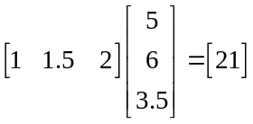  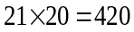  Gen will earn $420 | Creates a 1x3 row matrix showing hours worked  Creates a 3x1 column matrix showing pay rates (or similar combination)  Multiplies matrices in the correct order | 1  1  1
b) | =B4 * (C4 + D4 *1.5 + E4 * 2)  or similar | Uses correct cell references throughout  Correctly orders operations | 1  1
c) | (22 x 10) + (33 x 2) + (44 x 3)  = 418  418 – 350 = 68  68 x 50 cents = $34 | Determines rate for each day correctly  Finds difference between earning and base rate  Determines reduction in allowance based on income | 1  1  1
Question 3 (3 marks)
Solution | Behaviours | Marks
Large eggs cost 200c for 120 g  $\frac{20}{12}≈1.666$, 1.67c/g  Small eggs cost 100c for 45 g  $\frac{20}{9}≈2.222$, 2.22c/g  The larger eggs are the better value because they cost less per gram. | Accurately (1) divides number of cents by number of grams (1) for both sizes  Correctly concludes on the basis of less cost per gram | 1  1  1

Section Two: Calculator-assumed section (40 marks)
Question 4 (4 marks)
 | Solution | Behaviours | Marks
a) | 0.007184 x 80^{0.425} x 159^{0.725} | Correctly substitutes given values for pronumerals | 1
b) | 1.825 m² | Evaluates correctly  Expresses answer correct to four significant figures and using correct units | 1  1
c) | 18250 cm² | Multiplies accurately by 10 000 | 1
Question 5 (9 marks)
 | Solution | Behaviours | Marks
a) | G C N T  GCNT  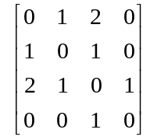 | Labels rows and columns  Has 0s on the leading diagonal  Enters correct data | 1  1  1
b) | Tina | States name of row where sum of elements is one | 1
c) | 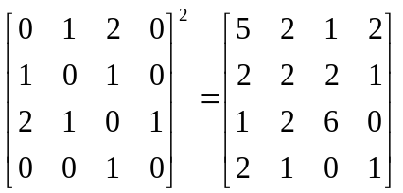 | Shows original matrix is multiplied by itself  States resulting 4x4 matrix with all elements correct | 1  1
d) | 0, the value of 0 means that Tina and Nick cannot message each other via another person | Identifies element in row 4, column 3 as 0  Explains that Nick and Tina cannot communicate via a third person | 1  1
e) | 9 | Determines the sum of the elements in column 3 of M² | 1

Question 6 (8 marks)
 | Solution | Behaviours | Marks
a) | For AAA Bank, P/E ratio = $\frac{3365}{207.5}$≈16.2  For ZZZ Bank, P/E ratio = $\frac{32055}{223.1}$≈14.4  ZZZ Bank has a lower P/E ratio so John would be paying less for every dollar of current earnings in ZZZ Bank than in AAA Bank  John should buy more of ZZZ Bank (other things being equal) | Calculates P/E ratios correctly for each bank (1 mark each)  Selects bank with the lowest ratio  Gives qualified reason/explanation as to why the bank with the lowest P/E ratio should be selected | 2  1  1
b) | Dividends paid  = 82+84 = 166c per share  Annual earnings per share = 207.5c  percentage of annual earnings distributed  =$\frac{166}{207.5}×100=80\%$ | Calculates the total dividend and divides by the annual earnings  Expresses this as a percentage | 1  1
c) | 65% of 223.1c = 145.015c  145.015 – 66 = 79.015  i.e. expected final dividend will be approximately 79.1 or 79.2 c | Determines 65% of the annual earnings  Subtracts the interim dividend to determine the final dividend | 1  1
Question 7 (6 marks)
 | Solution | Behaviours | Marks
a) |  | Identifies all values outside the ranges given as ideal  (1 if at least 3) | 2
   | HDL | Chol. | LDL | PTRI | Risk
  Ideal range | 1.1 to 3.5 | <5.5 | <3.5 | <1.5 | <3.5
  Year
  2009 | 1.4 | 5.7 | 3.8 | 1.1 | 4.1
  2011 | 1.6 | 7.2 | 5 | 1.3
  2012 | 1.3 | 5.2 | 3.4 | 1.1
  2013 | 1.5 | 5.4 | 3.4 | 1
  2014 | 1.7 | 4.9 | 2.8 | 0.8
b) | Risk = $\frac{Chol}{HDL}$ | Selects both variables correctly | 2
c) | Risk(2014) = $\frac{4.9}{1.7}$  = 2.9  Yes, within ideal range | Uses formula created to determine Risk  Identifies that result is in ideal range | 1  1

Question 8 (7 marks)
 | Solution | Behaviours | Marks
a) | 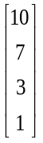 | Determines correct column matrix | 1
b) | 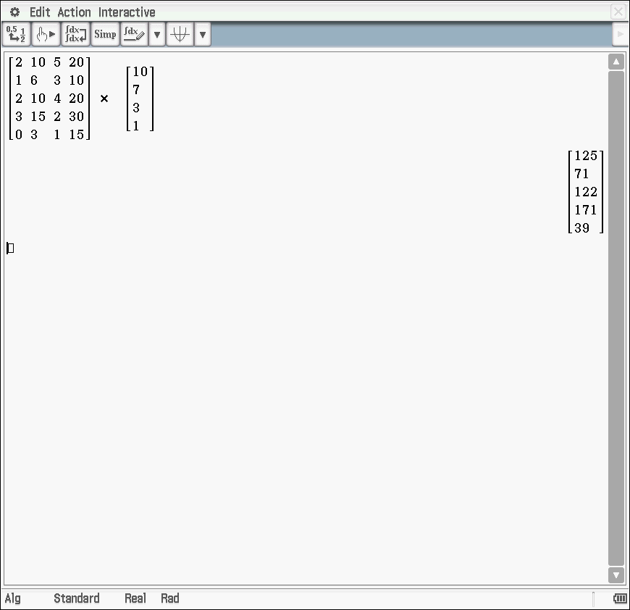 | Writes down the correct matrix product  Performs multiplication of matrices (using technology) | 1  1
c) | 125  Row 1 column 1 | Has the correct total for P1  Locates position of data in the matrix | 1  1
d) | Each row represents the total score for the players who are in row order of P1 to P5. | Identifies each row as belonging to a different player  Nominates data as being the total number of points | 1  1
Question 9 (6 marks)
 | Solution | Behaviours | Marks
a) | 19 x 0.97 = $18.43 | Divides by 10 000 and multiplies by 0.97 | 1
b) | 350 x 0.8666 = $303.30 | Multiplies by 0.8666 | 1
c) | 1 ÷ 0.8666 = $1.15 | Chooses division of correct numbers | 1
d) | 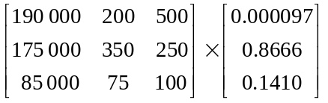  Or  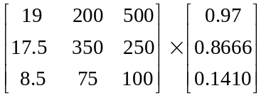 | Establishes correct matrices  Matrices are written in correct order  Uses matrix multiplication | 1  1  1

Sample assessment task

Mathematics Applications – ATAR Year 11

Task 7 (Investigation 3) – Unit 2
Assessment type: Investigation
This investigation provides an opportunity for students to demonstrate the use of the statistical investigative process using univariate data.
Notes for teachers
- Part A could be completed during class time or at home.
- Part B provides validation of the student work submitted in Part A and should be completed in class under supervised conditions.
While the Authority provides sample assessment tasks for guidance, it is the expectation of the Authority that teachers will develop tasks customised to reflect their school’s context and the needs of the student cohort. This resource is available on a public website and use of the resource without modification may affect the integrity of the assessment.

Part A
Materials required: Standard writing equipment
Calculator with graphing facilities (to be provided by the student)
Other materials allowed: In-class technology and/or calculator with graphic/statistical capabilities, drawing templates
Task weighting: 7% (5% from Part A: preparation activity and 2% from Part B: in-class validation)
Maximum number of marks for Part A: 24 marks
Task weighting for Part A:
5% of the school mark for this pair of units

Who are the better drivers?
A student in class has read an article that suggested that people in the 30–40-year-old age group are more careful when driving on the road than 20–30-year-olds.The student also added that a driver requires fast reflexes to be a good driver. This prompted a discussion with other students in the class who thought the ability to concentrate was also very important.
Investigate the statements made above and produce a report that justifies your answer to the question, ‘Who are better drivers?’
A completed statistical investigation should include:
- an introduction that outlines the question to be answered and any further questions that could be explored
- selection and application of suitable mathematical and graphical techniques you have studied to analyse the provided data
- interpretation of your results relating your answer to the original problem
- communication of your results and conclusions in a concise systematic manner.
Your investigation report should include the following.
- Introduction – two or three sentences providing an overview of your investigation and any statistical questions that can be used to support your findings. (3 marks)
- Numerical and graphical analysis
  - choose various statistical measures you have studied to analyse the data (5 marks)
  - consider the most appropriate graphs that represent the data provided. (5 marks)
- Interpretation of the results of this analysis in relation to the original question (7 marks)
  - describe any trend and pattern in your data (two to three sentences)
  - state how your data relates to the original problem (two to three sentences)
  - use your knowledge and understanding gained in this unit to explain your results (one paragraph).
- Conclusion (4 marks)
  - summarise your findings and conclusions (one paragraph).

Data
A sample of data is provided below. The data were generated from a random sample of 60 people who provided information on their reaction time using their dominant hand, and their concentration activity.
20–30-year-olds |  |  |  | 30–40-year-olds
 | Reaction time (sec)  (dominant hand) | Concentration  activity (secs) |  |  | Reaction time (sec)  (dominant hand) | Concentration  activity (secs)
1 | 0.03 | 52 |  | 1 | 0.35 | 35
2 | 0.38 | 61 |  | 2 | 0.51 | 61
3 | 0.39 | 34 |  | 3 | 0.35 | 38
4 | 0.39 | 22 |  | 4 | 0.32 | 43
5 | 0.44 | 38 |  | 5 | 0.37 | 43
6 | 0.31 | 24 |  | 6 | 0.38 | 47
7 | 0.43 | 41 |  | 7 | 0.37 | 48
8 | 0.34 | 19 |  | 8 | 0.31 | 64
9 | 0.56 | 59 |  | 9 | 0.37 | 38
10 | 0.34 | 44 |  | 10 | 0.31 | 43
11 | 0.38 | 40 |  | 11 | 0.45 | 33
12 | 0.56 | 41 |  | 12 | 0.37 | 38
13 | 0.37 | 56 |  | 13 | 0.31 | 31
14 | 0.44 | 33 |  | 14 | 0.34 | 52
15 | 0.32 | 50 |  | 15 | 2.61 | 58
16 | 0.31 | 41 |  | 16 | 0.35 | 34
17 | 0.35 | 40 |  | 17 | 0.4 | 49
18 | 18.62 | 60 |  | 18 | 0.31 | 35
19 | 0.35 | 47 |  | 19 | 0.32 | 47
20 | 0.34 | 47 |  | 20 | 0.42 | 37
21 | 0.94 | 50 |  | 21 | 0.35 | 36
22 | 0.32 | 28 |  | 22 | 0.32 | 38
23 | 0.35 | 38 |  | 23 | 0.41 | 43
24 | 0.37 | 40 |  | 24 | 0.31 | 60
25 | 0.4 | 58 |  | 25 | 0.32 | 36
26 | 0.45 | 43 |  | 26 | 0.35 | 47
27 | 0.34 | 34 |  | 27 | 0.3 | 30
28 | 0.32 | 27 |  | 28 | 0.14 | 35
29 | 0.3 | 39 |  | 29 | 0.36 | 41
30 | 0.67 | 77 |  | 30 | 0.27 | No data

Marking key for sample assessment task 7 – Part A
Sample introduction
After being posed the question, ‘Are 30–40-year-old drivers better than 20–30-year-old drivers?’ I have been asked to investigate this statement. While other factors may affect someone’s ability to drive, I will use the data provided showing reflex and concentration times to try to explore this statement.
Specific behaviours | Marks
Provides a simple introduction of the question | 1
Restates question in own words | 1
Mentions reflexes and concentration as two measures of driving ability | 1
Total | /3

Numerical analysis
 |  | Dominant  hand | Concentration activity
20–30-year-olds  (group A) | Mean | 0.38 | 42.77
20–30-year-olds  (group A) | Median | 0.36 | 41.00
20–30-year-olds  (group A) | Standard deviation | 0.07 | 12.94
30–40-year-olds  (group B) | Mean | 0.35 | 43.33
30–40-year-olds  (group B) | Median | 0.35 | 42.00
30–40-year-olds  (group B) | Standard deviation | 0.06 | 9.61

 | Group A dominant hand | Group B  dominant hand | Group A  concentration activity | Group B  concentration activity
Minimum | 0.3 | 0.14 | 19 | 30
Q1 | 0.34 | 0.31 | 34 | 36
Median | 0.37 | 0.35 | 40.5 | 42
Q3 | 0.43 | 0.37 | 47.75 | 47.75
Maximum | 0.56 | 0.51 | 61 | 64

Specific behaviours | Marks
Calculates measures of central tendency, including mean and median | 1
Calculates mean and median with outliers removed | 1
Calculates range | 1
Calculates standard deviation or interquartile range (IQR) | 1
Calculates standard deviation and IQR | 1
Total | /5

Graphical analysis
Box and whisker plots
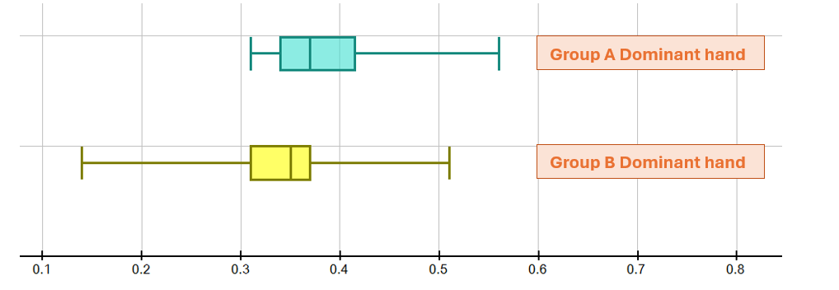
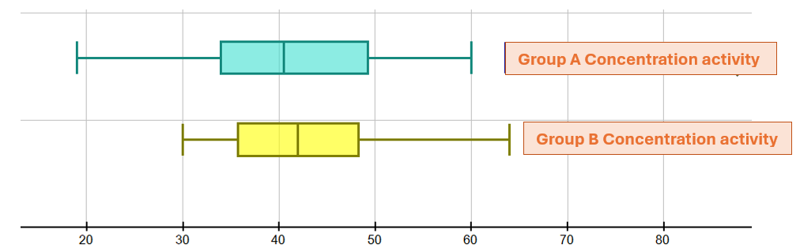
Back-to-back stem and leaf plots
 | Stem and leaf
Group A dominant hand | Seconds | Group B dominant hand
 | 0.0
 | 0.1 | 4
 | 0.2 | 7
9 9 8 8 7 7 5 5 5 4 4 4 4 2 2 2 1 1 0 | 0.3 | 0 1 1 1 1 1 2 2 2 2 4 5 5 5 5 5 6 7 7 7 7 8
5 4 4 3 0 | 0.4 | 0 1 2 5
6 6 | 0.5 | 1
7 | 0.6
 | 0.8

 | Stem and leaf
Group A concentration activity | Seconds | Group B concentration activity
 | 0
9 | 10
8 7 4 2 | 20
9 8 8 4 4 3 | 30 | 0 1 3 4 5 5 5 6 6 7 8 8 8 8
7 7 4 3 1 1 1 0 0 0 | 40 | 1 3 3 3 3 7 7 7 8 9
9 8 6 2 0 0 | 50 | 2 8
1 0 | 60 | 4
7 | 70
 | 80

Distributions: Dominant hand
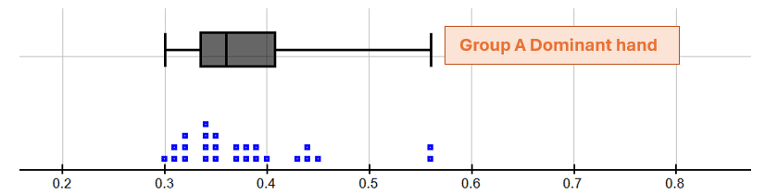
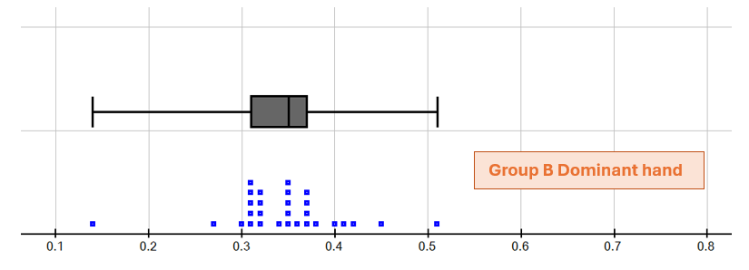
Distribution: Concentration activities
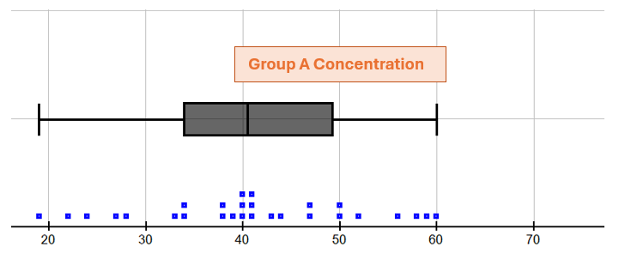
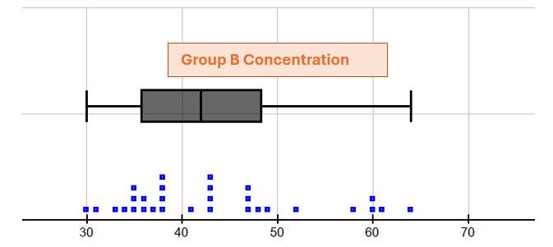
Specific behaviours | Marks
Constructs simple single graphs | 1
Shows comparative graphs: stem and leaf, histograms or dot frequency | 1
Uses box and whisker plots to compare group A and group B attributes | 1
Presents correct graphs, including labelling | 2
Total | /5

Interpretation
Discussion of frequency/proportion, measures of central tendency, removal of outliers and measures of spread
Sample interpretation:
It is clear from looking at measures of central tendency, such as mean and median, that group B performed faster on the reflex activity.
Outliers have been removed from six data points, as these would have increased the mean and median for group A reflexes.
Group A produced better results on the concentration activity, with the mean and median indicating group A were faster.
The range of scores for group B was higher for the reflex activity, and higher for group A on the concentration activity.
The interquartile ranges are higher for group A in both reaction times and the concentration activity.
On the concentration task, there was a greater range for the group A results, which is confirmed by the larger standard deviation compared with group B. The distribution for group A is symmetrical, but the group B distribution indicates a tail of people with larger times, indicating a positive skew in the results.
Specific behaviours | Marks
Discusses frequency | 1
Discusses proportion e.g. median | 1
Discusses removal of outliers and effects on mean and median | 1
Makes comparisons using measures of spread e.g. range, IQR | 1
Makes comparisons using central tendency measures: mean and median | 1
Discusses clusters of results in the data | 1
Interpretation linked to numerical and graphical data | 1
Total | /7

Conclusion
Short statement outlining summary of findings
Sample conclusion:
To summarise, while the mean and median scores were better for 30–40-year-olds than those for 20⁠–⁠30-year-olds for the reflex activity, 20–30-year-olds concentration times were better than 30–40-year-olds, with a cluster of the older group showing slower concentration results and a significant number of younger people demonstrating very good concentration results (with the median being lower than the mean).
Reaction times and concentration are important skills for driving, but we would need to make a study of other skills or data to answer the question posed. Other skills are important, such as general knowledge and adherence to road rules, risk taking behaviour etc. Road accident statistics could also help to answer the question.
Specific behaviours | Marks
Makes a valid statement about the results | 1
Relates conclusion back to the original question | 1
Proposes that other data should be collected to help answer question | 1
Provides a concise and coherent summary of the analysis | 1
Total | /4

Part B: In-class validation
Time allowed for this task: Up to 50 minutes, in class, under supervised conditions
Materials required: Standard writing equipment, calculator with graphic/statistical capabilities, drawing templates
Marks available: 31 marks
Task weighting for Part B: 2%
Some of the students who completed the activity in Part A thought that the non-dominant hand reaction time could also provide significant evidence in answering the question.
Another sample of data was extracted and is provided below. The data were generated from a random sample of 50 people who provided the information. The tables below display the participants’ reaction times using their non-dominant hand, and the results for the concentration activity.
20–30-year-olds |  |  |  |  | 30–40-year-olds
 | Reaction time (sec)  (non-dominant hand) |  | Concentration  activity (sec) |  |  |  | Reaction time (sec)  (non-dominant hand) | Concentration  activity (sec)
1 | 0.42 | 69 |  |  | 1 | 0.33 |  | 5
2 | 0.35 | 36 |  |  | 2 | 0.38 |  | 5
3 | 0.97 | 66 |  |  | 3 | 0.37 |  | 60
4 | 0.33 | 49 |  |  | 4 | 3.3 |  | 15
5 | 0.37 | 54 |  |  | 5 | 0.35 |  | 5
6 | 0.38 | 31 |  |  | 6 | 0.29 |  | 3
7 | 0.37 | 36 |  |  | 7 | 0.32 |  | 2
8 | 0.44 | 31 |  |  | 8 | 0.32 |  | 10
9 | 0.47 | 51 |  |  | 9 | 0.28 |  | 2
10 | 2 | 50 |  |  | 10 | 0.45 |  | 25
11 | 1.6 | 35 |  |  | 11 | 0.39 |  | 30
12 | 0.36 | 50 |  |  | 12 | 0.36 |  | 6
13 | 0.45 | 30 |  |  | 13 | 0.4 |  | 30
14 | 0.29 | 41 |  |  | 14 | 0.47 |  | 5
15 | 0.4 | 33 |  |  | 15 | 0.38 |  | 17
16 | 0.4 | 28 |  |  | 16 | 0.34 |  | 20
17 | 0.18 | 46 |  |  | 17 | 0.37 |  | 8
18 | 0.32 | 32 |  |  | 18 | 0.33 |  | 10
19 | 0.4 | 28 |  |  | 19 | 0.42 |  | 20
20 | 0.35 | 56 |  |  | 20 | 2.4 |  | 10
21 | 0.42 | 33 |  |  | 21 | 0.3 |  | 10
22 | 0.39 | 24 |  |  | 22 | 0.29 |  | 10
23 | 0.42 | 34 |  |  | 23 | 0.37 |  | 25
24 | 0.4 | 36 |  |  | 24 | 0.38 |  | 45
25 | 0.32 | 33 |  |  | 25 | 0.31 |  | 11

Question 1 (12 marks)
One of the class members conducted a numerical analysis of the data, producing the following results.
 |  | Non-dominant  hand | Concentration  activity
20–30-year-olds  (group C) | Mean | 0.512 | 40.48
20–30-year-olds  (group C) | Median | 0.4 | 36
20–30-year-olds  (group C) | Standard deviation | 0.405 | 11.88
30–40-year-olds  (group D) | Mean | 0.556 | 15.56
30–40-year-olds  (group D) | Median | 0.37 | 10
30–40-year-olds  (group D) | Standard deviation | 0.69 | 13.82

 | Group C  non-dominant | Group D  non-dominant | Group C  concentration | Group D  concentration
Minimum | 0.18 | 0.28 | 28 | 2
Q1 | 0.35 | 0.32 | 31.5 | 5
Median | 0.4 | 0.37 | 36 | 10
Q3 | 0.43 | 0.395 | 50 | 22.5
Maximum | 2 | 3.3 | 69 | 60
She also provided the following graphical display of the data on reaction time.
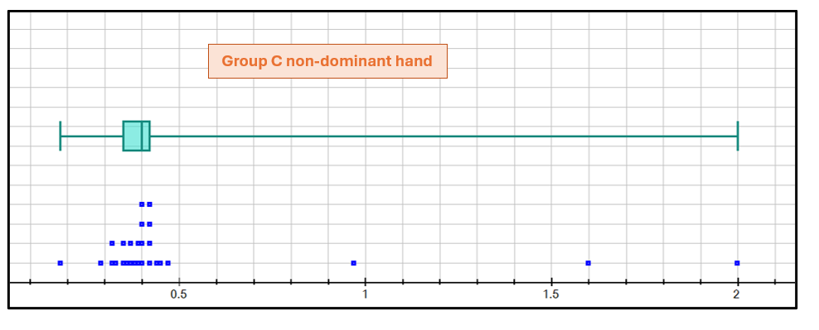
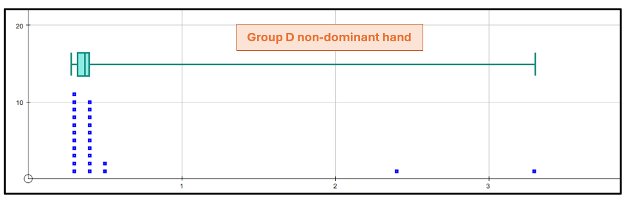
Another class member argued that this was misleading, as the data obviously included outliers, and these should be removed before drawing conclusions. She provided the following alternative, but incomplete, analysis, after the removal of outliers.
 |  | Non-dominant  hand | Concentration  activity
20–30-year-olds  (group C) | Mean | 0.38
20–30-year-olds  (group C) | Median | 0.38
20–30-year-olds  (group C) | Standard deviation | 0.045
30–40-year-olds  (group D) | Mean | 0.36
30–40-year-olds  (group D) | Median | 0.36
30–40-year-olds  (group D) | Standard deviation | 0.049

 | Group C  non-dominant | Group D  non-dominant | Group C  concentration | Group D  concentration
Minimum | 0.29 | 0.28
Q1 | 0.35 | 0.32
Median | 0.39 | 0.36
Q3 | 0.42 | 0.38
Maximum | 0.47 | 0.47
- Remove any outliers from the data, providing evidence of how you decided which data were outliers, and complete the tables above. (6 marks)

The distributions of the reaction times for both groups, with outliers removed, are displayed below.
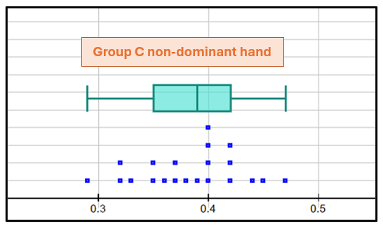
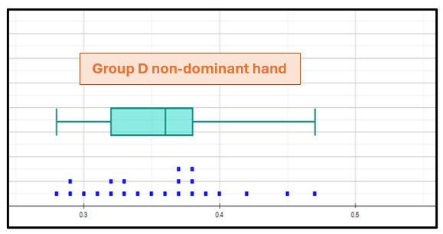
- Interpret these displays and state any conclusions that you think can be drawn from the data relating to the non-dominant hand reaction times of each group. (6 marks)

Question 2 (12 marks)
- Provide a suitable graphical display for the comparison of the data relating to the concentration activity. (6 marks)
- Interpret your graphical displays and state any conclusions that you think can be drawn from the data relating to the concentration activity times of each group. (6 marks)

Question 3 (7 marks)
Summarise your overall findings and conclusions, based on analysis of the data provided, in relation to the original question.

Marking key for sample assessment task 7 – Part B
Question 1
- Using data from calculator for
Group C: Q₃ – Q₁ =18.5, so for outliers, the concentration time needs to be less than 3.75
(= Q₁ -1.518.5) or greater than 81.5 (= Q₃ +1.518.5). Hence no outliers in the data.
Group D: Q₃ – Q₁ =17.5, so for outliers, the concentration time needs to be less than 0 or greater than 48.75. Hence, no outliers below Q_{1,} but the 60 needs to be removed as an outlier above Q₃.
 |  | Non-dominant  hand | Concentration activity
20–30-year-olds  (group C) | Mean | 0.38 | 40.48
20–30-year-olds  (group C) | Median | 0.38 | 36
20–30-year-olds  (group C) | Standard deviation | 0.045 | 11.88
30–40-year-olds  (group D) | Mean | 0.36 | 13.75
30–40-year-olds  (group D) | Median | 0.36 | 10
30–40-year-olds  (group D) | Standard deviation | 0.049 | 10.64

 | Group C  non-dominant | Group D  non-dominant | Group C  concentration | Group D  concentration
Minimum | 0.29 | 0.28 | 28 | 2
Q1 | 0.35 | 0.32 | 31.5 | 5
Median | 0.39 | 0.36 | 36 | 10
Q3 | 0.42 | 0.38 | 50 | 20
Maximum | 0.47 | 0.47 | 69 | 45

Specific behaviours | Marks
Calculates Q₃ – Q₁ | 1
Calculates the correct ‘boundaries’ to identify outliers | 1
Identifies no outliers for group C and enters the required statistics correctly | 1
Identifies the need to remove the 60 from the group D data | 1
Calculates and enters the required new statistics for group D correctly | 2
Total | /6
- Reaction time comparisons
After the removal of outliers, the median reaction time for group D is slightly less than for group C (0.36 compared with 0.39 seconds), and while there is not much difference in the range between the two data sets (min: 0.28 (D) 0.29(C) and max: 0.47(D and C)), Q₃ is higher for group C than group D (0.42 compared with 0.38). The distribution for group C is skewed towards higher reaction times compared with the distribution for group D, which is skewed towards lower reaction times. Overall, this tends to suggest that
30–40-year-olds have lower reaction times (although it is only a small sample).

Specific behaviours | Marks
Discusses proportion e.g. median | 1
Makes comparisons using measures of spread e.g. range, IQR | 1
Makes comparisons using central tendency measures: mean and median | 1
Discusses clusters of results or skewness in the data | 2
Links results and draws inferences relating to original question | 1
Total | /6
Question 2
- Graphical displays
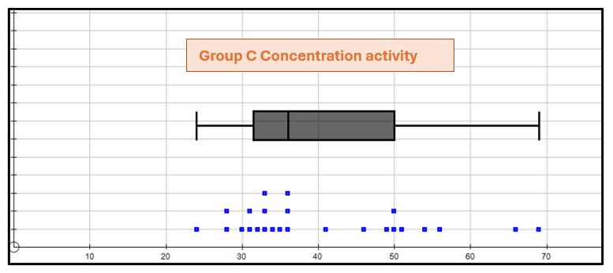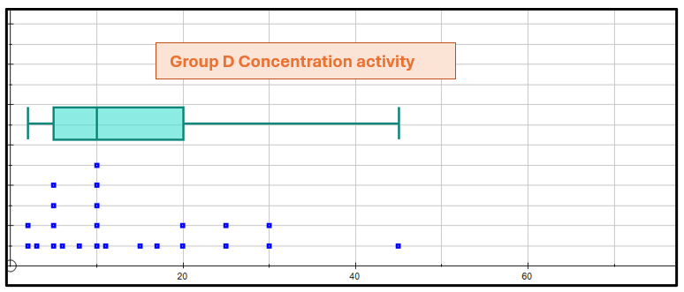
Specific behaviours | Marks
Constructs simple single graphs | 1
Shows comparative graphs: stem and leaf, dot frequency etc. | 1
Uses box and whisker plots to compare attributes | 1
Presents correct graphs, including labelling | 2
Graphs reflect use of data with outliers removed | 1
Total | /6

- Discussion of frequency/proportion, measures of central tendency and measures of spread.
Sample interpretation:
Group C produced far better results on the concentration activity, with the mean and median indicating
20–30-year-olds concentrate for longer. The interquartile range for both groups is roughly the same, but the standard deviation of the 20–30-year-olds was higher than for the 30–40-year-olds. 75% of the
30–40-year-olds surveyed had a lower concentration time than the 20–30-year-olds with the lowest time.
The distribution for 20–30-year-olds is more symmetrical, although both distributions indicate a close clumping of people at the lower end of the data. However, there is more clumping of 30–40-year-olds in the lower half.
Specific behaviours | Marks
Discusses frequency | 1
Discusses proportion, e.g. median | 1
Makes comparisons using measures of spread, e.g. range, IQR | 1
Makes comparisons using central tendency measures: mean and median | 1
Makes comment about the skewness or symmetry of the distributions | 1
Draws an appropriate conclusion/s | 1
Total | /6
Question 3
Statement outlining summary of findings and any conclusions drawn.
Sample:
To summarise, while the mean and median scores were slightly better for 30–40-year-olds (group C) than those for 20–30-year-olds (group D) for the non-dominant hand reaction time activity, group C concentration times were far better than group D, with all the younger participants showing a better concentration time than 75% of the older participants.
Reaction times and concentration are important skills for driving and if they were the only factors, then it could be concluded that ‘20–30-year-olds are better drivers than 30–40-year-olds’. However, there is a need to make a study of other skills or data to answer the question posed. Other skills are important, such as general knowledge and adherence to road rules, risk taking behaviour etc. Road accident statistics could also help to answer the question.
Specific behaviours | Marks
Makes valid statement(s) about the results | 2
Provides a concise and coherent summary of the analysis | 2
Relates conclusion back to the original question | 1
Proposes that other data should be collected to help answer question | 2
Total | /7

