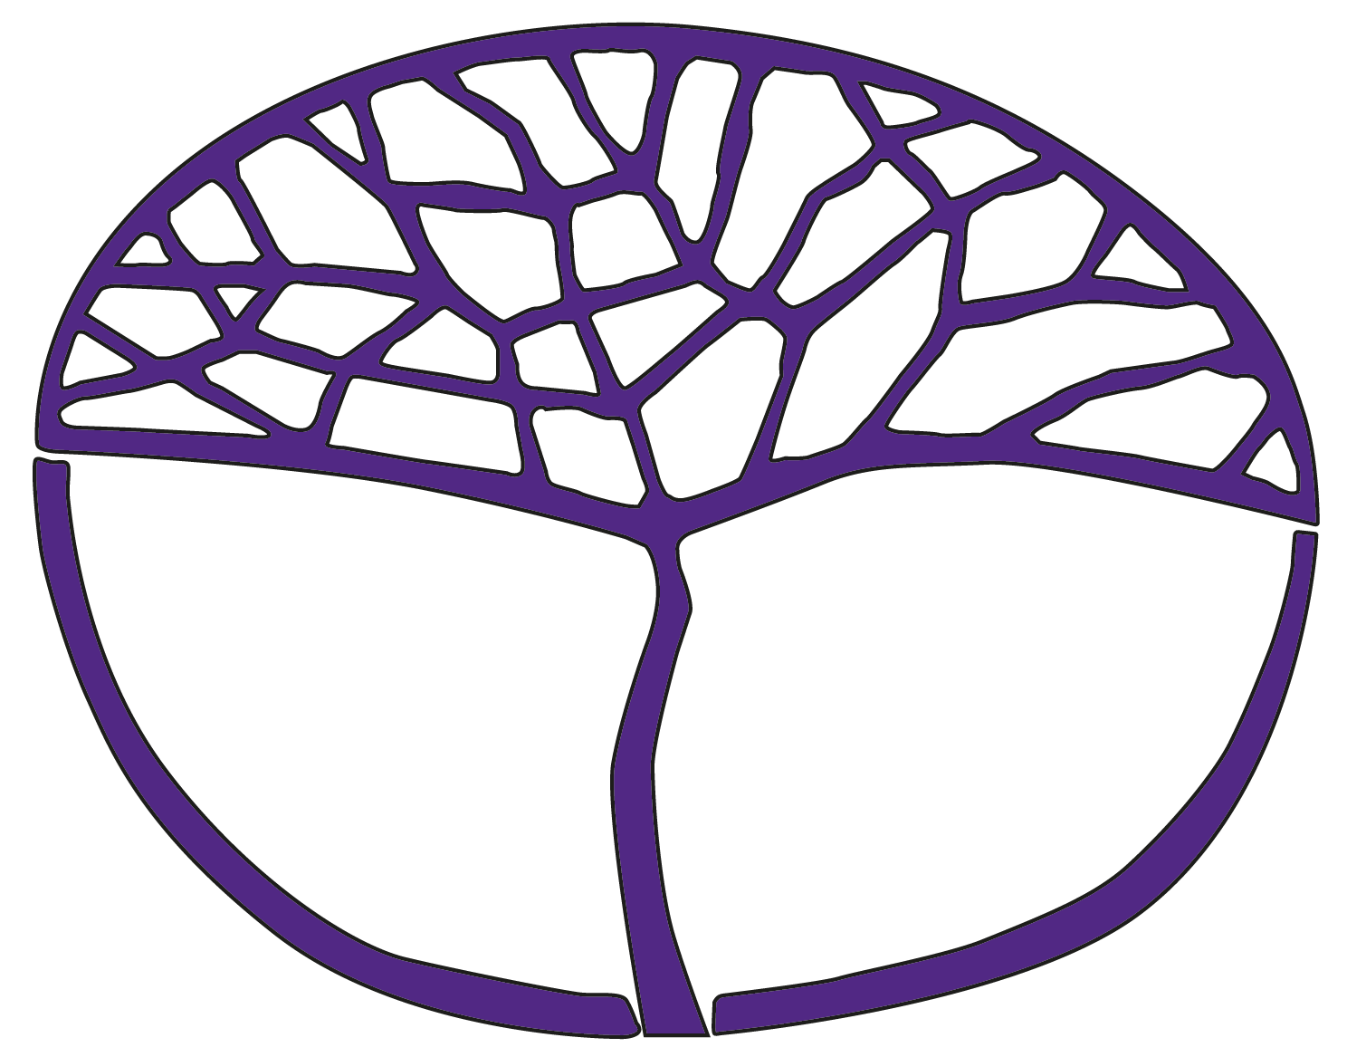Sample Assessment Outline

Aboriginal and Intercultural Studies

ATAR Year 12

**Acknowledgement of Country**

Kaya. The School Curriculum and Standards Authority (the Authority) acknowledges that our offices are on Whadjuk Noongar boodjar and that we deliver our services on the country of many traditional custodians and language groups throughout Western Australia. The Authority acknowledges the traditional custodians throughout Western Australia and their continuing connection to land, waters and community. We offer our respect to Elders past and present.

**Copyright**

© School Curriculum and Standards Authority, 2024

This document – apart from any third-party copyright material contained in it – may be freely copied, or communicated on an intranet, for non-commercial purposes in educational institutions, provided that the School Curriculum and Standards Authority (the Authority) is acknowledged as the copyright owner, and that the Authority’s moral rights are not infringed.

Copying or communication for any other purpose can be done only within the terms of the *Copyright Act 1968* or with prior written permission of the Authority. Copying or communication of any third-party copyright material can be done only within the terms of the *Copyright Act 1968* or with permission of the copyright owners.

Any content in this document that has been derived from the Australian Curriculum may be used under the terms of the [Creative Commons Attribution 4.0 International licence](https://creativecommons.org/licenses/by/4.0/).

**Disclaimer**

Any resources such as texts, websites and so on that may be referred to in this document are provided as examples of resources that teachers can use to support their learning programs. Their inclusion does not imply that they are mandatory or that they are the only resources relevant to the course. Teachers must exercise their professional judgement as to the appropriateness of any they may wish to use.

Sample assessment outline

Aboriginal and Intercultural Studies – ATAR Year 12

Unit 3 and Unit 4

|  |  |  |  |  |
| --- | --- | --- | --- | --- |
| Assessment type  (from syllabus) | Assessment  type weighting (from syllabus) | Assessment  task weighting | When/start and submission date | Assessment task |
| **Inquiry** | 20% | 10% | Semester 1  Weeks 8–10 | **Task 2:** Inquiry investigating Unit 3 – Diversity and change regarding the forced removal of children from their families.  This task will include an investigation, followed by an in-class validation and reflection based on unseen questions, directly connected to the content of the inquiry. |
| 10% | Semester 2  Weeks 3–5 | **Task 5:** Inquiry investigating Unit 4 – Place and belonging regarding *Terra Nullius* and Native Title.  This task will include an investigation, followed by an in-class validation and reflection based on unseen questions, directly connected to the content of the inquiry. |
| **Response** | 40% | 10% | Semester 1  Week 7 | **Task 1:** A series of short-answer questions and one extended response question based on sources and content from Unit 3 – Cultural perspectives, and Place and belonging. Conducted in class under test conditions. |
| 10% | Semester 1  Week 14 | **Task 3:** A series of short-answer and extended response questions based on sources and content from Unit 3 – Diversity and Change, and Australian First Nations Peoples’ contributions to Australian society. Conducted in class under test conditions. |
| 10% | Semester 2  Week 9 | **Task 6:** A series of short-answer questions based on sources and content from Unit 4 – Empowering people. Conducted in class under test conditions. |
| 10% | Semester 2  Week 13 | **Task 7:** A series of short-answer and extended response questions based on sources and content from Unit 4 – Relationships with the environment over time. Conducted in class under test conditions. |
| **Examination** | 40% | 15% | Semester 1  Week 15 | **Task 4: Semester 1 examination** – 3 hours plus 10 minutes reading time  Section One – short answer, 10 –15 questions, 60% of the total examination  Section Two – extended response, 40% of the total examination |
| 25% | Semester 2  Week 15 | **Task 8:** **Semester 2 examination** – 3 hours plus 10 minutes reading time  Section One – short answer, 10 –15 questions, 60% of the total examination  Section Two – extended response, 40% of the total examination |
| **Total** | **100%** | **100%** |  |  |