Media Production and Analysis
Year 12 | ATAR
Lesson-by-lesson package on Pre-Production Planning

Acknowledgement of Country
Kaya. The School Curriculum and Standards Authority (the Authority) acknowledges that our offices are on Whadjuk Noongar boodjar and that we deliver our services on the country of many traditional custodians and language groups throughout Western Australia. The Authority acknowledges the traditional custodians throughout Western Australia and their continuing connection to land, waters and community. We offer our respect to Elders past and present.
Copyright
© School Curriculum and Standards Authority, 2022
This document – apart from any third party copyright material contained in it – may be freely copied, or communicated on an intranet, for non-commercial purposes in educational institutions, provided that the School Curriculum and Standards Authority (the Authority) is acknowledged as the copyright owner, and that the Authority’s moral rights are not infringed.
Copying or communication for any other purpose can be done only within the terms of the Copyright Act 1968 or with prior written permission of the Authority. Copying or communication of any third party copyright material can be done only within the terms of the Copyright Act 1968 or with permission of the copyright owners.
Any content in this document that has been derived from the Australian Curriculum may be used under the terms of the Creative Commons Attribution 4.0 International licence.
Disclaimer
This lesson-by-lesson package is an additional support document based on a Media Production and Analysis, 12 ATAR teacher’s interpretation of syllabus content. This syllabus content was identified as new or changed in the Media Production and Analysis 12 ATAR syllabus reviewed for teaching in 2023.
Any resources such as texts, worksheets, websites and so on that may be referred to in this document are provided as examples of resources that teachers can use to support their learning programs. Their inclusion does not imply that they are mandatory or that they are the only resources relevant to the course.
Company names or names of products referred to in this document are used for education related, non-commercial and descriptive purposes only. These names may be registered trademarks and the property of their respective owners.

Pre-production planning

Aims
By the end of this package, students should have developed strong understanding of:
- exploring and evaluating the ideas of others to inform the development of own ideas
- selecting appropriate strategies and formats to document and communicate ideas
- constructing own production/s to communicate theme/s for a specific purpose, context and/or audience
- reflecting on, modifying and refining ideas and documentation
- independent management of pre-production, production and post-production processes.

Package structure
This lesson-by-lesson set is a Project-based Learning package. Typically, students are introduced to an overarching project at the beginning of the set, and the lessons throughout will assist them in arriving at their final product. This lesson set will span a number of weeks, covering the following areas:
- synopsis
- treatment
- script
- storyboard.

Project overview
Students will have developed their final production idea from synopsis to storyboard format. This is a large project that will take several lessons that can be interspersed with theory lessons if needed.
For full details on production project requirements, see the SCSA website at https://senior-secondary.scsa.wa.edu.au/syllabus-and-support-materials/arts/media-production-and-analysis.
Each section has been given an estimated timeframe to ensure that students are on track. Teachers can apply a level of flexibility as ideas develop, but should also prevent students wasting time, such as taking several weeks to develop a synopsis.
At the end of each section, there is a review with both a teacher and critical friend to ensure that theme is consistently being reinforced.

Lesson section 1: synopsis (estimated time 1 week)
Objective of lesson section:
Develop a synopsis.
Syllabus links:
- selecting appropriate strategies and formats to document and communicate ideas
- constructing own production/s to communicate theme/s for a specific purpose, context and/or audience.
- Outline ATAR Media Final Production criteria
Production must be five minutes maximum.
Must include exploration of theme.
Can be fiction or non-fiction.
For further criteria to explore, see most up-to-date Practical (production) examination requirements on the School Curriculum and Standards Authority website at https://senior-secondary.scsa.wa.edu.au/syllabus-and-support-materials/arts/media-production-and-analysis.
Examine the Practical (production) examination marking key for how productions are assessed.
- Watch successful year 12 ATAR films for inspiration
Some quality examples from Perspectives 2022 at https://sites.google.com/view/sharedmediaresources/media-perspectives-2022?authuser=0.
Charlotte and Jane at https://www.youtube.com/watch?v=6391nFR2mXk.
Golden Soil at https://drive.google.com/file/d/1phrnrXk9kh8AATdRZuQmYv5_F-x7n5nX/view.
A Sticky Situation at https://www.youtube.com/watch?v=FeFBBq_7sPI.
- Students begin ‘Synopsis’
Synopsis. Students are to write a four-sentence overview of their intended narrative or documentary. This should include a character arc, or a narrative arc that leads the protagonist through a ‘change’ or revelation. The theme should be apparent in the character’s journey. Details very light.
Purpose of this step is to define the theme and intended message.
Note: this is subject to change as student writes the treatment and begins to develop their characters and story progression.
Note for documentaries: students must have a clear intention for their documentary to guide their investigations. They will not necessarily know exactly what interviewees will say, but their questions will dictate the way an issue and theme is framed.
For teacher support materials, see end of package.
- Section close
Students find a ‘critical friend’ who they need to pitch the synopsis to and get feedback from. Teacher collects synopsis (or receives pitch from student) to help define idea and ensure student has clear theme to develop.
Student refines synopsis based on feedback in class or for homework.

Lesson section 2: treatment (estimated time 1-2 weeks)
Objective of lesson section:
Develop synopsis into a treatment.
Syllabus links:
- constructing own production/s to communicate theme/s for a specific purpose, context and/or audience
- reflecting on, modifying and refining ideas and documentation.
- Writing a treatment
For the treatment, students will flesh out the finer details of the story and the events that occur. To be written like a narrative, including feelings and emotions intended, but not necessarily shot types.
Purpose of this step is to construct the causal effects of conflicts and resolutions. At this stage it is very easy to identify plot holes and character inconsistencies and also flesh out how the theme resonates. Students may change the theme and message at this point. The tone of the story should be very apparent at this stage.
Note: this is the most important stage for documentaries, and often in the professional industry they will be the source of most planning. This will include the types of documentary styles/techniques intended to be used, such as montages, juxtapositions and interviews. Students are allowed to go into a documentary with a goal, and ultimately change this as they learn more. The teacher should provide flexibility here while ensuring students don’t just ‘wing it’. This type of personal investigative growth is an excellent framework for a narrative in a documentary.
For teacher support materials, see end of package.
- Submission and critical friend review
Students to submit to teacher and critical friend for feedback.
Key questions:
- Do the characters act logically?
- Are there any plot holes?
- Is the theme consistent throughout?
- Does the intended genre and narrative consistently support the theme?
- Are there any further opportunities to reinforce the theme?
- Student takes away feedback to improve draft
Can be done in class or as homework.

Lesson section 3: script format (estimated time 1-2 weeks)
Objective of lesson section:
Bring treatment to script format
Syllabus links:
- exploring and evaluating the ideas of others to inform the development of own ideas
- selecting appropriate strategies and formats to document and communicate ideas
- constructing own production/s to communicate theme/s for a specific purpose, context and/or audience
- reflecting on, modifying and refining ideas and documentation
- independent management of pre-production, production and post-production processes.
- Scriptwriting
Student will convert their treatment into a proper industry-standard script format.
Any script formatting software, such as celtx, StudioFinder or Final Draft, will work.
View How to write a script at https://openlab.citytech.cuny.edu/comd3523-fa2016/files/2016/09/sample-screenplay-page.gif.
Purpose of this step is for students to prepare their film to pre-production level. Students should have a very clear theme by this stage and shouldn’t need to change it. Rule of thumb, one script page = one minute of film time. If students have created a 12 page script, this will certainly be too long for the intended time requirements. Students need to label each scene with headings and numbers for easier storyboarding and shotlisting. Students will start thinking about how each scene will play out visually and can include shot types, but it is not essential. Some directors include shot types in their script, such as James Cameron (for example, see the script for Terminator 2 Judgment Day at https://www.scriptslug.com/script/terminator-2-judgement-day-1991), but this is not an expectation. Primary purpose is utility for production.
For teacher support materials, see end of package.
- Submission and critical friend review
Students to submit to teacher and critical friend for feedback.
Key questions:
- Is the script formatted properly, including scene numbers, for easy production?
- Is there sufficient detail in the script – i.e. no large areas where plot hasn’t been developed?
- Student takes away feedback to improve draft.
Can be done in class or as homework.

Lesson section 4: storyboard and further planning documents (estimated time two weeks)
Objective of lesson section: convert script into storyboard and further planning documents.
Syllabus link:
- exploring and evaluating the ideas of others to inform the development of own ideas
- selecting appropriate strategies and formats to document and communicate ideas
- constructing own production/s to communicate theme/s for a specific purpose, context and/or audience
- reflecting on, modifying and refining ideas and documentation.
- Storyboard
Students convert their script into visual ideas, considering the look and feel of each shot and how best to deliver their ideas to the screen. They will start to consider framing, mise-en-scene and other art direction. Each shot needs to be labelled and correspond to scene headings in their script for easier shooting processes and planning. At this stage, students should be considering colours that best exemplify their theme.
For help with choosing colours, students can use the colour wheel tool at https://www.canva.com/colors/color-wheel/.
The objective is to consider the use of film techniques to explore theme – not the drawing quality.
For teacher support materials, see bottom of package.
- Further planning
Further planning documents. Shot list, lighting plans, prop lists, mood board.
Shot list – not required but can assist with complex shoots that have many set ups and need to be shot out of sequence, or in locations available for a very limited time where efficiency is key. It is important to allow students time on set to explore visuals and play around with potentially stronger angles and shots.
Lighting plans – not essential, but can assist in shoots that require strong, intentional lighting where the students know the layout of the venue very clearly. Lighting can be emergent and unless students have extensive experience in this domain, lighting plans should be avoided. It often takes ‘seeing’ the shot on camera to ensure the lighting is working as intended.
Prop lists – this is an essential element, and some students will definitely arrive on set without key props if this is not built into a checklist.
Casting – have students cast their film?
For teacher support materials, see end of package.

- Submission and critical friend review
Students to submit to teacher and critical friend for feedback.
Key questions:
- Are there further opportunities for visual storytelling?
- Has the student forgotten any key props?
- Student takes away feedback to improve draft
Can be done in class or as homework.
- Section close
Recommended to bring script to lesson-by-lesson package on Art Direction for development of mood board.
- Are students prepared to go away and shoot their film?
- Do they need further technical skills?
- Have they sourced actors?
- Are the students planning to do rehearsals?
- Location scouting?

Lesson section 1: support materials
PowerPoint from SCSA Curriculum Session MPA 2023 at https://www.slideshare.net/AndrewWare24/theme-and-preproduction.
Film Title: ‘Sticky Situation’
Synopsis:
A young writer and filmmaker, Robert Wilson is creating a story but is unsure how to link the ending of his next story and considers giving up. A small drawing Robert created, a Stickman, comes to life and goes on a fun adventure to help his creator finish and bridge the gap in his story. Through perseverance with an idea, Robert has a stroke of creative inspiration and is able to complete the narrative.
Synopsis Planning ‘Charlotte and Jane’
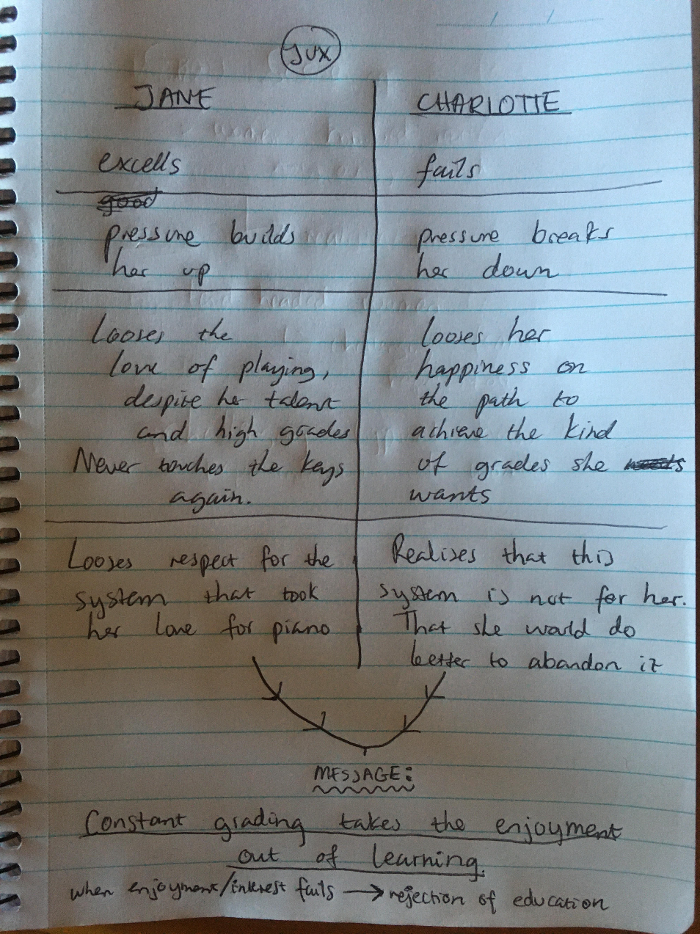
‘If we juxtapose the characters to show that regardless of whether you succeed or fail under the ATAR system, constant grading takes the enjoyment out of learning.
For Jane, despite her achievements, she loses her love for piano. She completes high school as a top student, yet loses all respect for the education she had.
For Charlotte, she spends all her time trying desperately to do well, and finds no enjoyment in this constant struggle. She ends up rebelling against the system and drops out. This education has broken Charlotte.
In this system, the focus of education is on the grade.
The worth of these characters is in their grade.
Neither of them find any enjoyment from it.
And when enjoyment dies, interest fails.
And it is disinterest that causes kids to reject education. To rebel against the system.
So the message is: constant grading takes the enjoyment out of learning.’
Synopsis intro ‘Golden Soil’
Golden Soil is an art-house film with elements of documentary style through Italian neo realism rhetoric and meat pie Western rhetoric that documents the evolution of land, not in terms of its composition, but in terms of its significance to society. The significance of land changes with its ownership, but the idea of the art film is not this simple. The documentary is aimed at conveying the significance of land, to the indigenous people of Australia, and how the unfair change in ownership has meant that the purpose of land is not to be a part of the ecosystem anymore, as thought of by the Indigenous people, but merely a place to live on by recent colonisation. Thus, this art-house film aims to showcase how land has lost significance as a being, and that it has unfairly changed ownership forcibly, meaning the ecosystem established for thousands of years is ruptured and destroyed. The film is subjective, as it is from the perspective of the indigenous man, however, it has elements of objectivity, as the man does not tell his personal story, just the experience of indigenous culture throughout Australia.

Lesson section 2: treatment support materials
A Sticky Situation Treatment draft with aspects that teacher should be looking out for when providing feedback.
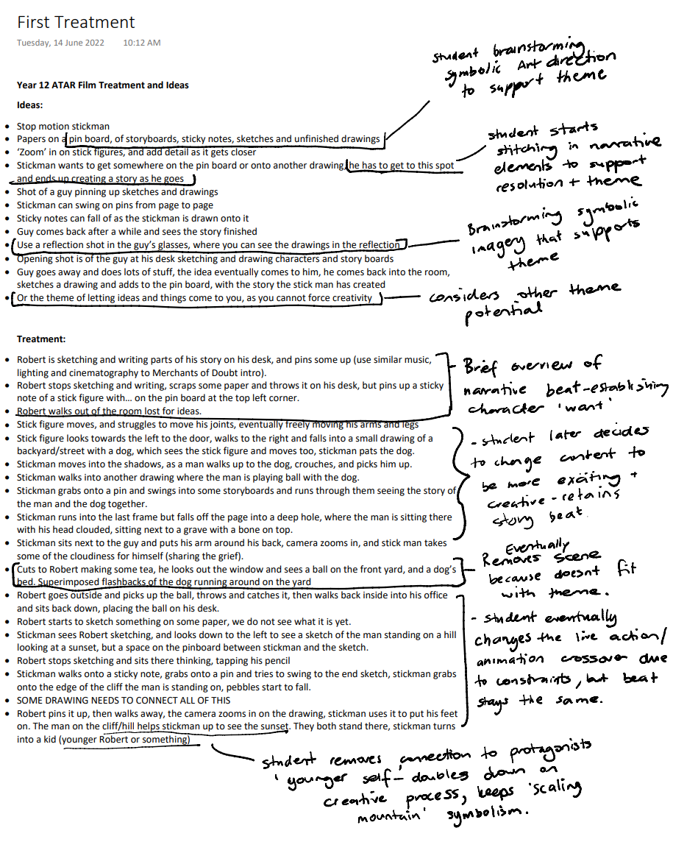

A Sticky Situation Final Treatment
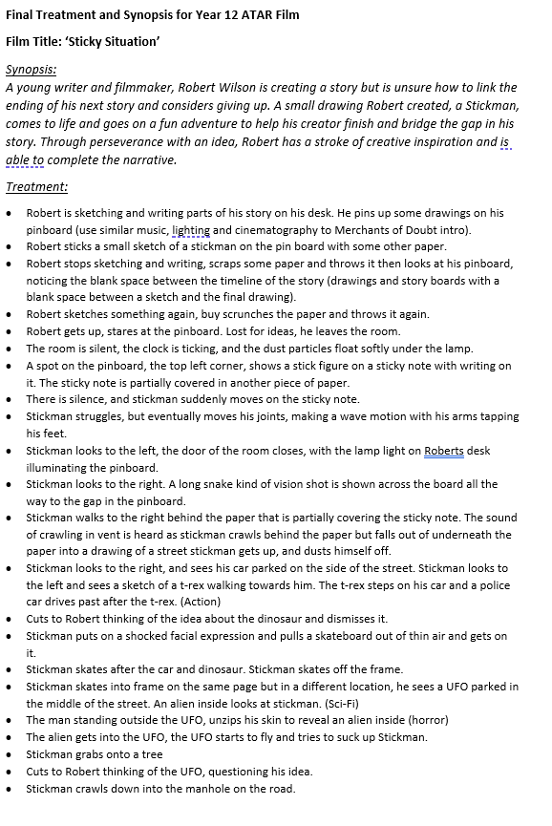
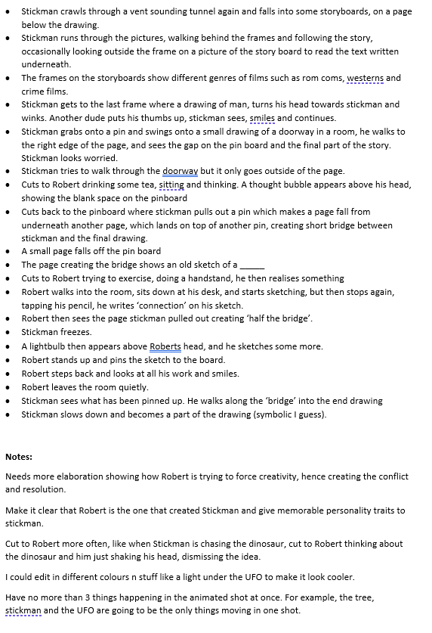

Excerpt from “Golden Soil” scene breakdown: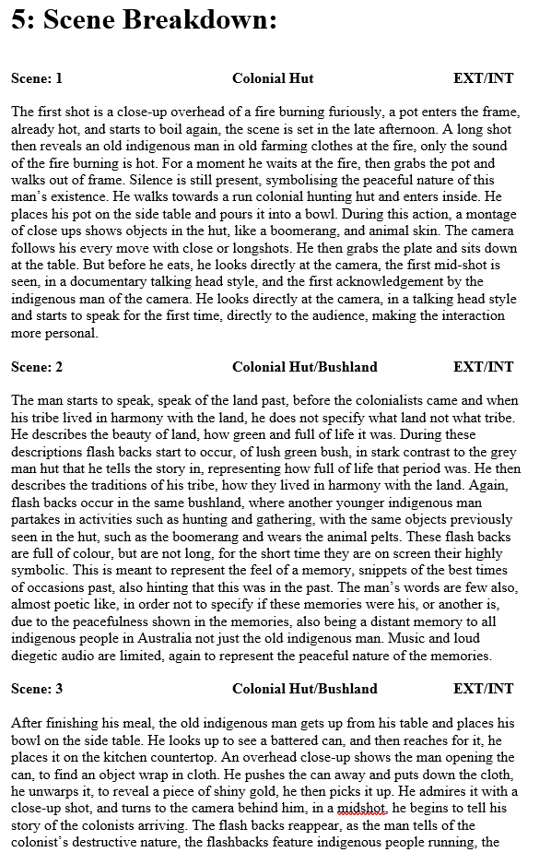
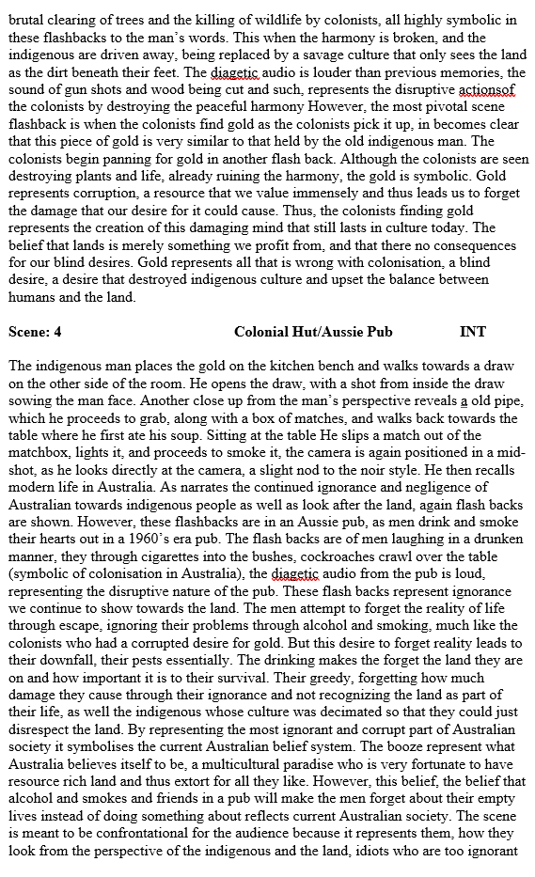
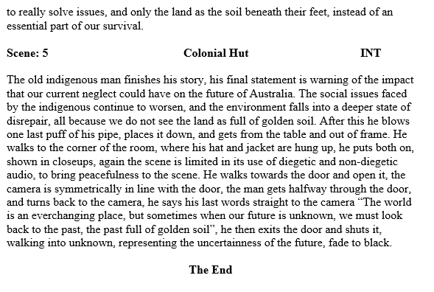
‘Charlotte and Jane’ draft two-column audiovisual script
The initial script can be viewed at
https://drive.google.com/file/d/1-8g-R1NX4aEGZgxFO7rqJGkmzh9uNRzt/view.
A video showing an example of teacher feedback can be viewed at https://www.youtube.com/watch?v=nJq0Cn_CpLA.

Lesson section 3: support materials
Excerpt from ‘A Sticky Situation’ script with important aspects highlighted to look out for as teacher:

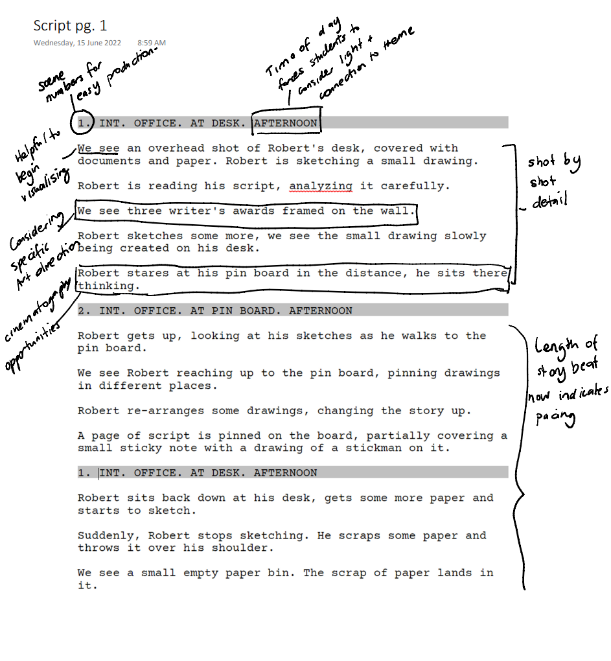
Excerpt from ‘Golden Soil’ script:
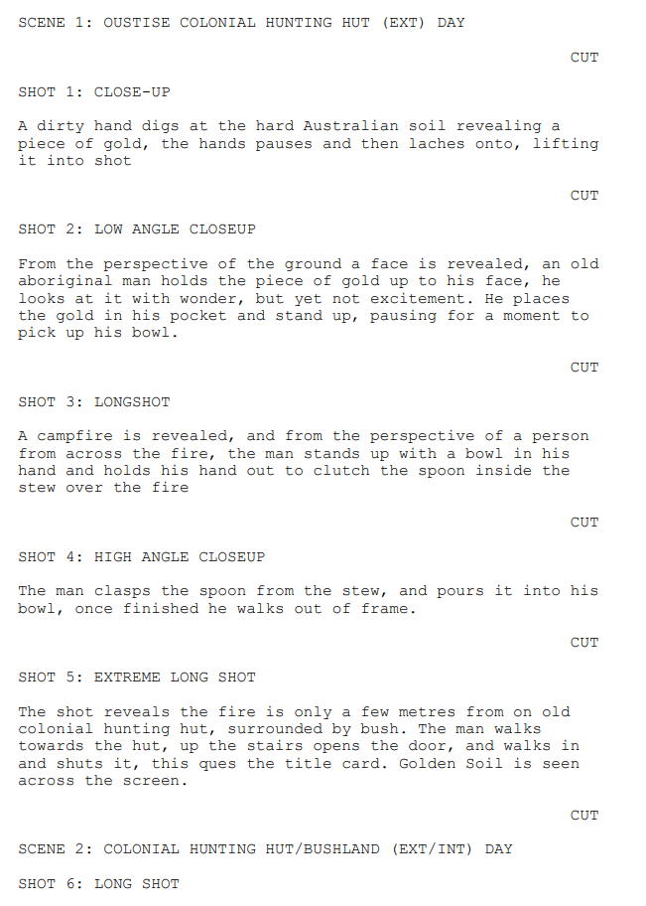

Lesson section 4: support materials
Excerpt from ‘Charlotte and Jane’ storyboards:
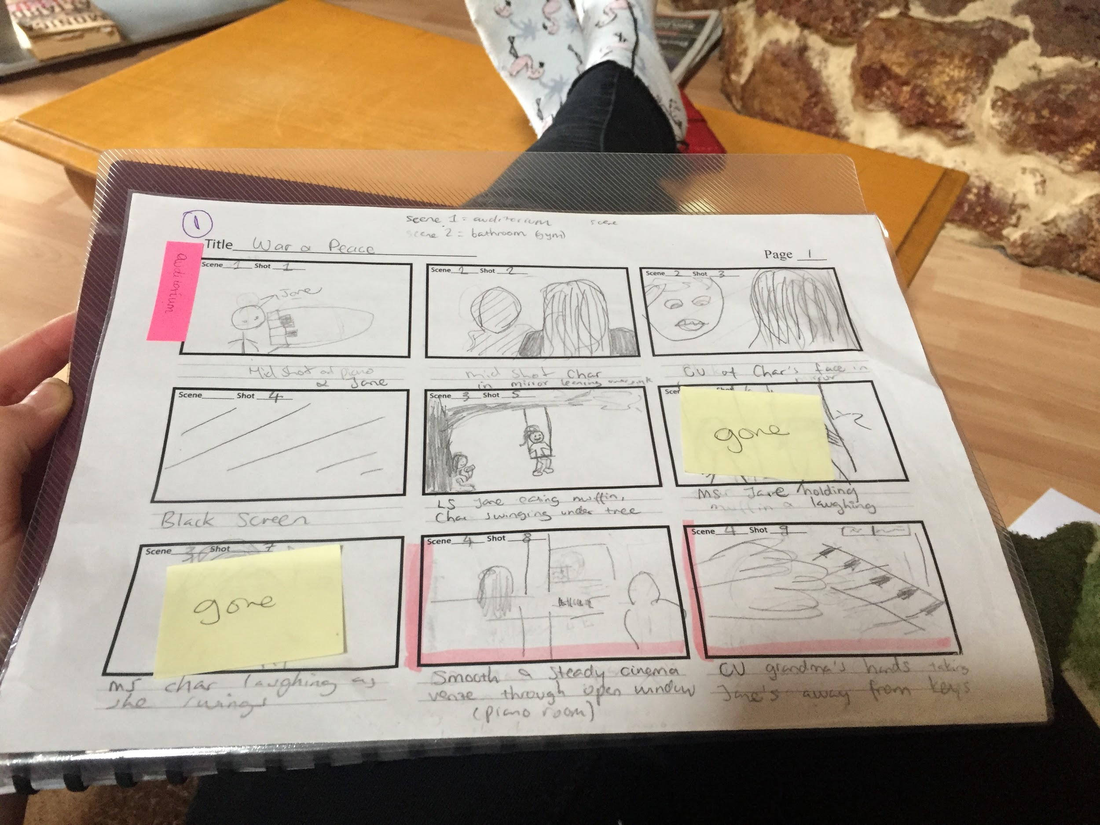
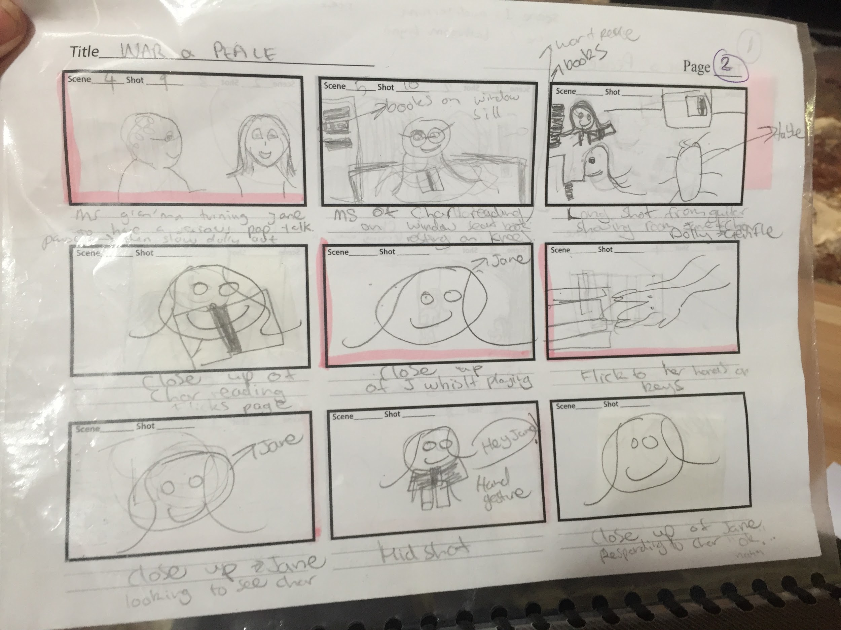
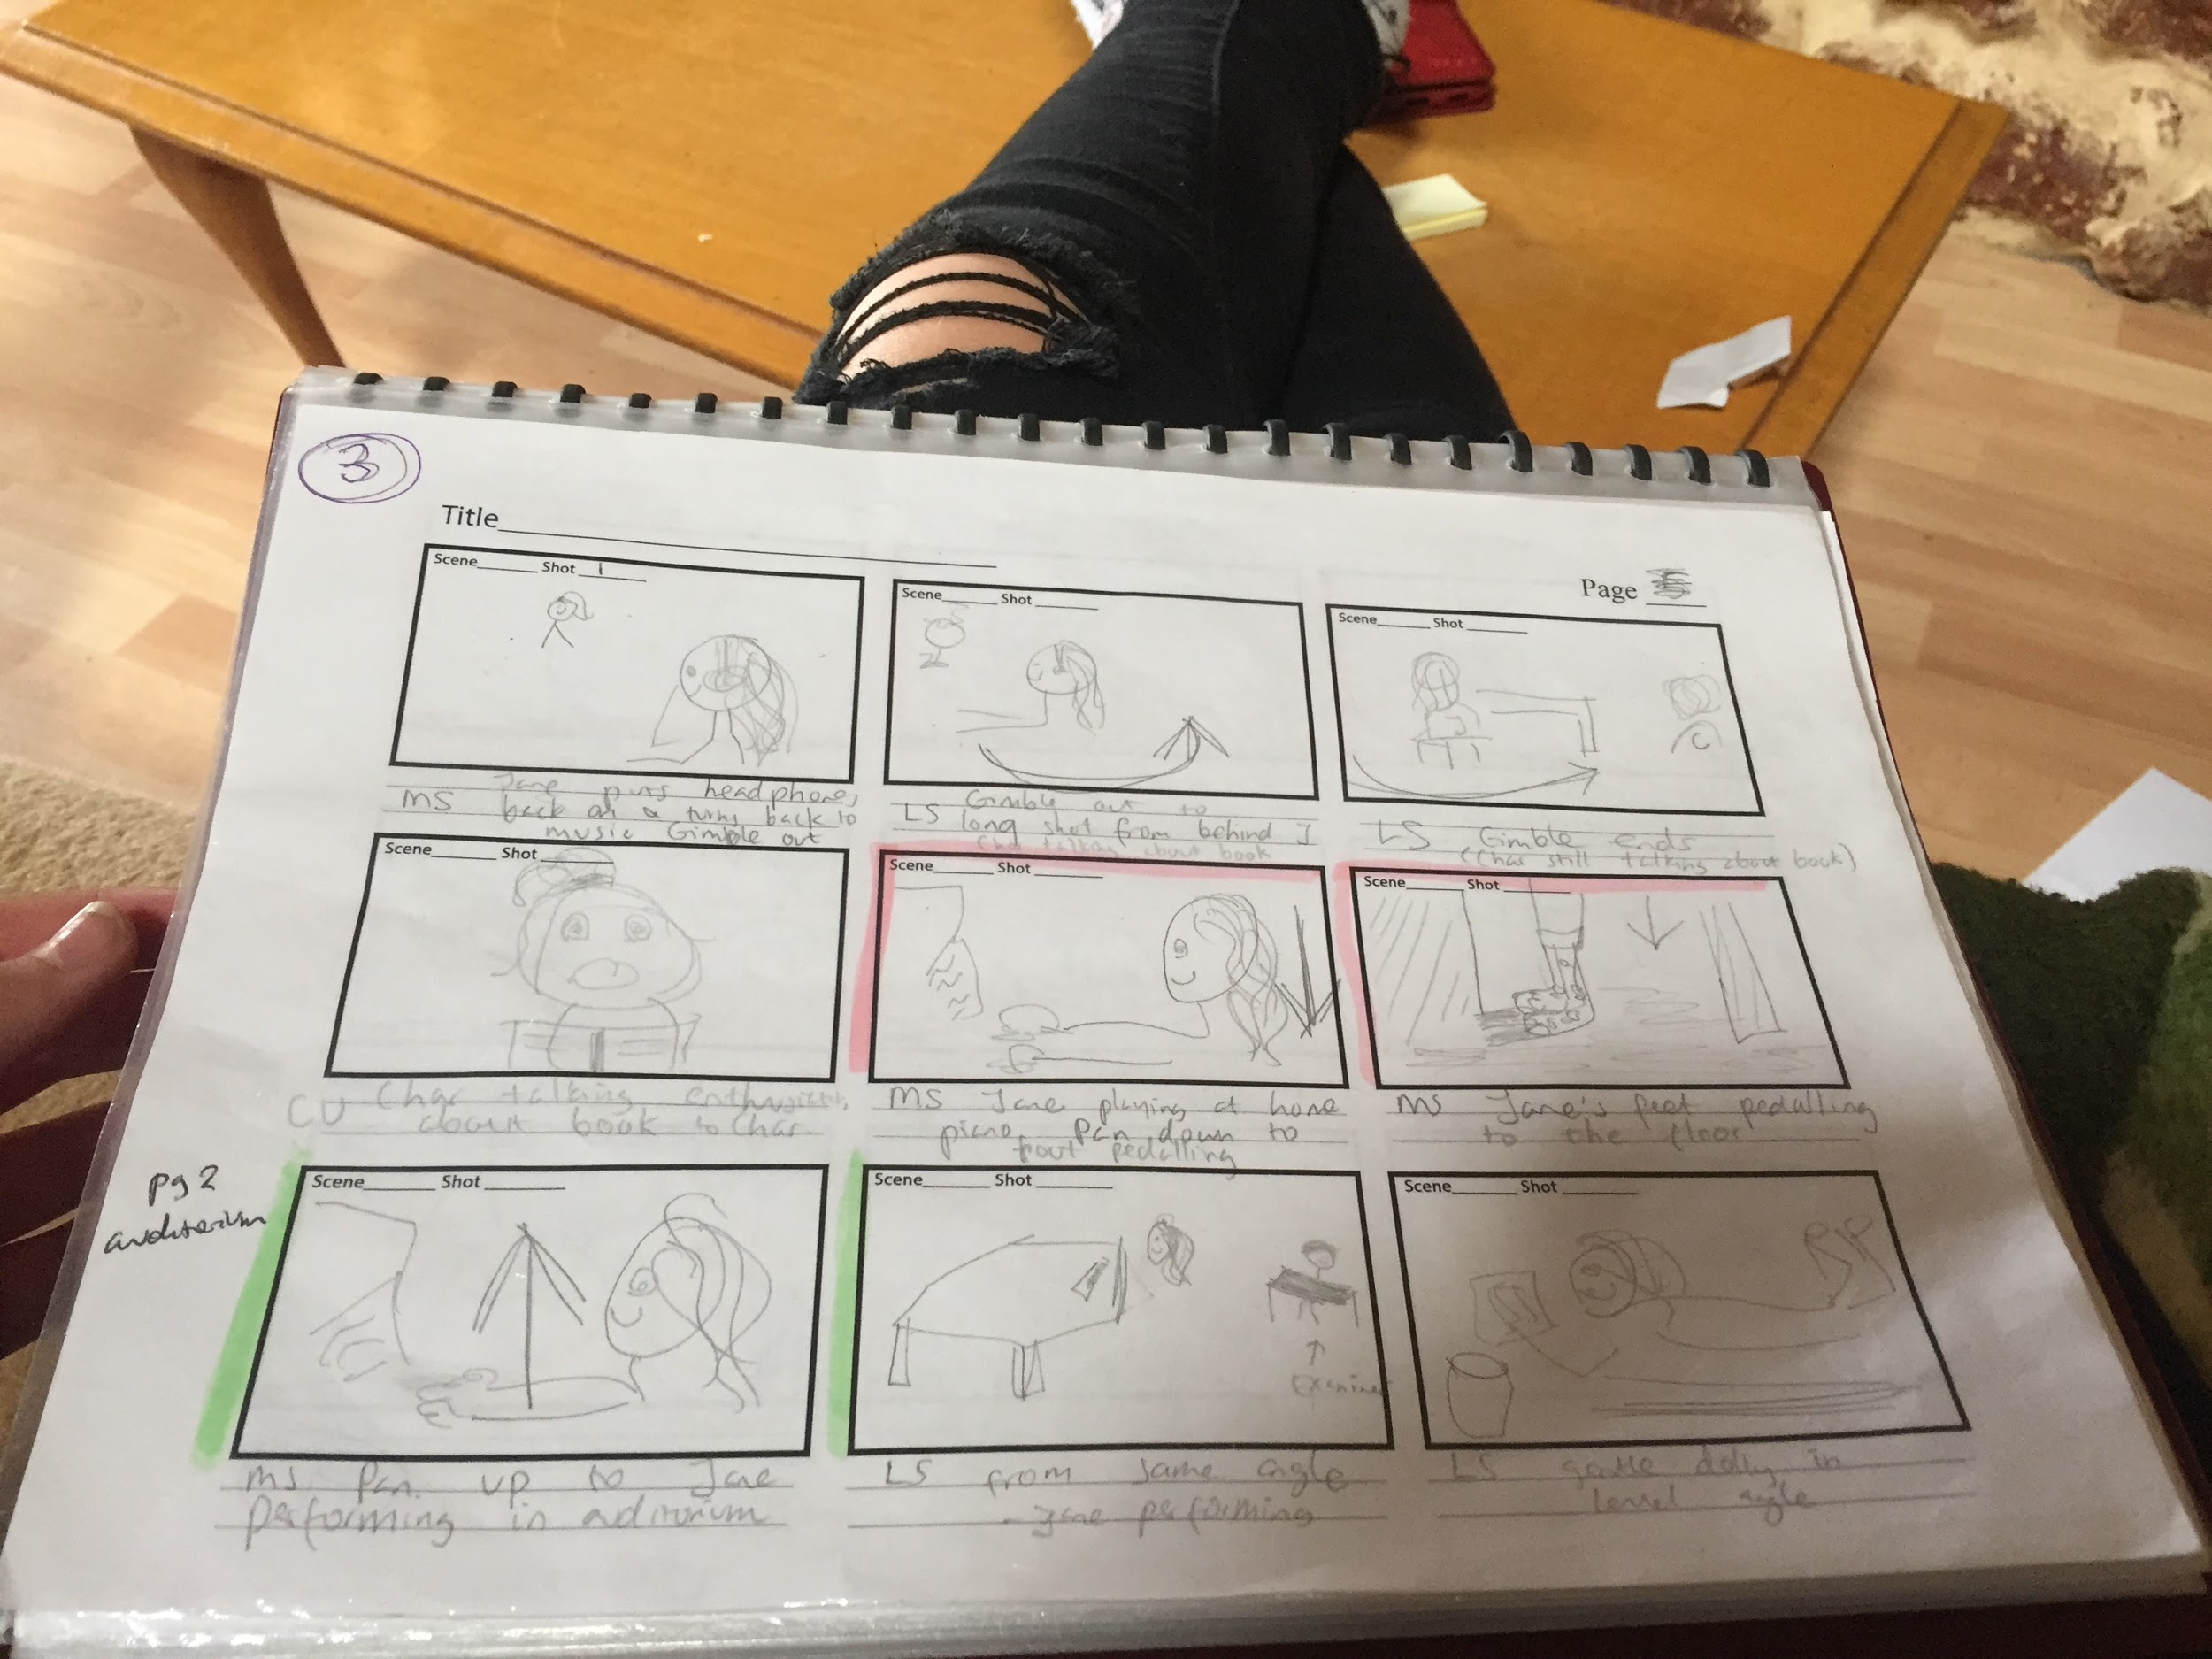
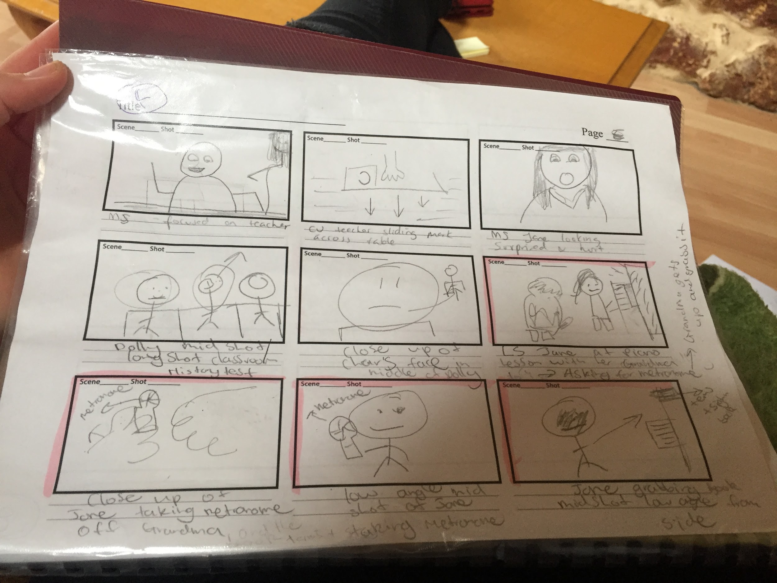

Excerpt from A Sticky Situation storyboards:
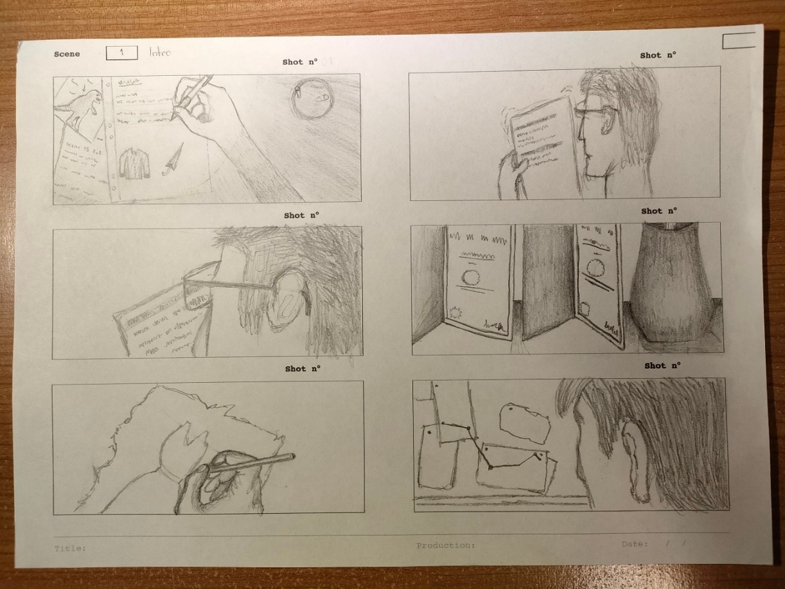
Further planning documents:
Golden Soil (https://drive.google.com/drive/folders/1-BE2wfm5_kCIsdlf4Ag6iRJpWGmiGHAO)
A Sticky Situation (https://drive.google.com/drive/folders/10Nqgb9-auEkl45gtbGYwv03OMWdO3_Dz)
Charlotte and Jane (https://drive.google.com/drive/folders/14UC7-bjFgee3Akpg16d_yjFE26rbXcpc)

Acknowledgements

Short film Short film from: Bourgault, E. and Anson, R. (2020). Charlotte and Jane [Video]. Retrieved June, 2022, from https://youtu.be/6391nFR2mXk.
Short film Short film from: Bromage, W. (2021). Golden Soil [Video]. Retrieved June, 2022, from https://drive.google.com/file/d/1phrnrXk9kh8AATdRZuQmYv5_F-x7n5nX/view.
Short film Short film from: Szabo, T. (2021). A Sticky Situation [Video]. Retrieved June, 2022, from https://www.youtube.com/watch?v=FeFBBq_7sPI.
Image Image from: Benest, G. (2015). The Importance of Screenplay Formatting [How to Write a Script Infographic]. Retrieved June, 2022, from https://scriptmag.com/features/importance-screenplay-formatting.
Screenplay Screenplay from: Cameron, J. and Wisher Jr., W. (1991) Judgement Day. Retrieved June, 2022, from https://www.scriptslug.com/script/terminator-2-judgement-day-1991.
PowerPoint PowerPoint from: Ware, A. (2022). Theme and Preproduction [PowerPoint]. Retrieved July, 2022, from https://www.slideshare.net/AndrewWare24/theme-and-preproduction
Image Image from: Bourgault, E. (2020) [Synopsis Planning ‘Charlotte and Jane’]. Provided via email.

