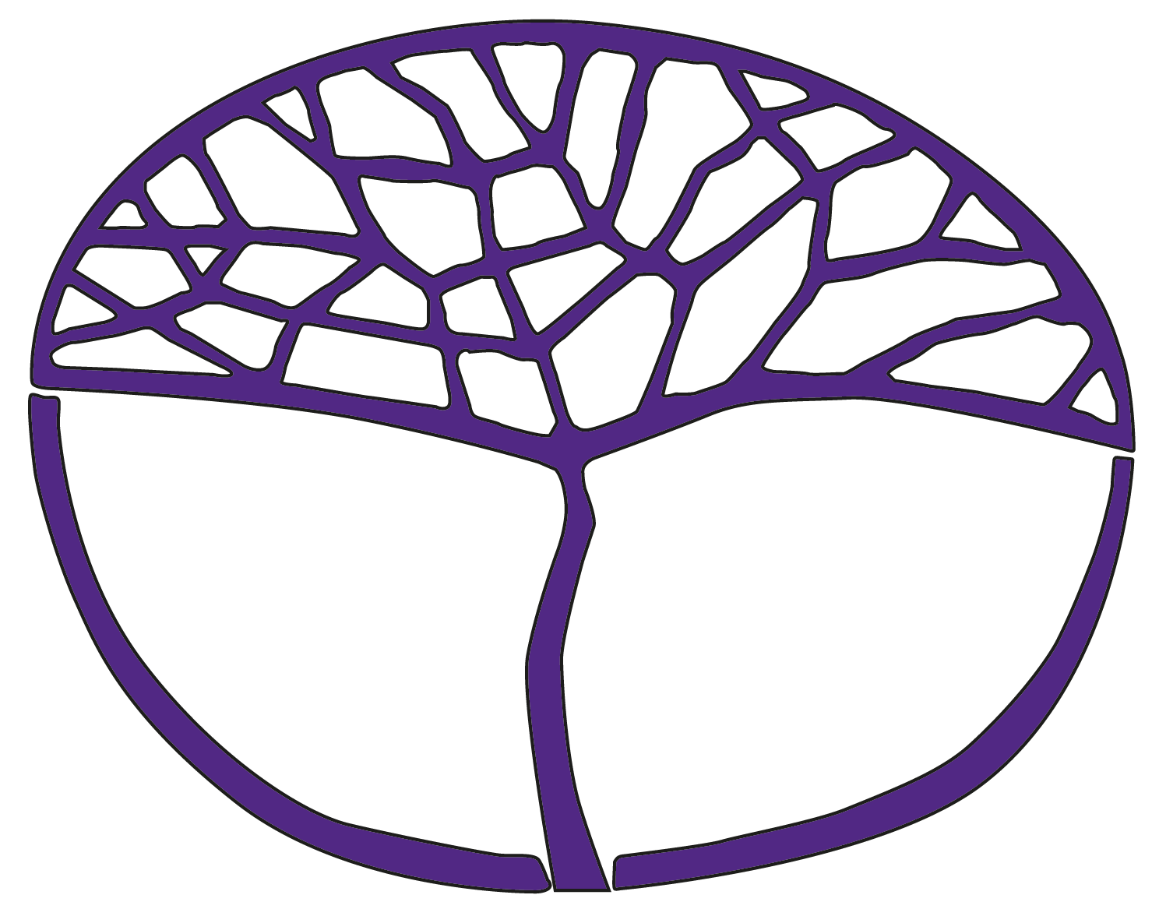Sample Assessment Outline

English as an Additional Language or Dialect

General Year 11

**Acknowledgement of Country**

Kaya. The School Curriculum and Standards Authority (the Authority) acknowledges that our offices are on Whadjuk Noongar boodjar and that we deliver our services on the country of many traditional custodians and language groups throughout Western Australia. The Authority acknowledges the traditional custodians throughout Western Australia and their continuing connection to land, waters and community. We offer our respect to Elders past and present.

**Copyright**

© School Curriculum and Standards Authority, 2014

This document – apart from any third-party copyright material contained in it – may be freely copied, or communicated on an intranet, for non-commercial purposes in educational institutions, provided that the School Curriculum and Standards Authority (the Authority) is acknowledged as the copyright owner, and that the Authority’s moral rights are not infringed.

Copying or communication for any other purpose can be done only within the terms of the *Copyright Act 1968* or with prior written permission of the Authority. Copying or communication of any third-party copyright material can be done only within the terms of the *Copyright Act 1968* or with permission of the copyright owners.

Any content in this document that has been derived from the Australian Curriculum may be used under the terms of the [Creative Commons Attribution 4.0 International licence](https://creativecommons.org/licenses/by/4.0/).

**Disclaimer**

Any resources such as texts, websites and so on that may be referred to in this document are provided as examples of resources that teachers can use to support their learning programs. Their inclusion does not imply that they are mandatory or that they are the only resources relevant to the course. Teachers must exercise their professional judgement as to the appropriateness of any they may wish to use.

Sample assessment outline

English as an Additional Language or Dialect – General Year 11

Unit 1 – Cross-cultural perspectives and Unit 2 – Life experiences

|  |  |  |  |
| --- | --- | --- | --- |
| Assessment type (from syllabus) | **Assessment task  weighting** | Week due | Description of assessment task |
| Investigation  20% | 10% | Semester 1  Week 10 | **Task 2:** Choose a person from your own culture/community who is significant to you. This may be someone you know, or someone you know of. Investigate this person through research and/or conducting interviews with others from your community. Present your findings in a brief report. |
| 10% | Semester 1  Week 9 | **Task 7:** Investigate the impact of technology on leisure and entertainment and how this has changed over time. Present your findings in a brief report. |
| Response  25% | 12.5% | Semester 1  Week 5 | Task 1: Read, view and listen to a range of texts about significant people, places and events in Australia. Respond to short and extended answer questions about these texts. |
| 12.5% | Semester 2  Week 3 | Task 5: Read or view a text/s which focuses on self-image or cultural conceptions of beauty or fashion. Respond to short and extended answer questions about this text/s. |
| Production  (written)  30% | 15% | Semester 1  Week 15 | **Task 3:** Consider the cultural facilities available and/or events held in your local community and how these could be expanded or improved. Write a letter to your local council with your requests and suggestions. |
| 15% | Semester 2  Week 6 | Task 6: Read or view a text, such as *Mean Girls.* In response, write a short essay discussing a theme such as conforming to images or stereotypes, self-image, or cultural conceptions of beauty and/or fashion. |
| Production  (oral)  25% | 12.5% | Semester 1  Week 20 | Task 4: Investigate a place or event from your own culture/community that is significant to you. Give a presentation about your subject choice and explain why it is important to you. |
| 12.5% | Semester 2  Week 12 | Task 8: In pairs or small groups, facilitate a tutorial exploring the impact of social media on identity. |
| Total | 100% |  | | |