Sample Assessment Tasks
Mathematics Applications
ATAR Year 12

Acknowledgement of Country
Kaya. The School Curriculum and Standards Authority (the Authority) acknowledges that our offices are on Whadjuk Noongar boodjar and that we deliver our services on the country of many traditional custodians and language groups throughout Western Australia. The Authority acknowledges the traditional custodians throughout Western Australia and their continuing connection to land, waters and community. We offer our respect to Elders past and present.
Copyright
© School Curriculum and Standards Authority, 2018
This document – apart from any third-party copyright material contained in it – may be freely copied, or communicated on an intranet, for non-commercial purposes in educational institutions, provided that the School Curriculum and Standards Authority (the Authority) is acknowledged as the copyright owner, and that the Authority’s moral rights are not infringed.
Copying or communication for any other purpose can be done only within the terms of the Copyright Act 1968 or with prior written permission of the Authority. Copying or communication of any third-party copyright material can be done only within the terms of the Copyright Act 1968 or with permission of the copyright owners.
Any content in this document that has been derived from the Australian Curriculum may be used under the terms of the Creative Commons Attribution 4.0 International licence.
Disclaimer
Any resources such as texts, websites and so on that may be referred to in this document are provided as examples of resources that teachers can use to support their learning programs. Their inclusion does not imply that they are mandatory or that they are the only resources relevant to the course. Teachers must exercise their professional judgement as to the appropriateness of any they may wish to use.

Sample assessment task

Mathematics Applications – ATAR Year 12

Task – Unit 3
Assessment type: Response
Conditions: Time for the task: up to 50 minutes, in class, under test conditions
Materials required: Section One: Calculator-free
Standard writing equipment
Section Two: Calculator-assumed
Calculator (to be provided by the student)
Other materials allowed: Drawing templates, one A4 page of notes in Section Two
Marks available: 52 marks
Section One: Calculator-free – 27 marks
Section Two: Calculator-assumed – 25 marks
Task weighting: 8% for the pair of units
_________________________________________________________________________________
Section One: Calculator-free (27 marks)
Suggested time: 20 minutes
Question 1 (4 marks)
- Define the set of vertices and a list of edges for Graph 1. (2 marks)
- Is Graph 1 planar? Explain your answer. (2 marks)
Question 2 (8 marks)
A Friday night darts competition has five competitors: Alex (A), Bob (B), Colin (C), Dave (D) and Evan (E), who will play each other in a round-robin competition over a number of weeks. On the first Friday, rounds 1 and 2 are played where:
Round 1 – Alex plays Bob; Colin plays Dave; and Evan has a bye.
Round 2 – Alex plays Evan; Colin plays Bob; and Dave has a bye.
- Draw a graph to represent the games played on the first Friday night. (2 marks)
- Draw a graph to represent all the games to be played in the whole competition. (2 marks)
- Construct the corresponding adjacency matrix to represent the whole competition. (3 marks)
- Explain the significance of the numbers in the leading diagonal of the matrix. (1 mark)

Question 3 (6 marks)
The cost of a carton of eggs increased from $3.60 in 2015 to $4.80 in 2016.
- Given that the increasing cost of a carton of eggs models an arithmetic sequence, determine a recurrence relation for the cost of a carton of eggs. (1 mark)
- Given that the increasing cost of a carton of eggs models a geometric sequence, determine a recurrence relation for the cost of a carton of eggs. (2 marks)
- Use the two models above to find the difference in the cost of two dozen eggs in 2017.
(3 marks)
Question 4 (9 marks)
A wedding photographer is quoting the following price for producing a wedding album for the newlyweds:
A fixed minimum cost of $150, with 80 photos in a hard-backed album. Further photos may also be added in lots of 10 photos at $0.70 per photo, up to a maximum of 200 photos.
The photographer wants to set up a table showing:
- the type of album where $T_{1}$ is the basic album with 80 photos at a cost of $150
- the number of photos in each of the possible album sizes
- the cost in dollars of each of the different albums.
- Complete the blank cells in the table below. (3 marks)
Type | T₁ | T₂ | T₃ | T₄ | T₅ |  | T_{n}
Number of pictures | 80 |  |  |  |  |  | 200
$ cost of album | $150
- Write a rule that will calculate the number of pictures in each album type = $T_{n}$. (3 marks)
- Write a rule that will calculate the cost of each album type = $C_{n}$. (3 marks)

Section Two: Calculator-assumed (25 marks)
Suggested time: 30 minutes
Question 5 (4 marks)
The Smitt family are taking their guests on a tour of the local tourist sites. The places they wish to visit are labelled as the vertices in the network diagram below. They leave from their home (H) at 9.30 am.
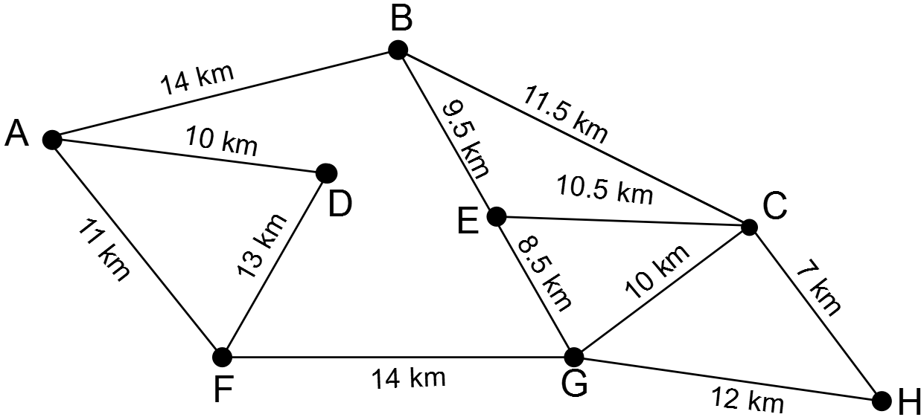
- Justify, with evidence, why the graph above can be classified as Hamiltonian. (2 marks)
- If they travel at an average speed of 60 km h–1 and stop for 15 minutes at each site, what time will they arrive home? (2 marks)
Question 6 (12 marks)
A fish farm operates a fish breeding pond in which the population of a particular fish increases by 3% per month.
- Give the recurrence formula to calculate the fish population at the end of each month, assuming the rate does not change, and the initial population is 1000 fish. (2 marks)
- Calculate the population numbers at the end of the first six months of its operation, given the initial population is 1000 fish. (2 marks)
- After the initial six months, 40 fish are removed from the pond at the end of each month. Assuming the population growth is maintained at 3%, how many fish are expected to be in the pond at the end of 12 months? (3 marks)
- Describe what is happening to the population. (1 mark)
- Estimate, to the nearest whole number, the maximum number of fish that may be removed from the pond each month without the number of fish decreasing. (4 marks)
Question 7 (9 marks)
The height of a seedling (in centimetres) each month after planting is modelled by the recurrence relation $a_{n+1}=a_{n}+0.6$ and $a_{0}=3.1$
- Deduce the simplified rule for the height every n^{th} month after planting. (3 marks)
- Show that the following statement is true $a_{10}=2×a_{9}\text{- }a_{8}$. (2 marks)
- Demonstrate how the above statement can be generalised to $a_{n+2}=2×a_{n+1}\text{- }a_{n}$. (4 marks)

Marking key for sample assessment task – Unit 3
Section One: Calculator-free (27 marks)
Question 1 (4 marks)
- Define the set of vertices and a list of edges for Graph 1.
Solution
$V\left(G_{1}\right)=\left\{A,B,C,D,E,F\right\}$ and $E\left(G_{1}\right)=AB,AD,AF,BF,BC,CD,DE,EF$
Behaviours | Marks
Defines the vertices of Graph 1  Defines the edges of Graph 1 | 1  1
Subtotal | /2
- Is Graph 1 planar? Explain your answer.
Solution
Yes, the graph is planar as it can be drawn so that none of the edges intersect other than at the vertices.
Behaviours | Marks
States that Graph 1 is planar  States that Graph 1 can be drawn where no edges intersect | 1  1
Subtotal | /2

Question 2 (8 marks)
A Friday night darts competition has five competitors: Alex (A), Bob (B), Colin (C), Dave (D) and Evan (E), who will play each other in a round-robin competition over a number of weeks. On the first Friday, rounds 1 and 2 are played where:
Round 1 – Alex plays Bob; Colin plays Dave; and Evan has a bye.
Round 2 – Alex plays Evan; Colin plays Bob; and Dave has a bye.
- Draw a graph to represent the games played on the first Friday night.
Solution
Behaviours | Marks
Draws and labels all five vertices  Draws only the four correct edges required | 1  1
Subtotal | /2
- Draw a graph to represent all the games that will be played in the whole competition.
Solution
Behaviours | Marks
Includes all five vertices in the graph  Draws all ten edges correctly | 1  1
Subtotal | /2

- Construct the corresponding adjacency matrix to represent the whole competition.
Solution
A = $\left[\begin{aligned} \begin{matrix}0 & 1 & 1 \\ 1 & 0 & 1\end{matrix} \begin{matrix}1 & 1 \\ 1 & 1\end{matrix} \\ \begin{matrix}1 & 1 & 0 \\ 1 & 1 & 1 \\ 1 & 1 & 1\end{matrix} \begin{matrix}1 & 1 \\ 0 & 1 \\ 1 & 0\end{matrix}\end{aligned}\right]$
Behaviours | Marks
Constructs a five by five matrix to represent the graph  Includes a leading diagonal of zeros and all other entries are one | 1  2
Subtotal | /3
- Explain the significance of the numbers in the leading diagonal of the matrix.
Behaviours | Mark
Explains that diagonal of zeros represents that the teams do not play against themselves | 1
Question 3 (6 marks)
The cost of a carton of eggs increased from $3.60 in 2015 to $4.80 in 2016.
- Given that the increasing cost of a carton of eggs models an arithmetic sequence, determine a recurrence relation for the cost of a carton of eggs.
Solution
$$T_{n}=T_{n-1}+1.2, T_{1}=3.6$$
Behaviours | Mark
Defines the recurrence relationship correctly | 1
- Given that the increasing cost of a carton of eggs models a geometric sequence, determine a recurrence relation for the cost of a carton of eggs.
Solution
$$T_{n}=\frac{4}{3}T_{n-1}, T_{1}=3.6$$
Behaviours | Marks
Defines the recurrence relationship correctly  States $T_{1}=3.6$ | 1  1
Subtotal | /2

- Use the two models above to find the difference in the cost of two dozen eggs in 2017.
Solution
Using arithmetic recursion: $T_{3}=T_{2}+1.2$ Using geometric recursion: $T_{3}={\frac{4}{3}T}_{2}$
$T_{3}=4.8+1.2$ $T_{n}=\frac{4}{3}×4.8$
$T_{3}=6$ $T_{3}=6.4$
Cost in 2017 is $6.00 Cost in 2017 is $6.40
Difference in cost is 40 cents
Behaviours | Marks
Determines cost in 2017 using arithmetic relation from part (a)  Determines cost in 2017 using geometric relation from part (b)  Expresses the difference in cost using appropriate units | 1  1  1
Subtotal | /3
Question 4 (9 marks)
The photographer wants to set up a table showing:
- the type of album where $T_{1}$ is the basic album with 80 photos at a cost of $150
- the number of photos in each of the possible album sizes
- the cost in dollars of each of the different albums.
- Complete the blank cells in the table below.
Solution
Type | T₁ | T₂ | T₃ | T₄ | T₅ |  | T_{n}
Number of pictures | 80 | 90 | 100 | 110 | 120 |  | 200
$ cost of album | $150 | 157 | 164 | 171 | 178 |  | 234

Behaviours | Marks
Completes the number of pictures in each cell correctly  Completes the cost of each album type correctly  Completes $T_{n}$ correctly | 1  1  1
Subtotal | /3

- Write a rule that will calculate the number of pictures in each album type = $T_{n}$
Solution
$T_{n}=a+\left(n-1\right)d$ given $a=80$ and ${\text{T}}_{2}=90$
$$⇒T_{2}=80+d=90 \\ ⇒d=10 \\ ⇒T_{n}=80+\left(n-1\right)10$$$⇒T_{n}=70+10n$
Behaviours | Marks
Applies the linear rule with correct common difference d  Calculates a from the table of values  States the rule in terms of n | 1  1  1
Subtotal | /3
- Write a rule that will calculate the cost of each album type = C_{n}.
Solution
$C_{n}=a+\left(n-1\right)d$ given $a=150$ and ${\text{C}}_{2}=157$
$$⇒C_{2}=150+d=157 \\ ⇒d=7 \\ ⇒C_{n}=150+\left(n-1\right)7 \\ ⇒C_{n}=143+7n$$
Behaviours | Marks
Applies the linear rule with correct common difference d  Calculates a from the table of values  States the rule in terms of n | 1  1  1
Subtotal | /3

Section Two: Calculator-assumed (25 marks)
Question 5 (4 marks)
The Smitt family are taking their guests on a tour of the local tourist sites. The places they wish to visit are labelled as the vertices in the network diagram below. They leave from their home (H) at 9.30 am.
- Justify, with evidence, why the graph above can be classified as Hamiltonian.
Solution
The graph contains a cycle that visits every site (vertex) once only and does not repeat any paths.
H – G – F – D – A – B – E – C – H or reverse
Behaviours | Marks
Indicates that the graph contains a cycle that begins and ends at H and visits each vertex once only and repeats no edge  Correctly identifies the cycle | 1  1
Subtotal | /2
- If they travel at an average speed of 60 km hr–1 and stop for 15 minutes at each site, what time will they arrive home?
Solution
90 km at 60 km hr–1 $⇒$ travel time is 90 mins
7 stops, 15 mins at each stop $⇒$ stopovers for 105 mins
Arrive home at 195 mins after 9.30 am $⇒$ 12.45 pm
Behaviours | Marks
Determines travel time and stopover time correctly  Calculates return time by adding travel time and stopover time to 9.30 am | 1  1
Subtotal | /2

Question 6 (12 marks)
A fish farm operates a fish breeding pond in which the population of a particular fish increases by 3% per month.
- Give the recurrence formula to calculate the fish population at the end of each month, assuming the rate does not change, and the initial population is 1000 fish.
Solution
$P_{n+1}=1.03×P_{n}$ where $P_{0}=1000$
Behaviours | Marks
Defines the recurrence relationship  States $P_{0}=1000$ | 1  1
Subtotal | /2
- Calculate the population numbers at the end of the first six months of its operation, given the initial population is 1000 fish.
Solution
n | 0 | 1 | 2 | 3 | 4 | 5 | 6
P_{n} | 1000 | 1030 | 1060 | 1092 | 1125 | 1159 | 1194

Behaviours | Marks
Starts the sequence at $P_{1}=1030$  Completes the sequence at $P_{6}=1194$ | 1  1
Subtotal | /2

- After the initial six months, 40 fish are removed from the pond at the end of each month. Assuming the population growth is maintained at 3%, how many fish are expected to be in the pond at the end of 12 months?
Solution
Given $Q_{n}=Q_{0}×1.03-40,$ and $⇒Q_{0}=1194$  $⇒Q_{6}=1167$ | 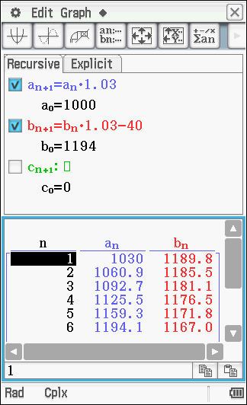
Behaviours |  | Marks
States the new recurrence relation  States the initial condition $Q_{0}$  Calculates the correct population |  | 1  1  1
Subtotal |  | /3
- Describe what is happening to the population.
Solution
The population of fish is declining slowly.
Behaviours | Mark
States the correct change in population | 1
 | /1

- Estimate, to the nearest whole number, the maximum number of fish that may be removed from the pond each month without the number of fish decreasing.
Solution
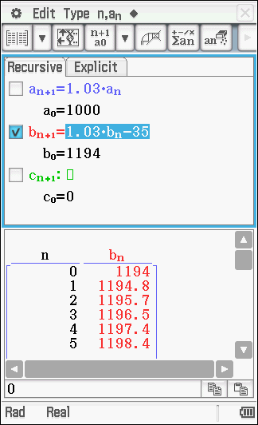 | 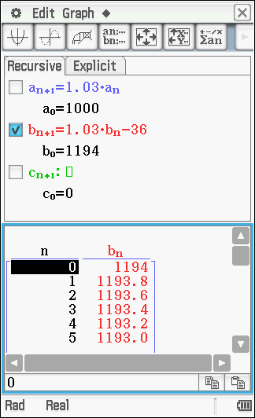
Given $Q_{n}=Q_{0}×1.03-k$, where k is the number of fish taken from the pond
$Q_{0}=1194\text{ and }k=36$ Or $Q_{0}=1194\text{ and }k=35$
$Q_{5}=Q_{0}×1.03-36,$ $Q_{5}=Q_{0}×1.03-35,$
$⇒Q_{5}≈1193$ $⇒Q_{5}≈1198$
$⇒Q\text{ is decreasing}$ $⇒Q\text{ is increasing}$
Hence, $k=35$ is the maximum number of fish to be taken per month without depleting the population.
Behaviours |  | Marks
Uses recurrence formula $Q_{n}=Q_{0}×1.03-k$ to check values of k  Shows that $k≥36$causes a decrease in Q  Shows that $k=35$causes an increase in Q  States k = 35 is the maximum value for which Q increases |  | 1  1  1  1
Subtotal |  | /4

Question 7 (9 marks)
The height of a seedling (in centimetres) each month after planting is modelled by the recurrence relation $a_{n+1}=a_{n}+0.6$ and $a_{0}=3.1$
- Deduce the simplified rule for the height every n^{th} month after planting.
Solution
$a_{n+1}=a_{n}+0.6$ and $a_{1}=3.7$ $⇔T_{n}=a+\left(n-1\right)d$
$⇔T_{n}=3.7+\left(n-1\right)0.6$
$T_{n}=0.6n+3.1$
Behaviours | Marks
Uses a linear relation such as $T_{n}=a+\left(n-1\right)d$  Defines a and d correctly  Simplifies the expression | 1  1  1
Subtotal | /3
- Show that the following statement is true $a_{10}=2×a_{9}\text{- }a_{8}$.
Solution
$a_{10}=2×a_{9}\text{- }a_{8}$ $⇔8.5=2×7.9\text{- }7.3$
$⇔8.5=15.8\text{- }7.3$ True
Behaviours | Marks
Substitutes the correct values into the equation  Demonstrates the left-hand side of the equation = right-hand side | 1  1
Subtotal | /2
- Demonstrate how the above statement can be generalised to $a_{n+2}=2×a_{n+1}\text{- }a_{n}$.
Solution
$$a_{n+1}=a_{n}+d$$
$⇔a_{n+1}-a_{n}=d$ (1)
$a_{n+2}=a_{n+1}+d$ (2)
Substituting (1) into (2)
$$a_{n+2}=a_{n+1}+a_{n+1}-a_{n}$$
$$a_{n+2}={2×a}_{n+1}-a_{n}$$
Behaviours | Marks
Sets up equations (1) and (2)  Eliminates the constant by substitution  Simplifies the equation to give the result | 2  1  1
Subtotal | /4

Sample assessment task

Mathematics Applications – ATAR Year 12

Task 1 – Unit 3
Assessment type: Investigation
Conditions: The investigation requires the use of the statistical investigation process. The task can be completed during class time or at home. If the task is completed outside class time, regular check ins should be scheduled. Students may use any appropriate technology.
Note: while the Authority provides sample assessment tasks for guidance, it is the expectation of the Authority that teachers will develop tasks customised to their school’s context and the needs of the student cohort. This resource is available on a public website and use of the resource without modification may affect the integrity of the assessment.

Task weighting: 10% for the pair of units

AFL player statistics (55 marks)
Background
In the Australian Football League (AFL), having the best players is no guarantee of doing well. However, the individual performance of players is often measured by performance criteria; the number of kicks, marks, handballs, tackles or possessions etc. that they may have over the season.
Using the AFL Tables website at https://afltables.com/afl/stats/stats_idx.html, select the Detailed Player Stats for any year. Choose an AFL team and investigate and compare what relationship exists between the players’ physical attributes and key performance criteria.
Investigate any apparent association, demonstrating your knowledge from topic 3.1 to analyse, explain and test the associations within the data.
You will need to follow the Statistical Investigation Process:
- clarify the problem and identify or pose the question/s to be answered with data (8 marks)
- design a plan to obtain or collect and organise appropriate data (13 marks)
- select and apply appropriate graphical and numerical techniques to analyse data (19 marks)
- sort, describe, summarise and compare data
- identify relationships in the data and construct data displays
- interpret the results of the analysis and communicate findings in a systematic and concise manner. (15 marks)
Important note to students
All work presented in this investigation must be your own and not someone else’s or a collaboration of efforts. You must present your findings in a report of no more than four A4 pages.

Marking key for sample assessment Task 1 – Unit 3
Note: teachers may need to customise this marking key with examples of the types of responses that can be expected based on the conditions under which the task is administered. This sample solution has been split into separate sections to illustrate some of the expected behaviours. Specific behaviours are to be identified within the report and are not expected to be compartmentalised. For behaviours worth more than 1 mark, the quality of the response must be considered.
Clarify the problem and identify or pose the question/s to be answered with data
Behaviours | Marks
Provides a restatement of the problem given | 1
Includes at least 2–3 sentences clearly interpreting the requirements of the task | 1
Poses a question to seek sensible interpretation of a possible association | 1
Poses a question to compare association of two dependent variables (physical attributes) against one independent category (weight or height) or to compare association of a dependent variables against both independent categories | 1
Clearly identifies the datasets to be used | 2
Identifies possible limitations of the data | 1
Identifies underlying assumptions related to the investigation | 1
Subtotal | /8
Design a plan to obtain or collect and organise appropriate data
Behaviours | Marks
Extracts and organises data from the given source into tables | 1
Identifies suitable variables and states units for multiple datasets | 1
Identifies the dependent and independent variables within each bivariate dataset | 1
States the plan for displaying the data in scatterplots to identify patterns (what/why) | 1–2
States the plan to fit a least squares regression line to each set of bivariate data to model a relationship (what/why) | 1–2
States the plan to use a residual plot to assess the appropriateness of the linear model (what/why) | 1–2
States the plan to quantify the strength of association through the calculation of the correlation coefficient (what/why) | 1–2
States the plan to assess the strength of linear association in terms of the explained variation using the coefficient of determination (what/why) | 1–2
Subtotal | /13

Select and apply appropriate graphical and numerical techniques to analyse data
Behaviours | Marks
Constructs a bivariate scatterplot | 1
Constructs multiple plots to compare associations | 1
Constructs scatterplots that correctly display selected data and are clearly labelled | 1
Identifies patterns in the data that suggest the presence of an association | 1
Identifies the presence/absence of any outliers and the effect on the strength of association | 1
Describes each bivariate dataset correctly in terms of form (linear or nonlinear) and direction (positive or negative) | 1–2
Describes bivariate datasets correctly in terms of the strength of any association (strong, moderate or weak) | 1–2
Models a linear relationship (one/all) to the data by fitting a least squares regression line | 1–2
Expresses the regression line/s using variables defined in the context of the question | 1
Constructs a clearly labelled residual plot | 1–2
Assesses and comments on the suitability of the linear model using the residual plot | 1
Demonstrates the use of the least squares regression line to make a prediction by interpolation and extrapolation | 2
Includes calculation of numerical measure quantifying associations (r) in analysis | 1
Includes calculation of numerical measure assessing strength of associations (r²) in analysis | 1
Subtotal | /19
Interpret the results of the analysis and communicate findings in a systematic and concise manner
Behaviours | Marks
Discusses the limitations of predictions made by interpolation and extrapolation | 1
Interprets strength of the association (r) in the context of the data used (some/all) | 1
Interprets strength of linear association in terms of the explained variation (r²) in the context of the data used (some/all) | 1
Seeks to make comparisons between associations | 1
Draws valid conclusions comparing associations across multiple datasets | 1
Uses numerical measures to justify comparisons between associations | 1
Considers additional variables to explain relationships | 1
Relates observations and conclusions are back to original question/s (some/all) | 1–2
Distinguishes between association and cause and effect in interpretations | 1
Demonstrates the application of complex procedures to investigate and comprehensively report on a range of pertinent relationships | 1
Communicates investigation findings in a systematic and concise way | 1–2
Communicates findings in the context of the investigation and using correct mathematical language | 1–2
Subtotal | /15
Total | /55

