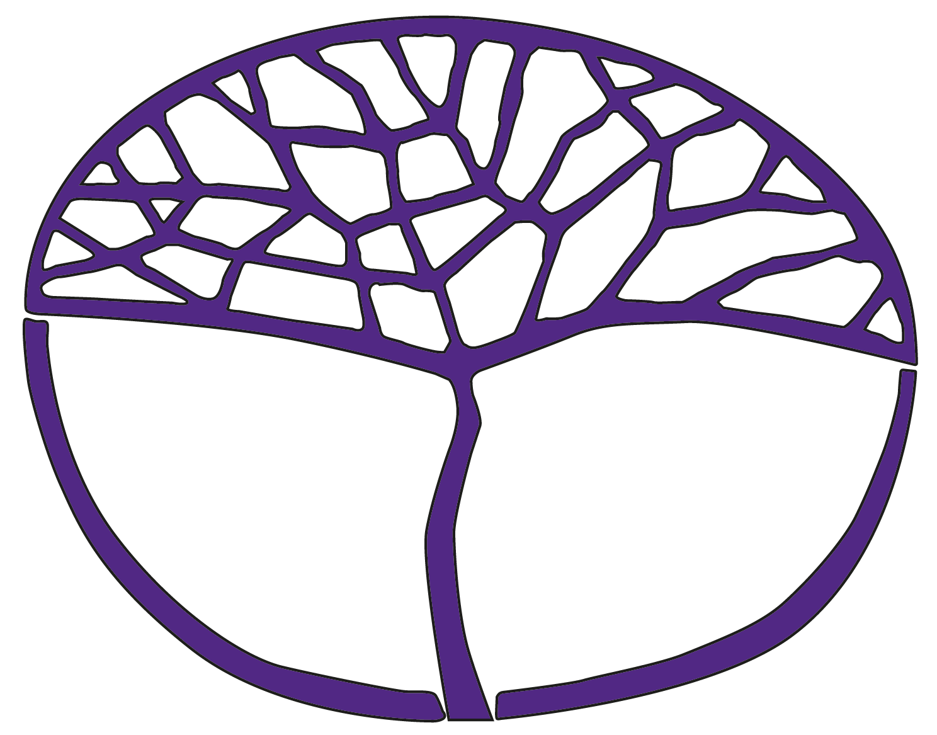
Sample Course Outline
Visual Arts
ATAR Year 12

Acknowledgement of Country
Kaya. The School Curriculum and Standards Authority (the Authority) acknowledges that our offices are on Whadjuk Noongar boodjar and that we deliver our services on the country of many traditional custodians and language groups throughout Western Australia. The Authority acknowledges the traditional custodians throughout Western Australia and their continuing connection to land, waters and community. We offer our respect to Elders past and present.
Copyright
© School Curriculum and Standards Authority, 2015
This document – apart from any third-party copyright material contained in it – may be freely copied, or communicated on an intranet, for non-commercial purposes in educational institutions, provided that the School Curriculum and Standards Authority (the Authority) is acknowledged as the copyright owner, and that the Authority’s moral rights are not infringed.
Copying or communication for any other purpose can be done only within the terms of the Copyright Act 1968 or with prior written permission of the Authority. Copying or communication of any third-party copyright material can be done only within the terms of the Copyright Act 1968 or with permission of the copyright owners.
Any content in this document that has been derived from the Australian Curriculum may be used under the terms of the Creative Commons Attribution 4.0 International licence.
Disclaimer
Any resources such as texts, websites and so on that may be referred to in this document are provided as examples of resources that teachers can use to support their learning programs. Their inclusion does not imply that they are mandatory or that they are the only resources relevant to the course. Teachers must exercise their professional judgement as to the appropriateness of any they may wish to use.

Sample course outline

Visual Arts – ATAR Year 12

Unit 3 and Unit 4

Semester 1, Unit 3 – Commentaries
Week | Key teaching points
1 | Unit focus: Commentaries  In this unit, students engage with the social and cultural purposes of art making to produce a unique and cohesive body of work and resolved artwork. They reflect on self as central to their environment and consider the influences that impact them. Students investigate social, cultural, religious and personal factors, and look at issues, events and topics that are of significance or importance to their life.  Syllabus content  Inquiry  - explore drawing involving observation, to conceptualise ideas, explore themes and develop meaning in artwork  Visual Influence  - investigate the techniques and approaches used by other artists to inform the development of own artwork  Key teaching points and tasks  - Examinable task: commence Task 1 – ‘Running with scissors’, due Week 8  Visual language  - explore visual language (elements and principles of art) to communicate concepts of individual difference and personal characteristics  - consider visual language which influences production and response
2–4 | Syllabus content  Inquiry  - explore a variety of ways to produce, present and document a body of work  Visual influence  - examine ways other artists have communicated persuasive ideas, issues or comment in artwork  Key teaching points and tasks  - study specific artists and artwork with similar techniques, subject matter or approaches  - Examinable task: continue Task 1, ‘Running with scissors’  Inquiry  - continue to explore different approaches to drawing in developing self-portraits  - explore personal experience of contemporary society through documentation of thinking and working practices  - experiment, develop and refine the use of media and techniques to produce solutions to create innovative illustrations and sculptural forms  Visual language  - manipulate visual language (elements and principles of art) in the development and production of own artwork  Syllabus content  Visual influence  - investigate the techniques and approaches used by other artists to inform the development of own artwork  Social, cultural and historical contexts  - in-depth examination and research of artists, groups, movements or cultures contextualising their practice within particular social, cultural or historical contexts  - undertake investigations and present case studies making links between art practices from different times and places  Key teaching points and tasks  - Investigation Task 3 – commence research/investigation (Australian or international context) due Week 10  Social, cultural and historical contexts  - examine and discuss artist/s and the artwork/s that have been shaped or influenced by specific social, cultural or historical concerns  Visual influence  - research Australian and/or international artists whose practice provides commentary on contemporary issues in own and/or other cultural contexts
5–7 | Syllabus content  Inquiry  - use a range of investigative approaches to explore, manipulate, develop and refine artwork  Visual influence  - select stylistic influences and use specific artworks relating influences to own artwork  Art practice  - explore ways to use skills and processes to create new art forms and visual art practices  - follow correct health and safety practices, respecting and acknowledging the work and rights of others  Key teaching points and tasks  - Examinable task – continue Task 1, ‘Running with scissors’  Inquiry  - explore alternatives, experiment and make informed decisions about the development of designs and solutions  - experiment with the versatility and limitations of paper. Purposefully cut, fold, curve and gather to create sculptural objects/installations  - experiment, develop and refine the use of media and techniques to produce innovative inquiry outcomes  Art practice  - select, discern, manipulate and apply materials, skills and processes to produce artwork in selected art form  Syllabus content  Visual analysis  - analyse and respond to unfamiliar artwork representative of a range of art forms and styles  Meaning and purpose  - identify formal, stylistic and technical elements which contribute to the function or meaning in the artwork  - analyse social, religious, political and cultural commentary of artwork from different times and places  - identify alternative perspectives and meaning communicated in artwork  Personal response  - support and justify opinions by offering a range of interpretations of artwork  - provide alternative points of view when responding to artwork  Social, cultural and historical contexts  - compare artwork that has been shaped or influenced by specific social, cultural or historical concerns  Key teaching points and tasks  - Analysis Task 2 – unseen image analysis due Week 6  - Investigation Task 3 – research/investigation (Australian or international context) due Week 10  Visual analysis  - identify alternative perspectives and meaning conveyed in artwork  - consider visual language (elements and principles of art) and use art terminology to comment on the differences and similarities between artworks, and discuss formal organisation
8–12 | Syllabus content  Visual language  - use visual language (elements and principles of art) to transform artwork and communicate concepts in a considered and insightful way  Art forms, media and techniques  - adapt and apply materials and techniques to create artwork in selected art forms  - experiment and refine the use of media and techniques to create innovative artwork  Art practice  - explore ways to use skills and processes to create new art forms and visual art practices  - follow correct health and safety practices, respecting and acknowledging the work and rights of others  - make informed and sensitive choices when developing and presenting artwork about different religious, cultural and social practices  Presentation  - plan, document and present an account of the thinking and working practices leading to the development of a body of work  Reflection  - reflect on and maintain documentation of the development of thinking and working practices  - acknowledge primary and/or secondary visual influence/s  Key teaching points and tasks  - Examinable task – Task 1 Part 1: ‘Running with scissors’ body of work feedback due Week 8  - Art practice: Resolved artwork commencing Week 9  Inquiry  - consider a variety of ways to extend and refine artwork  - document the process of media exploration, inquiry and working practices  - organise work, demonstrating independent planning and time management  - make comparisons and connections between artwork and influences, using art terminology to discuss formal organisation (composition), meaning and artistic style  Art practice  - select, manipulate and discerningly apply materials, skills and processes to produce artwork in selected art forms  Reflection  - consider and describe ideas, meanings, influences and personal direction in the documentation draft of an artist statement  Syllabus content  Visual analysis  - use critical analysis frameworks and investigations to make comment on artwork  - consider visual language (elements and principles of art) which influence production and response  - make comparisons and connections between artwork, using art terminology to discuss formal organisation (composition), meaning and artistic style  Personal response  - support and justify opinions by offering a range of interpretations of artwork  Key teaching points and tasks  - Investigation Task 3 – research/investigation: Australian or international context, due Week 10  Visual analysis  - contextualise the style and artistic approach of selected artist/s and discuss the meanings generated in artworks
13 | Syllabus content  Reflection  - reflect on and maintain documentation of development of thinking and working practices  - acknowledge primary and/or secondary visual influence/s  Key teaching points and tasks  - Examinable task – Task 1, ‘Running with scissors’, reviewed weekly  Art forms, media and techniques  - refine use of media and techniques to produce innovative artwork  Reflection  - revise artist statement to clarify personal ideas, meaning, influences and process taken in art making
14 | Syllabus content  Reflection  - provide an artist statement that describes the ideas, meaning, influences and personal direction taken in art making  Presentation  - discerningly select and exhibit a body of work  Key teaching points and tasks  - Examinable task – Task 1 Part 2: ‘Running with scissors’ resolved artwork, artist statement and visual evidence of work, due Week 14  Reflection  - prepare visual evidence of working practice to support resolved artwork and artist statement
15 | Key teaching points and tasks  - Semester 1 written examination Task 4  Prepare for and complete the ATAR Year 12 written examination based on the syllabus content from Unit 3 (modelled on the examination design brief).

Semester 2, Unit 4 – Points of view
Week | Key teaching points
1 | Unit focus: Points of view  Identify and explore concepts and/or issues of personal significance that provide a broad opportunity to pursue and communicate a personal point of view. Explore factors that influence and shape points of view, such as politics, identity, gender and religion to present an authentic body of work.  Syllabus content  Visual language  - explore, apply and refine visual language (elements and principles of art) to create innovative and personal visual solutions in the development and production of a body of work  Visual analysis  - use critical analysis frameworks and historical research to undertake in-depth contextual or cross-cultural investigations  Key teaching points and tasks  - Examinable task – Task 5 Part 1: commence ‘AnOther’ body of work, due Week 8  - Investigation Task 7 – research/investigation: commence research of selected artist/s and art movement/s  Inquiry  - use innovative and expressive approaches to drawing, involving observation, to conceptualise ideas and explore themes
2–4 | Syllabus content  Inquiry  - use innovative and expressive approaches to drawing and investigate a range of ways to develop and produce artwork  Visual language  - explore, apply and refine visual language (elements and principles of art) to create innovative and personal visual solutions in the development and production of a body of work  Visual influence  - personal selection and in-depth research of artists and art forms to inform own practice  Art forms, media and techniques  - combine and use materials and techniques in selected art forms to purposefully construct and communicate personal meaning  Art practice  - apply a range of skills and processes to produce artwork, demonstrating expressive and technical competence  - follow correct health and safety practices, respecting and acknowledging the work and rights of others  Reflection  - reflect on and maintain documentation of the development of thinking and working practices, explaining ideas and justifying a point of view  Meaning and purpose  - examine artwork that challenges attitudes, beliefs, values and ideologies  - examine the relationship between audience, artwork and meaning using visual analysis, art history and research  Key teaching points and tasks  - Examinable task – Task 5 Part 1: continue ‘AnOther’ body of work, due Week 8  - Investigation Task 7 – continue research/investigation of selected artist/s and art movement/s, due Week 10  Inquiry  - further explore drawing to investigate ways of developing and communicating ideas and personal viewpoints  - explore personal experience of contemporary society through documentation of thinking and working practices
5–7 | Syllabus content  Visual language  - explore, apply and refine visual language (elements and principles of art) to create innovative and personal visual solutions in the development and production of a body of work  Visual influence  - investigate artists and artwork that represent individual, collective, innovative or challenging responses to themes, issues or points of view in the visual arts  Art forms, media and techniques  - investigate, extend and refine materials and techniques in the development and production of artwork  Art practice  - make informed and sensitive choices when developing and presenting artwork about different religious, cultural and social practices  Key teaching points and tasks  - Examinable task – Task 5 Part 1: continue ‘AnOther’ body of work, due Week 8  Inquiry  - select, combine, manipulate and refine artwork developing a personal style and individual approach to visual art practice
8–12 | Syllabus content  Visual analysis  - analyse and compare unfamiliar artworks representative of a range of art forms, styles, times and places  - consider visual language (elements and principles of art) which influence production and response  - make comparisons and connections between artwork using art terminology to discuss formal organisation, meaning and artistic style  Personal response  - explore issues that shape critical response and discuss contextual factors that affect meaning and interpretation  - use visual analysis and research to support personal responses and different points of view  Meaning and purpose  - examine artwork that challenges attitudes, beliefs, values and ideologies  - identify formal, stylistic and technical elements which contribute to the function or meaning in artwork  Social, cultural and historical contexts  - research social, cultural, historical and other contextual factors influencing art practice, using criticism and specific examples  - undertake investigations and present case studies firmly locating the production and reception of selected artists, movements or groups in their social, cultural and historical contexts  Key teaching points and tasks  - Investigation Task 7 – research/investigation of selected artist/s and art movement/s,  due Week 10  - Analysis Task 6 – in-class compare and contrast extended response due Week 8. Analyse two images and respond to factors affecting points of view such as time, place, culture, religion and/or politics, synthesising this knowledge to express a personal viewpoint or position  - Examinable task – Task 5 Part 1: continue ‘AnOther’ body of work feedback, due Week 8  Inquiry  - plan, document and produce a cohesive body of work that demonstrates sustained inquiry and exploration of concepts  Visual analysis  - consider visual language – elements and principles of art, signs, symbols and conventions which determine production and response  Syllabus content  Art practice  - apply a range of skills and processes to produce artwork, demonstrating expressive and technical competence  Presentation  - present an account of the thinking and working practices leading to the development of a body of work  Reflection  - reflect on and maintain documentation of the development of thinking and working practices, explaining ideas and justifying a point of view  Key teaching points and tasks  - Examinable task – Task 5 Part 2: ‘AnOther’ commence resolved artwork in Week 9, due Week 14
13 | Key teaching points and tasks  - Examinable task – Task 5 Part 2: ‘AnOther’ continue resolved artwork, due Week 14  Presentation  - discerningly select a body of work to present with the resolved artwork for the practical assessment  Reflection  - refine artist statement to be displayed with resolved artwork  - prepare visual evidence of working practices to support resolved artwork and artist statement
14 | Syllabus content  Presentation  - select and display artwork for exhibition, considering space and audience  Reflection  - provide an artist statement that describes the ideas, meaning, influences and personal direction taken in art making  - acknowledge primary and/or secondary visual influence/s  Key teaching points and tasks  - Examinable task – Task 5 Part 2: ‘AnOther’ continue resolved artwork, artist statement and visual evidence of work, due Week 14  - Submit resolved artwork, artist statement and visual evidence for practical assessment
15 | Key teaching points and tasks  - Semester 2 written examination Task 8  Prepare for and complete the ATAR Year 12 written examination based on the syllabus content from Unit 3 and Unit 4 (modelled on the examination design brief)

