Design

ATAR course
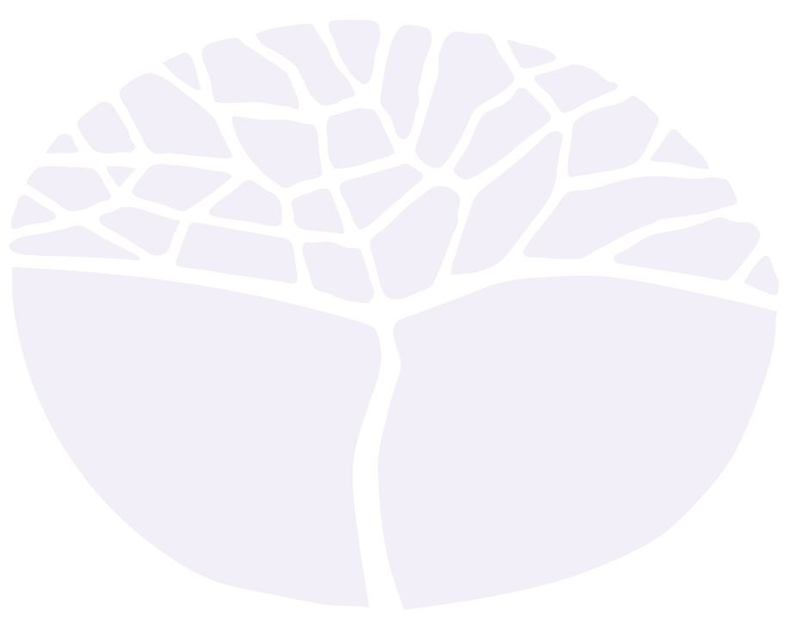
Year 12 Syllabus

Acknowledgement of Country
Kaya. The School Curriculum and Standards Authority (the Authority) acknowledges that our offices are on Whadjuk Noongar boodjar and that we deliver our services on the country of many traditional custodians and language groups throughout Western Australia. The Authority acknowledges the traditional custodians throughout Western Australia and their continuing connection to land, waters and community. We offer our respect to Elders past and present.
Important information
This syllabus is effective from 1 January 2024.
Users of this syllabus are responsible for checking its currency.
Syllabuses are formally reviewed by the School Curriculum and Standards Authority (the Authority) on a cyclical basis, typically every five years.
Copyright
© School Curriculum and Standards Authority, 2023
This document – apart from any third-party copyright material contained in it – may be freely copied, or communicated on an intranet, for non-commercial purposes in educational institutions, provided that the School Curriculum and Standards Authority (the Authority) is acknowledged as the copyright owner, and that the Authority’s moral rights are not infringed.
Copying or communication for any other purpose can be done only within the terms of the Copyright Act 1968 or with prior written permission of the Authority. Copying or communication of any third-party copyright material can be done only within the terms of the Copyright Act 1968 or with permission of the copyright owners.
Any content in this document that has been derived from the Australian Curriculum may be used under the terms of the Creative Commons Attribution 4.0 International licence.
Content
Rationale 1
Aims 2
Organisation 3
Structure of the syllabus 3
Organisation of content 3
Representation of the general capabilities 5
Representation of the cross-curriculum priorities 6
Unit 3 – Responsible design 8
Unit description 8
Unit content 8
Unit 4 – Influential design 12
Unit description 12
Unit content 12
Assessment 14
School-based assessment 14
Reporting 17
ATAR course examination 18
Practical (portfolio) examination design brief – Year 12 19
Written examination design brief – Year 12 20
Acknowledgements 21
Appendix 1 – Grade descriptions Year 12* 22

Rationale
Design is a fundamental literacy that supports the conception and visualisation of ideas. Designers have the opportunity to improve and transform the world in which we live. Good design should aim to foster and promote innovation, while delivering sustainable solutions for specific purposes and audiences.
The study of Design empowers students to identify, understand, interpret, create and communicate through visual and tactile means; to influence everyday life for individuals, societies and the natural world.
Students are introduced to design theory, design history and design practice through the experience of applying a design process. The design process involves identification of a perceived need, problem or opportunity that is then articulated in a design brief. Concepts and ideas are developed through the application of Design Thinking, incorporating a variety of tools, methods and strategies that are shaped by considerations of aesthetics and functionality, as well as social, cultural, historical, environmental and economic factors. This Design Thinking approach encourages students to engage a user-centred design process that is iterative and prototype driven.
Students of Design are challenged to unravel open-ended problems and to develop a variety of potential outcomes. They are encouraged to make design decisions that demonstrate skills in analysis, judgement and synthesis, while simultaneously developing their technical skills.
The Design course equips students with highly transferrable knowledge and skills for further education and employment pathways within a range of industries. The problem solving, Design Thinking and visual communication skills obtained in this course, in partnership with industry specific knowledge, provides students with an increasingly valuable skill set relevant to all fields of design as well as technology, engineering, business, science and innovation.

Aims
The Design ATAR course enables students to:
- develop knowledge and understanding of design language, terminology and frameworks
- understand and apply linear and iterative design processes
- develop ability to use design inquiry methods creatively and critically, and make and justify discerning design choices
- develop ability to identify and explore open-ended design challenges, and to propose a variety of potential outcomes, taking into account social, cultural, historical, environmental and economic factors
- develop ability to manipulate and organise design elements, design principles and selected media and materials to communicate ideas for specific audiences.

Organisation
This course is organised into a Year 11 syllabus and a Year 12 syllabus. The cognitive complexity of the syllabus content increases from Year 11 to Year 12.

Structure of the syllabus
The Year 12 syllabus is divided into two units which are delivered as a pair. The notional time for the pair of units is 110 class contact hours.

Unit 3 – Responsible design
In this unit, students become aware of the legal, ethical and environmental responsibilities of a designer as they focus on the development of useful, sustainable and/or ethical design forms.
Unit 4 – Influential design
In this unit, students learn how the communication of ideals, messages, information and values can influence opinion and attitudes.
Each unit includes:
- a unit description – a short description of the focus of the unit
- unit content – the content to be taught and learned.

Organisation of content
The course content is the focus of the learning program.
The course content is divided into two areas:
- Design features
- Design phases.
Design features

Design frameworks
Students explore the differences between linear and iterative design process frameworks to facilitate innovative and creative solutions to identified problems. While a linear design process is comprised of defined steps in a specific sequence, working towards a single solution, an iterative design process involves a repeated cycle of prototyping, testing and refining ideas based on stakeholder feedback to continually improve design outcomes. Students apply and document the iterative Double Diamond design process model.

Design knowledge
Design knowledge is integral to the application of a design process, and includes the study of core design language and terminology along with contemporary and historical design references. Students must develop a solid understanding of these fundamental conventions and their application, significance and influence on the creation of successful design outcomes.

Design responsibilities
This content relates to the legal rights, responsibilities and professional obligations of designers. Students gain an understanding of intellectual property and copyright protection, and become aware of relevant standards for compliance to ensure the safety, reliability, consistency and quality of designs.
Design phases
In this syllabus, the design process is based on the Double Diamond model, developed by the British Design Council. In comparison to a linear model consisting of a predetermined sequence and the completion of steps, this non-linear design process is iterative and focuses on refinement of ideas. Students should use this model purely as a framework and be prepared to do things in a different order or retrace their steps to clarify or redefine problems as they occur. This allows the best design outcome to be discovered, rather than pursuing the first idea that is derived.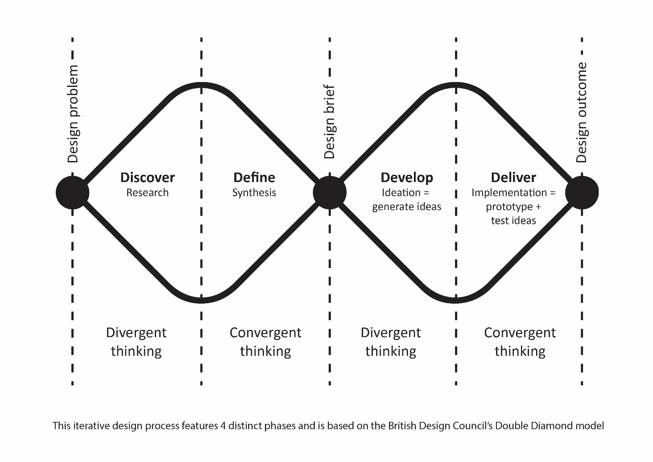

Discover
This phase of the design process involves exploring a design need, opportunity or problem. This may begin with an initial idea or inspiration, and is often focused on discovering and understanding the needs of clients, customers and end-users. Using creative and divergent Design Thinking strategies, students work towards identifying a problem, along with clarifying the key stakeholders.

Define
The next phase of the design process involves reviewing, selecting and discarding ideas. Using critical and convergent Design Thinking, findings from the Discover stage are analysed, defined and refined. Students understand the constraints and purpose of the design as they develop a detailed design brief to clearly articulate a problem that requires a solution.

Develop
During this phase, students take an experimental approach to generate multiple ideas inspired by the design brief. By applying creative Design Thinking strategies, students develop, visualise and iterate concepts that address the problem or issue identified during the Discover and Define phases.

Deliver

In the Deliver phase of the Double Diamond design process, the design concept is refined through multiple iterations. Physical and/or digital low-fidelity prototyping is used to test and improve design ideas, while stakeholder feedback is considered and synthesised. Critical Design Thinking is used to filter ideas and support decision making, to ensure the most suitable and effective design outcome is presented for implementation.

Representation of the general capabilities
The general capabilities encompass the knowledge, skills, behaviours and dispositions that will assist students to live and work successfully in the twenty-first century. Teachers should find opportunities to incorporate the capabilities into the teaching, learning and assessment program for the Design ATAR course. The general capabilities are not assessed unless they are identified within the specified unit content.

Literacy
Literacy is of fundamental importance in the study of design. Students will access design content through a variety of print, oral, visual, spatial and electronic forms, including data books, texts, computer software, images, and written technical materials. They learn to investigate, interpret and apply design elements and principles from a variety of sources to design solutions for tasks. They analyse and evaluate information for reliability, relevance and accuracy. They learn to monitor their own language use for accuracy in the use of design terms for clarity of ideas, processes and explanations of design activities and development and evaluation of design outcomes.

Numeracy
Numeracy is fundamental in calculating material quantities and evaluating design process costs. Students develop their understandings and skills of numeracy while undertaking tasks to produce, test and evaluate products. Design theory continues to be studied to forge greater understanding of the scientific, mathematical and technical concepts that explain how designed products function.

Information and communication technology capability

Information and communication technology (ICT) capability is important in all stages of the design process. Students use digital tools and strategies to locate, access, process and analyse information. They use ICT skills and understandings to investigate and devise design ideas. Students access information from websites and software programs to develop design solutions. Students may use computer-aided drawing software and computer control software to develop design outcomes.

Critical and creative thinking

Critical and creative thinking is integral to the design process. The Design Thinking methodologies are fundamental to the Design ATAR course. Students develop understandings and skills in critical and creative thinking during periods of evaluation at numerous stages of the design process. They devise plausible solutions to problems, and then through interrogation, critically assess the performance of the most efficient solution. Students identify possible refinements in their design solutions and analyse, evaluate and modify the developing solution to create a prototype.

Personal and social capability

Personal and social capability skills are developed and practised in the Design ATAR course by students enhancing their communication skills and participating in teamwork. Students have opportunities to work collaboratively during stages of investigation and production of products. Students develop increasing social awareness through the study of the impact of the use of materials and manufacturing technology in society and on the environment.

Ethical understanding
Students have opportunities to explore and understand the diverse perspectives and circumstances that shape design processes, and the actions and possible motivations of people in the past compared with those of today. Students have opportunities, both independently and collaboratively, to explore the values, beliefs and principles that have influenced past design achievements, and the ethical decisions required by global design processes of today.

Intercultural understanding
Students have opportunities to explore the different beliefs and values of a range of cultural groups and develop an appreciation of cultural diversity. Students have opportunities to develop an understanding of different contemporary perspectives with regard to design inspiration, product styles, building materials, energy supply and use, historical design influences on different groups within society, and how these contribute to individual and group actions in the contemporary world.

Representation of the cross-curriculum priorities
The cross-curriculum priorities address the contemporary issues which students face in a globalised world. Teachers should find opportunities to incorporate the priorities into the teaching and learning program for the Design ATAR course. The cross-curriculum priorities are not assessed unless they are identified within the specified unit content.

Aboriginal and Torres Strait Islander histories and cultures
Students may have opportunities to explore Aboriginal and Torres Strait Islander development and use of design and the interconnectedness between design, purpose and innovation, and how these relate to identity, people, culture and country/place.

Asia and Australia's engagement with Asia

Students may have opportunities to explore traditional, contemporary and emerging design achievements in the countries of the Asia region. Students explore Australia’s rich and ongoing engagement with the peoples and countries of Asia to create appropriate products and services to meet personal, community, national, regional and global needs.

Sustainability
Students take action to create more sustainable patterns of living. Students can develop knowledge, understanding and skills necessary to design for effective sustainability.

Students focus on the knowledge, understanding and skills necessary to choose design solutions with regard to costs and benefits. They evaluate the extent to which the process and designed solutions embrace sustainability. Students reflect on past and current practices and assess new and emerging designs from a sustainability perspective.

Unit 3 – Responsible design

Unit description
This unit focuses on the development of designs for a worthwhile purpose, or that will benefit society. Students experiment with the Double Diamond design process to create useful, sustainable and/or ethical design forms. They understand the various ways in which designers are responsible for ensuring the safety and suitability of their design decisions as they respond to environmental, social and cultural needs, towards the refinement of an appropriate design outcome.

Unit content
An understanding of the Year 11 content is assumed knowledge for students in Year 12. It is recommended that students studying Unit 3 and Unit 4 have completed Unit 1 and Unit 2.
This unit includes the knowledge, understandings and skills described below. This is the examinable content.
Note:
- sub-dot points following the phrase ‘for example’ support understanding of the dot point, but are not specific examinable content.
- sub-dot points following the word ‘including’ are specific examinable content.

Design features

Design frameworks
- understand the limitations of a linear design process
- application and documentation of an iterative design process:
- Double Diamond model
- discover
- define
- develop
- deliver

Design knowledge
- analysis and synthesis of the elements of design:
- line
- directional, organic, implied
- shape
- two-dimensional, geometric, abstract
- tone
- tonal scale, high key, low key
- form
- three-dimensional, proportion
- space
- positive, negative, organised
- colour
- psychological effects
- additive, subtractive
- RGB and CMYK
- texture
- visual, tactile
- analysis of design principles within design solutions:
- balance
- contrast
- emphasis
- repetition
- movement
- scale
- unity
- variety
- pattern
- harmony
- alignment
- hierarchy
- selection and application of appropriate typographic styles, including:
- serif, sans serif
- script, display
- analysis of Gestalt principles within design solutions, including:
- figure/ground
- similarity
- proximity
- continuation
- closure
- investigation of relevant historical and/or contemporary designs:
  - designer/s attributed to the work
  - date and/or period of creation
  - social, cultural and/or political context/s
  - key visual motifs, features and/or concepts
  - key materials, techniques and/or technologies

Design responsibilities
- interpret the categories of intellectual property (IP) law relevant to design:
- copyright
- protects the original representation of ideas and 2D designs not commercially produced
- protected for 70 years after death of creator, free and automatic
- registered design
- protects the overall appearance of a functional product
- protected for 5–10 years, if fees are paid
- patents
- protect how an invention works or functions
- protected for 20 years, with fees payable every five years
- trademark
- protects a letter, number, word, phrase, sound, smell, shape, logo, picture or any combination of these
- protected indefinitely, if fees are paid every 10 years
- identify relevant national and/or international standards appropriate to the design brief
- understand occupational safety and health (OSH) concepts and their impact in design:
- ergonomics
- ensuring designs are compatible with the needs, abilities and limitations of the user
- safe design
- hazard identification and risk assessment to eliminate the risk of injury throughout the life of the design
- recommend sustainability strategies to reduce environmental impact during the design life cycle

Design phases

Discover
- identify and explore a design need, problem or opportunity using Design Thinking strategies, for example:
- design mindsets
- empathy mapping
- needfinding
- identify and develop a target audience/end-user profile:
- demographic characteristics
- psychographic segmentation, for example:
- attitudes and values
- lifestyle
- personality
- priorities and motivations
- social status
- VALS™ model
- identify, classify and consider stakeholders:
- power vs interest grid
- explore sources of inspiration, for example:
- site/location
- similar or competitive designs
- visual stimulation/mood boards
- colour/material swatches
- historical and/or contemporary designs
- reflect on and summarise the discovery phase

Define
- construction of a design brief, including:
- core design problem
- stakeholders
- target audience/end-user characteristics
  - aim or purpose of the design
  - constraints
  - context of the design
  - deliverables

Develop
- application of creative Design Thinking strategies to generate multiple ideas inspired by the design brief, for example:
- concept maps
- visual brainstorming
- forced associations
- Bloom’s action verbs
- SCAMPER
- Six Thinking Hats® system
- synectic triggers
- identify and interpret semiotic concepts evident in design, including:
- sign – symbol, index, icon
- signifier
- signified
- use of drawing and low-fidelity methods to visualise information and ideas
- reflect on and refine ideas through annotated iterations
- reflect on and summarise the Develop phase

Deliver
- synthesis of critical Design Thinking to support decision making, for example:
- PMI
- SWOT analysis
- compare and contrast
- persuasion map
- graphic organisers
- Six Thinking Hats® system
- experimentation with physical or digital low-fidelity prototyping to test the effectiveness of design ideas
- explore a variety of materials and/or techniques appropriate to the design brief
- investigate design conventions relevant to the design outcome
- explore target audience/end-user feedback methods, for example:
- qualitative research
- questioning/surveys/user-based evaluation
- usability testing
- refinement of prototype/s to meet the design brief
- compose suitable presentation formats to communicate a design outcome
- application of skills to communicate a design outcome

Unit 4 – Influential design

Unit description
This unit focuses on the communication of ideals, messages, information and values, to influence opinion and attitudes. Students design products and visual layouts to encourage a change in thinking or actions. They analyse the audience through demographic characteristics and psychographic segmentation to develop persuasive designs in response to real world problems. Students synthesise their understanding of design knowledge through the application of Design Thinking strategies as part of an iterative design process.

Unit content
This unit builds on the content covered in Unit 3.
This unit includes the knowledge, understandings and skills described below. This is the examinable content.
Note:
- sub-dot points following the phrase ‘for example’ support understanding of the dot point, but are not specific examinable content.
- sub-dot points following the word ‘including’ are specific examinable content.

Design features

Design frameworks
- consolidation and documentation of an iterative design process:
- Double Diamond model
- discover
- define
- develop
- deliver
- compare the differences between linear and iterative design processes

Design knowledge
- analysis and synthesis of the elements of design
- synthesis of relevant design principles within design outcomes
- use of relevant typographic terminology to justify design decisions, including:
- ascender, descender
- baseline, cap line
- leading, kerning
- typeface, character
- uppercase, lowercase
- synthesis of Gestalt principles within design outcomes
- interpretation of historical and/or contemporary designs appropriate to a design brief

Design responsibilities
- appropriate attribution of others intellectual property (IP)
- consult relevant national and/or international standards appropriate to the design brief
- apply relevant occupational safety and health (OSH) concepts appropriate to the design brief
- justify sustainability strategies to reduce environmental impact during the design life-cycle

Design phases

Discover
- clarify a design need, problem or opportunity
- classify and annotate sources of inspiration
- interpret and apply a target audience/end-user profile
- interpret and establish stakeholder requirements
- reflect and summarise the discovery phase

Define
- elaboration of a comprehensive design brief

Develop
- experimentation with creative Design Thinking strategies to generate multiple ideas inspired by the design brief
- exploration of communication strategies, including:
- emotion
- humour
- metaphor
- shock tactics
- use of drawing and low-fidelity methods to visualise information and ideas
- reflect on and refine ideas through annotated iterations
- reflect on and summarise the develop phase

Deliver
- analysis of critical Design Thinking to justify decision making
- evaluation of physical and/or digital low-fidelity prototyping to improve design ideas
- refine and justify the selection of materials and/or techniques
- employ design conventions relevant to the design outcome
- collate and incorporate target audience/end-user feedback
- refinement of prototype/s to meet the design brief
- synthesise presentation formats to communicate a design outcome
- refinement of skills to communicate a design outcome

Assessment
Assessment is an integral part of teaching and learning that at the senior secondary years:
- provides evidence of student achievement
- identifies opportunities for further learning
- connects to the standards described for the course
- contributes to the recognition of student achievement.
Assessment for learning (formative) and assessment of learning (summative) enable teachers to gather evidence to support students and make judgements about student achievement. These are not necessarily discrete approaches and may be used individually or together, and formally or informally.
Formative assessment involves a range of informal and formal assessment procedures used by teachers during the learning process in order to improve student achievement and to guide teaching and learning activities. It often involves qualitative feedback (rather than scores) for both students and teachers, which focuses on the details of specific knowledge and skills that are being learnt.
Summative assessment involves assessment procedures that aim to determine students’ learning at a particular time, for example when reporting against the standards, after completion of a unit/s. These assessments should be limited in number and made clear to students through the assessment outline.
Appropriate assessment of student work in this course is underpinned by reference to the set of predetermined course standards. These standards describe the level of achievement required to achieve each grade, from A to E. Teachers use these standards to determine how well a student has demonstrated their learning.
Where relevant, higher order cognitive skills (e.g. application, analysis, evaluation and synthesis) and the general capabilities should be included in the assessment of student achievement in this course. All assessment should be consistent with the requirements identified in the course assessment table.
Assessment should not generate workload and/or stress that, under fair and reasonable circumstances, would unduly diminish the performance of students.

School-based assessment
The Western Australian Certificate of Education (WACE) Manual contains essential information on principles, policies and procedures for school-based assessment that must be read in conjunction with this syllabus.
School-based assessment involves teachers gathering, describing and quantifying information about student achievement.
Teachers design school-based assessment tasks to meet the needs of students. As outlined in the WACE Manual, school-based assessment of student achievement in this course must be based on the Principles of Assessment:
- Assessment is an integral part of teaching and learning
- Assessment should be educative
- Assessment should be fair
- Assessment should be designed to meet its specific purpose/s
- Assessment should lead to informative reporting
- Assessment should lead to school-wide evaluation processes
- Assessment should provide significant data for improvement of teaching practices.
The table below provides details of the assessment types and their weighting for the Design ATAR Year 12 syllabus.
Summative assessments in this course must:
- be limited in number to no more than eight tasks
- allow for the assessment of each assessment type at least once over the year/pair of units
- have a minimum value of 5 per cent of the total school assessment mark
- provide a representative sampling of the syllabus content.
Assessment tasks not administered under test or controlled conditions require appropriate authentication processes.

Assessment table practical component – Year 12
Type of assessment | Weighting | To SCSA | Weighting for combined mark
Production  On completion of each unit, students are expected to deliver at least one design outcome.  On completion of the pair of units, students are expected to have comprehensively applied an iterative design process to:  - discover a design need, problem or opportunity  - define a design brief  - develop ideas  - deliver at least two design outcomes (may be part of the same design brief)  Note: students will compile evidence of their application of an iterative design process in a portfolio which forms the practical examination. | 100% | 100% | 50%

Assessment table written component – Year 12
Type of assessment | Weighting | To SCSA | Weighting for combined mark
Response  Students demonstrate an understanding of design knowledge and frameworks as they analyse and respond to stimuli or prompts related to the unit content, including historical and/or contemporary design forms. Responses can include short answers, oral presentation, multimodal presentation, flowcharts and diagrams. | 40% | 100% | 50%
Written examination  Typically conducted at the end of each semester and/or unit and reflecting the examination design brief for this syllabus. | 60%
Teachers must use the assessment table to develop an assessment outline for the pair of units.
The assessment outline must:
- include a set of assessment tasks
- include a general description of each task
- indicate the unit content to be assessed
- indicate a weighting for each task and each assessment type
- include the approximate timing of each task (for example, the week the task is conducted, or the issue and submission dates for an extended task).

Reporting
Schools report student achievement, underpinned by a set of pre-determined standards, using the following grades:
Grade | Interpretation
A | Excellent achievement
B | High achievement
C | Satisfactory achievement
D | Limited achievement
E | Very low achievement
The grade descriptions for the Design ATAR Year 12 syllabus are provided in Appendix 1. They are used to support the allocation of a grade. They can also be accessed, together with annotated work samples, on the course page of the Authority website at www.scsa.wa.edu.au.
To be assigned a grade, a student must have had the opportunity to complete the education program, including the assessment program (unless the school accepts that there are exceptional and justifiable circumstances).
Refer to the WACE Manual for further information about the use of a ranked list in the process of assigning grades.
The grade is determined by reference to the standard, not allocated on the basis of a pre-determined range of marks (cut-offs).

ATAR course examination
All students enrolled in the Design ATAR Year 12 course are required to sit the practical and written components of the ATAR course examination. The examination is based on a representative sampling of the content for Unit 3 and Unit 4. Details of the written and practical ATAR course examinations are prescribed in the examination design briefs on the following pages.
Refer to the WACE Manual for further information.

Practical (portfolio) examination design brief – Year 12
Provided by the candidate
A signed Declaration of authenticity
A portfolio of up to 30 A3 pages (including a maximum of 4 A3 pages of a design proposal), saved as a PDF and submitted on USB
Submission | Supporting information
Portfolio  100% of the practical examination | The candidate is required to submit a portfolio that documents a comprehensive and practical application of an iterative design process.  The design process must explore open-ended design challenges that culminate in the presentation of a design proposal.  The design proposal should effectively communicate at least two design outcomes for a specific purpose and audience.  Evidence of creative and critical design inquiry methods to inform discerning design choices should be clearly presented throughout the portfolio.  Emphasis should be placed on the visual development of ideas through low-fidelity experimentation using digital and/or non-digital methods. Ideas should be supported by succinct annotation. Further refinement, development and presentation of the final design proposal may demonstrate high-fidelity skills, where appropriate.  Specifically, the following evidence must be included in the practical (portfolio) submission:  - application of an iterative design process  - development of a comprehensive design brief exploring a design problem  - consideration of legal, ethical, environmental and/or safety responsibilities relevant to the design problem  - application of creative Design Thinking strategies to generate ideas  - experimentation with critical Design Thinking strategies and refinement through prototyping and testing  - selection and use of appropriate media, materials and techniques throughout the design process  - presentation of a design proposal that effectively responds to the design brief.
Note: for further information, teachers are advised to refer to the Design ATAR Course Practical (portfolio) examination requirements document for each relevant year.

Written examination design brief – Year 12
Time allowed
Reading time before commencing work: ten minutes
Working time for paper: two and a half hours
Permissible items
Standard items: pens (blue/black preferred), pencils (including coloured), sharpener, correction fluid/tape, eraser, ruler, highlighters
Section | Supporting information
Section One  Short answer  30% of the written examination  4–6 questions  Suggested working time: 45 minutes | The candidate must complete all questions in this section.  Questions may contain parts.  The candidate may be required to demonstrate an understanding of design knowledge and frameworks.  Questions may require candidates to refer to stimulus material from a range of design forms or diagrams.
Section Two  Extended answer  70% of the written examination  Three questions  Suggested working time: 105 minutes | The candidate must complete all questions in this section.  Questions may be scaffolded.  Questions may require the candidate to refer to practical work completed throughout the year or stimulus material, including: case studies, market research, survey results, written texts, diagrams and/or pictorial representations.  Questions may require the candidate to refer to historical and/or contemporary designs studied throughout the year.  Questions will require the candidate to apply design language and terminology in extended written form.  The structure of extended written answers can include, but is not limited to: an essay format, annotations, lists and dot points.

Acknowledgements
Diagram based on: Design Council. (2019). Double Diamond model. Retrieved March, 2022, from https://www.designcouncil.org.uk/sites/default/files/asset/document/Double%20Diamond%20Model%202019.pdf.
Double Diamond model concept from: Design Council. (n.d.). The process: Using the Double Diamond. Retrieved March, 2022, from https://www.designcouncil.org.uk/news-opinion/what-framework-innovation-design-councils-evolved-double-diamond.

Appendix 1 – Grade descriptions Year 12*
A | Integrates extensive knowledge and understanding of design language, terminology and frameworks throughout the design process.
 | Applies extensive critical and creative design inquiry methods to generate and refine ideas.
 | Insightfully explores and experiments with a range of creative outcomes, considering all relevant design responsibilities.
 | Integrates and manipulates design elements and principles skilfully, with refined use of media and materials.
 | Demonstrates a discerning understanding and meticulous application of an iterative design process to facilitate compelling and inventive solutions to identified problems.

B | Justifies and interprets using knowledge and understanding of design language, terminology and frameworks throughout the design process.
 | Applies diverse critical and creative design inquiry methods to generate and refine ideas.
 | Effectively explores and experiments with a range of outcomes, considering relevant design responsibilities.
 | Selects and adapts design elements and principles effectively, with discerning use of media and materials.
 | Demonstrates a detailed understanding and thorough application of an iterative design process to facilitate effective and appealing solutions to identified problems.

C | Coherently applies knowledge and understanding of design language, terminology and frameworks during the design process.
 | Applies some critical and creative design inquiry methods to generate and refine ideas.
 | Explores and experiments alternative outcomes, with reference to design responsibilities.
 | Applies design elements and principles competently, with considered use of media and materials.
 | Demonstrates a clear understanding and capable application of an iterative design process to facilitate relevant solutions to identified problems.

D | Inconsistently applies knowledge and understanding of design language, terminology and frameworks in the design process.
 | Uses design inquiry methods to generate and refine ideas.
 | Develops simple outcomes with some consideration of design responsibilities.
 | Uses design elements and principles to some effect, with simple use of media and materials.
 | Demonstrates basic understanding and application of a design process to produce simple solutions to identified problems.

E | Does not meet the requirements of a D grade and/or has completed insufficient assessment tasks to be assigned a higher grade.
*These grade descriptions will be reviewed at the end of the second year of implementation of this syllabus.

