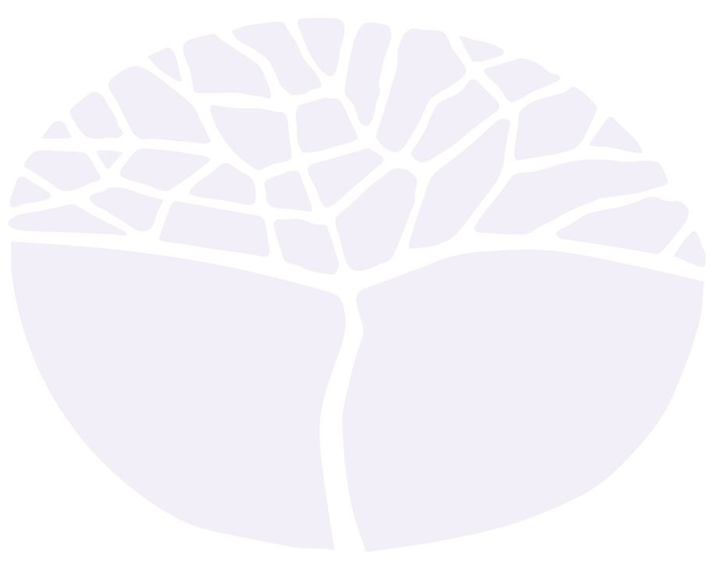
Drama
WACE courses
Set text list

Acknowledgement of Country
Kaya. The School Curriculum and Standards Authority (the Authority) acknowledges that our offices are on Whadjuk Noongar boodjar and that we deliver our services on the country of many traditional custodians and language groups throughout Western Australia. The Authority acknowledges the traditional custodians throughout Western Australia and their continuing connection to land, waters and community. We offer our respect to Elders past and present.
Copyright
© School Curriculum and Standards Authority, 2018
This document – apart from any third party copyright material contained in it – may be freely copied, or communicated on an intranet, for non-commercial purposes in educational institutions, provided that the School Curriculum and Standards Authority is acknowledged as the copyright owner, and that the Authority’s moral rights are not infringed.
Copying or communication for any other purpose can be done only within the terms of the Copyright Act 1968 or with prior written permission of the School Curriculum and Standards Authority. Copying or communication of any third party copyright material can be done only within the terms of the Copyright Act 1968 or with permission of the copyright owners.
Any content in this document that has been derived from the Australian Curriculum may be used under the terms of the Creative Commons Attribution 4.0 International licence.
Disclaimer
Any resources such as texts, websites and so on that may be referred to in this document are provided as examples of resources that teachers can use to support their learning programs. Their inclusion does not imply that they are mandatory or that they are the only resources relevant to the course.

Australian set text list
- Abela, Donna. Jump for Jordan.
- Bell, Hilary. Wolf Lullaby.
- Bovell, Andrew. Secret River.
- Bovell, Andrew. When the Rain Stops Falling.
- Cameron, Matt. Ruby Moon.
- Enoch, Wesley and Deborah Mailman. Seven Stages of Grieving.
- Isaacs, Chris. Flood.
- Monjo, Justin and Nick Enright. Cloudstreet.
- Nowra, Louis. Cosi.
- Oxenburgh, Dicken and Andrew Ross. Merry-Go-Round in the Sea.
- Rayson, Hannie. Two Brothers.
- Winmar, Dallas. Aliwa!
- Zen Zen Zo. The Tempest (adaptation).

World set text list
- Beckett, Samuel. Endgame.
- Berkoff, Steven. Metamorphosis.
- Brecht, Bertolt. Mother Courage.
- Churchill, Caryl. Top Girls.
- Complicité. Mnemonic.
- Dürrenmatt, Friedrich. The Visit: A tragicomedy (translated by Joel Agee).
- Ibsen, Henrik. Hedda Gabler.
- Ionesco, Eugene. Rhinoceros.
- Levenson, Steven (writer) and Benj Pasek and Justine Paul (composers). Dear Evan Hansen.
- Miller, Arthur. The Crucible.
- Reza, Yasmin. God of Carnage.
- Shakespeare, William. Twelfth Night.
- Stephens, Simon. The Curious Incident of the Dog in the Night-Time.

