Ancient History
General course

Externally set task Source Booklet
China from the time of the Warring States c. 475–c. 206 BC
Sample 2016

Copyright
© School Curriculum and Standards Authority, 2014
This document – apart from any third party copyright material contained in it – may be freely copied, or communicated on an intranet, for non-commercial purposes in educational institutions, provided that the School Curriculum and Standards Authority is acknowledged as the copyright owner, and that the Authority’s moral rights are not infringed.
Copying or communication for any other purpose can be done only within the terms of the Copyright Act 1968 or with prior written permission of the School Curriculum and Standards Authority. Copying or communication of any third party copyright material can be done only within the terms of the Copyright Act 1968 or with permission of the copyright owners.
Any content in this document that has been derived from the Australian Curriculum may be used under the terms of the Creative Commons Attribution-NonCommercial 3.0 Australia licence
Disclaimer
Any resources such as texts, websites and so on that may be referred to in this document are provided as examples of resources that teachers can use to support their learning programs. Their inclusion does not imply that they are mandatory or that they are the only resources relevant to the course.

Ancient History

Externally set task Source Booklet

China from the time of the Warring States to the rise and fall of the Qin dynasty c. 475–c. 206 BC

Source 1
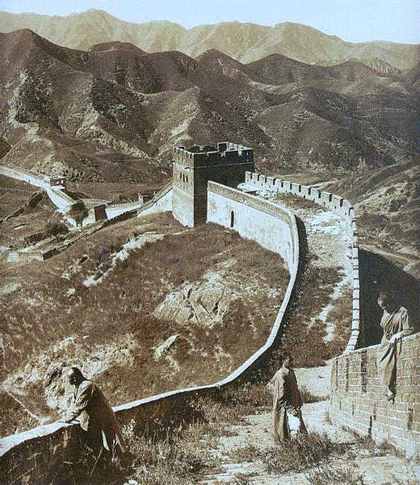
Ponting, H. (1907). Photograph of the Great Wall of China from 1907

Source 2

Economic reforms
Qin Shi Huang and Li Si unified China economically by standardizing the Chinese units of measurements such as weights and measures, the currency, the length of the axles of carts to facilitate transport on the road system. The emperor also developed an extensive network of roads and canals connecting the provinces to improve trade between them. The currencies of the different states were also standardized to the Ban liang coin. Perhaps most importantly, the Chinese script was unified. Under Li Si, the seal script of the state of Qin was standardized through removal of variant¹ forms within the Qin script itself. This newly standardized script was then made official throughout all the conquered regions, thus doing away with all the regional scripts to form one language, one communication system for all of China.
Extract from: Qin Shi Huang. (n.d.). Wikipedia

1 variant forms – different forms

ACKNOWLEDGEMENTS

Source 1 Ponting, H. (1907). Photograph of the Great Wall of China from 1907 [Image]. Retrieved January, 2014, from http://commons.wikimedia.org/wiki/File:Greatwall_large.jpg

Source 2 Extract from: Qin Shi Huang. (n.d.). Wikipedia. Retrieved February, 2014, from http://en.wikipedia.org/wiki/Qin_Shi_Huang
Used under the Creative Commons Attribution-ShareAlike 3.0 Unported License.

