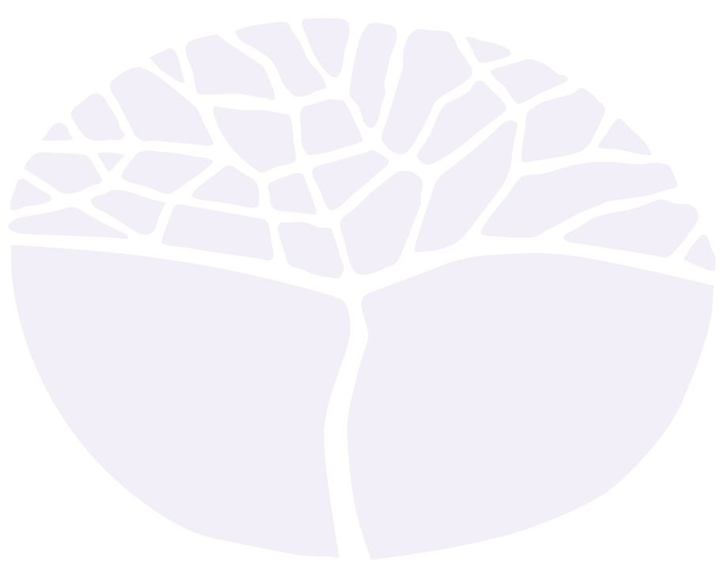
Design

ATAR course
Year 11 Syllabus

Acknowledgement of Country
Kaya. The School Curriculum and Standards Authority (the Authority) acknowledges that our offices are on Whadjuk Noongar boodjar and that we deliver our services on the country of many traditional custodians and language groups throughout Western Australia. The Authority acknowledges the traditional custodians throughout Western Australia and their continuing connection to land, waters and community. We offer our respect to Elders past and present.
IMPORTANT INFORMATION
This syllabus is effective from 1 January 2023.
Users of this syllabus are responsible for checking its currency.
Syllabuses are formally reviewed by the School Curriculum and Standards Authority on a cyclical basis, typically every five years.
Copyright
© School Curriculum and Standards Authority, 2022
This document – apart from any third party copyright material contained in it – may be freely copied, or communicated on an intranet, for non-commercial purposes in educational institutions, provided that the School Curriculum and Standards Authority is acknowledged as the copyright owner, and that the Authority’s moral rights are not infringed.
Copying or communication for any other purpose can be done only within the terms of the Copyright Act 1968 or with prior written permission of the School Curriculum and Standards Authority. Copying or communication of any third party copyright material can be done only within the terms of the Copyright Act 1968 or with permission of the copyright owners.
Any content in this document that has been derived from the Australian Curriculum may be used under the terms of the Creative Commons Attribution 4.0 International (CC BY) licence.
Content
Rationale 1
Aims 2
Organisation 3
Structure of the syllabus 3
Organisation of content 3
Representation of the general capabilities 5
Representation of the cross-curriculum priorities 6
Unit 1 – Representational design 8
Unit description 8
Unit content 8
Unit 2 – User-centred design 13
Unit description 13
Unit content 13
Assessment 17
School-based assessment 17
Reporting 19
Acknowledgements 20
Appendix 1 – Grade descriptions Year 11* 21

Rationale
Design is a fundamental literacy that supports the conception and visualisation of ideas. Designers have the opportunity to improve and transform the world in which we live. Good design should aim to foster and promote innovation, while delivering sustainable solutions for specific purposes and audiences.
The study of Design empowers students to identify, understand, interpret, create and communicate through visual and tactile means; to influence everyday life for individuals, societies and the natural world.
Students are introduced to design theory, design history and design practice through the experience of applying a design process. The design process involves identification of a perceived need, problem or opportunity that is then articulated in a design brief. Concepts and ideas are developed through the application of Design Thinking, incorporating a variety of tools, methods and strategies that are shaped by considerations of aesthetics and functionality, as well as social, cultural, historical, environmental and economic factors. This Design Thinking approach encourages students to engage a user-centred design process that is iterative and prototype driven.
Students of Design are challenged to unravel open-ended problems and to develop a variety of potential outcomes. They are encouraged to make design decisions that demonstrate skills in analysis, judgement and synthesis, while simultaneously developing their technical skills.
The Design course equips students with highly transferrable knowledge and skills for further education and employment pathways within a range of industries. The problem solving, Design Thinking and visual communication skills obtained in this course, in partnership with industry specific knowledge, provides students with an increasingly valuable skill set relevant to all fields of design as well as technology, engineering, business, science and innovation.

Aims
The Design ATAR course enables students to:
- develop knowledge and understanding of design language, terminology and frameworks
- understand and apply linear and iterative design processes
- develop ability to use design inquiry methods creatively and critically, and make and justify discerning design choices
- develop ability to identify and explore open-ended design challenges, and to propose a variety of potential outcomes, taking into account social, cultural, historical, environmental and economic factors
- develop ability to manipulate and organise design elements, design principles and selected media and materials to communicate ideas for specific audiences.

Organisation
This course is organised into a Year 11 syllabus and a Year 12 syllabus. The cognitive complexity of the syllabus content increases from Year 11 to Year 12.

Structure of the syllabus
The Year 11 syllabus is divided into two units, each of one semester duration, which are typically delivered as a pair. The notional time for each unit is 55 class contact hours.

Unit 1 – Representational design
In this unit, students begin to experiment with various techniques for representation, such as sketching, drawing, photographing and prototyping, to communicate design ideas and Design Thinking. They are introduced to an iterative design process to create possible design outcomes.

Unit 2 – User-centred design
In this unit, students increase their understanding of design methodologies through the introduction to an iterative design process. They prototype and modify designs to test the impact on audiences and address practical outcomes for users.
Each unit includes:
- a unit description – a short description of the focus of the unit
- unit content – the content to be taught and learned.

Organisation of content
The course content is the focus of the learning program.
The course content is divided into two areas:
- Design features
- Design phases.

Design features

Design frameworks
Students explore the differences between linear and iterative design process frameworks to facilitate innovative and creative solutions to identified problems. While a linear design process is comprised of defined steps in a specific sequence, working towards a single solution, an iterative design process involves a repeated cycle of prototyping, testing and refining ideas based on stakeholder feedback to continually improve design outcomes. Students apply and document the iterative Double Diamond design process model.

Design knowledge
Design knowledge is integral to the application of a design process, and includes the study of core design language and terminology along with contemporary and historical design references. Students must develop a solid understanding of these fundamental conventions and their application, significance and influence on the creation of successful design outcomes.

Design responsibilities
This content relates to the legal rights, responsibilities and professional obligations of designers. Students gain an understanding of intellectual property and copyright protection, and become aware of relevant standards for compliance to ensure the safety, reliability, consistency and quality of designs.

Design phases
In this syllabus, the design process is based on the Double Diamond model, developed by the British Design Council. In comparison to a linear model consisting of a predetermined sequence and the completion of steps, this non-linear design process is iterative and focuses on refinement of ideas. Students should use this model purely as a framework and be prepared to do things in a different order or retrace their steps to clarify or redefine problems as they occur. This allows the best design outcome to be discovered, rather than pursuing the first idea that is derived.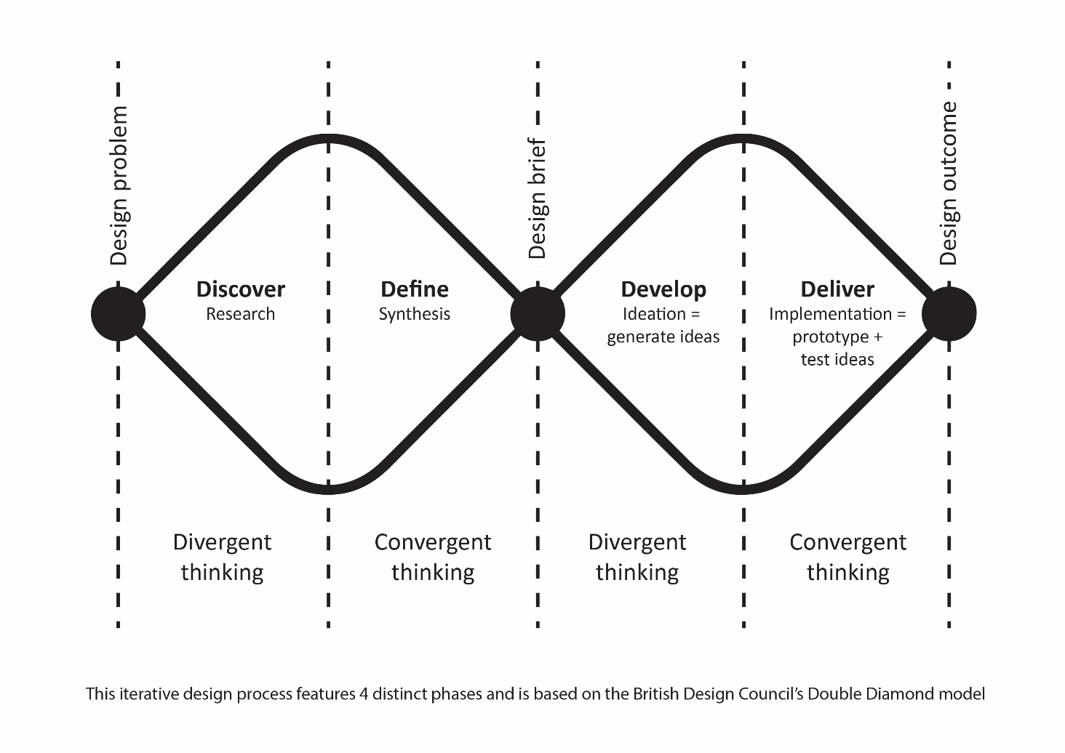

Discover
This phase of the design process involves exploring a design need, opportunity or problem. This may begin with an initial idea or inspiration, and is often focused on discovering and understanding the needs of clients, customers and end-users. Using creative and divergent Design Thinking strategies, students work towards identifying a problem, along with clarifying the key stakeholders.

Define
The next phase of the design process involves reviewing, selecting and discarding ideas. Using critical and convergent Design Thinking, findings from the Discover stage are analysed, defined and refined. Students understand the constraints and purpose of the design as they develop a detailed design brief to clearly articulate a problem that requires a solution.

Develop
During this phase, students take an experimental approach to generate multiple ideas inspired by the design brief. By applying creative Design Thinking strategies, students develop, visualise and iterate concepts that address the problem or issue identified during the Discover and Define phases.

Deliver
In the Deliver phase of the Double Diamond design process, the design concept is refined through multiple iterations. Physical and/or digital low-fidelity prototyping is used to test and improve design ideas, while stakeholder feedback is considered and synthesised. Critical Design Thinking is used to filter ideas and support decision making, to ensure the most suitable and effective design outcome is presented for implementation.

Representation of the general capabilities
The general capabilities encompass the knowledge, skills, behaviours and dispositions that will assist students to live and work successfully in the twenty-first century. Teachers should find opportunities to incorporate the capabilities into the teaching, learning and assessment program for the Design ATAR course. The general capabilities are not assessed unless they are identified within the specified unit content.

Literacy
Literacy is of fundamental importance in the study of design. Students will access design content through a variety of print, oral, visual, spatial and electronic forms, including data books, texts, computer software, images, and written technical materials. They learn to investigate, interpret and apply design elements and principles from a variety of sources to design solutions for tasks. They analyse and evaluate information for reliability, relevance and accuracy. They learn to monitor their own language use for accuracy in the use of design terms for clarity of ideas, processes and explanations of design activities and development and evaluation of design outcomes.

Numeracy
Numeracy is fundamental in calculating material quantities and evaluating design process costs. Students develop their understandings and skills of numeracy while undertaking tasks to produce, test and evaluate products. Design theory continues to be studied to forge greater understanding of the scientific, mathematical and technical concepts that explain how designed products function.

Information and communication technology capability
Information and communication technology (ICT) capability is important in all stages of the design process. Students use digital tools and strategies to locate, access, process and analyse information. They use ICT skills and understandings to investigate and devise design ideas. Students access information from websites and software programs to develop design solutions. Students may use computer-aided drawing software and computer control software to develop design outcomes.

Critical and creative thinking
Critical and creative thinking is integral to the design process. The Design Thinking methodologies are fundamental to the Design ATAR course. Students develop understandings and skills in critical and creative thinking during periods of evaluation at numerous stages of the design process. They devise plausible solutions to problems, and then through interrogation, critically assess the performance of the most efficient solution. Students identify possible refinements in their design solutions and analyse, evaluate and modify the developing solution to create a prototype.

Personal and social capability
Personal and social capability skills are developed and practised in the Design ATAR course by students enhancing their communication skills and participating in teamwork. Students have opportunities to work collaboratively during stages of investigation and production of products. Students develop increasing social awareness through the study of the impact of the use of materials and manufacturing technology in society and on the environment.

Ethical understanding
Students have opportunities to explore and understand the diverse perspectives and circumstances that shape design processes, and the actions and possible motivations of people in the past compared with those of today. Students have opportunities, both independently and collaboratively, to explore the values, beliefs and principles that have influenced past design achievements, and the ethical decisions required by global design processes of today.

Intercultural understanding
Students have opportunities to explore the different beliefs and values of a range of cultural groups and develop an appreciation of cultural diversity. Students have opportunities to develop an understanding of different contemporary perspectives with regard to design inspiration, product styles, building materials, energy supply and use, historical design influences on different groups within society, and how these contribute to individual and group actions in the contemporary world.

Representation of the cross-curriculum priorities
The cross-curriculum priorities address the contemporary issues which students face in a globalised world. Teachers should find opportunities to incorporate the priorities into the teaching and learning program for the Design ATAR course. The cross-curriculum priorities are not assessed unless they are identified within the specified unit content.

Aboriginal and Torres Strait Islander histories and cultures
Students may have opportunities to explore Aboriginal and Torres Strait Islander development and use of design and the interconnectedness between design, purpose and innovation, and how these relate to identity, people, culture and country/place.

Asia and Australia's engagement with Asia
Students may have opportunities to explore traditional, contemporary and emerging design achievements in the countries of the Asia region. Students explore Australia’s rich and ongoing engagement with the peoples and countries of Asia to create appropriate products and services to meet personal, community, national, regional and global needs.

Sustainability
Students take action to create more sustainable patterns of living. Students can develop knowledge, understanding and skills necessary to design for effective sustainability.
Students focus on the knowledge, understanding and skills necessary to choose design solutions with regard to costs and benefits. They evaluate the extent to which the process and designed solutions embrace sustainability. Students reflect on past and current practices and assess new and emerging designs from a sustainability perspective.

Unit 1 – Representational design

Unit description
This unit introduces students to the discipline of design. They begin to experiment with various techniques for representation, such as sketching, drawing, photographing and prototyping, to communicate design ideas and Design Thinking. Students develop an understanding of key design terminology to support their observation and analysis of different design forms. They begin to understand how representation can be used to communicate meaning through semiotics. Students apply relevant and appropriate skills and techniques while following the Double Diamond design process model to create possible design outcomes.

Unit content
This unit includes the knowledge, understandings and skills described below.

Design features

Design frameworks
- understand the limitations of a linear design process:
  - design brief
  - research
  - ideate
  - develop
  - refine
  - produce
- introduction to an iterative design process:
  - Double Diamond model
- discover
- define
- develop
- deliver

Design knowledge
- characteristics and application of the elements of design:
  - line
- directional, organic, implied
  - shape
- two-dimensional, geometric, abstract
  - tone
- tonal scale, high key, low key
  - form
- three-dimensional, proportion
  - space
- positive, negative, organised
  - colour
- primary, secondary, tertiary
- complementary, analogous, monochromatic
- hue, saturation, tint, shade
- cool, warm, neutral palettes
  - texture
- visual, tactile
- characteristics and application of design principles:
  - balance
  - contrast
  - emphasis
  - repetition
  - movement
  - scale
  - unity
  - variety
  - pattern
  - harmony
  - alignment
  - hierarchy
- identification of different typographic styles, including:
  - serif, sans serif
  - script, display
- characteristics of Gestalt principles of perception, including:
  - figure/ground
  - similarity
  - proximity
  - continuation
  - closure
- investigation of historical and/or contemporary designs appropriate to a design brief:
  - designer/s attributed to the work
  - date and/or period of creation
  - social, cultural and/or political context/s
  - key visual motifs, features and/or concepts
  - key materials, techniques and/or technologies

Design responsibilities
- consider the categories of intellectual property (IP) that legally protect original ideas from being copied or imitated:
  - copyright
  - registered design
  - patents
  - trademark
- awareness of national and/or international standards to ensure safety, reliability, consistency and quality of designs
- understand occupational safety and health (OSH) concepts and their impact in design:
  - ergonomics
- ensuring designs are compatible with the needs, abilities and limitations of the user
  - safe design
- hazard identification and risk assessment to eliminate the risk of injury throughout the life of the design
- consider sustainability strategies to reduce environmental impact during the design life cycle

Design phases

Discover
- interpret a specified design need or problem
- identify and develop a target audience/end-user profile:
  - demographic characteristics
  - psychographic segmentation, for example:
- attitudes and values
- lifestyle
- personality
- priorities and motivations
- social status
- VALS™ model
- identify and classify stakeholders:
  - power vs interest grid
- explore sources of inspiration, for example:
  - site/location
  - similar or competitive designs
  - visual stimulation/mood boards
  - colour/material swatches
  - historical and/or contemporary designs
- reflect on and summarise the discovery phase

Define
- interpretation of the design brief that includes:
  - core design problem
  - stakeholders
- client
- others
  - target audience/end-user characteristics
  - aim or purpose of the design
  - constraints
- timeframe
- cost analysis or budget
- special considerations or requirements
- materials and technologies
  - context of the design
- where will it be used, seen or applied
  - deliverables
- expectations for communicating the design proposal

Develop
- application of creative Design Thinking strategies to generate multiple ideas inspired by the design brief, for example:
  - concept maps
  - visual brainstorming
  - forced associations
  - Bloom's action verbs
  - SCAMPER
  - Six Thinking Hats® system
  - synectic triggers, for example:
- add
- animate
- combine
- empathise
- repeat
- subtract
- superimpose
- transfer
- recognize semiotic concepts evident in design, including:
  - sign – symbol, index, icon
  - signifier
  - signified
- use of drawing and low-fidelity methods to visualise information and ideas
- reflect on and refine ideas through annotated iterations
- reflect and summarise the Develop phase

Deliver
- application of critical Design Thinking to support decision making, for example:
  - compare and contrast
  - graphic organisers
  - persuasion map
  - PMI chart
  - Six Thinking Hats® system
  - SWOT analysis
- experimentation with physical and/or digital low-fidelity prototyping to test the effectiveness of design ideas
- investigate materials and/or techniques relevant to the design brief
- consider design conventions relevant to the design outcomes
- explore target audience/end-user feedback methods, for example:
  - qualitative research
  - usability testing
  - questioning/surveys/user-based evaluation
- refinement of prototype/s to meet the design brief
- experiment with presentation formats to communicate a design outcome
- application of skills to communicate a design outcome

Unit 2 – User-centred design

Unit description
In this unit, students work through phases of the Double Diamond model to design products, devices, objects or services for an end-user. They will prototype and modify designs to test the impact on audiences and address practical outcomes for users. Students will determine and define the function, form and features of their design in order to effectively communicate how their proposal meets the needs of the design brief.

Unit content
This unit builds on the content covered in Unit 1.
This unit includes the knowledge, understandings and skills described below.

Design features

Design frameworks
- application and experimentation with an iterative design process:
  - Double Diamond model
- discover
- define
- develop
- deliver

Design knowledge
- characteristics and application of the elements of design:
  - line
  - shape
  - tone
  - form
  - space
  - colour
  - texture
- characteristics and application of design principles:
  - balance
  - contrast
  - emphasis
  - repetition
  - movement
  - scale
  - unity
  - variety
  - pattern
  - harmony
  - alignment
  - hierarchy
- understanding of typographic terminology, including:
  - ascender, descender
  - baseline, cap line
  - leading, kerning
  - uppercase, lowercase
- application of Gestalt principles of perception
- interpretation of relevant historical and/or contemporary designs

Design responsibilities
- appropriate attribution of others intellectual property (IP)
- awareness of national and/or international standards to ensure safety, reliability, consistency and quality of designs
- apply relevant occupational safety and health (OSH) concepts appropriate to the design brief
- apply sustainability strategies to reduce environmental impact during the design life cycle

Design phases

Discover
- identify and explore a design need, problem or opportunity using Design Thinking strategies, for example:
  - empathy mapping
  - design mindsets
  - needfinding
- identify and develop a target audience/end-user profile:
  - demographic characteristics
  - psychographic segmentation
- identify, classify and consider stakeholders:
  - power vs interest grid
- explore sources of inspiration, for example:
  - colour/material swatches
  - historical and/or contemporary designs
  - similar or competitive designs
  - site/location
  - visual stimulation/mood boards
- reflect on and summarise the discovery phase

Define
- construction of a design brief that includes:
  - core design problem
  - stakeholders
- client
- others
  - target audience/end-user characteristics
  - aim or purpose of the design
  - constraints
- timeframe
- cost analysis or budget
- special considerations or requirements
- materials and technologies
  - context of the design
- where it will be used, seen or applied
  - deliverables
- expectations for communicating the design proposal

Develop
- experimentation with creative Design Thinking strategies to generate multiple ideas inspired by the design brief, for example:
  - Bloom’s action verbs
  - concept maps
  - forced associations
  - SCAMPER
  - Six Thinking Hats® system
  - synectic triggers, for example:
- add
- animate
- combine
- empathise
- repeat
- subtract
- superimpose
- transfer
  - visual brainstorming
- consideration of communication strategies, including:
  - emotion
  - humour
  - metaphor
  - shock tactics
- use of drawing and low-fidelity methods to visualise information and ideas
- reflect on and refine ideas through annotated iterations
- reflect and summarise the develop phase

Deliver
- synthesis of critical Design Thinking to support decision making, for example:
  - compare and contrast
  - graphic organisers
  - persuasion map
  - PMI
  - Six Thinking Hats® system
  - SWOT analysis
- evaluation of physical and/or digital low-fidelity prototyping to improve design ideas
- explore a variety of materials and/or techniques appropriate to the design brief
- apply design conventions relevant to the design outcomes
- interpret and apply target audience/end-user feedback
- refinement of prototype/s to meet the design brief
- develop suitable presentation formats to communicate a design outcome
- refinement of skills to communicate a design outcome

Assessment
Assessment is an integral part of teaching and learning that at the senior secondary years:
- provides evidence of student achievement
- identifies opportunities for further learning
- connects to the standards described for the course
- contributes to the recognition of student achievement.
Assessment for learning (formative) and assessment of learning (summative) enable teachers to gather evidence to support students and make judgements about student achievement. These are not necessarily discrete approaches and may be used individually or together, and formally or informally.
Formative assessment involves a range of informal and formal assessment procedures used by teachers during the learning process in order to improve student achievement and to guide teaching and learning activities. It often involves qualitative feedback (rather than scores) for both students and teachers, which focuses on the details of specific knowledge and skills that are being learnt.
Summative assessment involves assessment procedures that aim to determine students’ learning at a particular time, for example when reporting against the standards, after completion of a unit/s. These assessments should be limited in number and made clear to students through the assessment outline.
Appropriate assessment of student work in this course is underpinned by reference to the set of pre-determined course standards. These standards describe the level of achievement required to achieve each grade, from A to E. Teachers use these standards to determine how well a student has demonstrated their learning.
Where relevant, higher order cognitive skills (e.g. application, analysis, evaluation and synthesis) and the general capabilities should be included in the assessment of student achievement in this course. All assessment should be consistent with the requirements identified in the course assessment table.
Assessment should not generate workload and/or stress that, under fair and reasonable circumstances, would unduly diminish the performance of students.

School-based assessment
The Western Australian Certificate of Education (WACE) Manual contains essential information on principles, policies and procedures for school-based assessment that must be read in conjunction with this syllabus.
School-based assessment involves teachers gathering, describing and quantifying information about student achievement.
Teachers design school-based assessment tasks to meet the needs of students. As outlined in the WACE Manual, school-based assessment of student achievement in this course must be based on the Principles of Assessment:
- Assessment is an integral part of teaching and learning
- Assessment should be educative
- Assessment should be fair
- Assessment should be designed to meet its specific purpose/s
- Assessment should lead to informative reporting
- Assessment should lead to school-wide evaluation processes
- Assessment should provide significant data for improvement of teaching practices.
The table below provides details of the assessment types and their weighting for the Design ATAR Year 11 syllabus.
Summative assessments in this course must:
- be limited in number to no more than eight tasks
- allow for the assessment of each assessment type at least once for each unit in the unit pair
- have a minimum value of 5 per cent of the total school assessment mark
- provide a representative sampling of the syllabus content.
Assessment tasks not administered under test or controlled conditions require appropriate authentication processes.

Assessment table – Year 11
Type of assessment | Weighting
Production  On completion of each unit, students are expected to deliver at least one design outcome.  Students explore a design process to:  - discover a design need, problem or opportunity  - define a design brief  - develop ideas  - deliver design outcomes.  Students must compile evidence of their application of a design process. | 50%
Response  Students demonstrate an understanding of design knowledge and frameworks as they analyse and respond to stimuli or prompts related to the unit content, including historical and/or contemporary design forms. Responses can include short answers, oral presentations, multimodal presentations, flow charts and diagrams. | 30%
Examination  Typically conducted at the end of each semester and/or unit. In preparation for Unit 3 and Unit 4, the examination should reflect the examination design brief included in the ATAR Year 12 syllabus for this course. | 20%
Teachers must use the assessment table to develop an assessment outline for the pair of units (or for a single unit where only one is being studied).
The assessment outline must:
- include a set of assessment tasks
- include a general description of each task
- indicate the unit content to be assessed
- indicate a weighting for each task and each assessment type
- include the approximate timing of each task (for example, the week the task is conducted, or the issue and submission dates for an extended task).

Reporting
Schools report student achievement, underpinned by a set of pre-determined standards, using the following grades:
Grade | Interpretation
A | Excellent achievement
B | High achievement
C | Satisfactory achievement
D | Limited achievement
E | Very low achievement
The grade descriptions for the Design ATAR Year 11 syllabus are provided in Appendix 1. They are used to support the allocation of a grade. They can also be accessed, together with annotated work samples, on the course page of the Authority website at www.scsa.wa.edu.au.
To be assigned a grade, a student must have had the opportunity to complete the education program, including the assessment program (unless the school accepts that there are exceptional and justifiable circumstances).
Refer to the WACE Manual for further information about the use of a ranked list in the process of assigning grades.
The grade is determined by reference to the standard, not allocated on the basis of a pre-determined range of marks (cut-offs).

Acknowledgements
Diagram based on: Design Council. (2019). Double Diamond model. Retrieved March, 2022, from https://www.designcouncil.org.uk/sites/default/files/asset/document/Double%20Diamond%20Model%202019.pdf.
Double Diamond model concept from: Design Council. (n.d.). The process: Using the Double Diamond. Retrieved March, 2022, from https://www.designcouncil.org.uk/news-opinion/what-framework-innovation-design-councils-evolved-double-diamond.

Appendix 1 – Grade descriptions Year 11*
A | Justifies and interprets using knowledge and understanding of design language, terminology and frameworks throughout the design process.
 | Applies diverse critical and creative design inquiry methods to generate and refine ideas.
 | Effectively explores and experiments with a range of outcomes, considering relevant design responsibilities.
 | Selects and adapts design elements and principles effectively, with discerning use of media and materials.
 | Demonstrates a detailed understanding and thorough application of appropriate design processes to facilitate effective and appealing solutions to identified problems.

B | Coherently applies knowledge and understanding of design language, terminology and frameworks during the design process.
 | Applies some critical and creative design inquiry methods to generate and refine ideas.
 | Explores and experiments alternative outcomes, with reference to design responsibilities.
 | Applies design elements and principles competently, with considered use of media and materials.
 | Demonstrates a clear understanding and capable application of appropriate design processes to facilitate relevant solutions to identified problems.

C | Inconsistently applies knowledge and understanding of design language, terminology and frameworks in the design process.
 | Uses design inquiry methods to generate and refine ideas.
 | Develops simple outcomes with some consideration of design responsibilities.
 | Uses design elements and principles to some effect, with simple use of media and materials.
 | Demonstrates basic understanding and application of a design process to produce simple solutions to identified problems.

D | Seldom demonstrates understanding and of design language, terminology and frameworks.
 | Uses limited design inquiry methods to generate and refine ideas.
 | Delivers partial outcomes with limited consideration of design responsibilities.
 | Uses design elements and principles inconsistently, with inappropriate use of media and materials.
 | Demonstrates limited understanding and application of a design process to produce incomplete solutions to identified problems.

E | Does not meet the requirements of a D grade and/or has completed insufficient assessment tasks to be assigned a higher grade.
*These grade descriptions will be reviewed at the end of the second year of implementation of this syllabus.

