Student Records Management System
School guide for online EAL/D eligibility declarations: international

Student Records Management System
School administrator’s guide for dashboard navigation: international
Acknowledgement of Country
Kaya. The School Curriculum and Standards Authority (the SCSA) acknowledges that our offices are on Whadjuk Noongar boodjar and that we deliver our services on the country of many traditional custodians and language groups throughout Western Australia. The SCSA acknowledges the traditional custodians throughout Western Australia and their continuing connection to land, waters and community. We offer our respect to Elders past and present.
Copyright
© School Curriculum and Standards Authority, 2023
This document – apart from any third party copyright material contained in it – may be freely copied, or communicated on an intranet, for non­commercial purposes in educational institutions, provided that the School Curriculum and Standards Authority (the SCSA) is acknowledged as the copyright owner, and that the SCSA’s moral rights are not infringed.
Copying or communication for any other purpose can be done only within the terms of the Copyright Act 1968 or with prior written permission of the SCSA. Copying or communication of any third party copyright material can be done only within the terms of the Copyright Act 1968 or with permission of the copyright owners.
Any content in this document that has been derived from the Australian Curriculum may be used under the terms of the Creative Commons Attribution 4.0 International licence.
School Curriculum and Standards Authority
Street address: 303 Sevenoaks Street CANNINGTON WA 6107
Postal address: PO Box 816 CANNINGTON WA 6987
Phone: (08) 9273 6300
General email: info@scsa.wa.edu.au
Web: www.scsa.wa.edu.au
Cover photo credit: GlobalStock via iStock

Contents
Online EAL/D eligibility declarations 1
Eligibility to enrol in the Year 12 EAL/D ATAR course 1
EAL/D ATAR eligibility process 2
Checklist 3
Six steps for EAL/D teacher recommendation 4
Step 1: Log in to the SRMS portal 4
Step 2: Select students’ EAL/D eligibility declarations 5
Step 3: View students’ EAL/D eligibility declarations 7
Step 4: Amend students’ EAL/D declarations 8
Step 5: Verify and recommend endorsement of students’ EAL/D declarations 10
Step 6: Check the SRMS portal for students’ EAL/D eligibility status 13
Five steps for principal endorsement 14
Step 1: Log in to the SRMS portal 14
Step 2: Select students’ EAL/D eligibility declarations 15
Step 3: View students’ EAL/D eligibility declarations 17
Step 4: Endorse students’ EAL/D eligibility declarations 18
Step 5: Check the SRMS portal for students’ EAL/D eligibility status 20
Review process 21

Online EAL/D eligibility declarations
To enrol in the Year 12 English as an Additional Language or Dialect (EAL/D) Australian Tertiary Admission Rank (ATAR) course, students must submit an online EAL/D eligibility declaration to their school principal or delegate via the student portal (https://studentportal.scsa.wa.edu.au).
Refer to the Student guide for online EAL/D eligibility declarations.
This user guide is for teachers and principals or deputy principals who will endorse these EAL/D eligibility declarations in the Student Records Management System (SRMS).

Eligibility to enrol in the Year 12 EAL/D ATAR course
The EAL/D ATAR course is available to students who speak English as an additional language or dialect, and whose use of Standard Australian English (SAE) is restricted or still developing.
The School Curriculum and Standards Authority (the SCSA) requires all schools to determine the eligibility of a student for enrolment in the Year 12 EAL/D ATAR course.
The EAL/D ATAR course is designed for students for whom English is not their first or home language.
This includes:
- students who are Aboriginal or Torres Strait Islander, or from Cocos Island or Christmas Island, for whom SAE has been the medium of instruction, but for whom SAE is an additional language/dialect, and whose exposure to SAE is primarily within the school context
- students who are deaf or hard-of-hearing and communicate using signing, such as Auslan, as their first language
- students who have:
- not more than seven years of education where English is the main medium of course delivery immediately prior to entering their final year of school, or
- more than seven years where English is the main medium of course delivery but limited exposure/restricted knowledge of academic English, or
- varying exposure to English, but who have had disrupted* schooling in one or more countries, including Australia.
Schools are best placed to identify and confirm the eligibility of students against these sub-categories. Factors for consideration in school judgements include:
- refugee or low socio-economic status backgrounds
- poverty
- post-traumatic stress disorder (PTSD) or trauma
- * disrupted schooling, including:
- frequent or significant changes to language of instruction
- long-term or numerous interruptions to schooling
- other experiences that may affect their ability to access English learning area courses other than EAL/D.

EAL/D ATAR eligibility process
Students who intend to enrol in the Year 12 EAL/D ATAR course must submit to their school principal or delegate via the student portal:
- an EAL/D eligibility declaration
- supporting information (first language, education background)
- relevant evidence (e.g. school reports, passport, school letter, teacher declaration).
Use the checklist on the following page to make sure students have everything they need before they start their online EAL/D eligibility declaration.
Students will need to use a computer, either at home or at school. If they have any questions, they can ask their parent/s or carer/s or teacher to help them. Teachers can ensure that students provide correct information and supporting evidence, reducing the need for amendment.
If students require support to complete their online EAL/D eligibility declaration, it is recommended that they complete the process as a group in the classroom, so teachers can help them.
There are five stages to enrolment in the Year 12 EAL/D ATAR course.
- Student declaration submitted in the student portal.
- Teacher verification of information and evidence. Any mistakes by the student can be fixed here.
- Teacher recommendation.
- Principal endorsement.
- Student may be enrolled in the Year 12 EAL/D ATAR course.
The nominated teacher
- reviews the declaration against the eligibility criteria
- reviews the information and evidence to ensure there are no errors and that the evidence is appropriate
- verifies the declaration
- provides a recommendation to the principal.
The principal (or delegate)
- reviews the declaration against the eligibility criteria
- reviews the recommendation on endorsement
- endorses the declaration and approves eligibility for enrolment in the Year 12 EAL/D ATAR course.
Information about the EAL/D eligibility process and the submission dates for declarations can be found on the EAL/D page of the SCSA website
(https://senior-secondary.scsa.wa.edu.au/syllabus-and-support-materials/english/english-as-an-additional-language-or-dialect).
Any student who has not had their EAL/D eligibility finalised and endorsed by the Year 12 enrolment deadline, as published in the Activities Schedule for that year, will not be able to enrol in the Year 12 EAL/D ATAR course for that year.

Checklist
Logging in to the student portal
1
To log in to the student portal, students will need their WA student number, which is on their school report/s. It may also be on their SmartRider. Students will need a personal email address. They must be able to access this personal email account when they complete their online declaration.
Residential and language information
2
Students will need to provide the following supporting information:
- residential information
- where they were born
- all the countries they have lived in
- parent/carer information
- country/ies of birth
- language/s used with the student
- student’s language background
- first language/s learned
- language/s used most now
- language/s other than English that they can speak confidently
3
Educational background
Students must provide details of the schools they attended for every school year from Year 1:
- calendar year
- academic year/grade
- name of the school
- location of the school
- curriculum used at the school (i.e. national or international)
- language/s used by their teacher in the classroom
- language/s used for assessments, examinations and reporting
4
Supporting evidence
The evidence students need to provide depends on which option they choose. They should photograph or scan at least one of the following pieces of evidence:
- a passport, ID card, ImmiCard, or other identity document
- visa, travel evidence (i.e. passport stamp) or international movement record/s
- a genuine, authentic letter from a previous school, principal or teacher
- a school report, which may be:
- from your current school
- from a previous school within Australia or outside Australia
- in English or in a language other than English (translation is not necessary)
Students should save their evidence to their computer or mobile device as .pdf, .jpg, .jpeg or .png files, with a maximum size of 4MB for each file. Word documents will not be accepted. They must use English letters to name their files.

Six steps for EAL/D teacher recommendation
The EAL/D teacher will verify students’ declarations and recommend endorsement in the SRMS. Students must nominate a teacher when they complete their declaration. Teachers must be added to the SRMS by a school administrator and assigned the ‘EAL/D endorser ‒ teacher’ role. The teacher may be the classroom teacher, year coordinator or career counsellor. The teacher must:
- know the student to verify the information and evidence
- understand the criteria in the policy to make an informed recommendation.

Step 1: Log in to the SRMS portal
Log in to the SRMS portal (https://srms.scsa.wa.edu.au).
The first time you log in, click on and read the login instructions (highlighted below). Contact your school administrator if you have not received the email with the link.
Enter your work email address and password in the non-government school login panel.
Tick the check box (highlighted below) to show that you have read and understand the terms of use. Click on the Login button (highlighted below) to enter the SRMS portal.
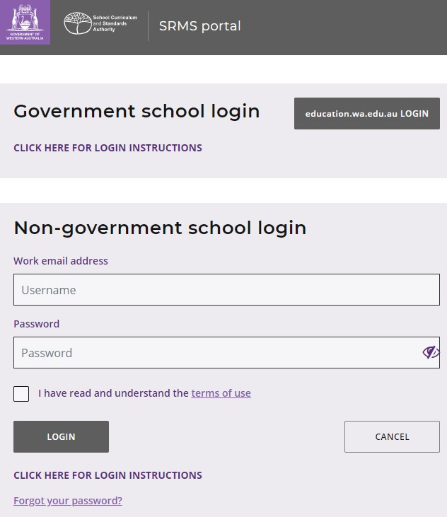
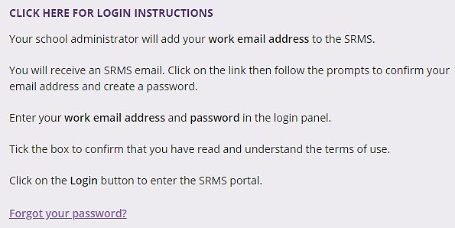

If you forget your password, click on Forgot your password.
Enter your work email address and tick the check box to confirm that you are not a robot.
You will be prompted to select images as part of the verification process, then invited to choose another password.

Step 2: Select students’ EAL/D eligibility declarations
To retrieve your students’ declarations, select EAL/D Declarations from the Student Applications drop-down list (highlighted below).
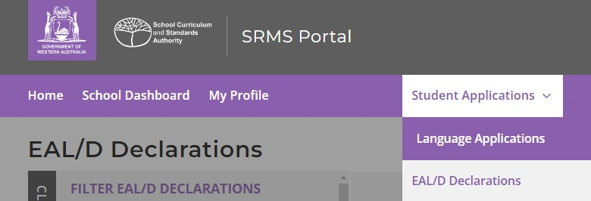
All EAL/D declarations from your students will be displayed on the screen.
The Status column shows the stage of each EAL/D declaration in the EAL/D eligibility process (New, Submitted, In progress, Info required, Finalised).
The Sub status column shows you the action that has been completed for each EAL/D declaration (Teacher endorsed, School endorsed, Eligible, Not eligible).
Submitted EAL/D declarations will have a tick and Submitted (highlighted below) in the Status column. The Sub status column will be blank.
The Requires attention by me column shows as Yes (highlighted below) for any declaration where the student selected your name as their EAL/D teacher, advising you to complete your verification and recommendation.
There may be declarations where the student has selected My teacher is not listed here. The Sub status column will show as Teacher, but the Requires attention by me column will be blank. You may still complete your verification and recommendation for these declarations.
Teachers must endorse each student’s declaration within three working days of noticing that a declaration requires their attention. This is to ensure that the declaration can be processed in a timely manner before the Year 12 enrolment deadline.
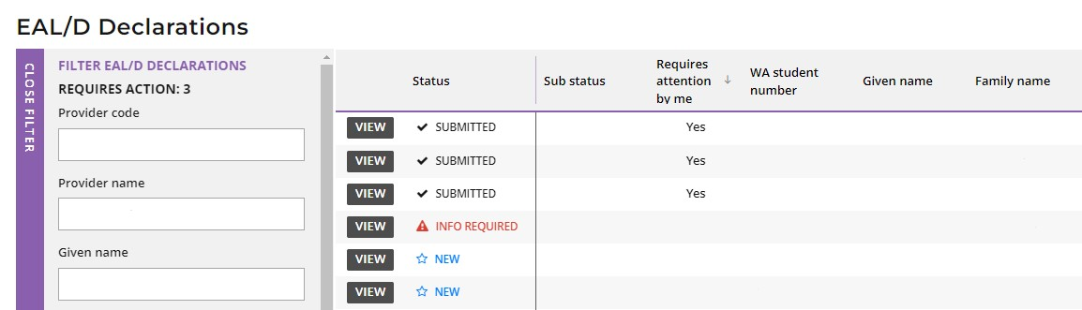
Filter students’ EAL/D eligibility declarations
Use the filter check boxes on the left side of the EAL/D Declarations screen to view declarations at different stages in the EAL/D eligibility process.
Tick the Submitted check box, then click on the Search button (highlighted below) to show all declarations waiting for teacher or school endorsement. Tick the New check box or the Info required check box, then click on the Search button to show all declarations that students have started but not submitted or all declarations that have been returned to students for amendment.
The Sub status filter (highlighted below) selects declarations that have been Teacher endorsed, School endorsed, or those that are Ready to publish.
Alternatively, you can type in the student’s Given name and/or Family name, or their WA student number, then click on the Search button (highlighted below) to select that student’s declaration.
Click on the Reset button (highlighted below) to reset the filters and view all the declarations.
You can see the number of declarations that require your attention (highlighted below). This number will reduce as you complete the required action.
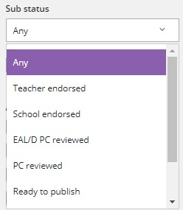
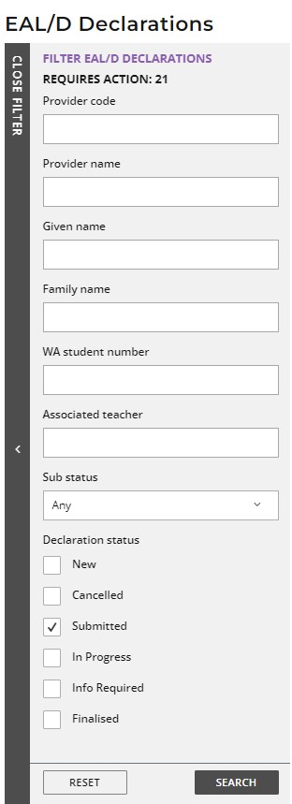

Step 3: View students’ EAL/D eligibility declarations
Click on the View button (highlighted below) to read all the details and supporting evidence in that student’s declaration (example below).
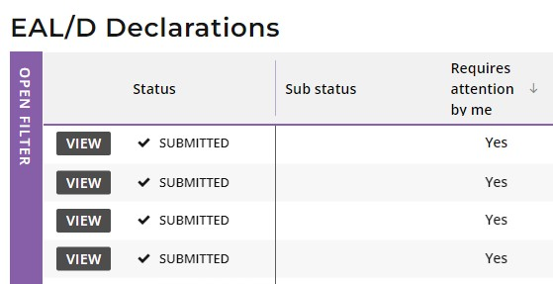
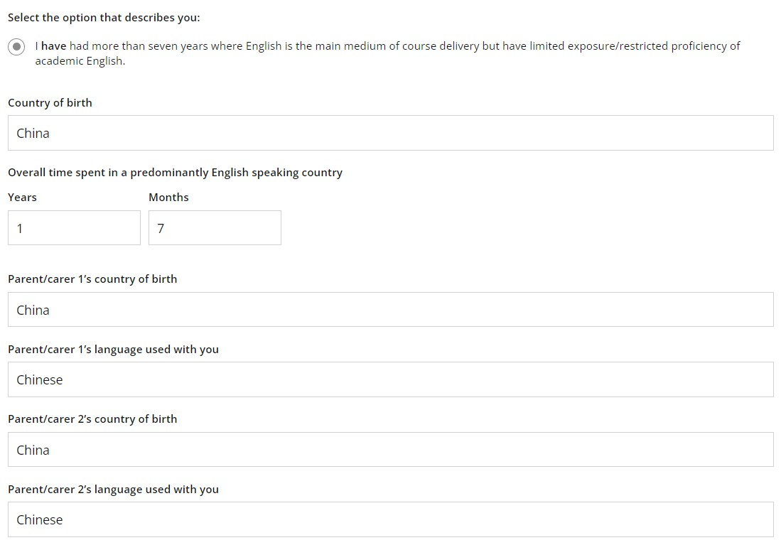
When reviewing the student’s education background, if the name of the school is very long, it will be abbreviated with an ellipsis. Hover with your mouse over the name, and it will be displayed in full (highlighted below).
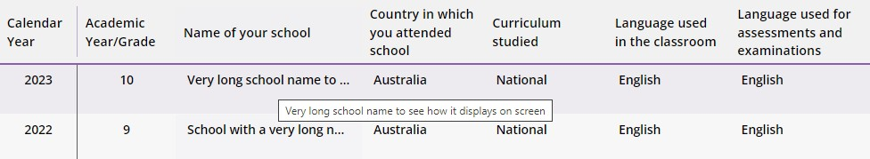

Step 4: Amend students’ EAL/D declarations
If you see any errors or the student’s language or educational background is incomplete, tick the Amendment required check box under the relevant section/s that require an amendment/s (highlighted below).
If you would like to see more supporting evidence, select the Amendment required check box under the Upload supporting evidence section (highlighted below).
Select the reason for your amendment request from the Reason drop-down list (highlighted below).
Choose Please correct the information highlighted in the yellow box/es (highlighted below) to ask the student to amend any of their responses in the tables.
If you would like to see more supporting evidence, the document/s are incomplete, or they cannot be opened, then choose one of the reasons related to the supporting evidence.
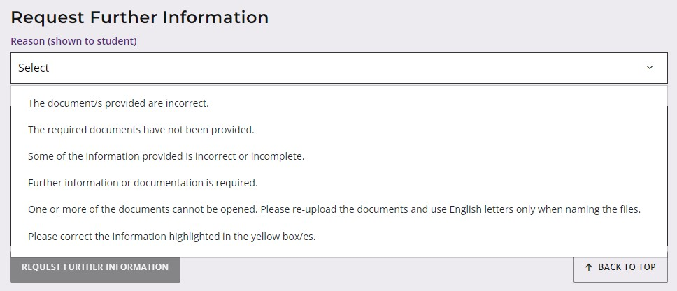
Enter details in the Instructions text box about any amendment/s or further information that you would like the student to provide.
Click on the Request further information button (highlighted below) to submit this request to the student.
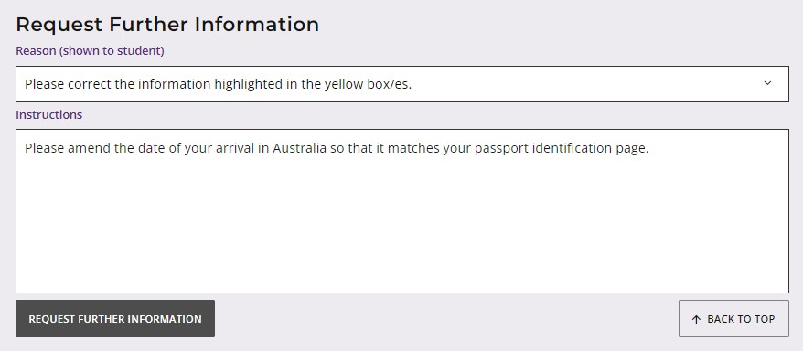
The student will need to log in to the student portal again and amend their declaration as requested.
The section/s for amendment will be highlighted in yellow, so they can edit their details and/or add further supporting evidence.
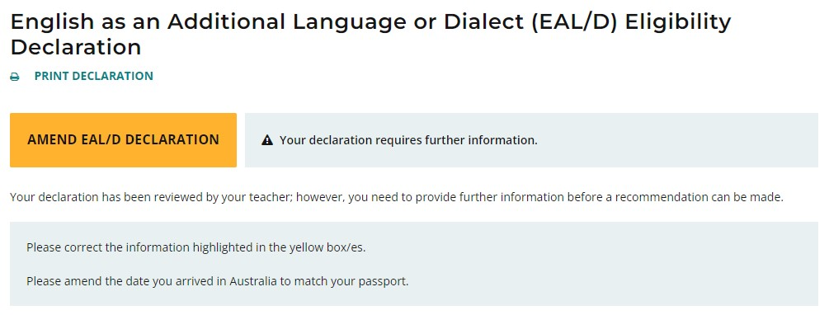
The student will not be able to amend any other section/s of their declaration.
When the student has amended their declaration, they will submit it again for your review.
If you see any further error/s in their declaration, you can repeat the process above to request further amendment/s or information.

Step 5: Verify and recommend endorsement of students’ EAL/D declarations
Scroll down to the Verify Declaration section.
Select either I verify that this student is a genuine EAL/D candidate who meets the criterion and recommend endorsement, or I cannot recommend endorsement.
You must provide an explanation in the Comment text box for either option.
Enter the appropriate criterion for the student in the Comment text box if you choose to recommend endorsement.
Click on the Submit button (highlighted below), to submit your recommendation.
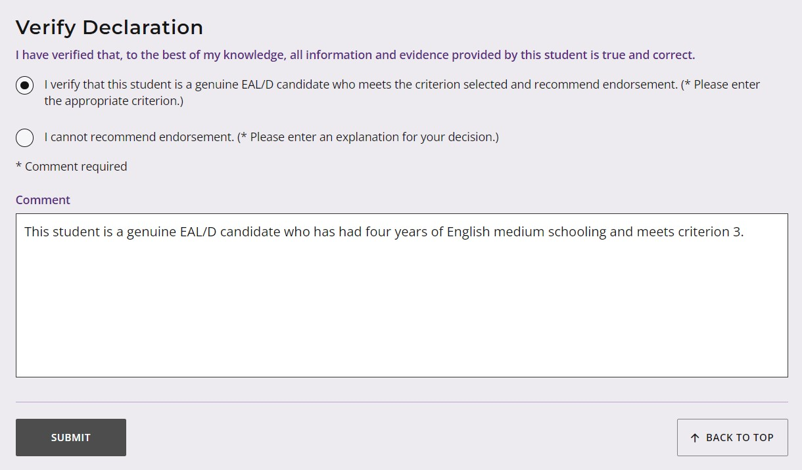
You will see a reminder that the next step is for the declaration to be endorsed by your principal, deputy principal or delegate.
Click on the Continue button (highlighted below) to proceed.
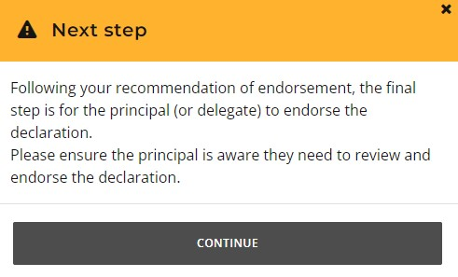
If you are unable to recommend endorsement, you must enter your reason for this decision in the Comment text box.
Click on the Submit button (highlighted below), to submit your recommendation.
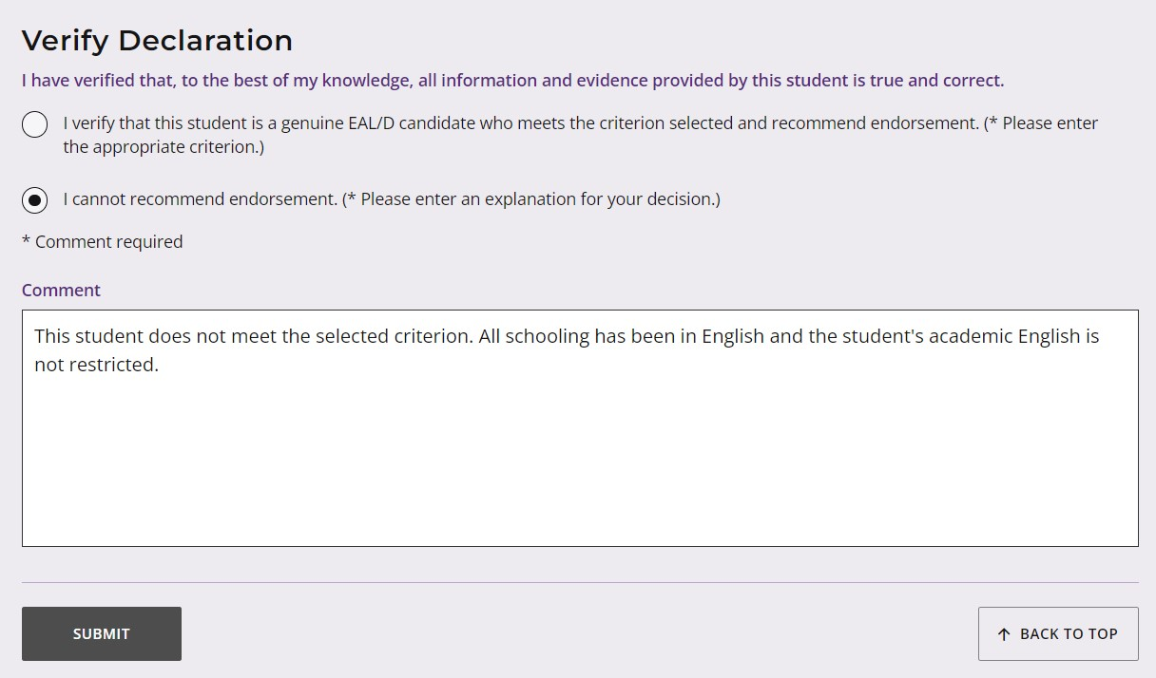
You will see a warning, asking if you are sure, because your decision may affect the student’s ability to enrol in the Year 12 EAL/D ATAR course.
Click on the Continue button (highlighted below) to proceed.
If you decide not to continue, click on the Cancel button to return to the Verify Declaration panel and change your recommendation.
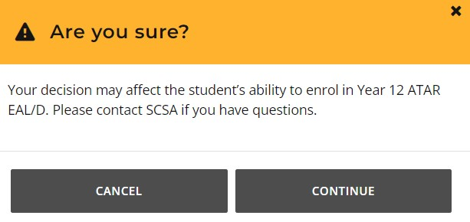
When you have completed your recommendation, you will return to the EAL/D Declarations screen.
The Status column shows as Submitted (highlighted below).
The Sub status column shows as Teacher endorsed (highlighted below).
The Requires attention by me column will now be blank, to show that you have endorsed your students’ EAL/D eligibility declarations.
The Requires action total will reduce as you complete your recommendation of your students’ EAL/D eligibility declarations.
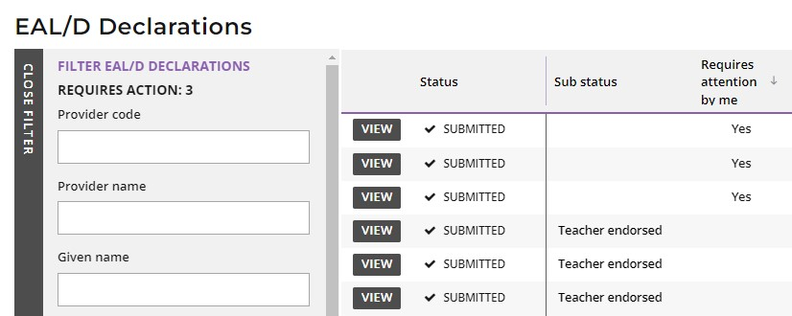

Step 6: Check the SRMS portal for students’ EAL/D eligibility status
At any time, you can check the EAL/D Declarations screen in the SRMS portal to monitor the progress of students’ declarations. The EAL/D Declarations screen will update whenever a declaration advances through the EAL/D eligibility approval stages.
Below are terms you will see during the online EAL/D eligibility declaration process that relate to the status and sub status of students’ declarations.
Status
New | New, but incomplete EAL/D eligibility declaration
Submitted | EAL/D eligibility declaration has been submitted and is waiting for teacher or school endorsement
In progress | EAL/D eligibility declaration has been school endorsed
Finalised | EAL/D eligibility status has been determined
Cancelled | EAL/D eligibility declaration has been cancelled

Sub status
Teacher endorsed | EAL/D teacher has verified and recommended endorsement of this EAL/D eligibility declaration
School endorsed | Principal or deputy principal has endorsed this EAL/D eligibility declaration
Eligible | The declaration has been assessed as eligible
Not eligible | The declaration has been assessed as not eligible
Ready to publish | The principal consultant to publish this EAL/D eligibility status – for 2023 only
Appeal? | The student may request a review in the student portal within two weeks of publication of their EAL/D eligibility. The SCSA conducts the review and there is no longer an appeal stage; however, the Sub status still shows as ‘Appeal’ for 2023
Appeal lodged | The student has requested a review in the student portal. The SCSA conducts the review and there is no longer an appeal stage; however, the Sub status still shows as ‘Appeal’ for 2023
Students can check the status of their declarations by logging in to the student portal.
The status of students’ declarations will change from In progress to either Eligible or Not eligible in the student portal.

Five steps for principal endorsement
Principal endorsement is completed by the principal or delegate in the SRMS. The principal or delegate must be added by a school administrator to the SRMS and given the ‘EAL/D endorser ‒school’ role. Principal endorsement of a student’s declaration is the final approval of student eligibility. An appropriate delegate may be the deputy/vice-principal, dean of curriculum, AUSMAT/WACE/year coordinator (if not acting as the teacher). A classroom teacher or an external coordinator is not an appropriate delegate.
The person given the role of the delegate must:
- have the appropriate authority to make decisions on behalf of the principal
- understand that this declaration is a legal document and that if a student is found to have provided incorrect or misleading information in support of their declaration for eligibility to enrol in EAL/D, the student may be withdrawn from the course or have their result in the course removed from the SCSA’s records, in accordance with the relevant legislation.

Step 1: Log in to the SRMS portal
Log in to the SRMS portal (https://srms.scsa.wa.edu.au).
The first time you log in, click on and read the login instructions (highlighted below). Contact your school administrator if you have not received the email with the link.
Enter your work email address and password in the Non-government school login panel. Tick the check box (highlighted below) to show that you have read and understand the terms of use. Click on the Login button (highlighted below) to enter the SRMS portal.

If you forget your password, click on Forgot your password. Enter your work email address and tick the check box to confirm that you are not a robot. You will be prompted to select images as part of the verification process, then invited to choose another password.

Step 2: Select students’ EAL/D eligibility declarations
Select EAL/D Declarations from the Student Applications drop-down list (highlighted below).
All submitted EAL/D declarations from your students will be displayed on the screen.
The Status column shows the stage of each EAL/D declaration in the EAL/D eligibility process (New, Submitted, In progress, Info required, Finalised).
The Sub status column shows you the action that has been completed for each EAL/D declaration (Teacher endorsed, School endorsed, Eligible, Not eligible).
Submitted EAL/D declarations will have a tick and Submitted (highlighted below) in the Status column. The Sub status column will show as Teacher endorsed (highlighted below), to show that the teacher has completed their verification and recommendation.
The Requires attention by me column shows as Yes (highlighted below), advising you to act.
Principals or deputy principals must endorse each student’s declaration within three working days of noticing that a declaration requires their attention. This is to ensure that the declaration can be processed in a timely manner before the Year 12 enrolment deadline.
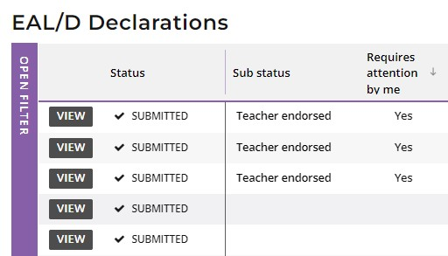

Filter students’ EAL/D eligibility declarations
Use the filter check boxes on the left side of the EAL/D Declarations screen to view declarations at different stages in the EAL/D eligibility process.
Tick the Submitted check box, then click on the Search button (highlighted below) to show all declarations waiting for teacher or school endorsement. Tick the New check box or the Info required check box, then click on the Search button to show all declarations that students have started but not submitted or all declarations that have been returned to students for amendment.
The Sub status filter (highlighted below) selects declarations that have been Teacher endorsed, School endorsed, or those that are Ready to publish.
Alternatively, you can type in the student’s Given name and/or Family name, or their WA student number, then click on the Search button (highlighted below) to select that student’s declaration.
Click on the Reset button (highlighted below) to reset the filters and view all the declarations.
You can see the number of declarations that require your attention (highlighted below). This number will reduce as you complete the required action.

Step 3: View students’ EAL/D eligibility declarations
Click on the View button (highlighted below) to the left of the student’s name to read all details and supporting evidence in that student’s declaration (example shown below).
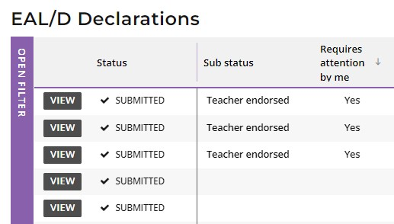
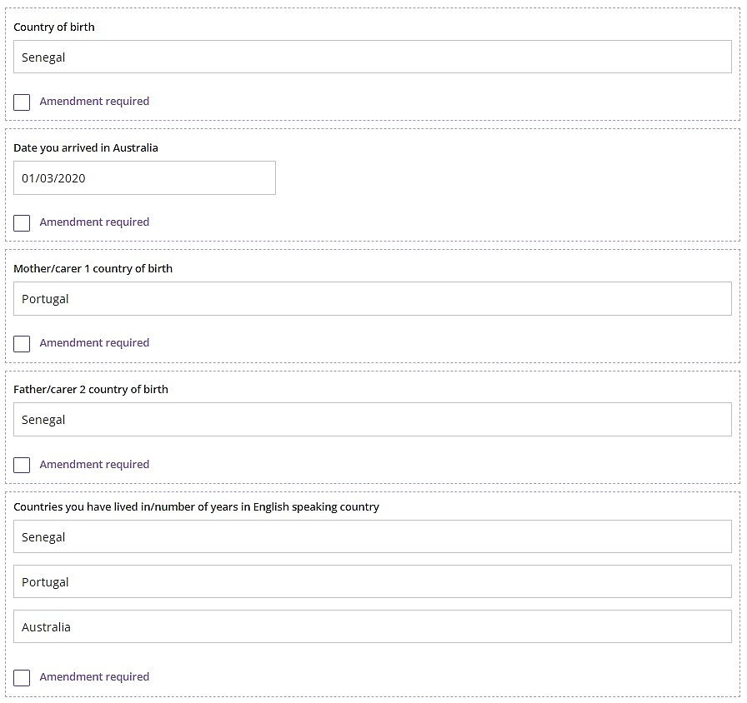
When reviewing the student’s education background, if the name of the school is very long, it will be abbreviated with an ellipsis. Hover with your mouse over the name and it will be displayed in full (highlighted below).

Step 4: Endorse students’ EAL/D eligibility declarations
Scroll down to the Endorse Declaration section.
Select either I endorse this student as a genuine EAL/D candidate, or I cannot endorse this student’s declaration.
If you endorse the declaration, it is optional to add an explanation in the Comment text box.
Click on the Submit button (highlighted below) to submit your endorsement.
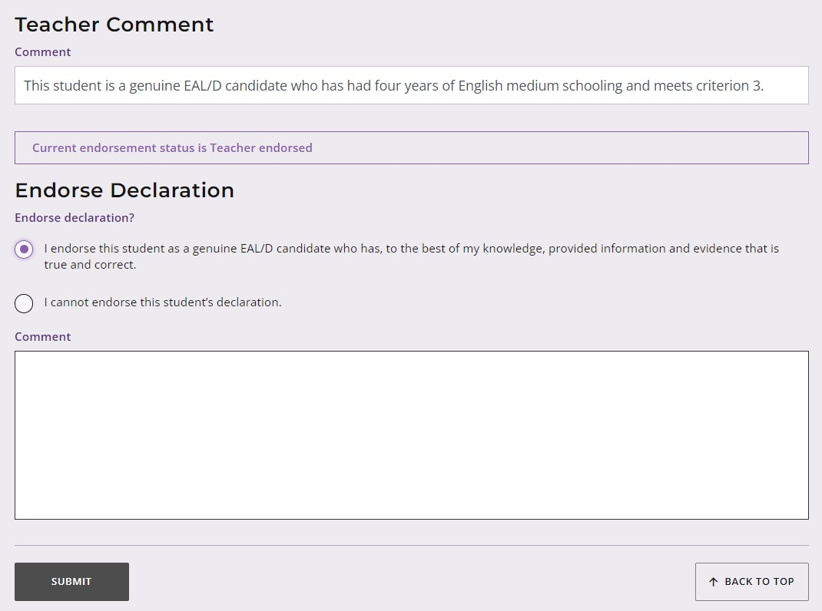
If you choose not to endorse a student’s declaration, you must add an explanation for your decision in the Comment text box.
Click on the Submit button (highlighted below), to submit your endorsement.
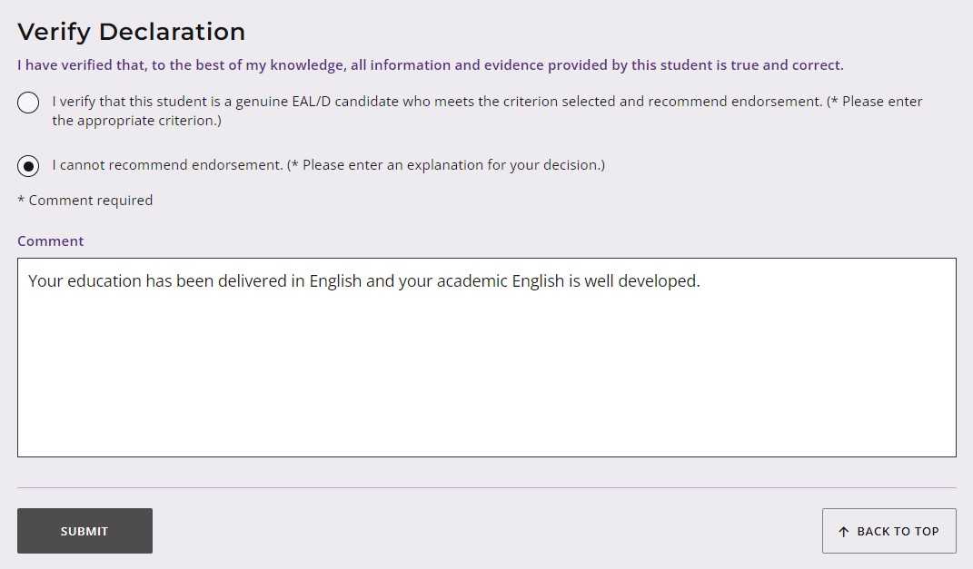

You will see a warning, advising you that if you choose not to endorse the student, the student may not be able to enrol in the Year 12 EAL/D ATAR course.
Click on the Continue button (highlighted below) to proceed.
Click on the Cancel button if you decide to return to the Endorse Declaration panel.
You will return to the EAL/D Declarations screen.
The Status will show as In progress (highlighted below) confirming that these declarations have progressed to the SCSA to publish EAL/D eligibility status in the student portal.
The Sub status will show as School endorsed (highlighted below) to confirm that these EAL/D declarations have been finalised by the school principal or delegate.
The Requires attention by me column will now be blank to show that you have endorsed your students’ EAL/D eligibility declarations.
The Requires action total will reduce as you endorse your students’ EAL/D eligibility declarations.
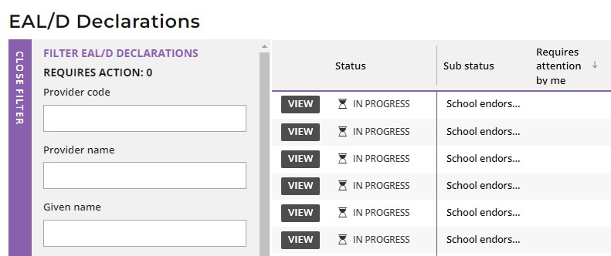
The SCSA will publish EAL/D eligibility in 2023; however, the principal or delegate’s decision is final.

Step 5: Check the SRMS portal for students’ EAL/D eligibility status
At any time, you can check the EAL/D Declarations screen in the SRMS portal to monitor the progress of students’ declarations. The EAL/D Declarations screen will update whenever a declaration advances through the EAL/D eligibility approval stages.
Below are terms you will see throughout the online EAL/D eligibility process that relate to the status and sub status of students’ declarations.
Status
New | New, but incomplete EAL/D eligibility declaration
Submitted | EAL/D eligibility declaration has been submitted and is waiting for teacher or school endorsement
In progress | EAL/D eligibility declaration has been school endorsed
Finalised | EAL/D eligibility status has been determined
Cancelled | EAL/D eligibility declaration has been cancelled

Sub status
Teacher endorsed | EAL/D teacher has verified and recommended endorsement of this EAL/D eligibility declaration
School endorsed | Principal or deputy principal has endorsed this EAL/D eligibility declaration
Eligible | The declaration has been assessed as eligible
Not eligible | The declaration has been assessed as not eligible
Ready to publish | The principal consultant to publish this EAL/D eligibility status – for 2023 only
Appeal? | The student may request a review in the student portal within two weeks of publication of their EAL/D eligibility. The SCSA conducts the review and there is no longer an appeal stage; however, the Sub status still shows as ‘Appeal’ for 2023
Appeal lodged | The student has requested a review in the student portal. The SCSA conducts the review and there is no longer an appeal stage; however, the Sub status still shows as ‘Appeal’ for 2023
Students can check the status of their declarations by logging in to the student portal.
The status of students’ declarations will change from In progress to either Eligible or Not eligible in the student portal.

Review process
If the principal decides that a student is Ineligible to enrol in the Year 12 EAL/D ATAR course, this will be published in the student portal (highlighted below).
If the student thinks that they do meet one of the eligibility criteria, they can request a review of their EAL/D eligibility declaration by the SCSA.
This must be done before the due date, which is shown on the EAL/D screen in the student portal. The review due date is also published in the Activities Schedule.
Note: students can only request one review.
To request a review, the student should click on the Request review button (highlighted below).
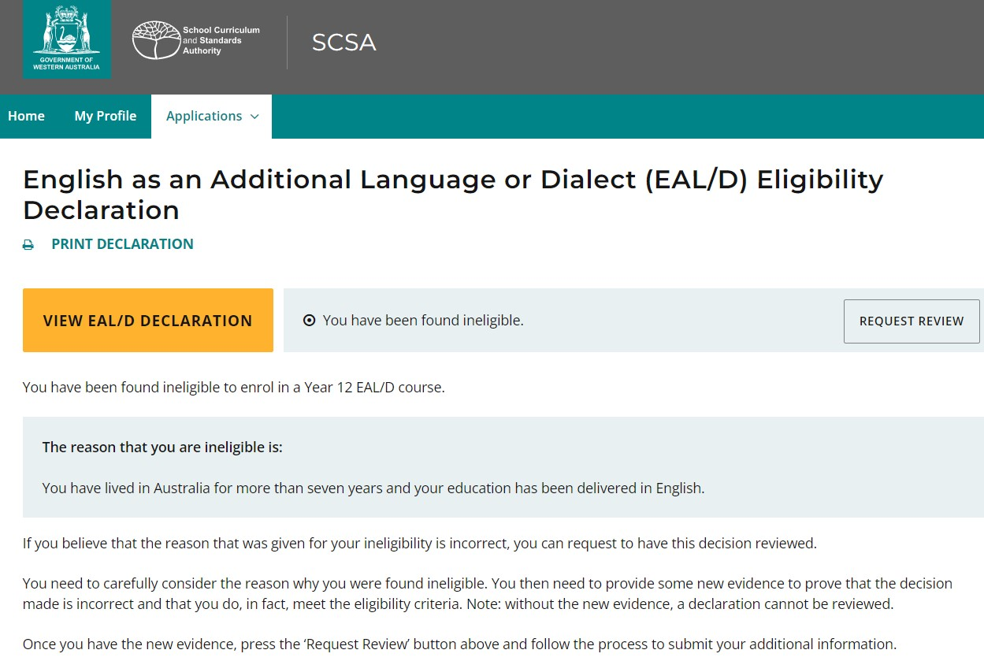
To show that they meet the criteria, the student needs to provide additional supporting evidence and further details to support their request for a review. They will repeat Step 3 to upload their supporting evidence.
The student should check their document/s and information that they provide because, after submission, they cannot upload other documents or make any changes.
The student should click on the Request review button. If they have not uploaded at least one additional document and provided a comment, the request for a review cannot be submitted.
The SCSA will review the student’s declaration with the additional supporting evidence and information they have provided.
After the review has been completed, the SCSA will notify the student by email. The student can also see the outcome of the review in the student portal. The review eligibility status will be either Eligible or Ineligible and the student will be able to view a comment explaining the decision.

