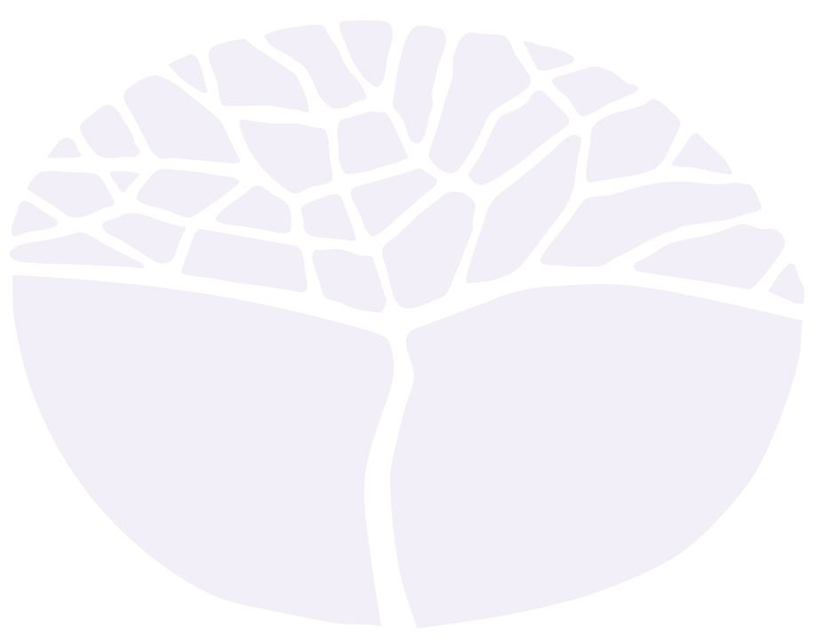
Health and Physical Education

Preliminary course
Year 11 and Year 12 syllabus

Acknowledgement of Country
Kaya. The School Curriculum and Standards Authority (the Authority) acknowledges that our offices are on Whadjuk Noongar boodjar and that we deliver our services on the country of many traditional custodians and language groups throughout Western Australia. The Authority acknowledges the traditional custodians throughout Western Australia and their continuing connection to land, waters and community. We offer our respect to Elders past and present.
Important information
This syllabus is effective from 1 January 2024.
Users of this syllabus are responsible for checking its currency.
Syllabuses are formally reviewed by the School Curriculum and Standards Authority (the Authority) on a cyclical basis, typically every five years.
Copyright
© School Curriculum and Standards Authority, 2023
This document – apart from any third-party copyright material contained in it – may be freely copied, or communicated on an intranet, for non-commercial purposes in educational institutions, provided that the School Curriculum and Standards Authority (the Authority) is acknowledged as the copyright owner, and that the Authority’s moral rights are not infringed.
Copying or communication for any other purpose can be done only within the terms of the Copyright Act 1968 or with prior written permission of the Authority. Copying or communication of any third-party copyright material can be done only within the terms of the Copyright Act 1968 or with permission of the copyright owners.
Any content in this document that has been derived from the Australian Curriculum may be used under the terms of the Creative Commons Attribution 4.0 International licence.
Content
Introduction to the Preliminary courses 1
Rationale for the Health and Physical Education Preliminary course 2
Aims 2
Organisation 3
Structure of the syllabus 3
Organisation of content 3
Representation of the general capabilities 4
Representation of cross-curriculum priorities 6
Unit 1 7
Unit description 7
Unit outcomes 7
Unit content 7
Unit 2 8
Unit description 8
Unit outcomes 8
Unit content 8
Unit 3 9
Unit description 9
Unit outcomes 9
Unit content 9
Unit 4 10
Unit description 10
Unit outcomes 10
Unit content 10
School-based assessment 11

Introduction to the Preliminary courses
Preliminary courses provide a relevant option for students who cannot access the ATAR or General course content with adjustment and/or disability provisions, or who are unable to progress directly to training from school, or who require modified and /or independent education plans. Preliminary courses are designed for students who have been identified as having a recognised disability under the Disability Discrimination Act 1992, and who meet the above criteria.
The preliminary courses are:
- Business Management and Enterprise
- English
- Food Science and Technology
- Health and Physical Education
- Materials Design and Technology
- Mathematics
- Religion and Life
- Visual Arts
Preliminary courses provide opportunities for practical and well-supported learning to help students develop a range of skills to assist them upon leaving school. They acknowledge the broad range of abilities of students with special needs and the need for adapted approaches to teaching and learning.
Preliminary courses may form all or part of a student’s program of study. Schools will make decisions about the content to be taught in each course on the basis of individual student needs, goals and priorities.

Rationale for the Health and Physical Education Preliminary course
The Health and Physical Education Preliminary course provides students with the opportunity to enhance their own and others’ health, safety, wellbeing, and to participate in physical activity. It offers students an experiential curriculum that is contemporary and relevant.
In the Health and Physical Education Preliminary course, students are encouraged to strengthen their sense of self, and to build and maintain satisfying relationships. It assists with their development of resilience, decision making and ability to take actions to promote their health, safety and physical activity participation. Opportunities are provided for students to access and use resources for themselves and the communities with which they identify and to which they belong.
Integral to the Health and Physical Education Preliminary course is the acquisition of movement skills that enable students to confidently and competently participate in a range of physical activities. Students develop movement skills in a variety of physical activities as a foundation for lifelong physical activity participation. In doing so, they have opportunities to develop an appreciation of the significance of physical activity and outdoor recreation. Movement is a powerful medium for learning through which students can acquire, practise and refine personal, interpersonal, behavioural and social skills.

Aims
The Health and Physical Education Preliminary course aims to develop students’:
- skills to take positive action to protect and enhance health, wellbeing, safety and physical activity
- understanding and use of personal, behavioural, social and cognitive skills and strategies to promote a sense of personal identity and wellbeing, and to build and maintain respectful relationships
- movement skills and concepts to respond in a variety of physical activity contexts and settings
- participation in, and enjoyment of, regular movement-based learning experiences.

Organisation

Structure of the syllabus
This Year 11 and Year 12 syllabus is divided into four units.

Unit 1
This unit focuses on developing fundamental movement skills, concepts and safety rules related to physical activity. It introduces basic concepts of health and protective behaviours.

Unit 2
This unit focuses on developing fundamental movement skills, concepts and safety rules related to physical activity. It builds on developing and maintaining positive health behaviours and provides strategies for harm minimisation.

Unit 3
This unit focuses on extending fundamental movement skills, concepts and safety rules in a variety of leisure and recreational activities. It extends knowledge of health behaviours and how this knowledge supports a healthy lifestyle.

Unit 4
This unit further extends knowledge of rules and processes in a range of physical activities, continues to extend the development of fundamental movement skills, and introduces basic tactical concepts. The health component of the syllabus focuses on the development of communication skills in a variety of contexts.
Each unit includes:
- a unit description – a short description of the focus of the unit
- unit outcomes – a set of statements describing the learning expected as a result of studying the unit
- unit content – the content to be taught and learned
- suggested activities – a list of activities which could be included in a teaching and learning program for the unit

Organisation of content
This course consists of a combined Year 11 and Year 12 syllabus. The syllabus is divided into four units. Each unit is designed to be delivered over a semester; however, the pace of delivery will reflect the abilities of the students.
The content is organised into performance and health concepts. Within the time allocated to deliver the syllabus, there should be equal time assigned to each. When planning to deliver the syllabus, teachers have the flexibility to select contexts appropriate to the needs, abilities and interests of students.

Representation of the general capabilities
The general capabilities encompass the knowledge, skills, behaviours and dispositions that will assist students to live and work successfully in the twenty-first century. Teachers may find opportunities to incorporate the capabilities into the teaching and learning program for the Health and Physical Education Preliminary course. The general capabilities are not assessed unless they are identified within the specified unit content.

Literacy
Literacy involves students listening to, reading, viewing, speaking, writing and creating texts, and using and modifying language for different purposes in a range of contexts. It encompasses knowledge and skills students need to access information, make meaning, interact with others, and participate in activities within and beyond school.
The course assists in the development of literacy by introducing terminology specific to health and physical education. Students learn and apply language used to describe factors influencing health. They develop basic health consumer skills to assist them to access, read, understand and evaluate health information. They consolidate and develop communication skills to effectively work in personal and group situations through participation in a range of practical and collaborative activities.

Numeracy
Numeracy encompasses the knowledge, skills, behaviours and dispositions that students need to use mathematics in a wide range of situations. When teachers identify numeracy demands across the curriculum, students have opportunities to transfer their mathematical knowledge and skills to contexts outside the mathematics classroom.
Students apply mathematical techniques and strategies in their use of spatial awareness in movement activities. They also develop skills in the interpretation of data when evaluating the nutritional information of a range of foods.

Information and communication technology capability
The nature and scope of information and communication technology (ICT) capability is not fixed, but is responsive to ongoing technological developments. Students develop capability in using ICT for tasks associated with information access and management, information creation and presentation, problem solving, decision making, communication, creative expression, and evidence-based reasoning. Students develop knowledge, skills and dispositions around ICT and its use, and the ability to transfer these across environments and applications.
Health and physical activity information in online environments is expansive and originates from a diverse range of credible and less credible sources. Students develop and apply targeted search techniques and skills to assess the suitability and relevance of information.

Critical and creative thinking
This capability combines two types of thinking – critical thinking and creative thinking. Critical thinking involves students learning to use information to solve problems. Creative thinking involves students in learning to generate and apply new ideas, and seeing or making new links that generate a positive outcome. Students learn to collect and organise information as they pursue activities to investigate risk and protective factors for health. They study information and put ideas into action through the implementation of actions to improve personal health.
Personal and social capability
Personal and social capability encompasses students' personal/emotional and social/relational dispositions. It develops effective life skills for students, including understanding and handling themselves, their relationships, learning and work. The more students learn about their own emotions, values, strengths and capacities, the more they are able to manage their own emotions and behaviours, and to understand others and establish positive relationships.
The development of self-awareness, self-management, social awareness and social management are key features within the course. Students learn to recognise personal responses as they embark on developing leadership, decision-making and conflict resolution skills, and respond to feedback as they engage in physical activities. Reflection is used as a means of identifying personal strengths and building on these, and determining successful strategies to address barriers and enablers to health. Practical activities within the course support students to develop and refine communication skills, and to work independently and collaboratively. Students build resilience and develop productive coping strategies supporting them to be adaptable to changing personal and social circumstances.
Ethical understanding
Students learn to behave ethically as they recognise ethical issues with others, discuss ideas, and learn to be accountable as members of a democratic community. As ethics is largely concerned with what we ought to do and how we ought to live, students need to understand how people can come to ethical decisions.
Personal and social attitudes and values are important influences on decisions about health and participation in physical activity. Students examine the role of attitudes and values and how they impact on lifestyle choices as either barriers or enablers. Students consider how values, beliefs and differing interpretations of information about health and physical activity influence ethical understandings.
Intercultural understanding
Intercultural understanding involves students learning to value their own cultures and practices and those of others. Intercultural understanding encourages students to make connections between their world and the worlds of others, and to work through differences.
Cultural attitudes and perspectives are important influences on health and wellbeing. While reviewing lifestyle factors affecting health and planning for outdoor activities, students examine the complexities of culture and its impact on beliefs and practices.

Representation of cross-curriculum priorities
The cross-curriculum priorities address contemporary issues which students face in a globalised world. Teachers may find opportunities to incorporate the priorities into the teaching and learning program for the Health and Physical Education Preliminary course. The cross-curriculum priorities are not assessed unless they are identified within the specified unit content.
Aboriginal and Torres Strait Islander histories and cultures
This priority provides opportunities for all learners to develop their knowledge of Australia by exploring the world’s oldest continuous living cultures. Students may be provided with opportunities to explore and appreciate the Aboriginal and Torres Strait Islander Peoples’ histories and cultures through the selection of specific health contexts. Students may have the opportunity to participate in diverse physical activities and cultural practices, such as traditional and contemporary sports.
Asia and Australia's engagement with Asia
This priority reflects Australia’s extensive engagement with Asia in social, cultural, political, and economic spheres. Students develop an understanding of Asian societies, cultures, beliefs and environments, and the connections between the peoples of Asia, Australia, and the rest of the world.
Through participation in selected contexts, students engage with diverse cultures, traditions and belief systems of the Asia region, and through the development of communication and interpersonal skills that reflect cultural understanding, empathy and respect. Students may be provided with opportunities to recognise the influence within Australian culture of traditional and contemporary movement activities from the Asia region, and their cultural significance for Australian society.
Sustainability
Education for sustainability develops the knowledge and skills necessary for people to act in ways that contribute to more sustainable patterns of living. Sustainability education encourages students to think about the future, focusing on preserving and protecting environments. Actions that support more sustainable patterns of living require consideration of connected systems (environmental, social, cultural, and economic) in our world.
Students explore how they connect and interact with the environment and people in different social groups within their social networks and wider communities. They consider how these connections and interactions within systems play an important role in promoting, supporting and sustaining the wellbeing of individuals, the community, and the environment as a whole, now and into the future.

Unit 1

Unit description
The focus of this unit is the development of a repertoire of fundamental movement skills and the improvement of general coordination, together with the introduction of basic rules in selected activities. Students gain knowledge of basic personal health practices, how to choose reliable sources of health information and implement positive personal health strategies.

Unit outcomes
By the end of this unit, students will:
- perform fundamental movement skills
- follow basic rules in a variety of activities
- identify and understand basic health skills and concepts.

Unit content
This unit includes the knowledge, understandings and skills described below.

Performance concepts
- fundamental movement skills
- coordinated balanced movement in individual activities
- skills to control an object in modified game situations
- basic rules and safety concepts when moving and interacting with others in a variety of activity settings

Health skills and concepts
- what it means to be healthy
- health dimensions
- physical, social, emotional/mental health
- stress management
- recognising signs and symptoms of stress
- simple stress management strategies
- personal hygiene practices
- cleanliness
- personal grooming
- hand washing
- dental hygiene
- introduction to protective behaviours
- basic relationship types
- characteristics of positive, healthy relationships
- recognising and responding to peer pressure
- signs of bullying
- safe use of the internet and social networking
- support networks – people and places who can support healthy decisions
- location and choice of accurate and reliable sources of health information

Unit 2

Unit description
The focus of this unit is the development of a repertoire of fundamental movement skills in modified games while observing basic rules and safety concepts. Students identify and implement ways to minimise harm and maintain positive behaviours through developing and applying decision-making skill which support health.

Unit outcomes
By the end of this unit, students will:
- perform fundamental movement skills
- follow basic rules in a variety of activities
- identify and understand relationship concepts as well as ways to minimise harm.

Unit content
This unit includes the knowledge, understandings and skills described below.

Performance concepts
- development of fundamental movement skills
- coordination in individual activities
- skills to control an object in modified game situations
- basic rules and safety concepts when moving and interacting with others in a variety of activity settings

Health skills and concepts
- communication/interpersonal skills
- verbal/non-verbal skills to communicate feelings, needs and opinions; and strategies to fairly involve others in activities, including give and take, and seeking help when necessary
- passive, assertive and aggressive communication skills in specific situations
- introduction to co-operation and collaboration
- drug education
- categories of drugs and their effect on the body and behaviour
- short and long term effects of alcohol
- standard drink measures
- harm minimisation
- identifying and managing risk and risky situations
- decision making processes and simple models
- support networks – people and places who can support healthy decisions

Unit 3

Unit description
The focus of this unit is the application of basic rules and safety concepts within structured and/or informal game play, together with the development of movement skills in various leisure and recreational activities. Students identify and implement ways to support and maintain healthy relationships, healthy eating and reduce their risk of disease.

Unit outcomes
By the end of this unit, students will:
- apply basic rules and safety concepts
- extend their ability in a range of movement skills in a variety of sports and leisure activities
- identify behaviours which support a healthy lifestyle, with a focus on relationships, nutrition and communicable diseases.

Unit content
This unit includes the knowledge, understandings and skills described below.

Performance concepts
- basic rules and safety concepts when moving and interacting with others in a variety of activity settings
- structured play
- informal situations
- the importance of safety and being spatially aware of others in simple games and physical activity
- fundamental movement skills as applied to activities, such as:
- a range of individual and team games
- modified sports
- leisure and recreational activities
- simple game situations

Health skills and concepts
- relationships and sexuality
- ways to support and maintain healthy relationships
- characteristics of healthy relationships, including self-respect and respect for others
- physical and emotional changes associated with puberty and adolescence
- nutrition
- healthy eating
- consumer health – labels and advertising
- communicable diseases
- identify types
- risk factors
- prevention (harm minimisation)
- where to go for help
- asking questions about health from different sources, including teachers, school counsellor, healthcare professionals
- use of multiple sources of reliable health information

Unit 4

Unit description
The focus of this unit is the extension of movement skills in a variety of recreational activities as well as the application of basic rules and safety concepts within simple games and sports. Students further develop communication skills; identify strategies to prevent and treat basic injuries; and access a variety of sources of health information.

Unit outcomes
By the end of this unit, students will:
- apply basic rules and safety concepts in simple games and sports
- demonstrate ways of playing games and activities safely
- identify ways to maintain health through positive interpersonal and communication skills
- identify and demonstrate positive safety practices in a variety of environments.

Unit content
This unit includes the knowledge, understandings and skills described below.

Performance skills
- the role of rules in simple games and sports, and ways of playing games and activities safely, with an emphasis on:
- fairness
- game control
- injury prevention
- safe and correct use of equipment
- accepting decisions of umpire, coach and/or captain
- extension of fundamental movement skills as applied to activities, such as:
- a range of individual and team games
- modified sports
- leisure and recreational activities
- simple game situations
- roles of offensive and defensive positions

Health skills and concepts
- behaviours which support a healthy lifestyle
- actions (short and long term) that support and improve health
- healthy actions in different places, such as in the home, school, local park, shopping centres, leisure activities
- taking responsibility for health
- impact on personal health from interactions with healthy and unhealthy places/behaviours
- safety
- injury prevention strategies
- basic first aid practices
- asking questions about health from different sources, including teachers, school counsellor, healthcare professionals
- use of multiple sources of reliable health information

School-based assessment
Approaches to assessment should support teachers to identify, broaden and deepen their understanding of what students can do, and assist teachers to determine the educational priorities for each student.
The unit content forms the basis of a teaching, learning and assessment program. The content points in each unit form the basis of teaching and learning opportunities for students, and also provide examples of assessable activities on which teachers can make informed judgements.
Teachers are required to develop an assessment outline for each unit.
The assessment outline must:
- include a set of assessment tasks
- include a general description of each task
- indicate the unit content to be assessed
- include the approximate timing of each task (for example, the week the task is conducted, or the issue and submission dates for a task).
To cater for individual needs and student capabilities, a range of assessment tasks will be developed by the teacher, appropriate for a student’s expected ways of learning.
The assessment tasks will provide opportunities for teachers and students to reflect on progress towards individual learning goals. Teachers make decisions about each student’s readiness to progress to the next level of proficiency on his or her individual learning goals using a range of assessment tools.
Tools for the collection of evidence to support student progress towards individual learning goals may include:
- observation rubrics
- oral and/or written tasks, or any combination of oral and written tasks
- work experience feedback and/or reports.
Decisions about whether it is appropriate to offer adjustments to students in course work and assessment tasks are the responsibility of the school.

Unit completion
Schools report on each student’s learning progress for a unit in Preliminary courses as either completed or not completed.
To be deemed to have completed the course, the school determines whether a student meets the following criteria:
- completion of the education and assessment program for the unit (unless the school accepts that there are exceptional and justifiable circumstances)
- evidence of progress in demonstrating the unit outcomes, including sufficient attendance and engagement, either independently or with support.
The WACE Manual contains essential information on principles, policies and procedures for school-based assessment that needs to be read in conjunction with this syllabus.

