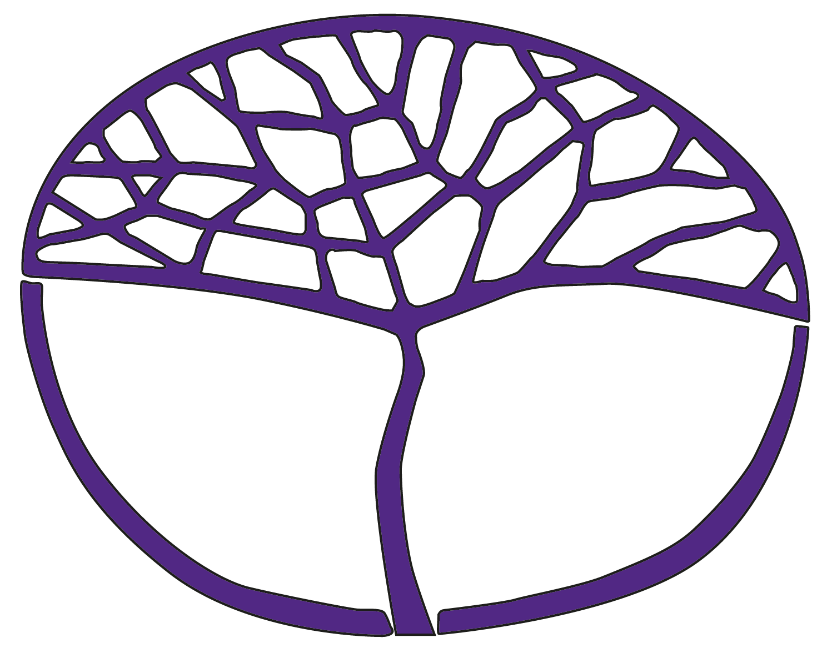Sample Assessment Outline

Careers and Employability

General Year 11

**Acknowledgement of Country**

Kaya. The School Curriculum and Standards Authority (the Authority) acknowledges that our offices are on Whadjuk Noongar boodjar and that we deliver our services on the country of many traditional custodians and language groups throughout Western Australia. The Authority acknowledges the traditional custodians throughout Western Australia and their continuing connection to land, waters and community. We offer our respect to Elders past and present.

**Copyright**

© School Curriculum and Standards Authority, 2024

This document – apart from any third-party copyright material contained in it – may be freely copied, or communicated on an intranet, for non-commercial purposes in educational institutions, provided that the School Curriculum and Standards Authority (the Authority) is acknowledged as the copyright owner, and that the Authority’s moral rights are not infringed.

Copying or communication for any other purpose can be done only within the terms of the *Copyright Act 1968* or with prior written permission of the Authority. Copying or communication of any third-party copyright material can be done only within the terms of the *Copyright Act 1968* or with permission of the copyright owners.

Any content in this document that has been derived from the Australian Curriculum may be used under the terms of the [Creative Commons Attribution 4.0 International licence](https://creativecommons.org/licenses/by/4.0/).

**Disclaimer**

Any resources such as texts, websites and so on that may be referred to in this document are provided as examples of resources that teachers can use to support their learning programs. Their inclusion does not imply that they are mandatory or that they are the only resources relevant to the course. Teachers must exercise their professional judgement as to the appropriateness of any they may wish to use..

Sample assessment outline

Careers and Employability – General Year 11

Unit 1 and Unit 2

|  |  |  |  |  |
| --- | --- | --- | --- | --- |
| Assessment type | Assessment type weighting | Assessment task weighting | When/start and submission date | Assessment task |
| Investigation | 50% | 20% | Semester 1  Weeks 7–9 | **Task 2:** Research two different jobs suited to personal preferences and present findings in a written report. Includes assessment of communication skills, digital literacy skills, time management skills and critical thinking skills. |
| 15% | Semester 2  Weeks 3–5 | **Task 5:** A group activity which involves researching formal and informal learning opportunities. Present findings in a multimedia slideshow. Includes assessment of communication skills, digital literacy skills and teamwork skills. |
| 15% | Semester 2  Weeks 10–13 | **Task 7:** Research key government documents relating to employment and present findings in an information pamphlet. This task will include an in-class validation based on unseen questions, directly related to the content of the investigation. Includes assessment of communication skills, digital literacy skills and critical thinking skills. |
| Career portfolio | 20% | 10% | Semester 1  Weeks 10–11 | **Task 3:** Develop a pathway plan which contains goals, an action plan, career exploration, academic review and self-reflection. Includes assessment of communication skills, digital literacy skills and problem-solving skills. |
| 10% | Semester 2  Weeks 8–9 | **Task 6:** Develop a career portfolio which contains a pathway plan, résumé, personal brand profile, evidence of achievement and qualifications, and evidence of skills. Includes assessment of communication skills and digital literacy skills. |
| Response | 30% | 10% | Semester 1  Week 3 | **Task 1:** Short answer questions based on the nature of work, conducted in class under test conditions. Includes assessment of communication skills. |
| 10% | Semester 1  Week 16 | **Task 4:** An extended answer question based on enterprising characteristics and innovation, conducted in class under test conditions. Includes assessment of communication skills. |
| 10% | Semester 2  Week 16 | **Task 8:** Short answer questions based on the changing nature of life and work roles, work/life balance and personal wellbeing. Includes assessment of communication skills and problem-solving skills. |
| **Total** | **100%** | **100%** |  |  |