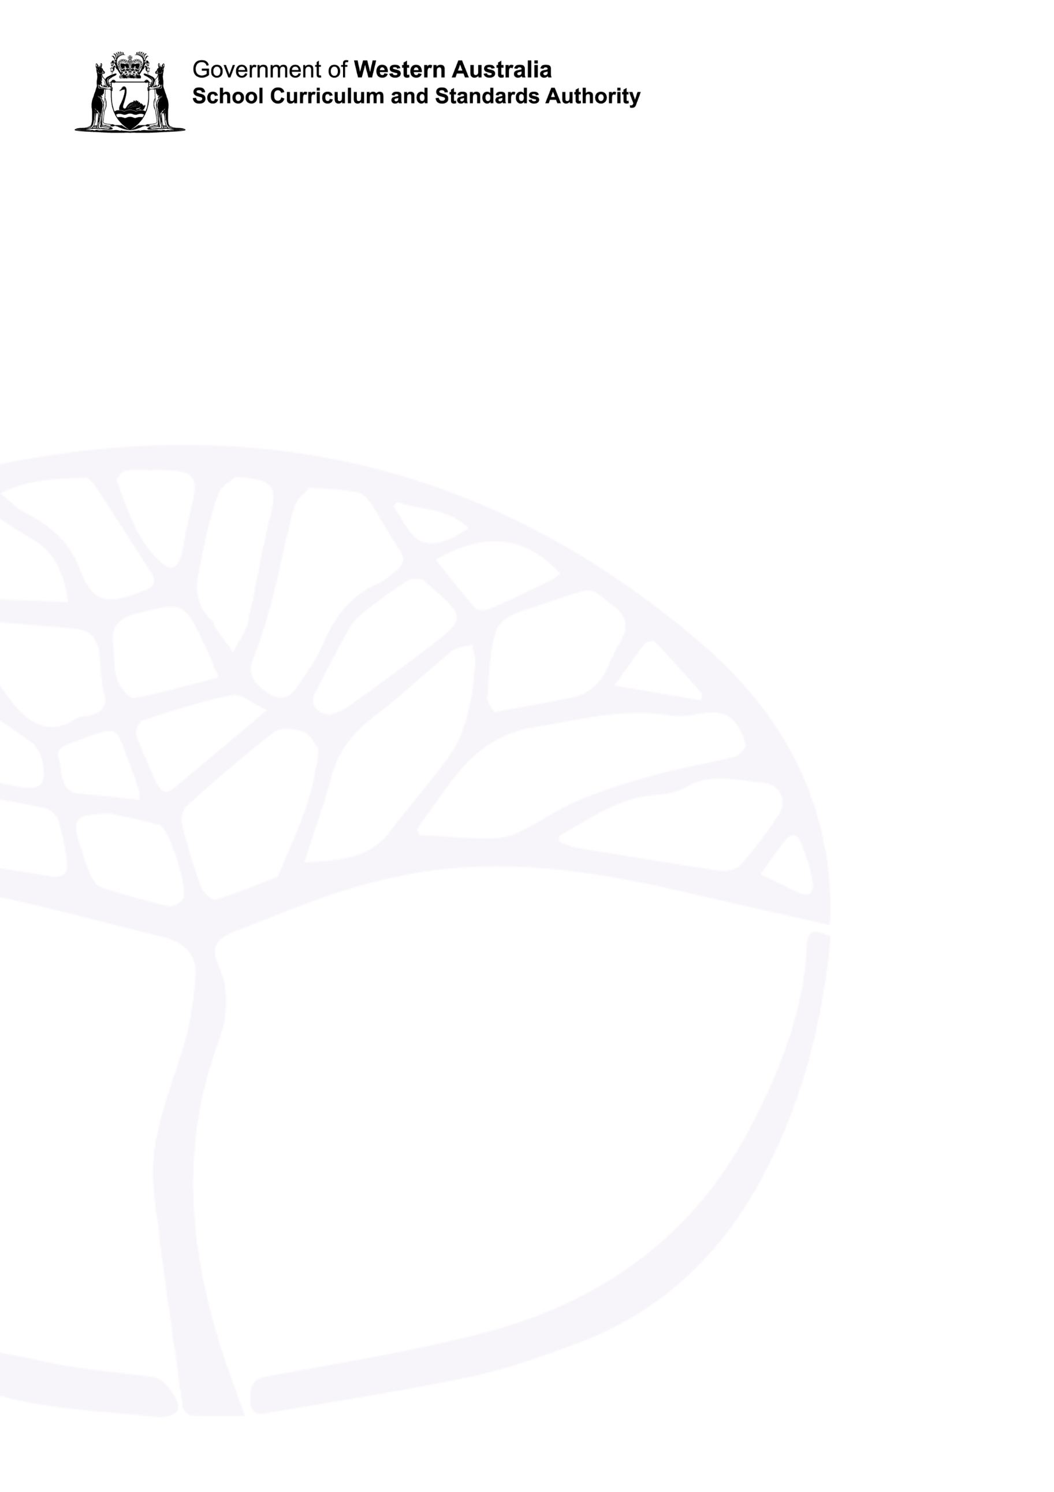
English Suggested Text List
English General course for Year 11 and 12

Acknowledgement of Country
Kaya. The School Curriculum and Standards Authority (the Authority) acknowledges that our offices are on Whadjuk Noongar boodjar and that we deliver our services on the country of many traditional custodians and language groups throughout Western Australia. The Authority acknowledges the traditional custodians throughout Western Australia and their continuing connection to land, waters and community. We offer our respect to Elders past and present.
Copyright
© School Curriculum and Standards Authority, 2024
This document – apart from any third-party copyright material contained in it – may be freely copied, or communicated on an intranet, for non-commercial purposes in educational institutions, provided that the School Curriculum and Standards Authority (the Authority) is acknowledged as the copyright owner, and that the Authority’s moral rights are not infringed.
Copying or communication for any other purpose can be done only within the terms of the Copyright Act 1968 or with prior written permission of the Authority. Copying or communication of any third-party copyright material can be done only within the terms of the Copyright Act 1968 or with permission of the copyright owners.
Any content in this document that has been derived from the Australian Curriculum may be used under the terms of the Creative Commons Attribution 4.0 International licence.
Disclaimer
Any resources such as texts, websites and so on that may be referred to in this document are provided as examples of resources that teachers can use to support their learning programs. Their inclusion does not imply that they are mandatory or that they are the only resources relevant to the course. Teachers must exercise their professional judgement as to the appropriateness of any they may wish to use.

Advice for using texts in educational settings
Teachers use their professional judgement when selecting texts to use in their teaching and learning programs. They base their decisions on the requirements of the Western Australian curriculum, student data, the needs of their students and proposed learning intentions and success criteria.
When using texts in the classroom, teachers are also required to:
- conform with relevant legal requirements and Department policies
- address duty of care responsibilities
- meet copyright requirements
- adhere to the requirements of classification categories.
Parent or guardian permission should be sought when showing a publication, film, video or computer game that has a PG or M classification to students under 15 years of age. Texts classified MA 15+ may not be shown to any students without parental consent, and allowances must be made in case of withdrawal. For further information, see the Department of Education policy Select and use texts in the classroom at https://www.education.wa.edu.au/web/policies/-/use-of-texts-in-educational-settings.
Schools may develop proformas for advising parents or guardians and/or seeking permission for their child to view or use a particular text/s with a specific classification category.

English General Year 11 and 12 suggested text list
The following are examples of texts suitable for the English General course and are intended to stimulate thinking about teacher resources in relation to the content of the curriculum.
This is a suggested list only. Schools may select texts beyond this list.
It is recommended that a minimum of approximately one third of all texts studied be Australian texts. Australian writers/texts are indicated with an asterisk (*).
Title | Author/Director/Source | Text Type
Anything But Fine* | Tobias Madden | Novel
Becoming Kirralee Lewis* | Jane Harrison | Novel
Being Black ‘n Chicken, and Chips* | Matt Okine | Novel
Bye, Beautiful* | Julia Lawrinson | Novel
The Dead I Know* | Scot Gardner | Novel
Go Ask Alice | Beatrice Sparks | Novel
The Killer's Tears | Anne-Laure Bondoux | Novel
Pig Boy* | J.C. Burke | Novel
Saving Jazz* | Kate McCaffrey | Novel
Six* | Karen Tayleur | Novel
The Surprising Power of a Good Dumpling* | Wai Chim | Novel
The Wave | Morton Rhue | Novel
When Michael Met Mina* | Randel Abdel-Fattah | Novel
You’d Be Home Now | Kathleen Glasgow | Novel
The Appleton Ladies’ Potato Race* | Melanie Tait | Play
Black is the New White* | Nakkiah Lui | Play
Blackrock* | Nick Enright | Play
City of Gold* | Meyne Wyatt | Play
The Club* | David Williamson | Play
The Crucible | Arthur Miller | Play
The Glass Menagerie | Tennessee Williams | Play
Romeo and Juliet | William Shakespeare | Play
Collected Poems | Carol Ann Duffy | Poetry
The Complete Poetry | Maya Angelou | Poetry
Don’t Start Me Talking:  Lyrics 1984–2012 | Paul Kelly | Poetry (song)
The Hijab Files* | Maryam Azam | Poetry
Milk and Honey | Rupi Kaur | Poetry
My People* | Oodgeroo | Poetry
Poetry Unlocked: An Anthology Arranged in Themes | Elaine Hamilton and Robin Farr (editors) | Poetry
Sometimes Gladness* | Bruce Dawe | Poetry
The Unboxing of a Black Girl | Angela Shante | Poetry
Borderlands: Riding the Slipstream* | Paul Collins (editor) | Short stories
Meet me at the Intersection* | Ambelin Kwaymullina and Rebecca Lim (editor) | Short stories
Ray Bradbury Stories Volume 1 | Ray Bradbury | Short stories
Ray Bradbury Stories Volume 2 | Ray Bradbury | Short stories
All Summer Long | Hope Larson | Graphic novel
The Best We Can Do: An Illustrated Memoir | Thi Bui | Graphic novel
Blue* | Pat Grant | Graphic novel
Laika | Nick Abadzis | Graphic novel
The Complete Maus | Art Spiegelman | Graphic novel
Nimona | ND Stevenson | Graphic novel
A Part of Me is Still Unknown* | Meg O’Shea  https://thenib.com/a-part-of-me-is-still-unknown/ | Graphic novel (online)
So Below* | Sam Wallman  https://sobelow.org/ | Graphic novel (online)
This One Summer | Jillian Tamaki and Mariko Tamaki | Graphic novel
Trashed | Derf Backderf | Graphic novel
Azaria: A True History | Maree Coote | Picture book
Girl on a Motorcycle | Amy Novesky and Julie Morstad | Picture book
Hike | Pete Oswald | Picture book
Memorial* | Gary Crew and Shaun Tan | Picture book
Mirror | Jeannie Baker | Picture book
The Paper Boat: A Refugee Story | Thao Lam | Picture book
The Singing Bones: Inspired by Grimms’ Fairy Tales* | Shaun Tan | Picture book
The Waiting Place: When Home is Lost and a New One Not Yet Found | Dina Nayeri and Anna Bosch Miralpeix | Picture book
Window | Marion Arbona | Picture book
Australia Day* | Stan Grant | Non-fiction
The Book that Made Me* | Judith Ridge (editor) | Non-fiction
Chasing the Truth: A Young Journalist’s Guide to Investigative Reporting (She Said Young Readers Edition) | Jodi Kantor and Megan Twohey, adapted by Ruby Shamir | Non-fiction
Growing Up Aboriginal in Australia* | Anita Heiss (editor) | Non-fiction
Growing Up African in Australia* | Maxine Beneba Clarke (editor) | Non-fiction
Growing Up Asian in Australia* | Alice Pung (editor) | Non-fiction
Growing Up Disabled in Australia* | Carly Findlay (editor) | Non-fiction
Growing Up in Country Australia* | Rick Morton (editor) | Non-fiction
Growing Up Indian in Australia* | Aarti Betigeri (editor) | Non-fiction
Growing Up Queer in Australia* | Benjamin Law (editor) | Non-fiction
Growing Up Torres Strait Islander in Australia* | Samantha Faulkner (editor) | Non-fiction
No Silly Questions* | Sam Koslowski and Zara Seidler | Non-fiction
Not the End of the World: How We Can Be the First Generation to Build a Sustainable Planet | Hannah Ritchie | Non-fiction
The School* | Brendan James Murray | Non-fiction
The Woman who Fooled the World: Belle Gibson’s Cancer Con* | Beau Donelly and Nick Toscano | Non-fiction
Broken Girl: A True Story* | Bradley Trevor Greive and Caroline Laner Breure | Memoir
Good Indian Daughter* | Ruhi Lee | Memoir
The Happiest Refugee* | Ahn Do | Memoir
Surf for Your Life* | Mick Fanning and Tim Baker | Memoir
Blackfish | Gabriela Cowperthwaite | Documentary
Bra Boys* | Sunny Abberton and Macario De Souza | Documentary
Cronulla Riots: The Day that Shocked the Nation* | Jaya Balendra  https://www.sbs.com.au/cronullariots/documentary.html | Documentary (interactive)
Free Solo | Jimmy Chin and Elizabeth Chai Vasarhelyi | Documentary
Fyre: The Greatest Party That Never Happened | Chris Smith | Documentary
Jandamarra's War* | Mitch Torres | Documentary
K’Gari: The Real Story of a True Fake* | Boris Etingof  https://www.sbs.com.au/kgari/ | Documentary (interactive)
Lost for Words* | SBS | Documentary (series)
Missing* | Kylie Boltin and Matt Smith  https://www.sbs.com.au/missing/ | Documentary (interactive)
The Oasis* | Ian Darling and Sascha Ettinger Epstein | Documentary
Racing Extinction | Louie Psihoyos | Documentary
The Speed Cubers | Sue Kim | Documentary
That Sugar Film* | Damon Gameau | Documentary
The Way We Wore* | ABC | Documentary (series)
You Can’t Ask That* | SBS | Documentary (series)
Barbie | Greta Gerwig | Film
Drop Dead Gorgeous | Michael Patrick Jann | Film
Dunkirk | Christopher Nolan | Film
The Fabelmans | Steven Spielberg | Film
Ford v Ferrari | James Mangold | Film
Into the Wild | Sean Penn | Film
King Richard | Reinaldo Marcus Green | Film
Ladies in Black* | Bruce Beresford | Film
Mean Girls | Mark Waters | Film
The Merger* | Mark Grentell | Fillm
The New Boy* | Warwick Thornton | Film
Sound of Metal | Darius Marder | Film
Sweet As* | Jub Clerc | Film
Toomelah* | Ivan Sen | Film
Derry Girls | Netflix | Television (sitcom)
Fisk* | ABC | Television (sitcom)
Heartstopper | Netflix | Television (romance)
The Newsreader* | ABC | Television (drama)
Robbie Hood* | SBS | Television (comedy)
Severance | Apple TV+ | Television (science fiction)
Stranger Things | Netflix | Television (science fiction)
Ted Lasso | Apple TV+ | Television (sitcom)
Ten Pound Poms* | Stan | Television (drama)

