English as an Additional Language or Dialect

Common Oral Assessment Task   
Technical Guide

**Acknowledgement of Country**

Kaya. The School Curriculum and Standards Authority (the Authority) acknowledges that our offices are on Whadjuk Noongar boodjar and that we deliver our services on the country of many traditional custodians and language groups throughout Western Australia. The Authority acknowledges the traditional custodians throughout Western Australia and their continuing connection to land, waters and community. We offer our respect to elders past and present.

**Copyright**

© School Curriculum and Standards Authority, 2024

This document – apart from any third-party copyright material contained in it – may be freely copied, or communicated on an intranet, for non-commercial purposes in educational institutions, provided that the School Curriculum and Standards Authority (the Authority) is acknowledged as the copyright owner, and that the Authority’s moral rights are not infringed.

Copying or communication for any other purpose can be done only within the terms of the *Copyright Act 1968* or with prior written permission of the Authority. Copying or communication of any third-party copyright material can be done only within the terms of the *Copyright Act 1968* or with permission of the copyright owners.

Any content in this document that has been derived from the Australian Curriculum may be used under the terms of the [Creative Commons Attribution 4.0 International licence](https://creativecommons.org/licenses/by/4.0/).

**Disclaimer**

Any resources, such as texts, websites and so on that may be referred to in this document are provided as examples of resources that teachers can use to support their learning programs. Their inclusion does not imply that they are mandatory or that they are the only resources relevant to the course. Teachers must exercise their professional judgement as to the appropriateness of any they may wish to use.

School Curriculum and Standards Authority  
303 Sevenoaks Street  
Cannington WA 6107

For further information, please contact:  
Telephone: +61 8 9273 6300

Email: [info@scsa.wa.edu.au](mailto:info@scsa.wa.edu.au)  
Web: [www.scsa.wa.edu.au](http://www.scsa.wa.edu.au)

Contents

Introduction 1

Recording the COAT interview 1

Using an appropriate recording device 1

Setting up and recording an interview in Webex 2

Scheduling an interview/setting up a COAT interview meeting template in Webex 2

Scheduling an interview from a Webex template 4

Accessing and downloading the interview recording 5

Uploading the EAL/D COAT file 6

Using SIRS and SIRS2 in the EAL/D COAT process 6

Uploading COAT files into SIRS2 6

Appendix: Roles and responsibilities 9

Introduction

All students enrolled in the Year 12 English as an Additional Language or Dialect (EAL/D) ATAR course are required to complete the common oral assessment task (COAT) developed by the School Curriculum and Standards Authority (the Authority) for the course.

**The COAT is compulsory and forms part of the school-based assessment for the Year 12 EAL/D ATAR course.**

The Authority is responsible for developing and providing the COAT to schools. Schools will be required to administer and assess the COAT using the marking key provided as part of the school‑based assessment program during the period specified by the Authority in the *Activities Schedule.*

This guide provides information about:

* recording the COAT interview
* the EAL/D COAT file upload process using SIRS2.

Recording the COAT interview

Each recording should be 10 minutes in length and saved in .mp4 format at a maximum 720p resolution.

The filename must match the filename specified in the SIRS report COT005. Note: information about how to generate reports in SIRS can be found in the *Data Procedures Manual* on the Authority website at <https://scsa.wa.edu.au/publications/data-procedures-manual>.

Using an appropriate recording device

The recording device should include the following specifications:

* internal or external camera
* internal or external microphone
* installed video recording software. Webex®, Microsoft Teams® or Zoom® are suitable online meeting platforms for recording the COAT. They are compatible with most operating systems and offer a free account option.
* a folder specifically set up on the computer for filing each of the saved recordings or cloud‑based storage that can be accessed by the teacher and/or the COAT contact.

A laptop with a rear-facing or external camera is ideal for recording the COAT. This allows the interviewer to monitor the recording in real time, and the student will not see their image being recorded.

If you do not have access to a laptop with a rear-facing camera or an external camera, but do have access to a laptop or computer, the COAT interview recordings can be preconfigured and then recorded using a mobile device with a camera, such as a smartphone or tablet. Online meeting platforms can be used if the settings (recording the interview, saving to an account with cloud‑based storage etc.) are configured using a laptop/computer prior to the administration of the COAT. This will help ensure that the recordings are saved to a server rather than the mobile device’s internal storage.

It is not recommended that schools use a mobile device to record students’ COAT interviews, as this may result in the files being saved only to the mobile device. These are often large, high resolution audiovisual files in an incompatible format. Significant work is then required to transfer files to a computer, ensure the file format is correct and the file size is small enough to upload.

It is also not recommended that schools use a video camera with external storage to record students’ COAT interviews, as substantial editing and compression is needed to make the upload process manageable for teachers/school administrators.

To ensure that each audiovisual file is a manageable size to upload, online meeting software can be used to record an interview with a single participant. The audiovisual files are small and can be saved to a local drive or cloud-based storage. Interviews can also be set up in advance using the appropriate file naming conventions (i.e. student number only).

**Note: check with your school or system/sector to see what hardware and software is available.**

Setting up and recording an interview in Webex

All Department of Education (the Department) staff have a Webex licence. This licence includes cloud storage for recordings. Webex meeting recordings are also available using a free account; however, they must be saved on a local drive on your device.

Webex allows you to set and save your interview meeting settings in a template, so that you do not have to reset them for each new interview. This template also includes an automatic recording setting.

Scheduling an interview/setting up a COAT interview meeting template in Webex

The following instructions and screenshots are based on you having a Department Webex licence and email account.

1. Go to: <https://www.webex.com/>
2. Click on **Sign In** (see screenshot below).

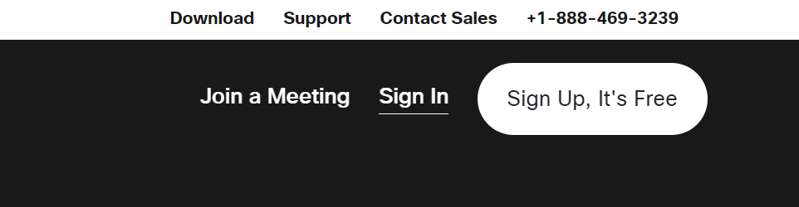

1. The **Sign in** screen will appear. Type in your Department email address and click on the **Next** button.

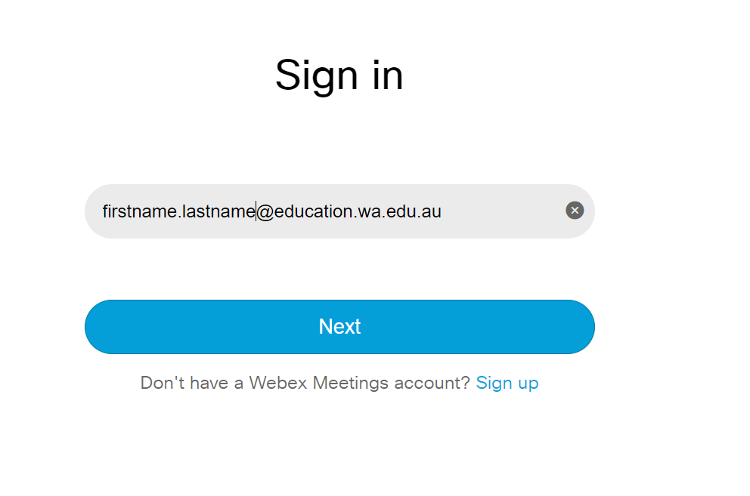

1. Your personal Webex room will appear. Click on the **Schedule a meeting** button (see screenshot below).

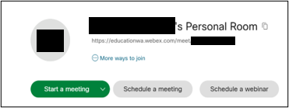

1. The **Schedule a meeting** screen will appear. Enter the name for the interview meeting template in the **Meeting topic** field and set the duration for 10 minutes (see screenshot below).

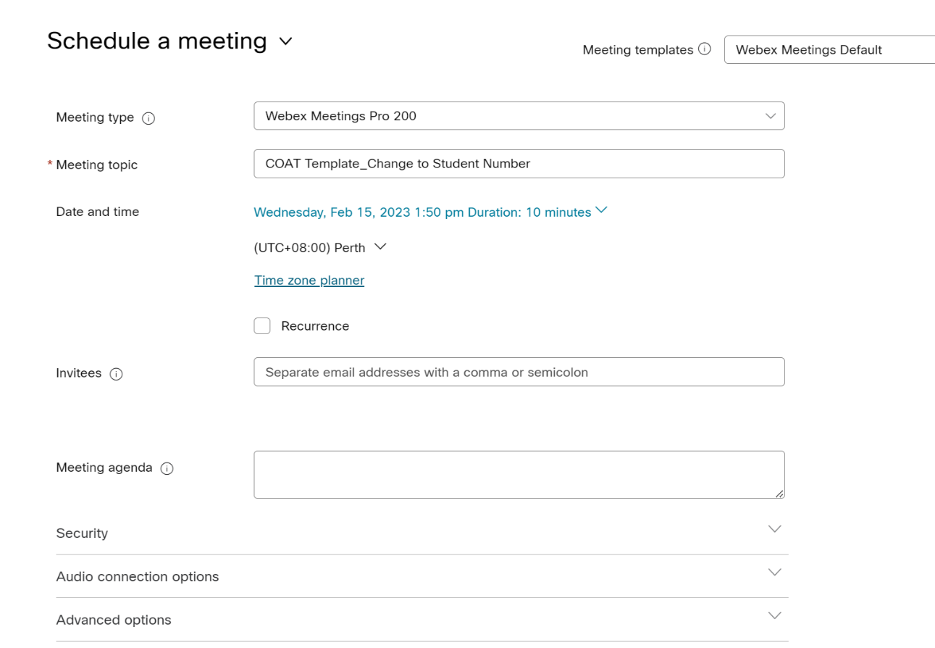

1. Scroll further down the page, until you see the **Advanced options**, and tick the **Automatic recording** check box (see screenshot below).

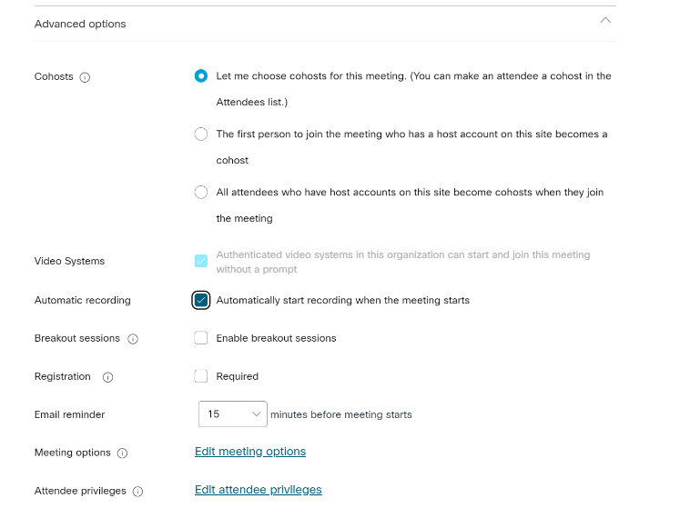

1. Scroll to the bottom of the page and click on **Save settings as meeting template** (see screenshot below).

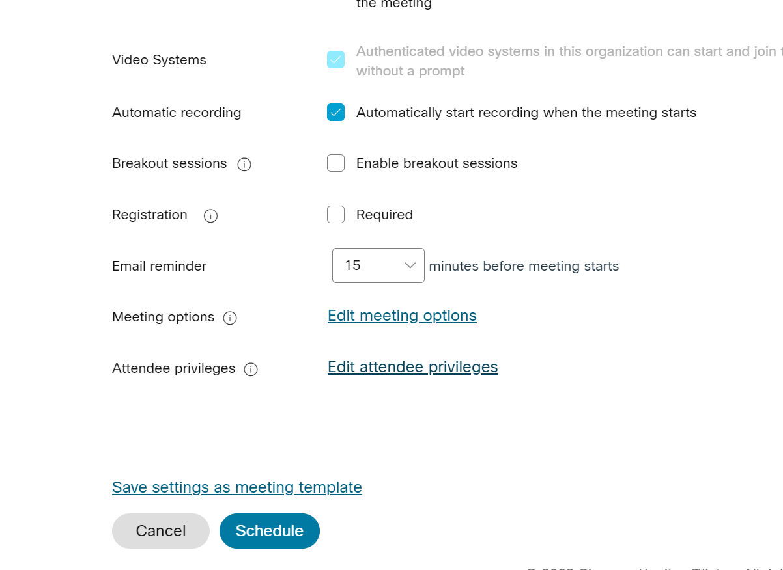

1. The **Save as meeting template** pop-up window will appear. Check the template name is correct, and click on the **Save** button (see screenshot below).

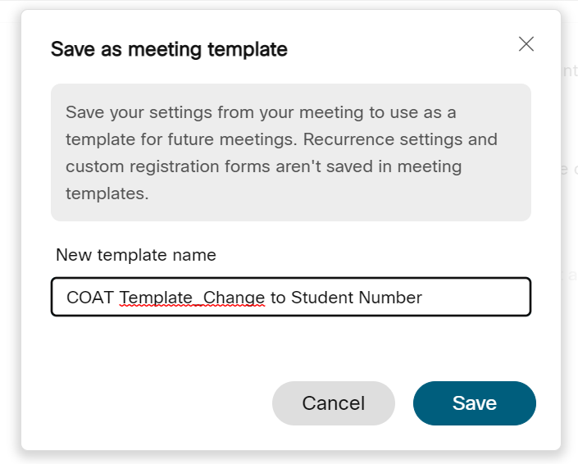

Scheduling an interview from a Webex template

1. In your personal Webex room, click on the **Schedule a meeting** button.
2. Select the correct template from the **Meeting templates** drop-down list.
3. Change the **Meeting topic** to the student’s WASN.
4. Set the date and time (see screenshot below).

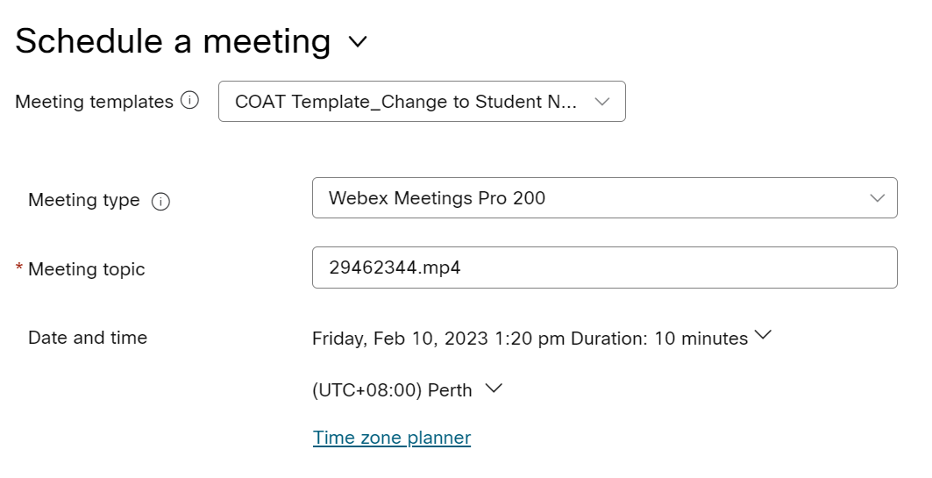

1. Scroll down and click on the **Save** button.

Note: you can join the interview on any device (e.g. smart phone or tablet) and the recording will save to your account. For further assistance with Webex and recording interviews using a free account, go to: <https://help.webex.com/en-us/article/n62735y/Webex-%7C-Record-a-meeting#id_134755>.

Accessing and downloading the interview recording

After the interview has ended, the recording will take approximately 20 minutes (depending on the file size) to save. Once the recording has been processed, it will be available in the **Recordings** section.

1. Go to: <https://www.webex.com/>
2. Click on **Recordings** on the left-hand side of the screen (see screenshot below).

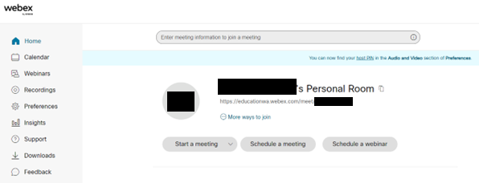

1. A list of your recordings will appear. Find the recording you want and click on the download arrow (see screenshot below).

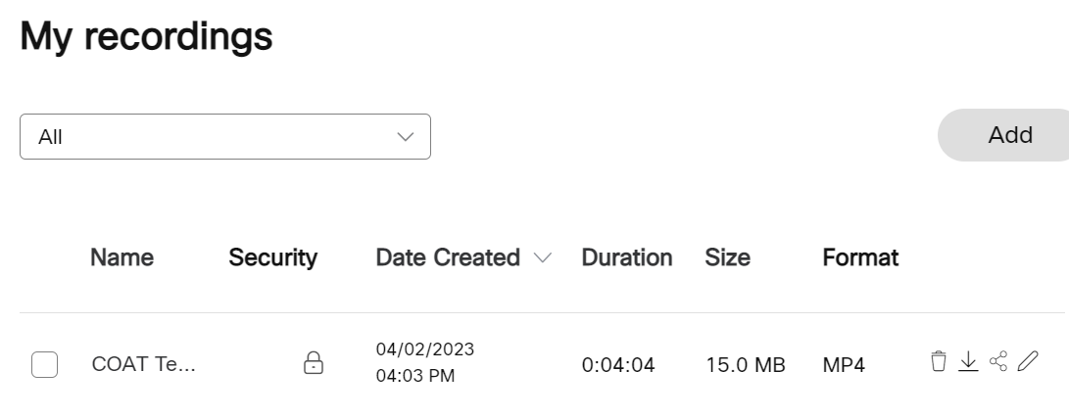

This will save the audiovisual file to your local drive. Once the file has been downloaded to your computer, it can be uploaded into **SIRS2** via the **COAT: Upload Video** page.

Note:

* Check the filename requirements are correct in COT005 before uploading the audiovisual file.
* The SIRS report COT005 will be blank until the marks have been uploaded into SIRS.

Uploading the EAL/D COAT file

Using SIRS and SIRS2 in the EAL/D COAT process

The following must be completed by the school SIRS administrator.

* Assign the COAT contact (provider role) in SIRS. This contact will be emailed relevant COAT information. Note: this provider role does not allow the contact to access SIRS or SIRS2.
* Assign a SIRS user account to the COAT contact. **The COAT contact will need access to SIRS and SIRS2.**

The table below identifies the relevant system to be used throughout the COAT process.

|  |  |
| --- | --- |
| Process | SIRS |
| Updating COAT school contact details | SIRS |
| Downloading a list of students in the Year 12 EAL/D ATAR course by class (COT001) | SIRS |
| Checking the Year 12 EAL/D ATAR course enrolments (CSE028) | SIRS |
| Downloading the COAT preparation booklet | EAL/D page of website |
| Downloading the WASN identification sheet | SIRS |
| Downloading the marking key | EAL/D page of website |
| Downloading the marks collection forms | SIRS2 |
| Uploading COAT raw marks | SIRS |
| Verifying uploaded COAT raw marks (COT001) | SIRS |
| Uploading audiovisual recording and student audiovisual files | SIRS2 |
| Checking for missing student audiovisual recordings (COT005) | SIRS |
| Downloading COAT feedback report (COT007) | SIRS |

Uploading COAT files into SIRS2

The following must be completed by the COAT contact with a SIRS user account (or the main SIRS user).

**Instructions and requirements before uploading files into SIRS2**

The following requirements should be met **before** uploading COAT files into SIRS2.

* All COAT files must be formatted as .mp4 file format/extension. All other file formats/extensions will be rejected.
* Files must follow the file naming convention below, where the file name is the student number/WASN, e.g. **12345678.mp4** for a student with the WASN 12345678.
* No single student can have two or more .mp4 files associated with their name.
* No single .mp4 file should be associated with two or more students.
* No two or more .mp4 files should share the same file name.

**Instructions for uploading files into SIRS2**

The requirements outlined in the sectionabove **must** be met before you can begin the uploading process below.

1. Log in to SIRS2 with your username and password for SIRS. If you do not have your username and password, speak to your school administration to obtain them.
2. In the main navigation bar, click on the **COAT** drop-down list and then click on **Upload** (see screenshot below).

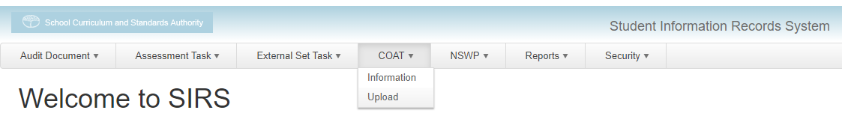

1. The **COAT: Upload Video** page will appear. Click on the **Upload** tab and fill out the following fields in the order below.
   * **Provider:** select your school/provider from the drop-down list.
   * **Course:** select **COAT – English as an Additional Language or Dialect Oral** from the drop‑down list.

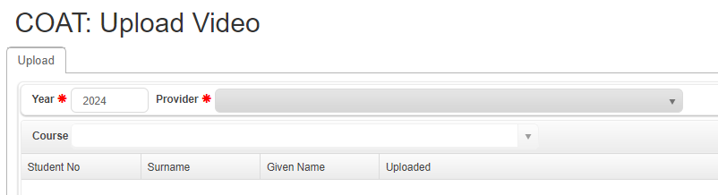

A table will appear with the relevant students’ details.

1. Click on the **Upload File** button.

Note: once a file has been uploaded, it cannot be **removed/deleted**, only replaced, as outlined in the following section.

1. In the pop-up window, navigate to the file directory where the .mp4 files are located.
2. Select one or more .mp4 files.

Note: to bulk upload multiple .mp4 files, follow the instructions below.

* Click on a .mp4 file and hold down the **Shift** button.
* Click on other .mp4 files to select a range.

1. Click on the **Open** button and the upload process for the selected .mp4 files will begin.

Note: steps 4 to 7 can be repeated as many times as necessary until all necessary files are uploaded.

The .mp4 files will be automatically sorted according to the students listed in the table based on the student number/WASN in the .mp4 file name.

In the **Uploaded** column, a loading bar will display the current progress of the upload for that specific student.

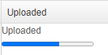

Note: if the selected files contain incorrect file names (such as file names that don’t match with any of the student numbers listed in the table) or has an incorrect file format/extension, a notification/alert will be sent to the user of the selected files stating the issue and reason. Files that have no issues will continue to be uploaded.

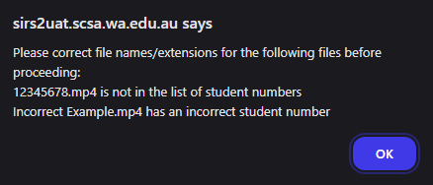

Once the upload bar is filled, the text **‘Uploaded’** will be displayed, representing the completion of the upload process for that student’s file.

**Instructions for replacing/re-uploading files into SIRS2**

The instructions below should be followed if one or more students’ uploaded files need to be replaced/re-uploaded.

1. Ensure the name/s of the replacement .mp4 file/s is the correct student number/WASN. Adhere to the naming convention outlined in the section: Instructions and requirements before uploading files into SIRS2.
2. Follow the instructions outlined in the section: Instructions for uploading files into SIRS2 and upload the replacement file/s.

Note: uploading the replacement file/s will automatically delete and replace the previously uploaded file/s for the relevant students.

Appendix: Roles and responsibilities

|  |  |
| --- | --- |
| Role | Responsibilities |
| **School SIRS admin** | In SIRS (<https://sirs.scsa.wa.edu.au>):   * assign COAT contact (provider role) * assign user login to COAT contact (e.g. P0990f) * assign ‘COATInfoProvider’ user role.   Note: check that this has been done in SIRS (and SIRS2). |
| **Teacher** | * Conduct and record audiovisual student COAT interviews. |
| **COAT contact** | In SIRS2 (<https://sirs2.scsa.wa.edu.au/>):   * Record audiovisual files (PDF links in SIRS2 browser window above the login information*).   *PDF guides are available for reference.   * Filename for the actual COAT upload is the student number **only**, e.g. **2212345** as suffix indicating file type, i.e. .mp4 is added automatically. * Run COT005 for test filename requirements process.   Note: do not run COT005 at this step as it will be blank. See note in step 7.   * Set up recording method for audiovisual student COAT interviews. * Check that the filenames for upload match the required filenames provided in COT005.   Note: until marks are uploaded into SIRS via RSCOT, COT005 will be blank.   * Sign into SIRS2 and upload the COAT files. All COAT files being uploaded into SIRS2 must be in **.mp4** file format and contain the naming convention **WASN.mp4**. |