

03/08/2026
Student portal
Student guide for online EAL/D eligibility declarations

Acknowledgement of Country
Kaya. The School Curriculum and Standards Authority (the Authority) acknowledges that our offices are on Whadjuk Noongar boodjar and that we deliver our services on the country of many traditional custodians and language groups throughout Western Australia. The Authority acknowledges the traditional custodians throughout Western Australia and their continuing connection to land, waters and community. We offer our respect to Elders past and present.
© School Curriculum and Standards Authority, 2022
This document – apart from any third-party copyright material contained in it – may be freely copied, or communicated on an intranet, for non-commercial purposes in educational institutions, provided that the School Curriculum and Standards Authority (the Authority) is acknowledged as the copyright owner, and that the Authority’s moral rights are not infringed.
Copying or communication for any other purpose can be done only within the terms of the Copyright Act 1968 or with prior written permission of the Authority. Copying or communication of any third-party copyright material can be done only within the terms of the Copyright Act 1968 or with permission of the copyright owners.
Any content in this document that has been derived from the Australian Curriculum may be used under the terms of the Creative Commons Attribution 4.0 International (CC BY) licence.
School Curriculum and Standards Authority
Street address: 303 Sevenoaks Street CANNINGTON WA 6107
Postal address: PO Box 816 CANNINGTON WA 6987
Phone: (08) 9273 6300
General email: info@scsa.wa.edu.au
Web: www.scsa.wa.edu.au
Cover image adapted from: londoneye. (2013). [iStock photograph ID: 181861202]. Retrieved March, 2025, from https://www.istockphoto.com/

Contents
Introduction 4
Eligibility to enrol in the Year 12 EAL/D ATAR course 4
EAL/D ATAR eligibility process 5
Five steps to submit an online EAL/D eligibility declaration 5
Checklist 6
Step 1: Log in to the student portal 7
Set up your personal email address 8
Set up your new password 9
Complete your Student Declaration and Permission 9
Returning to the student portal 10
Step 2: Start your EAL/D eligibility declaration 11
Your details 11
1: EAL/D declaration type 12
2: Supporting information 14
3: Educational background 15
Step 3: Upload your supporting evidence 18
4: Supporting evidence 18
How to prepare and upload your supporting evidence 20
Step 4: Submit your EAL/D eligibility declaration 22
Amend your EAL/D eligibility declaration 23
Step 5: Check the student portal for your EAL/D eligibility status 24
Request a review 25

Introduction
To enrol in the Year 12 English as an Additional Language or Dialect (EAL/D) Australian Tertiary Admission Rank (ATAR) course, you must submit an online EAL/D eligibility declaration to your school principal, deputy principal or delegate.
This user guide shows you how to submit an EAL/D eligibility declaration in the student portal (https://studentportal.scsa.wa.edu.au).

Eligibility to enrol in the Year 12 EAL/D ATAR course
The EAL/D ATAR course is available to students who speak English as an additional language or dialect, and whose use of Standard Australian English (SAE) is restricted or still developing.
The School Curriculum and Standards Authority (the Authority) requires all schools to determine the eligibility of a student for enrolment in the Year 12 EAL/D ATAR course.
The EAL/D ATAR course is designed for students for whom English is not their first or home language.
This includes:
- students who are Aboriginal or Torres Strait Islander, or from Cocos Island or Christmas Island, for whom SAE has been the medium of instruction, but for whom SAE is an additional language/dialect, and whose exposure to SAE is primarily within the school context
- students who are deaf or hard of hearing and communicate using signing, such as Auslan, as their first language
- students who have:
- not more than seven years of education where English is the main medium of course delivery immediately prior to entering their final year of school, or
- more than seven years where English is the main medium of course delivery but limited exposure/restricted knowledge of academic English, or
- varying exposure to English, but who have had disrupted* schooling in one or more countries, including Australia.
Schools are best placed to identify and confirm the eligibility of students against these subcategories. Factors for consideration in school judgements include:
- refugee or low socio-economic status backgrounds
- poverty
- post-traumatic stress disorder (PTSD) or trauma
- * disrupted schooling, including:
- frequent or significant changes to language of instruction
- long-term or numerous interruptions to schooling
- other experiences that may affect their ability to access English learning area courses other than EAL/D.

EAL/D ATAR eligibility process
Students who intend to enrol in the Year 12 EAL/D ATAR course must submit to their school principal or delegate via the student portal:
- an EAL/D eligibility declaration
- supporting information (first language, education background)
- relevant evidence (e.g. school reports, school letter, teacher declaration).
Use the checklist on the following page to make sure you have everything you need before you start your online EAL/D eligibility declaration.
You will need to use a computer, either at home or at school. If you have any questions, ask your parent/s or carer/s or EAL/D teacher to help you.
There are five stages to enrolment in the Year 12 EAL/D ATAR course.
- Student declaration submitted in the student portal.
- Teacher verification of information and evidence. Any mistakes by the student can be fixed here.
- Teacher recommendation.
- Principal endorsement.
- Student may be enrolled in the Year 12 EAL/D ATAR course.
Information about the EAL/D eligibility process and the submission dates for declarations can be found on the EAL/D page of the Authority website
(https://senior-secondary.scsa.wa.edu.au/syllabus-and-support-materials/english/english-as-an-additional-language-or-dialect).
Any student who has not had their EAL/D eligibility finalised and endorsed by the Year 12 enrolment deadline, as published in the Activities Schedule for that year, will not be able to enrol in the Year 12 EAL/D ATAR course for that year.
Students can enrol in the EAL/D General and Foundation courses if they have eligibility approval from their teacher and school principal. For a student to be approved, the school must complete and retain the required documentation (Form for eligibility for enrolment in Year 12 General and Foundation EAL/D and for extra time to complete the OLNA) and supporting evidence.

Five steps to submit an online EAL/D eligibility declaration
Step 1: Log in to the student portal
Step 2: Start your EAL/D eligibility declaration
Step 3: Upload your supporting evidence
Step 4: Submit your EAL/D eligibility declaration
Step 5: Check the student portal for your EAL/D eligibility status

Checklist
1
Logging in to the student portal
To log in to the student portal, you will need your WA student number, which you will find on your school report/s. It may also be on your SmartRider.
You will need a personal email address and must be able to access your personal email account when you complete your online declaration.
2
Supporting information: language background
You will need to provide the following supporting information:
- your language background
- first and home language/s
- language/s used most now
- language/s other than English that you can speak confidently
- residential information
- where you were born
- all the country/ies you have lived in
- parent/carer information
- country/ies of birth
- language/s used with you
3
Supporting information: schooling details
You must provide details of the schools you attended for every school year from Year 1:
- calendar year
- academic year/grade
- name of the school
- location of the school
- curriculum used at the school (i.e. national or international)
- language/s used by your teacher in the classroom
- language/s used for assessments and examinations
4
Supporting evidence
Photograph or scan at least one piece of evidence. Acceptable evidence includes:
- an authentic letter from a previous school, principal or teacher
- a school report, which may be:
  - from your current school
  - from a previous school in Australia or outside Australia
  - in English or in a language other than English (translation is not necessary).
Save your supporting evidence to your computer or mobile device as .pdf, .jpg, .jpeg or .png files, with a maximum size of 4MB for each file. Word documents will not be accepted. You must use English letters to name your files.


Step 1: Log in to the student portal
Click on the link to the student portal (https://studentportal.scsa.wa.edu.au).
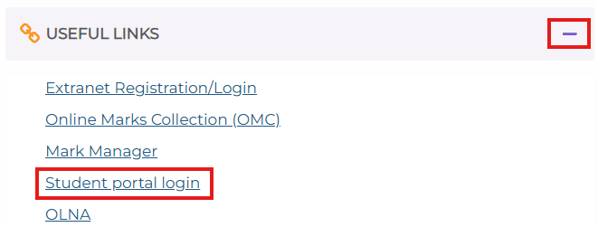
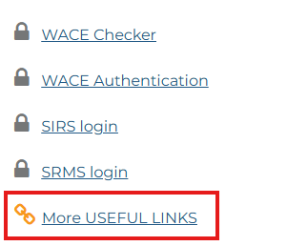
You will find this link on the home page of the School Curriculum and Standards Authority (the Authority) website (https://scsa.wa.edu.au/) by clicking More USEFUL LINKS and then expanding the USEFUL LINKS dropdown at the bottom of the page.
Enter your WA student number, which is on your school report/s. It may also be on your SmartRider.
Your initial password is a combination of your family name and date of birth — Nnddmmyyyy:
- Nn = the first two letters of your family name: the first as a capital letter (A–Z) and the second as a lower-case letter (a–z), excluding any punctuation or spaces
- ddmmyyyy = your date of birth in day-month-year format.
Tick the check box (highlighted below) to show that you have read and understand the terms of use and privacy collection notice, then click on the Login button (highlighted below) to enter the student portal.
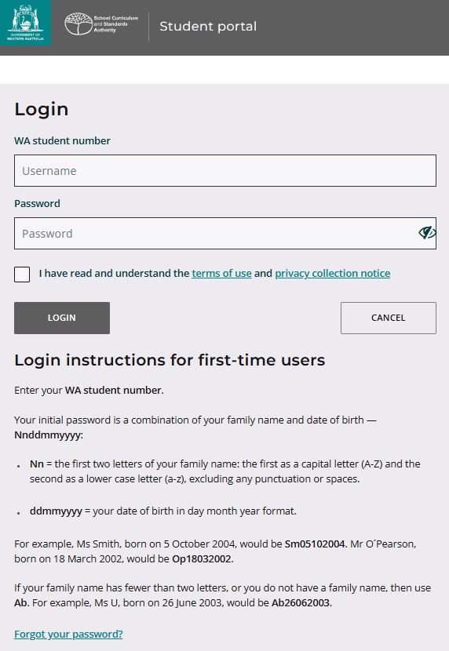

Set up your personal email address
Enter your personal email address, then re-enter it to confirm it. Click on the Set button (highlighted below).
Note: use your personal email address so that you can receive emails after you have left school and your school email address has expired.
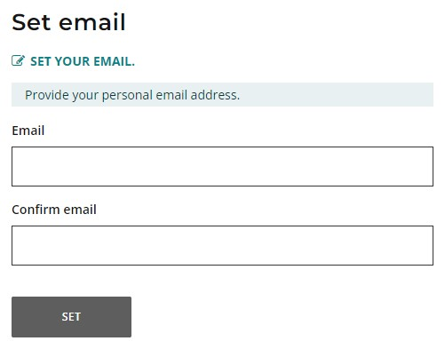
You will see an error message if your email and confirmation email do not match.
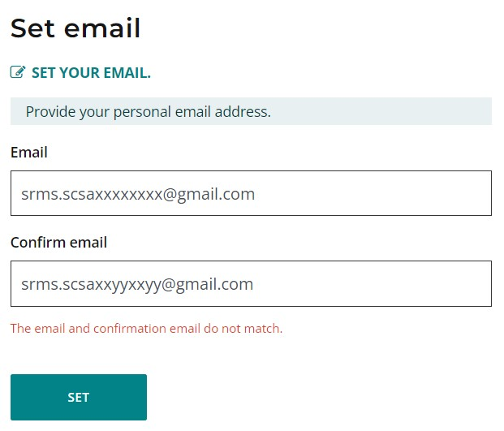
A confirmation email will be sent to this email address.
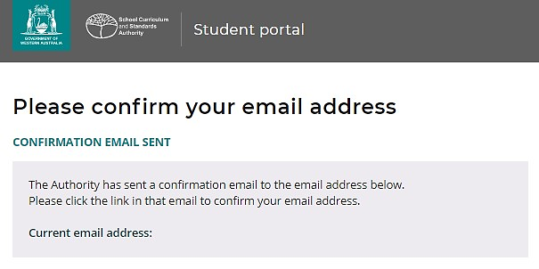
Go to your personal email account and click on the link in the email to confirm your email address and complete your registration. If you cannot log in to your personal email account, contact your school or the Authority’s Help Desk at wacehelp@scsa.wa.edu.au.

Set up your new password
When you have confirmed your email address, you will be asked to reset your password.
Your new password must contain a minimum of 14 characters, with at least one digit (0–9), at least one capital letter (A–Z), at least one lower-case letter (a–z), and at least one special character (such as #, $, or !). Choose a new password that is easy to remember and keep it in a secure place.
Re-enter your new password to confirm it.
Click on the Reset button (highlighted below) to reset your new password.
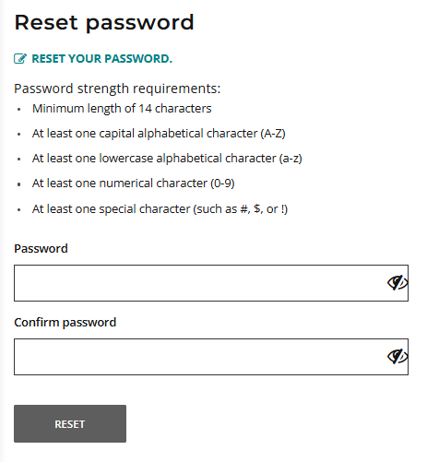

Complete your Student Declaration and Permission
If you are in Year 12, or in Years 10 or 11 and enrolled in an ATAR course, you will be taken to the Student Declaration and Permission page, which includes information about compliance with the Western Australian Certificate of Education (WACE) requirements and rules as set out in the Year 12 Information Handbook.
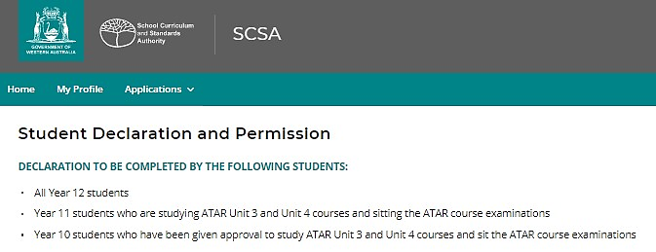
Tick the check box (highlighted below) to confirm that you have read and understand the information, then click on the Submit button (highlighted below).
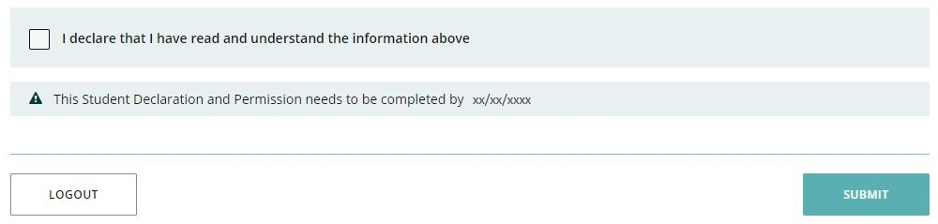
The Authority also asks permission to use your results (should you win an award), and other
schoolwork (without identifying who you are) in media communications.
Click on either Yes or No (highlighted below) for each statement.
When you have responded to each statement, click on the Submit button (highlighted below) to enter the student portal.
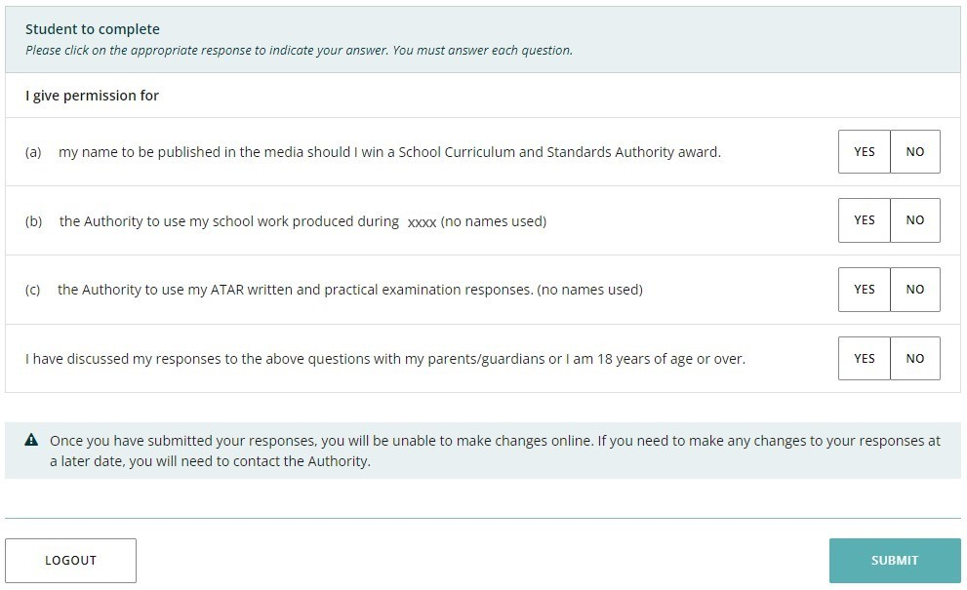

Returning to the student portal
The next time you log in to the student portal, you will only need to enter your WA student number and your new password in the login panel.


Step 2: Start your EAL/D eligibility declaration
Select EAL/D declaration from the Applications drop-down list in the green horizontal navigation bar (highlighted below). This will take you to the first screen of the EAL/D eligibility declaration.
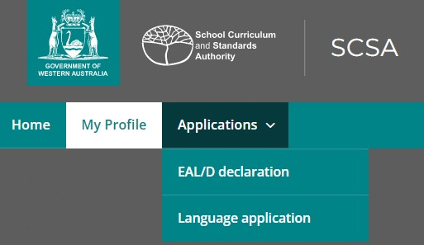

Your details
The personal details you will see cannot be changed, as they have been provided by your school to the Authority. If there are any errors, you must contact your school.
The deadline is for Year 12 students only and does not apply to students in Years 10 and 11.
Click on the Start EAL/D declaration button (highlighted below).
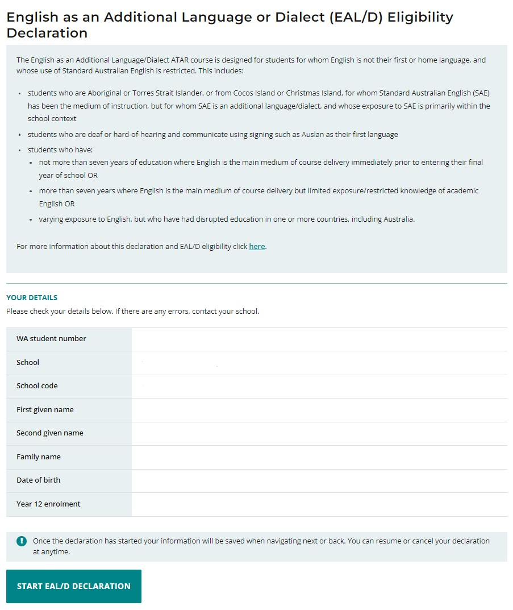

1: EAL/D declaration type
Choose your EAL/D teacher’s name from the drop-down list (highlighted below). If you do not see your teacher’s name, select My teacher is not listed here.
Select your first language and home language from the drop-down list of languages. As you start typing, a predictive list of languages will appear as a drop-down list. Select the correct language for your answer. If your language does not appear, type it in the field.
There are five EAL/D eligibility criteria, and you must meet one of them to enrol in the Year 12 EAL/D ATAR course. Select one of the five options that describes you (highlighted below). If you are not sure which option to select, ask your teacher to help you.
Tick the check box (highlighted below) to declare that you are a student whose first or home language is not English.
Click on the Next button (highlighted below), which will take you to 2: Supporting information. If you have not entered your first and home language/s and selected one option, you will not be able to proceed.
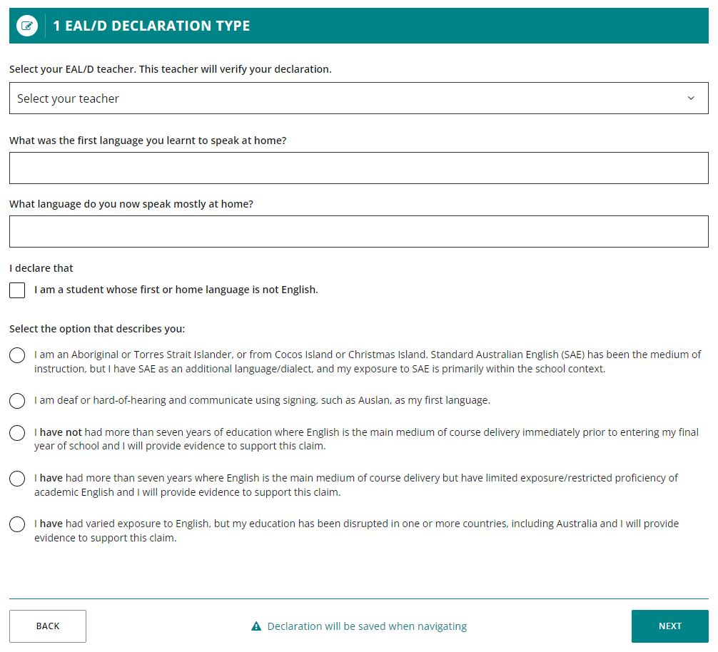

Note: each time you click on the Next or Back buttons, your declaration will be saved automatically.
You can stop at any time and start again by clicking on the Resume EAL/D declaration button (highlighted below).
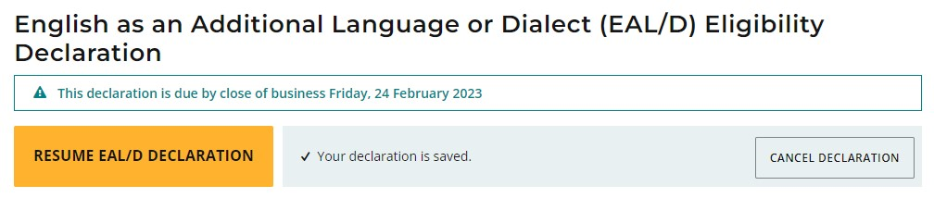
If choose English as your first and/or home language, you will be asked if you are sure that this information is correct.
Click on the Close button to close this warning.
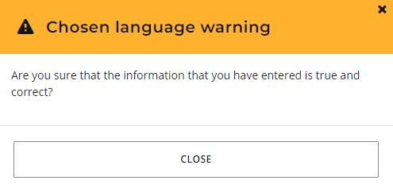
If you have entered English as your first and/or home language, you will see the warning below, advising you that you are not eligible to enrol in the EAL/D ATAR course.
You will not be able to continue with your declaration. Speak to your school about your English course options.
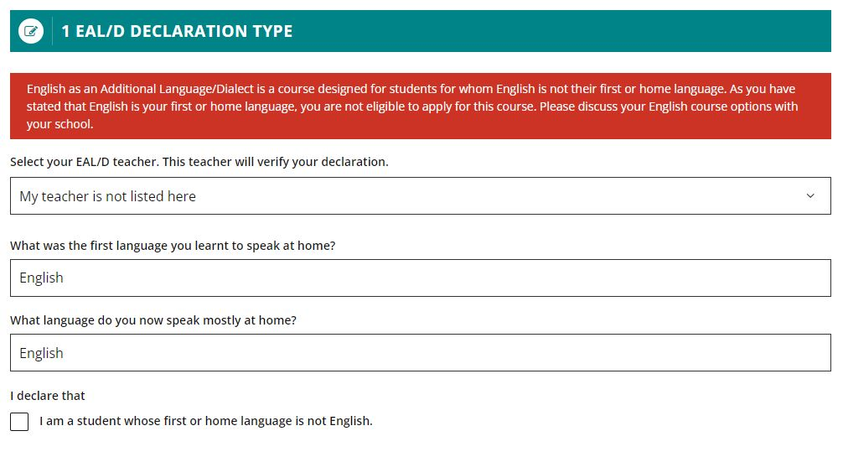

2: Supporting information
Enter your country of birth, the country of birth of your parent/s or carer/s, the language/s each parent/carer uses with you, all the countries you have lived in, and the language/s other than English you can speak confidently.
The supporting information helps your teacher and principal understand about your language background and ensures that you have selected the correct eligibility option. There is no ‘better’ or ‘preferred’ language, so make sure you answer truthfully and include all the language/s you speak/know. For each question, predictive text will help you fill in the country name/s and language/s spoken. If your language does not appear, you can type it in the field.
Click on Add another (highlighted below) to add another country or language spoken, if needed.
Click on the Next button (highlighted below), which will take you to 3: Educational background.
If you have not completed all the required information on this page, you will not be able to proceed.
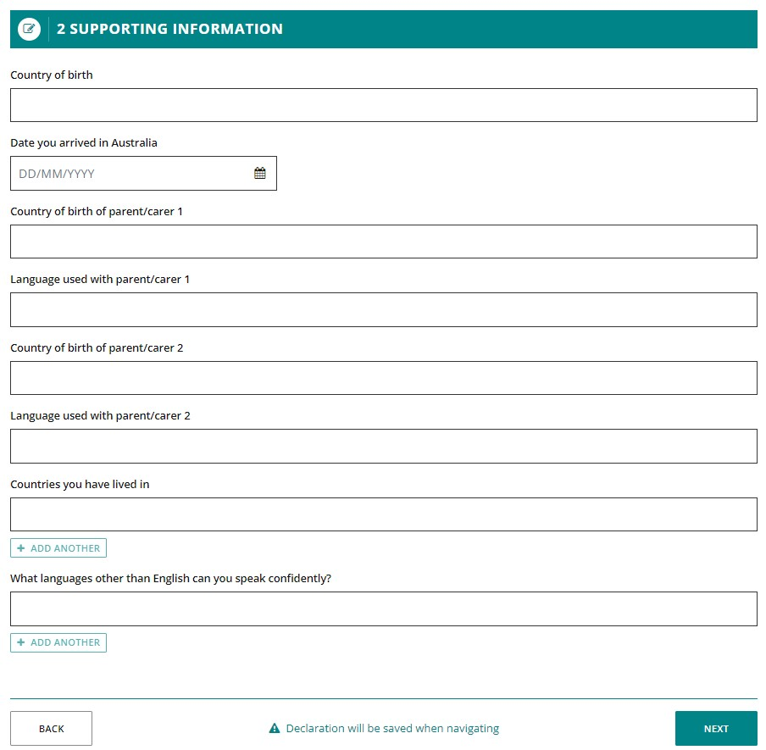

3: Educational background
You must provide details for every year of school you have attended.
Click on the Add button (highlighted below) next to a calendar year.
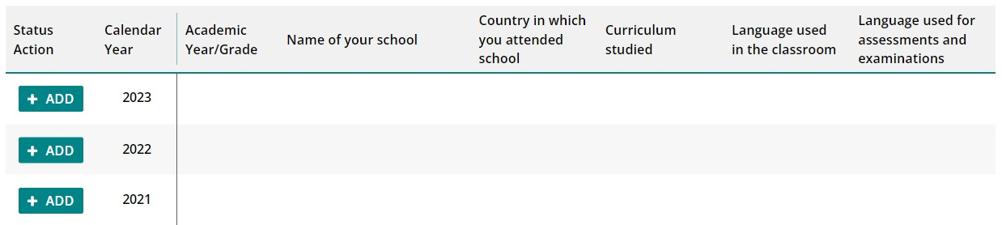
A school details box will appear. Did you go to school in that calendar year? Select Yes or No.
If you select Yes, you must enter information in all the fields. Click on the Add another function (highlighted below) to add another language/s, if needed.
Click on the Add button (highlighted below) to save these school details for that year.
Repeat the process until you have provided information for all the calendar years on the screen.
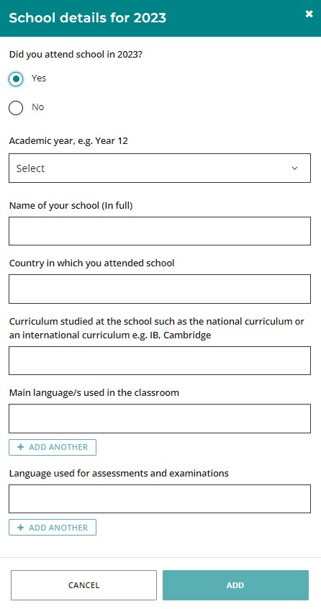
If you did not go to school in a calendar year, select No and click on the Add button (highlighted below). This will show as No schooling (highlighted below) for that year.
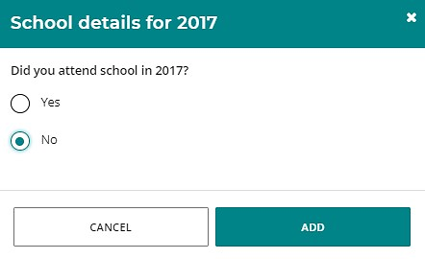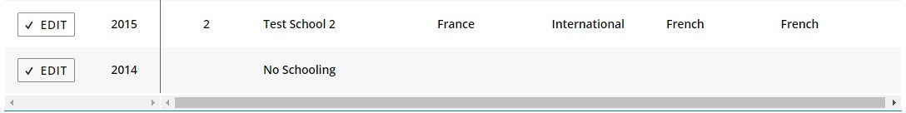
If your school was in a country where the school year ends in June or July (e.g. the UK or the USA), enter the academic year that you finished in that calendar year. For example, if you were in Year 9 from January to June or July, then in Year 10 from September to December, enter Year 9 because that was the academic year that you completed.
If you went to different schools in a calendar year, enter the school you went to in the first six months of that calendar year.
If you attended schooling prior to the earliest year listed on the table, please enter the details into the Additional information text box. You may also optionally add any further details about the schools you attended in this field.
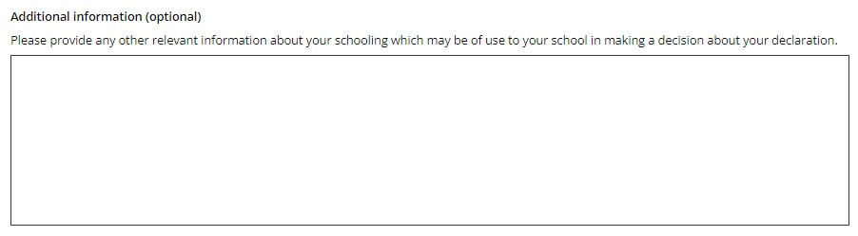
Check all the information you have entered. If you want to change anything, click on the Edit button (highlighted below) next to a calendar year.
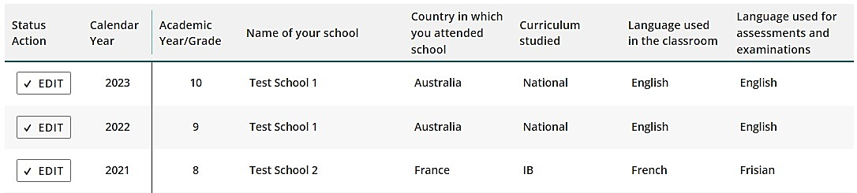
Edit the details then click on the Update button (highlighted below) to save your information.
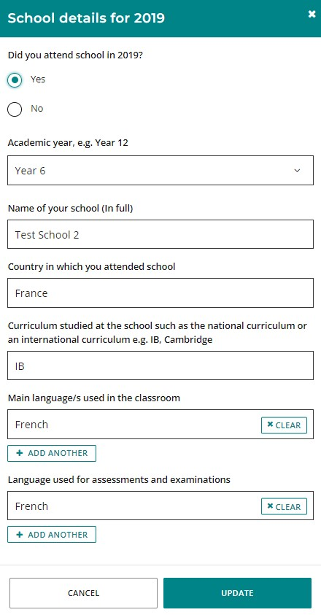
If you plan to enrol in a language course, you must provide the language and type of course (i.e. First, Background or Second Language).
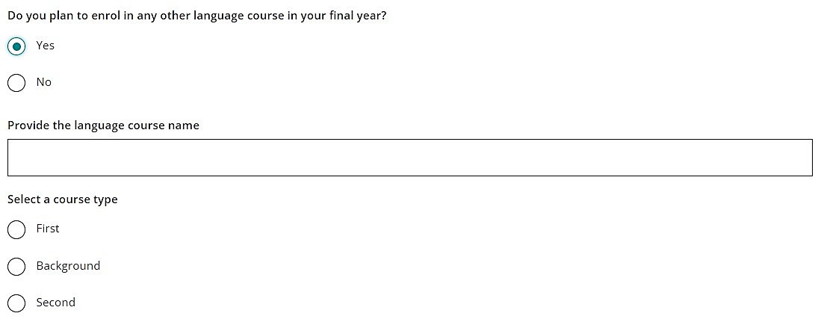
Click on the Next button (highlighted below) to take you to 4: Supporting evidence. If you do not complete all sections, you will not be able to proceed.


Step 3: Upload your supporting evidence

4: Supporting evidence
The evidence you upload helps your EAL/D teacher and principal verify that you meet the requirements for eligibility.
Acceptable evidence includes:
- an authentic letter from a previous school, principal or teacher
- a school report, which may be:
  - from your current school
  - from a previous school in Australia or outside Australia
  - in English or in a language other than English (translation is not necessary).
You must provide at least one piece of evidence to support your declaration.
Here are some examples of appropriate evidence for each option.
Option 1
I am an Aboriginal or Torres Strait Islander, or from Cocos Island or Christmas Island. Standard Australian English (SAE) has been the medium of instruction, but I have SAE as an additional language/dialect, and my exposure to SAE is primarily within the school context.
- A school report from your current school, or from a previous school.
- A student ID card.
Option 2
I am deaf or hard of hearing and communicate using signing, such as Auslan, as my first language.
- A school report from your current school, or from a previous school.
- A student ID card.
Option 3
I have not had more than seven years of education where English is the main medium of course delivery immediately prior to entering my final year of school.
- A school report from a school you attended where English was not the main medium of course delivery (e.g. a school report in a language other than English).
- A letter from a school you attended where English was not the main medium of course delivery (e.g. a letter from the principal/administration stating what language is used in the classroom/for assessments).
- Travel documentation where neither of the above can be obtained.
Option 4
I have had more than seven years where English is the main medium of course delivery but have limited exposure/restricted proficiency of academic English.
- A school report from your current school.
- Previous school reports from any year of schooling.
- A school report from a school you attended that shows you studied a national curriculum (i.e. not an international curriculum, such as International Baccalaureate, Cambridge etc.)
- Travel documentation where none of the above can be obtained.
Option 5
I have had varied exposure to English, but my education has been disrupted in one or more countries, including Australia.
- A school report from your current school or a previous school report from any year of schooling.
- Travel documents/evidence of significant disruptions to schooling.
- Other relevant documentation, e.g. a letter from your current English and/or EAL/D teacher.
If you are unsure about what evidence you need, speak to your teacher.

How to prepare and upload your supporting evidence
Photograph or scan your supporting evidence and save the file/s to your computer or mobile device. Save your file/s as .pdf, .jpg, .jpeg or .png files, with a maximum size of 4MB for each file. Word documents will not be accepted.
Use English letters to name your files. Do not use spaces or unrecognisable characters or symbols, such as < > ? ! / \ " * : , # % & ( ) { } + = @ when naming files.
Select the document you want to upload from the drop-down list (highlighted below).
Click on the Browse button (highlighted below) to select the file from your computer or mobile device and click on the Open button (Upload button on a Mac) to upload this file.
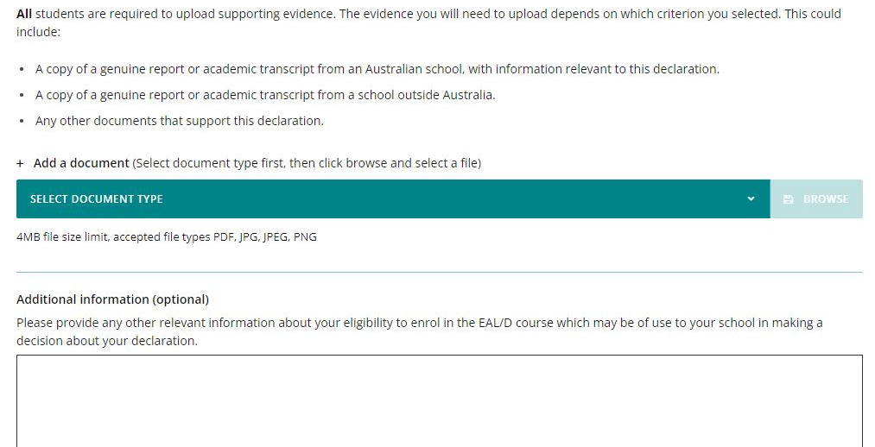
Repeat the process above to add another document.
If you have any additional evidence, select Other supporting evidence from the drop-down list and upload your file.
If you have not uploaded at least one piece of evidence, you will not be able to proceed.
When you have uploaded each document, it will show as Saved in the Status column and Original in the Process step column (both highlighted below), with details of when you uploaded it in the Date uploaded column.
If you upload a file by mistake, click on the Remove button (highlighted below) to remove that file.
Repeat the process to upload the correct document.
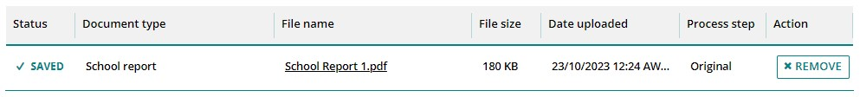
If you want to add any further details, enter this information in the Additional information text box. This is optional.
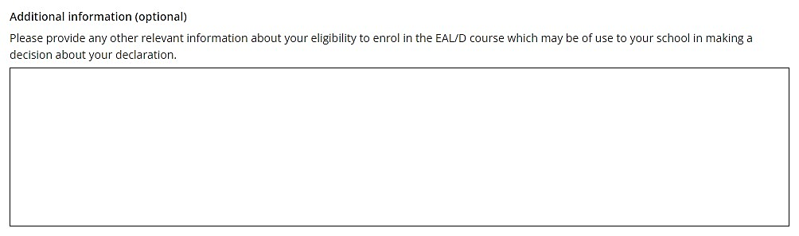
When you have uploaded your supporting evidence, click on the Next button (highlighted below) to take you to Step 4: Submit your EAL/D eligibility declaration.


Step 4: Submit your EAL/D eligibility declaration
Check that everything is correct in your declaration. Click on the Back button (highlighted below) to make any changes.
If you make any mistakes in your declaration or forget to add information, your EAL/D teacher can ask you to amend it and/or upload more supporting evidence.
Read the student declaration and tick the check box (highlighted below) to confirm that you have provided the supporting evidence and that, to the best of your knowledge, all the information you have provided is true and correct.
Click on the Submit declaration button (highlighted below).
When you have submitted your EAL/D eligibility declaration, your EAL/D teacher and your school principal will review and endorse it.
After you have submitted your declaration, you can click on the View or Print buttons to read or print your declaration.
If you decide to cancel your declaration, click on the Cancel declaration button (highlighted below). You can only do this before you submit your declaration.
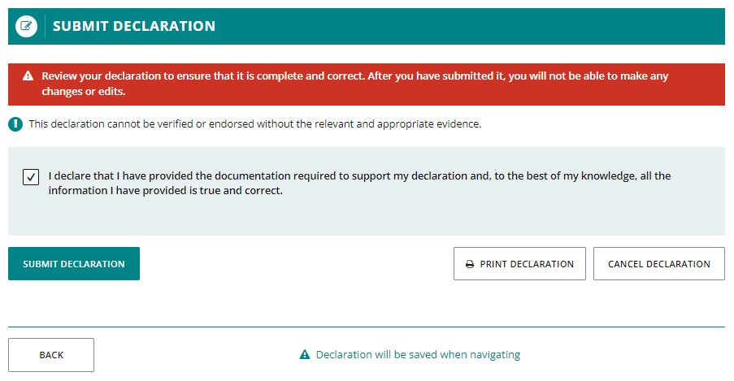

Amend your EAL/D eligibility declaration
Your teacher will review your EAL/D eligibility declaration and supporting evidence. If there are any mistakes or if your school wants further information, your EAL/D teacher will request an amendment or additional evidence from you.
Log in to the student portal where you will see the amendment request from your EAL/D teacher (highlighted below).
Click on the Amend EAL/D declaration button (highlighted below) to amend your declaration.
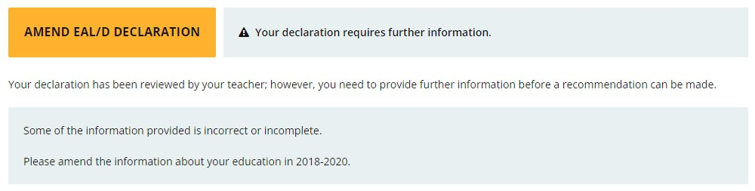
Click on the Next button to move through the declaration.
You will only be able to change the information requested by your EAL/D teacher, which will be highlighted in yellow (example below).
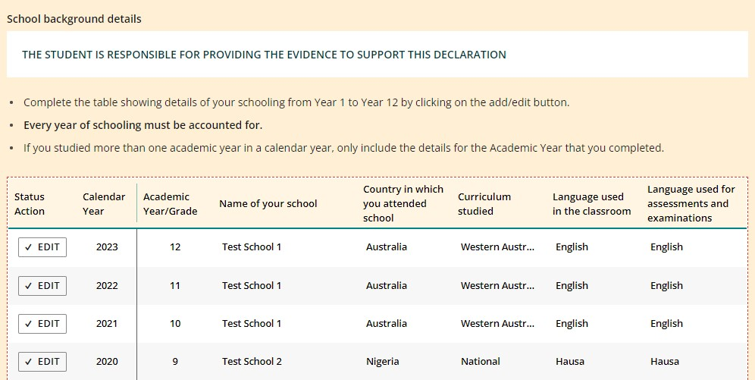
When you have amended your declaration, you will need to repeat Step 4: Submit your EAL/D eligibility declaration so your EAL/D teacher can review and endorse it.


Step 5: Check the student portal for your EAL/D eligibility status
Select EAL/D declaration from the Applications drop-down list in the green horizontal navigation bar (highlighted below).
The status of your declaration will change from In progress to either Eligible or Not eligible (all highlighted below).
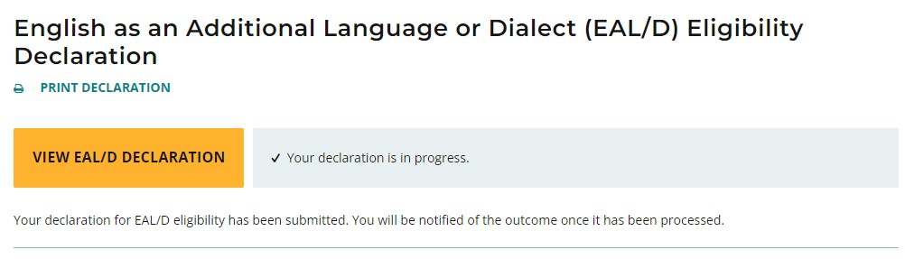
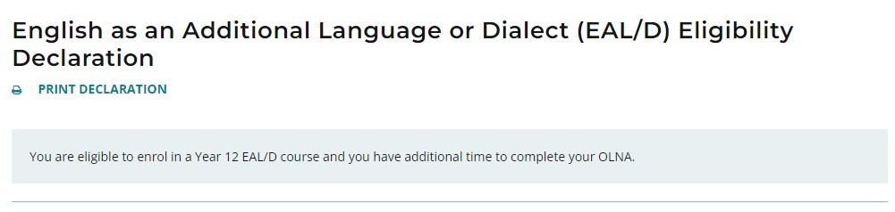
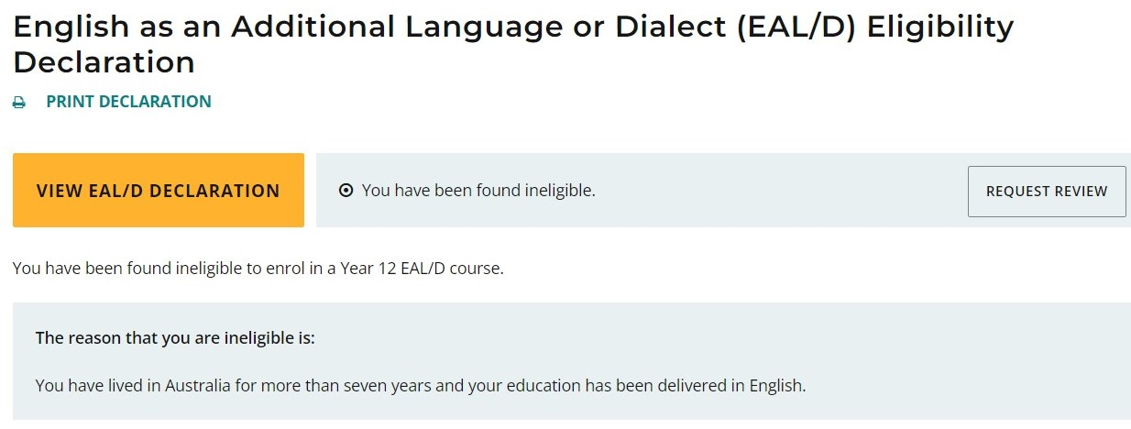
You can contact your school for further information about this decision.

Request a review
If your principal decides that you are Ineligible to enrol in the Year 12 EAL/D ATAR course, this will be shown in the student portal (highlighted below).
If you think that you do meet one of the eligibility criteria, you can request a review of your EAL/D eligibility declaration by the Authority.
You must do this before the due date, which is shown on the EAL/D screen in the student portal. The review due date is also published in the Activities Schedule.
Note: you can only request one review.
To request a review, click on the Request review button (highlighted below).
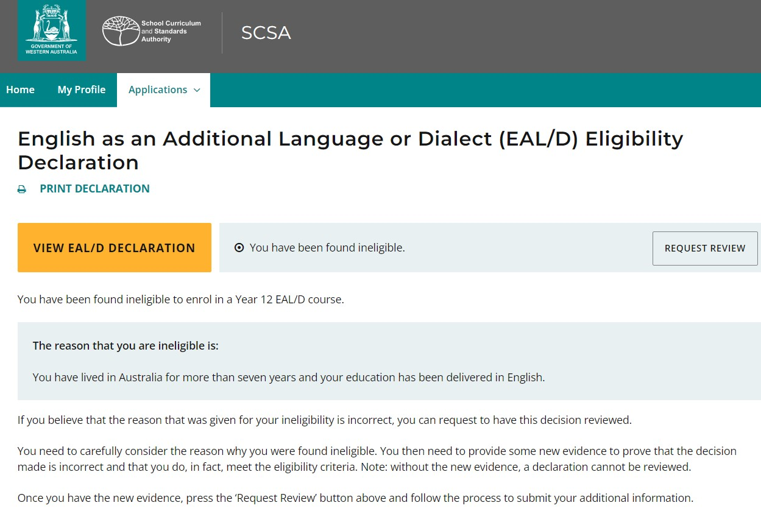
You will be prompted to confirm your email address because the outcome of your review will be sent to the email address that you have registered in the student portal.
Click on the Close button (highlighted below) if your email address is correct.
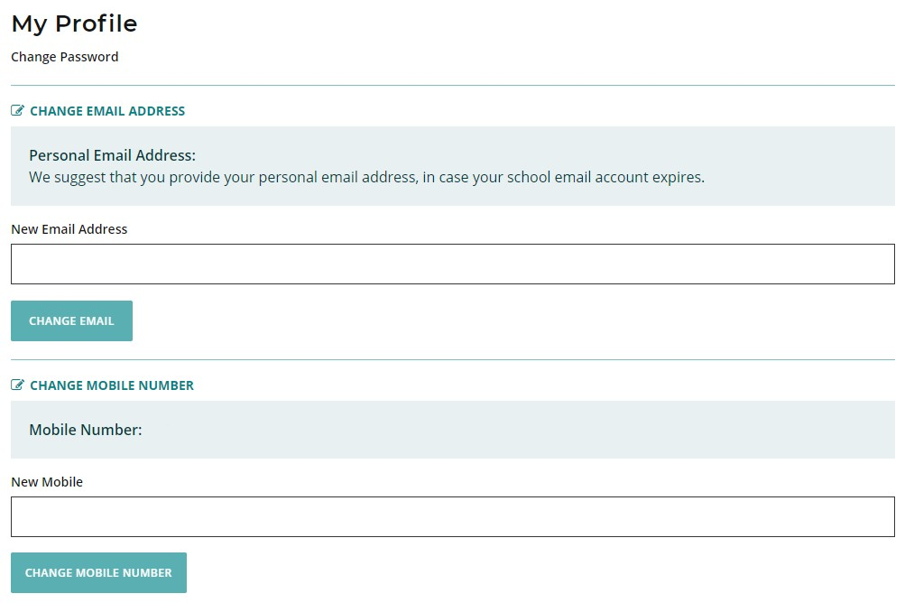
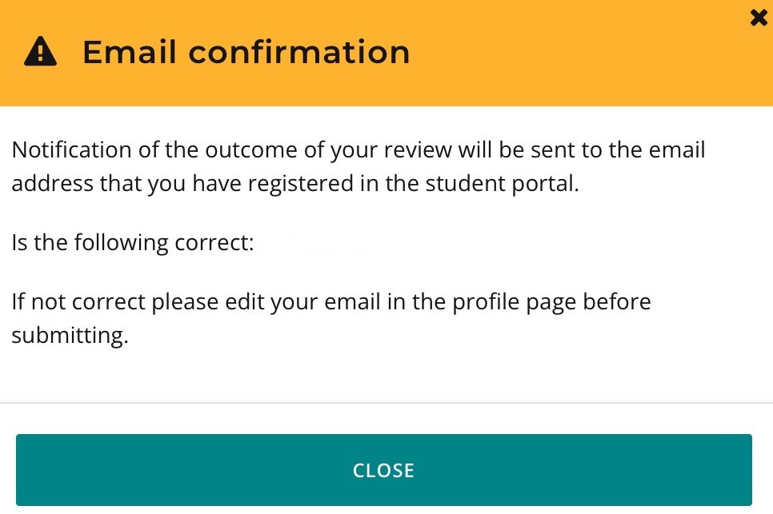
To change your email address, select the My profile tab (highlighted above), enter your new email address then click on the Change email button (highlighted below).
To show that you meet the criteria, you will need to provide additional supporting evidence and further details to support your request for a review.
Repeat Step 3 to upload your additional supporting evidence.
This supporting evidence will show as Saved in the Status column and Review in the Process step column (both highlighted below).
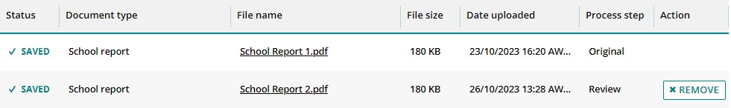
You must also provide further information in the Comments text box.
Carefully check your document/s and information that you provide because after you request a review you cannot upload other documents or make any changes.
Click on the Request review button (highlighted below). If you have not uploaded at least one additional document and provided a comment, the request for a review cannot be submitted.
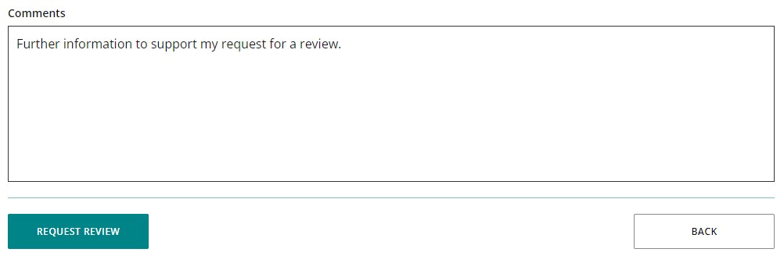
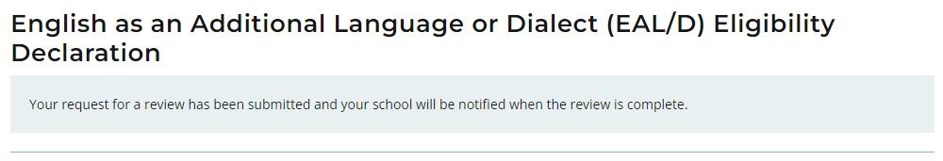
The Authority will review your declaration with the additional supporting evidence and information you have provided.
After the review has been completed, the Authority will notify your school by email. You can also see the outcome of the review in the student portal.
The review eligibility status will be either Eligible or Ineligible and you will see a comment explaining the decision.



