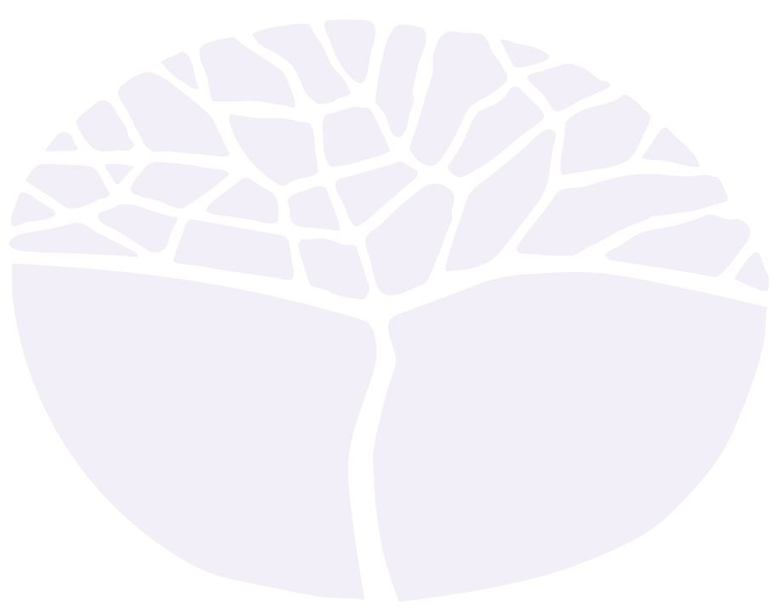
Aboriginal Languages of Western Australia
General course – Wajarri

Externally set task
Sample 2016

Note: This Externally set task sample is based on the following content from Unit 3 of the General Year 12 syllabus.
Learning context
- Relationships and responsibilities between people and country, including oral language practices and technology

Content
Language knowledge and use
- Features of language
- Varieties of texts

Cultural understandings
- Country and community
- roles, relationships and responsibilities of family and kin in own and other families
- seasonal activities and technology (past and present)
- Language and the environment
- seasonal activities
In future years, this information will be provided late in Term 3 of the year prior to the conduct of the
Externally set task. This will enable teachers to tailor their teaching and learning program to ensure that the content is delivered prior to the students undertaking the task in Term 2 of Year 12.

Copyright
© School Curriculum and Standards Authority, 2014
This document – apart from any third party copyright material contained in it – may be freely copied, or communicated on an intranet, for non-commercial purposes in educational institutions, provided that the School Curriculum and Standards Authority is acknowledged as the copyright owner, and that the Authority’s moral rights are not infringed.
Copying or communication for any other purpose can be done only within the terms of the Copyright Act 1968 or with prior written permission of the School Curriculum and Standards Authority. Copying or communication of any third party copyright material can be done only within the terms of the Copyright Act 1968 or with permission of the copyright owners.
Any content in this document that has been derived from the Australian Curriculum may be used under the terms of the Creative Commons Attribution-NonCommercial 3.0 Australia licence
Disclaimer
Any resources such as texts, websites and so on that may be referred to in this document are provided as examples of resources that teachers can use to support their learning programs. Their inclusion does not imply that they are mandatory or that they are the only resources relevant to the course.

Aboriginal Languages of Western Australia: Wajarri

Externally set task
Working time for the task: 60 minutes
Total marks: 35 marks
Weighting: 15% of the school mark

Part 1: Viewing, reading and responding
Read the Wajarri text below and answer all five (5) questions that follow, in English, relating your answers to the text.
(10 marks)
Thumbuny (Santalum spicatum)
Barndi bigawu, mara bigawu, jina bigawu, yalibirrilu duthu bilhburr yaarguna.
Nganajungulu gantharrilu bawunmarda barnaguwi. Balu garndalymanmarda yabuguwi,
yirrgalyingurany wirrimanmarda. Gargarrigu thunagulu yalibirri bilarriri, ilyurumalgu.
Gargarrigu bigagi. Nganajungu Thumbuny ngardi barndi bigawu, barndimangu bigawu.
Barndi wirnda nganajungu Thumbuny. Yalibirri warany.
From: Dann, D. (2003). Waranygu bayalgu
- Name three (3) things sandalwood was used for. (3 marks)
________________________________________________________________________________
________________________________________________________________________________
________________________________________________________________________________
________________________________________________________________________________
- How were the dogs injured by the emus? (1 mark)
________________________________________________________________________________
________________________________________________________________________________

- List the three (3) steps necessary to make the ointment. (3 marks)
________________________________________________________________________________
________________________________________________________________________________
________________________________________________________________________________
________________________________________________________________________________
________________________________________________________________________________
- What was sandalwood made into? (1 mark)
________________________________________________________________________________
- What did the emus look for? (2 marks)
________________________________________________________________________________
________________________________________________________________________________
________________________________________________________________________________
________________________________________________________________________________

Part 2: Writing (15 marks)
6(a) Describe, in Wajarri, features of the local seasons and traditional seasonal activities of your community, based on the availability of flora and fauna.
(b) Consider the impact of new technologies and provide some examples to illustrate how technology may have affected these seasonal activities.
________________________________________________________________________________
________________________________________________________________________________
________________________________________________________________________________
________________________________________________________________________________
________________________________________________________________________________
________________________________________________________________________________
________________________________________________________________________________
________________________________________________________________________________
________________________________________________________________________________
________________________________________________________________________________
________________________________________________________________________________
________________________________________________________________________________
________________________________________________________________________________
________________________________________________________________________________
________________________________________________________________________________
________________________________________________________________________________
________________________________________________________________________________
________________________________________________________________________________
________________________________________________________________________________
________________________________________________________________________________
________________________________________________________________________________
________________________________________________________________________________
Acknowledgement
Part 1 text Dann, D. (2003). Waranygu bayalgu. Geraldton, WA: Yamaji Language Centre, p. 44
Courtesy Yamaji Language Centre, 22 Sanford Street, Geraldton WA 6530

