Sample Assessment Tasks

Mathematics

Preliminary – all units

Acknowledgement of Country
Kaya. The School Curriculum and Standards Authority (the Authority) acknowledges that our offices are on Whadjuk Noongar boodjar and that we deliver our services on the country of many traditional custodians and language groups throughout Western Australia. The Authority acknowledges the traditional custodians throughout Western Australia and their continuing connection to land, waters and community. We offer our respect to Elders past and present.
Copyright
© School Curriculum and Standards Authority, 2023
This document – apart from any third-party copyright material contained in it – may be freely copied, or communicated on an intranet, for non-commercial purposes in educational institutions, provided that the School Curriculum and Standards Authority is acknowledged as the copyright owner, and that the Authority’s moral rights are not infringed.
Copying or communication for any other purpose can be done only within the terms of the Copyright Act 1968 or with prior written permission of the School Curriculum and Standards Authority. Copying or communication of any third-party copyright material can be done only within the terms of the Copyright Act 1968 or with permission of the copyright owners.
Any content in this document that has been derived from the Australian Curriculum may be used under the terms of the Creative Commons Attribution 4.0 International licence.
Disclaimer
Any resources such as texts, websites and so on that may be referred to in this document are provided as examples of resources that teachers can use to support their learning programs. Their inclusion does not imply that they are mandatory or that they are the only resources relevant to the course.

Sample assessment task

Mathematics – Preliminary

Task 1 – Unit 1

Conditions
Suggested time for completion: 1 week
__________________________________________________________________________________

Task 1: My lunch order – Buying items from the school canteen
Teacher instructions
Engage students in the context of the task by discussing the following situation.
There is a new canteen at school and your parents/carers give you $10 of pocket money to buy lunch once a week. You are excited about trying the new food. Look at the menu below and imagine what you would like to try.
Provide students with brown bags to write lunch orders on (these will be required in the ‘Your turn’ part of this task).
Canteen menu
Salad sandwich $5.00
Sushi tray $6.00
Ham sandwich $4.00
Sausage roll $3.00
Biscuits $1.00
Fruit $1.00
Juice $1.00
Water $1.00
Provide students with an image of a sushi tray and one of a plate of biscuits. The items depicted in each image should be arranged to enable students to subitise when determining the quantity of food items in each image. Below are suggestions.
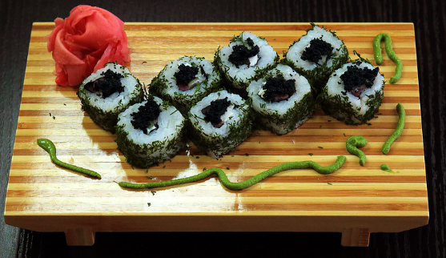  [sushi tray [image]. Retrieved May, 2023 from https://openverse.org/image/12a09ae8-3ea1-4564-b343-3f0a11891db6?q=sushi | 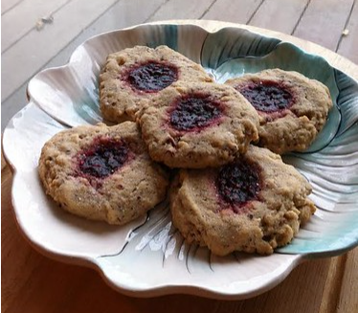  [Biscuits [Image]. Retrieved May, 2023 from https://openverse.org/image/d7f79677-f275-427d-a0b0-7c210128326d?q=cookies

Class discussion
- How many sushi rolls are on a tray? Explain two different strategies to find the answer.
- How many biscuits are on the plate? Explain two different strategies to find the answer.
- Which food has the most items, the biscuits, or the sushi?
- Is it possible to buy one ham sandwich and one salad sandwich with $10? Why or why not?
- How many biscuits can you buy with $5?
- How many sausage rolls can you buy with $10? Will there be any change? How much?
Your turn
- Read the canteen menu and choose items for your school lunch.
- Work out the total cost of your order and state if $10 is enough to purchase your chosen items.
- Make any changes you need to your chosen items.
- Write/draw your final lunch order on the lunch bag you have been given.
- Optional: choose another other combination of items. Work out if your $10 pocket money is enough to buy them.

Task 1 – Completion checklist
Teachers may use the table below to record their collection of evidence (including oral responses) by recording the date in which the behaviours were observed. Additional comments about student performance in the task may be added when relevant.
Unit outcomes
- read, write, say, subitise and count whole numbers up to ten, and compare sets of different size, and describe order
- use addition or subtraction to quantify up to ten objects in simple situations
- apply subitising, counting, addition and subtraction skills to money as whole numbers up to ten

Behaviours observed | Date evidence collected | Optional additional comments
Explains one or two ways of determining a small quantity (e.g. subitising, counting)
Identifies the largest set of food items shown in the pictures (sushi or biscuits)
Uses menu provided to identify cost of items, chooses items and calculates the total cost
States if the total cost of the selected items is equal or less than $10

Overall judgement  (circle the relevant statement) | The student has engaged with the task | The student has not engaged with the task

Sample assessment task – Unit 2

Mathematics – Preliminary

Task 2 – Unit 2

Conditions
Period allowed for completion of the task: 1 week
__________________________________________________________________________________

Task 2: My timetable project

Teacher instructions
Engage students by using images/videos to show activities they usually complete during the day (e.g. morning tea, putting things away, Mathematics lesson). Invite students to connect each image to a time duration, e.g. morning tea takes about half an hour while putting something in their bags takes one minute.
Group discussion
- Give each student five strips of paper. Ask each student to write or draw one different thing they do during the day on each paper strip. Ask students to order the paper strips to reflect the sequence of events during the day. Invite students use time-related words to talk about their days with a teacher or peer.
- Play a video of an audible crosswalk signal and invite students to estimate how long the crossing sound plays for. Discuss strategies to keep track of seconds and give students a second opportunity to estimate. Students record their estimates, with support if needed.
Play the video a third time and use a stopwatch to quantify the duration of the sound. Share this information with students in seconds. Ask students to compare the correct duration with their estimations and determine if their estimation was correct, under, or over.
- Discuss the duration of the sound in relation to one minute (e.g. 70 seconds is a slightly more than one minute, 30 seconds is half of a minute). Encourage students to participate in the discussion using language of time.
Individual work
Place clocks without batteries next to images of daily activities, sequenced correctly. For example:
Clock displaying 10am | Start of Mathematics lesson
Clock displaying 10.30am | Start of morning tea
Clock displaying 11am | Start of English lesson
Clock displaying 12pm | Start of lunch
Ask students to determine what time each of those activities usually start by telling the time on the clocks.

Task 2 – Completion checklist
Unit outcomes
quantify time in using the standard units (including seconds, minutes, hours, days) and use them appropriately in daily contexts

Behaviours observed | Date evidence collected | Optional additional comments
Correctly connects activities with approximate durations
Sequences events using paper strips
Estimates duration of an event in seconds, compares it with measured duration
Uses time language to talk about sequences and duration of events in seconds and minutes
Tells time to half an hour

Overall judgement  (circle relevant statement) | The student has engaged with the task | The student has not engaged with the task

Sample assessment task

Mathematics – Preliminary

Task 3 – Unit 3

Conditions
Period suggested for completion of the task: 2 weeks
__________________________________________________________________________________

Task 3: Fun day out
Your class of ten students is going on an excursion to an entertainment park called Adventurer World.
The park provides the attached pamphlet to help visitors plan the cost of the day, by looking at the choices of travel, food, drinks and any activities they would like to take part in.
You must plan a day that will cost up to $50 per student.
Section 1: Group work
In pairs or small groups, look at the pamphlet and choose options for transport, food, and activities for the whole class to enjoy.
- Calculate the total cost of transporting the whole class to Adventurer World
- Calculate the total cost per student to participate in the excursion.
- Calculate the total amount that will be spent in souvenirs.
- Calculate how much money each student will have left over.
Section 2: Individual work
Based on the budget you calculated, the school decided that the next excursion to Adventurer World must cost $4 less than what you planned in your pair/group. You may need to cut out souvenirs from your plans to bring costs down.
Use the pamphlet and your new budget to create a new plan for the day.
- Were you able to include a souvenir in your plan? Explain why or why not.
- You have been asked to place the money for transport in an envelope. How much money do you need to put in the envelope to pay for the whole class?
- Will there be any money left over for each student? If so, how much?

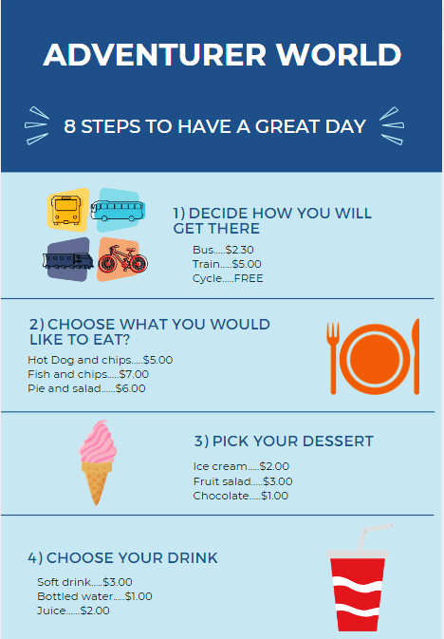

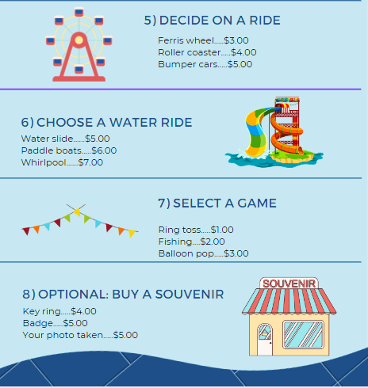

Pamphlet – alternative format
Adventurer World
8 steps to have a great day
- Decide how you will get there
Bus $2.30
Train $5.00
Cycle FREE
- Choose what you would like to eat
Hot dog and chips $5.00
Fish and chips $7.00
Pie and salad $6.00
- Pick your dessert
Ice cream $2.00
Fruit salad $3.00
Chocolate $1.00
- Choose your drink
Soft drink $3.00
Bottled water $1.00
Juice $2.00
- Decide on a ride
Ferris wheel $3.00
Roller coaster $4.00
Bumper cars $5.00
- Choose a water ride
Water slide $5.00
Paddle boats $6.00
Whirlpool $ 7.00
- Select a game
Ring toss $1.00
Fishing $2.00
Balloon pop $ 3.00
- Optional: buy a souvenir
Key ring $4.00
Badge $5.00
Your photo taken $5.00

Task 3 – Completion checklist
Unit outcomes
- use multiplication and division skills effectively and recognise when answers are appropriate
- apply multiplication and division skills to money as whole numbers up to $50
- choose the correct arithmetic operations on a calculator when completing a money calculation
Note: this task focuses on multiplication. Other tasks will provide opportunities for students to demonstrate completion in division related outcomes.
Behaviours observed | Date evidence collected | Optional additional comments
Plans outing based on determined budget
Multiplies the cost of a specific item by 10 to determine the total cost of that item for the whole class
Adds all items of the itinerary to determine the total cost per student
Uses subtraction to calculate how much money each student will have leftover
Uses subtraction to determine next year’s budget (Section 2)

Overall judgement  (circle the relevant statement) | The student has engaged with the task | The student has not engaged with the task

Sample assessment task

Mathematics – Preliminary

Task 4 – Unit 4

Conditions
Period allowed for completion of the task: 2 weeks
__________________________________________________________________________________

Task 4: Planning your School Sports Day
Teachers are encouraged to adapt the context of this task to suit a school event that is more familiar to the students.
You have been asked to decide on the music genre to be played during intervals at your school Sports Day. Your decision must reflect the preferences of your class. The event organiser also wants to know if they can use the playlist from last year’s event or if they need to create a new one.
Group work
- Last year, the whole school was interviewed. Look at last year’s data and identify which music genre was most and least voted.
Pop | Rock | Country | Hip Hop
- Which music genre received the most votes?
- Which music genre received the least votes?
- What was the difference between them?
- Label four jars or boxes with the four music genres above, with support, if needed. Ask your peers to vote on their preferred music genre by placing a block (cube) in the corresponding jar.
- Once voting has been completed, organise the blocks in lines (columns) so each column represents one music genre.
- Place the labels from each jar under each column to identify what they represent.
- Write the total amount of votes for each genre at the top of each column.
- Determine which genre received the most votes.
- Compare the results.
Can the event organisers use last year’s play list? Explain your answer.
Individual Work
You have now been asked to interview your classmates to determine which type of food they would prefer to have on the day.
- Collect data by asking your peers to write their favourite lunch choice on a self-adhesive note.
- Sort the data collected by placing the self-adhesive notes under categories (examples are provided below should be adapted by teachers to suit the class data, other examples may be hot food, pastries, raw food etc.)
- Determine which type of food was the most voted by your classmates.
Vegetarian food | Foods containing meat | Sweet foods
What would be the best food to have available at the sport day? Explain your answer.

Task 4 – Completion checklist
Unit outcomes
- collect data about familiar everyday events and display this in graphs
- interpret simple graphs related to familiar everyday events

Behaviours observed | Date evidence collected | Optional additional comments
Reads simple column graphs
Identifies most and least voted
Collects simple data about familiar contexts
Creates a simple graph using one-to-one correspondence
Compares data from last year and this year’s votes
Sorts and classify simple data under category headings
Identifies which category had most votes

Overall judgement  (circle the relevant statement) | The student has engaged with the task | The student has not engaged with the task

Acknowledgements
Sample assessment task – Unit 1
Clker-Free-Vector-Images. (2014). [Clipart of a brown paper bag]. Retrieved July, 2023, from https://pixabay.com/vectors/paperbag-paper-bag-bag-package-296511/
Samoilov, Y. (2013). Sushi Set [Photograph]. Retrieved July, 2023, from https://www.flickr.com/photos/103414654@N05/10590577674
Used under Creative Commons Attribution 2.0 Generic licence.
thebittenword.com. (2014). Raspberry-Hazelnut Thumbprint Cookies Laura Joyce [Photograph]. Retrieved July, 2023, from https://www.flickr.com/photos/22198928@N00/15854761948
Used under Creative Commons Attribution 2.0 Generic licence.
Adventurer World pamphlet
Ramos, G. (n.d.). Public Transport Vehicles Icons [Graphic]. Retrieved July, 2023, from https://www.canva.com/icons/MADWEj6dV_I/
iconsy. (n.d.). Dish Fork and Knife Restaurant Travel [Graphic]. Retrieved July, 2023, from https://www.canva.com/icons/MADrPLICCr4/
Ramos, G. (n.d.). Strawberry Soft Serve [Graphic]. Retrieved July, 2023, from https://www.canva.com/icons/MAEBQmTZAgI/
gstudioimagen. (n.d.). Soda Drink [Graphic]. Retrieved July, 2023, from https://www.canva.com/icons/MAB_5b4eo90/
sketchifyedu. (n.d.). Blocky Flat Buildable Theme Park Ferris Wheel [Graphic]. Retrieved July, from https://www.canva.com/icons/MAE6c72cqxE/
blueringmedia. (n.d.). Water Slide on Island [Graphic]. Retrieved July, 2023, from https://www.canva.com/photos/MAEbsyAeQDA/
anatolir. (n.d.). Carnival Colorful Flags Icon, Flat Style [Graphic]. Retrieved July, 2023, from https://www.canva.com/icons/MAD3VjF18_I/
sketchify. (n.d.) Lined Cartoon Souvenir Shop [Graphic]. Retrieved July, 2023, from https://www.canva.com/icons/MAE7qXnhW-E/

