Mathematics Essential

General course

Year 11 syllabus

**Acknowledgement of Country**

Kaya. The School Curriculum and Standards Authority (the Authority) acknowledges that our offices are on Whadjuk Noongar boodjar and that we deliver our services on the country of many traditional custodians and language groups throughout Western Australia. The Authority acknowledges the traditional custodians throughout Western Australia and their continuing connection to land, waters and community. We offer our respect to Elders past and present.

**Important information**

This syllabus is effective from 1 January 2024.

Users of this syllabus are responsible for checking its currency.

Syllabuses are formally reviewed by the School Curriculum and Standards Authority (the Authority) on a cyclical basis, typically every five years.

**Copyright**

© School Curriculum and Standards Authority, 2023

This document – apart from any third-party copyright material contained in it – may be freely copied, or communicated on an intranet, for non-commercial purposes in educational institutions, provided that the School Curriculum and Standards Authority (the Authority) is acknowledged as the copyright owner, and that the Authority’s moral rights are not infringed.

Copying or communication for any other purpose can be done only within the terms of the *Copyright Act 1968* or with prior written permission of the Authority. Copying or communication of any third-party copyright material can be done only within the terms of the *Copyright Act 1968* or with permission of the copyright owners.

Any content in this document that has been derived from the Australian Curriculum may be used under the terms of the [Creative Commons Attribution 4.0 International licence](https://creativecommons.org/licenses/by/4.0/)

**Content**

Overview of Mathematics courses 1

Rationale 2

Aims 3

Organisation 4

Structure of the syllabus 4

Organisation of content 5

Progression from the Year 7–10 curriculum 5

Representation of the general capabilities 6

Representation of the cross-curriculum priorities 7

Unit 1 8

Unit description 8

Learning outcomes 8

Unit content 8

Unit 2 14

Unit description 14

Learning outcomes 14

Unit content 14

School-based assessment 19

Grading 20

Appendix 1 – Grade descriptions Year 11 21

Appendix 2 – Glossary 22

# Overview of Mathematics courses

There are six mathematics courses. Each course is organised into four units, with Unit 1 and Unit 2 being taken in Year 11 and Unit 3 and Unit 4 in year 12. The ATAR course examination for each of the three ATAR courses is based on Unit 3 and Unit 4 only.

The courses are differentiated, each focusing on a pathway that will meet the learning needs of a particular group of senior secondary students.

**Mathematics Preliminary** is a course which focuses on the practical application of knowledge, skills and understandings to a range of environments that will be accessed by students with special education needs. Grades are not assigned for these units. Student achievement is recorded as ‘completed’ or ‘not completed’. This course provides the opportunity for students to prepare for post-school options of employment and further training.

**Mathematics Foundation** is a course which focuses on building the capacity, confidence and disposition to use mathematics to meet the numeracy standard for the Western Australian Certificate of Education (WACE). It provides students with the knowledge, skills and understanding to solve problems across a range of contexts, including personal, community and workplace/employment. This course provides the opportunity for students to prepare for post-school options of employment and further training.

**Mathematics Essential** is a General course which focuses on using mathematics effectively, efficiently and critically to make informed decisions. It provides students with the mathematical knowledge, skills and understanding to solve problems in real contexts for a range of workplace, personal, further learning and community settings. This course provides the opportunity for students to prepare for post-school options of employment and further training.

**Mathematics Applications** is an ATAR course which focuses on the use of mathematics to solve problems in contexts that involve financial modelling, geometric and trigonometric analysis, graphical and network analysis, and growth and decay in sequences. It also provides opportunities for students to develop systematic strategies based on the statistical investigation process for answering statistical questions that involve analysing univariate and bivariate data, including time series data.

**Mathematics Methods** is an ATAR course which focuses on the use of calculus and statistical analysis. The study of calculus provides a basis for understanding rates of change in the physical world, and includes the use of functions, their derivatives and integrals, in modelling physical processes. The study of statistics develops students’ ability to describe and analyse phenomena that involve uncertainty and variation.

**Mathematics Specialist** is an ATAR course which provides opportunities, beyond those presented in the Mathematics Methods ATAR course, to develop rigorous mathematical arguments and proofs, and to use mathematical models more extensively. The Mathematics Specialist ATAR course contains topics in functions and calculus that build on and deepen the ideas presented in the Mathematics Methods ATAR course as well as demonstrate their application in many areas. The Mathematics Specialist ATAR course also extends understanding and knowledge of statistics and introduces the topics of vectors, complex numbers and matrices. The Mathematics Specialist ATAR course is the only ATAR mathematics course that should not be taken as a stand-alone course.

# Rationale

Mathematics is the study of order, relation and pattern. From its origins in counting and measuring, it has evolved in highly sophisticated and elegant ways to become the language used to describe much of the physical world. Statistics is the study of ways of collecting and extracting information from data and of using that information to describe and make predictions about the behaviour of aspects of the real world in the face of uncertainty. Together, mathematics and statistics provide a framework for thinking and a means of communication that is powerful, logical, concise and precise.

The Mathematics Essential General course focuses on enabling students to use mathematics effectively, efficiently and critically to make informed decisions in their daily lives. It provides students with the mathematical knowledge, skills and understanding to solve problems in real contexts for a range of workplace, personal, further learning and community settings. This course offers students the opportunity to prepare for post-school options of employment and further training.

For all content areas of the Mathematics Essential General course, the proficiency strands of understanding, fluency, problem solving and reasoning from the Year 7–10 curriculum continue to be very much applicable and should be inherent in students’ learning of the course. Each of these is essential and mutually reinforcing. For all content areas, practice, together with a focus on understanding, allows students to develop fluency in their skills. Students will encounter opportunities for problem solving, such as finding the interest on a sum of money to enable comparison between different types of loans. In the Mathematics Essential General course, reasoning includes critically interpreting and analysing information represented through graphs, tables and other statistical representations to make informed decisions. The ability to transfer mathematical skills between contexts is a vital part of learning in this course. For example, familiarity with the concept of a rate enables students to solve a wide range of practical problems, such as fuel consumption, travel times, interest payments, taxation, and population growth.

The content of the Mathematics Essential General course is designed to be taught within contexts that are relevant to the needs of the particular student cohort. The skills and understandings developed throughout the course will be further enhanced and reinforced through presentation related to areas encountered in vocational education and training (VET), apprenticeships, traineeships or employment.

# Aims

The Mathematics Essential General course aims to develop students’ capacity, disposition and confidence to:

* understand concepts and techniques drawn from mathematics and statistics
* solve applied problems using concepts and techniques drawn from mathematics and statistics
* use reasoning and interpretive skills in mathematical and statistical contexts
* communicate in a concise and systematic manner using appropriate mathematical and statistical language
* choose and use technology appropriately.

# Organisation

This course is organised into a Year 11 syllabus and a Year 12 syllabus. The cognitive complexity of the syllabus content increases from Year 11 to Year 12.

## Structure of the syllabus

The Year 11 syllabus is divided into two units, each of one semester duration, which are typically delivered as a pair. The notional time for each unit is 55 class contact hours.

**Unit 1**

This unit includes the following four topics:

* Basic calculations, percentages and rates
* Using formulas for practical purposes
* Measurement
* Graphs

**Unit 2**

This unit includes the following four topics:

* Representing and comparing data
* Percentages
* Rates and ratios
* Time and motion

Each unit includes:

* a unit description – a short description of the focus of the unit and suggested contexts through which the content could be taught
* learning outcomes – a set of statements describing the learning expected as a result of studying the unit
* unit content – the content to be taught and learned, including examples in context which emphasise the intent of the course.

Throughout each unit, students apply the mathematical thinking process to real-world problems

* interpret the task and gather the key information
* identify the mathematics which could help to complete the task
* analyse information and data from a variety of sources
* apply existing mathematical knowledge and strategies to obtain a solution
* verify the reasonableness of the solution
* communicate findings in a systematic and concise manner.

In Unit 2, students apply the statistical investigation process to real-world tasks

* clarify the problem and pose one or more questions that can be answered with data
* design and implement a plan to collect or obtain appropriate data
* select and apply appropriate graphical or numerical techniques to analyse the data
* interpret the results of this analysis and relate the interpretation to the original question
* communicate findings in a systematic and concise manner.

## Organisation of content

Unit 1 provides students with the mathematical skills and understanding to solve problems relating to calculations, the use of formulas to find an unknown quantity, applications of measurement and the use and interpretation of graphs. Teachers are advised to apply the content of all topics in contexts which are meaningful and of interest to their students. Possible contexts for this unit are Earning and managing money and Nutrition and health.

Unit 2 provides students with the mathematical skills and understanding to solve problems related to representing and comparing data, percentages, rates and ratios, and time and motion. Teachers are advised to apply the content of all topics in contexts which are meaningful and of interest to the students. Possible contexts for this unit to achieve this goal are Transport and Independent living.

**Role of technology**

It is assumed that students will be taught the Mathematics Essential General course with a range of technological applications and techniques. If appropriately used, these have the potential to enhance the teaching and learning of mathematics. However, students also need to continue to develop skills that do not depend on technology. The ability to be able to choose when, or when not, to use some form of technology and to be able to work flexibly with technology are important skills in this course.

## Progression from the Year 7–10 curriculum

For all content areas of the Mathematics Essential General course, the proficiency strands of Understanding, Fluency, Problem solving and Reasoning from the Year 7–10 curriculum are still very much applicable and should be inherent in students’ learning of the course. Each strand is essential and all are mutually reinforcing. For all content areas, practice allows students to develop fluency in their skills. They will encounter opportunities for problem solving, such as finding the interest on an amount in order to be able to compare different types of loans. In the Mathematics Essential General course, reasoning includes critically interpreting and analysing information represented through graphs, tables and other statistical representations to make informed decisions. The ability to transfer mathematical skills between contexts is a vital part of learning in this course. For example, familiarity with the concept of a rate enables students to solve a wide range of practical problems, such as fuel consumption, travel times, interest payments, taxation, and population growth.

## Representation of the general capabilities

The general capabilities encompass the knowledge, skills, behaviours and dispositions that will assist students to live and work successfully in the twenty-first century. Teachers may find opportunities to incorporate the capabilities into the teaching and learning program for the Mathematics Essential General course. The general capabilities are not assessed unless they are identified within the specified unit content.

**Literacy**

Literacy skills and strategies enable students to express, interpret, and communicate mathematical information, ideas and processes. Mathematics provides a specific and rich context for students to develop their ability to read, write, visualise and talk about situations involving a range of mathematical ideas. Students can apply and further develop their literacy skills and strategies by shifting between verbal, written and spoken, graphic, numerical and symbolic forms of representing problems in order to formulate, understand and solve problems and communicate results. Students learn to communicate their findings in different ways, using multiple systems of representation and data displays to illustrate the relationships they have observed or constructed.

**Numeracy**

The students who undertake this course will continue to develop their numeracy skills. This course contains financial applications of mathematics that will assist students to become literate consumers of investments and loans. It also contains statistics topics that will equip students for the ever-increasing demands of the information age. Students will be well equipped to make informed decisions about events and activities which involve an element of chance.

**Information and communication technology capability**

In the Mathematics Essential General course, students use information and communications technology (ICT) to apply mathematical knowledge to a range of problems. Software may be used for statistical analysis, data representation and manipulation, and calculation. They use digital tools to visualise and manipulate shapes in design.

**Critical and creative thinking**

The Mathematics Essential General course provides students with opportunities to use their mathematical knowledge, skills and understanding to solve problems in real contexts. Solutions to these problems involve drawing on knowledge of the context to decide what and how mathematics will help to reach a conclusion.

**Personal and social capability**

In the Mathematics Essential General course, students develop personal and social competence through setting and monitoring personal and academic goals, taking initiative, building adaptability, communication, teamwork and decision-making. The elements of personal and social competence relevant to the Mathematics Essential General course mainly include the application of mathematical skills for their decision-making, life-long learning, citizenship and self-management. In addition, students will work collaboratively in teams and independently as part of their mathematical explorations and investigations.

**Ethical understanding**

In the Mathematics Essential General course, students develop ethical understanding through   
decision-making connected with ethical dilemmas that may arise when engaged in mathematical calculation and the dissemination of results and the social responsibility associated with teamwork and attribution of input. The areas relevant to the Mathematics Essential General course include issues associated with ethical decision-making as students work collaboratively in teams and independently as part of their mathematical explorations and investigations. Acknowledging errors rather than denying findings and/or evidence involves resilience and examined ethical behaviour. They develop communication, research and presentation skills to express viewpoints.

**Intercultural understanding**

Students understand mathematics as a socially constructed body of knowledge that uses universal symbols but has its origin in many cultures. Students understand that some languages make it easier to acquire mathematical knowledge than others. Students also understand that there are many culturally diverse forms of mathematical knowledge, including diverse relationships to number and that diverse cultural spatial ability and understandings are shaped by a person’s environment and language.

## Representation of the cross-curriculum priorities

The cross-curriculum priorities address contemporary issues which students face in a globalised world. Teachers may find opportunities to incorporate the priorities into the teaching and learning program for the Mathematics Essential General course. The cross-curriculum priorities are not assessed unless they are identified within the specified unit content.

**Aboriginal and Torres Strait Islander histories and cultures**

Mathematics courses value the histories, cultures, traditions and languages of Aboriginal and Torres Strait Islander Peoples’ past and ongoing contributions to contemporary Australian society and culture. Through the study of mathematics within relevant contexts, opportunities may allow for the development of students’ understanding and appreciation of the diversity of Aboriginal and Torres Strait Islander Peoples’ histories and cultures.

**Asia and Australia's engagement with Asia**

There are strong social, cultural and economic reasons for Australian students to engage with the countries of Asia and with the past and ongoing contributions made by the peoples of Asia in Australia. It is through the study of mathematics in an Asian context that students engage with Australia’s place in the region. Through analysis of relevant data, students are provided with opportunities to further develop an understanding of the diverse nature of Asia’s environments and traditional and contemporary cultures.

**Sustainability**

The Mathematic Essential General course provides the opportunity for the development of informed and reasoned points of view, discussion of issues, research and problem solving. Teachers are encouraged to select contexts for discussion connected with sustainability. Through analysis of data, students have the opportunity to research and discuss this global issue and learn the importance of respecting and valuing a wide range of world perspectives.

# Unit 1

## Unit description

This unit provides students with the mathematical skills and understanding to solve problems relating to calculations, applications of measurement, the use of formulas to find an unknown quantity and the interpretation of graphs. Throughout this unit, students use the mathematical thinking process. This process should be explicitly taught in conjunction with the unit content. Teachers are advised to apply the content of the four topics in this unit: Basic calculations, percentages and rates; Algebra; Measurement; and Graphs, in contexts which are meaningful and of interest to their students. Possible contexts for this unit are Earning and managing money and Nutrition and health.

It is assumed that an extensive range of technological applications and techniques will to be used in teaching this unit. The ability to choose when or when not to use some form of technology, and the ability to work flexibly with technology, are important skills.

The number formats for the unit are whole numbers, decimals, common fractions, common percentages, square and cubic numbers written with powers.

## Learning outcomes

By the end of this unit, students:

* understand the concepts and techniques in calculations, algebra, measurement, and graphs
* apply reasoning skills and solve practical problems in calculations, measurement, algebra and graphs
* communicate their arguments and strategies when solving problems using appropriate mathematical language
* interpret mathematical information and ascertain the reasonableness of their solutions to problems.

## Unit content

This unit includes the knowledge, understandings and skills described below.

Throughout this unit, students apply the mathematical thinking process to real-world problems relating to the topic content.

Students:

* interpret the task and gather the key information
* identify the mathematics which could help to complete the task
* analyse information and data from a variety of sources
* apply existing mathematical knowledge and strategies to obtain a solution
* verify the reasonableness of the solution
* communicate findings in a systematic and concise manner.

**Topic 1.1: Basic calculations, percentages and rates (16 hours)**

**Checking and making sense of all calculations**

* + 1. use leading digit approximation to obtain estimates of calculations
    2. check results of calculations for accuracy
    3. understand the meaning and magnitude of numbers involved, including fractions, percentages and the significance of place value after the decimal point
    4. ascertain the reasonableness of answers, in terms of context, to arithmetic calculations
    5. round up or round down answers to the accuracy required, including to the required number of decimal places

**Basic calculations**

* + 1. choose and use addition, subtraction, multiplication and division, or combinations of these operations, to solve practical problems
    2. apply arithmetic operations according to their correct order
    3. convert between fractions, decimals and percentages, using a calculator when appropriate
    4. evaluate fractions and decimals of quantities to the required number of decimal places; for example,  of 250 mL, 0.4 of 3 kg
    5. apply approximation strategies for calculations if appropriate
    6. use mental and/or flexible written strategies when appropriate
    7. use a calculator appropriately and efficiently for multi-step calculations

Examples in context – Basic calculations:

* creating a budget for living at home and for living independently
* using timesheets, which include overtime, to calculate weekly wages
* using and interpreting tax tables
* converting between weekly, fortnightly and yearly incomes
* converting a recipe for a larger or smaller number of servings
* determining how much money is spent in the school canteen each day

**Percentages**

* + 1. calculate a percentage of a given amount, using mental/written strategies or technology when appropriate
    2. determine one amount expressed as a percentage of another
    3. apply percentage increases and decreases in situations, for example, mark-ups and discounts and GST

Examples in context – Percentages:

* expressing ingredients of packaged food as percentages of the total quantity, or per serving size, or per 100 grams
* comparing the quantities, both numerically and in percentage terms, of additives within a product or between similar products; for example, flavours
* calculating commissions, including retainers from sales information

**Rates (no inverse proportion)**

* + 1. identify common usage of rates, such as: km/h as a rate to describe speed or beats/minute as a rate describing pulse rate
    2. convert units of rates occurring in practical situations to solve problems. For example, 1 tablespoon (tbsp) = 4 teaspoons (tsp) or 1 tbsp = 20 mL (Australia) or 15 mL (US and UK)
    3. use rates to make comparisons

Examples in context – Rates:

* using rates to compare and evaluate nutritional information, such as quantity per serve and quantity per 100 g
* using unit prices to compare best buys
* calculating heart rates as beats per minute given the number of beats and different time periods
* comparing heart rates before and after exercise between individuals
* applying rates to calculate the energy used in various activities over different time periods
* completing calculations with rates, including solving problems involving direct proportion in terms of rate; for example, if a person works for 3 weeks at a rate of $300 per week, how much do they earn?

**Topic 1.2: Using formulas for practical purposes (6 hours)**

1.2.1 identify common use of formulas to describe practical relationships between quantities

1.2.2 substitute values for the variables in a mathematical formula in given form to calculate the value of the subject of the formula

Examples in context:

* using formulas to determine the height of a male (H) given the bone radius (r)
* calculate weekly wage (W) given base wage (b) and overtime hours (h) at 1.5 times rate (r)

$W=b+1.5×h×r$

**Topic 1.3: Measurement (22 hours)**

**Linear measure**

* + 1. choose and use appropriate metric units of length, their abbreviations, conversions between them, and appropriate levels of accuracy, such as mm for building and other trade contexts, cm for textiles
    2. estimate lengths
    3. convert between metric units of length and other length units for simple practical purposes, for example, 1 inch ≈ 2.54 cm
    4. calculate perimeters of familiar shapes, including: triangles, squares, rectangles and composites of these

Examples in context – Linear measure:

* determining the dimensions/measurements of food packaging
* determining the length of the lines on a sporting field to calculate the cost of marking it

**Area measure**

* + 1. choose and use appropriate metric units of area, their abbreviations and conversions between them
    2. estimate the areas of different shapes
    3. convert between metric units of area and other area units
    4. calculate areas of rectangles and triangles, and composites of these shapes

Examples in context ­– Area measure:

* determining the area of the walls of a room for the purpose of painting
* estimating the number of tiles required to tile a floor
* establishing and maintaining a large scale vegetable garden, including soil, mulch and fertiliser

**Mass**

* + 1. choose and use appropriate metric units of mass, their abbreviations and conversions between them
    2. estimate the mass of different objects

Examples in context – Mass:

* comparing and discussing the components of different food types for the components of packaged food expressed as grams
* calculating and interpreting dosages for children from adults’ medication using various formulas (Fried, Young, Clark) in milligrams

**Volume and capacity**

* + 1. choose and use appropriate metric units of volume, their abbreviations, and conversions between them
    2. understand the relationship between volume and capacity, recognising that   
       1 cm3 = 1 mL and 1 m3 = 1 kL
    3. estimate volume and capacity of various objects
    4. calculate the volume and capacity of cubes and rectangular and triangular prisms

Examples in context – Volume and capacity:

* determining the volume of water collected from a roof under different conditions
* materials for applications, such as fertiliser, pool chemicals, paint
* calculating and interpreting dosages for children from adults’ medication using various formulas (Fried, Young, Clark) in millilitres

**Units of energy**

* + 1. use units of energy to describe consumption of electricity, such as kilowatt hours
    2. use units of energy used for foods, including kilojoules and calories
    3. use units of energy to describe the amount of energy expended during activity
    4. convert from one unit of energy to another, such as calories/kilojoules

Examples in context – Units of energy:

* compare the nutritional energy between different types and amounts of foods and drinks
* compare the energy required for different activities, considering duration and intensity of activity, ages, genders and/or body shapes
* compare energy used for operating different appliances for given times

**Topic 1.4: Graphs (11 hours)**

**Reading and interpreting graphs**

* + 1. interpret information presented in graphs, such as: conversion graphs, line graphs, step graphs, column graphs and picture graphs
    2. interpret information presented in two-way tables
    3. discuss and interpret graphs found in the media and in factual texts

Examples in context – Reading and interpreting graphs:

* analysing and interpreting a range of graphical information about global weather patterns that affect food growth
* interpreting a range of graphical information provided on gas and electricity bills

**Drawing graphs**

* + 1. determine which type of graph is the best one to display a dataset
    2. use spreadsheets to tabulate and graph data
    3. draw a line graph to represent any data that demonstrates a continuous change, such as hourly temperature

Examples in context – Drawing graphs:

* expressing ingredients of particular food types as percentages of the total quantity, or per serving size, or per 100 grams, presenting the information in different formats; for example, column graphs, and pie graphs
* creating graphs to show the deductions from gross wages, such as tax, Medicare levy and superannuation

# Unit 2

## Unit description

This unit provides students with the mathematical skills and understanding to solve problems related to representing and comparing data, percentages, rates and ratios and time and motion. Students further develop the use of the mathematical thinking process and apply the statistical investigation process. The statistical investigation process should be explicitly taught in conjunction with the statistical content within this unit. Teachers are advised to apply the content of the four topics in this unit: Representing and comparing data; Percentages; Rates and ratios; and Time and motion, in a context which is meaningful and of interest to their students. Possible contexts for this unit are Transport and Independent living.

It is assumed that students will be taught this course with an extensive range of technological applications and techniques. The ability to be able to choose when or when not to use some form of technology and to be able to work flexibly with technology are important skills.

The number formats for the unit are whole numbers, decimals, fractions and percentages, rates and ratios.

## Learning outcomes

By the end of this unit, students:

* understand the concepts and techniques used in representing and comparing data, percentages, rates and ratios and time and motion
* apply reasoning skills and solve practical problems in representing and comparing data, percentages, rates and ratios and time and motion
* communicate their arguments and strategies when solving mathematical and statistical problems using appropriate mathematical or statistical language
* interpret mathematical and statistical information and ascertain the reasonableness of their solutions to problems.

## Unit content

This unit includes the knowledge, understandings and skills described below.

For topic 2.1 students apply the statistical investigation process to real-world tasks relating to the topic content.

Students:

* clarify the problem and pose one or more questions that can be answered with data
* design and implement a plan to collect or obtain appropriate data
* select and apply appropriate graphical or numerical techniques to analyse the data
* interpret the results of this analysis and relate the interpretation to the original question
* communicate findings in a systematic and concise manner.

**Topic 2.1: Representing and comparing data (16 hours)**

**Classifying data**

* + 1. identify examples of categorical data
    2. identify examples of numerical data

**Data presentation and interpretation**

* + 1. display categorical data in tables and column graphs
    2. display numerical data as frequency distributions, dot plots, stem and leaf plots and histograms
    3. recognise and identify outliers
    4. compare the suitability of different methods of data presentation in real-world contexts

**Summarising and interpreting data**

* + 1. identify the mode and calculate other measures of central tendency, the arithmetic mean and the median, using technology when appropriate
    2. investigate the suitability of measures of central tendency in various real-world contexts
    3. investigate the effect of outliers on the mean and the median
    4. calculate and interpret quartiles
    5. use informal ways of describing spread, such as: spread out/dispersed, tightly packed, clusters, gaps, more/less dense regions, outliers
    6. interpret statistical measures of spread, such as: the range, interquartile range and standard deviation
    7. investigate real-world examples from the media illustrating inappropriate uses, of measures of central tendency and spread

**Comparing data sets**

* + 1. compare back to back stem plots for different data sets
    2. complete a five number summary for different data sets
    3. construct and interpret box plots using a five number summary
    4. compare the characteristics of the shape of histograms using symmetry, skewness and bimodality

Examples in context – Representing and comparing data:

* analysing and interpreting a range of statistical information related to car theft, car accidents and driver behaviour
* using statistics and graphs to determine the number of people in each blood type, given the population percentages of blood types in different countries
* compare and contrast costs of items from different retail outlets

For topics 2.2, 2.3 and 2.4, students apply the mathematical thinking process to real-world problems relating to the topic content.

Students:

* interpret the task and gather the key information
* identify the mathematics which could help to complete the task
* analyse information and data from a variety of sources
* apply existing mathematical knowledge and strategies to obtain a solution
* verify the reasonableness of the solution
* communicate findings in a systematic and concise manner.

**Topic 2.2: Percentages (6 hours)**

**Percentage calculations**

* + 1. review calculating a percentage of a given amount
    2. review one amount expressed as a percentage of another

**Applications of percentages**

* + 1. determine the overall change in a quantity following repeated percentage changes; for example, an increase of 10% followed by a decrease of 10%
    2. calculate simple interest

Examples in context – Percentages:

* calculating stamp duty costs involved in buying a car, using percentages and tables
* calculating depreciation of a vehicle over time
* using statistics and graphs to determine the number of people in each blood type given the population percentages of blood types in different countries

**Topic 2.3: Rates and ratios: (12 hours)**

**Ratios**

* + 1. identify common use of ratios to express comparisons of quantities in practical situations
    2. use diagrams or concrete materials to show simple ratios, such as 1 to 4, 1:1:2
    3. understand the relationship between simple fractions, percentages and ratio, for example, a ratio of 1:4 is the same as 20% to 80% or $\frac{1}{5}$ to $\frac{4}{5}$
    4. express a ratio in simplest form
    5. determine the ratio of two quantities in context
    6. divide a quantity in a given ratio, for example, share $12 in the ratio 1 to 2
    7. use ratio to describe simple scales

Examples in context – Ratios:

* discussing the use of ratios, percentages or fractions as different ways of relating the quantities in mixtures, for example cordial or mortar
* calculating ratio of food, clothing, transport costs within a budget

**Rates**

* + 1. review identifying common usage of rates, such as km/h
    2. convert units for rate; for example, km/h to m/s, mL/min to L/h
    3. complete calculations with rates, including solving problems involving direct proportion in terms of rate
    4. use rates to make comparisons
    5. use rates to determine costs

Examples in context – Rates:

* calculating cost of tradesman using rates per hour, call-out fees
* using rates to calculate fuel consumption for different vehicles under different driving conditions
* calculating food, clothing, transport costs per day, week or month

**Topic 2.4: Time and motion (21 hours)**

**Time**

* + 1. use of units of time, conversions between units, fractional, digital and decimal representations
    2. represent time using 12 hour and 24 hour clocks
    3. calculate time intervals, for example, time between, time ahead, time behind
    4. interpret timetables, such as bus, train and ferry timetables
    5. use several timetables and electronic technologies to plan the most time-efficient routes
    6. interpret complex timetables, such as tide charts, sunrise charts and moon phases

2.4.7 compare the time taken to travel a specific distance with various modes of transport

Examples in context – Time:

* calculating reaction times through experiments
* calculating total time using multiple modes of public transport, for example, bus and train

**Distance and length**

* + 1. use scales to calculate distances and lengths on plans, maps and charts
    2. plan routes for practical purposes, accounting for local conditions.

Examples in context – Distance and length:

* calculating distances travelled to school and the time taken considering different average speeds
* determining the best way to travel from A to B passing by service station

**Speed**

* + 1. identify the appropriate units for different activities, such as walking, running, swimming and flying
    2. calculate speed, distance or time using the formula speed = distance/time
    3. calculate the time or costs for a journey from distances estimated from maps
    4. interpret distance versus time graphs
    5. calculate and interpret the average speed

Examples in context – Speed:

* calculating stopping distances for different speeds by using formulas for different conditions, such as road type, tyre conditions and vehicle type
* calculating the average speed in situations such as a four hour trip covering 250 km

# School-based assessment

The *Western Australian Certificate of Education (WACE) Manual* contains essential information on principles, policies and procedures for school-based assessment that needs to be read in conjunction with this syllabus.

Teachers design school-based assessment tasks to meet the needs of students. The table below provides details of the assessment types for the Mathematics Essential Year 11 General syllabus and the weighting for each assessment type.

**Assessment table – Year 11**

|  |  |
| --- | --- |
| Type of assessment | Weighting |
| Response  Students respond using their knowledge of mathematical facts, terminology and procedures, and problem-solving and reasoning skills.  Responses can be in written or oral form.  Evidence can include: tests, assignments, quizzes and observation checklists. | 50% |
| Practical applications (included in both Unit 1 and Unit 2)  Students are required to practically apply mathematics understandings and skills using the mathematical thinking process to develop solutions or arrive at conclusions, to real-world tasks.  Evidence should include data and information sources, mathematical strategies/calculations and a written solution or conclusion.  Evidence forms can include: written work, observation checklists, spreadsheets, pictures, diagrams, tables or graphs, media, photographs, video and/or models created by the student.  Statistical investigation process (included in Unit 2 only.)  Students apply the statistical investigation process to solve a real-world problem.  Evidence should include data collection, information sources, statistical analysis and a written conclusion.  Evidence forms can include: written work, spreadsheets, tables, graphs.  Note:  Tasks can be of short or long duration.  While these tasks may require scaffolding, a gradual reduction would be expected over time. | 50% |

Teachers are required to use the assessment table to develop an assessment outline for the pair of units   
(or for a single unit where only one is being studied).

The assessment outline must:

* include a set of assessment tasks
* include a general description of each task
* indicate the unit content to be assessed
* indicate a weighting for each task and each assessment type
* include the approximate timing of each task (for example, the week the task is conducted, or the issue and submission dates for an extended task).

In the assessment outline for the pair of units, each assessment type must be included at least once over the year/pair of units. In the assessment outline where a single unit is being studied, each assessment type must be included at least once.

In addition to this advice on the minimum number of assessments, students must complete one practical application and one statistical investigation to meet the minimum requirement in the practical assessment section of the assessment table.

The set of assessment tasks must provide a representative sampling of the content for Unit 1 and Unit 2.

Assessment tasks not administered under test/controlled conditions require appropriate validation/authentication processes. This may include observation, annotated notes, checklists, interview, presentations or in-class tasks assessing related content and processes.

## Grading

Schools report student achievement in terms of the following grades:

|  |  |
| --- | --- |
| Grade | Interpretation |
| A | Excellent achievement |
| B | High achievement |
| C | Satisfactory achievement |
| D | Limited achievement |
| E | Very low achievement |

The teacher prepares a ranked list and assigns the student a grade for the pair of units (or for a unit where only one unit is being studied). The grade is based on the student’s overall performance as judged by reference to a set of pre-determined standards. These standards are defined by grade descriptions and annotated work samples. The grade descriptions for the Mathematics Essential Year 11 General syllabus are provided in Appendix 1. They can also be accessed, together with annotated work samples, through the Guide to Grades link on the course page of the Authority website at [www.scsa.wa.edu.au](https://www.scsa.wa.edu.au).

To be assigned a grade, a student must have had the opportunity to complete the education program, including the assessment program (unless the school accepts that there are exceptional and justifiable circumstances).

Refer to the *WACE Manual* for further information about the use of a ranked list in the process of assigning grades.

# Appendix 1 – Grade descriptions Year 11

|  |  |
| --- | --- |
| **A** | **Interpret the task and choose the maths**  Identifies information that is concentrated or from multiple sources. Chooses the appropriate mathematics to solve a range of problems in unstructured but familiar situations. |
| **Apply mathematical knowledge to obtain a solution**  Applies information and calculates accurate solutions for multi-step problems.  Modifies calculated results or conclusions when conditions are changed. |
| **Interpret and communicate**  Compares situations, and explains or justifies solutions and conclusions to multi-step problems. Uses comprehensive mathematical language and ideas. Links responses to the original question or context. |

|  |  |
| --- | --- |
| **B** | **Interpret the task and choose the maths**  Identifies and links more than one piece of information. Chooses the appropriate mathematics to solve problems in mostly familiar and sometimes unstructured but familiar situations. |
| **Apply mathematical knowledge to obtain a solution**  Applies information and calculates mostly accurate solutions for problems with limited steps.  Checks calculated results and makes adjustments where necessary. |
| **Interpret and communicate**  Expresses or justifies solutions to limited step problems using a range of mathematical language with some link to the original question or context. Mostly includes correct units. |

|  |  |
| --- | --- |
| **C** | **Interpret the task and choose the maths**  Identifies relevant information and chooses the appropriate mathematics to solve a problem in straightforward or familiar situations. |
| **Apply mathematical knowledge to obtain a solution**  Applies information and calculates mostly accurate solutions for single step problems.  Rounds to specified level or appropriate to familiar, everyday contexts. |
| **Interpret and communicate**  Expresses solutions or conclusions to single-step problems using simple mathematical language or a routine statement. Mostly includes correct units in short responses. |

|  |  |
| --- | --- |
| **D** | **Interpret the task and choose the maths**  Identifies relevant information that is narrow in scope or when supported by scaffolding or prompts. |
| **Apply mathematical knowledge to obtain a solution**  Applies information from simple tables, graphs and text to answer structured questions that require short calculations or where an example is supplied. |
| **Interpret and communicate**  Provides limited evidence of methods or calculations used to answer a familiar problem.  Provides some detail with limited use of mathematical language, in interpretation or presenting a conclusion when prompted. |

|  |  |
| --- | --- |
| **E** | Does not meet the requirements of a D grade and/or has completed insufficient assessment tasks to be assigned a higher grade. |

# Appendix 2 – Glossary

This glossary is provided to enable a common understanding of the key terms in this syllabus.

**Unit 1**

**Basic calculations, percentages and rates**

**Best buy**

The smallest cost per unit, for example, cents/100 gram.

**Direct proportion**

Direct proportion involves situations where two values vary, but the ratio between the values stays the same. For example, earnings over several weeks can be determined based on a constant weekly rate of pay.

**GST**

The Goods and Services Tax is a broad sales tax of 10% on most goods and services transactions in Australia.

**Joule**

A joule is the SI unit of work.

**Kilowatt hour (kWh)**

The kilowatt hour, or kilowatt-hour, is a unit of energy equal to 1000 watt hours or 3.6 megajoules. The kilowatt hour is most commonly known as a billing unit for energy delivered to consumers by electric utilities.

**Leading digit approximation**

A method of approximation which involves using the first digit of a number. The other digits are replaced with zeros. For example, when calculating 356 + 563 a leading digit approximation is 300 + 500 which is 800.

**Megajoule (MJ)**

The megajoule (MJ) is equal to one million joules.

**Using formulas for practical purposes**

**Base wage**

Pay received for a given work period, as an hour or week, but not including additional pay, as for overtime work.

**Subject of a formula**

A formula is an equation which specifies how a number of variables are related to one another. Formulas are written so that a single variable, the subject of the formula, is on the left hand side of the equation. Everything else goes on the right hand side of the equation. For example, in the formula: $W=b+1.5×h×r$, where $W$ is the weekly wage, $b$ the base wage, $h$ the overtime hours and $r$ the rate of pay, ‘ $W$‘is the subject. Formulas are used to calculate the value of the subject when values of all of the other variables are known.

**Measurement**

**Capacity**

Capacity versus volume. Volume refers to the space taken up by an object itself, while capacity refers to the amount of a liquid or other pourable substance a container can (or does) hold.

**Clark’s formula**

A formula used to calculate the dosage of medicine for children aged 2-17 (general) when given only the adult dose.

Dosage for children (general formula) = adult dosage $×\frac{weight \left(in kg\right)}{70}$

**Fried’s formula**

A formula used to calculate the correct dose of medication for a child aged 1-2 years when given only the adult dose.

Dosage for children (1-2 years) = adult dosage $×\frac{age \left(in months\right)}{150}$

**Yung’s formula**

A formula used to calculate the dose of medication for a child under 12 years of age when given only the adult dose.

Dosage for children (2-12) years= adult dosage $×\frac{age \left(in years\right)}{age \left(in years\right)+12}$

**Graphs**

**Dataset**

A collection of data

**Step graph**

A graph consisting of one or more non-overlapping horizontal line segments that follow a step-like pattern.

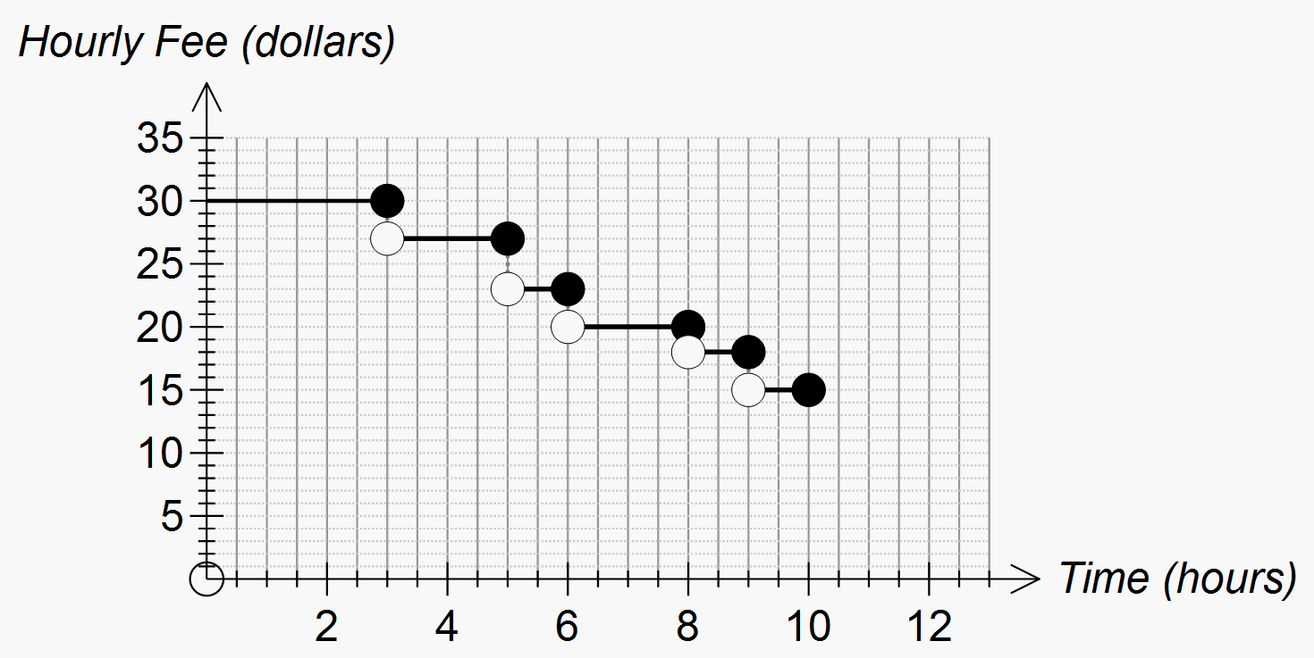

**Unit 2**

**Representing and comparing data**

**Back to back stem and leaf plot**

A method for comparing two data distributions by attaching two sets of ‘leaves’ to the same ‘stem’ in a stem and leaf plot.

For example, the stem and leaf plot below displays the distribution of pulse rates of 19 students before and after gentle exercise.

|  |  |  |
| --- | --- | --- |
| **Pulse rate** | | |
| Before |  | After |
| 9 8 8 8 | 6 |  |
| 8 6 6 4 1 1 | 7 |  |
| 8 8 6 2 | 8 | 6 7 8 8 |
| 6 0 | 9 | 0 2 2 4 5 8 9 9 |
| 4 | 10 | 0 4 4 |
| 0 | 11 | 8 |
|  | 12 | 4 4 |
|  | 13 |  |

**Bimodality**

A data distribution is said to have the characteristic of bimodality when it has two values or data ranges that appear most often in the data. The bimodal histogram can signal something out of the ordinary. It can also reflect the presence of two different processes being ‘mixed’ in the displayed data, for example, two different species.

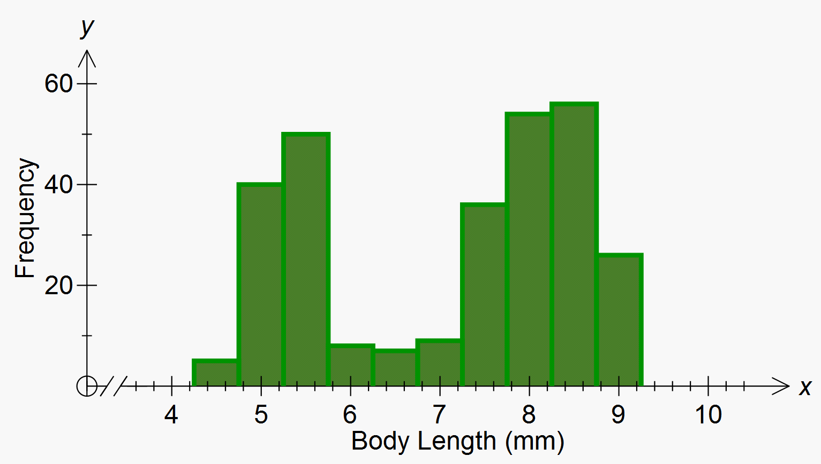

**Categorical data**

Data associated with a categorical variable is called categorical data.

A categorical variable is a variable whose values are categories.

Examples include blood group (A, B, AB or O) or house construction type (brick, concrete, timber, steel, other).

**Dot plot**

A dot plot is a representation of a distribution of data. It consists of a group of data points plotted on a simple scale.

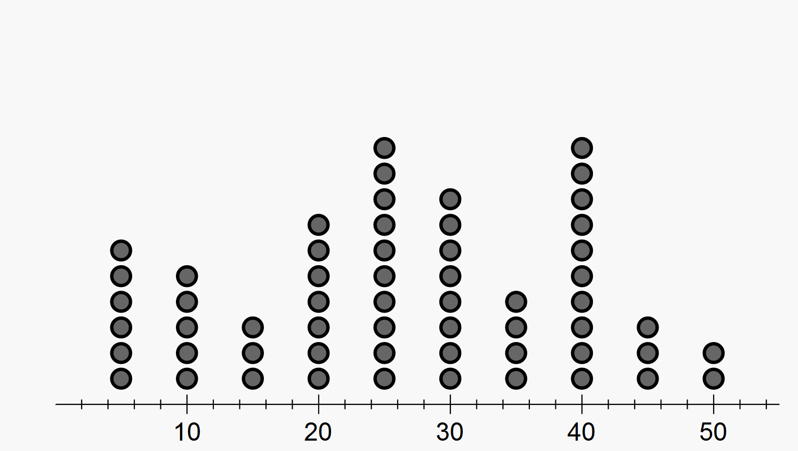

**Five number summary**

A five number summary is a method of summarising a set of data using the minimum value, the lower or first quartile (Q1), the median, the upper or third quartile (Q3) and the maximum value. Forms the basis for a boxplot.

**Frequency**

Frequency, or observed frequency, is the number of times that a particular value occurs in a data set.

For grouped data, it is the number of observations that lie in that group or class interval.

**Frequency distribution**

A frequency distribution is the division of a set of observations into a number of classes, together with a listing of the number of observations (the frequency) in that class.

**Histogram**

A histogram is a statistical graph for displaying the frequency distribution of continuous data. It is a graphical representation of the information contained in a frequency table. In a histogram, class frequencies are represented by the areas of rectangles centred on each class interval. The class frequency is proportional to the rectangle’s height when the class intervals are all of equal width.

The histogram below displays the frequency distribution of the heights (in cm) of a sample of 42 people with class intervals of width 5 cm.

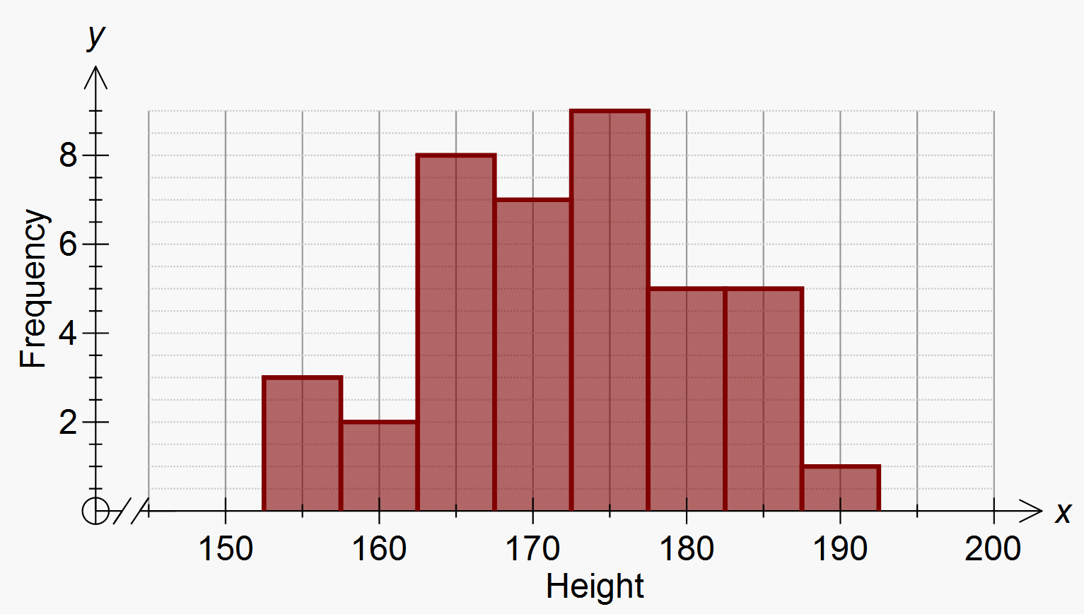

**Interquartile range (IQR)**

A measure of the spread within a numerical data set. It is equal to the upper quartile (Q3) minus the lower quartile (Q1); that is, IQR = Q3 – Q1

The IQR is the width of an interval that contains the middle 50% (approximately) of the data values. To be exactly 50%, the sample size must be a multiple of four.

**Mean**

The arithmetic mean of a list of numbers is the sum of the data values divided by the number of values in the list.

In everyday language, the arithmetic mean is commonly called the average.

For example, for the following list of five numbers 2, 3, 3, 6, 8 the mean equals

**Median**

The median is the value in a set of ordered set of data values that divides the data into two parts of equal size. When there are an odd number of data values, the median is the middle value. When there is an even number of data values, the median is the average of the two central values.

**Mode**

The mode is the most frequently occurring value is a data set.

**Outlier**

An outlier in a set of data is an observation that appears to be inconsistent with the remainder of that set of data. An outlier is a surprising observation which warrants investigation.

**Population**

A population is the complete set of individuals, objects, places etc. that we want information about.

**Quartile**

Quartiles are the values that divide an ordered data set into four (approximately) equal parts. It is only possible to divide a data set into exactly four equal parts when the number of data of values is a multiple of four.

There are three quartiles. The first, the lower quartile (Q1) divides off (approximately) the lower 25% of data values. The second quartile (Q2) is the median. The third quartile, the upper quartile (Q3), divides off (approximately) the upper 25% of data values.

In particular, the lower quartile (Q1) is the 25th percentile, the median is the 50th percentile and the upper quartile is the 75th percentile.

**Range**

The range is the difference between the largest and smallest observations in a data set.

The range can be used as a measure of spread in a data set, but it is extremely sensitive to the presence of outliers and should only be used with care.

**Skewness**

The shape of a numerical data distribution is mostly simply described as symmetric if it is roughly evenly spread around some central point or skewed, if it is not.

Symmetrical distribution

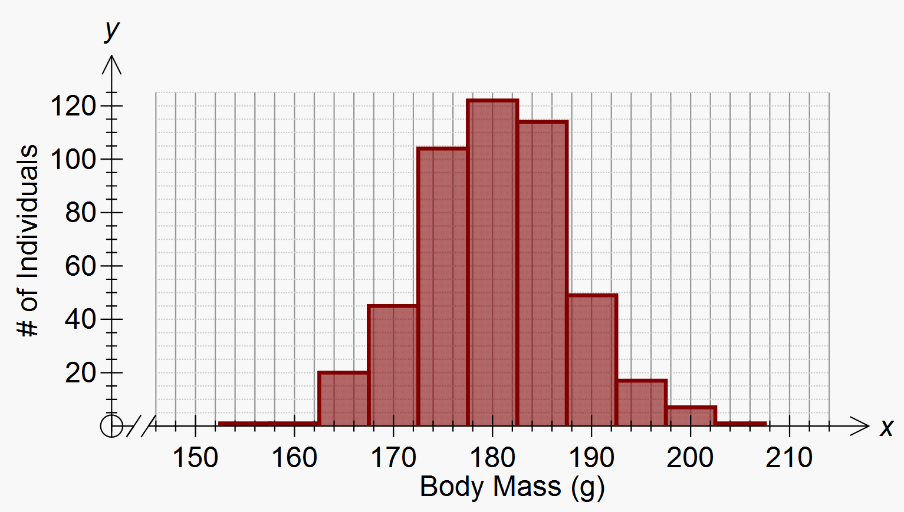

Skewed distribution

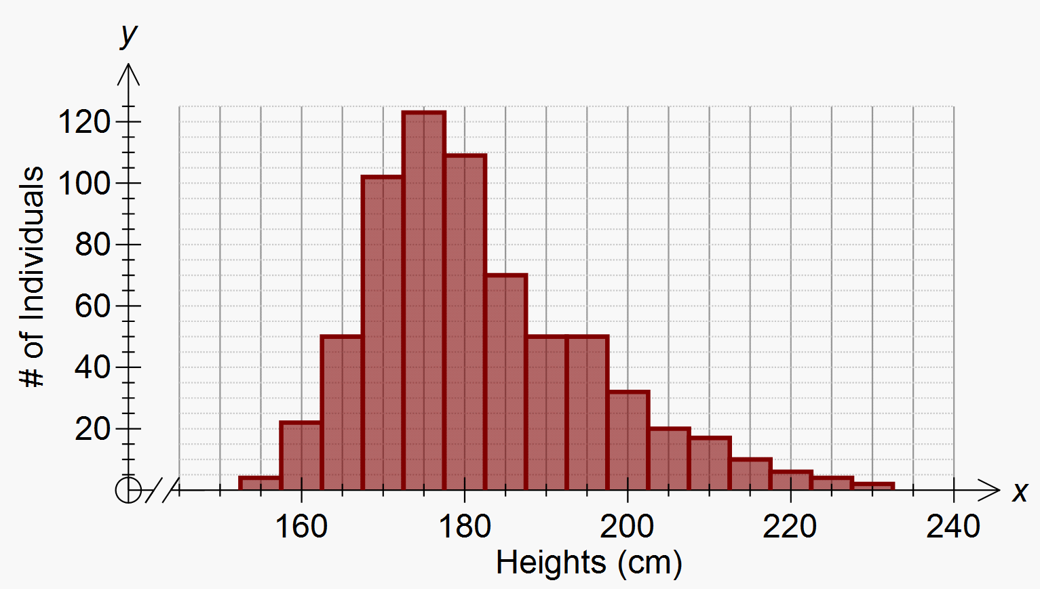

**Standard deviation**

The standard deviation is a measure of the variability or spread of a data set. It gives an indication of the degree to which the individual data values are spread around the mean. Calculation of standard deviation may be done via the use of appropriate technology.

**Statistical investigation process**

The statistical investigation process is a cyclical process that begins with the need to solve a real-world problem and aims to reflect the way statisticians work. One description of the statistical investigation process in terms of four steps is as follows.

Step 1. Clarify the problem and pose one or more questions that can be answered with data.

Step 2 Design and implement a plan to collect or obtain appropriate data.

Step 3. Select and apply appropriate graphical or numerical techniques to analyse the data.

Step 4. Interpret the results of this analysis and relate the interpretation to the original question; communicate findings in a systematic and concise manner.

Collect data

Analyse data

Interpret and communicate

Problem

**Stem and leaf plot**

A stem-and-leaf plot is a method of organising and displaying numerical data in which each data value is split into two parts, a ‘stem’ and a ‘leaf’.

For example, the stem and leaf plot below displays the resting pulse rates of 19 students.



In this plot, the stem unit is ‘10’ and the leaf unit is ‘1’. Thus the top row in the plot displays pulse rates of 68, 68, 68 and 69.

**Percentages**

**Simple interest**

Simple interest is the interest accumulated when the interest payment in each period is a fixed fraction of the principal. For example, if the principle *P* earns simple interest at the rate of *r* % per period, then after *t* periods the accumulated simple interest is

Interest = $\frac{P × r × t}{100}$

**Time and motion**

**Average speed**

The total distance travelled divided by the total time taken.

**Reaction time**

The time a person takes to react to a situation (pressing the brake) requiring them to stop.

**Stopping distances**

The distance a car travels after the driver has applied the brake given the speed of the vehicle and/or conditions of the road which can be found using formula or tables.

Stopping distance $=$ braking distance $+$ reaction time (secs) $×$ speed.