School administrators, Heads of Learning Area – Mathematics and teachers of Mathematics Essential General Year 12 are requested to note for 2027 the following minor syllabus changes. The syllabus is labelled as ‘For teaching from 2027’.
Mathematics Essential | General Year 12 | Summary of minor syllabus changes for 2027
The content identified by strikethrough has been deleted from the syllabus and the content identified in italics has been revised in the syllabus for teaching from 2027.
Glossary

Graphs in practical situations
Step graph
A graph consisting of one or more non-overlapping horizontal line segments that follow a step-like pattern.
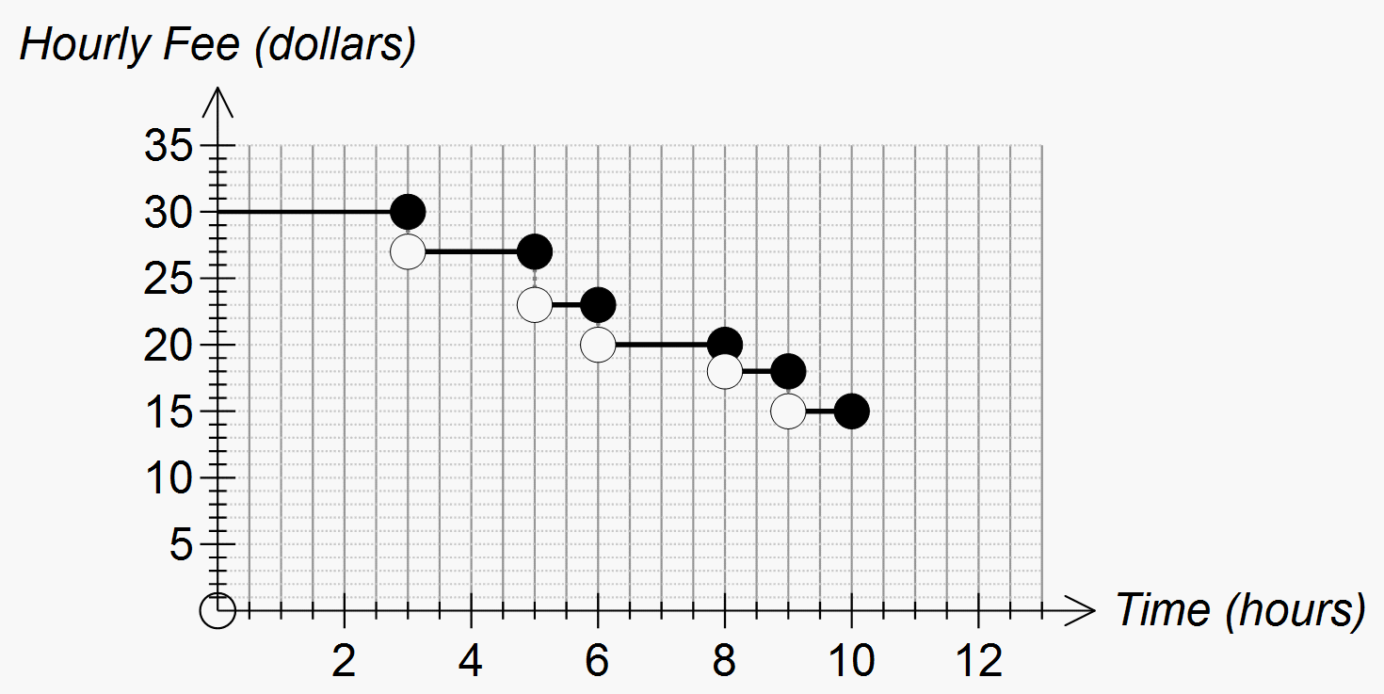
Bivariate data scatter plot
A two-dimensional data plot using Cartesian co-ordinates to display the values of two variables in a bivariate data set.
For example, the scatterplot below displays the CO₂ emissions in tonnes per person (CO₂) plotted against gross domestic product per person in $US (gdp GDP) for a sample of 24 countries in 2004. In constructing this scatterplot, GDP has been used as the explanatory independent variable.
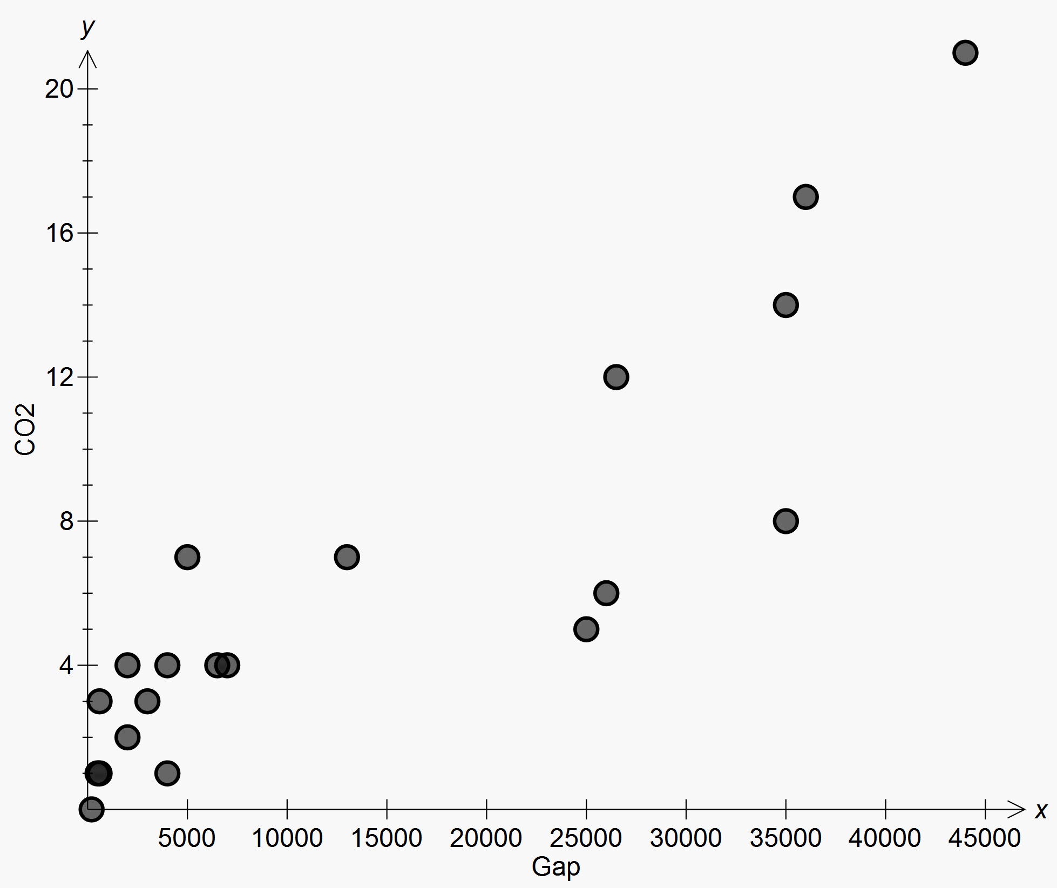
gdp GDP

co₂
Causality
A relationship between an explanatory independent and a response dependent variable is said to be causal if the change in the explanatory independent variable actually causes a change in the response dependent variable. Simply knowing that two variables are associated, no matter how strongly, is not sufficient evidence by itself to conclude that the two variables are causally related.
Possible explanations for an observed association between an explanatory independent and a response dependent variable include:
- the explanatory independent variable is actually causing a change in the response dependent variable
- there may be causation, but the change may also be caused by one or more uncontrolled variables whose effects cannot be disentangled from the effect of the response dependent variable; this is known as confounding
- there is no causation, the association is explained by at least one other variable that is associated with both the explanatory independent and the response dependent variable; this is known as a common response
- the response dependent variable is actually causing a change in the explanatory independent variable.
Explanatory Independent variable
When investigating relationships in bivariate data, the explanatory independent variable is the variable used to explain or predict a difference in the response dependent variable.
For example, when investigating the relationship between the temperature of a loaf of bread and the time it has spent in a hot oven, temperature is the response dependent variable and time is the explanatory independent variable.
Extrapolation
In the context of fitting a linear relationship between two variables, extrapolation occurs when the fitted model is used to make predictions using values of the explanatory independent variable that are outside the range of the original data. Extrapolation is a dangerous process as it can sometimes lead to quite erroneous predictions.
Interpolation
In the context of fitting a linear relationship between two variables, interpolation occurs when the fitted model is used to make predictions using values of the explanatory independent variable that lie within the range of the original data. See also extrapolation.

