Mathematics Applications

ATAR course
Year 12 syllabus

Acknowledgement of Country
Kaya. The School Curriculum and Standards Authority (the Authority) acknowledges that our offices are on Whadjuk Noongar boodjar and that we deliver our services on the country of many traditional custodians and language groups throughout Western Australia. The Authority acknowledges the traditional custodians throughout Western Australia and their continuing connection to land, waters and community. We offer our respect to Elders past and present.
Important information
This syllabus is effective from 1 January 2024.
Users of this syllabus are responsible for checking its currency.
Syllabuses are formally reviewed by the School Curriculum and Standards Authority (the Authority) on a cyclical basis, typically every five years.
Copyright
© School Curriculum and Standards Authority, 2023
This document – apart from any third-party copyright material contained in it – may be freely copied, or communicated on an intranet, for non-commercial purposes in educational institutions, provided that the School Curriculum and Standards Authority (the Authority) is acknowledged as the copyright owner, and that the Authority’s moral rights are not infringed.
Copying or communication for any other purpose can be done only within the terms of the Copyright Act 1968 or with prior written permission of the Authority. Copying or communication of any third-party copyright material can be done only within the terms of the Copyright Act 1968 or with permission of the copyright owners.
Any content in this document that has been derived from the Australian Curriculum may be used under the terms of the Creative Commons Attribution 4.0 International licence.
Content
Overview of mathematics courses 1
Rationale 2
Aims 3
Organisation 4
Structure of the syllabus 4
Organisation of content 4
Representation of the general capabilities 5
Representation of the cross-curriculum priorities 7
Unit 3 8
Unit description 8
Learning outcomes 8
Unit content 8
Unit 4 12
Unit description 12
Learning outcomes 12
Unit content 12
School-based assessment 15
Grading 16
ATAR course examination 17
Examination design brief – Year 12 17
Appendix 1 – Grade descriptions Year 12 19
Appendix 2 – Glossary 23

Overview of mathematics courses
There are six mathematics courses. Each course is organised into four units. Unit 1 and Unit 2 are taken in Year 11 and Unit 3 and Unit 4 in Year 12. The ATAR course examination for each of the three ATAR courses is based on Unit 3 and Unit 4 only.
The courses are differentiated, each focusing on a pathway that will meet the learning needs of a particular group of senior secondary students.
Mathematics Preliminary is a course which focuses on the practical application of knowledge, skills and understandings to a range of environments that will be accessed by students with special education needs. Grades are not assigned for these units. Student achievement is recorded as ‘completed’ or ‘not completed’. This course provides the opportunity for students to prepare for post-school options of employment and further training.
Mathematics Foundation is a course which focuses on building the capacity, confidence and disposition to use mathematics to meet the numeracy standard for the WACE. It provides students with the knowledge, skills and understanding to solve problems across a range of contexts, including personal, community and workplace/employment. This course provides the opportunity for students to prepare for post-school options of employment and further training.
Mathematics Essential is a General course which focuses on using mathematics effectively, efficiently and critically to make informed decisions. It provides students with the mathematical knowledge, skills and understanding to solve problems in real contexts for a range of workplace, personal, further learning and community settings. This course provides the opportunity for students to prepare for post-school options of employment and further training.
Mathematics Applications is an ATAR course which focuses on the use of mathematics to solve problems in contexts that involve financial modelling, geometric and trigonometric analysis, graphical and network analysis, and growth and decay in sequences. It also provides opportunities for students to develop systematic strategies based on the statistical investigation process for answering questions that involve analysing univariate and bivariate data, including time series data.
Mathematics Methods is an ATAR course which focuses on the use of calculus and statistical analysis. The study of calculus provides a basis for understanding rates of change in the physical world, and includes the use of functions, their derivatives and integrals, in modelling physical processes. The study of statistics develops students’ ability to describe and analyse phenomena that involve uncertainty and variation.
Mathematics Specialist is an ATAR course which provides opportunities, beyond those presented in the Mathematics Methods ATAR course, to develop rigorous mathematical arguments and proofs, and to use mathematical models more extensively. The Mathematics Specialist ATAR course contains topics in functions and calculus that build on and deepen the ideas presented in the Mathematics Methods ATAR course, as well as demonstrate their application in many areas. This course also extends understanding and knowledge of statistics and introduces the topics of vectors, complex numbers and matrices. The Mathematics Specialist ATAR course is the only ATAR mathematics course that should not be taken as a stand-alone course.

Rationale
Mathematics is the study of order, relation and pattern. From its origins in counting and measuring, it has evolved in highly sophisticated and elegant ways to become the language now used to describe many aspects of the world in the twenty-first century. Statistics are concerned with collecting, analysing, modelling and interpreting data in order to investigate and understand real world phenomena and solve practical problems in context. Together, mathematics and statistics provide a framework for thinking and a means of communication that is powerful, logical, concise and precise.
The Mathematics Applications ATAR course is designed for students who want to extend their mathematical skills beyond Year 10 level, but whose future studies or employment pathways do not require knowledge of calculus. The course is designed for students who have a wide range of educational and employment aspirations, including continuing their studies at university or TAFE.
The proficiency strands of the Year 7–10 curriculum – Understanding, Fluency, Problem-solving and Reasoning – continue to be relevant and are inherent in all aspects of this course. Each of these proficiencies is essential and all are mutually reinforcing. Fluency, for example, might include learning to perform routine calculations efficiently and accurately, or being able to recognize quickly from a problem description the appropriate mathematical process or model to apply. Understanding that a single mathematical process can be used in seemingly different situations, helps students to see the connections between different areas of study and encourages the transfer of learning. This is an important part of learning the art of mathematical problem-solving. In performing such analyses, reasoning is required at each decision-making step and in drawing appropriate conclusions. Presenting the analysis in a logical and clear manner to explain the reasoning used is also an integral part of the learning process.
Throughout the course, there is an emphasis on the use and application of digital technologies.

Aims
The Mathematics Applications ATAR course aims to develop students’:
- understanding of concepts and techniques drawn from the topic areas of number and algebra, geometry and trigonometry, graphs and networks, and statistics
- ability to solve applied problems using concepts and techniques drawn from the topic areas of number and algebra, geometry and trigonometry, graphs and networks, and statistics
- reasoning and interpretive skills in mathematical and statistical contexts
- capacity to communicate the results of a mathematical or statistical problem-solving activity in a concise and systematic manner using appropriate mathematical and statistical language
- capacity to choose and use technology appropriately and efficiently.

Organisation
This course is organised into a Year 11 syllabus and a Year 12 syllabus. The cognitive complexity of the syllabus content increases from Year 11 to Year 12.

Structure of the syllabus
The Year 12 syllabus is divided into two units which are delivered as a pair. The notional time for the pair of units is 110 class contact hours.

Organisation of content

Unit 3
Contains the three topics:
- Bivariate data analysis
- Growth and decay in sequences
- Graphs and networks
‘Bivariate data analysis’ introduces students to some methods for identifying, analysing and describing associations between pairs of variables, including using the least-squares method as a tool for modelling and analysing linear associations. The content is to be taught within the framework of the statistical investigation process.
‘Growth and decay in sequences’ employs recursion to generate sequences that can be used to model and investigate patterns of growth and decay in discrete situations. These sequences find application in a wide range of practical situations, including modelling the growth of a compound interest investment, the growth of a bacterial population, or the decrease in the value of a car over time. Sequences are also essential to understanding the patterns of growth and decay in loans and investments that are studied in detail in Unit 4.
‘Graphs and networks’ introduces students to the language of graphs and the way in which graphs, represented as a collection of points and interconnecting lines, can be used to analyse everyday situations, such as a rail or social network.

Unit 4
Contains the three topics:
- Time series analysis
- Loans, investments and annuities
- Networks and decision mathematics.
‘Time series analysis’ continues students’ study of statistics by introducing them to the concepts and techniques of time series analysis. The content is to be taught within the framework of the statistical investigation process. ‘Loans, investments and annuities’ aims to provide students with sufficient knowledge of financial mathematics to solve practical problems associated with taking out or refinancing a mortgage and making investments. ‘Networks and decision mathematics’ uses networks to model and aid
decision-making in practical situations.
Each unit includes:
- a unit description – a short description of the focus of the unit
- learning outcomes – a set of statements describing the learning expected as a result of studying the unit
- unit content – the content to be taught and learned.

Role of technology
It is assumed that students will be taught this course with an extensive range of technological applications and techniques. These have the potential to enhance the teaching and learning of mathematics. However, students also need to continue to develop skills that do not depend on technology. The ability to choose when and when not to use some form of technology, and the ability to work flexibly with technology, are important skills in this course.

Representation of the general capabilities
The general capabilities encompass the knowledge, skills, behaviours and dispositions that will assist students to live and work successfully in the twenty-first century. Teachers may find opportunities to incorporate the capabilities into the teaching and learning program for the Mathematics Applications ATAR course. The general capabilities are not assessed unless they are identified within the specified unit content.

Literacy
Literacy skills and strategies enable students to express, interpret, and communicate complex mathematical information, ideas and processes. Mathematics provides a specific and rich context for students to develop their ability to read, write, visualise and talk about complex situations involving a range of mathematical ideas. Students can apply and further develop their literacy skills and strategies by shifting between verbal, graphic, numerical and symbolic forms of representing problems in order to formulate, understand and solve problems and communicate results. This process of translation across different systems of representation is essential for complex mathematical reasoning and expression. Students learn to communicate their findings in different ways, using multiple systems of representation and data displays to illustrate the relationships they have observed or constructed.

Numeracy
Students who undertake this course will continue to develop their numeracy skills at a more sophisticated level, making decisions about the relevant mathematics to use, following through with calculations selecting appropriate methods and being confident of their results. This course contains topics that will equip students for the ever-increasing demands of the information age, developing the skills of critical evaluation of numerical information in its various forms of collection and presentation. Students will enhance their numerical operation skills via engagement with consumer arithmetic problems, mensuration and trigonometric calculations, algebraic modelling and analysis of practical situations, and the statistical analysis of data.

Information and communication technology capability
Students use information and communication technology (ICT) both to develop theoretical mathematical understanding and to apply mathematical knowledge to a range of problems. They use software aligned with areas of work and society with which they may be involved, such as for statistical analysis, generation of algorithms, manipulation and complex calculations. They use digital tools to make connections between mathematical theory, practice and application; for example, to use data, to address problems, and to operate systems in authentic situations.

Critical and creative thinking
Students compare predictions with observations when evaluating a theory. They check the extent to which their theory-based predictions match observations. They assess whether, if observations and predictions don't match, it is due to a flaw in theory or method of applying the theory to make predictions – or both. They revise, or reapply their theory more skilfully, recognising the importance of self-correction in the building of useful and accurate theories and making accurate predictions.

Personal and social capability
Students develop personal and social competence in mathematics through setting and monitoring personal and academic goals, taking initiative, building adaptability, communication, teamwork and decision making. The elements of personal and social competence relevant to mathematics mainly include the application of mathematical skills for their decision making, life-long learning, citizenship and self-management. In addition, students will work collaboratively in teams and independently as part of their mathematical explorations and investigations.

Ethical understanding
Students develop ethical understanding in mathematics through decision making connected with ethical dilemmas that arise when engaged in mathematical calculation and the dissemination of results and the social responsibility associated with teamwork and attribution of input. The areas relevant to mathematics include issues associated with ethical decision making as students work collaboratively in teams and independently as part of their mathematical explorations and investigations. Acknowledging errors rather than denying findings and/or evidence involves resilience and ethical understanding. They develop increasingly advanced communication, research, and presentation skills to express viewpoints.

Intercultural understanding
Students understand mathematics as a socially constructed body of knowledge that uses universal symbols but has its origin in many cultures. Students understand that some languages make it easier to acquire mathematical knowledge than others. Students also understand that there are many culturally diverse forms of mathematical knowledge, including diverse relationships to number and that diverse cultural spatial abilities and understandings are shaped by a person’s environment and language.

Representation of the cross-curriculum priorities
The cross-curriculum priorities address contemporary issues which students face in a globalised world. Teachers may find opportunities to incorporate the priorities into the teaching and learning program for the Mathematics Applications ATAR course. The cross-curriculum priorities are not assessed unless they are identified within the specified unit content.

Aboriginal and Torres Strait Islander histories and cultures
Mathematics courses value the histories, cultures, traditions and languages of Aboriginal and Torres Strait Islander Peoples’ past and ongoing contributions to contemporary Australian society and culture. Through the study of mathematics within relevant contexts, opportunities will allow for the development of students’ understanding and appreciation of the diversity of Aboriginal and Torres Strait Islander Peoples’ histories and cultures.

Asia and Australia's engagement with Asia
There are strong social, cultural and economic reasons for Australian students to engage with the countries of Asia and with the past and ongoing contributions made by the peoples of Asia in Australia. It is through the study of mathematics in an Asian context that students engage with Australia’s place in the region. By analysing relevant data, students have opportunities to further develop an understanding of the diverse nature of Asia’s environments and traditional and contemporary cultures.

Sustainability
Each of the mathematics courses provides the opportunity for the development of informed and reasoned points of view, discussion of issues, research and problem solving. Teachers are therefore encouraged to select contexts for discussion that are connected with sustainability. Through the analysis of data, students have the opportunity to research and discuss sustainability and learn the importance of respecting and valuing a wide range of world perspectives.

Unit 3

Unit description
This unit has three topics: ‘Bivariate data analysis’, ‘Growth and decay in sequences’, and ‘Graphs and networks’.
‘Bivariate data analysis’ introduces students to some methods for identifying, analysing and describing associations between pairs of variables, including the use of the least-squares method as a tool for modelling and analysing linear associations. The content is to be taught within the framework of the statistical investigation process.
‘Growth and decay in sequences’ employs recursion to generate sequences that can be used to model and investigate patterns of growth and decay in discrete situations. These sequences find application in a wide range of practical situations, including modelling the growth of a compound interest investment, the growth of a bacterial population, or the decrease in the value of a car over time. Sequences are also essential to understanding the patterns of growth and decay in loans and investments that are studied in detail in Unit 4.
‘Graphs and networks’ introduces students to the language of graphs and the ways in which graphs, represented as a collection of points and interconnecting lines, can be used to model and analyse everyday situations, such as a rail or social network.
Classroom access to technology to support the graphical and computational aspects of these topics is assumed.

Learning outcomes
By the end of this unit, students:
- understand the concepts and techniques in bivariate data analysis, growth and decay in sequences and graphs and networks
- apply reasoning skills and solve practical problems in bivariate data analysis, growth and decay in sequences and graphs and networks
- implement the statistical investigation process in contexts requiring the analysis of bivariate data
- communicate their arguments and strategies, when solving mathematical and statistical problems, using appropriate mathematical or statistical language
- interpret mathematical and statistical information and ascertain the reasonableness of their solutions to problems and their answers to statistical questions
- choose and use technology appropriately and efficiently.

Unit content
An understanding of the Year 11 content is assumed knowledge for students in Year 12. It is recommended that students studying Unit 3 and Unit 4 have completed Unit 1 and Unit 2.
This unit includes the knowledge, understandings and skills described below. This is the examinable content.
Topic 3.1: Bivariate data analysis (20 hours)

The statistical investigation process
3.1.1 review the statistical investigation process: identify a problem; pose a statistical question; collect or obtain data; analyse data; interpret and communicate results

Identifying and describing associations between two categorical variables
3.1.2 construct two-way frequency tables and determine the associated row and column sums and percentages
3.1.3 use an appropriately percentaged two-way frequency table to identify patterns that suggest the presence of an association
3.1.4 describe an association in terms of differences observed in percentages across categories in a systematic and concise manner, and interpret this in the context of the data

Identifying and describing associations between two numerical variables
3.1.5 construct a scatterplot to identify patterns in the data suggesting the presence of an association
3.1.6 describe an association between two numerical variables in terms of direction (positive/negative), form (linear/non-linear) and strength (strong/moderate/weak)
3.1.7 calculate, using technology, and interpret the correlation coefficient (r) to quantify the strength of a linear association

Fitting a linear model to numerical data
    - identify the response variable and the explanatory variable for primary and secondary data
    - use a scatterplot to identify the nature of the relationship between variables
    - model a linear relationship by fitting a least-squares line to the data
    - use a residual plot to assess the appropriateness of fitting a linear model to the data
    - interpret the intercept and slope of the fitted line
3.1.13 use the coefficient of determination to assess the strength of a linear association in terms of the explained variation
    - use the equation of a fitted line to make predictions
3.1.15 distinguish between interpolation and extrapolation when using the fitted line to make predictions, recognising the potential dangers of extrapolation
3.1.16 write up the results of the above analysis in a systematic and concise manner

Association and causation
3.1.17 recognise that an observed association between two variables does not necessarily mean that there is a causal relationship between them
3.1.18 recognise possible non-causal explanations for an association, including coincidence and confounding due to a common response to another variable, and communicate these explanations in a systematic and concise manner

The data investigation process
3.1.19 implement the statistical investigation process to answer questions that involve identifying, analysing and describing associations between two categorical variables or between two numerical variables

Topic 3.2: Growth and decay in sequences (15 hours)

The arithmetic sequence
    - use recursion to generate an arithmetic sequence
3.2.2 display the terms of an arithmetic sequence in both tabular and graphical form and demonstrate that arithmetic sequences can be used to model linear growth and decay in discrete situations
3.2.3 deduce a rule for the $n^{th}$ term of a particular arithmetic sequence from the pattern of the terms in an arithmetic sequence, and use this rule to make predictions
3.2.4 use arithmetic sequences to model and analyse practical situations involving linear growth or decay

The geometric sequence
    - use recursion to generate a geometric sequence
3.2.6 display the terms of a geometric sequence in both tabular and graphical form and demonstrate that geometric sequences can be used to model exponential growth and decay in discrete situations
3.2.7 deduce a rule for the $n^{th}$ term of a particular geometric sequence from the pattern of the terms in the sequence, and use this rule to make predictions
3.2.8 use geometric sequences to model and analyse (numerically, or graphically only) practical problems involving geometric growth and decay

Sequences generated by first-order linear recurrence relations
3.2.9 use a general first-order linear recurrence relation to generate the terms of a sequence and to display it in both tabular and graphical form
3.2.10 generate a sequence defined by a first-order linear recurrence relation that gives long term increasing, decreasing or steady-state solutions
3.2.11 use first-order linear recurrence relations to model and analyse (numerically or graphically only) practical problems

Topic 3.3: Graphs and networks (20 hours)

The definition of a graph and associated terminology
3.3.1 demonstrate the meanings of, and use, the terms: graph, edge, vertex, loop, degree of a vertex, subgraph, simple graph, complete graph, bipartite graph, directed graph (digraph), arc, weighted graph, and network
3.3.2 identify practical situations that can be represented by a network, and construct such networks
3.3.3 construct an adjacency matrix from a given graph or digraph and use the matrix to form multi-stage matrices to solve associated problems

Planar graphs
    - demonstrate the meanings of, and use, the terms: planar graph and face
3.3.5 apply Euler’s formula, $v+f-e=2$ to solve problems relating to planar graphs

Paths and cycles
3.3.6 demonstrate the meanings of, and use, the terms: walk, trail, path, closed walk, closed trail, cycle, connected graph, and bridge
3.3.7 investigate and solve practical problems to determine the shortest path between two vertices in a weighted graph (by trial-and-error methods only)
3.3.8 demonstrate the meanings of, and use, the terms: Eulerian graph, Eulerian trail, semi-Eulerian graph, semi-Eulerian trail and the conditions for their existence, and use these concepts to investigate and solve practical problems
3.3.9 demonstrate the meanings of, and use, the terms: Hamiltonian graph and semi-Hamiltonian graph, and use these concepts to investigate and solve practical problems

Unit 4

Unit description
This unit has three topics: ‘Time series analysis’, ‘Loans, investments and annuities’, and ‘Networks and decision mathematics’.
‘Time series analysis’ continues students’ study of statistics by introducing them to the concepts and techniques of time series analysis. The content is to be taught within the framework of the statistical investigation process.
‘Loans investments and annuities’ aims to provide students with sufficient knowledge of financial mathematics to solve practical problems associated with taking out or refinancing a mortgage and making investments.
‘Networks and decision mathematics’ uses networks to model and aid decision making in practical situations.
Classroom access to the technology necessary to support the graphical, computational and statistical aspects of this unit is assumed.

Learning outcomes
By the end of this unit, students:
- understand the concepts and techniques in time series analysis, loans, investments and annuities, and networks and decision mathematics
- apply reasoning skills and solve practical problems in time series analysis, loans, investments, annuities, networks and decision mathematics
- implement the statistical investigation process in contexts requiring the analysis of time series data
- communicate their arguments and strategies, when solving mathematical and statistical problems, using appropriate mathematical or statistical language
- interpret mathematical and statistical information
- evaluate the reasonableness of their solutions to problems and their answers to questions
- choose and use technology appropriately and efficiently.

Unit content
This unit builds on the content covered in Unit 3.
This unit includes the knowledge, understandings and skills described below. This is the examinable content.

Topic 4.1: Time series analysis (15 hours)

Describing and interpreting patterns in time series data
    - construct time series plots
4.1.2 describe time series plots by identifying features such as trend (long term direction), seasonality (systematic, calendar-related movements), and irregular fluctuations (unsystematic, short term fluctuations), and recognise when there are outliers

Analysing time series data
4.1.3 smooth time series data by using a simple moving average, including the use of spreadsheets to implement this process
    - calculate seasonal indices by using the average percentage method
4.1.5 deseasonalise a time series by using a seasonal index, including the use of spreadsheets to implement this process
    - fit a least-squares line to model long-term trends in time series data
4.1.7 predict from regression lines, making seasonal adjustments for periodic data

The data investigation process
4.1.8 implement the statistical investigation process to answer questions that involve the analysis of time series data

Topic 4.2: Loans, investments and annuities (20 hours)

Compound interest loans and investments
4.2.1 use a recurrence relation to model a compound interest loan or investment and investigate (numerically or graphically) the effect of the interest rate and the number of compounding periods on the future value of the loan or investment
4.2.2 calculate the effective annual rate of interest and use the results to compare investment returns and cost of loans when interest is paid or charged daily, monthly, quarterly or six-monthly
4.2.3 with the aid of a calculator or computer-based financial software, solve problems involving compound interest loans, investments and depreciating assets

Reducing balance loans (compound interest loans with periodic repayments)
4.2.4 use a recurrence relation to model a reducing balance loan and investigate (numerically or graphically) the effect of the interest rate and repayment amount on the time taken to repay the loan
4.2.5 with the aid of a financial calculator or computer-based financial software, solve problems involving reducing balance loans

Annuities and perpetuities (compound interest investments with periodic payments made from the investment)
4.2.6 use a recurrence relation to model an annuity, and investigate (numerically or graphically) the effect of the amount invested, the interest rate, and the payment amount on the duration of the annuity
4.2.7 with the aid of a financial calculator or computer-based financial software, solve problems involving annuities (including perpetuities as a special case)

Topic 4.3: Networks and decision mathematics (20 hours)

Trees and minimum connector problems
    - identify practical examples that can be represented by trees and spanning trees
4.3.2 identify a minimum spanning tree in a weighted connected graph, either by inspection or by using Prim’s algorithm
4.3.3 use minimal spanning trees to solve minimal connector problems

Project planning and scheduling using critical path analysis (CPA)
4.3.4 construct a network to represent the durations and interdependencies of activities that must be completed during the project
4.3.5 use forward and backward scanning to determine the earliest starting time (EST) and latest starting times (LST) for each activity in the project
    - use ESTs and LSTs to locate the critical path(s) for the project
    - use the critical path to determine the minimum time for a project to be completed
4.3.8 calculate float times for non-critical activities

Flow networks
4.3.9 solve small-scale network flow problems, including the use of the ‘maximum flow-minimum cut’ theorem

Assignment problems
    - use a bipartite graph and/or its tabular or matrix form to represent an assignment/ allocation problem
    - determine the optimum assignment(s), by inspection for small-scale problems, or by use of the Hungarian algorithm for larger problems

School-based assessment
The Western Australian Certificate of Education (WACE) Manual contains essential information on principles, policies and procedures for school-based assessment that needs to be read in conjunction with this syllabus.
Teachers design school-based assessment tasks to meet the needs of students. The table below provides details of the assessment types for the Mathematics Applications ATAR Year 12 syllabus and the weighting for each assessment type.

Assessment table – Year 12
Type of assessment | Weighting
Response  Students response using knowledge of mathematical facts, concepts and terminology, applying problem-solving skills and algorithms. Response tasks can include: tests, assignments, quizzes and observation checklists. Tests are administered under controlled and timed conditions. | 40%
Investigation  Students use the mathematical thinking process and the statistical investigation process to plan, research, conduct and communicate the findings of an investigation. They can investigate problems to identify the underlying mathematics, or select, adapt and apply models and procedures to solve problems. This assessment type provides for the assessment of the mathematical thinking process and statistical investigation process using course-related knowledge and modelling skills.  It is recommended that at least one investigation/project should involve application of the statistical investigation process.  Evidence can include observation and interview, written work or multimedia presentations. | 20%
Examination  Students apply mathematical understanding and skills to analyse, interpret and respond to questions and situations. Examinations provide for the assessment of conceptual understandings, knowledge of mathematical facts and terminology, problem-solving skills, and the use of algorithms.  Examination questions can range from those of a routine nature, assessing lower level concepts, through to those that require responses at the highest level of conceptual thinking.  Typically conducted at the end of each semester and/or unit and reflecting the examination design brief for this syllabus. | 40%
Teachers are required to use the assessment table to develop an assessment outline for the pair of units.
The assessment outline must:
- include a set of assessment tasks
- include a general description of each task
- indicate the unit content to be assessed
- indicate a weighting for each task and each assessment type
- include the approximate timing of each task (for example, the week the task is conducted, or the issue and submission dates for an extended task).
In the assessment outline for the pair of units, each assessment type must be included at least once over the year/pair of units.
The set of assessment tasks must provide a representative sampling of the content for Unit 3 and Unit 4.
Assessment tasks not administered under test/controlled conditions require appropriate validation/authentication processes. This may include observation, annotated notes, checklists, interview, presentations or in-class tasks assessing related content and processes.

Grading
Schools report student achievement in terms of the following grades:
Grade | Interpretation
A | Excellent achievement
B | High achievement
C | Satisfactory achievement
D | Limited achievement
E | Very low achievement
The teacher prepares a ranked list and assigns the student a grade for the pair of units. The grade is based on the student’s overall performance as judged by reference to a set of pre-determined standards. These standards are defined by grade descriptions and annotated work samples. The grade descriptions for the Mathematics Applications ATAR Year 12 syllabus are provided in Appendix 1. They can also be accessed, together with annotated work samples, through the Guide to Grades link on the course page of the Authority website at www.scsa.wa.edu.au.
To be assigned a grade, a student must have had the opportunity to complete the education program, including the assessment program (unless the school accepts that there are exceptional and justifiable circumstances).
Refer to the WACE Manual for further information about the use of a ranked list in the process of assigning grades.

ATAR course examination
All students enrolled in the Mathematics Applications ATAR Year 12 course are required to sit the ATAR course examination. The examination is based on a representative sampling of the content for Unit 3 and Unit 4. Details of the ATAR course examination are prescribed in the examination design brief on the following page.
Refer to the WACE Manual for further information.

Examination design brief – Year 12
This examination consists of two sections.
Section One: Calculator-free
Time allowed
Reading time before commencing work: five minutes
Working time for paper: fifty minutes
Permissible items
Standard items: pens (blue/black preferred), pencils (including coloured), sharpener, correction fluid/tape, eraser, ruler, highlighters
Special items: nil
Additional information
Changeover period during which the candidate is not permitted to work: up to 15 minutes
Section Two: Calculator-assumed
Time allowed
Reading time before commencing work: ten minutes
Working time for paper: one hundred minutes
Permissible items
Standard items: pens (blue/black preferred), pencils (including coloured), sharpener, correction tape/fluid, eraser, ruler, highlighters
Special items: drawing instruments, templates, notes on two unfolded sheets of A4 paper, and up to three calculators, which can include scientific, graphic and Computer Algebra System (CAS) calculators, are permitted in this ATAR course examination
Provided by the supervisor
A formula sheet
Additional information
It is assumed that candidates sitting this examination have a calculator with CAS capabilities for Section Two. The candidate is required to demonstrate knowledge of mathematical facts, conceptual understandings, use of algorithms, use and knowledge of notation and terminology, and problem-solving skills.
Questions can require the candidate to solve problems, investigate mathematical patterns, apply reasoning skills, interpret results and communicate their arguments and strategies to justify mathematical relationships. Examination questions can range from those of a routine nature, assessing lower level concepts, through to those that require responses to the highest level of conceptual thinking.
Instructions to candidates indicate that, for any question or part question worth more than two marks, valid working or justification is required to receive full marks.
Section | Supporting information
Section One: Calculator-free  35% of the total examination  5–10 questions  Working time: 50 minutes | Questions examine content and procedures that can reasonably be expected to be completed without the use of a calculator, i.e. without undue emphasis on algebraic manipulations or time-consuming calculations.  The candidate is required to provide answers that include calculations, tables, graphs, interpretation of data, descriptions and/or conclusions.  Stimulus material can include diagrams, tables, graphs, drawings, print text and/or data gathered from the media.
Section Two: Calculator-assumed  65% of the total examination  8–13 questions  Working time: 100 minutes | Questions examine content and procedures for which the use of a calculator is assumed.  The candidate is required to provide answers that include calculations, tables, graphs, interpretation of data, descriptions and/or conclusions.  Stimulus material can include: diagrams, tables, graphs, drawings, print text and/or data gathered from the media.  The candidate can be required to solve practical problems, investigate mathematical patterns, apply reasoning skills, interpret results and communicate their arguments and strategies to justify mathematical relationships.  The candidate can be required to solve problems from unfamiliar situations, choosing and using mathematical models with adaptations where necessary, comparing their solutions with the situations concerned, and then presenting their findings in context.

Appendix 1 – Grade descriptions Year 12
A | Identifies and organises relevant information  Identifies and organises relevant information for complex problems involving a series of steps or processes.  Defines variables from text to draw networks and diagrams.  Organises data in a concise, clear format and appropriately presents it in tabular, diagrammatic and/or graphical form.  Identifies the underlying assumptions related to the relevant mathematics of an investigation.
Chooses effective models and methods and carries through the methods correctly
Accurately applies mathematical knowledge and understanding to solve unstructured problems using sub-problems.
Generalises and extends models from previous parts of the question.
Translates between representations in unpractised ways.
Selects appropriate calculator techniques to solve multi-step problems in unfamiliar contexts.
Selects and appropriately uses numerical, graphical, symbolic and statistical methods to develop mathematical ideas.
Produces results, carries out analysis and generalises in situations requiring investigative techniques.
Follows mathematical conventions and attends to accuracy
Follows mathematical conventions and attends to accuracy in non-routine situations.
Provides concise and accurate solutions to mathematical problems set in applied and theoretical contexts.
Selects, extends and applies mathematical and/or statistical procedures to investigate a problem.
Links mathematical results to data and contexts to reach reasonable conclusions
Recognises implied conditions in real-life applications and defines and explains the limitations of models.
Interprets the result and draws the correct conclusion about the effect of changing conditions.
Considers the strengths and limitations of an investigation and refines the results to make sensible conclusions.
Communicates mathematical reasoning, results and conclusions
Sets out the steps of the solution in a clear and logical sequence, including suitable justification and explanation of methods and processes used.
Adds a detailed diagram to illustrate and use in the solution of a problem.
Presents work with the final answer clearly identified, using the correct units and relating to the context of the question.
Communicates investigation findings with a comprehensive interpretation of mathematical results in the context of the investigation.

B | Identifies and organises relevant information  Identifies and organises relevant information for problems involving a few steps or processes.  Draws a network or diagram and labels with appropriate variables.  Organises data clearly and appropriately presents it in tabular, diagrammatic and/or graphical form.  Identifies suitable variables and constant parameters related to various aspects of an investigation.
Chooses effective models and methods and carries through the methods correctly
Selects an appropriate strategy and applies mathematical knowledge to solve problems that contain a few steps.
Translates between representations in practised ways.
Selects appropriate calculator techniques to solve multi-step problems.
Selects and appropriately uses numerical, graphical, symbolic and statistical methods to develop mathematical ideas.
Attempts to analyse and calculate specific cases of generalisation in situations requiring investigative techniques.
Follows mathematical conventions and attends to accuracy
Interprets and uses mathematical terminology, symbols and conventions in routine situations.
Rounds, unprompted, to suit context or correctly to specified accuracy.
Completes mostly accurate solutions to mathematical problems set in applied and theoretical contexts.
Selects and applies mathematical and/or statistical procedures previously learnt to investigate a problem.
Links mathematical results to data and contexts to reach reasonable conclusions
Identifies specified conditions in real-life applications, recognises and rejects inappropriate solutions.
Links the effect of changing conditions to the original solution.
Uses examples in mathematical analysis of an investigation and draws valid conclusions related to a given context.
Communicates mathematical reasoning, results and conclusions
Carries through calculations and simplifications in a clear sequence, showing a logical line of reasoning.
Defines variables associated with a given diagram and uses them in the working of a problem.
Presents work with the final answer clearly identified and using the correct units.
Communicates investigation findings in a systematic and concise way using mathematical language and relating the solution to the original problem or statement.

C | Identifies and organises relevant information  Identifies and extracts key information needed to solve a familiar problem.  Identifies variables in a network or diagram.  Organises some data and presents it in tabular, diagrammatic and/or graphical form.  Identifies some mathematical content related to various aspects of an investigation in a given context.
Chooses effective models and methods and carries through the methods correctly
Selects a strategy and applies mathematical knowledge to answer structured questions that require short responses.
Recognises and uses information in different representations.
Uses familiar calculator applications to solve routine problems.
Selects appropriate numerical, graphical, symbolic and statistical methods to carry through a single thread of reasoning in situations requiring investigative techniques.
Follows mathematical conventions and attends to accuracy
Applies mathematical definitions, rules and procedures in practised situations.
Applies basic conventions for diagrams and graphs.
Rounds appropriately in a given context and to specified accuracy in short responses.
Generates some accurate and generally complete solutions to mathematical problems set in applied and theoretical contexts.
Selects and applies, with direction, mathematical and/or statistical procedures previously learnt to investigate a problem.
Links mathematical results to data and contexts to reach reasonable conclusions
Identifies specified conditions in real-life applications and recognises inappropriate solutions in routine problems.
Recognises that changing conditions will affect the outcome.
Makes inferences from analysis and uses these to draw conclusions related to an investigation.
Communicates mathematical reasoning, results and conclusions
Shows adequate working and supports answers with simple or routine statements.
Relates the working to a labelled diagram that has been given as part of the question.
Presents a solution but the final answer is not always clearly identified.
Communicates investigation findings in a systematic way using some mathematical expression and everyday language.

D | Identifies and organises relevant information  Uses given information to solve simple routine problems.  Identifies variables in a simple network or diagram.  Displays data using an inappropriate presentation format.  Identifies limited mathematical content of an investigation.
Chooses effective models and methods and carries through the methods correctly
Follows an appropriate strategy to solve simple routine and familiar problems that require short responses.
Deals with information in familiar representations only.
Uses a calculator for straightforward problems.
Makes some attempt to select appropriate numerical, graphical, symbolic and statistical methods in situations requiring investigative techniques.
Follows mathematical conventions and attends to accuracy
Applies limited mathematical conventions to practised problems.
Rounds inconsistently or inappropriately.
Generates partly accurate and generally incomplete solutions to mathematical problems set in applied and theoretical contexts.
Attempts to apply, with direction, mathematical and/or statistical procedures previously learnt to investigate a problem.
Links mathematical results to data and contexts to reach reasonable conclusions
Is unable to recognise specified or changing conditions in real-life applications.
Draws some conclusions from the results of an investigation.
Communicates mathematical reasoning, results and conclusions
Shows some working in an attempt to answer simple questions.
Sets out calculations in a manner that is difficult to check for accuracy.
Presents working with no indication of the final answer evident.
Offers simple conclusions that are not supported by data or calculations.

E | Does not meet the requirements of a D grade and/or has completed insufficient assessment tasks to be assigned a higher grade.

Appendix 2 – Glossary
This glossary is provided to enable a common understanding of the key terms in this syllabus.

Unit 3

Bivariate data analysis
Association
Association is a general term used to describe the relationship between two (or more) variables. For example, is there an association between attitude to capital punishment (agree with, no opinion, disagree with) and gender (male, female)? Is there an association between a person’s height and foot length? The term association is often used interchangeably with the term correlation. The latter tends to be used when referring to the strength of a linear relationship between two numerical variables.
Causation
A relationship between an explanatory and a response variable is said to be causal if the change in the explanatory variable actually causes a change in the response variable. Simply knowing that two variables are associated, no matter how strongly, is not sufficient evidence by itself to conclude that the two variables are causally related.
Possible explanations for an observed association between an explanatory and a response variable include:
- the explanatory variable is actually causing a change in the response variable
- there may be causation, but the change may also be caused by one or more uncontrolled variables whose effects cannot be disentangled from the effect of the response variable; this is known as confounding
- there is no causation; the association is explained by at least one other variable that is associated with both the explanatory and the response variable; this is known as a common response
- the response variable is actually causing a change in the explanatory variable.
Coefficient of determination
In a linear model between two variables, the coefficient of determination ($R^{2}$) is the proportion of the total variation that can be explained by the linear relationship existing between the two variables, usually expressed as a percentage. For two variables only, the coefficient of determination is numerically equal to the square of the correlation coefficient ($r^{2}$).
Example
A study finds that the correlation between the heart weight and body weight of a sample of mice is $r$ = 0.765. The coefficient of determination = $r^{2}$ = 0.765² = 0.5852 … or approximately 59%.
From this information, it can be concluded that approximately 59% of the variation in heart weights of these mice can be explained by the variation in their body weights.
Note: The coefficient of determination has a more general and more important meaning in considering relationships between more than two variables, but this is not a school-level topic.
Common response
See Causation.
Confounding
See Causation.
Correlation
Correlation is a measure of the strength of the linear relationship between two variables. See also Association.
Correlation coefficient (r)
The correlation coefficient ($r$) is a measure of the strength of the linear relationship between a pair of variables $-1≤r≤1$. Calculating $r$ may be performed using appropriate technology.
Explanatory variable
When investigating relationships in bivariate data, the explanatory variable is the variable used to explain or predict a difference in the response variable.
For example, when investigating the relationship between the temperature of a loaf of bread and the time it has spent in a hot oven, temperature is the response variable and time is the explanatory variable.
Extrapolation
In the context of fitting a linear relationship between two variables, extrapolation occurs when the fitted model is used to make predictions using values of the explanatory variable that are outside the range of the original data. Extrapolation is a dangerous process as it can sometimes lead to quite erroneous predictions. See also interpolation.
Interpolation
In the context of fitting a linear relationship between two variables, interpolation occurs when the fitted model is used to make predictions using values of the explanatory variable that lie within the range of the original data. See also extrapolation.
Least-squares line
In fitting a straight-line $y=a+bx$ to the relationship between a response variable $y$ and an explanatory variable $x$, the least‐squares line is the line for which the sum of the squared residuals is the smallest.
Determination of the equation for the least-squares line may be accessed via the use of appropriate technology.
Residual values
The difference between the observed value and the value predicted by a statistical model, for example, by a least-squares line.
Residual plot
A residual plot is a scatterplot with the residual values shown on the vertical axis and the explanatory variable shown on the horizontal axis. Residual plots are useful in assessing the fit of the statistical model (for example, by a least-squares line).
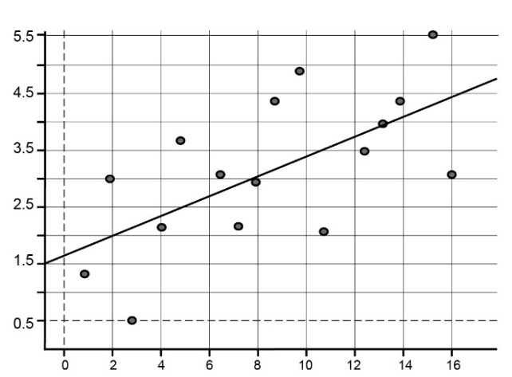
scatterplot with least-squares line
Residual plot continued
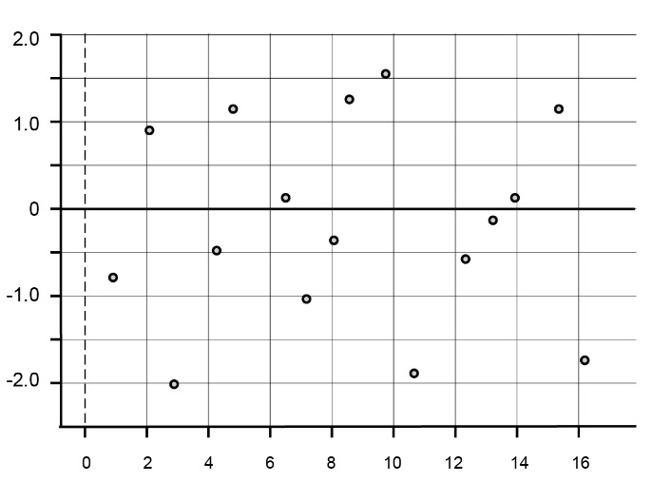
residual plot
When the least-squares line captures the overall relationship between the response variable $y$ and the explanatory variable $x$, the residual plot will have no clear pattern (be random) – see above. This is what is hoped for. If the least-squares line fails to capture the overall relationship between a response variable and an explanatory variable, a residual plot will reveal a pattern in the residuals. A residual plot will also reveal any outliers that may call into question the use of a least-squares line to describe the relationship. Interpreting patterns in residual plots is a skilled art and is not required in this syllabus.
Response variable
See Explanatory variable.
Scatterplot
A scatterplot is a two-dimensional data plot using Cartesian co-ordinates to display the values of two variables in a bivariate data set.
For example, the scatterplot below displays the CO₂ emissions in tonnes per person (CO₂) plotted against Gross Domestic Product per person in $US (GDP) for a sample of 24 countries in 2004. In constructing this scatterplot, GDP has been used as the explanatory variable.
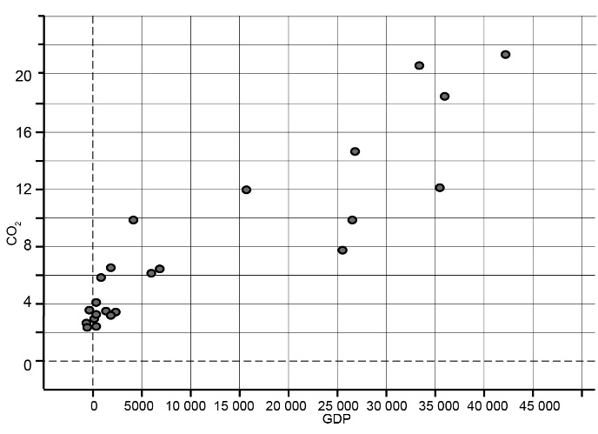

Statistical investigation process
The statistical investigation process is a cyclical process that begins with the need to solve a real-world problem and aims to reflect the way statisticians work. One description of the statistical investigation process in terms of four steps is as follows.
Step 1. Clarify the problem and formulate one or more questions that can be answered with data.
Step 2. Design and implement a plan to collect or obtain appropriate data.
Step 3. Select and apply appropriate graphical or numerical techniques to analyse the data.
Step 4. Interpret the results of this analysis and relate the interpretation to the original question; communicate findings in a systematic and concise manner.
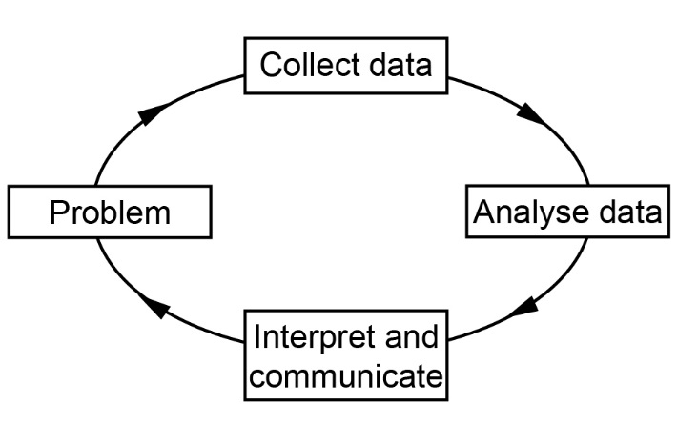
Two-way frequency table
A two-way frequency table is commonly used for displaying the two-way frequency distribution that arises when a group of individuals or objects are categorised according to two criteria.
For example, the two-way table below displays the frequency distribution that arises when 27 children are categorised according to hair type (straight or curly) and hair colour (red, brown, blonde, black).
Hair colour | Hair type |  | Total
 | Straight | Curly
red | 1 | 1 | 2
brown | 8 | 4 | 12
blonde | 1 | 3 | 4
black | 7 | 2 | 9
Total | 17 | 10 | 27
The row and column totals represent the total number of observations in each row and column and are sometimes called row sums or column sums.
If the table is ‘percentaged’ using row sums, the resulting percentages are called row percentages. If the table is ‘percentaged’ using column sums, the resulting percentages are called column percentages.
Growth and decay in sequences
Arithmetic sequence
An arithmetic sequence is a sequence of numbers such that the difference between any two successive members of the sequence is constant.
For example, the sequence
2, 5, 8, 11, 14, 17, …
is an arithmetic sequence with first term 2 and common difference 3.
By inspection of the sequence, the rule for the $n^{th}$ term $t_{n}$ of this sequence is:
$$t_{n}=2+\left(n-1\right)3=3n-1 n≥1$$
If $t_{n}$ is used to denote the $n^{th}$ term in the sequence, then a recursion relation that will generate this sequence is:
$$t_{1}=2, t_{n+1}=t_{n}+3 n≥1$$
First-order linear recurrence relation
A first-order linear recurrence relation is defined by the rule:
$t_{1}=a, { t}_{n+1}={bt}_{n}+c$ for $n≥1$
For example, the rule: $t_{1}=10, t_{n}={5t}_{n-1}+1$for $n≥1$ is a first-order recurrence relation.
The sequence generated by this rule is: 10, 51, 256, … as shown below.
$t_{1}$= 10, $t_{2}$= 5$t_{1}$ + 1 = 5 × 10 + 1 = 51, $t_{3}$ = 5$t_{2}$ + 1 = 5 × 51 + 1 = 256, …
Examples of the use of first-order linear recurrence relations applied to practical problems include; investigating the growth of a trout population in a lake recorded at the end of each year and where limited recreational fishing is permitted, or the amount owing on a reducing balance loan after each payment is made.
Geometric growth or decay (sequence)
A sequence displays geometric growth or decay when each term is some constant multiple (greater or less than one) of the preceding term. A multiple greater than one corresponds to growth. A multiple less than one corresponds to decay.
For example, the sequence:
1, 2, 4, … displays geometric growth because each term is double the previous term.
100, 10,1, 0.1, … displays geometric decay because each term is one tenth of the previous term.
Geometric growth is an example of exponential growth in discrete situations.
Examples of practical situations where such sequences could be applied include: analysing a compound interest loan or investment; the growth of a bacterial population that doubles in size each hour; the decreasing height of the bounce of a ball at each bounce; or calculating the value of office furniture at the end of each year using the declining (reducing) balance method to depreciate.
Geometric sequence
A geometric sequence is a sequence of numbers where each term after the first is found by multiplying the previous one by a fixed non-zero number called the common ratio. For example, the sequence
2, 6, 18, ... is a geometric sequence with first term 2 and common ratio 3.
By inspection of the sequence, the rule for the $n^{th}$ term of this sequence is: $t_{n}=2×3^{n-1}$ $n≥1$
If $t_{n}$ is used to denote the $n^{th}$ term in the sequence, then a recursion relation that will generate this sequence is: $t_{1}$ = 2, $t_{n+1}$ = 3$t_{n}$ $n≥1$
Linear growth or decay (sequence)
A sequence displays linear growth or decay when the difference between successive terms is constant. A positive constant difference corresponds to linear growth, while a negative constant difference corresponds to decay.
Examples:
The sequence, 1, 4, 7, … displays linear growth because the difference between successive terms is 3.
The sequence, 100, 90, 80, … displays linear decay because the difference between successive terms is –10. By definition, arithmetic sequences display linear growth or decay.
Examples of practical situations where such sequences could be applied include: analysing a simple interest loan or investment; calculating a taxi fare based on the flag fall and the charge per kilometre; or calculating the value of an office photocopier at the end of each year using the straight-line method or the unit cost method of depreciation.
Recursion
See Recurrence relation.
Recurrence relation
A recurrence relation is an equation that recursively defines a sequence; that is, once one or more initial terms are given, each further term of the sequence is defined as a function of the preceding terms.
Sequence
A sequence is an ordered list of numbers (or objects).
For example, 1, 3, 5, 7 is a sequence of numbers that differs from the sequence 3, 1, 7, 5 because order matters.
A sequence maybe finite, for example, 1, 3, 5, 7 (the sequence of the first four odd numbers), or infinite, for example, 1, 3, 5, … (the sequence of all odd numbers).
Graphs and networks
Adjacent (graph)
See Graph.
Adjacency matrix
An adjacency matrix for a non-directed graph with $n$ vertices is a $n$ × $n$ matrix in which the entry in row $i$ and column $j$ is the number of edges joining the vertices $i$ and $j$. In an adjacency matrix, a loop is counted as 1 edge.
Example:
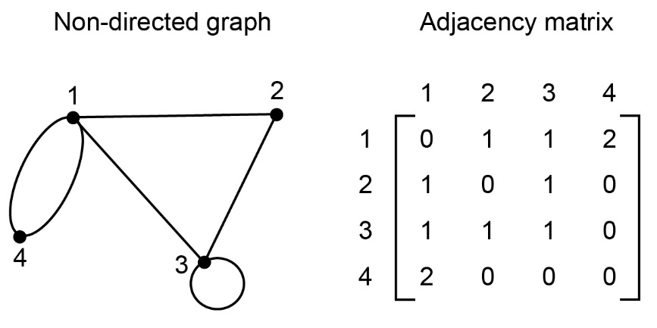
Adjacency matrix continued
For a directed graph the entry in row $i$ and column $j$ is the number of directed edges (arcs) joining the vertex $i$ and $j$ in the direction $i$ to $j$.
Example:
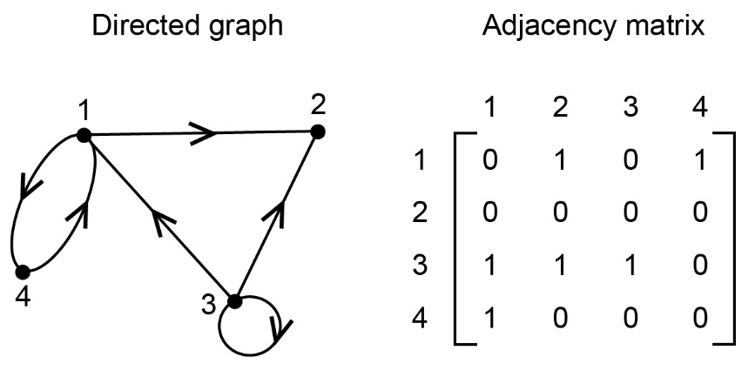
Arc
See Directed graph.
Bipartite graph
A bipartite graph is a graph whose set of vertices can be split into two distinct groups in such a way that each edge of the graph joins a vertex in the first group to a vertex in the second group.
Example:
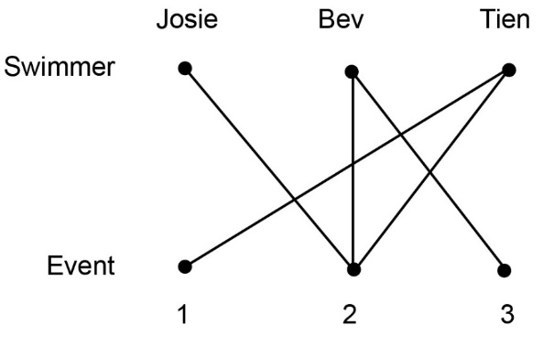
Bridge
See Connected graph.
Closed path
See Path
Closed trail
See Trail.
Closed walk
See Walk.
Complete graph
A complete graph is a simple graph in which every vertex is joined to every other vertex by an edge. The complete graph with $n$ vertices is denoted $K_{n}$. A complete bipartite graph is a bipartite graph where every vertex of the first set is connected to every vertex of the second set.
Connected graph
A graph is connected if there is a path between each pair of vertices. A bridge is an edge in a connected graph that, if removed, leaves a graph disconnected.
Cycle
A cycle is a closed path which begins and ends at the same vertex and which has no repeated edges or vertices except the first. If $a$, $b$, $c$ and $d$ are the vertices of a graph, the closed walk $bcdb$ that starts and ends at vertex $b$ (shown dotted) an example of a cycle.
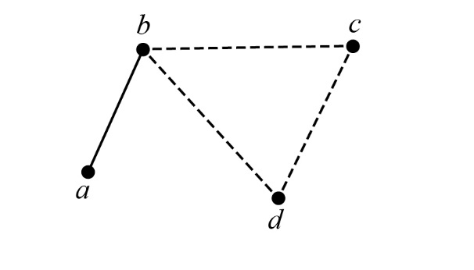
A cycle starting and ending at $b$
Degree of a vertex (graph)
In a graph, the degree of a vertex is the number of edges that enter or exit from the vertex, thus loops are counted twice.
In the graph below, deg $a$ = 4, deg $b$ = 2, deg $c$ = 4 and deg $d$ =2.
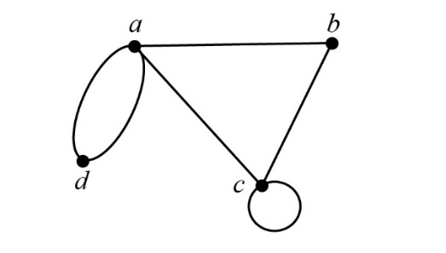
Digraph
See Directed graph.
Directed graph
A directed graph is a diagram comprising points, called vertices, joined by directed lines called arcs. The directed graphs are commonly called digraphs.
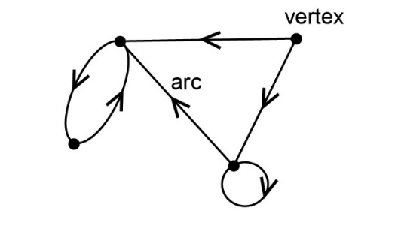
Edge
See Graph.
Euler’s formula
For a connected planar graph, Euler’s rule states that $v+f-e=2$, where $v$ is the number vertices, $e$ is the number of edges and $f$ is the number of faces.
Eulerian graph
A connected graph is Eulerian if it has a closed trail (starts and ends at the same vertex), that is, includes every edge and once only; such a trail is called an Eulerian trail. An Eulerian trail may include repeated vertices. A connected graph is semi-Eulerian if there is an open trail that includes every edge once only.
Face
The faces of a planar graph are the regions bounded by the edges, including the outer infinitely large region. The planar graph shown has four faces.
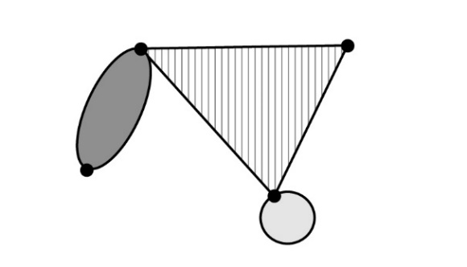
Food web
A food web (or food chain) depicts feeding connections (who eats whom) in an ecological community.
Graph
A graph is a diagram that consists of a set of points, called vertices, that are joined by a set of lines called edges. Each edge joins two vertices. A loop is an edge in a graph that joins a vertex in a graph to itself. Two vertices are adjacent if they are joined by an edge. Two or more edges which connect the same vertices are called multiple edges.
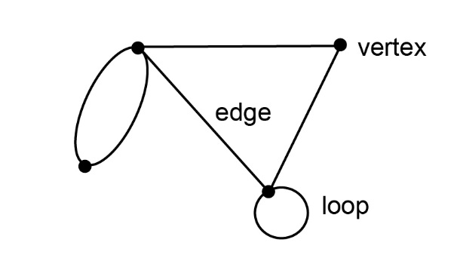
Hamiltonian graph
A connected graph is Hamiltonian if it contains a closed path (starts and ends at the same vertex), that includes every vertex (except the first one) once only. No edge is repeated.
Semi-Hamiltonian graph
A Semi-Hamiltonian graph contains a path that includes every vertex in a graph once only but is not a cycle.
Königsberg bridge problem
The Königsberg bridge problem asks: Can the seven bridges of the city of Königsberg all be traversed in a single trip that starts and finishes at the same place?
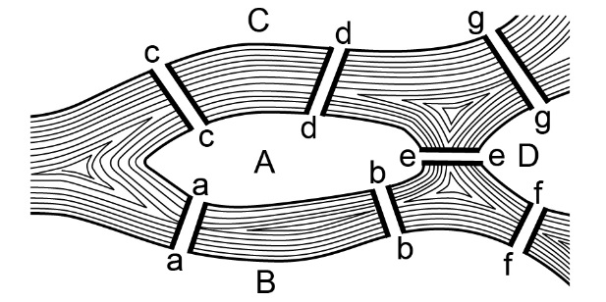
Length (of a walk)
The length of a walk is the number of edges it includes.
Multiple edges
See Graph.
Network
The word network is frequently used in everyday life, for example, television network, rail network. Practical situations that can be represented by the construction of a network include: trails connecting camp sites in a National Park, a social network, a transport network with one-way streets, a food web, the results of a round-robin sporting competition.
Weighted graphs or digraphs can often be used to model such networks.
Open path
See Path.
Open walk
See Walk.
Open trail
See Trail.
Path (in a graph)
A path in a graph is a walk in which all of the edges and all the vertices are different. A path that starts and finishes at different vertices is said to be open, while a path that starts and finishes at the same vertex is said to be closed. A cycle is a closed path.
If $a$ and $d$ are the vertices of a graph, a walk from $a$ to $d$ along the dotted edges is a path. Depending on the graph, there may be multiple paths between the same two vertices, as is the case here.
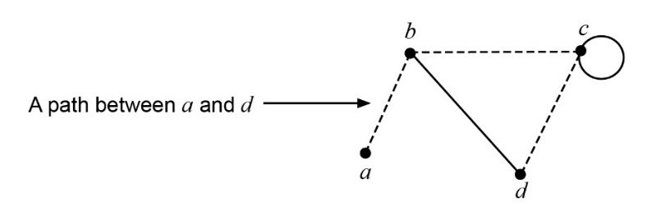
Planar graph
A planar graph is a graph that can be drawn in the plane. A planar graph can always be drawn so that no two edges cross.
Semi-Eulerian graph
See Eulerian graph.
Simple graph
A simple graph has no loops or multiple edges.
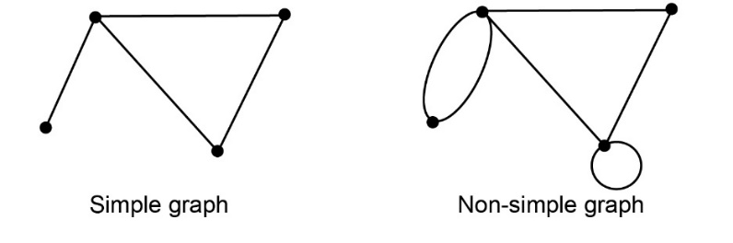
Subgraph
When the vertices and edges of a graph $A$ (shown dotted) are also vertices and edges of the graph $G$, graph $A$ is said to be a subgraph of graph $G$.
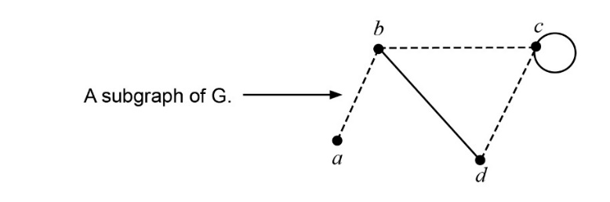
Trail
A trail is a walk in which no edge is repeated.
The travelling salesman problem
The travelling salesman problem can be described as follows: Given a list of cities and the distance between each city, find the shortest possible route that visits each city exactly once. While in simple cases this problem can be solved by systematic identification and testing of possible solutions, there is no known efficient method for solving this problem.
Vertex
See Graph.
Walk (in a graph)
A walk in a graph is a sequence of vertices such that from each of its vertices there is an edge to the next vertex in the sequence. A walk that starts and finishes at different vertices is said to be an open walk. A walk that starts and finishes at the same vertex is said to be closed walk.
If $a$, $b$, $c$ and $d$ are the vertices of a graph with edges $ab, bc, cc, cd$ and $bd$, then the sequence of edges ($ab, bc, cc, cd$) constitute a walk. The route followed on this walk is shown dotted on the graph below.
This walk is denoted by the sequence of vertices $abccd$. The walk is open because it begins and finishes at different vertices.
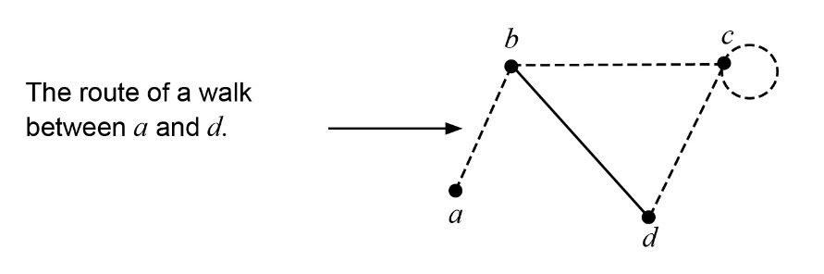
A walk can include repeated vertices (as is the case above) or repeated edges.
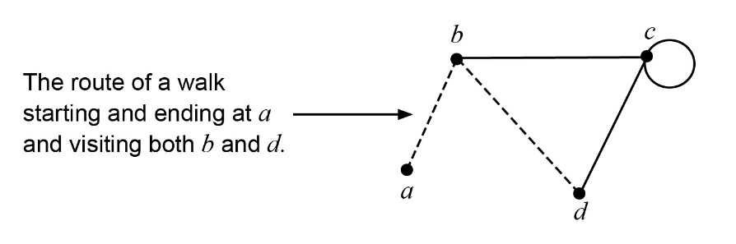
A example of a closed walk with both repeated edges, and hence vertices, is defined by the sequence of edges ($ab, bd, db, ba$) and is denoted by the sequence of vertices $abdba$. The route followed is shown dotted in the graph below. Depending on the graph, there may be multiple walks between the same two vertices, as is the case here.
Weighted graph
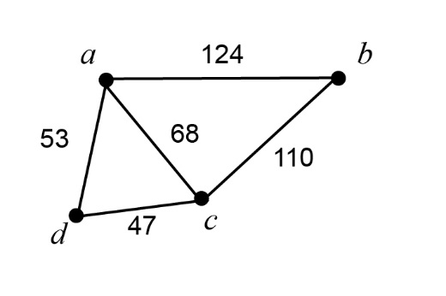
A weighted graph is a graph in which each edge is labelled with a number used to represent some quantity associated with the edge. For example, if the vertices represent towns, the weights on the edges may represent the distances in kilometres between the towns.

Unit 4
Time series analysis
Average percentage method
In the average percentage method for calculating a seasonal index, the data for each ‘season’ are expressed as percentages of the average for the year. The percentages for the corresponding ‘seasons’ for different years are then averaged using a mean to arrive at a seasonal index.
Moving average
In a time series, a simple moving average is a method used to smooth the time series whereby each observation is replaced by a simple average of the observation and its near neighbours. This process reduces the effect of non‐typical data and makes the overall trend easier to see.
Note: There are times when it is preferable to use a weighted average rather than a simple average, but this is not required in the current syllabus.
Seasonal adjustment (adjusting for seasonality)
Seasonal adjustment is a term used to describe a time series from which periodic variations due to seasonal effects have been removed.
See also Seasonal index.
Seasonal index
The seasonal index can be used to remove seasonality from data. An index value is attached to each period of the time series within a year. For the seasons of the year (Summer, Autumn, Winter, Spring), there are four separate seasonal indices; for months, there are 12 separate seasonal indices, one for each month, and so on. There are several methods for determining seasonal indices.
Seasonal variation
A regular rise and fall in the time series that recurs each year. Seasonal variation is measured in terms of a seasonal index.
Smoothing (time series)
See Moving average.
Time series
Values of a variable recorded, usually at regular intervals, over a period of time, is called a time series. The observed movement and fluctuations of many such series comprise long-term trend, seasonal variation, and irregular variation or noise.
Irregular variation or noise (time series)
Irregular variation or noise is erratic and short-term variation in a time series that is the product of chance occurrences.
Time series plot
The graph of a time series, with time plotted on the horizontal axis, is called a time series plot.
Trend (time series)
Trend is the term used to describe the general direction of a time series (increasing/decreasing) over a long period of time.
Loans, investments and annuities
Annuity
An annuity is a compound interest investment from which payments are made on a regular basis for a fixed period of time. At the end of this time the investment has no residual value.
For example, a problem could require determining the amount to be invested in an annuity to provide a regular monthly income of a certain amount for a fixed period of time, say 10 years.
Book value
The book value is the value of an asset recorded on a balance sheet. The book value is based on the original cost of the asset, less depreciation.
For example, if the original cost of a printer is $500 and its value depreciates by $100 over the next year, then its book value at the end of the year is $400.
There are three commonly used methods for calculating yearly depreciation in the value of an asset, namely, reducing balance depreciation, flat rate depreciation, or unit cost depreciation.
Compound interest
The interest earned by investing a sum of money (the principal) is compound interest if each successive interest payment is added to the principal for the purpose of calculating the next interest payment.
For example, if the principal $P$ earns compound interest at the rate of $i$ % per period, then after $n$ periods the total amount accrued is $P{(1+\frac{i}{100})}^{n}$. When plotted on a graph, the total amount accrued is seen to grow exponentially.
Problems involving compound interest loans or investments could include:
determining the future value of a loan; the number of compounding periods for an investment to exceed a given value; the interest rate needed for an investment to exceed a given value.
Effective annual rate of interest
The effective annual rate of interest $i_{effective}$ is used to compare the interest paid on loans (or investments) with the same nominal annual interest rate $i$ but with different compounding periods (daily, monthly, quarterly, annually, other).
If the number of compounding periods per annum is $n$, then
$$i_{effective}={\left(1+\frac{i}{n}\right)}^{n}-1$$
For example, if the quoted annual interest rate for a loan is 9%, but interest is charged monthly, then the effective annual interest rate charged is
$i_{effective}={(1+\frac{0.09}{12})}^{12}-1=0.093807$ …, or around 9.4%.
Diminishing value depreciation: see Reducing balance depreciation.
Flat rate depreciation
In flat rate or straight-line depreciation, the value of an asset is depreciated by a fixed amount each year. Usually this amount is specified as a fixed percentage of the original cost.
Straight-line depreciation
See Flat rate depreciation.
Perpetuity
A perpetuity is a compound interest investment from which payments are made on a regular basis in perpetuity (forever). This is possible because the payments made at the end of each period exactly equal the interest earned during that period.
Reducing balance depreciation
In reducing balance depreciation, the value of an asset is depreciated by a fixed percentage of its value each year. Reducing balance depreciation is sometimes called diminishing value depreciation.
Unit cost depreciation
In unit cost depreciation, the value of an asset is depreciated by an amount related to the number of units produced by the asset during the year.
Networks and decision mathematics
Algorithm
An algorithm is a precisely defined routine procedure that can be applied and systematically followed through to a conclusion. An example is Prim’s algorithm for determining a minimum spanning tree in a network.
Critical path analysis (CPA)
A project often involves many related activities, some of which cannot be started until one or more earlier tasks have been completed. One way of scheduling such activities that takes this into account is to construct a network diagram.
The network diagram below can be used to schedule the activities of two or more individuals involved in cleaning and polishing a car. The completion times for each activity are also shown.
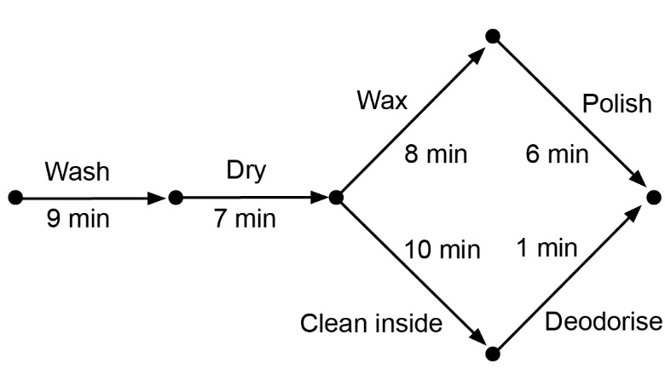
Critical path analysis is a method for determining the longest path (the critical path) in such a network, and hence, the minimum time in which the project can be completed. There may be more than one critical path in the network. In this project the critical path is ‘Wash-Dry-Wax-Polish’, with a total completion time of 30 minutes.
The earliest starting time (EST) of an activity, ‘Polish’, is 24 minutes because activities ‘Wash’, ‘Dry’ and ‘Wax’ must be completed first. The process of systematically determining earliest starting times is called forward scanning.
The shortest time that the project can be completed is 30 minutes. Thus, the latest starting time (LST) for the activity ‘De-odorise’ is 29 minutes. The process of systematically determining latest starting times is called backward scanning.
Float or slack
The amount of time that a task in a project network can be delayed without causing a delay to subsequent tasks is referred to as float or slack. For example, the activity ‘De-odorise’ is said to have a float of 3 minutes because its EST (26 minutes) is three minutes before its LST (29 minutes). As a result, this activity can be started at any time between 26 and 29 minutes after the project started. All activities on a critical path have zero floats.
Dummy link
A dummy link (activity) is one that has zero duration. It is necessary to use a dummy link in a project network if activities share some, but not all, of their immediate predecessors. A dummy link is represented on a network diagram using a dotted line.
Cut (in a flow network)
In a flow network, a cut is a partition of the vertices of a graph into two separate groups, with the source in one group and the sink in the other.
The capacity of the cut is the sum of the capacities of the cut edges directed from source to sink. Cut edges directed from sink to source are ignored.
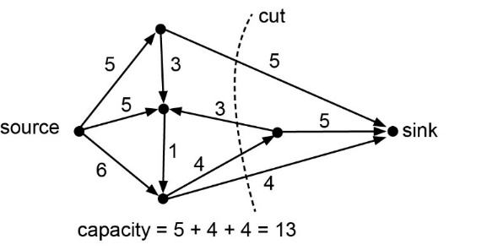
Example:
Earliest starting time (EST)
See Critical Path Analysis.
Float time
See Critical Path Analysis.
Flow network
A flow network is a directed graph where each edge has a capacity (for example, 100 cars per hour, 800 litres per minute) and each edge receives a flow. The amount of flow on an edge cannot exceed the capacity of the edge.
A flow must satisfy the restriction that the amount of flow into a node equals the amount of flow out of it, except when it is a source, which has more outgoing flow, or a sink, which has more incoming flow. A flow network can be used to model traffic in a road system, fluids in pipes, currents in an electrical circuit, or any situation in which something travels through a network of nodes.
Small-scale network problems could, for example, include determining the maximum volume of oil flow through a network of pipes from an oil stoorage tank (the source) to a terminal (the sink).
Hungarian algorithm
The Hungarian algorithm is used to solve assignment (allocation) problems.
Latest starting time (LST)
See Critical Path Analysis.
Maximum flow–minimum cut theorem
The maximum flow–minimum cut theorem states that in a flow network, the maximum flow from the source to the sink is equal to the capacity of the minimum cut. In everyday language, the minimum cut involved identifies the ‘bottle-neck’ in the system.
Example:
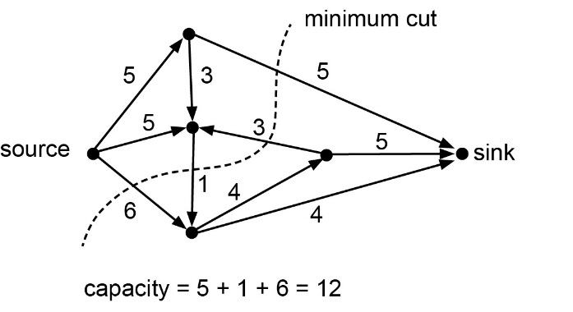
Minimum spanning tree
For a given connected weighted graph, the minimum spanning tree is the spanning tree of minimum length.
Prim’s algorithm
Prim’s algorithm is an algorithm for determining a minimum spanning tree in a connected weighted graph.
Round-robin sporting competition
A single round-robin sporting competition is a competition in which each competitor plays each other competitor once only.
Spanning tree
A spanning tree is a subgraph of a connected graph that connects all vertices and is also a tree.
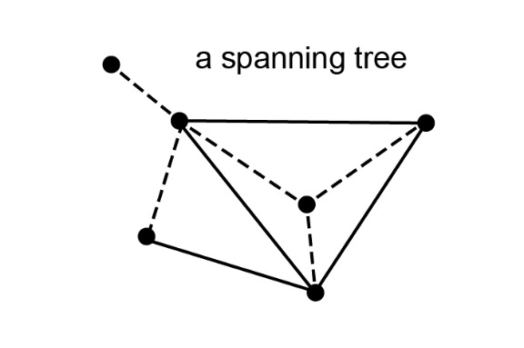
Tree
A tree is a connected graph with no cycles.
