Details of VET Certificate IV or higher for secondary students
- This form is used to assist schools in providing information about Certificate IV or higher programs to the School Curriculum and Standards Authority where student enrolments have been recorded.
- The basis for gathering this information is for the Authority to gain an understanding of the structures and context for the delivery and assessment of VET programs at higher AQF levels.
- This form may be also be used to provide information to VET regulators or to provide responses to other stakeholders.
Schools are encouraged to refer to the Department of Training and Workforce Development VET qualifications register for secondary school students for advice on the suitability of qualifications for secondary students.
The link to the register can be accessed here:
http://www.dtwd.wa.gov.au/training-providers-and-schools/vet-schools
Please provide details of any Certificate IV or higher qualifications that students are enrolled in on this form and return to the Authority at vetinfo@scsa.wa.edu.au by 4.30 pm on Friday, 14 September 2018.
School name | School code

Qualification code | Qualification title | Number of student enrolments | Student year level | RTO name | RTO code
Add additional rows as required.
Section 1: Qualification delivery arrangements
Tick () the appropriate box. Add additional rows as required.
Qualification code | Training delivery location
 | Private RTO | TAFE | School | Workplace | Other (please specify)
Tick () the appropriate box. Add additional rows as required.
Qualification code | Delivery arrangement
 | Profile | Auspice | Fee-for- service | School-based traineeship/ apprenticeship | Other (please specify)
Tick () the appropriate box. Add additional rows as required.
Qualification code | Delivery mode
 | Face-to-face | Online | Workplace | Other (please specify)
Tick () the appropriate box. Add additional rows as required.
Qualification code | Duration of program: (school year)
 | Less than 1 year | 1 year | 2 years | More than 2 years | Qualification to be completed by the end of Year 12 – Yes/No
Tick () the appropriate box. Add additional rows as required.
Qualification code | Delivery hours
 | 1 day per week | 2 days per week | 3 days per week | Block delivery
 | Hours | Hours | Hours | Block/s | Weeks | Hours

Section 2: Qualification requirements
- What are the training package entry requirement/s for this qualification?
- Does the school/RTO require any additional entry requirements? If so, what are they?

- Provide SIRS report CSE029 as an attachment for each individual qualification.
Include:
- Provider
- Year
- Qualification Code in Qualification
Prefix
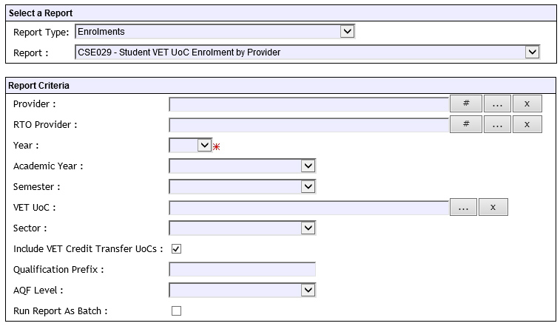
Section 3: Student characteristics
- How many students intending to enrol or already enrolled in this Certificate IV or higher have previously:
completed/enrolled in qualifications in a related training package?
completed/enrolled in industry related work experience?
Section 4: Industry/employer partners and Workplace Learning
- Will the students be undertaking Workplace Learning in conjunction with these qualifications?
 | Yes |  | No
If yes, will the students be enrolled in the Authority-developed Work Place Learning (ADWPL) program?
 | Yes |  | No
If no, please provide reason, e.g. not a requirement of the qualification; for example, the student has no capacity to undertake this within their current workload. Specify which qualification.
- Details of industry/employer partners, if applicable.

