Music Performance Resource Package
Year 11 and Year 12
Suggested technical work and repertoire
Suggested technical work
Scales
Technical repertoire
Suggested repertoire
Year 11
Year 12
Additional resources
Recommended additional listening for jazz and comtemporary
Suggest texts for jazz and contemporary drum kit and voice
Vocal stylistic differences – contexts
The suggested technical work and repertoire listed provide an indication of the standard of performance required in both Year 11 and Year 12 for each instrument across all contexts. Alternative technical work and repertoire may be selected in addition to or instead of the material provided in this package. Technical work should be selected to reflect the student’s level of instrumental development and to enhance and support repertoire being prepared by the student.

Copyright
© School Curriculum and Standards Authority, 2019
This document – apart from any third party copyright material contained in it – may be freely copied, or communicated on an intranet, for non-commercial purposes in educational institutions, provided that the School Curriculum and Standards Authority is acknowledged as the copyright owner, and that the Authority’s moral rights are not infringed.
Copying or communication for any other purpose can be done only within the terms of the Copyright Act 1968 or with prior written permission of the School Curriculum and Standards Authority. Copying or communication of any third party copyright material can be done only within the terms of the Copyright Act 1968 or with permission of the copyright owners.
Any content in this document that has been derived from the Australian Curriculum may be used under the terms of the Creative Commons Attribution 4.0 International (CC BY) licence.
Disclaimer
Any resources such as texts, websites and so on that may be referred to in this document are provided as examples of resources that teachers can use to support their learning programs. Their inclusion does not imply that they are mandatory or that they are the only resources relevant to the course.
MUSIC PERFORMANCE RESOURCE PACKAGE
The following resource package may be used by schools to assist in the delivery of the practical component for the Year 11 and Year 12 ATAR Music courses. Guidelines for practical school-based assessments and examinations are outlined and additional instrumental documents provide an indication of appropriate performance standards for students in Year 11 and Year 12.
The information has been provided to the School Curriculum and Standards Authority by instrumental and vocal teachers experienced in selecting repertoire for students who may have varying skills and abilities.

School-based practical (performance) assessment
Candidates must select a performance context. The candidate may perform some repertoire in a different context, providing the majority of the repertoire is in the context selected. Practical performance tasks should be programmed through consultation between the instrumental/vocal teacher and the classroom teacher. These tasks can be assessed using at least two of the performance activities outlined in the syllabus.

Course requirements for the practical (performance) component must include:
- Course outline – sequence and timing, assessed as stipulated in the syllabus and WACE manual.
- Assessment outline – detailing coverage of content, assessment types, tasks, weighting and timing for each task.
- Assessment tasks and marking keys.
- Marks book – recording marks, weighting and collating results of all assessments.
A copy of the above documents must be available to both the instrumental/vocal and classroom teacher for moderation and grading purposes. It is strongly recommended that across a year level, a range of different assessment types be covered.

School-based practical (performance) examination
The school-based practical (performance) examination for Year 11 and Year 12 is a requirement of the syllabus. It is recommended that the practical (performance) examination for ATAR is conducted to reflect the requirements of the WACE recital-based external examination. Detailed information about the WACE practical examination is available in the separate document: Music ATAR Course Practical (performance and/or composition portfolio) examination requirements (available on the Music ATAR course page under Examination Materials).
It is strongly recommended that the same criteria and weightings in the current Music Practical (performance) marking key (available on the Music ATAR course page under Examination Materials) be used for be school-based tasks and semester examinations. All candidates in all contexts must present a minimum of two contrasting pieces for each examination. The repertoire should contrast in tempo, genre/style and era as appropriate to context. The Semester 1 examination can include a reduced time allocation for the practical examination. Schools can include an instrumental/vocal teacher or a suitable instrumental specialist as a member of the marking panel for school-based performance examinations.

Context- and instrument-specific requirements
Requirements and advice regarding the different context and instrument options is located in the document: Music ATAR Course Practical (performance and/or composition portfolio) examination requirements (available on the Music ATAR course page under Examination Materials). The above document must be referred to by schools in conjunction with this document to plan their courses.

Practical (performance) resources:

Suggested technical work
- Technical works listed are suggestions only.
- Technical work is not examined in the WACE external examination but can be incorporated as part of the school-based assessment.
- Technical work should be selected to reflect the student’s level of instrumental development and to enhance and support repertoire being prepared by the student.

Suggested repertoire
While the pieces listed provide a wide range and scope of repertoire for prepared works, it is expected that instrumental/vocal teachers will select repertoire that meet all syllabus requirements and reflect the student’s skill and ability level.
- Pieces listed are suggestions only and provide an indication of the minimum level of performance required.
- Repertoire may be selected in addition to or instead of the typical pieces listed.
- Repertoire for Year 11 can also be drawn from the lists appropriate for Grades 4 to 6 and for Year 12 from Grade 6 onwards, as included in current performance syllabuses from accredited music examination boards available within Australia. Repertoire selected from other sources must be of an equivalent standard.
- For pieces where publishers are not stipulated, it is recommended that performers use scores that are as near to the original as possible.

Additional resources
- Recommended additional listening provides some suggested works for students to listen to in addition to the works they are preparing for performance.
- Suggested texts provide a list of useful teaching resources for some instruments and contexts.
- Vocal stylistic differences – contexts is a comparison of the four performance contexts for voice.

Supporting information
- School Curriculum and Standards Authority website
- WACE Manual
- Music ATAR Course Practical (performance and/or composition portfolio) examination requirements document, outlining WACE performance examination requirements and details of the submission process for the composition portfolios
- 11to12 Circular for submission dates, examination details and relevant updated material.
TABLE OF CONTENTS
WESTERN ART MUSIC 1
WIND INSTRUMENTS 1
FLUTE 1
CLARINET 8
BASS CLARINET 12
OBOE 15
BASSOON 19
SAXOPHONE 23
BRASS INSTRUMENTS 27
HORN 27
TRUMPET 30
TROMBONE/BASS TROMBONE/EUPHONIUM 33
TUBA 38
PERCUSSION 41
STRING INSTRUMENTS 46
VIOLIN 46
VIOLA 52
VIOLONCELLO 58
DOUBLE BASS 64
HARP – pedal harp 69
HARP – non-pedal harp 72
CLASSICAL GUITAR 75
KEYBOARD 81
ORGAN 81
PIANOFORTE 85
HARPSICHORD 89
VOICE 92
JAZZ 97
INSTRUMENTAL SPECIFICATIONS 97
WIND INSTRUMENTS 99
FLUTE 99
CLARINET 101
SAXOPHONE 103
BRASS INSTRUMENTS 105
TRUMPET 105
TROMBONE 107
DRUM KIT 109
GUITAR 112
BASS GUITAR AND/OR ACOUSTIC/DOUBLE BASS 114
PIANO/KEYBOARD 117
VOICE 120

CONTEMPORARY 126
DRUM KIT 126
GUITAR 131
BASS GUITAR 137
PIANO/KEYBOARD 140
VOICE 143
MUSIC THEATRE 148
VOICE 148
RECOMMENDED ADDITIONAL LISTENING 152
JAZZ 152
CONTEMPORARY 154
SUGGESTED TEXTS 156
JAZZ and CONTEMPORARY 156
DRUM KIT 156
VOICE 156
VOCAL STYLISTIC DIFFERENCES – CONTEXTS 159

WESTERN ART MUSIC

WIND INSTRUMENTS

FLUTE

SUGGESTED TECHNICAL WORK – YEAR 11
- All major, harmonic and melodic minor scales up to and including 4 sharps and 4 flats, all major and minor arpeggios and all major and minor broken chords of the same keys – range 2 octaves.
- A chromatic scale on A – range 2 octaves.
- Major scales in thirds D, F, A and E♭ majors – range 2 octaves.
- Dominant 7th arpeggios commencing on F and G – range 2 octaves.
Tempo: Crotchet = 66 beats per minute, 4 notes per beat.
Articulations: all tongued, all slurred, two slurred two tongued, two slurred two slurred.
Supporting texts and examples
Berbiguier, B. 18 Exercises or Etudes for Flute No.1, 3, 6, 7 (Schirmer)
Cockcroft, B. Zodiac – Libra No.7 (Reedmusic.com)
Gariboldi, G. Allegro Brilliante, AMEB Grade 4, Series 3
Gariboldi, B. Allegretto, AMEB Grade 5, Series 3
Koehler, E. Etude, AMEB Grade 4, Series 3
Koehler, E. Etude, AMEB Grade 5, Series 3
Moyse, M. 24 Petites Etudes Melodies, Nos.1, 3 (Alphonse Leduc)
Rae, J. 40 Modern Studies for Solo Flute, Nos.26, 27, 29, 35 (Universal)

SUGGESTED TECHNICAL WORK – YEAR 12
- All major, harmonic and melodic minor scales up to and including 5 sharps and 5 flats, all major and minor arpeggios and all major and minor broken chords of the same keys – range 2 octaves
- A chromatic scale on B♭ – range 2 octaves
- Major scales in thirds up to and including 4 sharps and 4 flats – range 2 octaves
- Dominant 7th arpeggios commencing on E♭, B♭ and B
Tempo: Crotchet = 66 beats per minute, 4 notes per beat.
Articulations: all tongued, all slurred, two slurred two tongued, two slurred two slurred. Major scales double tongued (2 articulations per note).
Supporting texts and examples
Anderson, J. 24 Progressive Studies Op.33, Nos.1, 3, 7, 8 (IMC)
Anderson, J. 24 Etudes Op.15 for Flute, Nos.2, 9a/b (Schirmer)
Berbiguier, B. 18 Exercises or Etudes for Flute, Nos.4, 8 (Schirmer)
Cockcroft, B. Zodiac – Capricorn, Pisces, Sagittarius (reedmusic.com)
Mower, M. 20 Commandments, Nos.6, 9, 11, 12, 13 (Itchy Fingers)
Moyse, M. De La Sonorite Art of Technique – Interval exercise p. 15 (Alphonse Leduc)
Rae, J. 20 Hard Rock Blues AMEB Grade 6, Series 3
Reichert, M. Finger Exercises, Nos.1 (Schott)

TECHNICAL WORK – SUGGESTED REPERTOIRE

Tonguing
Moyse, M. De la Sonorite p. 15
Vester, F. 100 Classical Studies, Nos.9, 12
Advanced
Mendelssohn, F. The Hebrides Overture (Fingal’s Cave)
Moyse, M. 10 Etudes, No.1
Anderses, K. J. 24 Exercises, No.2

Articulation patterns
Bays, M. Flute Handbook, p. 18
Rubank Selected Studies (Voxman), pp. 5, 13, 14/15, 23, 34, 35
Koehler, E. Studies, No.1, No.5 (Book 1)
Vester, F. 125 Easy Classical Studies, Nos.91, 109, 116, 117, 118, 119
Vester, F. 100 Classical Studies, Nos.7, 13, 21, 22
Advanced
Berbiguier, B. 18 Exercises, No.3
Boehm, T. 24 Caprices, No.23

Double tonguing
Bays, M. Flute Handbook, pp. 28–29
Vester, F. 125 Easy Classical Studies, No.125
Rubank Selected Studies (Voxman), pp. 21, 26, 47, 48, 60
Bullard, A. 50 for Flute (Book 2), Lively Flute
Koehler, E. Studies, No.4 (Book 2)
Vester, F. 100 Classical Studies, Nos.17, 91
Advanced
Bach, J. S. Sonata in C major 2nd movement
Mendelssohn, F. Scherzo ‘Midsummer Night’s Dream’
Paganini, N. 24 Caprices, No.5 (first section only)
Paganini, N. 24 Caprices, No.18
Triple tonguing
Bays, M. Flute Handbook, pp. 30–31
Rubank Selected Studies (Voxman), pp. 27, 41
Vester, F. 100 Classical Studies, No.87
Advanced
Busser, H. Prelude and Scherzo
Rossini, G. Overture ‘Semiramide’
Boehm, T. 24 Caprices, No.10
Platonov, V. N. 20 Studies for Flute, No.10
Reichert, M. A. Tagliche Ubungen for Flute Opus 5, No.7
Trills
Bays, M. Flute Handbook p. 51–52
Rubank Selected Studies (Voxman), pp. 2, 16, 55
Bullard, A. 50 for Flute (Book 2) Spooky Flute
Advanced
Berbiguier, T. 18 Exercises, No.2
Furstenau, A. 26 Ubungen Exercises Opus 107, No.19
Boehm, T. 24 Caprices, No.5

Ornamentation
Vester, F. 100 Classical Studies, Nos.47, 49
Vester, F. 125 Easy Classical Studies, Nos.52, 53, 54, 55, 76, 92, 115
Rubank Selected Studies (Voxman), pp. 8, 10, 17, 22, 30, 38
Bullard, A. 50 for Flute (Book 2), Circus Flute
Koehler, E. Studies (Book 2), No.10
Advanced
Furstenau, A. 26 Ubungen Exercises Opus 107, No.16
Paganini, N. 24 Caprices, No.11

Mixed metre
Bays, M. Flute Handbook, p. 47, 49
Rubank Selected Studies (Voxman), p. 7
Bullard, A. 50 for Flute (Book 1), Twopenny Flute
Advanced
Berbiguier, T. 18 Exercises, No.4
Paganini, N. 24 Caprices, No.11

Syncopation
Vester, F. 125 Easy Classical Studies, Nos.56, 57
Vester, F. 100 Classical Studies, Nos.40, 41
Advanced
Rimsky-Korsakov, N. Capriccio Espangnol (1V Scena e canto gitano)
Borodin, A. Polotsvian Dances (Allegro vivo)
Furstenau, A. 26 Ubungen Opus 107, No.24

Compound time
Vester, F. 125 Easy Classical Studies, Nos.9, 27, 36, 81, 83, 86, 87, 89, 96, 97, 98, 102, 106, 110, 124
Rubank Selected Studies (Voxman), pp. 20, 25, 28–29, 40, 50, 51, 56
Bullard, A. 50 for Flute (Book 2), Fluent Flute
Koehler, E. Studies (Book 2), Nos.6, 7
Advanced
Bach, J. S. Sonata in E major (3rd movement)
Rimsky-Korsakov, N. Capriccio Espagnol (IV Scena e canto gitano)
Stravinsky, I. The Firebird Suite
Paganini, N. 24 caprices, Nos.20, 23

3rd Octave
Bays, M. Flute Handbook, pp. 34–42 and 43–45
Bullard, A. 50 for Flute (Book 2) Solitary Flute
Koehler, E. Studies (Book 2), No.10
Advanced
Schubert, F. Rosamunde Overture
Tchaikovsky, P. ‘Chinese Dance’ Nutcracker Ballet
Paganini, N. 24 Caprices, No.9 (middle section) and No.23

Low register
Bays, M. Flute Handbook, p. 18
Koehler, E. Studies (Book 1), No.7
Advanced
Smetana, B. Moldau from Ma Vlast
Ravel, M. Bolero
Prokofiev, S. Sonata in D major 3rd movement

Intervals – embouchure flexibility
Vester, F. 125 Easy Classical Studies, Nos.84, 102, 105, 106, 122
Rubank Selected Studies (Voxman), pp. 9, 39
Bullard, A. 50 for Flute (Book 1) Victorian Flute (Book 2) Waltzing Flute
Koehler, E. Studies (Book 1), Nos.6, 15
Vester, F. 100 Classical Studies, Nos.20, 52, 53, 76, 79, 80, 81
Advanced
Bizet, G. L’Arlesienne (Suite, No.2)
Berbiguier, T. 18 Exercises, No.6
Paganini, N. 24 Caprices, No.2
Boehm, T. 24 Caprices, Nos.22 and 7
Moyse, M. 10 Etudes, No.1
Furstenau, A. 26 Ubungen Opus 107, No.21

Finger dexterity
Bays, M. Flute Handbook pp. 22, 23
Vester, F. 125 Easy Classical Studies, Nos.48, 49, 51, 58, 59, 60, 66, 69, 70, 78, 80, 93, 96, 97, 100, 101, 103, 106, 107, 109, 111, 113, 114, 116, 117, 120, 123
Rubank Selected Studies (Voxman), pp. 3, 24
Bullard, A. 50 for Flute (Book 2), Agile Flute
Koehler, E. Studies (Book 1), Nos.13, 14 (Book 2), Nos.4, 9
Advanced
Reichert Tagliche Ubungen, No.1

Finger dexterity – chromatic
Bays M. Flute Handbook, p. 47
Bullard, A. 50 for Flute (Book 1) Thoughtful Flute
Koehler, E. Studies (Book 2), No.7
Advanced
Rimsky-Korsakov, N. Capriccio Espagnol 11 Variazioni
Reichert, M. Tagliche Ubungen for Flute, No.6

Phrasing/interpretation
Bays, M. Flute Handbook, p. 48
Rubank Selected Studies (Voxman), pp. 31, 32, 33, 36
Bullard, A. 50 for Flute (Book1) Unhappy Flute (Book 2) Reflective Flute
Koehler, E. Studies (Book 1), No.13 (Book 2), No.6
Vester, F. 100 Classical Studies, Nos.1, 2, 3, 4, 33, 34, 35, 36, 78
Advanced
Bach, J. S. Sonata in e minor (3rd movement)
Gluck, C. W. ‘Orfeo’ dance of the Blessed Spirits
Mozart, W. A. ‘Andante’ Flute Quartet in D major
Paganini, N. 24 Caprices, No.21 (first section)

Dynamics
Bays, M. Flute Handbook, p. 19
Bullard, A. 50 for Flute (Book 2), Comical Flute, Spooky Flute
Koehler, E. Studies (Book 2), No.3
Moyse, M. De la Sonorite exercise, No.1 (p. 10)
Advanced
Poulenc, F. Sonata (2nd movement)

Legato
Bays, M. Flute Handbook, pp. 25–27
Vester, F. 125 Easy Classical Studies, Nos.1–8, 12–16, 121
Rubank Selected Studies (Voxman), pp. 4, 6, 31 (slow), pp. 11, 58–59 (fast)
Bullard, A. 50 for Flute (Book 1) Dreamy Flute, Plaintive Flute
Koehler, E. Studies (Book 1), No.8 (Book 2), No.6
Advanced
Poulenc, F. Sonata (2nd movement)
Bach, J. S. Sonata in e minor (3rd movement)
Ravel, M. Bolero
Berbiguier, T. 18 Etudies, No.6

Vibrato
Bays, M. Flute Handbook, p. 25
Moyse, M. De la Sonorite exercise, No.1 (p. 10)

SUGGESTED REPERTOIRE – YEAR 11
Arnold, M. Sonatina, Op.29, 2nd or 3rd movements (Lengnick) (Oxford University Press)
Bach, J. S. Suite in B minor, BWV 1067, Polonaise (including Double) and Badinerie (IMC)
(Peters edition)
Bach, J. S. Sonata in Eb major, 2nd movement, BWV 1031 (Henle)
Bailey, K. Jazz incorporated Volume 2, any piece (Kerin Bailey Music)
Benfall, S. Blues at Eleven (AMEB Grade 4, Series 3)
Berkeley, L. Sonatina for flute/recorder, 3rd movement (Schott)
Bolling, C. Suite for flute and Jazz piano ‘Baroque and Blue’ (Hal Leonard)
Boyd, A. Goldfish through Summer Rain (AMC) (Faberpoint)
Chedeville, N. Allegro ma non Presto (AMEB Grade 5, Series 3)
Chopin, F. Variations on a Theme by Rossini, Theme and Variations (IMC)
Debussy, C. The Little Shepherd (Schott)
Dodgson, S. Circus-Pony from New Pieces for Flute: book 2 (ABRSM)
Fauré, G. Morceau de Concours (Bourne and Co., New York)
Fauré, G. Piece from Fauré Flute Album (Novello)
Fauré, G. Sicilienne, Edition Musica or IMC
Gaubert, P. Madrigal (IMC)
Gretry, A. Concerto in C major, 2nd movement, from L. Moyse Flute Collection Flute Music of the Baroque (Schirmer)
Handel, G. F. Sonata in A minor 1st and 2nd movements (Peters) (Barenreiter)
Handel, G. F. Sonata in C major, 1st and 2nd movements (Peters) (Barenreiter)
Handel, G. F. Sonata in F major, any two movements (Peters) (Barenreiter)
Harris, P. With a Hint of Lime (AMEB Grade 5, Series 3)
Hyde, M. Wedding Morn from Five solos for flute and piano (EMI)
Kronke, P. Sarabande and Gavotte from Suite in Ancient Style, Op.81, Zimmerman
Locatelli, P. Largo and Allegro (AMEB Grade 4, Series 3)
Loeillet, J. Gavotte and Aria (AMEB Grade 4, Series 3)
Koepke, P. Villanella (AMEB Grade 5, Series 3)
Marcello, B. Adagio and Allegro (AMEB Grade 4, Series 3)
Marcello, B. Presto (AMEB Grade 5, Series 3)
Mozart, W. A. Sonata Bb major K.10, 1st and 2nd movements (Kalmus) (Barenreiter)
Mozart, W. A. Sonata in F major K13, 1st movement (Kalmus)
Negerevich, N. Timepiece (Dorian Music)
Piazzolla, A. Historie du Tango, Café (Henry Lemoine)
Poulenc, F. Sonata, 2nd movement (Chester)
Rabboni, G. Sonatas for Flute and Piano, Book 1, No1 (Kevin Mayhew)
Reger, M. Romanze for flute and piano (Breitkopf)
Roussel, A. Quatre Pieces for flute and piano Op.27, Krishna (Schott)
Rutter, J. Suite Antique, Prelude and Ostinato or Ostinato and Aria (Oxford University)
Telemann, G. P. Spiritoso and Andante (AMEB Grade 5, Series 3)
Telemann, G. P. Sonata in G major, 1st and 2nd movements (Barenreiter)
Telemann, G. P. Sonata in F major, 1st and 2nd movements (Barenreiter)
Vivaldi, A. Concerto in G minor ‘La Notte’, 2nd and 3rd movements (Schott)
Vivaldi, A. Concerto in G major RV 435 1st movement (Schott)
Wilson, A. Summer Samba (AMEB Grade 4, Series 3)
The following contains numerous suitable works:
24 Short Concert Pieces (SMC) or Concert and Contest Album (Rubank)
Anderson, J. Scherzino, Op.55, No.6
de Boisdeffre, R. Orientale
Donjon, J. Pan
Faure, G. Sicilienne
Godard, B. Allegretto or Idylle
Joncieres, V. Hungarian Serenade

SUGGESTED REPERTOIRE – YEAR 12
Bach, J. S. Sonata in G minor, BWV 1020, 1–2 movements (Henle) (Barenreiter) (Schirmer)
Bach, J. S. Sonata in Eb major BWV 1031, 1–2 movements (Henle) (Barenreiter) (Schirmer)
Bach, J. S. Sonata in E major BWV 1035, 1–2 movements (Henle) (Barenreiter)
Bach, J. S. Sonata in E minor, 1–2 movements (Henle) (Barenreiter) (Schirmer)
Bailey, K. No.5 – Butterfly Samba or No.1 – Raindrop impressions from Five Dances (Kerin Bailey Music)
Bailey, K. Wave Dancer, Night Sky from Five Pieces (Kerin Bailey Music)
Berkeley, L. Sonatina for Flute/Recorder, 1st movement or 2nd and 3rd movements (Schott)
Bloch, E. Suite Modale, any movement/s (Broude)
Bolling, C. Suite No.1, Baroque and Blue or Sentimentale or Javanaise (Hal Leonard)
Boyd, A. Goldfish through Summer Rain (Faberpoint)
Boyd, A. Bali Moods (AMC)
Busser, H. Petite Suite, any movement/s (Durand)
Burton, E. Sonatina, any movement (Carl Fischer)
Chaminade, C. Concertino, from L. Moyse Flute Collection ‘French Flute Music’ (Schirmer)
Chedeville, N. Vivace ma non Presto (AMEB Grade 6, Series 3)
Chopin, F. Variations on a theme by Rossini (IMC) (Schott)
Clarke, I. Hypnosis (IC Music/Just Flutes)
Clarke, I. Spiral Lament (IC Music/Just Flutes)
Clarke, I. Sunstreams (IC Music/Just Flutes)
Cooke, A. Sonatina, any movement/s (Oxford University Press)
Debussy, C. Syrinx for Solo Flute (Barenreiter) (Chester Music)
Donizetti, G. Sonata (AMEB Grade 6, Series 3)
Doppler, F. Hungarian Pastoral Fantasy Op.26, first section (Chester Music)
Dvorak, A. Sonatina, Op.100, 1st movement (IMC) (Schirmer)
Enesco, G. Cantabile et Presto, from L. Moyse Flute Collection ‘French Flute Music’ (Schirmer)
Fauré, G. Fantasie, from L. Moyse Flute Collection ‘French Flute Music’ (Schirmer)
Franck, C. Sonata, any movement (IMC) (Schirmer)
Gaubert, P. Madrigal (Enoch) (IMC) (Warner)
Gliere, R. Melody for flute and piano (Little Piper)
Gluck, C. Concerto in G major, any movement (Kalmus)
Gretry, A. Concerto in C major, any movement from L. Moyse Flute Collection Flute Music of the Baroque (Schirmer)
Handel, G. F. Sonata in G major HWV 363b, any movement/s (Barenreiter) (Peters)
Hindemith, P. Acht Stucke, any two or three movements (Schott)
Holcombe, B. Sonata No.2 any movement/s
Hyde, M. Sonata, any movement (AMC)
Hyde, M. Beside the Stream from Five solos for flute and piano (EMI)
Hoffmeister, F.A. Sonata in G major, Op.21/3 any movement (Schott)
Leclair, J.M. Sonata in G major, 1st and 2nd or 3rd and 4th movements (Schott)
Jacob, G. The Spell (Oxford University Press)
Martinů, B. Sonata, any movement (Schirmer)
Moszkowski, M. Moderato (AMEB Grade 6, Series 3)
Mower, M. Sonata Latino, any movement (Itchy Fingers)
Mouquet, J. Cinq Piece Breve, Op.3, any three movements from (Lemoine)
Mouquet, J. La Flute de Pan, any movement (IMC) (Lemoine)
Mozart, W. A. Sonata in C major, K.14 any movement/s (Barenreiter) (Kalmus) (Reinhardt)
Mozart, W. A. Sonata in F major, K.13 any movement/s (Barenreiter) (Kalmus) (Reinhardt)
Mozart, W. A. Concerto in D major K.314, any movement (IMC)
Mozart, W. A. Concerto in G major K.313, any movement (IMC)
Negerovich, N. Timepiece (Dorian Music)
Norton, C. Sonatina, 1st movement (Boosey & Hawkes)
Piazolla, A. Historie du Tango, any movement (Henry Lemoine)
Poulenc, F. Sonata, any movement (Chester)
Prokofiev, S. Sonata D major, Op.94, any movement (IMC) (Schirmer)
Rabboni, G. Sonatas for Flute and Piano book one, No.5 or No.12 (Kevin Mayhew)
Rutter, J. Suite Antique, any movement/s (Oxford)
Schubert, F. Introduction and Variations on a theme from ‘The Fair Maid of the Mill’ Introduction, Theme and any flute variation/s (IMC) (Barenreiter)
Schumann, R. 3 Romances, Op.94, any two (IMC)
Saint-Saëns, C. Romance Op.51 (Durand)
Schocker, G. Regrets and Resolutions (Theodore Presser)
Telemann, G. P. Sonata in C minor, any two movements (Barenreiter)
Telemann, G. P. Sonata in F minor TWV 41: f1, any two movements (Amadeus)
Vivaldi, A. Concerto ‘Il Cardelino’ in D major, 1st and 2nd or 2nd and 3rd movements from
L. Moyse: Flute Collection Flute Music of the Baroque (Schirmer)
Vivaldi, A. Concerto in G minor RV 439 ‘La Notte’ any 2–3 movements (Schott)
For piccolo players
Jacob, G. The Pied Piper, 2nd movement, March to the River Weser (Oxford University Press)
Vivaldi, A. Concerto in C major RV443, 1–2 movements (IMC)
Vivaldi, A. Concerto in A minor, 1–2 movements (IMC)

CLARINET

SUGGESTED TECHNICAL WORK – YEAR 11
- All major, harmonic and melodic minor scales up to and including 4 sharps and 4 flats, all major and minor arpeggios and all major and minor broken chords of the same keys – range 2 octaves.
- Chromatic scale on F – range 3 octaves.
- Major scales in thirds – F, D, B♭, A – range 2 octaves.
- Dominant 7^{ths} of C, F and G – range 2 octaves.
Tempo: Crotchet = 66 beats per minute, 4 notes per beat.
Articulations: all tongued, all slurred, two slurred two tongued, two slurred two slurred.
Supporting texts and examples
Hite, D. Melodious and Progressive Studies, Book 1 (a selection of studies by Demnitz, Nocentini, Baermann and Klose)
Rae, J. 40 Modern Studies, No.25 Ambiguity, No.32 Latin Jive
Rose, C. 32 Studies, No.1, 2, 7
Thurston, F. Passage Studies Volume 1, No.5, p. 8, No.15, p. 20
Uhl, A. 48 Studies for Clarinet, Book 1, No.11, 20
Weston, P. 50 Classical Studies for Clarinet, No.27, 31, 29, 23, 24

SUGGESTED TECHNICAL WORK – SCALES – YEAR 12
- All major, harmonic and melodic minor scales up to and including 5 sharps and 5 flats, all major and minor arpeggios and all major and minor broken chords of the same keys – range 2 octaves.
- Chromatic Scale on G – range 3 octaves G to G.
- Major scales in thirds up to and including 4 sharps and 4 flats – range 2 octaves.
- Dominant 7^{ths} of B♭ and D – range 2 octaves.
Tempo: Crotchet = 66 beats per minute, 4 notes per beat.
Articulations: all tongued, all slurred, two slurred two tongued, two slurred two slurred.
Supporting texts and examples
Hite, D. Melodious and Progressive Studies, Book 1 (A selection of studies by Demnitz, Nocentini, Baermann and Klose)
Rae, J. 40 Modern Studies – No.36 Hard Rock Blues, No.38 Inside-out
Rose, C. 32 Studies, Nos.3, 5, 6, 8, 13
Rose, C. 40 Studies, Book 1, Nos.8, 9
Uhl, A. 48 Studies for Clarinet, Book 1, Nos.4, 5, 6
Weston, P. 50 Classical Studies for Clarinet, Nos.34, 35, 37, 40

SUGGESTED TECHNICAL WORK – REPERTOIRE
Triplets
Rubank Intermediate Method, p. 21, No.4
Rubank Advanced Method Volume 1, p. 52, No.12
Walton, M. Note Cruncher, Book 2, p. 24, No.1
Collis, J. Book 2, p. 29, No.58, p. 15, No.34
Collis, J. Book 4, p. 10, No.13
Collis, J. Book 6, p. 13, No.13
Advanced
Uhl, A. 48 Studies for Clarinet, Book 1, p. 17, No.12
Rose, C. 40 Studies for Clarinet, p. 7, No.5
Weston, P. 50 Classical Studies for Clarinet
Stark, R. 24 Studi Di Virtuosismo for Clarinet
Rapid slurring semiquavers
Rubank Intermediate Method, p. 45, No.40
Rubank Advanced Method, p. 53, No.15
Thurston, F. Passage Studies, Book 2, p. 14, No.8
Advanced
Rose, C. 32 Etudes for the Clarinet, p. 13, No.12
Rose, C. 40 Studies for the Clarinet, p. 3, No.1
Thurston, F. Passage Studies, Book 2, p. 4, No.2, p. 5, No.3
Rapid tonguing semiquavers
Rubank Intermediate Method, p. 44, No.2
Rubank Advanced Method Volume 1, p. 54, No.17
Collis, J. Book 6, p. 23, No.22
Rose, C. 40 Studies for the Clarinet, p. 14, No.11
Advanced
Uhl, A. 48 Studies for Clarinet, Book 1, p. 24, No.17
Rose, C. 32 Etudes for the Clarinet, p. 30, No.30
Thurston, F. Passage Studies, Book 2, p. 12, No.7
McGinnis, R. Orchestral Excerpts Volume 2, p. 34 A Midsummer Night’s Dream
Voxman, H. Classical Studies for Clarinet
Crossing the break/alternate fingerings
Rubank Intermediate Method, p. 29, No.3
Collis, J. Book 4, p. 26, No.31, p. 43, No.51
Walton, M. Note Cruncher, Book 2, p. 3
Collis, J. Book 5, p. 13, No.14
Rae, J. 40 Modern Studies for Solo Clarinet, p. 22, No.29
AMEB Grade 3 (Series 2) List A, No.3
AMEB Grade 4 (Series 2) List A, No.2
Advanced
Thurston, F. Passage Studies, Book 3, p. 20, No.11
Rose, C. 32 Etudes for the Clarinet, p. 16, No.16, p. 28, No.28, p. 29, No.29
Uhl, A. 48 Studies for Clarinet, Book 1, p. 28, No.21
McGinnnis, R. Orchestral Excerpts, Volume 1, p. 44 Peter and the Wolf
Weston, P. 50 Classical Studies for Clarinet
Ornaments
Rubank Advanced Method Volume 2, p. 62, No.3, p. 74, No.2
Collis, J. Book 2, p. 27, No.54
Collis, J. Book 4, p. 38, No.44
Collis, J. Book 5, p. 3, No.3
AMEB Grade 4 (Series 2), List A, No.1
Advanced
Rose, C. 32 Etudes for the Clarinet, p. 2, No.1, p. 22, No.22
Weston, P. 50 Classical Studies for Clarinet
Thurston, F. Passage Studies, Book 3
Interval leaps
Rubank Advanced Method Volume 1, p. 57, No.29
Collis, J. Book 2, p. 13, No.31
Uhl, A. 48 Studies for Clarinet, Book 1, p. 30, No.23
Thurston, F. Passage Studies, Book 1, p. 8, No.5
Thurston, F. Passage Studies, Book 2, p. 8, No.5, p. 19, No.11
Advanced
Lazarus, H. Method for Clarinet Part 2, p. 249, No.10
Stark, R. Arpeggio Studies
Thurston, F. Passage Studies, Book 3, p. 6, No.3
Changing rhythms/syncopation
Rae, J. 40 Modern Studies, p. 15, No.22, p. 24, No.31, p. 25, No.32
Rose, C. 32 Etudes for Clarinet, p. 10, No.9
Uhl, A. 48 Studies for Clarinet, Book 1, p. 16, No.11
Thurston, F. Passage Studies, Book 1, p. 24, No.17
Collis, J. Book 4, p. 2, No.3
AMEB Grade 4 (Series 2) List A, No.1
Advanced
Rose, C. 40 Studies for Clarinet
Weston, P. 50 Classical Studies for Clarinet
Stark, R. 24 Studi di Virtuosismo
Lazarus, H. Method for Clarinet Parts 2 and 3
Tone development/phrasing
Collis, J. Book 5, p. 13, No.14
Collis, J. Book 6, p. 20, No.18, p. 17, No.16
Uhl, A. 48 Studies for Clarinet, Book 1, p. 3, No.1
Rae, J. 40 Modern Studies for Solo Clarinet, p. 21, No.28, p. 29, No.35
Advanced
Weston, P. 50 Classical Studies
Weston, P. 17 Classical Solos
Rose, C. 32 Etudes for Clarinet and 40 Studies for Clarinet (Andante and Adagio studies)
Stark, R. 24 Studi di Virtuosismo
Articulation
Rubank Advanced Method for Clarinet Volume 1, p. 49, No.1, p. 54, No.17
Collis, J. Book 4, p. 30, No.35, p. 33, No.38, p. 35, No.40
Collis, J. Book 5, p. 1, No.1, p. 44, No.35
Collis, J. Book 6, p. 41, No.39
Rae, J. 40 Modern Studies for Solo Clarinet, p. 20, No.27
AMEB Grade 3 (Series 2), List A, No.2
Advanced
Thurston, F. Passage Studies, Book 2, p. 6, No.4
Weston, P. 50 Classical Studies
Uhl, A. 48 Studies for Clarinet, Book 1
Lazarus, H. Method Parts 1, 2 and 3
Stark, R. 24 Studi di Virtuosismo
Other study selections
Klose, H. Complete Method
Kell, R. 30 Interpretative Studies for Clarinet
Kell, R. 17 Staccato Studies for Clarinet
Drucker, S. Orchestral Works Volumes 1–7
Voxman, H. Studies for the Clarinet
Paganini, N. Dix-Sept Studies
Jeanjean, P. 18 Studies for the Clarinet
Bonade, D. 16 Phrasing Studies

SUGGESTED REPERTOIRE – YEAR 11
Corelli, A. (arr. Kell) Gigue
Crusell, B. Andante from Concerto in Bb, Op.11
Dunhill, T. No.6 from Phantasy Suite
Ferguson, H. Pastorale and Burlesque from Four Short Pieces
Finzi, G. Prelude, Romance or Forlana from Five Bagatelles
Gade, N. Andante Con Moto or Allegro Vivace from Fantasy Pieces Op.43
Handel, G. (arr. Kell) Adagio or Siciliana and Giga
Lefèvre, X. Sonata No.5, 1st Movement from Five Sonatas (ed. Davies and Harris)
Lutoslawski, W. Dance Preludes, Nos.1 and 2
Moskowski, M. Two Spanish Dances (either one)
Molter, J. Moderato from Concerto No.4 in D major
Orlovich, M. Flight of fancy (reedmusic.com)
Schumann, R. Fantasy Piece (Fantasiestücke) No.1, Op.73
Tartini, G. (arr. Kell) Concertino, movement 1 and 2, or 3 and 4
Templeton, A. No.2, Modal Blues from Pocket Size Sonata
Thompson, T. Boogie Bounce from Boogie and Blues
Vanhal, J. B. Sonata in Bb, any movement
Vanhal, J. B. Sonata in Eb, 1st or 3rd movement
von Weber, C. M. Concerto No.1, 2nd movement
Wagner, R. (Baermann, C) Adagio
The following books contain numerous suitable works:
Christmann, A. H. (ed.) Solos for the Clarinet Player, G. Schirmer
King, T. (ed.) Clarinet Solos, Volume Two, Chester Music
Voxman, H. (ed.) Concert and Contest Collection, Rubank
Wastall, P. (ed.) Contemporary Music for Clarinet, Boosey & Hawkes
Harris, P., Davies, J. (ed.) Eighty Graded Studies for Clarinet Volume 1 and 2, Faber Music
Kireilis, R. (ed.) Master Solos, Intermediate Level, Hal Leonard
Simon, E. (ed.) Masterworks for Clarinet and Piano, Schirmer
Wastall, P. (ed.) Romantic Music for Clarinet, Boosey & Hawkes, Soloist Folio, Rubank

SUGGESTED REPERTOIRE – YEAR 12
Arnold, M. Sonatina, any movement
Banks, D. Prologue, Night Piece and Blues for Two
Bernstein, L. Sonata, 1st or 2nd movement
Brahms, J. Sonata in F minor, Op.120, No.1, any movement
Brahms, J. Sonata in Eb major, Op.120, No.2, any movement
Crusell, B. Andante Pastorale from Concerto in F minor
Davidson, L. Hoe Down (reedmusic.com)
Finzi, G. No.5 from Five Bagatelles
Mozart, W. Adagio from Concerto in A major K.622
Mozart, W. Larghetto from Clarinet Quintet in A major K.581
Hoffmeister, F. Concerto, any movement
Hughes, E. Scherzo Tarantella from Sonata Capricciosa
Hurlstone, W. Four Characteristic Pieces, any movement
Hyde, M. Legend for Clarinet and Piano
Lutoslawski, W. No.5 from Dance Preludes
Pierne, G. Canzonetta, Op.19
Previn, A. Fancy Passing or Passing Fancy
Poulenc, F. Sonata for Clarinet, 1st movement
Saint-Saëns, C. Sonata for clarinet and piano Op.167, 1st or 2nd movement
Schumann, R. Fantasy Piece (Fantasiestücke) No.2 or 3, Op.73
Stamitz, C. Concerto No.3 in Bb, 1st or 3rd movement
von Weber, C. M. Variations Op.33

BASS CLARINET

SUGGESTED TECHNICAL WORK – SCALES – YEAR 11
- All major, harmonic and melodic minor scales up to and including 4 sharps and 4 flats, all major and minor arpeggios and all major and minor broken chords of the same keys – range 2 octaves where possible, otherwise one.
- A chromatic scale up to 2 and a half octaves.
- Major scales in thirds: F, G, A and B♭ major, over 2 octaves.
- Dominant 7th: C, F and G, over 2 octaves.
Tempo: Crotchet = 66 beats per minute, 4 notes per beat
Articulations: all tongued, all slurred, two slurred two tongued, two slurred two slurred
Supporting texts and examples
Rae, J. 40 Modern Studies – No.22 Slavonic Dance; No.24 Exclusive
Rhoads, W. Etudes for Technical Facility for Alto and Bass clarinet, No.3, No.6, No.8
Blatt, T. (ed. Weston, P.) 50 Classical Studies for Clarinet, No.20
Demnitz, F. Elementary School for Clarinet, Chord Studies, A minor, p. 25

SUGGESTED TECHNICAL WORK – SCALES – YEAR 12
- All major, harmonic and melodic minor scales up to and including 5 sharps and 5 flats, all major and minor arpeggios and all major and minor broken chords of the same keys – range 2 octaves where possible, otherwise one.
- A chromatic scale up to two and a half octaves.
- Major scales in thirds: up to and including 3 flats and 3 sharps, over 2 octaves.
- Dominant 7th: B♭ and D, over 2 octaves.
Tempo: Crotchet = 66 beats per minute, 4 notes per beat
Articulations: all tongued, all slurred, two slurred two tongued, two slurred two slurred.
Supporting texts and examples
Demnitz, F. Elementary School for Clarinet, Chord Studies – No.8 E minor, p. 41
Rae, J. 40 Modern Studies – No.28 In a Dream; No.29 Helix
Rhoads, W. Etudes for Technical Facility for Alto and Bass clarinet – No.10, No.14, No.16
Rose, C. 40 Studies, Book 1, No.5
Weston, P. Demnitz Study 29 from 50 Classical Studies for Clarinet

SUGGESTED TECHNICAL WORK – REPERTOIRE
Crossing the break smoothly
Rae, J. 40 Modern Studies, No.18, No.24
Walton, M. Note Cruncher, Book 1, p. 12 Study in D minor, p. 16 Study in B minor
Rose, C. 32 Etudes, No.27, p. 27
Collis, J. Modern Course, Book 4, p. 3, No.4
Rhythmic studies
Rae, J. 40 Modern Studies, No.22
Collis, J. Modern Course, Book 4, p. 42, No.48
Voxman, H. Introducing the Alto or Bass Clarinet (Rubank), p. 26, No.4
Wastall, P. Practice Sessions, p. 11, Study No.2
Rubank Advanced, Volume 2, p. 49, No.1
Alternate fingerings
Walton, M. Note Cruncher, Book 1 Study in A major, p. 33 Study in B minor, p. 28 Study in
C minor
Collis, J. Modern Course, Book 2, p. 26, No.52
Collis, J. Modern Course, Book 4, p. 43, No.51
Rubank Advanced, Volume 2, p. 50, No.4
Rapid tonguing/staccato
Weston, P. 50 Classical Studies, p. 8, No.11, p. 11, No.17, p. 22, No.29
Walton, M. Note Cruncher, Book 1, p. 20 Study in B♭ major, p. 34 Study in B♭ major
Collis, J. Modern Course, Book 2, p. 21, No.44
Collis, J. Modern Course, Book 6, p. 23, No.22
Rubank Advanced, Volume 1, p. 50, No.5 (played as written or down the octave)
Interval leaps
Walton, M. Note Cruncher, Book 1, p. 31, Study in E minor
Rubank Advanced, Volume 1, p. 56, No.22, p. 57, No.29
Rubank Advanced, Volume 2, p. 51, No.7
Semiquavers
Thurston, F. Passage Studies, Book 2, No.8
Collis, J. Modern Course, Book 2, p. 26, No.51
Weston, P. 50 Classical Studies, p. 13, No.20
Wastall, P. Practice Sessions, p. 40 Study No.8, p. 42 Study No.10
Rubank Advanced Volume 1, p. 57, No.27
Triplets
Collis, J. Modern Course, Book 2, p. 29, No.58
Collis, J. Modern Course, Book 4, p. 1, No.1
Rubank Advanced Volume 2, p. 51, No.6
Chromatic fingering
Voxman, H. Introducing the Alto or Bass Clarinet (Rubank), p. 44, No.5
Walton, M. Note Cruncher, Book 2, p. 17
Advanced studies
Rhoads, W. E. Ten Solos for Concert and Contest

SUGGESTED REPERTOIRE – YEAR 11
Beon, A. Andante from Concerto in B flat major, Concert and Contest Collection for B♭ bass clarinet by H. Voxman (Rubank)
German, E. Pastorale and Bourree, Rubank
Phillips, G. Recitative and Slow Dance, Rubank
Prokofiev, S. Romance and Troika, Concert and Contest Collection for B♭ bass clarinet by
H. Voxman (Rubank)
Johnson, C. W. Woody Contrasts (Rubank)
Koepke, P. The Buffoon, Rubank
Ostransky, L. Autumn Song, Rubank
Spooner, O. Chalameau Sonata for Unaccompanied Bass Clarinet in the Low Register,
Southern Music Co.
Irish folksong The Foggy Dew, Rubank

SUGGESTED REPERTOIRE – YEAR 12
Boni, P. Largo and Allegro, Rubank
Bozza, E. Ballade
Cole, K. Excursions
Davis, W. Variations on a Theme of Robert Schumann
Eccles, H. Sonata in g minor for Bass Clarinet and Piano
Haydn, F. J. Divertissement in Bb major, Concert and Contest collection for Bb bass clarinet by
H. Voxman (Rubank)
Hervig, R. Sonatina, Concert and Contest collection for Bb bass clarinet by H. Voxman (Rubank)
Hoffman, A. Alborada
Marcello, B. Sonata in G major for Clarinet and Piano
Ostransky, L. Concertino in D minor, Concert and Contest collection for Bb bass clarinet by
H. Voxman (Rubank)
Rhoads, W. Ten Solos, (any one) Concert and Contest for Bass Clarinet and Piano,
Southern Music Co.
Tchaikovsky, P. I. Sleeping Beauty, Rubank
Vinter, G. Song and Dance for Clarinets and Piano

OBOE

SUGGESTED TECHNICAL WORK – YEAR 11
- All major, harmonic and melodic minor scales up to and including 3 sharps and 3 flats – range
2 octaves where possible.
- All major, harmonic and melodic minor arpeggios up to and including 3 sharps and 3 flats – range
2 octaves where possible.
- All chromatic scales – range 2 octaves where possible.
Tempo: Crotchet = 60 beats per minute in semiquavers.
Articulations: All tongued, slurred in pairs, 2 slurred 2 two tongued.
Supporting texts
AMEB Oboe Technical Work Book
Boosey & Hawkes The Complete Oboe Scale Book
Rubank Advanced Method for Oboe (Books 1 and 2)
Hinke, G. Elementary Method for Oboe
Lamotte, E. Dix-huit Etudes for Oboe or Saxophone

SUGGESTED TECHNICAL WORK – SCALES – YEAR 12
- All major, harmonic and melodic minor scales in keys up to and including 4 sharps and 4 flats over a
2 octave range where possible.
- All major and minor and arpeggios in keys up to and including 4 sharps and 4 flats over a 2 octave range where possible.
- All chromatic scales over a 2 octave range where possible.
Tempo: Crotchet = 60 beats per minute in semiquavers.
Articulations: All tongued, slurred in pairs, 2 slurred 2 two tongued.
Supporting texts
AMEB Oboe Technical Work Book
Boosey & Hawkes The Complete Oboe Scale Book
Rubank Advanced Method for Oboe (Books 1 and 2)
Lamotte, E. Dix-huit Études pour Hautbois for Oboe or Saxophone
Ferling, F. 48 Studies for Oboe, Op.31

SUGGESTED TECHNICAL WORK – REPERTOIRE
Double tonguing
Rubank Advanced Method Volume 1, p. 32, No.14
Salter G. 35 Melodic Studies, p. 15 ‘A Scolding’ and p. 16 ‘The Ogre’s Waltz’
Hinke, G. A. Elementary Method, p. 20, No.6, p. 21, No.8, p. 14, No.14
Advanced
Lamotte, A. Dix-huit Etudes, p. 20, No.18
Ferling, W. 48 Etudes, p. 4, No.8
Large intervals
Rubank Advanced Method Volume 1, p. 48, No.12, p. 49, No.17, p. 53, No.28
Hinke, G. A. Elementary Method, p. 13, No.19, p. 14, No.23, p. 17, No.29, p. 24, No.15
Advanced
Salviani, C. Studies for Oboe, p. 2, No.1, p. 20, No.16
Ferling, W. 48 Etudes, p. 13, No.26, p. 15, No.30
Lamotte, E. Dix-huit Etudes, p. 10, No.8
Low octave studies
Rubank Advanced Method Volume 1, p. 32, No.15
Salter, G. 35 Melodic Studies, p. 13 ‘A Sunday Outing’
Trills/ornaments
Rubank Advanced Method Volume 1, Musical Ornamentation Section (Embellishments), pp. 60–65, Nos.1–35
Advanced
Ferling, W. 48 Etudes, p. 1, No.1, p. 2, No.3, p. 3, No.5
Lamotte, E. Dix-huit Etudes, p. 7, No.5, p. 8, No.6, p. 14, No.12
Salviani, C. Studies for Oboe, p. 6, No.3
Legato playing
Rubank Advanced Method Volume 1, p. 30, No.12, p. 33, No.16, p. 36, No.20, p. 37, No.21, p. 42, No.25
Salter, G. 35 Melodic Studies, p. 7 ‘Ties’
Hinke, G. A. Elementary Method, Legato Studies Section, pp. 4–5, Nos.1–8
Advanced
Lamotte, E. Dix-huit Etudes, p. 11, No.9
Luft, J. H. Vingt-quatre Etudes, p. 10, No.6
Salviani, C. Studies for Oboe, p. 16, No.12
Dynamics
Rubank Advanced Method Volume 1, p. 30, No.12, p. 35, No.18, p. 42, Nos.24–25
Hinke, G. A. Elementary Method, p. 26, No.4
Advanced
Ferling, W. 48 Etudes, p. 4, No.7
Lamotte, E. Dix-huit Etudes, p. 2, No.1
Salviani, C. Studies for Oboe, p. 14, No.10
Compound time
Rubank Advanced Method Volume 1, p. 32, Nos.14+15, p. 33, No.16, p. 37, No.21
Salter, G. 35 Melodic Studies, p. 9 ‘The Hunt’ and p. 12 ‘Skippy’
Hinke, G. A. Elementary Method, p. 13, No.20, p. 14, No.21, p. 16, No.26
Advanced
Lamotte, E. Dix-huit Etudes, pp. 12–16, Nos.10–14
Luft, J. H. Vingt-quatre Etudes, p. 30, No.17
Ferling, W. 48 Etudes, p. 2, No.3, p. 7, No.13, p. 12, Nos.23–24
Mixed metre
Salter, G. 35 Melodic Studies, p. 8 ‘Summer Meadow’
Band parts studied as part of school program often have mixed metre
Orchestral excerpts: Stravinsky ‘Rite of Spring’ and ‘Pulcinella Suite’
Syncopation
Rubank Advanced Method Volume 1, p. 23, No.5, p. 31, No.13
Hinke, G. A. Elementary Method, p. 30, No.12
Advanced
Ferling, W. 48 Etudes, p. 10, No.19
Finger fluency/dexterity
Rubank Advanced Method Volume 1, p. 48, No.13, p. 52, No.26
Hinke, G. A. Elementary Method, Scale Studies, pp. 25–33, Nos.1–18
Salter, G. 35 Melodic Studies, p. 8 ‘Sleepy Harbour’, p. 19 ‘The Rooster’ and p. 20 ‘The Maypole’
Advanced
Lamotte, E. Dix-huit Etudes, p. 4, No.2, p. 5, No.3
Luft, J. H. Vingt-quatre Etudes, p. 1, No.1
Ferling, W. 48 Etudes, p. 14, No.28
Salviani, C. Studies for Oboe, p. 15, No.11
Phrasing/interpretation
Rubank Advanced Method Volume 1, p. 30, No.12, p. 33, No.16
Salter, G. 35 Melodic Studies, studies that teach breathing out and in, pp. 12–16 ‘Lament’,
‘A Sunday Outing’, The Slave Market’, ‘Andante Mafioso’, ‘A Scolding’, ‘Cast down’ and ‘The Ogre’s Waltz’
Advanced
Lamotte, E. Dix-huit Etudes, p. 7, No.5
Ferling, W. 48 Etudes – all of the slow etudes teach musical phrasing through breathing
Vibrato
Rubank Advanced Method Volume 1, p. 30, No.12, p. 33, No.16, p. 36, No.20
Salter, G. 35 Melodic Studies, p. 7 ‘Ties’, and p. 12 ‘Lament’
Hinke, G. A. Elementary Method, p. 8, No.5, p. 9, No.9
Advanced
Ferling, W. 48 Etudes – all of the slow etudes can be used for vibrato
Staccato
Rubank Advanced Method Volume 1, p. 31, No.13, p. 32, No.14, p. 35, No.18, p. 46, No.6, p. 49, No.15, p. 53, No.27
Salter, G. 35 Melodic Studies, p. 9 ‘Gnome’, p. 15 ‘A Scolding’ and p. 16 ‘The Ogre’s Waltz’
Hinke, G. A. Elementary Method, Staccato Exercises, pp. 18–24, Nos.1–15
Advanced
Ferling, W. 48 Etudes, p. 4, No.8, p. 12, No.24
Salviani, C. Studies for Oboe, p. 17, No.13
Chromatic passage playing
Hinke, G. A. Elementary Method, p. 38, No.27
Advanced
Lamotte, E. Dix-huit Etudes, p. 10, No.8
Ferling, W. 48 Etudes, p. 1, No.2
Luft, J. H. Vingt-quatre Etudes, p. 22, No.13
High octave studies
Advanced
Ferling, W. 48 Etudes, p. 6, No.12, p. 7, No.13
Luft, J. H. Vingt-quatre Etudes, any of these studies

SUGGESTED REPERTOIRE – YEAR 11
Bellini, V. Concerto in E♭ major, 1st movement
Berger, J. Toadinha (A Little Song) from Solos for the Oboe Player
Cimarosa, D. Concerto for Oboe and Strings, 1st and 2nd or 3rd and 4th movements
Fauré, G. Piece
Fiocco, J. H. Arioso
Glière, R. Song (Songs for the Oboe Player)
Handel, G. F. Concerto in Bb major, 1st and 2nd movements
Handel, G. F. Sonata in G minor, 1st or 4th movement
Handel, G. F. Sonata in F major, 1st movement
Head, M. Three Pieces: Elegiac Dance
Labate, B. Zephyrs (Oboe Solos)
Laurishkus, M. Two Arabian Dances (Solos for the Oboe Player)
Loeillet, J. B. Sonata in C major
Morricone, E. Gabriel’s Oboe
Nielsen, C. Two Fantasy Pieces, Op.2, Romance
Pierné, G. Serenade
Sammartini, G. Sonata in G major, 1st and 2nd movements or 3rd and 4th movements
Schumann, R. Three Romances, Op.94, No.1 or 3
Telemann, G. F. Sonata in A minor, 1st and 2nd movements or 3rd and 4th movements
Telemann, G. F. Sonata in C minor, any three contrasting movements
Telemann G. F. Concerto in F minor, 1st or 3rd movements
The following contains numerous suitable works:
Oboe Solos AMSCO

SUGGESTED REPERTOIRE – YEAR 12
Albinoni, T. Concerto in D minor, any movement
Bellini, V. Concerto, 1st or 2nd movement
Bozza, E. Fantasie Pastorale, first section
Britten, B. Six Metamorphoses after Ovid, Pan and/or Phaeton
Debussy, C. Menuet from 5 Pieces for Oboe and Harp
Grovlez, G. Sarabande and Allegro
Handel, G. F. Sonata in G minor, 1st and 2nd movements, or 1st and 4th movements
Handel, G. F. Sonata in C minor, 1st and 2nd movements
Handel, G. F. Sonata in F major, 1st and 2nd movements, or 1st and 4th movements
Handel, G. F. Concerto in G minor, 1st and 2nd movements
Hindemith, P. Sonata, 1st movement
Hummel, J. Selections from Introduction, Adagio, Theme and Variations, Op.102
Kalliwoda, J. Concertino, Op.110, first section
Marcello, A. Concerto in C minor, any movement
Mozart, W. A. Concerto in C major
Mozart, W. A. Oboe Sonata in F major, transcribed from Oboe Quartet, any movement
Nielsen, C. Two Fantasy Pieces, Op.2, Humoresque
Poulenc, F. Sonata
Rachmaninov, S. Vocalise
Saint-Saëns, C. Sonata, 1st or 2nd movement
Strauss, R. Concerto, 2nd movement
Vaughan Williams, R. Concerto, 1st movement
Vivaldi, A. Sonata in C minor, 1st movement

BASSOON

SUGGESTED TECHNICAL WORK – SCALES – YEAR 11
- All major, harmonic and melodic minor scales up to and including 3 sharps and 3 flats, over a 2 octave range.
- All major and minor arpeggios, up to and including 3 sharps and 3 flats over a 2 octave range.
- All chromatic scales – range 2 octaves.
Tempo: Crotchet = 60 beats per minute, 4 notes per beat.
Articulations: All tongued, 2 slurred and 2 tongued, slurred in pairs.
Supporting texts and examples
AMEB Bassoon Technical Work Book
Boosey & Hawkes The Complete Bassoon Scale Book
Davies, J. (Arr.) Scales and Arpeggios for the Bassoon
Milde, L. The Milde Bassoon Studies in Scales and Arpeggios
Parès, G. Scale and Arpeggio Studies
Rubank Advanced Method for Bassoon, Volume 1, p. 33 No.20, p. 40 No.28, p. 44 No.10,
p. 45 No.12, p. 46 No.14, p. 51 No.25, and p. 52 No.27
Spaniol, D. The New Weissenborn Method for Bassoon (scale studies and chord and intonation studies)

SUGGESTED TECHNICAL WORK – SCALES – YEAR 12
- All major, harmonic and melodic minor scales up to and including 4 sharps and 4 flats over a 2 octave range.
- All major and minor arpeggios, up to and including 4 sharps and 4 flats over a 2 octave range.
- All chromatic scales – range 2 octaves.
Tempo: Crotchet = 60 beats per minute, 4 notes per beat.
Articulations: All tongued, 2 slurred and 2 tongued, slurred in pairs, all slurred.
Supporting texts and examples
AMEB Bassoon Technical Work Book
Boosey & Hawkes The Complete Bassoon Scale Book
Davies, J. (Arr.) Scales and Arpeggios for the Bassoon
Milde, L. The Milde Bassoon Studies in Scales and Arpeggios
Milde, L. Concert Studies, Book 1, No.1
Parès, G. Scale and Arpeggio Studies

SUGGESTED TECHNICAL WORK – REPERTOIRE
Double tonguing
Rubank Advanced Method Volume 1, p. 25, No.10, p. 45, No.12
Weissenborn, J. Bassoon Studies, p. 4, Nos.4–5, p. 6, No.7
Advanced
Milde, L. Concert Studies, p. 8, No.4, p. 19, No.10
Weisberg, A. Art of Wind Playing, Exercises on double tonguing
Orchestral excerpt: Rossini, ‘William Tell Overture’
Large intervals
Rubank Advanced Method Volume 1, p. 39, No.26, p. 43, No.5
Weissenborn, J. Practical Method, Chapter XII ‘Andante’, Chapter XIII ‘L’istesso tempo’ and Chapter XX ‘Moderato’
Advanced
Weissenborn, J. Bassoon Studies, p. 14, No.18, p. 15, No.19, p. 20, No.25

3rd Octave and/or tenor clef
Rubank Advanced Method Volume 1, p. 20, No.2a, p. 21, Nos.3a and 4a, p. 22, No.5, p. 23, Nos.6 and 8, p. 23, Nos.6 and 8, p. 24, No.9
Weissenborn, J. Practical Method, Tenor Clef pages (different for each edition)
AMEB Technical Workbook, tenor clef exercises
Advanced
Rubank Advanced Method Volume 1, p. 31, No.16, p. 33, No.19, p. 36, No.22, p. 38, No.24, p. 40, No.28
Milde, L. Concert Studies, most of these studies have difficult tenor clef sections
Low octave studies
Rubank Advanced Method Volume 1, p. 20, No.2, p. 24, No.9, p. 25, No.10, p. 28, No.14
Weissenborn, J. Practical Method, Chapter XVI ‘Andante’ (Eb major) and Chapter XVII ‘L’istessso tempo’
Advanced
Orchestral excerpts from Tchaikowsky ‘Peter and the Wolf’ and ‘Symphony No.6’
Trills/ornamentation
Rubank Advanced Method Volume 1, pp. 60–68 covers trills, grace notes and mordents, ranging from easy to difficult
Weissenborn, J. Practical Method, Embellishment section
Advanced
Weissenborn, J. Practical Method, Chapter XXVI includes four pages of difficult studies with a wide range of ornamentation
Legato playing
Rubank Advanced Method Volume 1, p. 20, No.2, p. 31, No.16, p. 36, No.22, p. 51, No.25,
p. 52, No.27, p. 53, No.29
Advanced
Weissenborn, J. Concert Studies, p. 3, No.1, p. 4, No.4, p. 7, No.10
Milde, L. Concert Studies, p. 6, No.3, p. 10, No.5, p. 18, No.9
Dynamics
Rubank Advanced Method Volume 1, p. 26, No.11, p. 31, No.17, p. 47, No.17, p. 48, No.18
Advanced
Weissenborn, J. Bassoon Studies, p. 4, No.4, p. 10, No.15
Milde, L. Concert Studies, p. 10, No.5
Compound time
Rubank Advanced Method Volume 1, p. 20, No.3, p. 23, Nos.6 and 8, p. 26, No.11, p. 39, No.22, p. 40, No.28, p. 44, No.10, p. 48, No.18, p. 50, No.24, p. 51, No.26, p. 52, No.27, p. 53, No.29
Advanced
Weissenborn, L. Bassoon Studies, p. 18, No.22, p. 20, No.26, p. 22, No.28
Milde, L. Concert Studies, p. 14, No.7
Mixed metre
Band parts studied as part of school program often have mixed meter
Advanced
Weissenborn, J. Bassoon Studies, p. 10, No.15
Pivonka Rhythmic Studies for Bassoon
Orchestral excerpts: Stravinsky ‘Rite of Spring’ and ‘Pulcinella Suite’

Syncopation
Rubank Advanced Method Volume 1, p. 36, No.21, p. 38, No.25
Weissenborn, J. Method for Bassoon, Chapter XXIII ‘Allegro guisto’ and Chapter XXIV ‘Allegretto’
Advanced
Pivonka, K. Rhythmic Studies
Milde, L. Concert Studies, p. 24, No.13
Finger fluency/dexterity
Rubank Advanced Method Volume 1, p. 33, No.20, p. 40, No.28, p. 44, No.10, p. 45, No.12, p. 46, No.14, p. 51, No.25, p. 52, No.27
Advanced
Weissenborn, J. Practical Method, any of the ‘Daily Studies’
Milde, L. Concert Studies, all of these are suitable
Phrasing/interpretation
Rubank Advanced Method Volume 1, p. 22, No.5, p. 23, No.8, p. 31, No.17, p. 36, No.21,
p. 40, No.28
Advanced
Orchestral excerpt: Rimsky-Korsakov ‘Scheherazade’, 2nd movement
Vibrato
Any of the studies from Phrasing/Interpretation
Staccato
Rubank Advanced Method Volume 1, p. 25, No.10, p. 15, No.30, p. 32, No.18, p. 37, No.23, p. 38, No.24, p. 39, No.26, p. 42, No.3, p. 47, No.17
Advanced
Weissenborn, J. Bassoon Studies, p. 4, Nos.3 and 5, p. 6, Nos.7–8, p. 18, No.22, p. 22, No.29,
p. 24, No.30
Chromatic passage playing
Rubank Advanced Method Volume 1, p. 39, No.27
Weissenborn, J. Practical Method, Chapter XIX ‘Moderato’
Advanced
Milde, L. Concert Studies, p. 2, No.1 and p. 22, No.12

SUGGESTED REPERTOIRE – YEAR 11
Arne, T. Sonata No.5
Baines, F. Introduction and Hornpipe
Bergmann, W. Prelude and Fugue
Besozzi, A. Sonata in Bb major
Boismortier, J. Sonata No.2 in A minor, 1st or 4th movements
Boismortier, J. Sonata in D minor, Op.50, No.4, 1st and 2nd movements
Boismortier, J. Sonata in G minor, Op.24, No.5, 2nd movement
Dunhill, T. F. Lyric Suite
Fasch, J. F. Sonata in C major, 1st, 2nd and 3rd movements
Galliard, J. Six Sonatas, Volume 1
Gliere, R. Humoresque
Godfrey, F. Lucy Long
Hindemith, P. Sonata, 1st movement
Hurlstone, W. Sonata, 2nd or 3rd movements
Kerrison, J. Suite of Dances
Marcello, B. Sonata in G major
Mercy, L. Sonata in G major, Op.3
Merci, L. Sonata in G minor, 1st movement
Mozart, W. A. Concerto in B flat, 2nd movement
Trad. Arr Walton The Carnival of Venice
Vivaldi, A. Concerto in E minor (2nd movement)

SUGGESTED REPERTOIRE – YEAR 12
Bach, J. C. Concerto in Bb major, 3rd movement
Corrette, M. Les Delices de la Solitude, Sonatas No.1 or 5
Danzi, F. Concerto in F, 1st or 3rd movements
David, F. Concertino, op.12 Andante cantabile
Devienne, F. Sonata in G minor, Op.24, No.5, 3rd movement
Dreyfus, G. The Adventures of Sebastian the Fox (any two contrasting movements)
Hurlstone, W. Sonata in F major, 1st or 4th movement
Kozeluch, J. Concerto in C, 1st movement
Milde, L. Concert Study No.1
Milde, L. Tarantella
Mozart, W. A. Concerto in Bb major, 3rd movement
Saint-Saëns, C. Sonata, 1st movement
Senaille, J. Introduction and Allegro Spiritoso
Tansmann, A. Sonata, 2nd movement
Telemann, G. P. Sonata in F minor, 3rd and 4th movements
Vivaldi, A. Concerto in A minor FVIII No.2, any movement
von Weber, C. M. Concerto in F major, 2nd movement
Weissenborn, J. Capriccio

SAXOPHONE

SUGGESTED TECHNICAL WORK – SCALES – YEAR 11
- All major, harmonic and melodic minor scales up to and including 4 sharps and 4 flats over a 2 octave range.
- All major and minor arpeggios and all major and minor broken chords up to and including 4 sharps and 4 flats over a 2 octave range where possible, otherwise one.
- A chromatic scale for the full range of the instrument.
- Major scales in thirds over a 2 octave range where possible, otherwise one.
- Dominant sevenths of C, F and G.
Speed: crotchet = 66 beats per minute, 4 notes per beat.
Articulations: all tongued, all slurred, two slurred two tongued, two slurred two slurred.
Supporting texts and examples
Bullard, A. Sixty for Sax – No.40 Smokey Sax, No.44 Toreador Sax
Cockcroft, B. 60 Celtic Dances – The Drunken Sailor
Cockcroft, B. Zodiac – Libra
Lacour, G. 50 etudes faciles et progressives, Book 1 and 2 – Nos.25, 28, 32
Rae, J. 20 Modern Studies – Slavonic Dance, Helix, Slurp, Slurp!
Rae, J. 20 Modern Etudes – Ignition

SUGGESTED TECHNICAL WORK – SCALES – YEAR 12
- All major, harmonic and melodic minor scales up to and including 5 sharps and 5 flats over a 2 octave range.
- All major and minor arpeggios and all major and minor broken chords up to and including 4 sharps and 4 flats over a 2 octave range possible, otherwise one.
- A chromatic scale for the full range of the instrument.
- Major scales in thirds over a 2 octave range where possible, otherwise one.
- Dominant sevenths of D and B♭.
Speed: crotchet = 66 beats per minute, 4 notes per beat.
Articulations: all tongued, all slurred, two slurred two tongued, two slurred two slurred
Supporting texts and examples
Cockcroft, B. Zodiac – Sagittarius
Cockcroft, B. Advanced Studies – No.1
Lacour, G. 50 etudes faciles et progressives, Book 2. Nos.39, 42, 49
Rae, J. 20 Modern Studies – Hard Rock Blues, Inside-out
Rae, J. 20 Modern Etudes – Staccato Prelude
Voxman, H. Selected Studies – any key appropriate to the technical work

SUGGESTED TECHNICAL WORK – REPERTOIRE
Major scales
Rubank Supplementary Studies
Rubank Selected Studies
Guy Lacour 50 Etudes Progressives et Faciles, Book 1 and 2
Howard Harrison Amazing Studies for Saxophone
James Rae 20 Modern Studies
Luft, J. H. Etuden
Ferling, F. W. Forty Eight Studies
Minor scales
Rubank Supplementary Studies
Rubank Selected Studies
Guy Lacour 50 Etudes Progressives et Faciles, Book 1 and 2
Howard Harrison Amazing Studies for Saxophone
James Rae 20 Modern Studies
Luft, J. H. Etuden
Ferling, F. W. Forty Eight Studies
Arpeggios, arpeggios in inversions and scales in thirds
Rubank Sup.Studies, Nos.21, 23, 26, 34
Guy Lacour Book 1, Nos.14, 25
Guy Lacour Book 2, Nos.26, 37, 40, 47, 50
Rubank Sel.Studies, pp. 2, 3, 4, 7, 9, 15, 16, 22, 24, 30
Klose, H. Complete Methode Part 1, pp. 40, 41, 42, 43, 44, 45, 65, 66
Klose, H. Complete Methode Part 2, pp. 12, 13, 30, 36, 37, 38
Dominant 7^{ths}
Klose, H. Complete Methode Part 1, p. 48
Whole tone
Klose, H. Complete Methode Part 2, pp. 9, 10
Chromatic
Rubank Sup.Studies, Nos.28, 30
Amazing Studies, Nos.4, 5
Rubank Sel.Studies pp. 8, 9, 60
Klose, H. Complete Methode Part 2, pp. 58, 63, 71
Staccato
Guy Lacour Book 1, Nos.11, 12, 14, 21, 24
Guy Lacour Book 2, Nos.26, 31, 37, 42, 44, 49
Rubank Sup.Studies, Nos.21, 23, 30, 32
Amazing Studies, Nos.18, 46, 52, 53, 61
Rubank Sel.Studies, pp. 3, 11, 13
Klose, H. Complete Methode Part 1, pp. 53–63, 65, 66, 67
Mixed
Guy Lacour Book 1, Nos.12, 14
Guy Lacour Book 2, Nos.26, 29, 32, 39, 42, 44, 49
Amazing Studies, Nos.11, 12, 19, 24, 26, 31, 35, 41, 46, 54, 61, 66
Klose, H. Complete Methode, Part 1, pp. 53–63, 65, 66, 67
Accenting
Rubank Sup.Studies, Nos.14, 28, 29
Amazing Studies, Nos.5, 7, 54, 61
James Rae Nos.5, 19, 20
Rubank Sel.Studies, p. 18
Klose, H. Complete Methode,Part 1, pp. 53–63, 65, 66, 67
Extended range
Guy Lacour Book 1, Nos.12, 16, 17, 18, 23, 24
Guy Lacour Book 2, Nos.26, 28, 29, 31, 32, 33, 37, 39, 41, 42, 45
Rubank Sup.Studies, Nos.13, 14, 20, 21, 24, 26, 29, 33, 34, 35, 36
Rubank Sel.Studies, pp. 2, 3, 4, 6
Low register
Rubank Sup.Studies, No.13
Rubank Sel.Studies, pp. 2, 3, 4, 21
Guy Lacour Book 1, Nos.10, 11, 21, 23, 24
Guy Lacour Book 2, Nos.31, 32, 42
Klose, H. Complete Methode, Part 1, p. 33
Klose, H. Complete Methode, Part 2, p. 17 Aria
Ornamentation
Rubank Sup.Studies, Nos.20, 33
Amazing Studies, Nos.27, 35, 51, 58, 61, 63, 75, 76
Rubank Sel.Studies, pp. 3, 5, 6, 8, 10, 20, 21
Klose, H. Complete Methode, Part 1, pp. 35, 36, 64, 67
Klose, H. Complete Methode, Part 2, pp. 36, 42, 44
Legato playing
Guy Lacour Book 1, Nos.13, 15, 16, 18, 23, 25
Guy Lacour Book 2, Nos.30, 33, 36, 38, 40, 41, 43, 47
Rubank Sel.Studies p. 21
Amazing Studies, Nos.6, 47, 48, 61, 63
Klose, H. Complete Methode Part 2, pp. 4, 17
Large intervals
Rubank Sup.Studies, No.24
Rubank Sel.Studies, pp. 3, 4, 5, 7, 9, 11, 13, 16, 59
Guy Lacour Book 1, No.21
Guy Lacour Book 2, Nos.26, 33, 34, 35, 42, 49, 50
Amazing Studies, Nos.43, 44, 47, 61
Klose, H. Complete Methode Part 1, pp. 17, 18, 19
Klose, H. Complete Methode Part 2, pp. 4, 15, 16, 17
Dynamic control
The majority of studies previously mentioned contain ample dynamic contrast
Amazing Studies Nos.10, 11, 17, 18, 46, 57, 61, 66
Mixed metre
Amazing Studies Nos.35, 51, 54, 65, 75
James Rae Nos.2, 4, 5, 6, 8, 10, 12, 16, 18, 19, 20
Syncopation
Guy Lacour Book 1, No.20
Guy Lacour Book 2, No.33
Rubank Sel.Studies, pp. 5
Amazing Studies, Nos.4, 5, 12, 19, 42
Klose, H. Complete Methode Part 2, p. 69

SUGGESTED REPERTOIRE – YEAR 11
Alto saxophone
Bozza, E. Aria (Leduc edition)
Clerisse, R. Serenade Variee (Leduc edition)
Dubois, P. M. A La Russe
Dubois, P. M. A La Francaise
Maurice, P. Tableaux de Provence, 2nd movement: Farandole and 3rd movement:
La Bohemienne
Ostransky, L. Suite for Alto Saxophone
Reuff, J. Chanson et Passapied Op.16 (Leduc edition)
Shepherd, J. 4.2.2 From Saxophone Stunners Volume 1 (AWMP)
Tenor saxophone
Bennett, D. Concerto in G minor
Clerisse, R. Serenade Variee
Clerisse, R. A L’Ombre du Clocher
Lacome, P. Rigaudon
Shepherd, J. 4.2.2 from Saxophone Stunners Volume 1 (AWMP)
Alto saxophone collections
Voxman, H. Concert and Contest Collection, Rubank
Teal, L. Solos for Alto Saxophone, Schirmer
Harvey, P. Alto Saxophone Solos Volumes 1 and 2
Mule, M. Famous Classical Pieces Volumes 1 and 2
Tenor saxophone collections
Teal, L. Solos for the Tenor Saxophone Player
Harvey, P. Tenor Saxophone Solos Volume 1, London: Chester Music
Voxman, H. Concert and Contest Collection
Walton, M. The Vivaldi Album

SUGGESTED REPERTOIRE – YEAR 12
Alto saxophone
Ben-Haim, P. Three songs without words (Israeli Music)
Dubois, P L’Espagnole from Pieces characteristiques en forme de suite (Leduc edition)
Dukas, P. Alla Gitana (Leduc edition)
Fauré, G. Pavane
Francaix, J. Cinq danses exotiques for alto saxophone and piano (Schott edition)
Gurewich, J. Concerto in E minor, movement 3
Ibert, J. Aria
Massenet, J. Meditation from My Favourite Concert Pieces (reed music.com)
Maurice, P. Tableaux de Provence, 1st and 4th movements
Tcherepnine, A. Sonatine Sportive (Leduc edition)
Tenor saxophone
Hartley, W. S. Elegie
Ostransky, L. Ballet Impressions
Ravel, M. Piece en forme de Habanera (Leduc edition)
Singelee, J. B. Caprice Op.80
Singelee, J. B. Solo de Concert, Op.83, Rubank

BRASS INSTRUMENTS

HORN

SUGGESTED TECHNICAL WORK – SCALES – YEAR 11
- All major, harmonic and melodic minor scales up to and including 3 sharps and 3 flats over a 2 octave range where possible from E flat below middle C to high G.
- All major and minor arpeggios for the above scales.
- Dominant 7th on G over 2 octaves.
- Chromatic Scale on F over 2 octaves.
Speed: Crotchet = 96 beats per minute, 2 notes per beat.
Articulations: all tongued, all slurred, two tongued two slurred.
Supporting texts and examples
Horner, Anton Primary Studies, Nos.74, 79, 85, 87
Maxime-Alphonse Deux Cents Etudes, Book 1, Nos.10, 36, 42
Kopprasch, G. 60 Studies, Book 1

SUGGESTED TECHNICAL WORK – SCALES – YEAR 12
- All major, harmonic and melodic minor scales up to and including 4 sharps and 4 flats over a 2 octave range where possible from pedal C to high A flat.
- All major and minor arpeggios for the above scales.
- Dominant 7th on E over 2 octaves.
- Chromatic Scale on G over 2 octaves.
Speed: Crotchet = 108 beats per minute, 2 notes per beat.
Articulations: all slurred, two tongued two slurred.
Supporting texts and examples
Horner, Anton Primary Studies, Nos.95, 96, 99, 100
Maxime-Alphonse Book 1, Nos.12, 44, 48, 59, 69
Maxime-Alphonse Book 2, Nos.7, 10, 18, 28, 35, 37
Kopprasch, G. 60 Studies, Book 1, Nos.8, 9, 12, 13

SUGGESTED TECHNICAL WORK – REPERTOIRE
Rhythm/metre studies
Anton Horner
Articulation
Kopprasch, G. 60 Studies (Volume 1 entry, Volume 2 advanced)
Rubank Advanced Method for Horn (Volume 1 entry, Volume 2 advanced)
Mel Bay Anthology of French Horn Music (Advanced)
Intervals
Kopprasch, G. 60 Studies (Volume 1 entry, Volume 2 advanced)
Rubank Advanced Method for Horn (Volume 1 entry, Volume 2 advanced)
Mel Bay Anthology of French Horn Music (advanced)
Scales/arpeggios
Anton Horner
Rubank Advanced Method for Horn Volume 1 and 2
Franz, Oskar Etudes and Concert Studies
Flexibility
Rubank Advanced Method for Horn Volume 1 and 2
Range
Anton Horner
Scale studies
Rubank Advanced Method for Horn Volume 1 and 2 (advanced)
Mel Bay Anthology of French Horn Music (advanced) e.g. Bach B minor Mass,
Brandenburg 1 de Pre 20 Etudes
Stylistic studies
Anton Horner
Rubank Advanced Method for Horn Volume 1 and 2 (entry and advanced)
Mel Bay Anthology of French Horn Music (entry and advanced)
Valve/fingering technique
Anton Horner
Rubank Advanced Method for Horn Volume 1 and 2 (entry and advanced)
Orchestral excerpts
Mel Bay Anthology of French Horn Music (entry and advanced)
Pottag, M.
Hand stopping
Anton Horner
Rubank Advanced Method for Horn Volume 1 and 2 (entry and advanced)
Mel Bay Anthology of French Horn Music (entry and advanced)
Transposition
Anton Horner (entry)
Mel Bay Anthology of French Horn Music (Advanced)

SUGGESTED REPERTOIRE – YEAR 11
Beethoven, L. van Septet (from Solos for the horn player Mason Jones), Schirmer
Bradford-Anderson, M. March in Canon, Bradford-Anderson, Muriel
Brahms, J. Scherzo from Serenade in D Op.11 (from Solos for the horn player Mason Jones),
Schirmer
Butt, J. Suite for Horn, Hinrichsen
Cherubini, L. Sonata No.1 (from Brass French Horn Solo; International)
Gliere, R. M. Nocturne, Op.35, No.10, International
Gounod, C. 6 Pieces Melodiques Originales, any movement
James, I. Albert Hall Galop (from Just Brass Horn Solos), London: Chester Music
Handel, G. F. Sonata in G minor, 1st, 3rd or 4th movement
Mendelssohn, F. Symphony No.5, Op.107, Andante
Mozart, W. A. Concerto No.2 in E flat major, K.417, slow movement
Mozart, W. A. Concerto No.3 in E flat major, K.447, slow movement
Mozart, W. A. Concerto No.4 in E flat major, K.495, slow movement
Saint-Saens, C. Morceau de Concert, Op.94, 1st movement
Saint-Saens, C. Romance, Op.36
Strauss, F. Nocturno, Op.7
Telemann, G. P. Sonata in F minor, 1st, 3rd or 4th movement

SUGGESTED REPERTOIRE – YEAR 12
Abbott, A. Alla Caccia, Arcadia
Arnold, M. Fantasy for Horn, Faber
Beethoven, L. van Sonata in F major, Boosey & Hawkes
Butterworth, N. Prelude and Scherzo, Chappell
Chabrier, E. Larghetto, Salabert
Cherubini, L. Sonata No.2
Clerisse, R. Chant sans Paroles (Leduc edition)
Cooke, A. Rondo in B flat, Schott
Dukas, P. Villanette, Durand
Francaix, J. Canon in the Octave, Pierre Noel
Glazunov, A. Reverie, Rubank
Jacob, G. Concerto for Horn, 2nd movement, Williams
Mozart, W. A. Concert Rondo, K.371, Breitkofp and Hartel
Orr, R. Serenade, Schott
Piantoni, L. Air de Chasse (Leduc edition)
Rossini, G. Prelude, Theme and Variations, International
Strauss, F. Concerto (movement 2), Universal
Strauss, R. Concerto in E flat, No.1, Op.11
Vinter, G. Hunter's Moon, Boosey & Hawkes

TRUMPET

SUGGESTED TECHNICAL WORK – SCALES – YEAR 11
- All major, harmonic and melodic minor scales up to and including 4 sharps and 4 flats over a 2 octave range up to A.
- All major and minor arpeggios for the above scales.
- Dominant 7th on G.
- Chromatic scale on A over 2 octaves.
Speed: Crotchet = 96 beats per minute, 2 notes per beat.
Articulations: all tongued, all slurred, two tongued two slurred.
Supporting texts and examples
Colins, C. Advanced lip flexibilities Volume 1
Miller, J. Progressive Brass Studies, Nos.14, 20
Vizzutti, A. Trumpet Method Book 3 Melodic Studies – Intermediate etudes No.6, Vocalise Studies No.13, Rhythmic Etude No.3
Kopprasch, C. 60 selected Studies for Trumpet, Book 1, Nos.19, 28
Kopprasch, C. 60 Selected Studies for Trumpet, Book 2, Nos.35, 42
Arban, J.B. Complete Conservatory Method, p. 25 No.11, p. 26 No.14, p. 31 No.26, p. 32 No.28
Arban, J.B. Complete Conservatory Method – The Art of Phrasing

SUGGESTED TECHNICAL WORK – SCALES – YEAR 12
- All major, harmonic and melodic minor scales up to and including 5 sharps and 5 flats over a 2 octave range up to B♭.
- All major and minor arpeggios for the above scales.
- Dominant 7th on A.
- Chromatic Scale on B♭.
Speed: Crotchet = 108 beats per minute, 2 notes per beat.
Articulations: all tongued, all slurred, two tongued two slurred
Supporting texts and examples
Miller, J. Progressive Brass Studies, Nos.25, 29
Kopprasch, C. 60 Selected Studies for Trumpet, Book 2, Nos.52, 54, 57
Arban, J.B. Complete Conservatory Method, p. 34 No.32, p. 36 No.37, p. 28 No.18

TECHNICAL WORK – SUGGESTED REPERTOIRE
Rhythm/metre studies
Arban Grand Method for Cornet
Kopprasch 60 studies
Vizzutti, A. The Allen Vizzutti Trumpet Method, Book 3
Articulation
Koprasch 60 Studies
Concone The Complete Solfège
Schlossberg Daily Drills and Technical Studies for Trumpet
Intervals
Koprasch 60 Studies (easy, advanced)
Arban Grand Method for Cornet
Vizzutti, A. Vizzutti Advanced Etudes
Scales/arpeggios
Arban Grand Method for Cornet
Koprasch 60 Studies
Rubank Advanced method for trumpet Volume 1
Flexibility
Colin, C. Advanced Lip Flexibilities
Davidson, L. Trumpet Techniques
Schlossberg Daily Drills and Technical Studies for Trumpet
Arban Grand Method for Cornet
Range
Arban Grand Method for Cornet
Vizzutti, A. Vizzutti Advanced Etudes
Stylistic studies
Rubank Advanced Method for Trumpet Volume 1
Smith, P. Concert Etudes
Balasanyan 20 Studies
Arban Grand Method for Cornet
Vizzutti, A. Vizzutti Advanced Etudes
Advanced
Bordogni/Rochut Etudes Volume 1
Arban Characteristic Studies
Valve/fingering technique
Arban Grand Method for Cornet
Clark, H.L. Technical Studies for Cornet
Orchestral excerpts
Williams, E.S. Difficult Passages Volumes 1 and 2
Voisin, R. Orchestral excerpts Volumes 1–10
Transposition
Bordogni Etudes for Transposition

SUGGESTED REPERTOIRE – YEAR 11
Balay, G. Petite pièce Concertante, Warner Bros/Belwin
Bernstein, L. Rondo for Lifey, Amberson, Boosey & Hawkes
Boyce, W. Trumpet Tune (from Six Trumpet Tunes arr. Norman Richardson), Boosey & Hawkes ed.
Bozza, E. Lied (Leduc edition)
Code, P. Zanette, Allan
Cole, H. Hammersmith Gallop, Schott
Corteo Trumpet Music for Beginners, No.22, EMB
Elgar, I. Idylle (from Second Book of Trumpet Solos, arr. Wallace/Miller) Faber
Garson, M. & Vizzutti, A. Jazz Etude, 2nd movement (from Trumpet Solos for the Performing Artist) Alfred
Handel, G. F. Sound an Alarm, Solo Album, Boosey & Hawkes Durand OUP
Handel, G.F. The Trumpet Shall Sound (from Old English Trumpet Tunes, Book 2) Oxford
Haydn, J. Trumpet Concerto, 2nd movement, Schirmer or Boosey & Hawkes or Fischer
Hummel, J. N. The Noble Savage (from Second Book of Trumpet Solos, arr. Wallace/Miller) Faber
Monhardt, M. So Soft the Silver Sound and Clear (from Master Solos Intermediate Level)
Hal Leonard
Mozart, W. A. Adagio from Serenade in D, arr. Coy, N.
Mozart, W. A. Alleluja from Motet: ‘Exulate Jubliate’ (from 29 Cornet Solos and 2 encores, arr. Walter Beller), Schirmer
Mudge, R. Trumpet Concerto No.1, Boosey & Hawkes
Purcell, H. Trumpet Sonata, 1st and 2nd movements (from Six Trumpet Tunes, arr. Norman Richardson) Boosey & Hawkes
Rachmaninoff, S. Vocalise, International
Ropartz, J. G. Andante and Allegro, Fischer
Stanley, J. Trumpet Voluntary, YTP Volume 3, OUP
Street, A. Rondino, Boosey & Hawkes ed.
Tchaikovsky, P. Valse Sentimentale, Internationale
Zehm, F. Sonata Brevis, 1st movement, Schott

SUGGESTED REPERTOIRE – YEAR 12
Arnell, R. Trumpet Allegro, Op.58 No.2, Schott
Bach, J. S. Arioso, Fischer
Baines, F. Pastorale, Schott
Bissell, K.W. Little Suite, BMI, Canada
Bozza, E. Badinage (Leduc edition)
Buesser, H. Andante and Scherzo, International Music Co.
arr. Clark, H.L. The Debutante, Warner Bros
Cook, K. Impromptu, Hinrichsen
Fiocco, J.H. Allegro in B flat for Trumpet and Piano, Presser Co
Gibbons, O. Suite, Williams
Goedicke, A.F. Concert Study, Op.49, International Music Co. or Belwin
Hartmann, J. Facilita Air with Variations, Boosey & Hawkes
Haydn, J. Trumpet Concerto movement I or III, B&H or Fischer
Hindemith. Trumpet Sonata movement I, Schott
Hummel, P. Trumpet Concerto movement II or III, B&H or International Music Co.
Martinu, B. Trumpet Sonatina movement I (Leduc edtion)
Neruda, G. Trumpet Concerto movement I or II, Musica Rara
Peeters, F. Trumpet Sonata, Op.5, movement I, C F Peters
Porrino, E. Preludio, Aria E Scherzo, Zerboni
Riisager, K. Trumpet Concertino movement III, Hansen, W. Nr 3416
Senaille, J.B. Allegro Spiritoso, Schirmer (from Solos for the Trumpet Player, arr. Beeler)
Zehm, F. Cante e Rondo, Schott

TROMBONE/BASS TROMBONE/EUPHONIUM

SUGGESTED TECHNICAL WORK – YEAR 11
- All major, harmonic and melodic minor scales up to and including 2 sharps and 2 flats over a 2 octave range up to G (subject to the limitations of the instrument).
- All major and minor arpeggios for the above scales.
- Dominant 7th on F.
- Chromatic scale on G over 2 octaves.
Speed: crotchet = 96 beats per minute, 2 notes per beat.
Articulations: all tongued, all slurred, two slurred two tongued, two slurred two slurred.
Supporting texts and examples
Blazhevich Clef Studies for Trombone, Nos.41, 25, 15, 34, 101, 54
Arban Complete Method for Trombone and Euphonium Studies, No.11 p. 31, No.14 p. 33, No.26 p. 37, No.28 p. 38 (Alessi & Bowman ed. – Encore pub.)
Arban Complete Method for Trombone and Euphonium, Art of Phrasing, No.27 Friends of My Youth
p. 222, No.3 My Pretty Jane p. 216, No.28 Romance p. 223 (Alessi & Bowman ed. – Encore pub.)
Bordogni/Rochut Vocalises for Trombone and Euphonium, Nos.3, 4, 5
Kopprasch, C. 60 selected studies for Trombone, Book 1, Nos.5, 8
Bass trombone as above, and may include:
Stephanovsky, K. 20 Studies, Nos.2, 4, 5
Blume, R. 36 Studies for Trombone with F Attachment, Nos.2, 5, 6

SUGGESTED TECHNICAL WORK – YEAR 12
- All major, harmonic and melodic minor scales up to and including 5 sharps and 5 flats over a 2 octave range up to B♭ (subject to the limitations of the instrument).
- All major and minor arpeggios for the above scales.
- Dominant 7th on G.
- Chromatic scale on Ab over 2 octaves.
Speed: crotchet = 108 beats per minute, 2 notes per beat.
Articulations: all tongued, all slurred, two tongued two slurred.
Supporting texts and examples
Blazhevich Clef Studies for Trombone Nos.42, 75, 50, 43, 63, 88
Arban Complete Method for Trombone and Euphonium, Studies No.32 p. 40, No.37 p. 42, No.18 p. 34 (Alessi & Bowman ed. – Encore pub.)
Arban Complete Method for Trombone and Euphonium, Art of Phrasing No.123 Magic Flute
p. 260, No.119 Semiramide p. 258, No.135 Traviata p. 264 (Alessi & Bowman ed. – Encore pub.)
Bordogni/Rochut Vocalises for Trombone and Euphonium, Nos.13, 14, 16
Kopprasch, C. 60 selected studies for Trombone, Book 1, Nos.7, 9, 12
Bass trombone as above, and may include:
Stephanovsky 20 Studies Nos.16, 19, 20
Blume, R. Studies for Trombone with F Attachment Nos.7, 11, 17

TECHNICAL WORK – SUGGESTED REPERTOIRE
Rhythm/metre studies
Blazhevich Studies
Arban
Kopprasch 60 studies
Advanced
Uber
Articulation
Kopprasch 60 Studies
Bordogni/Rochut Etudes
Remington Warm Up Studies
Paul Tanner Complete Practice Book for Trombone
Schlossberg Daily Drills and Technical Studies for Trombone
Intervals
Arban Complete Method for Trombone
Advanced
Kopprasch 60 Studies for Trombone Volume 1 and 2
Blazhevich Clef Studies
Scales/arpeggios
Arban Complete Method for Trombone
Koprasch 60 Studies
Rubank Advanced method for trombone/Baritone Volume 1
AMEB technical work
Advanced
La Fosse Volume 2
Flexibility
Charles Colin Advanced Lip Flexibilities
Range
Remington Warm Up Studies
Paul Tanner Complete Practice Book for Trombone
Stylistic studies
Rubank Advanced method for trombone/Baritone Volume 1
Advanced
Bordogni/Rochut Etudes Volume 1
Arban Characteristic Studies
Slide/valve/fingering technique
Arban Complete Method for Trombone
Allan Ostrander Valve Exercises for Bass Trombone
Paul Tanner Complete Practice Book for Trombone
Stephanovsky 20 Studies for Bass Trombone
Orchestral excerpts
Keith Brown Orchestral Excerpts for Trombone and Tuba Volumes 1 to 10
Clef studies
Fink Tenor and Alto Clef
Blazhevich Clef Studies
La Fosse Volume 1
Advanced
La Fosse Volumes 2 and 3
Blazhevich Clef Studies
Uber 23 Virtuoso Clef Studies, Nos.1–4

SUGGESTED REPERTOIRE – YEAR 11
Trombone
Bach, J.S. Prelude in A flat (from: 48 Preludes and Fugues, Book 1) Bach for Trombone, arr. Mowat (Bass or treble clef editions: Brass Wind)
Berlioz, H. Recitative and Prayer (from: Grande Symphonie Funèbre et Triomphale, Op.15) (Bass/treble clef edition: Brass Wind)
Bernstein, L. Elegy for Mippy
Bordogni, M. Twenty Four Legato Studies, Nos.1–17, R. King
Castérède, J. Sonatine for Trombone: 2nd movement, Andante sostenuto, Leduc/UMP
Curnow, P.J. Fantasy for Trombone (Bass/treble clef) (Rosehill Music ed.)
Dubois, F. Cortege, Leduc
Gluck, C.W. Che farò senza Euridice (Orfeo ed Euridice). The Baroque Trombone, arr. Wills (Faber)
Goddard, B. Berceuse de Jocelyn
Gounod, C. Lend Me Your Aid
Gregson, E. Divertimento for Trombone, 2nd and 3rd movements, Canzona and Scherzino, Bass/treble clef (Studio Music ed.)
Guillmant, A. Concert Piece
Hasse, J.A. Hasse Suite, Rubank
Horovitz, J. Adam-Blues (Novello/Music Sales ed.)
Jacob, G. Concertino, Emerson
Jacob, G. Trombone Sonata, 1st movement, Emerson
Jacques, M. Cantilena (from: Cantilena and Rondo Scherzoso), Bass/Treble (Studio Music ed.)
Kopprasch, C. 60 Selected Studies, R. King
Larsson, L.E. Concertino Op.45/7, 2nd movement, Carl Gehrmans Musikforlag
Lovelock, W. Concerto, 2nd movement
Marcello, B. Sonata in A minor, 1st and 2nd movements, Adagio and Allegro
Mozart, W. A. Allegro or Adagio from Serenade in D, arr. Coy, N.
Mozart, W. A. Serenade for Trombone, arr. Clack, 1st movement, Allegro (Tenor/treble clef and/or Brass Wind ed.)
Parker, J. Dances with Bears, Jazzed Up too for Trombone, arr. Parker (Bass or treble clef and/or Brass Wind ed.)
Proctor, S. Azure (from: On your Metal) (Bass or treble clef and/or Brass Wind ed.)
Ramskill, R. Ballad (from: Vivaldi to Fats Waller for Trombone) (Bass or treble clef and/or Brass Wind ed.)
Ridout, A. Sonata for solo Trombone, 1st movement (Emerson ed.)
Rimsky-Korsakov, N. Concerto for Trombone, 1st and 2nd movements, Boosey & Hawkes ed.
Rimsky-Korsakov, N. Trombone Concerto, 1st movement, Allegro vivace (Boosey & Hawkes ed.)
Stone, D. Variations for Trumpet or Trombone and Piano, Boosey & Hawkes ed.
Telemann, G.P. Sonata in F minor for Bassoon or Trombone, 3rd and 4th movements, International
Wagenseil, G.C. Concerto, 1st or 2nd movements (from: The Classic Trombone), arr. Coy, N.
Bass trombone
Defaye, J. M. Danse Profane from Deux Danses, Leduc, arr. Knaub
Jacob, G. Cameos, 1st and 2nd movements, Emerson
Wilder, A. Sonata, 3rd movement, Mentor Music
Euphonium
Arban, J.B. Fantasie Brillante
Fiocco, J. H. Aria and Rondo, arr. Frankenpohl, A.
Handel, G. F. Sound an Alarm
Jacob, G. Concertino (Emerson ed.)
Mozart, W. A. Concert Aria (Rubank ed.)
Senaille, J. B. Introduction and Allegro Spiritoso (Hinrichsen ed.)
White, D. Lyric Suite
Young, E. Euphonium Sonata, 1st and 2nd movements
Young, E. Euphonium Suite, 2nd movement (R. Smith ed.)

SUGGESTED REPERTOIRE – YEAR 12
Trombone
Albrechtsberger, J. G. Concerto movements 1, 2 or 3, arr. Coy (from: The Classic Trombone)
Bernstein, L. Elegy for Mippy (from: Solos for the Trombone Player), Schirmer
Corelli, A. Sonata in F major
David, F. Concertino Andante, 1st or 2nd movements, International/Carl Fischer/Zimmerman
Fauré, G. Sicilienne, arr. Brown. IMC
Frescobaldi, G. Toccata, International
Galliard, J. E. Sonata No.1, Warner Bros/International
Guillmant, A. Concert Piece (Morceau Symphonique) Op.88 (from: Solos for the Trombone Player), Schirmer, or separately: International (BC and Tenor Clef)/Warner Bros (BC)
Haydn, M. Larghetto (from: The Classic Trombone), arr. Coy. Haydn, M. Andantino (from: The Classic Trombone), arr. Coy
Marcello, B. Sonata in G minor, IMC
Pryor, A. Blue Bells of Scotland
Rachmaninov, S. Vocalise, Schirmer
Reiche, E. Rondo from Concerto No.2, Schirmer
Saint-Saëns, C. Cavatine Op.144, Durand
Sanders, R. L. Sonata in E flat, 1st movement
Stevens, Halsey Sonata for Trombone or Tuba and Piano, Peer International
Tcherepnine, A. Andante, MP Belaieff
Telemann, G. P. Sonata in F minor for Bassoon or Trombone, movements 1 and 2, International
Bass trombone
Back, J S arr. Brown Prelude or Gigue from Cello Suite in D minor – IMC
Jacob, A. Cameos, movements 3, 4 or 5, Emerson
Telemann, G. P. Fantasia in C minor (from: 12 Fantasias), arr. Raph-Kalmus
Tomasi, H. Etre pas non Etre, Leduc
Euphonium
Capuzzi, G. A. Andante (from: Concerto for Double Bass), Hinrichsen
Carnivez, L. Introduction, Theme and Variations, Molinaar
Curnow, P. J. Rhapsody for Euphonium, Rosehill
Haydn, F. Aria and Allegro, Rubank
Iannaconne, A. Night Song, Tenuto
Jacob, A. Fantasia for Euphonium
Rachmaninoff, S. Vocalise (from: Solos for the Trombone Player), Schirmer
Schumann, R. Five Pieces on Folk Style, Op.102, Ludwig
Telemann, G. P. Fantasia in C minor (from: 12 Fantasias), arr. Raph-Kalmus
Tcherepnine, A. Andante, MP Belaieff
Uber, D. Ecnamor, Southern Music Co.
Wagner, R. O Star of Eve, Boosey & Hawkes
Wagner, R. Walters Prize Song, Boosey & Hawkes
Young, E. Euphonium Suite, R Smith and Co.

TUBA

SUGGESTED TECHNICAL WORK – YEAR 11
- All major, harmonic and melodic minor scales up to and including 4 sharps and 4 flats over a 2 octave range up to A (subject to the limitations of the instrument).
- All major and minor arpeggios for the above scales.
- Dominant 7th on G.
- Chromatic scale on A over 2 octaves.
Speed: crotchet = 96 beats per minute, 2 notes per beat.
Articulations: all tongued, all slurred, two slurred two tongued, two slurred two slurred.
Supporting texts and examples
Arban Complete Method for Tuba, Studies No.11, No.14, No.26, No.28 (Young & Jacobs ed. Encore pub.)
Arban Complete Method for Tuba, Art of Phrasing No.27 Friends of My Youth, No.3 My Pretty Jane, No.28 Romance (Young & Jacobs ed. – Encore pub.)
Blazevich, V. 70 Studies for Tuba No.6 p. 5, No.7 p. 6, No.9 p. 8, No.41 p. 50
Bordogni, M. 43 Bel Canto Studies for Tuba Nos.1, 4, 6
Koprasch, C. 60 Studies for Tuba Nos.5, 8, 10

SUGGESTED TECHNICAL WORK – YEAR 12
- All major, harmonic and melodic minor scales up to and including 5 sharps and 5 flats over a 2 octave range up to B♭ (subject to the limitations of the instrument).
- All major and minor arpeggios for the above scales.
- Dominant 7th on A.
- Chromatic scale on B♭ over 2 octaves.
Speed: crotchet = 108 beats per minute, 2 notes per beat.
Articulations: all tongued, all slurred, two slurred two tongued, two slurred two slurred.
Supporting texts and examples
Arban Complete Method for Tuba, Studies No.32, No.37, No.18 (Young & Jacobs ed. – Encore pub.)
Arban Complete Method for Tuba, Art of Phrasing No.123 Magic Flute, No.119 Semiramide, No.135 Traviata (Young & Jacobs ed. – Encore pub.)
Blazevich, V. 70 Studies for Tuba, Nos.43, 37, 44
Bordogni, M. 43 Bel Canto Studies for Tuba, Nos.5, 7, 16, 17
Vasiliev, S. 24 Melodius Etudes, Nos.2, 4, 6

SUGGESTED TECHNICAL WORK – REPERTOIRE
Rhythm/metre studies
Knaub including Blazevich (entry – medium)
Articulation
Tyrell (entry level)
Knaub (entry – medium)
Intervals
Knaub (medium)
Kopprasch (medium – advanced)
Scales/arpeggios
Tyrell (entry level)
Knaub (medium)
Langey (medium)
Bordogni (medium)
AMEB technical work
Range
Langey (high range)
Torchinsky, Kopprash (low range)
Stylistic studies
Bordogni (entry, Medium)
Uber 15 Progressive Studies (medium)
Valve/fingering technique
Tyrell (entry level)
Knaub (medium)
Langey (medium)
Bordogni (medium)
Torchinsky
Kopprash
Uber 15 Progressive Studies
Orchestral excerpts
Torchinsky, A. 20th Century Orchestral Excerpts
Wekselblatt, H. Solos for the Tuba Player
Keith Brown Orchestral Excerpts for Trombone and Tuba Volumes 1 to 10

SUGGESTED REPERTOIRE – YEAR 11
Amos, K. Compositae (Bass clef and Treble clef ed. CMA Publications 041)
Anon. Hornpipe No.14 (from: First Solos for the Tuba Player) arr. Wekselblatt, H. (Schirmer/Music Sales)
Arban, J.B. Complete Method, Study No1
Arnold, M. Fantasy for Tuba
Bach J.S. Two Bourees (Wekselblatt, H. Solos for the Tuba Player) (Schirmer ed.)
Berlioz, H. Requiem, No.2
Berlioz, H. Requiem, No.4
Berlioz, H. Requiem, No.6
Bernstein, L. Waltz for Mippy III (Wekselblatt, H. Solos for the Tuba Player) (Schirmer ed.)
Blazevich, A. Etudes, Nos.1–6
Bordogni, M. Bel Canto Studies, Nos.1–9 (Robert King ed.)
Bozza, E. Thème Variè (Leduc/U.M.P. ed.)
Capuzzi, A. Andante from Concerto for Double Bass (Hinrichsen ed.)
Capuzzi, A. Andante arr. Catelinet (Bass/treble clef and/or Peters H–1474 ed.)
Cimera, J. Advanced Tuba Studies, Nos.7–15
Defaye, J-M. Suite Marine, 1st and 4th movements, L'Éléphant de Mer (Leduc/UMP)
Defaye, J-M. Suite Marine, 2nd and 3rd movements, Le Cachelot and Le Requin (Leduc/UMP)
Frankenpohl, A. Concertino for Tuba and String Orchestra, Robert King
Frankenpohl, A. Concertino for Tuba: 2nd and 3rd movements, Lento and Allegro (Robert ing/U.M.P.)
Haddad, D. Suite for Tuba (Shawnee Press ed.)
Handel, G.F. Concerto in F minor, transcription, arr. Robert M. Barr (Ludwig Music Publishing Company)
Hartley, W. Suite for Unaccompanied Tuba (any three movements) (Elkan-Vogel/U.M.P.)
Heiden, B. Concerto for Tuba, 2nd movement, Andante
Hogg, M. E. Sonatina for Tuba (Complete) (Ensemble Publications/William Elkin)
Jacob, G. Tuba Suite, No.2 Hornpipe (Boosey & Hawkes ed.)
Jacob, G. Tuba Suite: No.4 Bourrée (Boosey & Hawkes ed.)
Langey The Bass, Grand Studies, Nos.1–6
Lawrence, L. Piece for Tuba and Piano in a minor (from: Master Solos Intermediate level – Tuba)
Hal Leonard
Mozart, W. A. Concerto No.3 for Horn, transcription
Mozart, W. A. Romance (from: Solos for the Tuba Player, Wekselblatt, H. ed.) Schirmer
Mozart, W. A. Rondo (from: Solos for the Tuba Player, Wekselblatt, H. ed.) Schirmer
Richardson, A. In the Lowlands (Elkin)
Senaillé, J. B. Introduciton and Allegro spiritoso for Tuba and Piano, arr. Catelinet (Bass/treble clef ed.; Peters H-853)
Telemann, G. P. Adagio and Allegro (from: Trumpet Concerto in D arr. Friedman)
Telemann, G. P. Prelude and Allegretto for Tuba and Piano, Southern Music
Tuthill, B. Fantasia for Tuba, Op.57 (Ensemble Publications/William Elkin)
Vaughan-Williams, R. Concerto in F minor for Tuba
Vivaldi, A. Allegro, arr. Swanson, Belwin Mills/I.M.P.
von Weber, C. M. Der Freischutz, Overture
Wagner, R. Tannhauser March
Wilder, A. Sonata for Tuba and Piano (any three movements) (Mentor Music/Emerson)
SUGGESTED REPERTOIRE – YEAR 12
Arnold, M. Fantasy for Solo Tuba, Op.102 (Faber)
Bach, J. S. Air and Bourrée, Carl Fischer
Barat, J. E. Introduction and Dance, Southern Music
Beversdorf, T. Sonata for Tuba and Piano, Interlochen
Beach, B. Divertissement for Tuba, Tenuto Pubs
Boda, J. Sonatine
Capuzzi, A. Andante and Rondo, arr. Catelinet (Bass/treble clef edition: Peters H-1474)
East, H. Sonatina for Tuba: 1st and 2nd movements (Ricordi/Boosey & Hawkes)
Easton, I. Small Mirror (Tuba and CD)
Gregson, E. Tuba Concerto, complete (Novello/Music Sales)
Heiden, B. Concerto for Tuba: 1st and 2nd movements or 2nd and 3rd movements, Allegro risoluto and Andante or Andante and Vivace (Peer Southern/Williams Elkin)
Hindemith, P. Tuba Sonata
Hogg, M. Sonatina, Ensemble Pubs/William Elkin
Handel, G. F. Sound an Alarm
Jacob, G. Tuba Suite, movements 1, 2, 3, 4, 6, Boosey & Hawkes
Marcello, B. Sonata No.1 in F, Southern Music
Marcello, B. Sonata No.5 in C, Southern Music
Nelhybel, V. Suite for Tuba and Piano, General Music
Presser, W. Suite for Tuba (any two movements), Ensemble Pubs
Ridout, A. Concertino for Tuba: complete (Emerson)
Senaillé, J. B. Introduction and Allegro Spiritoso, Hinrichsen
Tcherpnine, A. Andante, MP Belaieff
Tomasi, H. Etre pas non Etre, Leduc
Uber, D. 15 Progressive Etudes for Tuba or Bass Trombone, Touch of Brass pubs
Wilder, A. Suite No.1 for Tuba, movements 4 and 5, Margun

PERCUSSION

SUGGESTED TECHNICAL WORK – YEAR 11
Scales
- All major, harmonic and melodic minor scales up to and including 5 sharps and 5 flats over 2 octaves.
Performed patterns:
(i) scale at = 120, played as quavers
(ii) arpeggio at = 80, played as quavers
(iii) in thirds at = 120, played as quavers
- Chromatic scale starting on C at = 80, played as semiquavers
Supporting texts and examples
Mallets
AMEB Percussion Technical work Level 2. Grade 5, pp. 12, 13, 14 and 15
Goldenburg, M. Modern School for Xylophone, Marimba, Vibraphone, Etudes 1 to 20
Ẑivković, N. Funny Xylophone Book 1, No.2 to No.5
Timpani
Goodman, S. Modern Method for Tympani, pp. 61 to 68
Delecluse, J. Thirty Studies for Timpani Book 1, No.5 to No.10
Snare drum
AMEB Percussion Technical work Level 2. Grade 5, p. 8, 9, 10 and 11
Corniola, F. Rudiments and Motion, p.157
Bomhof, G. 21 Solos for Snare Drum, p.10 to p. 22

SUGGESTED TECHNICAL WORK – YEAR 12
Scales
- All major, harmonic and melodic minor scales up to and including 6 sharps and 6 flats over 2 octaves.
- Performed patterns:
(i) scale at = 144, played as quavers
(ii) arpeggio at = 100, played as quavers
(iii) in thirds at = 144, played as quavers
- Chromatic scale starting on C at = 100, played as semiquavers
Supporting texts and examples
Mallets
AMEB Percussion Technical work Level 2, Grade 6, pp. 22, 23, 24, 25, 26, 28, 29
Goldenburg, M. Modern School for Xylophone, Marimba, Vibraphone, Etudes 21 to 39
Ẑivković, N. Funny Xylophone, Book 1, Nos.7, 8
Timpani
Goodman, S. Modern Method for Tympani, pp. 69 to 71
Cumberland, A. 20 Graduated Studies for Timpani, Nos. 1 and 2
Snare drum
AMEB Percussion Technical work Level 2. Grade 6, pp. 18, 19, 21, 22
Cirone, A.J. Portraits in Rhythm (any study)
Fink, S. Studies for Snare Drum Volume 5: The Roll, Elite Edition 2805, N. Simrock

SUGGESTED REPERTOIRE – YEAR 11
Mallets
Asabuki, E Sparks for Maimba and Piano
Bach, J.S. Six Bach Two Part Inventions, arr. James Moore, Kendor Music Inc. (duets)
Beethoven, L. van Spring Sonata
Botsford, G. Black and White Rag
Chopin, F. Black Key Etude
Davila, J. Mango Bay and Tango from Impressions on Wood (Row-Loff)
Eyles, R. Ragged Ragtime Rags, Meredith Music Publications
Gomez, A. Etude in d minor
Gomez, A. Marimba Flamenca, Southern Music Co.
Gomez, A., Rife, M. Mbira Song, Southern Music Co.
Handel, G. F. Sonata No.3, transcribed Musser/Campbell/Feldstein, Belwin, Warner Brothers
Monti Czardas
Mozart, W. A. 18th Century Theme (from: Sonata in C), arr. Jolliff, A., Rubank
Peters, M. Barcelona
Peters, M. Dog Beach
Peters, M. Sea Refractions
Peters, M. Starscape
Peters, M. Teardrops
Peters, M. Three Pieces for Three Mallets
Rimsky-Korsakov, N. Flight of the Bumble Bee, arr. Maxey, L., Southern Music Co.
Rosano, N. Three Preludes (prelude in e minor, No.1)
Spears, J. Malletrix (unaccompanied)
Trinity Guild Hall Graded Music for Tuned Percussion, Book IV
Ukena, T. Blue Wood
Zivkovic, N. Sweet Quick Sixteen, No.2 from Funny Xylophone, Book 1 (Gretel)
Zivkovic, N. Double-Dodl-Dee, No.5 from Funny Xylophone, Book 1 (Gretel)
Zivkovic, N. Kampf der Samurai, No.4 from Funny Marimba, Book 1 (Gretel)
Zivkovic, N. Silvias Lied, No.5 from Funny Marimba, Book 1 (Gretel)
Works by Loeillet, Handel, Bernstein, Prokofiev, O’Reilly and Creston in Solos for the Percussion Player,
ed. O’Reilly
Snare drum
Beck, J. H. Colonial Capers, Kendor Publishing
Bomhof, G. 21 Solos for Snare Drum (any solo). De Haske
Cirone, A. J. Portraits in Rhythm (any study), Belwin Mills, Warner Bros. Publications
Colgrass, W. Two Unaccompanied Solos for Snare Drum, Solos for the Percussion Player Schirmer
Emsley, A. Hugh’s Chilled Red, Rhythmscape Publishing Australia
Fink, S. Studies for Snare Drum Volume 5: The Roll Nos.38–56, Elite Edition 2805,
N. Simrock
Gauthreaux, G. American Suite for unaccompanied Snare Drum No.IV, Meredith Music Publications
Goldenberg, M. 12 Progressive Solos for Snare Drum, Chappell/Intersong, Hal Leonard Pub.Co.
Houllif, M. Mix-Master from Contest Solos for the Intermediate Snare Drummer, Kendor Music, Inc.
Schinstine, W. J. Recital Suite for Solo Snare Drum, Kendor Music
Wilcoxon, C. The All-American Drummer (any solo from Nos.123 to 126), Ludwig Music

Timpani
Beck, J. Sonata for Timpani (any movement), Boston Music Company
Firth, V. Solo Impressions for Two Timpani and Piano
Firth, V. Solo Impressions for Three Timpani and Piano
Frock, G. Opening Toccata and Rock Stock from Seven Solo Dances for the Advanced Timpanist, Southern Music Co.
Goodman, S. Ballad for the Dance, Belwin, Warner Bros Publications
Jones, D. Sonata for Three Unaccompanied Kettle Drums, Published by Hinrichsen Edition
Muczynski, R. 3 Designs for 3 Timpani, Solos for the Percussion Player, G. Schirmer
O’Reilly, J. Primeval Dance, Solos for the Percussion Player, G. Schirmer
Peters, M. Tribal Serenade, Mitchell Peters
Ramey, P. Sonata for Three Unaccompanied Timpani
Ridout, A. Sonatina for Timpani, 1st or 3rd movements, Boosey & Hawkes
Sarcich, P. Concert Pieces for Timpani, Studio Four Music
Whaley, G. Statement for Timpani, Kendor or Rubank ed.
Multiple percussion
Beck, J. Istra, Kendor Music Inc.
Feldstein, S. Multiple percussion Music, 1970, Beginning, Alfred Music, New York
Feldstein, S. Multiple percussion Music, 1970, Intermediate, Alfred Music, New York
Goldenberg, M. Studies in Multiple Percussion, 1968, Chappell, New York
Joyce, K. DTKT, Rhythmscape Publications
Kraft, W. French Suite for Percussion Solo, 1962, New Music West
O’Reilly, J. Trinote, Solos for the Percussion Player, G. Schirmer
O’Reilly, J. Fireworks from Solos for the Percussion Player, G. Schirmer
O’Reilly, J. Two for One from Solos for the Percussion Player
Spears, J. Two Episodes (two timpani only), C.L. Barnhouse Co.
Tcherepnin, A. Sonatina for Two or Three Timpani, Solos for the Percussion Player, G. Schirmer
Weinberger, J. Timpani Concerto, AMP Inc., G. Schirmer
Whaley, G. Statement for Timpani
Whaley, G. Pieces from his series of books, Huston, Scott, Suite for Solo Timpanist, any one movement

SUGGESTED REPERTOIRE – YEAR 12
Mallets
Abe, K. Prism
Albeniz, I. Asturias, Leyenda-Preludio (Arr. Stensgaard, K.)
Bach, J. S. Violin Concerto No.1 in A minor (1st movement), BWV 1041
Brahms, J. Hungarian Dance No.5, arr., Quick, Rubank
Breuer, H. Mallet Solo Collection, Alfred Publishing Company
Chopin, F. Black Key Etude, Arr. Maxey, L. Southern Music Co.
Davila, J. Through the Looking Glass from Impression on Wood, Row-Loff (duet)
Davila, J. Salsa Verde from Impression on Wood, Row-Loff (with percussion accompaniment)
Edwards, R. Marimba Dances (any movement), Universal Edition ue 29283
Friedman, D. Mirror From Another (vibraphone) (any solo), Warner Bros. Publications
Glennie, E. Marimba Encores, Faber Music
Gomez, A. Gitano, Southern Music Co.
Gomez, A. Etude in D minor, Southern Music Co.
Gomez, A., Rife, M. Rain Dance, Southern Music Co.
Green, G.H. Caprice Valsant for Xylophone and Piano, Carl Fischer Music
Green, G.H. George Hamilton Green’s Xylophone Rags, ed. Eyles, R., Meredith Music Publications
Joyce, K., Man, K. Entrata (duet) and Shichi-Karak duet)
Lou Diemer, E. Toccata for Marimba
Mayuzumi, T. Concertino for Xylophone, either 1st or 3rd movement
Mozart, W. A. 18th Century Theme from Sonata in C, arr., Jolliffe, Rubank
Peters, M. Galactica
Peters, M. Yellow After the Rain (four mallets on marimba), Mitchell Peters
Piaszzolla, A. Tango Suite (Transcribed for Marimba Duo by Kevin Super), HoneyRock (duet)
Pitfield, T.B. Sonata for Xylophone (any movement), ed. Yoichi Hiraoka, Edition Peters 66161
Schmitt, M. Ghanaia, Norsk Musikforlag
Smadbeck, P. Rhythm Song, KPP@mostly marimba.com
Tanner, P. Her Majesty and Old Djenne (4 mallets on marimba), printed by Paul Tanner
Zivkovic, N. No ragtime No.7, Thessaloniki No.8, Der Wanderer No.6, Ein Liebeslied No.7,
from Funny Xylophone, Book 1 (Gretel)
Snare drum
Cirone, A. J. Portraits in Rhythm (any study), Belwin Mills, Warner Bros. Publications
Colgrass, W. Two Solos for Unaccompanied Snare Drum, Solos for the Percussion Player, Schirmer
Cossom, R. Lickin’ Stick, Rhythm Scape Publishing Australia
Corniola, F. Rudiments & Motions, Snare Drumming Up Close, Section 6 (any) Rudimental Solo
Delecluse, J. Test – Claire, Alphonse Leduc
Delecluse, J. Keiskleiriana (any solo), Alphonse Leduc
Emslie, A. Hugh’s Chilled Red, Rhythmscape Publishing Australia
Fink, S. Percussion Studio studies for snare drum, No.46 Sonatine
Fink, S. Snare Drum Suite, Zimmermann, Frankfurt
Fink, S. Solo for Percussion
Fink, S. Studies for Snare Drum, Volume 5: The Roll, Nos.38–56, Elite Edition 2805,
N. Simrock
Gadd, S. Variations on Crazy Army from Up Close, Alfred Music Publishing
Gauthreaux, G. American Suite for Unaccompanied Snare Drum No.V. Meredith Music Publications
Goldenberg, M. 12 Progressive Solos for Snare Drum, Chappell/Intersong, Hal Leonard Pub.Co.
Lylloff, B. Arhus Etude No.9, Wilhelm Hansen Edition, Copenhagen
Sarcich, P. Two Side Drum Solos, Studio Four Music
Schinstine, W. J. Evocation No.2, Kendor Music
Recital Suite for Solo Snare Drum
Smith Publications The Noble Snare, Compositions for Unaccompanied Snare Drum. Volume 4
Wilcoxon, C. The All-American Drummer (any solo from No.127 to No.150), Ludwig Music
Wilcoxon, C. Modern Rudimental Swing Solos (any solo)
Zivkovic, N. J. Pezzo da Concerto No.1, Edition Musica Europa
Timpani
Aiello, J. Classic-African, HaMar Percussion Publications, Inc.
Beck, J. Sonata for Timpani (any movement), Boston Music Company
Carter, E. Eight Pieces for Four Timpani, Saeta, Improvisation or March, AMP Hal Leonard
Firth, V. Solo Impressions for Four Timpani (with piano accompaniment), Carl Fisher, Inc.
Frock, G. Beguine and Samba from Seven Solo Dances for the Advanced Timpanist, Southern Music Co.
Frock, G. Ballade from Seven Solo Dances for the Advanced Timpanist, Southern Music Co.
Frock, G. ⁵₈ Dance from Seven Solo Dances for the Advanced Timpanist, Southern Music Co.
Jones, D. Sonata for Three Unaccompanied Kettle Drums, Published by Hinrichsen Edition
Muczynski, R. 3 Designs for 3 Timpani, Solos for the Percussion Player, G. Schirmer
Peters, M. Primal Mood, Mitchell Peters
Reidhammer, A. Groovin’ Timps for four Timpani, Alfred Publishing (Australia) Ltd.
Ridout, A. Sonatina for Timpani, 1st and 3rd movements, Boosey & Hawkes
Sarcich, P. Concert Pieces for Timpani, Studio Four Music
Multiple percussion
Fink, S. Sudden Change, Musikverlag Zimmermann, Frankfurt
Gaetano, M. Multiple Episode No.1 or 3, Studio Four Productions
Gauger, T. Nomad, Southern Music Co.
Kraft, W. French Suite for Percussion Solo, 1962, New Music West
Kraft, W. English Suite Multiple percussion Solo in 7 parts, Warner Bros. Publications
Montgomery, D. Rare Earth, Rhythmscape Publications

STRING INSTRUMENTS

VIOLIN

SUGGESTED TECHNICAL WORK – YEAR 11
Scales
A♭ major – slurred, whole bows
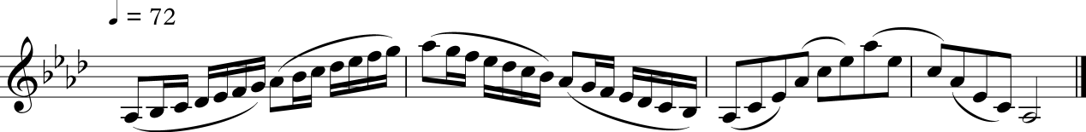
G major, 3 octaves, spiccato
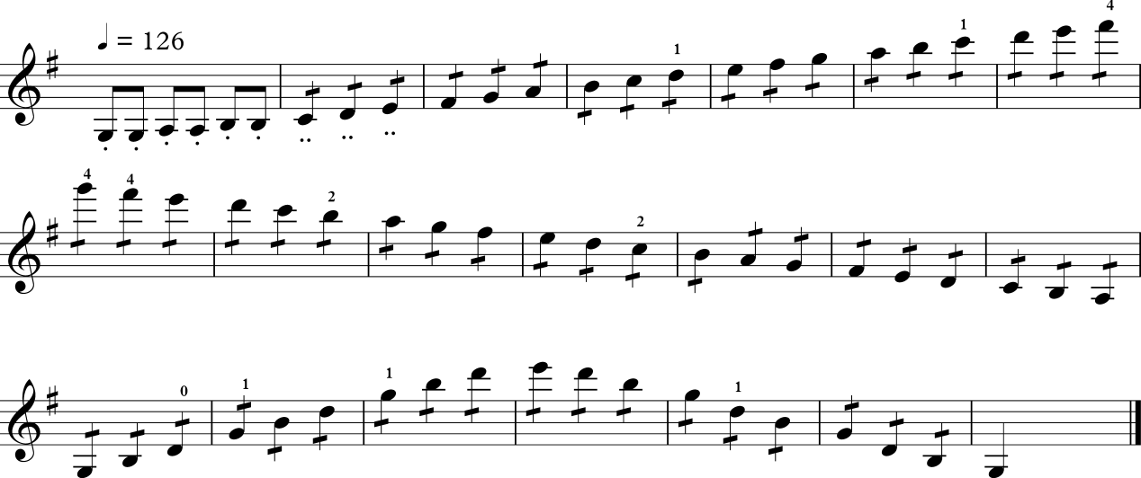
B♭ major – bow distribution
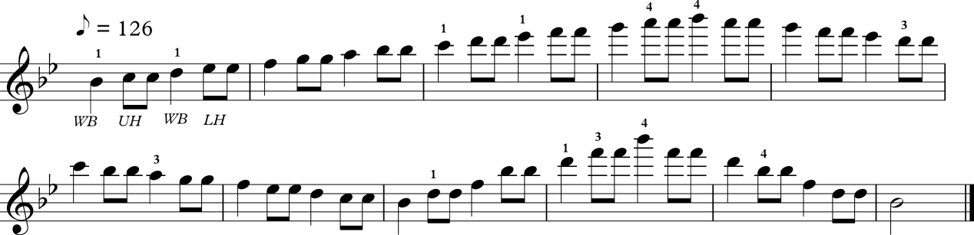
C# harmonic minor – up bow staccato
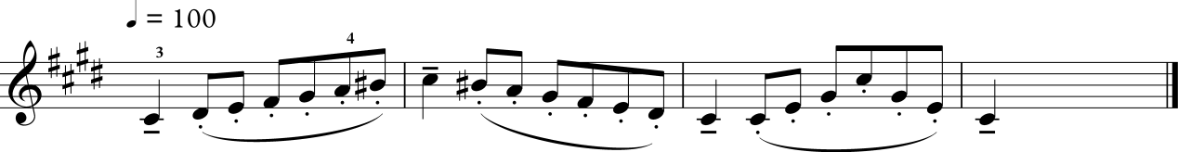
G harmonic minor in 6th position – heel and point
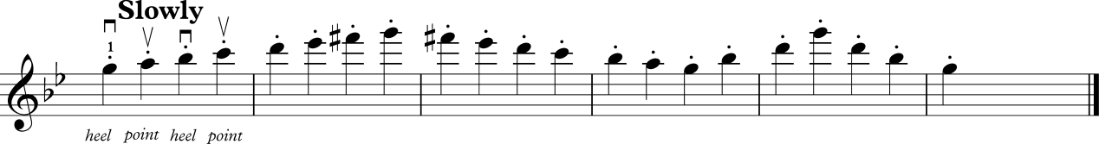
E major – circles at the heel
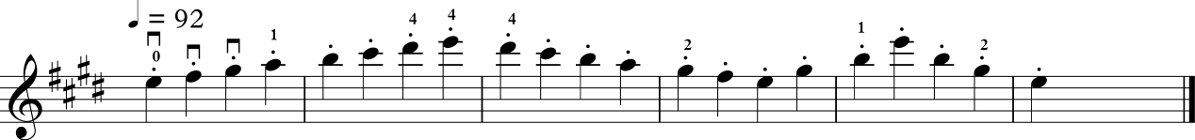
E harmonic minor – spiccato triplets
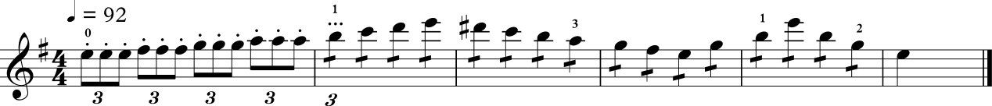
E melodic minor in 4th position – martele
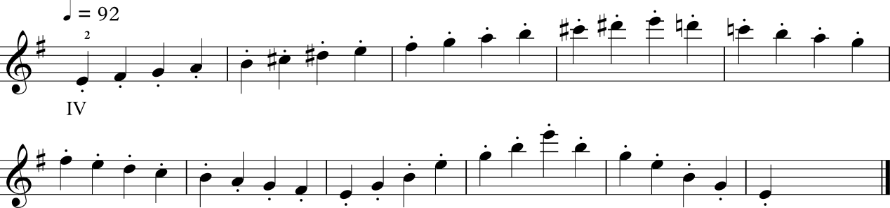
A major 3 octaves – portato
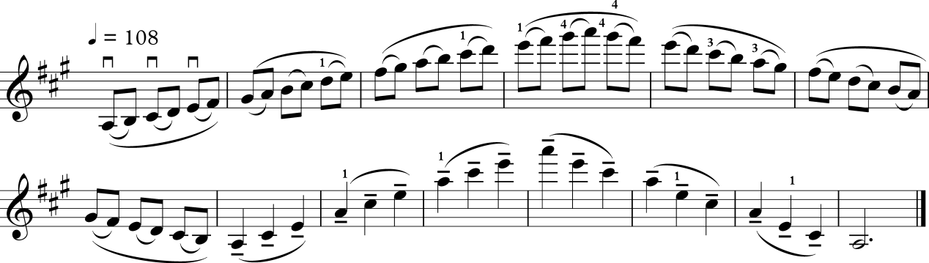
F# Melodic minor
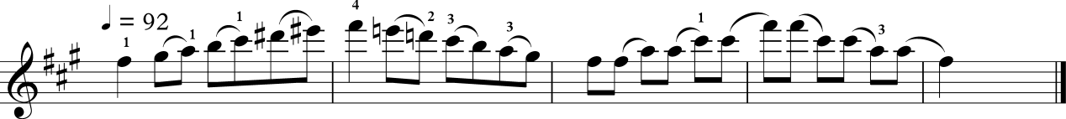
Dominant 7th on G and A – legato, whole bows
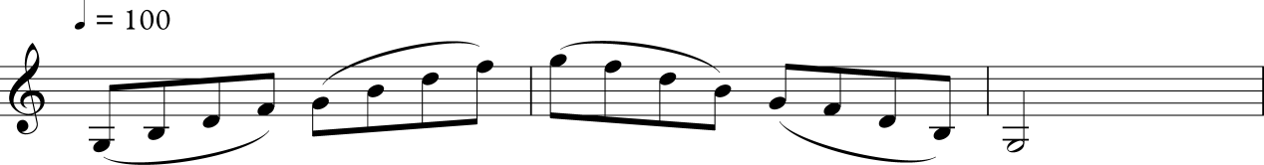
Diminished 7th on G – hook stroke
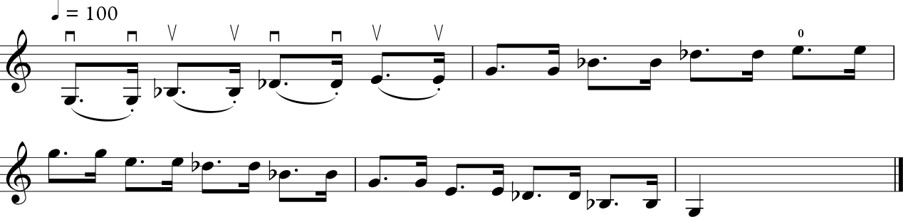
Diminished 7th on A – hook stroke at the point
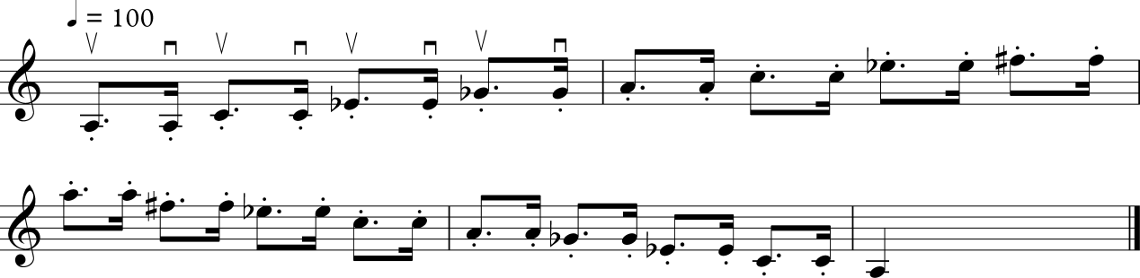
Shifting exercise
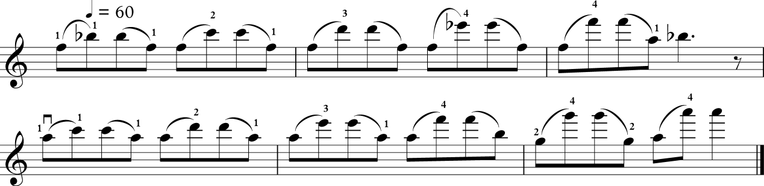
Chromatic scale on G
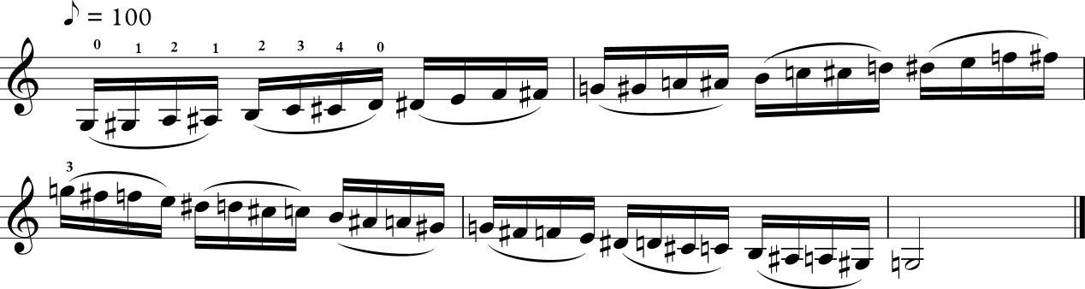
G major in sixths
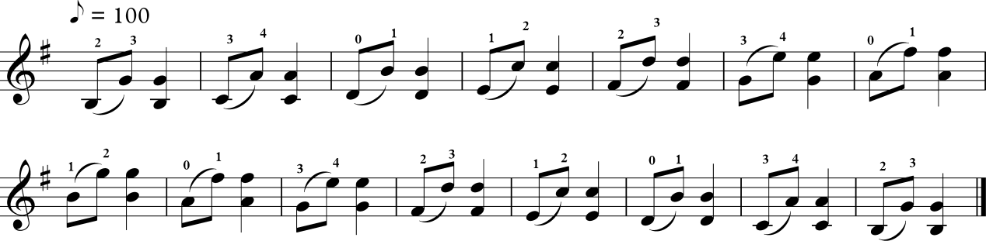
G major in octaves
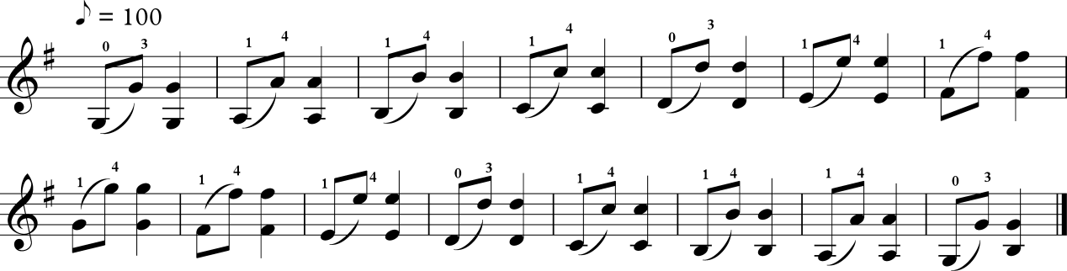
G major in 3^{rds}
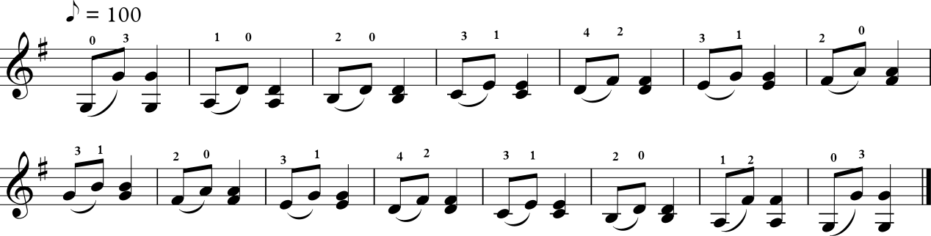
Natural and artificial harmonics
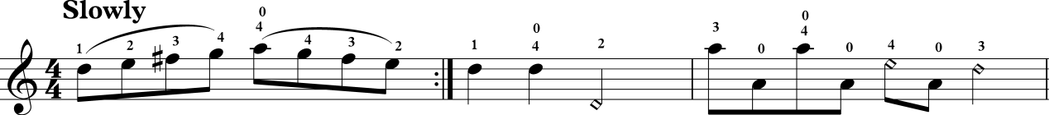

Chords
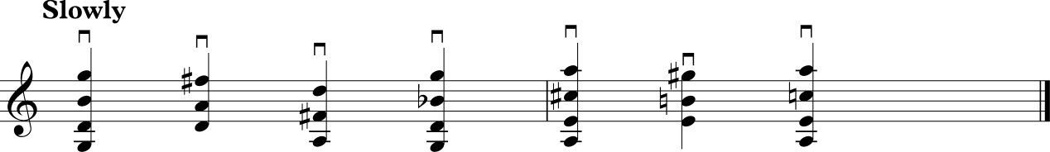

SUGGESTED TECHNICAL WORK – SCALES – YEAR 12
Scales
Major
A♭ and E 2 octaves
A and B♭ 3 octaves
Harmonic and melodic minor
A♭ and E 2 octaves
A and B♭ 3 octaves
Bowing: Separate bows, legato
Slurred, 1 octave per bow
Hook stroke, playing notes twice, and at the point
Spiccato, even quavers, single notes, playing each note twice
= 92
Chromatic scales
B♭ and B 2 octaves
Separate, 12 notes slurred to a bow
Arpeggios
to major and minor scales stated above. Compass as above
Dominant 7th
on A 2 octaves
Separate bows and slurred four notes to a bow
Dim 7th
on A 2 octaves
Separate bows and slurred four notes to a bow
Double stops
Major 2 octaves, in minims, separate bows, =60
3^{rds} G
6^{ths} E♭
8^{ve} G
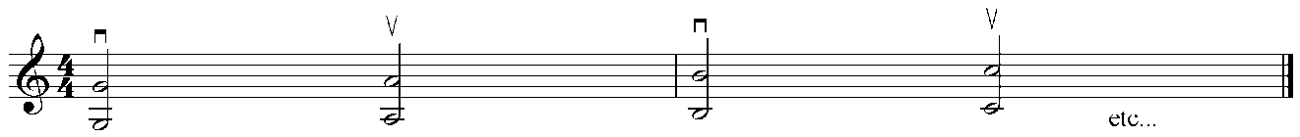

SUGGESTED REPERTOIRE – YEAR 11
Corelli Sonata Op.5 No.8, 3rd and 4th movements
Handel Sonata in F major, 1st and 2nd movements
Haydn Serenade Andante cantabile from String Quartet in F, Op.3 No.5
Mollenhauer The Boy Paganini
Piazzolla Ausencias from Vuelvo al sur, 10 tangos and other pieces
Schubert Sonatina in G minor, Op.137, No.3, 3rd movement, Minuet and Trio

SUGGESTED REPERTOIRE – YEAR 12
Bach, J.S. Six Solo Sonatas and Partitas, BMW 1001–1006, one or two contrasting movements from any one sonata or partita (Barenreiter or Henle or Peters or International Music Co.)
Bartok, B. Rumanian Folk Dances, arr Szekely, any three movements to count as one work. Universal (VE8474)
Bartok, B. Sonatina 1915 (arranged Gertler) both movement Nos.1 and 2 Editio Musica Budapest
Brahams, J. Hungarian Dance No.2, arranged Hubay, Augener
Dvorak, A. Slavonic Dance No.1 in G minor, arranged Kreisler
Elgar, E. Chanson de Martin, op15, No.1 – Novello
Elgar, E. Chanson de Nuit, Op.15, No.2 – Novello
Haydn, J. Concerto No.2 in G major, movement 1 or 2 and 3
Leclair, J.M. Sonata No.3 in D major, Sarabande and Tambourin, Schirmer
Massenet, J. Meditation from Thais (arr. Marsick) – Fischer
Mozart, W. A. Concerto No.1, K207, any movement
Mozart, W. A. Concerto No.3, K216, any movement
Ravel, M. Piece en Forme d’Habanera – Alphonse Leduc
Stravinsky, I. Suite Italienne, movements Nos.1 and 2 or No.3 – Boosey & Hawkes
Wieniawski, H. Kuyawaik, Muzurka

VIOLA

SUGGESTED TECHNICAL WORK – YEAR 11
D♭ major – slurred, whole bows
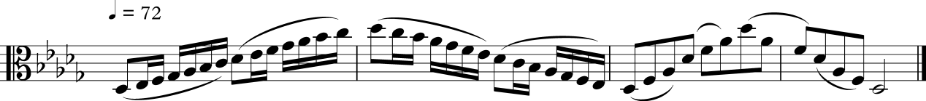
C major, 3 octaves, spiccato
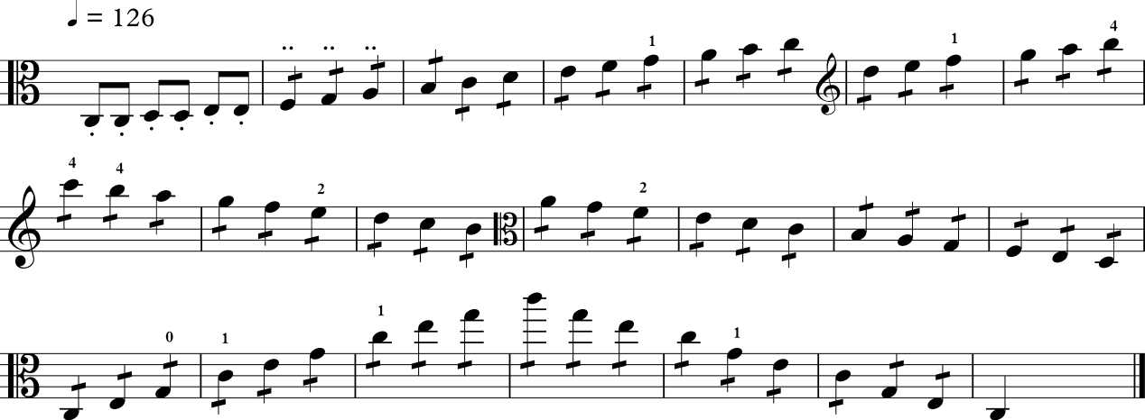
B♭ major – bow distribution
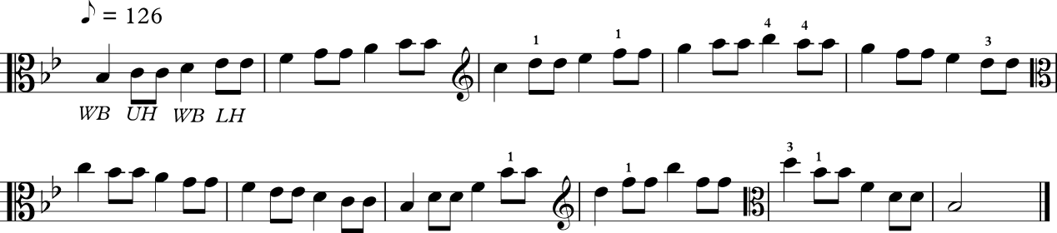
F# harmonic minor – up bow staccato
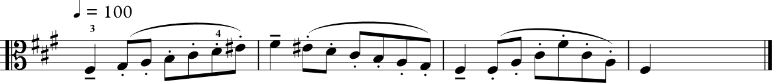
C harmonic minor in 6th position – heel and point
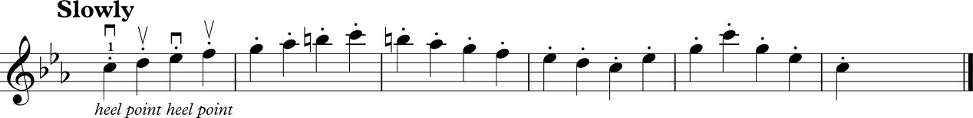
A major – circles at the heel
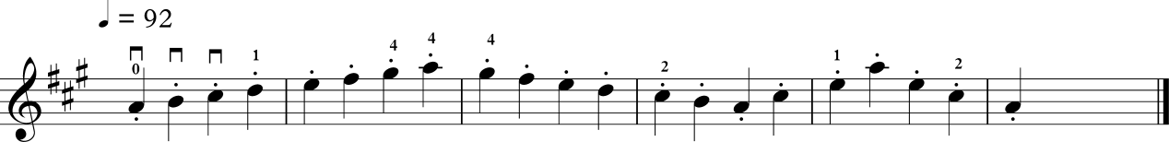

A harmonic minor – spiccato triplets
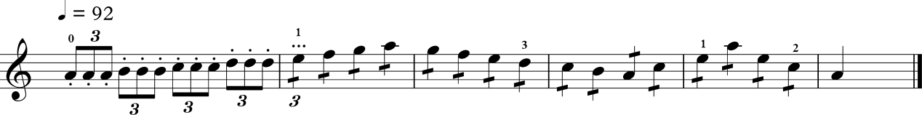
E melodic minor in 4th position – martelé
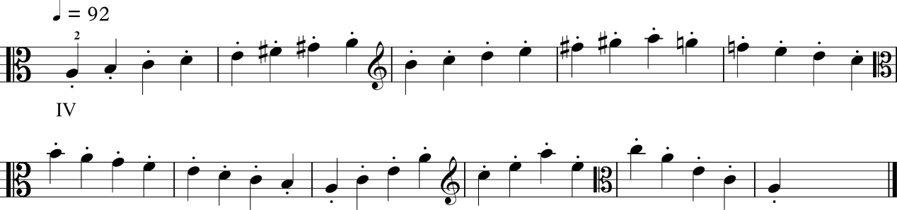
D major 3 octaves – portato
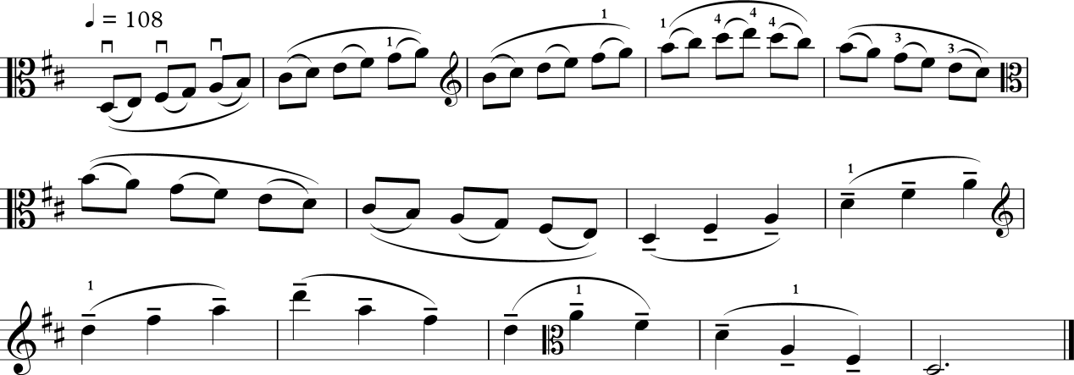
B melodic minor
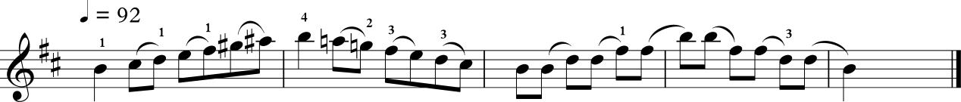
Dominant 7th on C and D – legato, whole bows
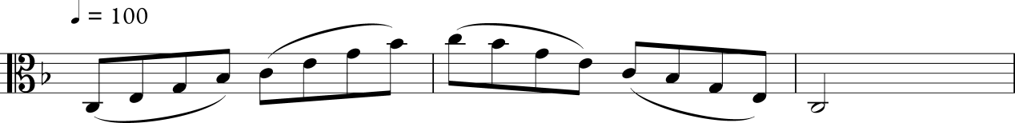

Diminished 7th on C – hook stroke
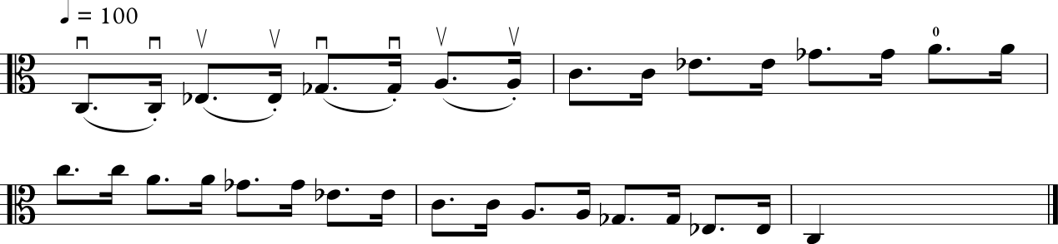
Diminished 7th on D – hook stroke at the point
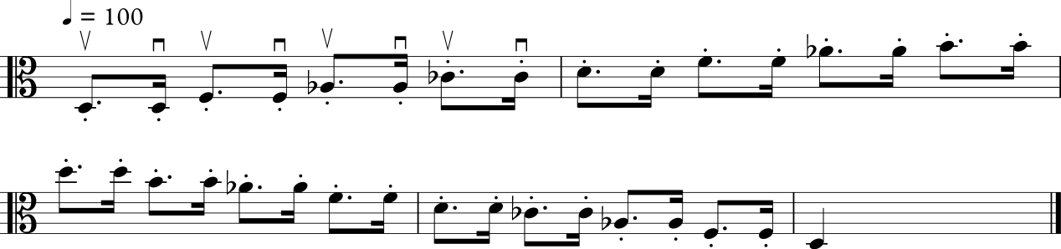
Shifting exercise
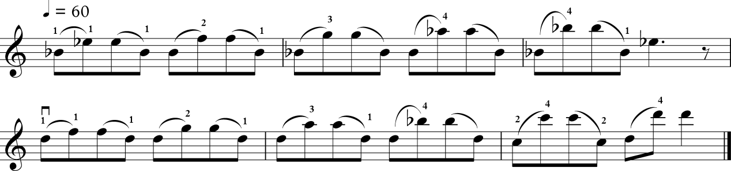
Chromatic scale on C
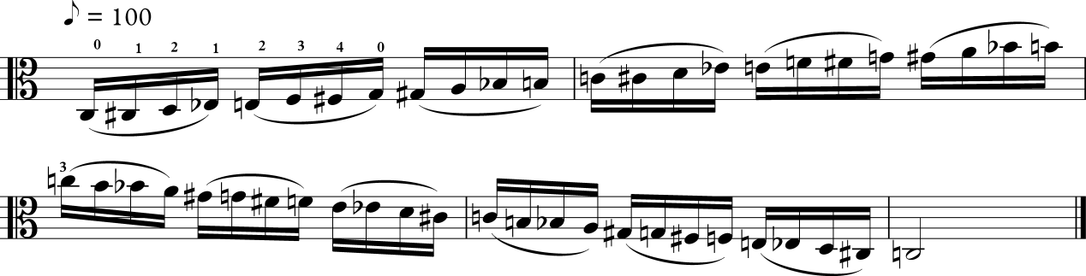
C major in sixths
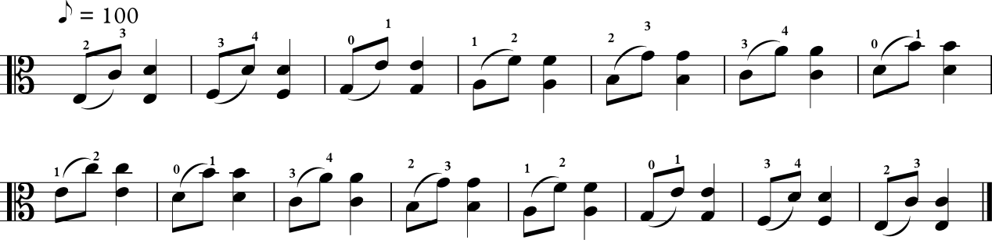
G major in octaves
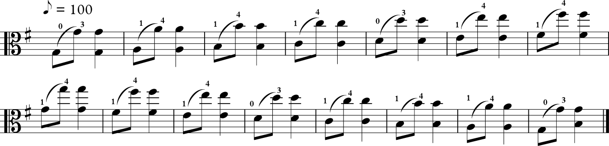
G major in 3rds
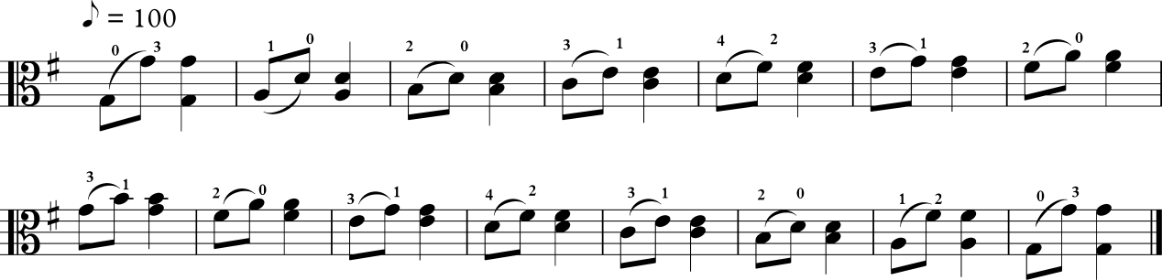
Natural and artificial harmonics
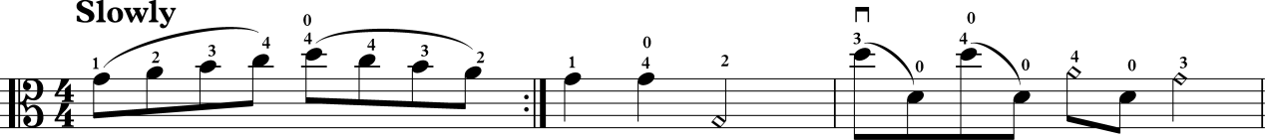

Chords
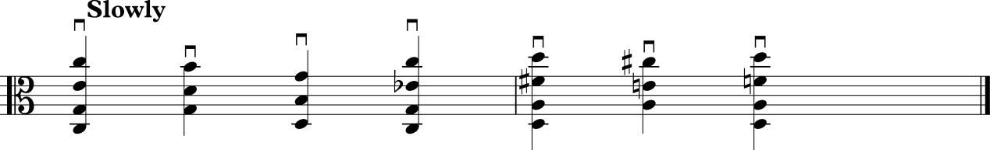

SUGGESTED TECHNICAL WORK – YEAR 12
Scales= 92
Major
D and A 2 octaves
D and E♭ 3 octaves
Harmonic and melodic minor
D♭ and A 2 octaves
C and E♭ 3 octavess
Bowing: Separate bows, legato
Slurred, one octave per bow
Hook stroke, playing notes twice, and at the point
Spiccato, even quavers, single notes, playing each note twice
= 80
Chromatic scale
E♭ and E 2 octaves
Separate bows, 12 notes slurred
Arpeggios
= 60, 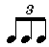
to major and minor scales stated above. Compass as above
Dominant 7th
on D 2 octaves
Dim 7th
on D 2 octaves
Bowing: Separate bows, legato, even quavers, single notes
Slurred, four notes per bow, even quavers
= 60
Double stops 2 octaves
3^{rds} C
6^{ths} A♭
8^{ve} C
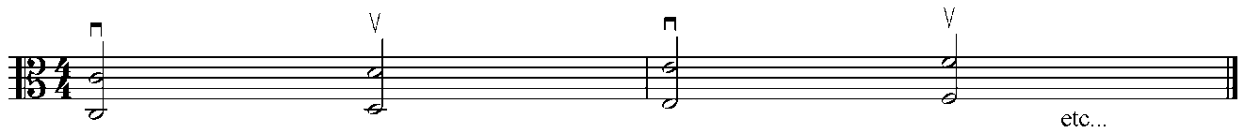

SUGGESTED REPERTOIRE – YEAR 11
Corelli arr. Kent Sarabanda and Giga from Sonata Op.5, No.8
Grieg arr. Forbes Two Elegiac Melodies from Classical and Romantic Pieces (OUP)
Handel arr. Jensen Sonata in C major (selections from)
Mozart arr. Klengel Andante from Album of Classical Pieces Volume 3
Schubert arr. Klengel 4 Waltzes Op.33 from Album of Classical Pieces Volume 3

SUGGESTED REPERTOIRE – YEAR 12
Bach, J.S. Three Viola de Gamba Sonatas arranged for Viola, Breitkopf and Hartel,
EB 3359 or Peters, P 4286a
Bax, A. Legend, Chapell
Beethoven L. Alla Polacca, arranged Forbes, Scott
Dittersdorf, K.D. Sonata in Eb, 1st and 2nd movements, Hofmeister
Eccles, H. Sonata in G minor – any two contrasting movements
Glazanov, A. Elegie, Opus 44, Boosey & Hawkes
Handel, G. Concerto in B minor – any two contrasting movements, Schott
Hindemith, P. Trauermusik
Hoffmeister, F.A. Viola Concerto in D major, 1st movement
Holst, G. Lyric movement, OUP
Jacob, G. Air and Dance, OUP
Locatelli, P. Sonata in G minor, 1st and 2nd movements, IMC
Marais, M. Five Old French Dances, any two movements, Chester
Milhaud, D. La Californienne from Quatre Visages
Milhaud, D. La Parisienne from Quatre Visages, No.4
Mozart, W. A. Adagio K261, arranged Forbes
Pleyel, I. Concerto in D major, 1st movement, Hinrichsen
Schumann, R. Marchenbuilder, Op.113, any one movement, Schirmer
Schumann, R. Sonata in G major, 1st and 2nd movements
Schumann, R. Sonata in D major, 3rd and 4th movements
Telemann G. Concerto in G, any two contrasting movements, Hortus Musicus
Vaughan-Williams, R. Suite for Viola, Group 2: Ballade, OUP
Vaughan-Williams, R. Carol and Christmas Dance from Suite for Viola, Group 1, OUP

VIOLONCELLO

SUGGESTED TECHNICAL WORK – YEAR 11
Major and minor scales
- C major – 3 octaves
- C melodic minor – 3 octaves
- C harmonic minor – 3 octaves
- D major – 3 octaves
- D melodic minor – 3 octaves
- D harmonic minor – 3 octaves
No open strings (except open C) to be played in these scales. Refer to AMEB Technical Work book for recommended fingering patterns.
Bowing patterns
- Slurred, four notes to a bow, repeating the tonic at each octave:
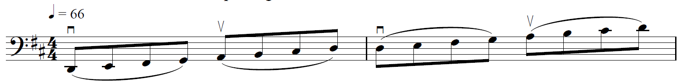
- Spiccato, two quavers per note at the balance point of the bow:
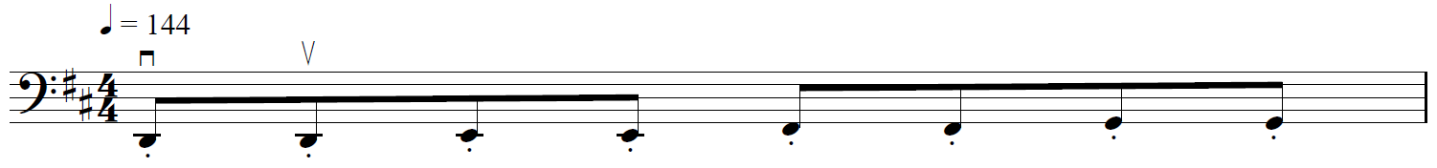
- Détaché, one quaver followed by six semiquavers:
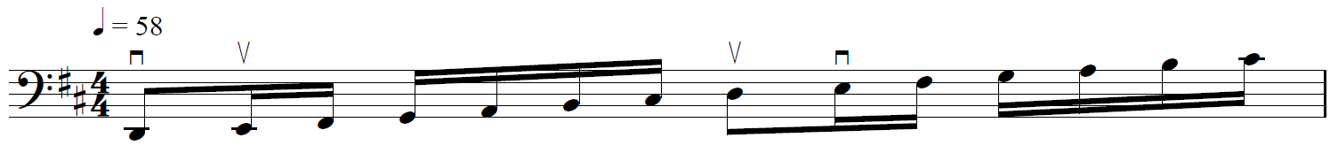
Chromatic scales
- Chromatic commencing on C – 3 octaves
- Chromatic commencing on D – 3 octaves
Slurred, six notes to a bow:
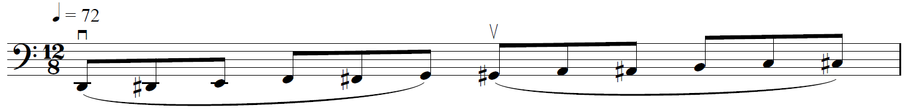
Major and minor arpeggios
- C major – 3 octaves
- C minor – 3 octaves
- D major – 3 octaves
- D minor – 3 octaves
Bowing patterns
- Slurred, three notes to a bow:
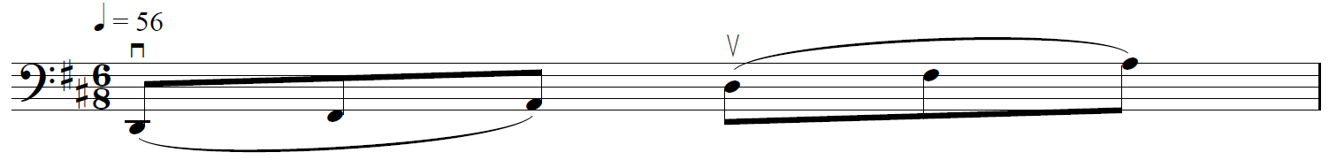
- Martelé, short stroke from the middle of the bow, remaining on the string:
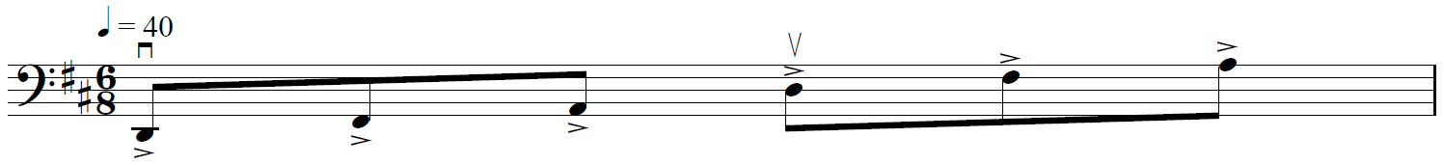
Dominant 7th and diminished 7th arpeggios
- Dominant 7th commencing on C – 3 octaves
- Diminished 7th commencing on C – 3 octaves
- Dominant 7th commencing on D – 3 octaves
- Diminished 7th commencing on D – 3 octaves
Slurred, four notes to a bow:
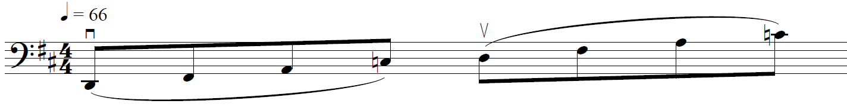

SUGGESTED REPERTOIRE – YEAR 11
Abbott, K. Autumn Song (www.reedmusic.com)
Bailey, K. Rock On The Edge from Jazzin’ Around for Strings – Cello
Bailey, K. Shades Of Night from Jazzin’ Around for Strings – Cello
Bazelaire, P. Bourrée d’Auvergne from Suite Française Op. 114
Bazelaire, P. Chanson de Bresse from Suite Française Op. 114
Beethoven, L. van Variations on a Russian Theme, arr. Nelson, from Keytunes Book 1 (Boosey and Hawkes)
Breval, J. Sonata in C major Op. 42, 1st movement, arr. Stutschewsky (Schott)
Chinzer, G. Sonata in G minor, 1st and 2nd movements, from Three 18th Century Sonatas (Faber)
Cui, C. Orientale from Kaleidoscope Op. 50, No. 9
Gabriel-Marie, J. La Cinquantaine, arr. Suzuki, Suzuki Cello School Book 3 Revised Edition (Summy-Birchard)
Hindemith, P. Langsam or Lebhaft from Drei leichte Stücke (Solos For Young Cellists Volume 2 – Summy-Birchard)
Järnefelt, A. Berceuse in E minor
MacMillan, J. Sabre Dance from Northern Skies (Boosey and Hawkes)
Marais, M. La Matelotte from Five Old French Dances, arr. Aldis and Mulke (Master Music Publications)
Marcello, B. Sonata in E minor, 1st and 2nd movements
Marcello, B. Sonata in C major, 2nd movement
Marcello, B. Sonata in C major, 3rd and 4th movements
Nölck, A. Capriccietto, No 7 from Zehn Originalstücke Op. 116 (Schott)
Pergolesi, G. Nina, arr. Deri, from Solos For The Cello Player (Schirmer)
Porta, B. Sonata in B major, 3rd and 4th movements, from Three 18th Century Sonatas (Faber)
Schubert, F. Ballet Music from Rosamunde, arr. Nelson, from Keytunes Book 1 (Boosey and Hawkes)
Tann, H. Lullaby from Spectrum for Cello (ABRSM)
Traditional (arr. Casals) Song Of The Birds from Learning The Tenor Clef (Faber)
Trad. (arr. Legg, Gout) Kalinka from Learning The Tenor Clef (Faber)
Wedgwood, P. Castaway from Up-grade! Cello, Grades 3-4 (Faber)
Wedgwood, P. Just Passing By from Jazzin’ About – Fun Pieces for Cello (Faber)
Wedgwood, P. Sometime Maybe from Jazzin’ About – Fun Pieces for Cello (Faber)

SUGGESTED TECHNICAL WORK – YEAR 12
Major and minor scales
- E major – 3 octaves
- E melodic minor – 3 octaves
- E harmonic minor – 3 octaves
- B♭ major – 2 octaves
- B♭ melodic minor – 2 octaves
- B♭ harmonic minor – 2 octaves
No open strings (except open C) to be played in these scales. Refer to AMEB Technical Work book for recommended fingering patterns.
Bowing patterns
- Slurred, four notes to a bow, repeating the tonic at each octave:
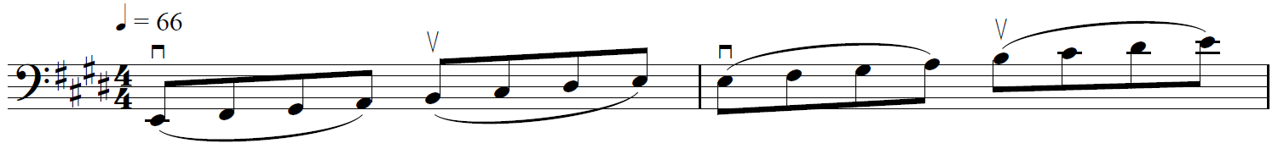
- Spiccato, two quavers per note at the balance point of the bow:
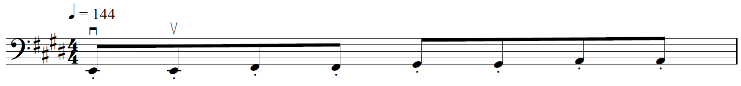
- Détaché, one quaver followed by six semiquavers:
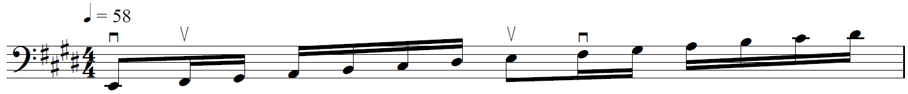
Chromatic scales
- Chromatic commencing on E – 3 octaves
- Chromatic commencing on B♭ – 2 octaves
Slurred, six notes to a bow:
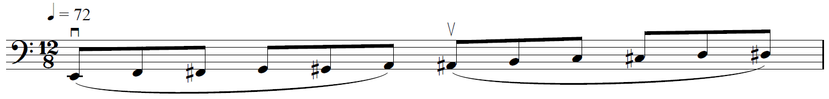
Major and minor arpeggios
- E major – 3 octaves
- E minor – 3 octaves
- B♭ major – 2 octaves
- B♭ minor – 2 octaves
Bowing patterns
- Slurred, three notes to a bow:
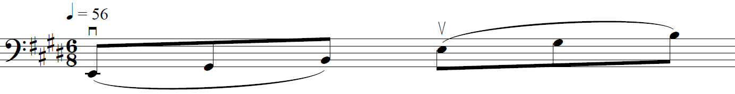
- Martelé, short stroke from the middle of the bow, remaining on the string:
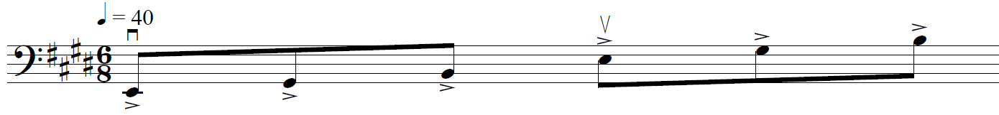
Dominant 7th and diminished 7th arpeggios
- Dominant 7th commencing on E – 3 octaves
- Diminished 7th commencing on E – 3 octaves
- Dominant 7th commencing on B♭ – 2 octaves
- Diminished 7th commencing on B♭ – 2 octaves
Slurred, four notes to a bow:
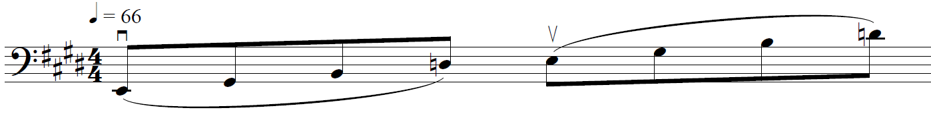

SUGGESTED REPERTOIRE – YEAR 12
Bach, J.S. Suite No 1 in G major, BWV 1007, 5th and 6th movements
Bartók, B. Gyermekeknek/Für Kinder No 1, No 4 and No 5, arr. Liebner and Halász (EMB)
Cole, J. Elegy from Spectrum for Cello (ABRSM)
Dove, J. Prayer Wheel from Spectrum for Cello (ABRSM)
Elgar, E. Chanson de Matin, arr. Legg and Gout, from Learning the Tenor Clef (Faber)
Fauré, G. Berceuse, Op. 16 (Edition Butorac)
Fauré, G. Pavane, arr. Legg and Gout, from Learning the Tenor Clef (Faber)
Marcello, B. Sonata No. 1 in F major, 1st and 2nd movements
Martinů, B. Pastorale No. 2 (Leduc)
Nicholls, S. Cake Walk from Recital Repertoire for Cellists, Book 1 (Faber)
Offenbach, J. In the Twilight, arr. Legg and Gout, from Learning the Tenor Clef (Faber)
Paradis, M. Sicilienne, arr. Dushkin (Schott)
Rimsky-Korsakov, N. Chanson Indoue, arr. Klengel, from Sadko - 14 pieces for cello (Mayhew)
Romberg, B. Sonata in E minor, Op. 38, No. 1, 1st movement (IMC)
Schubert, F. Serenade from 14 pieces, arr. Lloyd Webber (Mayhew)
Shostakovich, D. Romance from The Gadfly, arr. Cowles (Fentone)
Squire, W. Tarantella (Stainer and Bell)
Tchaikovsky, P. Valse Sentimentale, Op. 51, No. 6, arr. Rose (IMC)
Vivaldi, A. Concerto in D major, RV 403, 1st movement
Vivaldi, A. Sonata in E minor, RV 40, any two movements

DOUBLE BASS

SUGGESTED TECHNICAL WORK – YEAR 11
Scales and arpeggios
- A♭ major – 2 octaves
- A♭ melodic minor – 2 octaves
- A♭ harmonic minor – 2 octaves
- C major – 2 octaves
- C melodic minor – 2 octaves
- C harmonic minor – 2 octaves
Bowing patterns
1. Spiccato; four semiquavers per note
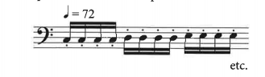
2. Hook stroke; one dotted quaver and one semiquaver per note
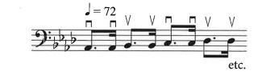
3. Slurred; four quavers per bow, repeating the tonic at each octave
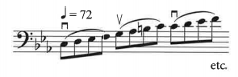
Chromatic scale
Commencing on D – 2 octaves, slurred; four quavers per bow
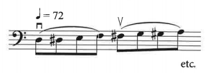
Arpeggios
- A♭ major – 2 octaves
- A♭ minor – 2 octaves
- C major – 2 octaves
- C minor – 2 octaves
Bowing pattern: slurred; three quavers per bow
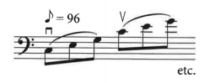
Dominant 7th
- Commencing on A♭ – 2 octaves
- Commencing on C – 2 octaves
Diminished 7th
- Commencing on A♭ – 2 octaves
- Commencing on C – 2 octaves
Bowing pattern: slurred; two quavers per bow
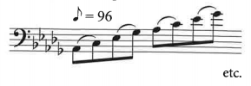

SUGGESTED TECHNICAL WORK – YEAR 12
Scales
Major
A♭, A, E and F 2 octaves
Harmonic and melodic minor
A♭, A, E and F 2 octaves
Bowing: separate bows, legato
Slurred, 1 octave per bow
Hook stroke, playing notes twice, at the nut and at the point
Spiccato, even quavers, playing each note twice
= 100
Arpeggios of the above scales. Compass as above
Bowing: separate bows, legato
= 60
Slurred, 3 notes per bow
= 60
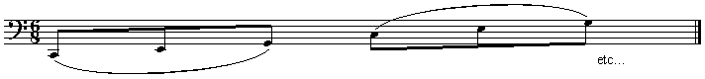
Chromatic scales
A♭ and F 2 octaves
Bowing: slurred in 4s
= 60
Dominant 7th
of A and F 2 octaves
Separate bows, legato
= 60
Slurred, four notes per bow, even quavers
= 60
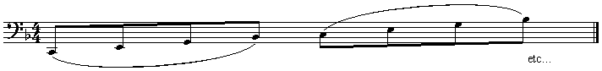
Diminished 7th
of A and F 2 octaves
Bowing: separate bows, legato, even quavers, single notes
Slurred, four notes per bow, even quavers
= 60
SUGGESTED TECHNICAL WORK – REPERTOIRE
Technique | Examples of studies/pieces/orchestral excerpts
Staccato | Gavotte by Gossec (Vance Volume 3)  Gavotte from Mignon by A. Thomas (Vance Volume 3)  Brandenburg Concerto, No.3 excerpt – allegro moderato  Bille Studies, Nos.6, 13 and 47 (Book 3)  Hrabe 86 Etudes (Book 1), No.3
Legato | Tre Giorni by Pergolesi (Vance Volume 3)  Othello exerpt  Bottessini Exercises for Double Bass, No.10  Simandl Etudes, Nos.1, 2 and 3
Slurs | Rabbath Study, No.1 (Book 1) – and staccato  Rabbath Study, No.3 (Book1)  Andante con moto and allegro from Symphony, No.5 by Beethoven (Simandl)  Marriage of Figaro overture – Presto by Mozart  Bottesini Exercises for Double Bass, No.8  Bille Studies, Nos.18, 27, 30, 31 and 32
Finger dexterity | Hebrides overture excerpt by Mendelssohn – allegro moderato  Simplified Higher Technique by Petracchi (any)  Any Rabbath Study  Vade Mecum by Vance
4th position | Rabbath exercises, pp. 31–33 (Book2)  Petracchi, p. 9  Mahler symphony, No.1 solo (3rd movement)  Shostakovich Symphony, No.5 (1st movement)
Shifting | Rabbath (Book2) p. 25  Vade Mecum by Vance (any)  Rabbath Study, No.16
Triplets | Rabbath Study, No.14 (Book2) and double stopping  Hrabe Study, No.16 – and slurs  Don Juan excerpts by Strauss
Double stopping | Vade Mecum by Vance  Spanish Ode by Rabbath  Rabbath (Book 2) pp. 39–40, Study, No.14
Accents/marcato | Russian Sailors Dance by R Gliere  Rabbath (Book 2), pp. 39–40, Study, No.14  Bille Study, No.34  Rabbath (Book 1) Studies 1 and 6
Combination bowing | Bille Studies (anything from Book 3)  Mozart Symphony, No.40 (1st movement)  Rabbath Study, No.9  Bruckner Symphony, No.8 (allegro moderato)  Berlioz Symphonie Fantastique (March to the scaffold)
Chromatic | Vade Mecum by Vance, p. 46  Shostakovich Symphony, No.1 (allegretto)

SUGGESTED REPERTOIRE – YEAR 11
Carroll, I. Fantasia from Three Pieces for the Double Bass
Carroll, I. Toccata from Three Pieces for the Double Bass
Carroll, I. Bolero from Three Pieces for the Double Bass
Fauré, G. Après un rêve
Marcello, B. Adagio (1st movement.) and Allegro (2nd movement) from Sonata in e minor
Saint-Saëns, C. L’Élephant from Le Carnaval des Animaux

SUGGESTED REPERTOIRE – YEAR 12
Bach, J.S. Suites for Cello, any movement, Peters
Capuzzi, A. Concerto in F, 1st or last movements
Capuzzi, A. Concerto in D, 1st or last movements
Corelli, A. Sonata in D minor, in entirety – International
Dragonetti, D. Six Waltzes for double bass alone, any or all (ed. Turetsky) – McGinnis and Marx Music
Eccles, H. Sonata in G minor, any two contrasting movements, International
Handel, G.F. Largo in G
Sarabande No.5 in G from Klassische Stucke, Book 1, Peters
Jacob, G. A Little Concerto, any movement(s) – Yorke
Marcello, B. Any Sonata, any two contrasting movements
Rabbath, F. Solos for the Double Bassist any of ‘Ode d’Espagne’, ‘Poucha Dass’ – Liben

HARP – pedal harp

SUGGESTED TECHNICAL WORK – YEAR 11
Scales
Major
A♭, A, C and F major 3 octaves, hands together, one octave apart
Harmonic minor
A, C♯, F and F♯ 3 octaves, hands together, one octave apart
Arpeggios
To major and minor scales stated above. 3 octaves, hands together, one octave apart, root position,
in 3s and in 4s.
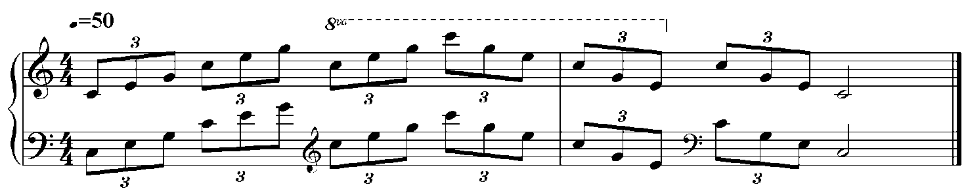
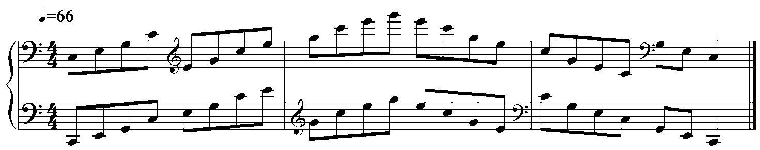
Dominant 7th
of A and F 3 octaves, hands together, root position

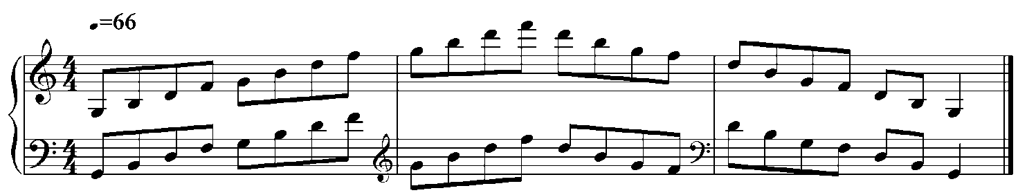SUGGESTED TECHNICAL WORK – REPERTOIRE – YEAR 11
Arpeggios (ascending, descending and one handed)
Naderman, F.J. Methode de Harpe Volume 2 (Billaudot), Other study in Arpeggios, p. 17
Salzedo, C. Conditioning Exercises (Schirmer), Exercise I–VI
Arpeggios (crossing)
Salzedo, C. Conditioning Exercises (Schirmer), Exercise VII–IX
Voicing
Naderman, F.J. Méthode de Harpe Volume 2 (Billaudot), Second Study of arpeggio with a Song
of Thumb (sic)
Naderman, F.J. Méthode de Harpe Volume 1 (Billaudot), Example with Four Parts, p. 23
Ornamentation
Naderman, F.J. Méthode de Harpe Volume 1 (Billaudot), About the Trill, p. 32
Salzedo, C. and Lawrence, L. Method for the Harp (Shirmer), One-hand trill and Two-hand trill, p. 51
Scales
Salzedo, C. Conditioning Exercises (Schirmer), Exercise X

SUGGESTED TECHNICAL WORK – YEAR 12
Scales
Major
A♭, C♭, E♭ and G♭ major 4 octaves in semiquavers, hands together, one octave or a tenth apart
= 72, four notes per beat
Harmonic minor
F and D 4 octaves in semiquavers, hands together, one octave or a tenth apart
= 72, four notes per beat
Melodic minor
C and E♭ 4 octaves in semiquavers, hands together, one octave apart
= 66, four notes per beat
Arpeggios
To major and minor scales stated above. 4 octaves, hands together, one octave apart, root position,
in 3s and in 4s.
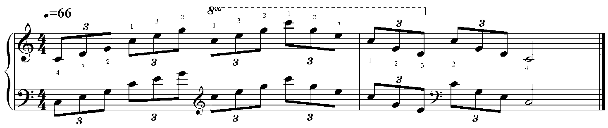
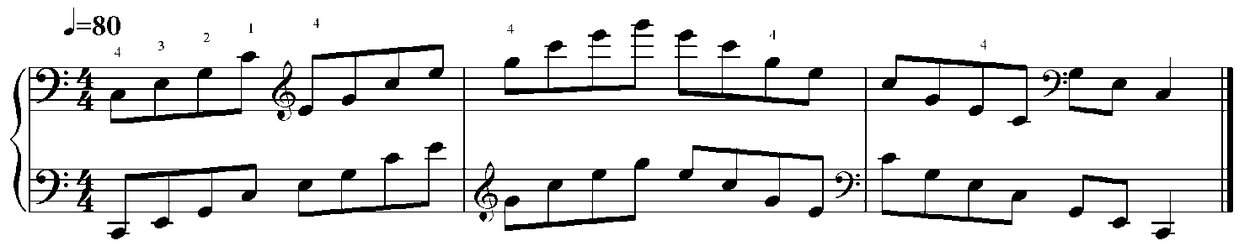
Dominant 7th
of B♭ and G 3 octaves, hands together, in root position and inversions
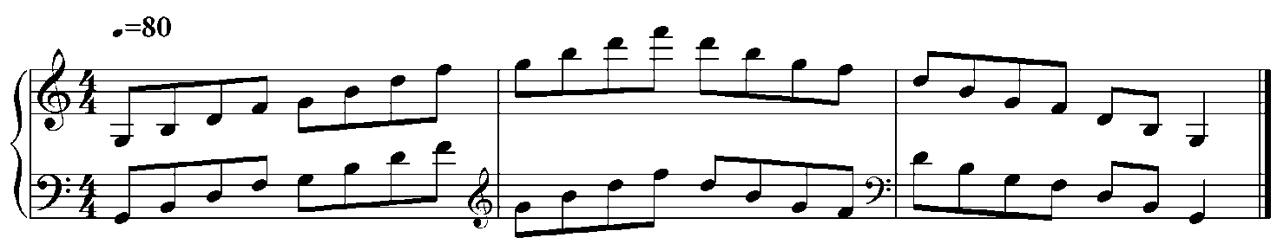

SUGGESTED TECHNICAL WORK – REPERTOIRE – YEAR 12
Arpeggios (ascending, descending and one hand)
Pozzoli Nos.16, 20, 21
Boscha, N. Vingt-Cinq Exercises (Leduc), Etudes, Op.62, Nos.X, XII or XXIV
Arpeggios (crossing: one hand and left over right)
Lariviere Exercices et Etudes pour la Harpe, Op.9 (Leduc), Etude No.1
Salzedo, C. and Lawrence, L. Method for the Harp (Shirmer), One-hand arpeggios
Octaves (consecutive, occilating)
Pozzoli Nos.19, 19bis and 23, Ricordi
Boscha, N. Vingt-Cinq Exercises (Leduc), Etudes Op.62, Nos.III, VII, XV or X
Salzedo, C. and Lawrence, L. Method for the Harp (Shirmer). Oscillating movement of the wrist
Scales
Boscha, N. Vingt-Cinq Exercises (Leduc), Etudes Op.62, No.VI
Lariviere Exercices et Etudes pour la Harpe, Op.9 (Leduc), Etude No.1
Voicing
Boscha, N. Vingt-Cinq Exercises (Leduc), Etudes Op.62 No.VIII or XVII
Ornamentation
Boscha, N. Vingt-Cinq Exercises (Leduc), Etudes Op.62 No.XI or XIV
Rolling chords
Boscha, N. Vingt-Cinq Exercises (Leduc), Etudes Op.62 No.XVIII
Harmonics
Salzedo, C. and Lawrence, L. Method for the Harp (Shirmer), Cortege

SUGGESTED REPERTOIRE – YEAR 11
Dussek, J.L. Six Sonatinas (any 1st movement), Musica Antiqua Bohemica
Grandjany, M. Pastorale
Ravel, M. Prelude (arr. Salzedo), Durand
Salzedo, C. Iridescence, Carl Fisher
Salzedo, C. Quietude, Carl Fisher

SUGGESTED REPERTOIRE – YEAR 12
Britten, B. Interlude from Ceremony of Carols
Grandjany, M. Arabesque
Handel, G.F. Musique de Haendel, Passacaille (from: Suite in G minor, HWV432, arr. for harp solo by Tiny Beon)
Salzedo, C. Chanson dans la Nuit or La Desirade
Thomas, J. Watching the Wheat, Adlais
Tournier, M. Four Preludes (any two), Leduc

HARP – non-pedal harp
(Must have a minimum 34 strings and be fully levered)

SUGGESTED TECHNICAL WORK – YEAR 11
Scales
Major
A, C, E♭ and F major 3 octaves, hands together, one octave apart
Harmonic minor
A and C 3 octaves, hands together, one octave apart
Arpeggios
To major and minor scales stated above. 3 octaves, hands together, one octave apart, root position,
in 3s and in 4s.
Dominant 7th
of A and F 3 octaves, hands together, root position

SUGGESTED TECHNICAL WORK – REPERTOIRE – YEAR 11
Arpeggios (ascending descending and one handed)
Salzedo, C. Conditioning Exercises (Schirmer), Exercise I–VI
Bochsa, R.N.Ch. 50 Lecons Progressives Volume 1 (rev. Megevand) (Billaudot), Nos.9, 19, 20
Arpeggios (crossing: one hand and left over right)
Salzedo, C. Conditioning Exercises (Schirmer), Exercise VII–IX
Bochsa, R.N.Ch. 50 Lecons Progressives Volume 1 (rev. Megevand) (Billaudot), No.21 from 50
Bochsa, R.N.Ch. 50 Lecons Progressives Volume 1 (rev. Megevand) (Billaudot), Nos.1, 3
Scales
Salzedo, C. Conditioning Exercises (Schirmer), Exercise X
Bochsa, R.N.Ch. 50 Lecons Progressives Volume 1 (rev. Megevand) (Billaudot), Nos.7, 8
Rolling chords
Bochsa, R.N.Ch. 50 Lecons Progressives Volume 1 (rev. Megevand) (Billaudot), Nos.12, 13
Harmonics
Bochsa, R.N.Ch. 50 Lecons Progressives Volume 1 (rev. Megevand) (Billaudot), No.14
Ornamentation
Bochsa, R.N.Ch. 50 Lecons Progressives Volume 1 (rev. Megevand) (Billaudot), Nos.22, 23

SUGGESTED TECHNICAL WORK – YEAR 12
Scales
Major
A, B♭ and C major 3 octaves in semiquavers, hands together, one octave or a tenth apart
= 72, four notes per beat
Harmonic minor
A and C 3 octaves, hands together, one octave apart
Arpeggios
To major and minor scales stated above. 3 octaves, hands together, one octave apart, root position,
in 3s and in 4s.
Dominant 7th
of B♭ and G 3 octaves, hands together, root position

SUGGESTED TECHNICAL WORK – REPERTOIRE – YEAR 12
Arpeggios (ascending, descending and one handed)
Naderman, F.J. Méthode de Harpe Volume 2 (Billaudot), Other study in Arpeggios, p. 17
Arpeggios (crossing: one hand and left over right)
Naderman, F.J. Méthode de Harpe Volume 1 (Billaudot), Exercises of Cross (sic), p. 39
Octaves
Bochsa, R.N.Ch. 50 Lecons Progressives Volume 1 (rev. Megevand) (Billaudot), Nos.15, 16
Scales
Naderman, F.J. Méthode de Harpe Volume 1 (Billaudot), March, p. 45
Rolling chords
Naderman, F.J. Méthode de Harpe Volume 1 (Billaudot), Exercises, pp. 50–53
Ornametation
Bochsa, R.N.Ch. 50 Lecons Progressives Volume 1 (rev. Megevand) (Billaudot), No.24

SUGGESTED REPERTOIRE – YEAR 11
Andres, B. Rigaudon and Passepied from Automates, Hortensia
Andres, B. La Gimblette Hortensia
Bach, J.C. Presto No.3 from Pièces Classiques pour la Harpe Celtique Volume 5,
arr. Bouchaud, Billaudot
Barber, G. Harp of the Western Wind from Windmill Sketches, Mrs Gail Barber, Texas
Orr, B. Prelude No.2 from Three Diatonic Preludes, OUP
Scarlatti, D. Sonata in C No.1 from Pièces Classiques pour la Harpe Celtique Volume 5,
arr. Bouchaud, Billaudot

SUGGESTED REPERTOIRE – YEAR 12
Andres, B. Bourree, Gigue or Tambourin (any two) from Automates, Hortensia
Bach, J.C. Presto No.3, Pièces Classiques pour la Harpe Celtique Volume 5, arr. Bouchaud, Billaudot
Beethoven, L.V. Danse Villageoise from Pièces Classiques pour la Harpe Celtique Volume 4, Billaudot
Clementi, M. Rondo de la Sonatine Op.36 No.1 from Pièces Classiques pour la Harpe Celtique Volume 4, Billaudot
Grandjany, M. Pastorale Durand
O'Carolyn, T. Concerto No.39 from Panorama de la Hapre Celtique, arr. Bouchaud, Editions Musicales Transatlantiques
Pitfield, T.B. Second Ostinato from 11 Minautres, Peters
Renie, H. Conte de Noel from Six Pieces Breves, Leduc

CLASSICAL GUITAR

SUGGESTED TECHNICAL WORK – YEAR 11
Scales
- C and D major over 2 ocatves
- E, F and G major over 3 octaves
- C sharp and D harmonic minor over 2 octaves
- C sharp and D melodic minor over 2 octaves
- Chromatic scale on E and F
Execution
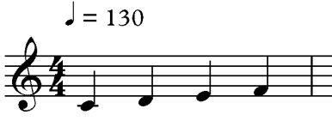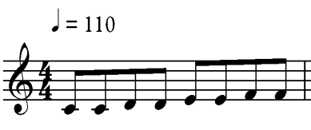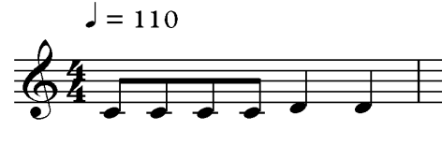
Scales in thirds
- C major over one octave
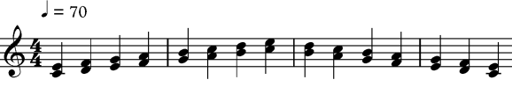
Right hand fingerings
- im, mi, ia, ai, ma, or am
Stroke
- Apoyando (rest stroke)
- Tirando (free stroke)
Dynamics
- Piano
- Forte
- Crescendo ascending then diminuendo descending
- Diminuendo ascending then crescendo descending
Technique
- Tasto
- Ponticello
- Etouffee (pizzicato)
- Vibrato (crotchet = 60 performed in crotchets)
Arpeggios
- C and D major, over 2 ocatves
- E, F and G major over 3 octaves
- C sharp and D minor over 2 octaves
= 60
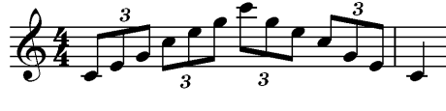
Harmony
- Demonstrate block chords I, IV, V, I in the keys of D major or G major and i, iv, V, i in the key of A minor
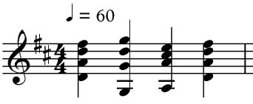

SUGGESTED TECHNICAL WORK – YEAR 12
Scales
- F sharp, G, A flat and A major, over 3 ocatves
- E, F and G major over a 3 octave range
- E, F and F sharp harmonic minor over 2 octaves
- E, F and F sharp melodic minor over 2 octaves
- Chromatic scale on G
Execution
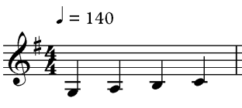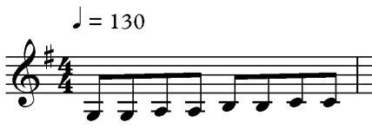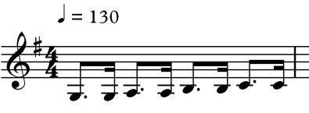
Scales in thirds
- G major over 2 octaves
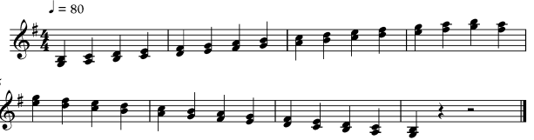
Right hand fingerings
- im, mi, ia, ai, ma, or am
Stroke
- Apoyando (rest stroke)
- Tirando (free stroke)
Dynamics
- Piano
- Forte
- Crescendo ascending then diminuendo descending
- Diminuendo ascending then crescendo descending
Technique
- Tasto
- Ponticello
- Etouffee (pizzicato)
- Vibrato (crotchet = 75 performed in triplets)
Arpeggios
- F sharp, G, A flat and A major, over 3 ocatves
- E, F and F sharp minor over 3 octaves
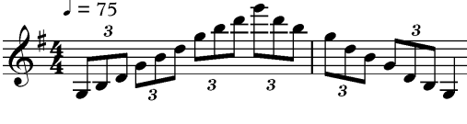
Harmony
- Demonstrate block chords I, IV, V, I in the key of G major and i, iv, V, i in the key of E or F minor
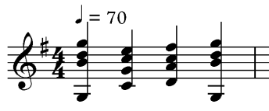

SUGGESTED TECHNICAL WORK – REPERTOIRE
Concept | Year 11  (min. AMEB Grade 4) | Year 12  (min. AMEB Grade 5) | Comments
Tuning and aural awareness | Tune independent of teacher | Tune accurately independent of teacher | Aural awareness of major and minor tonality, form, harmonic structure.
Posture and right hand sound production | Musicianship and Sight, Reading for Guitarists –  Oliver Hunt  World’s Favorite Solos for Classic Guitar Volume 43 – Harvey Vinson  Library of Guitar Classics – Jerry Willard  Etudes Simples (Volume 1 and 2) – Leo Brouwer  Slur, Ornament and Reach Development – Aaron Shearer  Microestudios 2 Volumes, Nos.6–10 and 11–15 –  Abel Carlevaro  Complete works of H Villa-Lobos – Preludes 2 and 4 | Musicianship and Sight, Reading for Guitarists –  Oliver Hunt  World’s Favorite Solos for Classic Guitar Volume 43 – Harvey Vinson  Library of Guitar Classics – Jerry Willard  Etudes Simples (Two Volumes) – Leo Brouwer  Slur, Ornament and Reach Development – Aaron Shearer  Microestudios 2 Volumes, Nos.6–10 and 11–15 –  Abel Carlevaro  Complete works of H Villa-Lobos – Other Preludes and Etudes | All of the repertoire presented in these volumes have a number of suitable pieces for developing a wide range of skills and concepts necessary at these stages of Guitar Performance. Teachers can consult the minimum levels of achievement stated in the requirements at the top of this chart.
Apoyando | Scales – Diatonic major and minor Scales – AMEB Technical Workbook | Scales – Diatonic major and minor Scales – AMEB Technical Workbook | NB. Scales can be configured with any sensible fingering.  Many of the pieces contained in the volumes above (under Posture and Right hand Sound Production) have excellent works to cover Apoyando (Rest stroke)
Tirando | AMEB Technical Work Book ex 4D, p. 33 Arpeggios | AMEB Technical Work Book ex 5B, p. 38 Arpeggios | Many of the pieces contained in the volumes above (under Posture and Right Hand Sound Production) have excellent works to cover Tirando (Free stroke)
Left hand
Flexibility | AMEB Technical Work Book ex 4B, p.32 Left hand slurring | AMEB Technical Work Book ex 6C, p. 44 Left hand slurring | Advanced ex 7B, p.52 AMEB Technical Work Book Left hand slurs
Articulation and coordination | A variety of Rhythms and Styles Student Repertoire Series Volume 2 – Lawrence Ferrara  Pieces from Latin America – Schwarzberger  Afterthoughts (1 and 2) – Richard Charlton  5 Exotic Studies – Philip Houghton | Right hand staccato –  WFS Sor Studies in A, p. 28 and Am, p. 35  Alternately use Fenando Sor – The Complete Studies, Lessons and Exercises for guitar – Brian Jeffery | All of the repertoire presented in these volumes have a number of suitable pieces for developing a wide range of skills and concepts necessary at these stages of Guitar Performance. Teachers can consult the minimum levels of achievement stated in the requirements at the top of this chart.
Tone quality | Tone Production on the Classical Guitar – John Taylor  Pumping Nylon – Scott Tenant (Book and DVD)  The Art of Playing Classical Guitar – Charles Duncan | Tone Production on the Classical Guitar – John Taylor  Pumping Nylon – Scott Tenant (Book and DVD)  The Art of Playing Classical Guitar – Charles Duncan | All of the repertoire presented in these volumes have a number of suitable pieces for developing a wide range of skills and concepts necessary at these stages of Guitar Performance. Teachers can consult the minimum levels of achievement stated in the requirements at the top of this chart.
Ensemble participation | Playing with others to perform for assessments. Music from intermediate to advanced ensemble works (one player per part). Suitable works by Richard Charlton, Christopher Keane, Rory O’Donohue, or any international composers for Guitar ensemble.  Duo Concertante – Giuliani  Divertissement for two guitars Op.38 – F Sor  Guitar Classics – Jerry Willard | Playing with others to perform for assessments. Music from intermediate to advanced ensemble works (one player per part). Suitable works by Richard Charlton, Christopher Keane, Rory O’Donohue, or any international composers for Guitar Ensemble.

SUGGESTED REPERTOIRE – YEAR 11
Classical guitar
Bach, J.S. Bourrée or Allemande from Suite in E minor for Lute BWV 996
Bach, J.S. Minuet from Cello Suite, No.1 BWV1007
Bach, J.S. Gavotte I and II from Suite, No.6 BWV 1012
Barrios, A.M. Villancico Navidad, Medallon Antiguo
Brouwer, L. Etudes Simples Series 2, Nos. 1–5
Carcassi, M. 25 Etudes, Opus 60, No.2, 9, 10, 13
Carolan, T. O Carolan’s Dream
Charlton, R. Rondo from Afterthoughts, Book 1, Cakewalk from Modern Times (Volume 4, Chanterelle)
Coste, N. Etude Op.38, No.2 or 20
Dowland, J. My Lord Willoughby’s Welcome Home, Mr Dowland’s Midnight
Guiliani, M. Maestoso from Three Sonatinas Op.4
Houghton, P. Six Short Guitar Solos: No. 1, Dompe ‘Drone Dance’, No. 2, The Stream, or
No. 4, The Red Gold Fish
Houghton, P. Five Exotic Studies – No. 4, Phantasy
Houghton, P. Black Rose Prelude
Johnson, R. Almain
Logy, A. Partita in A minor, Capriccio, Gavotte and Gigue
Lindsay-Clarke, V. Tango esta Noche
Mertz, J. K. Andante expressive, No.1 from Nachtviolin Op.2
Milan, L. Pavana from Libro de musica de Vihuela de mano intitulado El Maestro
Montoya, J.H. El Roble
Pujol, M.D. Candombe en Mi
Sagreras, J. Maria Luisa Mazurka No.2 from Tres Piezas Faciles, Op.19
Scarlatti, D. Five pieces, Larghetto or Aria
Sor, F. Minuet and Trio, No.1, Op.22, or Minuet and Trio, No.3, Op.25
Sor, F. 20 Sor Studies (ed. Segovia – Albert), Nos.1–5
Svoboda, P. Solos by Svoboda, Volume 2 – Wongaling, Bossa on the Beach, Lunar Sillhouette
Tarrega, F. Adelita, Lagrima, Rosita
Villa Lobos, H. Cinq Preludes, Nos.3 or 4

SUGGESTED REPERTOIRE – YEAR 12
Classical guitar
Bach, J.S. Prelude in D minor, BWV 999
Bach, J.S. Courante or Sarabande from Cello Suite, No.3 BWV 1009
Bach, J.S. Prelude from ‘Cello Suite, No.1 BWV 1006
Barrios, A.M. Aire de Zamba, Julia Florida Vals, Preludio, Aconquija
Bemnett, R.R. Impromptus, Nos.1, 3 or 5
Brouwer, L. Etudes Simples Series 2, Nos.6 and 7, Elogio de la Danza, Danza Characteristica
Carcassi, M. 25 Etudes, Opus 60, Nos.8, 18 or 20
Charlton, R. Afterthoughts, No.2 (any piece)
Dowland, J. Melancholy Galliard, Queen Elizabeth’s Galliard
Dyens, R. Tango en Skai
Giuliani, M. Six Preludes Op.83, Nos.1, 2, 3, 4 or 5
Giuliani, M. La Melonconia, No.7 from Giulianate Op.148
Houghton, P. Five Exotic Studies, No.5 – Tremolo Study (Oceana)
Houghton, P. Six Short Guitar Solos – The Ancients
Houghton, P. Kinkachoo I love You
Lauro, A. Quatro Valse Venezelano (any one)
Lauro, A. El Negrito
Morel, J. Danza Brasiliera
Myers, S. Cavatina
Piazzolla, A. Verano Portena, Tanguissimo
Pujol, M.D. Milonga, Preludio Tristan
Ryan, G. Smoke Rising from Scenes from the Wild West
Sagreras El Colibri
Sanz, G. Pavanas from Five Pieces (ed. Duarte – Universal)
Sanz, G. Canarios (ed. T Santos)
Sor, F. 20 Sor Studies, Nos.5–20 (ed. Segovia – Albert
Svoboda, P. Celtic Clash, Aurora
Tarrega, F. Recuerdos del Alhambra, Capriccho Arabe
Villa lobos, H. Cinq Preludes (any one)
Villa Lobos, H. Etude, No.1 or 11
Walton, W. Five Bagatelles (any one)
York, A. Faire, Sunday Morning, Overcast, Quicksilver, Sunburst

KEYBOARD

ORGAN

SUGGESTED TECHNICAL WORK – YEAR 11
Scales
Manual scales
= 84, four notes per beat
Major
A♭, B and E♭ 2 octaves, legato, hands separately and together
Harmonic and melodic minor
A♭, B and E♭ 2 octaves, legato, hands separately and together
Chromatic scales
A♭, B and E♭ 2 octaves, legato, hands separately and together
Manual contrary motion scales
= 60, four notes per beat
Major
D and E♭ 2 octaves, legato, hands separately and together
Harmonic minor
C and F 2 octaves, legato, hands separately and together
Manual arpeggios
Major and minor
= 52, four notes per beat (minimum speed)
A♭, B and E♭ 2 octaves, legato, hands separately and together
Pedal scales
Major
C, D and E♭ 2 octaves, legato
Harmonic and melodic minor
C, D and E♭ 2 octaves legato
Chromatic scales
C, D and E♭ 2 octaves legato
MM = 75, two notes per beat (minimum speed)
Pedal arpeggios
Major and minor
A, E♭ and F 1 octave, legato
MM = 65, two notes per beat (minimum speed)
Left hand and pedal scales contrary motion
Major
D and F 1 octave, legato
= 70, two notes per beat (minimum speed)
Pedal exercises
Note: Candidates must present one of the four exercises below as a component of their technical work.
Bach, J.S. Pedal Exercitum in G minor
Mendelssohn, F. Pedal part of the 12/8 Variation from Sonata in D minor, Op.65, No.6
Peeters, F. Pedal Exercise, No.4 in E major (p. 49) from Little Organ Book
(Summy-Birchard Inc. Distributed by Warner Bros.)
Peeters, F. Pedal Exercise, No.4 (p. 42) from Ars Organi Volume 2 (Schott Frères)

SUGGESTED TECHNICAL WORK – YEAR 12
Scales
Manual scales
= 92, four notes per beat
Major
A, D♭ and F♯ 2 octaves, legato, hands separately and together
Harmonic and melodic minor
A, D♭ and F♯ 2 octaves, legato, hands separately and together
Chromatic scales
A, D♭ and F♯ 2 octaves, legato, hands separately and together
Manual contrary motion scales
= 72, four notes per beat
Major
E and F 2 octaves, legato, hands separately and together
Harmonic minor
D♭ and E♭ 2 octaves, legato, hands separately and together
Manual arpeggios
Major and minor
= 60, four notes per beat
- Root position
A, D♭ and F♯ 2 octaves, legato, hands separately and together
Manual dominant 7^{ths}
= 60, four notes per beat
- Root position
A, D♭ and F♯ 2 octaves, legato, hands separately and together
Diminished 7^{ths}
= 60, four notes per beat
- Root position
A, D♭ and F♯ 2 octaves, legato, hands separately and together
Pedal scales
= 85, two notes per beat
Major
C♯ and E 2 octaves, legato
Harmonic and melodic minor
C♯ and E 2 octaves, legato
Chromatic scales
C♯ and E 2 octaves, legato
Pedal arpeggios
= 77, two notes per beat
Major
B, B♭ and C♯ 1 octave, legato
Minor
B, B♭ and C♯ 1 octave, legato
Left hand and pedal scales contrary motion
Major
B♭ and G 1 octave, legato
= 85, two notes per beat
Pedal exercises
Note: Candidates must present one of the three exercises below as a component of their technical work.
Bach, J.S. Fugue in D major, BWV 532, bars 119 to the end from (pedal part only)
Franck, C. Final in B flat, Op.21, Pedal solo (Bars 1–29)
Krebs, J.L. Prelude in G major, mm. 3–25 (p. 39) from The Organists’ Manual
(Roger E. Davis) (W. W. Norton & Company, New York)

SUGGESTED REPERTOIRE – YEAR 11
Archer, M. Reverie from A Little Suite for Organ (Incorporated Association of Organists Publication)
Bach, J.S. Ich ruf' zu dir, BWV 693
Bach, J.S. Gelobet seiest du, BWV 604
Bach, J.S. Heut triumphiret Gottes Sohn, BWV 630
Bach, J.S. In der ist Freude, BWV 615
Bach, J.S. Meine Seele erhebt den Herren, BWV 648
Bach, J.S. Prelude and Fugue in E minor, BWV 555
Bach, J.S. Wir glauben all’ an einen Gott, BWV 680
Boëllmann, L. Menuet from Suite Gothique
Buxtehude, D. Ciacona in E minor, Bux WV 160 (Barenreiter)
Clérambault, L-N. Dialogue sur les Grands Jeux from Suite du Premiere Ton
Daquin, L-C. Noël Suisse
Dupré, M. Seventy-nine Chorales, Op.28, numbers XXI, XXIV, XXX, XXXVII or XLII
Eben, P. Variation V only from Partita on ‘O Jesu all mein Leben bist du’ (Universal)
Jongen, J. Petit Prelude (OUP)
Jongen, J. Petite Piece (OUP)
Krebs, J.L. Trio in A minor (Fifteen Organ Trios, No.9, Masters Music Publications Inc.)
Langlais, J. Neuf Preludes, No.8 (Leduc)
Leighton, K. Fanfare from Easy Modern Organ Music (OUP)
Leighton, K. Ode (OUP)
Mendelssohn, F. Andante Religioso from Sonata, No.4, Op.65
Mendelssohn, F. Andante Tranquillo from Sonata, No.3, Op.65
Merkel, G. No. 3 from Choralstudien uber Wer nun den lieben Gott laBt walten, Op. 116
Peeters, F. Koraal from Suite Modale (Lemoine)
Reger, M. Herr, nun selbst den Wagen halt from Choralvorspiel zum gottesdienstlichen Gebrauch (Barenreiter BA 8249)
Rheinberger, J.G. Intermezzo from Sonata, No.8

SUGGESTED REPERTOIRE – YEAR 12
Bach, J.S. Ach bleib bei uns, Herr Jesu Christ, BWV 649
Bach, J.S. Prelude in C major, BWV 547
Bach, J.S. In dir ist Freude, BWV 615
Bach, J.S. Valet will ich dir geben, BWV 736
Boellmann, L. Toccata from Suite Gothique
Bonnet, J. Romance sans paroles, Op.7, No.8 (Leduc)
Brahms, J. Chorale Prelude: ‘O Welt, ich, muss dich lassen’, Op.122, No.3
Bridge, F. No. 5 from Six Organ Pieces (Boosey & Hawkes)
Buxtehude, D. Prelude, Fugue and Chaconne, BuxWV 137
Toccata and Fugue in F major, Bux WV 157 (Barenreiter)
Dubois, T. Interlude or Postlude-Cantique or Marche-Sortie from Seven Pieces for Organ (Kalmus K 09767)
Dupré, M. Numbers XLVIII or LIV from Seventy-Nine Chorales, Op.28
Dupré, M. Te lucis ante terminum (No.5 from ‘Le Tombeau de Titelouze’)
Eben, P. Improvisation uber ein slowwakisches Marienlied (ProOrgano 1062)
Franck, C. Cantabile in B major
Franck, C. Pastorale
Hammond Postlude from The Modern Organist, Volume 1 (Banks)
Hindemith, P. 1st or 2nd movements from Organ Sonata No.2
Homilius, G. A. Trio in G major (No.13 from Fifteen Organ Trios, Masters Music Publications Inc.)
Howells, H. Psalm-Prelude No.2 (Set 1) (Novello)
Jongen, J. Chant de Mai
Karg-Elert Dir, dir, Jehova or Sollt ich meinem Gott nicht singen from 20 Preludes &
Postludes, Op. 78 (Breitkopf)
8 Short Pieces, Op. 54 (any piece)
Langlais, J. Trois Meditations sur la Sainte Trinité, No.3 (Le Saint Espirit) (Editions Combre)
Langlais, J. Neuf Preludes, No.5 (Leduc)
Lübeck, V. Prelude and Fugue in E
Mathias, W. Processional from Modern Organ Music (OUP)
Mathias, W. Toccata Giocosa, Op.36, No.2 (OUP reproduced by Allegro Music)
Mendelssohn, F. Prelude and Fugue in D minor; Prelude in C minor
Merkel, G.A. 16 Orgelstücke, Op.179, No.15 (Musik Verlag 1878)
Messiaen, O. Les Bergers from ‘La Nativité’ (Leduc)
Peeters, F. Herr Jesus hat ein Gartchen (complete) from 10 Organ Chorales, Op.39 (Schott)
A Festival Voluntary (OUP)
Reger, M. Chorale Prelude ‘Wie schön leuchtet der Morgenstern’, Op.67, No.49
Reger, M. Jesus, meine Zuversicht from Choralvorspiel zum gottesdienstlichen Gebrauch (Barenreiter BA 8249)
Reger, M. Lobe den Herren from Choralvorspiel zum gottesdienstlichen Gebrauch (Barenreiter BA 8249)
Rutter, J. Toccata in Seven (OUP)

PIANOFORTE

SUGGESTED TECHNICAL WORK – YEAR 11
Scales – Similar motion, legato
= 84, four notes per beat
Major
B, E♭ and F♯ 4 octaves, hands separately and together, piano or forte
Harmonic and melodic minor
B, E♭ and F♯ 4 octaves, hands separately and together, piano or forte
Chromatic scales
B, E♭ and F♯ 4 octaves, legato, hands separately and together, piano or forte
Scales – similar motion, staccato
= 60, four notes per beat
Major
B and E♭ 4 octaves, hands separately and together, mezzo-forte
Harmonic and melodic minor
B and E♭ 4 octaves, hands separately and together, mezzo-forte
Chromatic scales
B and E♭ 4 octaves, hands separately and together, mezzo-forte
Contrary motion scales – legato
= 60, four notes per beat
Major
B and E♭ 2 octaves, hands together, mezzo-forte
Harmonic minor
B and E♭ 2 octaves, hands together, mezzo-forte
Arpeggios
= 52, four notes per beat
Major and minor
B, E♭ and F♯ 4 octaves, hands separately and together, root position only, mezzo- forte

TECHNICAL WORK – SUGGESTED REPERTOIRE – YEAR 11
The following studies may form a part of the technical work component for the pianoforte examination.
Berens, H. 46 Exercises for Left hand Alone Op.89, Book 1, Nos.17, 18, 19, 20, 21, 26, 27, 28 or 45 (Schirmer 1031)
Köhler, L. Short School of Velocity, Op.242, Nos.4, 5, 6, 8 or 9 from (Alfred)
Macdowell, E. Alla Tarantella from 12 Etudes for the Development of Technique and Style, Op.39
Moszkowsky, M. 20 Short Studies, Op.91, Nos.1, 3, 4, 5 (Alfred)

SUGGESTED TECHNICAL WORK – YEAR 12
Scales – similar motion, legato
= 92, four notes per beat
Major
A♭, D♭ and E 4 octaves, hands separately and together, piano or forte
Harmonic and melodic minor
A♭, D♭ and E 4 octaves, hands separately and together, piano or forte
Chromatic scales
A♭, D♭ and E 4 octaves, hands separately and together, piano or forte
Scales – similar motion, staccato
= 72, four notes per beat
Major
A♭ 4 octaves, hands separately and together, mezzo-forte
Harmonic and melodic minor
A♭ and D♭ 4 octaves, hands separately and together, mezzo-forte
Chromatic scales
D♭ and E 4 octaves, hands separately and together, mezzo-forte
Contrary motion scales – legato
= 72, four notes per beat
Major
A♭ and D♭ 2 octaves, hands together, mezzo-forte
Harmonic minor
A♭ and D♭ 2 octaves, hands together, mezzo-forte
Arpeggios
= 60, four notes per beat
Major and minor
A♭, D♭ and E 4 octaves, hands separately and together, root position only, mezzo-forte
Dominant 7^{ths}
= 60, four notes per beat
of D♭ and E 4 octaves, hands separately and together, root position only, mezzo-forte
Diminished 7^{ths}
= 60, four notes per beat
of D♭ and E 4 octaves, hands separately and together, root position only, mezzo-forte

TECHNICAL WORK – SUGGESTED REPERTOIRE YEAR 12
Studies may form a part of the technical work component for the pianoforte examination.
Berens, H. Any one from 25 Studies for the Left hand Alone, Op.89, Book 2 (Schirmer 1031)
Czerny, C. Exercises for Passage Playing, Op.261, Nos.110, 114, 118 or 125 (Peters 2404)
Köhler, L. Short School of Velocity, Op.242, Nos.11, 12, 13, 17, 18, 19 or 20 (Alfred)
Moszkowsky, M. 20 Short Studies, Op.91, Nos.7, 8, 10, 14, 15, 17 (Alfred)
Pozzoli, E. 24 Studi de Facile Meccanismo, Nos.5, 9, 10, 13 or 21 (Ricordi 427)

SUGGESTED REPERTOIRE – YEAR 11
Bach, CPE Allegro (3rd Mvt) from Sonata in C, Wq 51/1 (Selected Sonatas Vol. 3, Urtext)
Bach, CPE Allegro (3rd Mvt) from Sonata in C, Wq 65/36 (Selected Sonatas Vol. 3, Urtext)
Bach, CPE Allegro (1st Mvt) from Sonata in D, Wq 65/40 (Selected Sonatas Vol. 3, Urtext)
Bach, CPE Allegretto (3rd Mvt) from Sonata in E minor, Wq 65/30 (Selected Sonatas,
Vol. 2, Urtext)
Bach, CPE Allegro (1st Mvt) from Prussian Sonata No. 1 in F major, Wq 48 (Barenreiter)
Bach, J.S. Courante from French Suite, No.6, BWV 817
Bach, J.S. Two-part Inventions, Nos.1, 8, 9, 11 or 13
Bailey, K. Melinda’s Mini March from Jazzin’ Around (Kerin Bailey Music)
Bartók, B. Mikrokosmos, Volume 5, No.124 (Staccato) or 128 (Stamping Dance)
Chopin, F. Prelude in E minor, Op.28, No.4
Debussy, C. The Little Nigar
De Seixas, C. Toccata in F minor (AMEB Piano Grade 5, Series 17)
Dussek, J.L. Sonatina, Op.20, No.1 (complete)
Galuppi, B. Allegro (2nd Mvt) from Sonata No. 1 in A major (Schott 20266)
Grieg, E. Nocturne from Lyric Pieces, Op.54, No.4
Hutchens, F. Two Little Birds or Evening (EMI)
Hyde, M. Study for Scales and Staccato or Reverie or Woodland Sketch (Allans)
Kats-Chernin, E. Cinema (No. 12 from Twelve One-Page Piano Pieces) (Boosey & Hawkes)
Khachaturian, A. Album of Children’s Pieces, Volume 2, No.6 (Two Funny Aunties Argued)
Koh, J.B. Piano Peals for Piano with Soundtrack from Spectrum 4 (ABRSM Publications)
Lindborg, P. Búgó Resonances for Piano with Soundtrack from Spectrum 4 (ABRSM Publications)
Liszt, F. Consolation No. 1 or 2 (Peters)
Lunsqui, A. … tornando-se… from Spectrum 4 (ABRSM Publications)
Mathias, W. Dance or Finale from Little Suite for Piano (OUP)
Mendelssohn, F. Song without Words, Op.19, No.4
Mozart, W. A. Fantasia in D minor, K.397
Moszkowski, M. Inquietud, Op. 77, No. 4 (Schirmer)
Norton, C. Black Sheep of the Family from Lavender’s Kind of Blue (Boosey & Hawkes)
Oliveira, J.P. Looking into the Mirror for Piano with Soundtrack from Spectrum 4 (ABRSM Publications)
Purcell, H. Prelude from Suite No.5 in C major
Reger, M. Scherzo or Capriccio from Zehn Kleine Vortragsstucke, Op. 44 (Urtext)
Russell-Smith, G. Wistful Prelude from Jazzy Piano 2 (Universal 19363)
Schumann, R. Album for the Young, Op.68, Nos.14, 18, 19 or 30
Sculthorpe, P. Night Pieces, No.2 (Night)
Tüür, E-S. Short Meeting of Dark and Light from Spectrum 4 (ABRSM Publications)
Vir, P. Ratri from Spectrum 4 (ABRSM Publications)

SUGGESTED REPERTOIRE – YEAR 12
Bach, CPE. Allegro (1st Mvt) from Prussian Sonata No. 6 in A major, Wq 48 (Barenreiter)
Bach, CPE. Presto (3rd Mvt) from Prussian Sonata No. 4 in C minor, Wq 48 (Barenreiter)
Bach, CPE. Allegro di Molto (3rd Mvt) from Sonata in C major, Wq 62/10 (Selected
Sonatas Vol. 2, Urtext)
Bach, CPE. Presto (3rd Mvt) from Sonata in G minor, Wq 62/18 (Selected Sonatas Vol. 2,
Urtext)
Bach, CPE. Allegro assai (1st Mvt) from Sonata in G major, Wq 62/19 (Selected Sonatas
Vol. 2, Urtext)
Bach, J.S. Gigue from English Suite, No.4 in F major
Bach, J.S. Gigue from French Suite, No.6 in E major
Bach, J.S. Three-part Sinfonias, Nos.2, 4, 6 or 7
Bach, J.S. Prelude from Partita No. 5 in G major
Bach, J.S. Capriccio from Partita No. 2, BWV 826 (Urtext)
Bailey, K. Toccatina from Six Sketches (Kerin Bailey Music)
Bartók, B. Mikrokosmos, Volume 5, No.135 (Perpetuum Mobile) or No.139 (Jack-in-the-Box)
Beethoven, L, van Rondo from Sonata in E major, Op.14, No.1
Beethoven, L, van Sonata in B flat major, Op.22 (3rd movement only); Rondo in C, Op.51 No.1
Brahms, J. Intermezzo in B flat, Op.76, No.4
Bridge, F. Rosemary from Three Sketches (Boosey & Hawkes)
Chopin, F. Preludes, Op.28, Nos.13, 15 or 22
Clementi, M. Sonata, Op.26 No.2 (1st movement only)
Clementi, M. Presto (1st Mvt) from Sonata in B flat major, Op. 8 No. 3 (Urtext)
Clementi, M. Allegro con spirito (1st Mvt) from Sonata in A major, Op. 10, No. 1 (Urtext)
Debussy, C. Serenade of the Doll from Children’s Corner (Urtext)
Glass, Philip Piano Etude No. 16 (Chester Music Ltd)
Grieg, E. Butterfly, Op.43, No.1
Haflffter, E. Habanera (ABRSM Grade 8 Piano Pieces, 2013 & 2014)
Handel, G.F. Allegro (3rd Mvt) from Suite HWV 431) (ABRSM Publications)
Haydn, F. Finale from Sonata in G major, Hob. XVI: 27 (Peters)
Haydn, F. First or third movement from Sonata in F major, Hob. XVI: 47 (Peters)
Hyde, M. Concert Waltz for Left Hand (AMEB Piano Grade 7, Series 17)
Joplin, S. Pineapple Rag or Scott Joplin’s New Rag (Schirmer)
Mendelssohn, F. Songs without Words, Op.85, No.2 or Op.19, No.6 , or Op. 38, No. 2
Mompou, F. Jeunes Filles au Jardin from “Scenes d’Enfants” (Salabert)
Mozart, W. A. Sonata in B flat, K.570, first movement
Nazareth, E. Odeon (AMEB Piano Grade 8, Series 17)
Part, A. Allegro (1st Mvt) from Sonatina, Op. 1 No. 1 (Universal)
Scarlatti, D. Sonata in D major, K.416; Sonata in A major, K.429, Sonata in F minor, K. 239
Schubert, F. Moments Musicaux, No.5 or 6
Schumann, R. Bunte Blätter, Op.99, No.1 (Coloured Leaf)
Schumann, R. No.3 or No. 6, from Waldszenen, Op.82, No.30 from Album for the Young
Solal, M. No. 57 or No. 58, from jazzSolal! (Boosey & Hawkes)
Tchaikovsky, P. Romance in F minor (PWM)
Tcherepin, A. Bagatelles, Op.5, Nos.1, 2 or 3 (Heugel)
Whiffin, L. The Polycat Waltz (Australian Music Centre Publications)
Wieck-Schumann, C. Romance from 4 Pieces Caracteristiques, Op. 5 (Selected Piano Works, Urtext)

HARPSICHORD

SUGGESTED TECHNICAL WORK – YEAR 11
Scales – similar motion, legato
= 84, four notes per beat
Major
B, E♭ and E 3 octaves, hands separately and together
Harmonic and melodic minor
B, E♭ and E 3 octaves, hands separately and together
Chromatic scales
B, E♭ and E 3 octaves, hands separately and together
Scales – contrary motion, legato
= 60, four notes per beat
Major and harmonic minor
D, E♭ 2 octaves, hands together
Arpeggios
= 52, four notes per beat
Major and minor
B, E♭ and E 3 octaves, hands separately and together, root position only

SUGGESTED TECHNICAL WORK – YEAR 12
Scales – similar motion, legato
= 108, four notes per beat
Major
B♭, C♯ and F♯ 3 octaves, hands separately and together
Harmonic and melodic minor
B♭, C♯ and F♯ 3 octaves, hands separately and together
Chromatic scales
B♭, C♯ and F♯ 3 octaves, hands separately and together
Scales – similar motion, staccatto
= 72, four notes per beat
Major
B♭, C♯and F♯ 3 octaves, hands separately and together
Harmonic and melodic minor
B♭, C♯ and F♯ 3 octaves, hands separately and together
Chromatic scales
B♭, C♯ and F♯ 3 octaves, hands separately and together
Scales – Contrary motion, staccatto
= 72, four notes per beat
Major and harmonic minor
C♯ and E♭ 2 octaves, hands together
Arpeggios
= 72, four notes per beat
Major and minor
C♯, E♭ and F♯ 3 octaves, all inversions, legato, hands separately and together, root position only
Dominant 7^{ths}
= 72, four notes per beat
of C♯ and B♭ 3 octaves, legato, hands separately and together, root position only
Diminished 7 ^{ths}
= 72, four notes per beat
of C♯ and B♭ 3 octaves, legato, hands separately and together, root position only

SUGGESTED REPERTOIRE – YEAR 11
Bach, J.S. Allemande, BWV 837 from Baroque Keyboard Pieces, Book 2 (ABRSM Publications)
Bach, J.S. Menuet, BWV 818 a/5 (Baroque Keyboard Pieces Volume 3, ABRSM Publications)
Bach, J.S. Menuet: 5th movement from Suite in A minor, BWV 818a, No.28 from Baroque Keyboard Pieces, Book 3 (ABRSM Publishings)
Bach, J.S. Courante from French Suite No.6 in E major
Bach, J.S. Prelude in D, BWV 936: No.4 from Sechs kleine Präludien
Byrd, W. The Carman’s Whistle (complete) from Early Keyboard Music, Volume 1
(Schirmer 1559)
Byrd, W. Victoria from Early Keyboard Music, Volume 1 (Schirmer 1559)
Daquin, L. La Mélodieuse (Rondeau) (from 1er livre)
Gibbons, O. The Lord of Salisbury his Pavin from Early Keyboard Music, Volume 1 (Schirmer 1559)
Handel, G.F. Courante: 2nd movement from Suite in G minor, HWV 452, No.7 from Handel Klavierwerke, Volume 3 (Bärenreiter Ba 4222) or No.2 from Handel Selected Keyboard Works, Book 3 (5 Mischellaneious Suites) (ABRSM Publishing)
Mattheson, J. Air (Baroque Keyboard Pieces Volume 3, ABRSM Public1ations)
Two-part Inventions, Nos.1, 8, 9, 11 or 13
Paradies Sonata V in F major, 1st or 2nd movement
Purcell, H. A New Ground (Z.682), No.10, from Purcell Complete Keyboard Music, Book 2 (Chester/Music Sales: special order) or No.9, from Purcell Miscellaneous Keyboard Pieces (Stainer 7 Bell K22) or No.11, from Baroque Keyboard Pieces, Book 4 (ABRSM Publishing)
Purcell, H. Prelude from Suite No.3 in G major
Rameau, J-P. Menuets 1 and 2 from Baroque Keyboard Pieces, Book 3 (ABRSM Publishing)
Rameau, J-P. Tambourin (from Pièces de Clavecin). Rameau Complete Keyboard Works,
Volume 1 (Bärenreiter BA 6581)
Scarlatti, D. Sonata in G minor, Kp. 8, from Scarlatti Sonatas, Volume 1 (Heugel LP 31/UMP)
Scarlatti, D. Sonata in A, L. 191
Scarlatti, D. Sonata in B minor, L. 263
Scarlatti, D. Sonata in D, L. 482
Scarlatti, D. Sonata in D, L. S15
Scarlatti, D. Sonata in G minor, L. 89
Sweelinck, J.P. Malle Sijmen, SwWV 323, No.15 from Sweelinck Sämtliche Werke für Tasteninstrumente, Vo. 4 (Breitkopf & Härtel EB 8744)
Türk, D.G. 60 Pieces for Aspiring Players, Volume 1, No.47 (ABRSM Publications)

SUGGESTED REPERTOIRE – YEAR 12
Bach, J.S. Gigue from English Suite No.4 in F major
Bach, J.S. Gigue from French Suite No.6 in E major
Bach, J.S. Three-part Sinfonia, Nos.2, 4, 6 or 7
Bach, J.S. Prelude from Partita No. 5 in G major
Benda, F. First movement from Sonata in G (No.2 from Six Sonatas, Schott ED. 9018/MDS)
Buxtehude, D. Canzonetta (complete) in G major (p. 107) from Early Keyboard Music, Volume 1 (Schirmer 1559)
Frescobaldi, G. Fuga in G minor (p. 59) from Early Keyboard Music, Volume 1 (Schirmer 1559)
Froberger, J.J. Toccata in D minor (p. 67) from Early Keyboard Music, Volume 1 (Schirmer 1559)
Krall, D. Toccata Tutta de Salti from Early Keyboard Music, Volume 1 (Schirmer 1559)
Ligeti, G. Passacaglia Ungherese (Schott ED. 6843/MDS)
Paradies, D. Sonata X (Sonatas Volume 2), either movement (Schott 6121)
Paradies, D. Sonata III in E major, 1st movement
Paradies, D. Giga (Presto) from Sonata XII
Paradies, D. Sonata VI in A major, 2nd movement
Rameau, J-P. La Dauphine (Rameau Complete Keyboard Works Volume 1 (Barenreiter BA6581)
Scarlatti, D. Sonata in A major, K.429
Scarlatti, D. Sonata in A, L. 293 from Scarlatti Keyboard Pieces and Sonatas, Volume 2 (ABRSM Publications)
Scarlatti, D. Sonata in D major, K.416
Scarlatti, D. Sonata in E flat, L. 111
Scarlatti, D. Sonata in F sharp minor, L. 32
Scarlatti, D. Sonata in F sharp minor, L. 481

VOICE

SUGGESTED TECHNICAL WORK – YEAR 11
All scales/arpeggios to be sung to the octave using solfa, open vowel or scat syllables e.g. lah lah lah.
The student is to sing the following scales in keys suitable for his/her vocal range.
Scales
All scales to be sung in even quavers to the octave
- Major (crotchet=120)
- Major pentatonic (crotchet=100)
- Minor pentatonic (crotchet=100)
- Aeolian/natural minor (crotchet=120)
- Harmonic minor (crotchet=120)
- Melodic minor (crotchet=120)
- Chromatic to the sharpened 5th (crotchet=60)
- Whole tone to the octave (crotchet=60)
Arpeggios
All arpeggios to be sung in even quavers to the octave
- Major (crotchet=80)
- Minor (crotchet=80)
Articulation
- Legato, staccato
Dynamics
- p, mp, mf, f, crescendo, decrescendo

SUGGESTED TECHNICAL WORK – YEAR 12
All scales to be sung to the octave using solfa or open vowel.
The student is to sing the following scales in keys suitable for his/her vocal range.
Scales
All scales to be sung in even quavers to the 9th
- Major (crotchet=120)
- Major pentatonic (crotchet=100)
- Minor pentatonic to the flat 10th (crotchet=100)
- Aeolian/natural minor (crotchet=120)
- Harmonic minor (crotchet=120)
- Melodic minor (crotchet=120)
- Chromatic to the 8^{ve} (crotchet=60)
- Whole tone to the 8^{ve} (crotchet=60)
Arpeggios
All arpeggios to be sung in even quavers to the 10th
- Major (crotchet=80)
- Minor (crotchet=80)
Articulation
Legato, staccato
Dynamics
p, mp, mf, f, crescendo, decrescendo

TECHNICAL WORK – SUGGESTED REPERTOIRE
Studies to be comparable to accredited music examination boards available within Australia
ATAR Year 11: Grade 4/5
ATAR Year 12: Grade 6 or above
Recommended texts for studies
Peri, A. Vocalises and Exercises for Beginners
Concone, G. Opus 9: 50 Lessons for Voice (various editions for different voice types)
Melba, N. Melba Method
Vaccai, N. Practical Method for Voice (various editions for different voice types)
Diack, M. Vocal Exercises, Song Studies
Jennings, K. Sing Legato
Vocal resonance (tone colour, vowels)
Diack, M. Vocal Exercises
Song Studies 1–6: Intoning Exercises 1–11: Vowel Exercises 1–7
Ear training (intervals: improvisation: phrasing: ornamentation: syncopation)
Melba Method: Nos.1–3 for low voice
Vaccai
Cocone Opus 9, 50 Lessons for Medium Voice
17–Octaves: 19–Arpeggios: 20–3 key changes
Sing Legato: No.6 onwards
Registration (passagio: tilt: range)
Concone: 1–range of a tenth: 19–wide range and arpeggios
Vaccai: 1–diatonic scale: up and down over 8^{ve}–VII
Amelia Peri
Phonation (vowels: consonants: articulation: scat: onset: ornamentations: flexibility: arpeggios)
Melba: 9–low voice, 10 high voice–flexibility: 12A high–articulation: 11 high–triplets
Concone: 16–Staccato, messa de voce, slurring: 17–articulation: 20–marcato: 10–flexibility, wide range, marcato, fast
Vaccai: 8–appoggiatura, accacciatura (ornamentation): 9–mordant: 10 gruppetto
Breathing (phrasing: alignment: breath support: messa di voce: flexibility)
Melba Method Vocalises Part 2 low and high voice e.g. No.14–AMEB Gd 4–largo: 5 high: 6 low–phrasing
Concone: 13–Snatch breath
Amelia Peri–phrasing and dynamics

SUGGESTED REPERTOIRE – YEAR 11
Songs
The songs selected should be contrasting in mood and style. The student is encouraged to include one unaccompanied song in his or her programme. Western Art Music vocal candidates must present at least one song in a language other than English. Where a song is originally in a language other than English, it may be presented in either the original language or in an English translation. Though memorisation is not obligatory, it is desirable. The following list is not prescriptive but provides examples of songs of an appropriate standard.
Typical songs for male voices
Anon. Down Among the Dead Men, c 1700 (Boosey & Hawkes)
Arlen, H. If I Only Had A Brain (from: The Wizard of Oz). (United Artists Music)
Giordani, G. Caro Mio Ben (Schirmer)
Handel, G.F. Where'er You Walk (Schirmer)
Haydn, J. Liebes Madchen Hor Mir Zu (Schott)
Die Landlust (Peters)
Quilter, R. Over the Mountains (from: Three songs from old English popular songs, No.3.)
Rodgers & Hammerstein The Surrey with the Fringe On Top (from: Oklahoma)
Schonberg, C. Do You Hear the People Sing? (from: Les Miserables)
Smith, J.C. The Owl Is Abroad (from: The Tempest) (Boosey and Co Ltd.)
Trad. Welsh All Through the Night
A Shakespeare Song Book (ed. H.A. Chambers), Blandford Press
O Mistress Mine
When That I Was and A Little Tiny Boy
Trad. Arr. Sharp Scarborough Fair (Novello and Co)
Vaughan Williams, R. Linden Lea (Boosey & Hawkes)
Typical songs for female voices
Arne, T. When Daisies Pied (New Imperial)
Brahms, J. Wiegenlied Op.49, No.4 (Peters)
Franck, C. Panis Angelicus, Basics of Singing 6th Edition (current)
Harrhy, E. An Australian Lullaby (Allan and Co)
Mendelssohn, F. On Wings of Song
Gruss Op.19 No.5 (Peters)
Volkslied Op.47, No.4 (Peters)
Mozart, W. A. Wiegenlied (Peters)
Die Kleine Spinnerin (Peters)
Paisiello, G. Nel cor piu non mi sento (Schirmer)
Purcell, H. Fairest Isle (Allan and Co)
Quilter, R. Over the Mountains (Boosey & Hawkes)
Schubert, F. Wiegenlied (Peters)
Schumann, R. Volksliedchen (Peters)
Marienwurmchen (Peters)
Trad. arr. Hughes I Know Where I'm Going (Boosey and Co)
Weckerlin arr. Par Un Matin
Que Ne Suis-Je La Fougere
Trad. The Willow Song (Blandford Press)

SUGGESTED REPERTOIRE – YEAR 12
Songs
The songs selected should be contrasting in mood and style. The student is encouraged to include one unaccompanied song in his or her programme. Western Art Music vocal candidates must present at least one song in a language other than English. Where a song is originally in a language other than English, it may be presented in either the original language or in an English translation. Though memorisation is not obligatory, it is desirable. The following list is not prescriptive but provides examples of songs of an appropriate standard.
Typical songs for male voices
Brahms, J. Erlaube mir, feins Mädchen, Peters
Brahms, J. Sehnsucht, Volkslied, Op.14 No.8, Peters
Brahms, J. Sonntag, Boosey & Hawkes
Caldara, A. Sebben Crudele, Schirmer
Carissimi, G. G. Vittoria mio core!, Schirmer
Handel, G.F. Silent Worship, arr. Somervell, Curwen
Head, M. Money, O!, Boosey & Hawkes
James, W. G. Comrades of Mine, Ricordi and Co
James, W. G. Bush Night Song, Ricordi and Co
Mozart, W. A. When You Find a Maiden Charming, Il Seraglio
Pergolesi, G. Attributed to Nina, Schirmer
Rodgers & Hammerstein Oh What a Beautiful Morning! from Oklahoma
Scarlatti, D. O Cessate, Without repeat, Schirmer
Schönberg, C-M. Stars, from Les Miserables
Schubert, F. An Die Laute, Schott
Telemann, G. P. Die Jugend, Schott
Vaughan Williams, R. The Vagabond, Boosey & Hawkes
Folk
Down By the Sally Gardens, arr. Britten, Down By the Sally Gardens, arr. Hughes
The Lark in the Clear Air, Trad. Irish, arr. Jones, Allan and Co
Typical songs for female voices
Bach, J S. Bist du bei mir, Schott
Bennett, M. The Birds' Lament from The Aviary, Universal
Bernstein, L. One Hand, One Heart from West Side Story, Chappell and Co
Brahms, J. Da Unten im Tale, Peters
Britten, B. (arr.) Come You Not From Newcastle
Britten, B. (arr.) Sweet Polly Oliver
Britten, B. (arr.) Waly Waly
Dowland, J. Come Again Sweet Love, Boosey & Hawkes
Dvorak, A. The Lord is my Shepherd, Alfred Lengnick
Eriskay Love Lilt, Trad
Fauré, G. Mai, Hamelle
Haydn, J. A Pastoral Song, Peters
Haydn, J. The Mermaid's Song
Le Gallienne Solveig's Song, Allans Music Aust. Ltd
Martini, G. Plaisir d'amour, Allan and Co
Pergolesi, G. Se tu M'ami, se sospiri, Schirmer
Rodgers & Hammerstein Many a New Day from Oklahoma
Schönberg, C-M. On My Own, from Les Miserables
Schubert, F. Geheimnes
Schubert, F. Haiden-Roslein, Augener
Schubert, F. Lachen und Weinen, Peters
Sondheim, S. Green Finch and Linnet Bird, Sweeney Todd, Revelation Music Publishing
Telemann, G.P. Die Jugend, Schott
Trad. Scottish Ca the Yowes, Dorsey Bros Music Ltd
Weckerlin, J.B. (arr.) Jeunes Fillettes
Weckerlin, J.B. (arr.) Maman Dites-Moi
Basics of Singing 6th Edition (current)
Fauré, G. L'aurore, Op.posth
Franz, R. Im Frühling
Gilbert and Sullivan The Moon and I from The Mikado
Gounod, C. Ave Maria

JAZZ

INSTRUMENTAL SPECIFICATIONS

Technical work support
General techniques apply to all jazz instruments.
Nomenclature (chords and scales)
Knowledge of chord symbols and related Contemporary nomenclature relevant to chosen pieces. This could include dominant sevenths with altered tensions and extensions.
Texts include:
Haerle, Scales Jazz Improvisation and The Jazz Language
Coker, Improvising Jazz
Lawn, Jazz Theory and Practice
Aebersold, Introductions to all Volumes
Language of jazz
- ii, V–I relevant to chosen repertoire, ii–V–I Progressions, The Ramon Ricker Improvisation Series (Volume 4), Aebersold, ii–V–I Progression (Volume 3 and Volume 16)
- knowledge of guide tones–tritons
- knowledge of appropriate patterns and riffs relevant to chosen tunes
Texts include:
Baker, David, The Bebop Era
Coker, Casale, Campbell, Greene, Patterns for Jazz
Conventions
- knowledge of form
- ensemble etiquette

SOURCES OF REPERTOIRE
Common sources of Jazz and Contemporary repertoire
The New Real Book, Volumes 1–3
The Ultimate Jazz Fake Book
Jamey Aebersold play-a-longs, Volume 6 onwards
The Charlie Parker Omnibook
Publications by specific artists e.g. The Ari Hoenig Songbook, Avishai Cohen Songbook

GENERIC REPERTOIRE
The generic jazz repertoire listed below, is applicable for the jazz instruments listed in this resource package. Students can practise and perform the listed repertoire using either a recorded backing accompaniment or performing as part of an ensemble. For examination purposes, Jazz students must demonstrate an ability to solo and/or improvise appropriate to the repertoire and must demonstrate a swing feel in some of the repertoire. Note that Jazz repertoire will need to be appropriately arranged (and in most cases, scored). Refer to the Music Practical (performance and/or composition portfolio) examination requirements document for further clarification of score requirements for all instruments.
YEAR 11
Autumn Leaves
Blue Bossa
Blues in Bb (Tenor Madness, Blue Monk, Freddie Freeloader)
Blues in Eb (The Sidewinder)
Blues in F (Now’s the Time)
Blues in G (All Blues)
Bye Bye Blackbird
Cantaloupe Island
Caravan
Chameleon
Don’t Get Around Much Anymore
Fly Me to the Moon
Impressions (So What)
Little Sunflower
Mack the Knife
Perdido
St Thomas
Satin Doll
September in the Rain
Softly as in a morning Sunrise
Summertime
Sweet Georgia Brown
S'wonderful
Take the A-Train
Watermelon Man
Weaver of Dreams
When Sunny Gets Blue
When the Saints go Marching In
YEAR 12
A Child is Born
All of Me
Blues in Eb (Sandu)
Blues in F – ‘bebop’ blues (Birdlike, Au Privave, Barbados)
Blues in F minor (Afro Blue)
Blues in G (All Blues)
But Not For Me
Days of Wine and Roses
Driftin’ – Herbie Hancock
Doxy
Everybody's Party – John Scofield and Pat Metheny
Georgia on my Mind
Honeysuckle Rose
I Got Rhythm
Jitterbug Waltz
Killer Joe
Maiden Voyage
Mercy, Mercy, Mercy
Milestones (New)
Misty
My Favorite Things
Night and Day
Quiet Nights (Corcovado)
Red Barron – Billy Cobham
Song for my Father
Smoke Gets In Your Eyes
The Chicken – Jaco Pastorius
Work Song

WIND INSTRUMENTS

FLUTE

SUGGESTED TECHNICAL WORK – YEAR 11
Year 11 generic scales
Scales and arpeggios are to be played over a minimum of one octave in all 12 keys.
Minimum tempo: = 88 (play as straight or swung quavers/eighths).
Ionian
Aeolian/natural minor
Dorian
Mixolydian
Jazz (melodic) minor
Blues
Arpeggios: Ma⁷, mi⁷, Dom⁷, mi^{7(♭5)}, root position only

SUGGESTED TECHNICAL WORK – YEAR 12
Year 12 generic scales
Scales and arpeggios are to be played over a minimum of one octave in all 12 keys.
Minimum tempo: = 92 (play as straight or swung quavers/eighths).
Ionian
Dorian
Mixolydian
Aeolian
Lydian
Jazz (melodic) minor
Major pentatonic
Minor pentatonic
Blues
Arpeggios: Ma⁷, mi⁷, Dom⁷, mi^{7(♭5)}, mi/Ma⁷, root position only

TECHNICAL WORK – SUGGESTED REPERTOIRE
Studies and pieces – Year 11 and Year 12
Improvisation
Aebersold, J. Turnaround and Cyclic Progressions, Record and Book Kit, Studio P.R, USA
The following suggested titles are by Jamey Aebersold (Jamey Aebersold Jazz Inc.)
- The II–V⁷–I Progression (Volume 3)
- Salsa latin jazz (Volume 64)
- All Time Standards (Volume 25)
- Jazz Bossa Novas (Volume 31)
- Charlie Parker (All Bird) (Volume 6)
Bergonzi, J. Inside Improvisation, Volume 3: Jazz Line, Advance Music, USA
Crooke, H. How to Improvise, Advance Music, Germany
Haerle, D. The Jazz Language, Studio P.R, USA
Kane, B. Constructing Melodic Jazz Improvisation – Concert Key Edition for Piano/Guitar/Flute, Published by Jazz Path Publishing
Schnyder, D. Crossing Over Essentials for Jazz and Classical Flute, Second Floor Music
Technique and style (transcriptions)
Snidero, J. Jazz Conception Medium-Advanced, Advance Music
(Author unknown) Solos for Jazz Flute, All That Jazz, Carl Fischer
Osland M. The Music of Nestor Torres: Solo Transcriptions and Performing Artist Master Class CD, Alfred Publishing
Technical work
Adler, M. Jazz Flute Etudes (Advanced Studies in Improvisation), Houston Publishing, Inc.
Bay, W. Mel Bay's Complete Jazz Flute Book, Mel Bay Publications, Inc.
Haerle, D. Scales for Jazz Improvisation, Alfred Publishing Company
Keller, G. Jazz Chord/Scale Handbook, Advance Music
Rae, J. Jazz Flute Studies, Faber Music Ltd.
(Author unknown) Jazz Scale Studies – Flute, Universal Edition
Sight reading
Kane, Brian (2004), Creative Jazz Sightreading, Jazz Path Publishing, USA
Parker, Charlie (1978), The Charlie Parker Omnibook, ‘C’ edition, Alfred Publishing Company
Any suitable transcriptions by Herbie Mann or Hubert Laws
NB All technical, tone and technique work specified in the classical syllabus is also applicable to this jazz syllabus
NB: For Year 11 and Year 12 repertoire, refer to generic repertoire

CLARINET

SUGGESTED TECHNICAL WORK – YEAR 11
Year 11 generic scales
Scales and arpeggios are to be played over a minimum of one octave in all 12 keys.
Minimum tempo: = 88 (play as straight or swung quavers/eighths).
Ionian
Aeolian/natural minor
Dorian
Mixolydian
Jazz (melodic) minor
Blues
Arpeggios: Ma⁷, mi⁷, Dom⁷, mi^{7(♭5)}, root position only

SUGGESTED TECHNICAL WORK – YEAR 12
Year 12 generic scales
Scales and arpeggios are to be played over a minimum of one octave in all 12 keys.
Minimum tempo: = 92 (play as straight or swung quavers/eighths).
Ionian
Dorian
Mixolydian
Aeolian
Lydian
Jazz (melodic) minor
Major pentatonic
Minor pentatonic
Blues
Arpeggios: Ma⁷, mi⁷, Dom⁷, mi^{7(♭5)}, mi/Ma⁷, root position only

TECHNICAL WORK – SUGGESTED REPERTOIRE
Studies and pieces – Year 11 and Year 12
Scale and arpeggio technical work
Bay, William (1995), Mel Bay’s Jazz Clarinet Book, Mel Bay Publications
Bettoney-Baermann Method for Clarinet, Book 3, Cundy-Bettony, Carl Fischer Inc
Hearle, Dan (1975), Scales for Jazz Improvisation, Alfred Publishing Co., Inc
Klose, H. Complete Method, Alphonse Leduc
Rae, James (2006), Jazz Scale Studies, Universal Edition
General technical work – studies
Holcombe, Bill (1992), 24 Jazz Studies for Clarinet, Musicians Publications
O’Neill, John (2007), Developing Jazz Technique for Clarinet, Schott
Rae, James (1996), Progressive Jazz Studies, Faber Music
Technique and stylistic development
Daniels Eddie; Osland, Miles (2005), The Music of Eddie Daniels, Warner Brothers
De Franco, Buddy The Buddy De Franco Collection, Artists Transcriptions, Hal Leonard
Parker, Charlie (1978), Charlie Parker Omnibook, Atlantic Music Corp
Smith, Bill (2009), Jazz Clarinet, Parkside Publications
Snidero, Jim Jazz Conceptions, Advance music
Improvisation
The following suggested titles by Jamie Aebersold, Jamie Aebersold Jazz, Inc
- The II–V⁷–I Progression (Volume 3)
- Turnarounds, Cycles, and II–V⁷s (Volume 16)
- Major and minor (Volume 24)
- Maiden Voyage (Volume 54)
- All-Time Standards (Volume 25)
Baker, David (1988), Jazz Improvisation, Alfred Publishing Company
Crooke, Hal (1991), How to Improvise, Advance Music
Hearle, Dan (1980), The Jazz Language, Alfred Publishing Co., Inc
NB: For Year 11 and Year 12 repertoire, refer to generic repertoire

SAXOPHONE

SUGGESTED TECHNICAL WORK – YEAR 11
Year 11 generic scales
Scales and arpeggios should be played over the full range of the instrument (low B♭–High F♯) depending on the key. Scales and arpeggios are to be played over a minimum of one octave in all 12 keys.
Minimum tempo: = 88 (play as straight or swung quavers/eighths).
Articulation: Back tongued (every even note)
Ionian
Aeolian/natural minor
Dorian
Mixolydian
Jazz (melodic) minor
Blues
Arpeggios: Ma⁷, mi⁷, Dom⁷, mi^{7(♭5)}, root position only

SUGGESTED TECHNICAL WORK – YEAR 12
Year 12 generic scales
Scales and arpeggios should be played over the full range of the instrument (low B♭–High F♯) depending on the key. Scales and arpeggios are to be played over a minimum of one octave in all 12 keys.
Minimum tempo: = 92 (play as straight or swung quavers/eighths).
Ionian
Dorian
Mixolydian
Aeolian/natural minor
Lydian
Jazz (melodic) minor
Major pentatonic
Minor pentatonic
Blues
Arpeggios: Ma⁷, mi⁷, Dom⁷, mi^{7(♭5)}, min/Maj⁷, root position only

TECHNICAL WORK – SUGGESTED REPERTOIRE
Studies and pieces – Year 11 and Year 12
Improvisation
Aebersold, Jamey (1979), Turnaround and Cyclic Progressions, Record and Book Kit, Studio P.R, USA
Baker, D. (1976), Jazz Improvisation, Music Workshop Publications, USA
Bergonzi, J. (1994), Inside Improvisation, Volume 1: Melodic Structures, Advance Music, USA
Bergonzi, J. (1998), Inside Improvisation, Volume 3: Jazz Line, Advance Music, USA
Crooke, H. (1991), How to Improvise, Advance Music, Germany
Haerle, Dan (1980), The Jazz Language, Studio P.R, USA
Scale and arpeggio technical work
Kynaston, Trent (1984), Daily Studies for All Saxophones, Alfred Publishing, USA
Haerle, Dan (1983), Scales for Jazz Improvisation, Alfred Publishing Company
Keller, Gary (2002), Jazz Chord/Scale Handbook, Advance Music
Sight reading
Kane, Brian (2004), Creative Jazz Sightreading, Jazz Path Publishing, USA
Fishman, Greg (2008), Jazz Saxophone Duets, Greg Fishman Jazz Studios
Parker, Charlie (1978), The Charlie Parker Omnibook, Alfred Publishing Company
Hunter, Randy (2008), Level Three Jazz Etudes, Randy Hunter Jazz
NB: For Year 11 and Year 12 repertoire, refer to generic repertoire

BRASS INSTRUMENTS

TRUMPET

SUGGESTED TECHNICAL WORK – YEAR 11
Year 11 generic scales
Scales and arpeggios are to be played over a minimum of one octave in all 12 keys.
Minimum tempo: = 88 (play as straight or swung quavers/eighths).
Ionian
Aeolian/natural minor
Dorian
Mixolydian
Jazz (melodic) minor
Blues
Arpeggios: Ma⁷, mi⁷, Dom⁷, mi^{7(♭5)}, root position only

SUGGESTED TECHNICAL WORK – YEAR 12
Year 12 generic scales
Scales and arpeggios are to be played over a minimum of one octave in all 12 keys.
Minimum tempo: = 92 (play as straight or swung quavers/eighths).
Ionian
Dorian
Mixolydian
Aeolian
Lydian
Jazz (melodic) minor
Major pentatonic
Minor pentatonic
Blues
Arpeggios: Ma⁷, Mi7, Dom⁷, mi^{7(♭5)}, mi/Ma⁷, root position only

TECHNICAL WORK – SUGGESTED REPERTOIRE
Studies and pieces – Year 11 and Year 12
Scale and arpeggio technical work
Kase, Chris Twenty-first Century Technique
McNiel, John The Art of Jazz Trumpet
Shew, Bobby Exercises and Etudes (Balquhidder Music)
General technical work
Articulation
Arban Complete Method for Trumpet/Cornet (Carl Fischer ed.)
Frink, Laurie and McNiel, John Flexus (OmniTone press)
McNiel, John The Art of Jazz Trumpet
Intervals
Arban Complete Method for Trumpet/Cornet
Frink, Laurie and McNiel, John Flexus (OmniTone press)
Flexibility
Colin, Charles Advanced Lip Flexibilities
Frink, Laurie and McNiel, John Flexus (OmniTone press)
Schlossberg, Max Daily Drills
Range
Brisbois, Bud Trumpet Today
Macbeth, Carlton Original Louis Maggio System for Brass (Charles Colin Music)
Tone
Arban Complete Method for Trumpet/Cornet (Carl Fischer ed.)
Concone, Guiseppe (Korak, John ed.) The Complete Solfeggi (Balquihidder Music)
Stamp, James Warm-ups and Studies
Repertoire/Stylistic development
Improvisation
Aebersold, Jamey (1979), Turnaround and Cyclic Progressions (Jamey Aebersold Jazz)
Aebersold, Jamey (1991), Maiden Voyage, 14 easy-to-play Jazz Songs (Jamey Aebersold Jazz)
Baker, David (1988), Jazz Improvisation (Alfred Publishing Company)
Crooke, Hal (1991), How to Improvise (Advance Music)
Haerle, Dan (1980), The Jazz Language (Studio P.R.)
Herrman, Steve Amazing Phrasing – Trumpet
Style, sight reading, and conceptual development
Coker, Jerry (1997), Complete Method for Improvisation (Alfred Publishing Company)
Herrman, Steve Amazing Phrasing – Trumpet
Parker, Charlie The Charlie Parker Omnibook
Snidero, Jim Jazz Conceptions – Trumpet
Voisin, Roger Develop Sight Reading
NB: For Year 11 and Year 12 repertoire, refer to generic repertoire

TROMBONE

SUGGESTED TECHNICAL WORK – YEAR 11
Year 11 generic scales
Scales and arpeggios are to be played over a minimum of one octave in all 12 keys.
Minimum tempo: = 88 (play as straight or swung quavers/eighths).
Ionian
Aeolian/natural minor
Dorian
Mixolydian
Jazz (melodic) minor
Blues
Arpeggios: Ma⁷, mi⁷, Dom⁷, mi^{7(♭5)}, root position only

SUGGESTED TECHNICAL WORK – YEAR 12
Year 12 generic scales
Scales and arpeggios are to be played over a minimum of one octave in all 12 keys.
Minimum tempo: = 92 (play as straight or swung quavers/eighths).
Ionian
Dorian
Mixolydian
Aeolian
Lydian
Jazz (melodic) minor
Major pentatonic
Minor pentatonic
Blues
Arpeggios: Ma7, mi7, Dom7, mi^{7(♭5)}, mi/Ma⁷, root position only

TECHNICAL WORK – SUGGESTED REPERTOIRE
Studies and pieces – 11 and Year 12
Scale and arpeggio technical work
Arban Complete Method for Trombone
Haerle, Dan (1983), Scales for Jazz Improvisation, Alfred Publishing Company (examples in Treble Clef)
Keller, Gary (2002), Jazz Chord/Scale Handbook, Advance Music (examples in treble Clef)
Rubank Advanced method for trombone/Baritone Volume 1
General technical work
Articulation
Arban Complete Method for Trombone
Bordogni/Rochut Melodious Etudes for Trombone
Kopprasch 60 Studies for Trombone
Tanner, Paul Complete Practice Book for Trombone
Intervals
Arban Complete Method for Trombone
Tanner, Paul Complete Practice Book for Trombone
Flexibility
Colin, Charles Advanced Lip Flexibilities
Tanner, Paul Complete Practice Book for Trombone
Range
Tanner, Paul Complete Practice Book for Trombone
Tone
Arban Complete Method for Trombone
Bordogni/Rochut Melodious Etudes for Trombone
Tanner, Paul Complete Practice Book for Trombone
Repertoire/stylistic development
Improvisation
Aebersold, Jamey (1979), Turnaround and Cyclic Progressions, Record and Book Kit, Jamey Aebersold Jazz, USA
Aebersold, Jamey (1991), Maiden Voyage, 14 easy-to-play Jazz Songs, Record and Book Kit, Jamey Aebersold Jazz, USA
Baker, David (1988), Jazz Improvisation, Alfred Publishing Company: Second edition, USA
Crooke, Hal. (1991), How to Improvise, Advance Music, Germany
Haerle, Dan (1980), The Jazz Language, Studio P.R., USA
Style, Sight reading, and conceptual development
Brandao, Fernando (2006), Brazilian and Afro-cuban Jazz Conception-trombone, Advance Music, USA
Coker, Jerry (1997), Complete Method for Improvisation, Alfred Publishing Company
Parker, Charlie (1978), The Charlie Parker Omnibook, Alfred Publishing Company
Snidero, Jim (1996), Jazz Conceptions – 21 solo etudes, Trombone, Advance Music, USA
Snidero, Jim (2003), Intermediate Jazz Conception for Trombone, Advance Music, USA
NB: For Year 11 and Year 12 repertoire, refer to generic repertoire

DRUM KIT

SUGGESTED TECHNICAL WORK – YEAR 11
Rudiments
- Percussive Arts Society International Drum Rudiments document
http://www.pas.org/resources/education/Rudiments1.aspx
- Rudiment Tempo Ranges document
Drum kit styles
- Rock: = 70
8 bar passage of variations in common time. Patterns should incorporate 16th note rhythms on snare and bass drum. (Snare drum on beats 2 and 4 throughout.)
- Funk: = 90
8 bar passage of variations in common time. Patterns should incorporate 16th note rhythms on snare and bass drum. Strong dynamic and tonal contrast between snare drum back beats and ‘ghost notes’. (Dominant hand plays quarter notes throughout on hi-hat or ride cymbal.)
- Jazz: = 125
16 bar passage of variations in common time. Patterns should incorporate the conventional jazz ride cymbal rhythm, with some variations. Bass and snare drum play ‘comping’ phrases using 8th note triplets. (Hi-hat foot on 2 and 4 throughout.)
Supporting texts and examples
AMEB Percussion Technical work Level 2. Grade 5, p. 8 to p. 11
Rock School Drums, Grade 6, pp. 38–40
Corelli, R. Phantom Groove p. 116, using the double ghosted feel from page 107 (Charisma Publishing) (Funk)
Corniola, F. Rudiments and Motion, p.157
Corniola, F. Rhythm Section Drumming, Rhythmic Summary 3, p. 19 (Rock)
Pickering, J. Studio/Jazz Drum Cookbook, p. 54 and 55 (Mel Bay Publications) (Jazz)
Wilcoxon, C. The All-American Drummer, Solo No.123

SUGGESTED TECHNICAL WORK – YEAR 12
Rudiments
- Percussive Arts Society International Drum Rudiments document http://www.pas.org/resources/education/Rudiments1.aspx
- Rudiment Tempo Ranges document
Drum kit styles
- Rock: = 90
8 bar passage of variations in an odd time signature. Patterns should incorporate 16th note rhythms on snare and bass drum. (Snare drum on beats 2 and 4 throughout.)
- Funk: = 85
8 bar passage of ‘Linear’ variations in common time. Patterns should incorporate 16th note rhythms on snare and bass drum. Strong dynamic and tonal contrast between snare drum back beats and ‘ghost notes’.
- Jazz: = 100
16 bar passage of variations in ⁶₈ or ¹²₈. Latin Jazz [Afro-Cuban] melodic variations on snare, bass and toms appropriate to this style. (Hi-hat foot plays dotted crotchet throughout.)
Supporting texts and examples
AMEB Percussion Technical work Level 2. Grade 6, p. 18, 19, 21, 22
Rock School Drums, Grade 7, pp. 41–43
Garibaldi, D. Future Sounds, Groove Study, No.1, p. 41 (Alfred) (Funk)
Martinez, M. Afro Cuban Coordination for Drumset, p. 68 (Hal Leonard) (Jazz)
Roscetti, E. Drummers Guide To Odd Meters, p. 25 and 26 (Hal Leonard) (Rock)
Wilcoxon, C. The All-American Drummer, Solo No.127 and 132
NB: For Year 11 and Year 12 repertoire, refer to generic repertoire in addition to the following:
Drum kit – Year 11
Funk Corniola, F. Bon Voyage from Rhythm Section Drumming
Corniola, F. Highway to Funk from Rhythm Section Drumming
The Meters Cissy Strut
Jazz Funk Steely Dan Josie
Jazz/Fusion Herbie Hancock Chameleon
Pop Sting/Vinnie Colaiuta Seven Days
60’s Pop rock The Beatles I Want You
Fink, S. Drum Set Suite, Houghton & Warrington
La Rosa, M. Rhapsody for Drum Set
Miranda, A. Suite for Unaccompanied Drum set
Drum charts for backing tracks from top to bottom (Tom Jackson) (CD)
Trinity Guild Hall Drum Kit Grade 5 and 6 (CD)
Jazz
Drum kit – Year 12
Blues Stevie Ray Vaughan Cold Shot
Funk Billy Cobham Red Baron
Corniola, F. Early Morning Mist from Rhythm Section Drumming
Corniola, F. Oakland Drive from Rhythm Section Drumming
Corniola, F. Complex City from Rhythm Section Drumming
DIG The Favourie
Rock School Drum Kit Grade 7 Funkie Junkie
Rock School Drum Kit Grade 5 All Funked Up
Tower of Power What is Hip?
Jazz Houliff, M. Philly from Advanced Drum Kit Solos
Houliff, M. Aint it Rich from Advanced Drum Kit Solos
Jazz Funk Herbie Hancock Chameleon
Jazz Fusion Houliff, M. Con-Fusion from Advanced Drum Kit Solos
Rhythm and Blues D’Angelo Cruisin’
Rock Steely Dan Babylon Sisters
Trinity Guild Hall Grade 7 and 8 (Drum Kit) (CD)

GUITAR

SUGGESTED TECHNICAL WORK – YEAR 11
Year 11 generic scales
Scales and arpeggios are to be played over 2 octaves, in all 12 keys.
Minimum tempo: = 80 (play as semiquavers/sixteenths)
Ionian
Aeolian/natural minor
Dorian
Mixolydian
Jazz (melodic) minor
Blues
Arpeggios: Ma⁷, mi⁷, Dom⁷, mi^{7(♭5)}, root position only
Tempo: = 70 (play as semiquavers/ sixteenths)

SUGGESTED TECHNICAL WORK – YEAR 12
Year 12 generic scales
Scales and arpeggios are to be played over 2 octaves in all 12 keys.
Tempo: = 90 (play as semiquavers/sixteenths)
Ionian
Dorian
Mixolydian
Aeolian
Lydian
Jazz (melodic) minor
Major pentatonic
Minor pentatonic
Blues
Arpeggios: Ma⁷, Mi7, Dom⁷, mi^{7(♭5)}, mi/Ma⁷, root position only
Tempo: = 80 (play as semiquaversquavers/sixteenths)

TECHNICAL WORK – SUGGESTED REPERTOIRE
Studies and pieces – 11 and Year 12
Improvisation
Aebersold, Jamey (1979), Turnaround and Cyclic Progressions, Record and Book Kit, Studio P.R, USA
Aebersold, Jamey Volume 21, USA
Bergonzi, J. (1994), Inside Improvisation, Volume 1: Melodic Structures, Advance Music, USA
Crooke, H. (1991), How to Improvise, Advance Music, Germany
Haerle, Dan (1980), The Jazz Language, Studio P.R, USA
Scale and arpeggio technical work
Haerle, Dan (1983), Scales for Jazz Improvisation, Alfred Publishing Company
Joe Pass Guitar Chords (1986), Mel Bay Publications, Inc.
Modern method for guitar, Berklee Press USA
Sight reading
Classical Studies for Pick style Guitar, Berklee Press, USA
Melodic Rhythms for Guitar, Berklee Press USA
Guitar Method Book 1–2 by Gary Turner and Brenton White, Progressive Publishing
SUGGESTED REPERTOIRE – YEAR 11
Refer to Generic repertoire
Blue Bossa
Blues in Bb (Tenor Madness, Blue Monk, Freddie Freeloader)
Blues in Eb (The Sidewinder)
Blues in F (Now’s the Time)
Blues in G (All Blues)
Cantaloupe Island
Caravan
Don’t Get Around Much Anymore
Impressions (So What)
Little Sunflower
St Thomas
Softly as in a morning Sunrise
Sweet Georgia Brown
The Chicken
Watermelon Man
SUGGESTED REPERTOIRE – YEAR 12
Blues in F – ‘bebop’ blues (Birdlike, Au Privave, Barbados)
Blues in F minor (Afro Blue)
Blues in G (All Blues)
Doxy
Georgia on my Mind
Honeysuckle Rose
Killer Joe
Maiden Voyage
Mercy, Mercy, Mercy
Milestones (New)
Misty
Perdido
Satin Doll
Song for my Father
When the Saints Go Marching In
Work Song

BASS GUITAR AND/OR ACOUSTIC/DOUBLE BASS
BASS GUITAR

Year 11 generic scales
Scales and arpeggios are to be played to the 9th over one octave in all 12 keys.
Minimum tempo: = 80 (play as straight or swung quavers/eighths).
Ionian
Aeolian/natural minor
Dorian
Mixolydian
Jazz (melodic) minor
Blues
Arpeggios: Ma⁷, mi⁷, Dom⁷, mi^{7(♭5)}, root position only
Minimum tempo: = 70 (play as straight or swung quavers/eighths)
Year 12 generic scales
Scales and arpeggios are to be played to the 9th over one octave in all 12 keys.
Minimum tempo: = 90 (play as straight or swung quavers/eighths).
Ionian
Dorian
Mixolydian
Aeolian
Locrian
Jazz (melodic) minor
Major pentatonic
Minor pentatonic
Blues
Arpeggios: Ma⁷, mi⁷, Dom⁷, mi^{7(♭5)}, mi/Ma⁷, root position only
Minimum tempo: = 80 (play as straight or swung quavers/eighths).
Studies and pieces – Year 11 and Year 12
Scales
Patitucci 60 Melodic Etudes
Haerle Scales for Jazz Improvisation
Arpeggios and patterns
Ricker New Concepts in Linear Improvisation
Reid The Evolving Bassist
Scale patterns
Coker/Casale/Campbell/Greene (for bass clef) – Patterns for Jazz
Walking lines
Reid The Evolving Bassist
Time, groove and stylistic concepts
Patitucci Ultimate Play-along for Bass
Dr Licks Standing in the Shadows of Motown
Sight reading
Appleman Reading Contemporary Electric Bass Rhythms
Patitucci 60 Melodic Etudes

See p. 116 below for suggested repertoire generic to both bass guitar and acoustic/double bass
ACOUSTIC/DOUBLE BASS
Year 11 generic scales
Scales and arpeggios are to be played to the 9th over one octave in all 12 keys.
Minimum tempo: = 80 (play as straight or swung quavers/eighths).
Ionian
Aeolian/natural minor
Dorian
Mixolydian
Jazz (melodic) minor
Blues
Arpeggios: Ma⁷, mi⁷, Dom⁷, mi^{7(♭5)}, root position only
Minimum tempo: = 70 (play as straight or swung quavers/eighths).
Year 12 generic scales
Scales and arpeggios are to be played to the 9th over one octave in all 12 keys.
Minimum tempo: = 90 (play as straight or swung quavers/eighths)
Ionian
Dorian
Mixolydian
Aeolian
Lydian
Jazz (melodic) minor
Major pentatonic
Minor pentatonic
Blues
Arpeggios: Ma⁷, mi⁷, Dom⁷, mi^{7(♭5)}, mi/Ma⁷, root position only
Minimum tempo: = 80 (play as quavers/eighths).
Suggested studies and pieces – Year 11 and Year 12
Scales
Patitucci 60 Melodic Etudes
Haerle Scales for Jazz Improvisation
Arpeggios and patterns
Ricker New Concepts in Linear Improvisation
Reid The Evolving Bassist
Scale patterns
Coker/Casale/Campbell/Greene (for bass clef) – Patterns for Jazz
Walking lines
Reid The Evolving Bassist
Time, groove and stylistic concepts
Patitucci Ultimate Play-along for Bass
Sight reading
Patitucci 60 Melodic Etudes
See p. 116 below for suggested repertoire generic to both bass guitar and acoustic/double bass

REPERTOIRE GENERIC TO BOTH BASS GUITAR AND ACOUSTIC/DOUBLE BASS

SUGGESTED REPERTOIRE – YEAR 11
See Generic repertoire
Blues in F (Now’s the Time)
Blues in Bb (Tenor Madness, Blue Monk, Freddie Freeloader)
Blues in Eb (The Sidewinder)
Blues in G (All Blues)
Blue Bossa
Cantaloupe Island
Caravan
Don’t Get Around Much Anymore
Impressions (So What)
Little Sunflower
Softly as in a morning Sunrise
St Thomas
Sweet Georgia Brown
The Chicken
Watermelon Man

SUGGESTED REPERTOIRE – YEAR 12
All of Me
Autumn Leaves
Blues in G (All Blues)
Blues in Eb (Sandu)
Blues in F minor (Afro Blue)
Doxy
Georgia on my Mind
Honeysuckle Rose
Killer Joe
Maiden Voyage
Mercy, Mercy, Mercy
Milestones (New)
Misty
Perdido
Satin Doll
Song for my Father
When the Saints Go Marching In
Work Song

PIANO/KEYBOARD

SUGGESTED TECHNICAL WORK – YEAR 11
Year 11 generic scales
Scales are to be played over 4 octaves, similar motion in all 12 keys.
Minimum tempo: = 84 (play as semiquavers/sixteenth notes)
Ionian
Aeolian
Dorian
Mixolydian
Jazz (melodic) minor
Blues
Arpeggios: Ma⁷, mi⁷, Dom⁷, mi ^{7(♭5)}/half diminished, root position only
Arpeggios are to be played over 4 octaves, similar motion in all 12 keys. Minimum tempo: = 60
(play as semiquavers/sixteenth notes)

SUGGESTED TECHNICAL WORK – YEAR 12
Year 12 generic scales
Scales are to be played over 4 octaves, similar motion in all 12 keys.
Minimum tempo: = 96 (play as semiquavers/sixteenth notes)
Ionian
Dorian
Mixolydian
Aeolian
Lydian
Jazz (melodic) minor
Major pentatonic
Minor pentatonic
Blues
Arpeggios: Ma⁷, mi⁷, Dom⁷, mi^{7(♭5)}/half diminished, mi/Ma⁷, dim⁷, root position only
Arpeggios are to be played over 4 octaves, similar motion in all 12 keys. Minimum tempo: = 72
(play as semiquavers/sixteenth notes)

TECHNICAL WORK – SUGGESTED REPERTOIRE
Studies and pieces – Year 11 and Year 12
Technical exercises
Technical Exercises for the Intermediate to Professional Jazz Musician by Jordon Ruwe
ISBN: 0793555981
Jazz Hanon by Leo Alfassy
ISBN 0825622239
The Jazz Piano Book by Mark Levine
ISBN 0961470151
Hanon
ABRSM
Sight reading
Creative Jazz Sight Reading by Brian J Kane
ISBN 0-9760977-0-2
The Ultimate Jazz Fake Book by Herb Wong
ISBN 0881889792
Improvisation
How to Improvise: An Approach to Practicing Improvisation by Hal Crook
David N. Baker – How to Play Bebop, volumes 1, 2 and 3
Jamey Abersold – ii, V⁷ I progressions

SUGGESTED REPERTOIRE – YEAR 11
Refer to Generic repertoire
Autumn Leaves The New Real Book, Volume 1, Sher Music Co.
Blue Bossa The New Real Book, Volume 1, Sher Music Co.
Blues in Bb (Blue Monk) The Real Book, Sixth Edition (C Instruments)
Blues in Bb (Freddie Freeloader) From the Easy Jazz Combo Series for first/second year players
Blues in Bb (Tenor Madness) Jamey Aebersold, Volume 8, Sonny Rollins
Blues in Eb (The Sidewinder) Volume 106 Published by James Aebersold Jazz
Blues in F (Now’s the Time) Charlie Parker Omnibook by Charlie Parker (Paperback, Jan 1, 1978)
Blues in G (All Blues) The Real Book, Sixth Edition (C Instruments)
Bye Bye Blackbird The New Real Book, Volume 3, Sher Music Co.
Cantaloupe Island Volume 11 Published by Jamey Aebersold Jazz
Caravan The New Real Book, Volume 2, Sher Music Co.
Chameleon The Real Book, Volume 2, Sixth Edition (C Instruments)
Don’t Get Around Much Anymore The New Real Book, Volume 1, Sher Music Co.
Fly Me to the Moon The New Real Book, Volume 2, Sher Music Co.
Impressions (So What) The Real Book, Sixth Edition (C Instruments)
Little Sunflower The New Real Book, Volume 1, Sher Music Co.
Perdido The New Real Book, Volume 2, Sher Music Co.
Satin Doll The New Real Book, Volume 1, Sher Music Co.
Softly as in a Morning Sunrise The Real Book, Volume 2, Sixth Edition (C Instruments)
St Thomas The Real Book, Volume 2, Sixth Edition (C Instruments)
Summertime Volume 25 Published by Jamey Aebersold Jazz
Sweet Georgia Brown Volume 39 Published by Jamey Aebersold Jazz
Watermelon Man Volume 11 Published by Jamey Aebersold Jazz
Weaver of Dreams The New Real Book, Volume 1, Sher Music Co.
When Sunny Gets Blue The Real Book, Sixth Edition (C Instruments)
Additional repertoire can be found in publications such as:
The Bill Evans Songbook
The Giants of Jazz Piano (Keith Jarrett)
Oscar Peterson: Jazz Exercises, Minuets, Etudes and Pieces for Piano (note that pieces only are acceptable for examination standards)

SUGGESTED REPERTOIRE – YEAR 12
A Child is Born Volume 91 Published by Jamey Aebersold Jazz
All of Me The Real Book Volume 1, Sixth Edition (C Instruments)
Au Privave, Barbados Charlie Parker Omnibook by Charlie Parker (Paperback, Jan 1, 1978)
Blues in Eb Sandu: The New Real Book, Volume 1, Sher Music Co.
Blues in F minor (Afro Blue) The Real Book Volume 2, Sixth Edition (C Instruments)
Blues in F – ‘bebop’ blues Byrdlike The Real Book Volume 2, Sixth Edition (C Instruments)
Blues in G (All Blues) The Real Book – Sixth Edition (C Instruments)
But Not For Me The Real Book Volume 2, Sixth Edition (C Instruments)
Days of Wine and Roses The Real Book Volume 1, Sixth Edition (C Instruments)
Doxy The Real Book Volume 2, Sixth Edition (C Instruments)
Driftin’ Herbie Hancock
Everybody’s Party John Scofield and Pat Metheny
Georgia on my Mind The Real Book Volume 2, Sixth Edition (C Instruments)
Honeysuckle Rose Volume 71 Published by Jamey Aebersold Jazz
I Got Rhythm Volume 47 Published by Jamey Aebersold Jazz
Jitterbug Waltz Volume 72 Published by Jamey Aebersold Jazz
Killer Joe The Real Book Volume 2, Sixth Edition (C Instruments)
Maiden Voyage The New Real Book, Volume 3, Sher Music Co.
Mercy, Mercy, Mercy The New Real Book, Volume 1, Sher Music Co.
Milestones (New) Volume 50 Published by Jamey Aebersold Jazz
Misty The Real Book Volume 1, Sixth Edition (C Instruments)
Night and Day Volume 51 Published by Jamey Aebersold Jazz
Red Barron Bill Cobham
Smoke Gets in Your Eyes Volume 55 Published by Jamey Aebersold Jazz
Song for my Father The Real Book Volume 1, Sixth Edition (C Instruments)
The Chicken Jaco Pastorius
Work Song The Real Book, Sixth Edition (C Instruments)

VOICE

TECHNICAL WORK – YEAR 11
Technical requirements
Scales should be sung unaccompanied from memory in four different keys suited to the student’s vocal range using solfa or scat syllables. The starting note will be sounded.
Scales to the 8ve
Scales to be in straight or swung 8th notes (legato) onlyto the 8ve, with the exception of the Chromatic scale which should be sung to the sharpened 5th.
- Major (Ionian) (=100)
- Major pentatonic (=80)
- Minor pentatonic (=80)
- Aeolian/natural minor (=100)
- Blues (=80)
- Dorian (=100)
- Mixolydian (=100)
- Chromatic (up to sharpened 5th) (=60)
Arpeggios
The tonic (and chord) will be sounded. Arpeggios should be sung from memory in straight or swung quavers to the 7th.
Tempo: = 80
- Major 7th
- Minor 7th
- Dominant 7th
Dynamics – all scales and arpeggios
- p, mp, mf, f, crescendo, decrescendo
Improvisation – compulsory Jazz activity as appropriate to repertoire
- demonstrate improvisation skills over Blues form
- ad-libbing over chorus
- melodic improvisation in verse over song where appropriate

SUGGESTED TECHNICAL WORK – YEAR 12
Technical requirements
Scales should be sung unaccompanied from memory in four different keys suited to the student’s vocal range using solfa or scat syllables. The starting note will be sounded.
Scales to the 9th
All scales should be sung in straight or swung 8th notes (legato) only to the 9th with the exception of the Blues scale, which should be sung to the flattened 10th and the chromatic scale which is sung to the 8ve.
- Major (Ionian) (=120)
- Dorian (=120)
- Mixolydian ( =120)
- Aeolian/natural minor (=120)
- Jazz minor (=120)
- Major pentatonic (=100)
- Minor pentatonic (=100)
- Blues to flat 10th (=100)
- Chromatic to the 8ve
Arpeggios
The tonic (and chord) will be sounded. Arpeggios should be sung from memory in straight or swung quavers to the 10th. Tempo: crotchet=100.
- Major 7th
- minor 7th
- Dominant 7th
Dynamics – all scales and arpeggios
- p, mp, mf, f, crescendo, decrescendo
Improvisation – compulsory Jazz activity as appropriate to repertoire
- demonstrate improvisation skills over Blues form
- adlibbing over chorus
- melodic improvisation in verse over song where appropriate

TECHNICAL WORK – SUGGESTED REPERTOIRE
Scat singing and vocalise
Anita Wardell
Al Jarreau
Bobby McFerrin
Eddie Jefferson
Ella Fitzgerald
Jon Hendricks
Kurt Elling
Lambert, Hendricks and Ross
Mark Murphy
Sarah Vaughan
Jazz and Contemporary
Jim Snidero Jazz Conceptions
Aebersold Guide for Jazz and Scat Vocalists
Bob Stoloff Rhythm Etudes
Seth Riggs Singing for the Stars
Anne Peckham Contemporary Singer
Michelle Weir Vocal Improvisations
Trinity Exams Rock School
NB: Some studies from Western Art Music are recommended for Jazz and Contemporary singers as well.
Ear training: Jazz and Contemporary (improvisation)
(Intervals: improvisation: phrasing: ornamentation: syncopation)
Bob Stoloff: Diatonic exercises and the rest of the book!!
Jim Snidero: tracks 1–6 (maybe 7):
- to understand chord progressions
- jazz phrasing
Aebersold: Guide to Jazz and Scat Vocalists
- practical procedures for memorising chord progression
- soloing
- ear training
- intervals
Phonation: Jazz/Contemporary
(Vowels: consonants: articulation: scat: onset: ornamentation: flexibility: arpeggios)
Jazz Conception Jim Snidero: Groove Blues, Amen, A Doll–Diction, Scat – all have written scat syllables
Michele Weir Vocal Improvisation: scat syllables that pertain to particular rhythms
Registration: Jazz/Contemporary
(Passagio: tilt: range)
Seth Riggs Singing for the Stars: Ex 1 – Bubbling and trilling Patterns: working through ‘the mix’ (passagio)
Anne Peckham Contemporary Singer – various exercises
Rock School Syllabus
Breathing: Jazz/Contemporary (more phrasing)
(Phrasing: alignment: breath support: messa di voce: flexibility)
Jazz Singers Handbook: Sections 5 and 6 – Colouring melody and phrasing
Rhythm Etudes, Bob Stoloff – 1–4
Counting Exercises
Vocal resonance: Jazz/Contemporary
(Tone colour: vowels)
Listening to particular ‘styled’ singers

SUGGESTED REPERTOIRE – YEAR 11
Students are required to prepare six songs, with at least one from each of the four Jazz styles: Ballad, Blues, Jazz Standard and Latin.
Ballad
Body and Soul
Lover Man
Misty
My Funny Valentine
Blues
Goin’ to Chicago
Now’s the Time
Stormy Monday
Why don’t cha do right?
Jazz standard
All of Me
Autumn Leaves
Bye Bye Blackbird
Don’t Get Around Much Anymore
God Bless the Child
Honeysuckle Rose
How High the Moon
I Got Rhythm
Impressions
It Don’t Mean a Thing (if it ain’t got that swing)
Lullaby of Birdland
Softly As in a Morning Sunrise
Stormy Weather
Summertime
Take the A-Train
Time after Time
What Is This Thing Called Love?
Latin
How Insensitive
Meditation
One Note Samba
Quiet Nights of Quiet Stars
Slightly Out of Tune – Desifinado
Additional
All of Me
Alright, OK You Win
AMEB Contemporary and Popular Music (CPM) Step 2
AMEB CPM Step 3
Autumn Leaves
But Not for Me
Feelin’ Good
Fly Me to the Moon
Georgia on my Mind
Honeysuckle Rose
How Insensitive
It Had To Be You
It’s Only a Papermoon
Love is Here to Stay
Nice Work if You Can Get it
Now’s the time (with lyrics: based on the Eddie Jefferson version)
September Song
Stormy Monday
Sugar (with lyrics)
Sweet Georgia Brown
The Nearness of You

SUGGESTED REPERTOIRE – YEAR 12
Students are required to prepare six songs, with at least one from each of the four Jazz styles: Ballad, Blues, Jazz Standard and Latin.
Ballad
Body and Soul
Lover Man
Misty
My Funny Valentine
Blues
Goin’ to Chicago
Now’s the Time
Stormy Monday
Why don’t cha do right?
Jazz standard
All of Me
Autumn Leaves
Bye Bye Blackbird
Don’t Get Around Much Anymore
God Bless the Child
Honeysuckle Rose
How High the Moon
I Got Rhythm
Impressions
It Don’t Mean a Thing (if it ain’t got that swing)
Softly As in a Morning Sunrise
Stormy Weather
Summertime
Take the A-Train
Time after Time
What Is This Thing Called Love?
Latin
How Insensitive
Meditation
One Note Samba
Quiet Nights of Quiet Stars
Additional
A Nightingale Sang in Berkeley Square
Almost Like Being in Love
Beyond the Sea
Blue Skies
Corcovado
Cry Me a River
Dindi
East of the Sun and West of the Moon
Lullaby of Birdland
Misty
Moanin’ (with lyrics: refer to versions recorded by Sarah Vaughan and Anita Wardell)
My Funny Valentine
On the Street Where You Live
One Note Samba
Round Midnight
Route 66
So Nice (Summer Samba)
Softly as in a Morning Sunrise
Someone to Watch Over Me
Stardust
Take the A-Train
You Don’t Know What Love is

CONTEMPORARY
The Contemporary repertoire listed in this document is applicable for most of the instruments listed in this resource package. Students can practise and perform the listed repertoire using either a recorded backing accompaniment, or performing as part of an ensemble. For examination purposes, Contemporary students must demonstrate an ability to solo and/or improvise appropriate to the repertoire. Demonstration of an ability to improvise is optional, as appropriate to the repertoire and the instrument, but is strongly suggested for the guitar, bass and keys. In addition, the performance must contain repertoire that demonstrates stylistic variety and versatility of technique. Note that Contemporary repertoire will need to be appropriately arranged (and in most cases, scored). Refer to the Music Practical (performance and/or composition portfolio) examination requirements document for further clarification of score requirements for all instruments.

DRUM KIT

SUGGESTED TECHNICAL WORK – YEAR 11
Rudiments
- Percussive Arts Society International Drum Rudiments document
http://www.pas.org/resources/education/Rudiments1.aspx
- Rudiment Tempo Ranges document
Drum kit styles
- Rock: = 70
8 bar passage of variations in common time. Patterns should incorporate 16th note rhythms on snare and bass drum. (Snare drum on beats 2 and 4 throughout.)
- Funk: = 90
8 bar passage of variations in common time. Patterns should incorporate 16th note rhythms on snare and bass drum. Strong dynamic and tonal contrast between snare drum back beats and ‘ghost notes’. (Dominant hand plays quarter notes throughout on hi-hat or ride cymbal.)
- Jazz: = 125
16 bar passage of variations in common time. Patterns should incorporate the conventional jazz ride cymbal rhythm, with some variations. Bass and snare drum play ‘comping’ phrases using 8th note triplets. (Hi-hat foot on 2 and 4 throughout.)
Supporting texts and examples
AMEB Percussion Technical work Level 2. Grade 5, p. 8, 9, 10 and 11
Rock School Drums, Grade 6, p. 38, 39 and 40
Corelli, R. Phantom Groove p. 116, using the double ghosted feel from page 107 (Charisma Publishing) (Funk)
Corniola, F. Rhythm Section Drumming, Rhythmic Summary 3, p. 19 (Rock)
Corniola, F. Rudiments and Motion, p.157
Pickering, J. Studio/Jazz Drum Cookbook, p. 54 and 55 (Mel Bay Publications) (Jazz)
Wilcoxon, C. The All-American Drummer, Solo No.123

SUGGESTED TECHNICAL WORK – YEAR 12
Rudiments
- Percussive Arts Society International Drum Rudiments document
http://www.pas.org/resources/education/Rudiments1.aspx
- Rudiment Tempo Ranges document
Drum kit styles
- Rock: = 90
8 bar passage of variations in an odd time signature. Patterns should incorporate 16th note rhythms on snare and bass drum. (Snare drum on beats 2 and 4 throughout.)
- Funk: = 85
8 bar passage of ‘Linear’ variations in common time. Patterns should incorporate 16th note rhythms on snare and bass drum. Strong dynamic and tonal contrast between snare drum back beats and ‘ghost notes’.
- Jazz: = 100
16 bar passage of variations in ⁶₈ or ¹²₈. Latin Jazz [Afro-Cuban] melodic variations on snare, bass and toms appropriate to this style. (Hi-hat foot plays dotted crotchet throughout.)
Supporting texts and examples
AMEB Percussion Technical work Level 2. Grade 6, p. 18, 19, 21, 22
Rock School Drums, Grade 7 p. 41, 42, 43
Garibaldi, D. Future Sounds, Groove Study, No.1, p. 41 (Alfred) (Funk)
Martinez, M. Afro Cuban Coordination for Drumset, p.68 (Hal Leonard) (Jazz)
Roscetti, E. Drummers Guide To Odd Meters, p. 25 and 26 (Hal Leonard) (Rock)
Wilcoxon, C. The All-American Drummer, Solo No.127 and 132
RUDIMENT TEMPO RANGES
 | PAS International Drum Rudiments | ATAR Year 11 | ATAR Year 12
1 | Single Stroke Roll | = 60 | = 75
2 | Single Stroke Four (Four Stroke Ruff) | = 90 | = 120
3 | Single Stroke Seven | = 132 | = 140
4 | Multiple Bounce Roll | = 90 | = 90
5 | Triple Stroke Roll | = 66 | = 78
6 | Double Stroke Open Roll | = 60 | = 75
7 | Five Stroke Roll | = 108 | = 120
8 | Six Stroke Roll | = 108 | = 120
9 | Seven Stroke Roll | = 108 | = 120
10 | Nine Stroke Roll | = 108 | = 120
11 | Ten Stroke Roll | = 108 | = 120
12 | Eleven Stroke Roll | = 108 | = 120
13 | Thirteen Stroke Roll | = 108 | = 120
14 | Fifteen Stroke Roll | = 108 | = 120
15 | Seventeen Stroke Roll | = 108 | = 120
16 | Single Paradiddle | = 120 | = 130
17 | Double Paradiddle | = 60 | = 80
18 | Triple Paradiddle | = 112 | = 120
19 | Single Paradiddle-diddle | = 70 | = 82
20 | Flam | = 108 | = 120
21 | Flam Accent | = 90 | = 120
22 | Flam Tap | = 54 | = 60
23 | Flamacue | = 86 | = 96
24 | Flam Paradiddle | = 82 | = 90
25 | Single Flammed Mill | = 82 | = 90
26 | Flam Paradiddle-diddle | = 54 | = 60
27 | Pataflalfa | = 56 | = 62
28 | Swiss Army Triplet | = 60 | = 70
29 | Inverted Flam Tap | = 55 | = 65
30 | Flam Drag | = 78 | = 88
31 | Drag | = 108 | = 120
32 | Single Drag Tap | = 104 | = 116
33 | Double Drag Tap | = 52 | = 60
34 | Lesson 25 | = 78 | = 90
35 | Single Dragadiddle | = 80 | = 92
36 | Drag Paradiddle # 1 | = 54 | = 62
37 | Drag Paradiddle # 2 | = 74 | = 82
38 | Single Ratamacue | = 76 | = 82
39 | Double Ratamacue | = 48 | = 54
40 | Triple Ratamacue | = 74 | = 82

SUGGESTED REPERTOIRE – YEAR 11
Contemporary drum kit repertoire covers a wide range of styles. Some styles may not be strongly represented in this list, for example Country, Latin or Django Reindhart gypsy jazz. It is recommended that a variety of styles be included in the recital, with consideration given to the need to display a variety/range of technique and appropriate skill level.
Candidates should avoid using too much of the allocated recital time with a 'note for note' repetition of verse/chorus accompaniment type playing. Pieces can be edited/improvised to display a variety of technique. These edits are to be indicated on the score.
Repertoire:
(Solos to be played as per original recording or improvised at an appropriate technical level)
Style Composer/arranger Piece
Alternative Muse Super Massive Black Hole
Blues Rock School Drum Kit Grade 5 X-Blues III
Funk Corniola, F. Bon Voyage from Rhythm Section Drumming
Corniola, F. Highway to Funk from Rhythm Section Drumming
Houliff, M. Just for the Funk of it from Advanced Drum Kit Solos
The Meters Cissy Strut
Wild Cherry Play That Funky Music
Funk Shuffle Toto/Jeff Porcaro Rosanna
Grunge Nirvana/Dave Grohl Smells Like Teen Spirit
Nirvana/Dave Grohl Come As You Are
Heavy Rock ACDC You Shook Me All Night Long
Latin Rock Santana Black Magic Woman
Metal Rockschool Drum Kit Grade 5 Sidewinder
Rockschool Drum Kit Grade 5 D&A
Rockschool Drum Kit Grade 5 Bust Up
Moderate Tempo Rock Jimi Hendrix Hey Joe
Reggae/Punk/Rock Police/Stewart Copland Message in a Bottle
Rock Foo Fighters/Dave Grohl Ever Long
Rolling Stones Honky Tonk Woman
The Beatles/Ringo Starr Come Together
The Cream/Ginger Baker White Room
Rockabilly Rockschool Drum Kit Grade 5 Alka Setzer
Rock and Roll Little Richard/Earl Palmer Good Golly Miss Molly
Little Richard/Earl Palmer Lucille
Swing Funk Led Zepplin Good Times Bad Times
60’s pop rock The Shadows Apache
The Beatles I Want You
12/8 Groove Toto/Jeff Porcaro Hold the Line
12/8 Metal Ballad Metallica Nothing Else Matters
Fink, S. Drum Set Suite, Houghton & Warrington
Drum charts for backing tracks from top to bottom (Tom Jackson) (CD)
Trinity Guild Hall Drum Kit Grade 5 and 6 (CD)

SUGGESTED REPERTOIRE – YEAR 12
Contemporary drum kit repertoire covers a wide range of styles. Some styles may not be strongly represented in this list, for example Country, Latin or Django Reindhart gypsy jazz. It is recommended that a variety of styles be included in the recital, with consideration given to the need to display a variety of technique and appropriate skill level.
Candidates should avoid using too much of the allocated recital time with a 'note for note' repetition of verse/chorus accompaniment type playing. Pieces can be edited/improvised to display a variety of technique. These edits are to be indicated on the score.
Repertoire:
(Solos to be played as per original recording or improvised at an appropriate technical level)
Style Composer/arranger Piece
Disco Jamiroqui Cosmic Girl
Michael Jackson Don’t Stop Till You Get Enough
Michael Jackson Wanna Be Startin’ Somethin’
Disco Funk Ian Dury and the Blockheads Hit Me with Your Rhythm Stick
Funk Corniola, F. Early Morning Mist from Rhythm Section Drumming
Corniola, F. Oakland Drive from Rhythm Section Drumming
Corniola, F. Quiet Town from Rhythm Section Drumming
Corniola, F. Complex City from Rhythm Section Drumming
DIG The Favourie
Rock School Drum Kit Grade 5 All Funked Up
Funk Rock Red Hot Chili Peppers Suck My Kiss
Jazz Fusion Houliff, M. Con-Fusion from Advanced Drum Kit Solos
Metal Metallica Enter Sandman
Motown James Jamerson For Once in My Life
Jackson Five I Want You Back
Motown/Funk Stevie Wonder Sir Duke
Motown/Rock James Jamerson Heard It Through the Grapevine
Pop Paul Simon Fifty Ways to Leave Your Lover
Devo Whip It
Pop/Reggae The Police Walking on the Moon
Progressive Metal Rock School Drum Kit Grade 5 Sidewinder
Progressive Rock Radiohead Paranoid Android
Reggae Stevie Wonder Jammin’
Stevie Wonder Stir it Up
Rhythm and Blues D’Angelo Cruisin’
Rockabilly Rock School Drum Kit Grade 5 Alka Setzer
Rock Boogie Rock School Drum Kit Grade 7 Déjà vu
Van Halen style Rock Rock School Drum Kit Grade 7 Third Degree
Trinity Guild Hall Grade 7 and 8 (Drum Kit) (CD)

GUITAR

ACOUSTIC AND/OR ELECTRIC

SUGGESTED TECHNICAL WORK – YEAR 11
Scales and arpeggios are to be played in all keys. Minimum tempo: = 90, quaver per note
Scales
Aeolian
Ionian
Mixolydian
Dorian
Major pentatonic
Minor pentatonic
Jazz (melodic) minor
Blues scale
Arpeggios
Tempo: = 80, quaver per note
Major
Minor
Dominant 7th
Major 7th
Minor 7th
Chords
Major
Minor
Dominant 7
Minor 7
Major 7
Power chord
Minor 7 flat 5
Dominant 9
Dominant 7♯9

TECHNICAL WORK – YEAR 12
Scales and arpeggios are to be played in all keys. Minimum tempo: = 90
Scales
Aeolian
Mixolydian
Ionian
Dorian
Major pentatonic
Minor pentatonic
Jazz (melodic) minor
Blues scale
Arpeggios
Tempo: = 80
Major 9th
Minor 9th
Dominant 9th
Minor/major 9th

TECHNICAL WORK – SUGGESTED REPERTOIRE
Scales/ modes
Left hand slur exercises (play guitar with Steely Dan, Pumping Nylon)
Trinity Rock and Pop Guitar Syllabus Technical exercises from Grades 4–6
Scales and Exercises for Guitar and Plectrum Guitar by Trinity Guildhall
Technical Exercises as prescribed by CPM steps 1–4 and Trinity Rock School Grades Debut – Grade 8
Progressive Series – Guitar Method Books 1 and 2
Rock Guitar Books 1 and 2
Berlee Guitar Series – Volume 1and 2 by William Leavitt
Contemporary Guitar for Western Australian Schools by Dean Blanchard
Arpeggios
Sweep pick/ alternate picking
Major, minor, 7^{ths}, min 7^{♭5}, diminished, dominant, 9^{ths}
Chords
Diatonic scales chords – chord progressions (key specific)
Major and minor keys
Bar chords – powerchords
Comping – styles with appropriate voicings: Jim Kelly, Guitar Workshop, Berklee Press
Alfred’s Master Track Series
Left hand technical exercises – Guitar Fitness
Sight reading
Brent Block, Sight Reading Melodies, Volume 1
W.Leavitt, A Modern Method for Guitar
Mel Bay, Modern Guitar Method
Hal Leonard, Progressive Sight Reading for Electric Guitar (Levels 1–8)
Improvisation
Hal Leonard, 101 must-know Rock Licks
Hal Leonard, 101 must-know Blues Licks
Hal Leonard, 101 must-know Jazz Licks

SUGGESTED REPERTOIRE – YEAR 11
Contemporary guitar repertoire covers a wide range of styles. Some styles may not be strongly represented in this list, for example Country, Latin or Django Reindhart gypsy jazz. It is recommended that a variety of styles be included in the recital, with consideration given to the need to display a variety of technique and appropriate skill level.
Candidates should avoid using too much of the allocated recital time with a 'note for note' repetition of verse/chorus accompaniment type playing. Pieces can be edited/improvised to display a variety of technique. These edits are to be indicated on the score.
Instrumental repertoire:
(Solos to be played as per original recording or improvised at an appropriate technical level)
Style Piece Composer/arranger
60’s surf rock Misirlou Dick Dale
60’s pop rock Apache The Shadows
Progressive Rock Let’s Get Metaphysical David Gilmour
Various styles, rock Theme from Local Hero Mark Knopfler
Progressive Rock Ballad Theme from Top Gun Joe Satriani
Latin Rock ballad Samba Pa Ti Santana
Jazz rock ballad There & Beck Rockschool Grade 4
Blues Ballad Lenny Stevie Ray Vaughan
Blues X-Blues III Rockschool Grade 5
Secret Place Rockschool Grade 4
Soul Hold On I’m Going Rockschool Grade 4
Funk Cissy Strut (solo to be improvised) The Meters
Enough Said Rockschool Grade 4
Country Rock FBI The Shadows
Country Boogie Jessica The Allman Brothers Band
Rockabilly Alka Setzer Rockschool Grade 5
Metal ‘Musement Park Rockschool Grade 6
Sidewinder Rockschool Grade 5
D&A Rockschool Grade 5
Bust Up Rockschool Grade 5
Progressive metal Rage Against Everything Rockschool Grade 4
Unaccompanied repertoire:
Style Piece Composer/arranger
Ballad Is There Anybody Out There? Pink Floyd
Tears in the Rain Joe Satriani
Song repertoire:
(Solos to be played as per original recording or improvised at an appropriate technical level)
Style Piece Composer/arranger
Ballad Blackbird Beatles
Metal ballad Nothing Else Matters Metallica
Rock Honky Tonk Woman Rolling Stones
Living on a Prayer Bon Jovi
60’s rock All Along the Watch Tower Jimi Hendrix
Pop rock (various) Here Comes the Sun Beatles
Latin rock Black Magic Woman Santana
Moderate tempo rock Hey Joe Jimi Hendrix
Heavy rock You Shook Me All Night Long ACDC
Progressive metal Iron Man Black Sabbath
Funk Play That Funky Music Wild Cherry

Crossover repertoire (i.e. Jazz/fusion)
(Solos to be improvised using techniques appropriate for a Stage 2 standard)
Style Piece Composer/arranger
Jazz/Fusion Chameleon (solos to be improvised) Herbie Hancock
Watermelon Man (solos to be improvised) Herbie Hancock

SUGGESTED REPERTOIRE – YEAR 12
Contemporary guitar repertoire covers a wide range of styles. Some styles may not be strongly represented in this list, for example Country. It is recommended that a variety of styles be included in the recital, with consideration also given to the need to display a variety of technique and appropriate skill level.
Candidates should avoid using too much of the allocated recital time with a 'note for note' repetition of verse/chorus accompaniment type playing. Pieces can be edited/improvised to display a variety of technique, at an appropriate skill level. These changes are to be indicated on the score.
Instrumental repertoire:
(Solos to be played as per original recording or improvised at a similar technical level)
Style Piece Composer/arranger
Blues Secret Place Rockschool (Grade 4)
Hideaway Freddie King (or as performed
by John Mayall/Eric Clapton)
Texas Blues Scuttle Buttin’ Stevie Ray Vaughan
Mud Pie Rockschool (Grade 6)
Soul Hold On I’m Going Rockschool (Grade 4)
Jazz Rock Ballad ’Cause We Ended As Lovers Jeff Beck
Rock Ballad Crying Joe Satriani
Little Wing Jimi Hendrix (as performed by
Stevie Ray Vaughan)
Latin rock ballad Europa Carlos Santana
Progressive Rock Ballad Always With Me, Always With You Joe Satriani
The Loner Gary Moore
PMA Rockschool (Grade 6)
Rock Surfing with the Alien Joe Satriani
Bonzo Rockschool (Grade 8)
One By One Rockschool (Grade 6)
SRV Eric Johnson
Medium tempo rock Starry Night Joe Satriani
Van Halen style Rock Third Degree Rockschool (Grade 7)
Latin Rock Big, Big, Big Rockschool (Grade 6)
Fast rock shuffle Satch Boogie Joe Satriani
Rock Boogie Déjà vu Rockschool (Grade 7)
Rockabilly Alka Setzer Rockschool (Grade 5)
Jazz Rock (various) East Wes Eric Johnson
Jazz Fusion (various) Manhattan Eric Johnson
Progressive Rock XYZ Rush
The Crying Machine Steve Vai
Progressive rock funk Led Boots Jeff Beck
Funk Funkie Junkie Rockschool (Grade 7)
All Funked Up Rockschool (Grade 5)
Progressive metal Transylvania Iron Maiden
667 Rockschool (Grade 8)
‘Musement Park Rockschool (Grade 6)
Sidewinder Rockschool (Grade 5)
Unaccompanied instrumental repertoire:
Style Piece Composer/arranger
Chord Ballad Brother John Joe Satriani
Rock Eruption Edward Van Halen
Flamenco inspired acoustic Spanish Fly Edward Van Halen
rock (various styles)
Folk/Rock (various styles) Oceans John Butler
Rock (various styles) Classical Gas Mason Williams
(unaccompanied version)
Various styles Midnight Joe Satriani
Song repertoire:
(Solos to be played as per original recording or improvised at a similar technical level)
Style Piece Composer/arranger
Rock Black Dog Led Zeppelin
Rock and Roll Led Zeppelin
Back in Black ACDC
Crazy Train Ozzy Osborne
Rosanna Toto
Hold the Line Toto
Middle Man Living Colour
Love in an Elevator Aerosmith
Walk This Way Aerosmith
(must demonstrate rhythm parts and soloing)
Rock (various styles) Money Pink Floyd
Stairway to Heaven Led Zeppelin
(reduced number of verses)
Sultans of Swing Dire Straits
(reduced verses/choruses)
Latin Rock Smooth Carlos Santana
Blues Rock Oh Pretty Woman Gary Moore
Mary Had a Little Lamb Stevie Ray Vaughan
Country folk rock Why Georgia John Mayer
Funk rock Mellowship Slinky in B Maj Red Hot Chili Peppers
Funk rock Suck My Kiss Red Hot Chili Peppers
Funk rock (various) Couldn’t Stand the Weather Stevie Ray Vaughan
Rock funk (various) Neon John Mayer
Rock funk (various) Belief John Mayer
Jazz Funk Rock Kid Charlemaine Steely Dan
(reduced verses)
60’s Heavy rock Purple Haze Jimi Hendrix
Progressive rock Cult of Personality Living Colour
Rock Ballad Still Got the Blues Gary Moore
Hotel California Eagles
Rock ballad (various styles) Under the Bridge Red Hot Chili Peppers
Blues Walkin’ By Myself Gary Moore
Red House Jimi Hendrix
Metal Enter Sandman Metallica

Crossover repertoire (i.e. Jazz/fusion)
(Solos to be improvised using modes/pentatonic scales appropriate to Stage 3 requirements)
Style Piece Composer/arranger
Jazz/Fusion Revelation Robben Ford
Affirmation Jose Feliciano (as performed by George Benson)
Mr Stern Jim Kelly’s Guitar Workshop
Cantaloupe Island Herbie Hancock
So What (a la Ronny Jordan) Miles Davis

BASS GUITAR

SUGGESTED TECHNICAL WORK – YEAR 11
Scales
Tempo: = 70, quaver per note
Major/Ionian
Dorian
Aeolian
Mixolydian
Major pentatonic
Minor pentatonic
Jazz (melodic) minor
Blues scale
Arpeggios
Tempo: = 60, quaver per note
Major
Minor
Dominant 7th
Minor 7th
Major 7th
Dominant 9th
Minor ^{7b5}
Augmented
Diminished

SUGGESTED TECHNICAL WORK – REPERTOIRE
Rock School Bass Syllabus Technical Exs from Grade 4–6
Trinity Rock and Pop Bass Syllabus Technical Focus Pieces from Grade 5–7
Sight reading
Hal Leonard, Bass Method books 1–3

SUGGESTED TECHNICAL WORK – YEAR 12
Scales
Tempo: = 70
Ionian
Major
Dorian
Aeolian
Mixolydian
Lydian
Wholetone
Major pentatonic
Minor pentatonic
Jazz (melodic) minor
Blues
Dominant eight note scales
Harmonic minor

Arpeggios
Tempo: = 80
Major 9th
Minor 9th
Dominant 9th
Min/Maj 9th
Minor ^{7b5}

SUGGESTED REPERTOIRE – YEAR 11
Contemporary bass repertoire covers a wide range of styles. Some styles may not be strongly represented in this list, for example Latin or Country. It is recommended that a variety of styles be included in the recital, with consideration given to the need to display a variety of technique and appropriate skill level.
Candidates should avoid using too much of the allocated recital time with a 'note for note' repetition of verse/chorus accompaniment type playing. Pieces can be edited/improvised to display a variety of technique. These edits are to be indicated on the score.
STYLE PIECE COMPOSER/ARRANGER
Motown/Swing Ain’t No Mountain James Jamerson
How Sweet It Is To Be Loved By You James Jamerson
Jazz Funk Josie Steely Dan
Funk rock Bling Thing Rockschool Bass Grade 4
If You Have To Ask Red Hot Chili Peppers
Naked in the Rain Red Hot Chili Peppers
Walkabout Red Hot Chili Peppers
Rock John Paul Jones Style Stuart Clayton, Giants of Bass
Smoke on the Water Deep Purple
My Generation The Who
Heavy Rock Let It go Rockschool Bass Grade 4
Rock Ballad Sweet Child O’ Mine Guns and Roses
Rockabilly Alka Sezter Rockschool Bass Grade 5
Rock Shuffle Reeling in the Years Steely Dan
Pop Paul McCartney Style Stuart Clayton, Giants of Bass
Techno Electronica Rockschool Bass Grade 4
Reggae Is This Love Bob Marley
Soul My Goodness Rockschool Bass Grade 4
Blues Various blues standards Bass lines written or improvised to a
Stage 2 standard
Blues shuffle X Blues III Rockschool Bass Grade 5

SUGGESTED REPERTOIRE – YEAR 12
Contemporary bass repertoire covers a wide range of styles. Some styles may not be strongly represented in this list, for example Latin or Country. It is recommended that a variety of styles be included in the recital, with consideration given to the need to display a variety of technique and appropriate skill level.
Candidates should avoid using too much of the allocated recital time with a 'note for note' repetition of verse/chorus accompaniment type playing. Pieces can be edited/improvised to display a variety of technique. These edits are to be indicated on the score.
STYLE PIECE COMPOSER/ARRANGER
Motown For Once In My Life James Jamerson
Motown/Rock Heard It Through the Grapevine James Jamerson
Motown Funk Sir Duke Stevie Wonder
Jazz Funk Dune Tune Mark King
Funkus Regulus Rockschool Bass Grade 6
Watermelon Man Herbie Hancock (bass transcription from The Beat Goes On, Published by Music Minus One)
Blues Funk Feel So Bad (Ray Charles) Carol Kaye (Electric Bass Lines Bk 4)
Disco Funk Hit Me With Your Rhythm Stick Ian Dury and the Blockheads
Funk What is Hip Tower of Power
Funk Rock Aeroplane Red Hot Chili Peppers
Coffee Shop Red Hot Chili Peppers
Rock John Entwistle Style Stuart Clayton (Giants of Bass)
Rock of Pages Rockschool Bass (Grade 6)
Latin Jazz Rock What Game Shall We Play Stanley Clarke
Progressive Rock Paranoid Android Radiohead
Progressive Metal Anaesthesia (Pulling Teeth) Cliff Burton (Metallica)
Cliff Burton Style Stuart Clayton (Giants of Bass)
Reggae Master Blaster Stevie Wonder
Soul What’s Going On James Jamerson
Contemporary Portrait of Tracy Jaco Pastorius
Jazz Ballad Continuum (up to bar 45) Jaco Pastorius
Blues Various Blues standards Bass lines written or improvised to a
Stage 3 standard
Baroque Cello Suite No. 1 BMV 1007 Bach

PIANO/KEYBOARD

SUGGESTED TECHNICAL WORK – YEAR 11
Scales are to be played over 4 octaves in 12 keys. Minimum tempo: MM 84 (16th note)
Major
Mixolydian
Aeolian
Major pentatonic
Minor pentatonic
Dorian
Blues
Chromatic C, F, B♭ and E♭
Arpeggios
Arpeggios are to be played over four octaves in twelve keys. Minimum tempo: MM 52
(8th note triplet – 16th note)
Major 7th, minor 7th, Dominant 7th

SUGGESTED TECHNICAL WORK – YEAR 12
Scales are to be played over 4 octaves in 12 keys. Minimum tempo: MM 92 (8th note – 16th note)
Major
Mixolydian
Aeolian
Jazz (melodic) minor
Major pentatonic
minor pentatonic
Dorian
Blues
Chromatic
Arpeggios
Arpeggios are to be played over four octaves in twelve keys. Minimum tempo: MM 60 (16th note)
Major 7th, minor 7th, Dominant 7th, minor 7th (♭5)
SUGGESTED REPERTOIRE – YEAR 11
Contemporary piano repertoire covers a wide range of styles. Some styles may not be strongly represented in this list, for example Country or Latin. It is recommended that a variety of styles be included in the recital, with consideration given to the need to display a variety of technique and appropriate skill level.
The candidate can perform a maximum of ONE piece as an accompanist. All other repertoire must be arranged for the pianist/keyboardist as the feature instrument.
Instrumental repertoire:
(Solos to be played as per original recording or improvised at an appropriate technical level)
Style Piece Composer/arranger
Rock ‘n Roll Great Balls of fire Jerry Lee Lewis
Tutti Frutti Little Richard
Progressive Rock Lazy Jon Lord (Deep Purple)
Money Richard Wright (Pink Floyd)
Ballad Baby Grand Billy Joel
Your Song Elton John
Beth Kiss
Somewhere Out There James Horne
Samson Regina Spektor
Buy Now Pay Later Tim Freedman (The Whitlams)
Early Soul Hit the road Jack Ray Charles
I’ve got a women Ray Charles
Soul I just called to say I love you Stevie Wonder
60’s Rock Green Onions Booker T
70’s Rock Pretzel logic Steely Dan
80’s Rock Georgy Porgy David Pache (Toto)
Solo repertoire:
Style Piece Composer/arranger
Ballad Water Fountain David Foster
(Album: Touch of David Foster)
Ballad Brick Ben Folds
Please note that repertoire is best learned via a combination of printed and recorded sources. Students should be mentored and encouraged to devise their own piano/keyboard arrangements of selected repertoire based on the chord progression, melody, rhythmic structures and form.
SUGGESTED REPERTOIRE – YEAR 12
Contemporary piano repertoire covers a wide range of styles. Some styles may not be strongly represented in this list, for example Country or Latin. It is recommended that a variety of styles be included in the recital, with consideration given to the need to display a variety of technique and appropriate skill level.
The candidate can perform a maximum of ONE piece as an accompanist. All other repertoire must be arranged for the pianist/keyboardist as the feature instrument
Instrumental repertoire:
(Solos to be played as per original recording or improvised at a similar technical level)
Style Piece Composer/arranger
Early RnB/Blues Seventh Son Mose Allison
Blues Been down so long Sting/Kenny Kirkland
Ruby, Ruby Donald Fagan
Early Soul Unchain my heart Ray Charles
50’s Rock In Crowd Ramsey Lewis
70’s Rock Fire in the Hole Steely Dan
Mr Blue Sky Jeff Lynne (ELO)
Scenes from an Italian Restaurant Billy Joel
80’s Rock Shadows in the Rain Sting
That’s All Phil Collins (Genesis)
90’s Rock One Angry Dwarf Ben Folds five
Virtual Insanity Jamiraquai
Rock Hoedown Emerson Lake and Palmer
Darkside Tim Minchin
Butterflies and Hurricanes Matthew Bellamy (Muse)
You Sound Like Lousie Burdett Tim Freedman (The Whitlams)
Progressive Rock Money Richard Wright (Pink Floyd)
Emotion Sickness Daniel Johns (Silverchair)
Ballad Daniel Elton John
Funk Same Like B3 Directions in Groove
Funk The Favourite Directions in Groove
Funk/Fusion Cantaloupe Island Herbie Hancock
Revelation Yellow Jackets
70’s Pop/Fusion Deacon Blues Steely Dan
Soundtrack Winter Games David Foster
Solo repertoire:
Style Piece Composer/arranger
Ballad Some Children See Him Dave Grusin
Please note that repertoire is best learned via a combination of printed and recorded sources. Students should be mentored and encouraged to devise their own piano/keyboard arrangements of selected repertoire based on the chord progression, melody, rhythmic structures and form.

VOICE
Technical requirements
Scales should be sung unaccompanied from memory in 4 different keys suited to the student’s vocal range using solfa or scat syllables. The starting note will be sounded.

SUGGESTED TECHNICAL WORK – YEAR 11
Scales
All scales to be in straight or swung 8th notes to the octave, with the exception of the chromatic scale which should be sung to the sharpened 5th
- Major (Ionian) (=100)
- Major Pentatonic (=80)
- minor Pentatonic (=80)
- Aeolian/natural minor (=100)
- Blues (=80)
- Dorian (=100)
- Mixolydian (=100)
- Chromatic (up to sharpened 5th) (=60)
Arpeggios
The tonic will be sounded.
Arpeggios should be sung in straight or swung quavers from memory up to the 7th.
Tempo: =100
- Major 7th
- Minor 7th
- Dominant 7th
Dynamics – all scales and arpeggios
- p, mp, mf, f, crescendo, decrescendo

SUGGESTED TECHNICAL WORK – YEAR 12
Scales to the 8ve
Scales should be sung unaccompanied from memory in four different keys suited to the student’s vocal range using solfa or scat syllables. The starting note will be sounded.
Scales
All scales to be in straight or swung 8th notes to the 9th, with the exception of the Blues scale which is sung to the flattened 10th and the chromatic scale which is sung to the 8ve.
- Major (Ionian) (=120)
- Dorian (=120)
- Mixolydian (=120)
- Aeolian/Natural minor (=120)
- Jazz ( melodic) minor (=120)
- Major pentatonic (=100)
- Minor pentatonic (=100)
- Blues to the flattened 10th (=100)
- Chromatic to 8ve
Arpeggios
The tonic will be sounded.
Arpeggios should be sung in straight or swung quavers from memory to the 10th.
Tempo: crotchet=100
- Major 7th
- Minor 7th
- Dominant 7th
Dynamics – all scales and arpeggios
- p, mp, mf, f, crescendo, decrescendo
Improvisation
- demonstrate improvisation skills over Blues form
- adlibbing over chorus
- melodic improvisation in verse over song where appropriate

TECHNICAL WORK – SUGGESTED REPERTOIRE
Jazz and Contemporary
Jim Snidero Jazz Conceptions
Aebersold Guide for Jazz and Scat Vocalists
Bob Stoloff Rhythm Etudes
Seth Riggs Singing for the Stars (Stage 2: Speech Level Singing 22–25, Stage 3: 26–30)
Anne Peckham Vocal Workouts for the Contemporary Singer (Stage 2: 13–16, Stage 3: 16–20)
Michelle Weir Vocal Improvisations
Trinity Exams Rock School
Amelia Peri Vocalises and Exercises
NB: Some studies from Western Art Music are recommended for Jazz and Contemporary singers as well.
Ear training: Jazz and Contemporary (improvisation)
(Intervals: improvisation: phrasing: ornamentation: syncopation)
Bob Stoloff: Diatonic exercises and the rest of the book!!
Jim Snidero: tracks 1–6 (maybe 7):
- to understand chord progressions
- jazz phrasing
Aebersold: Guide to Jazz and Scat Vocalists
- practical procedures for memorising chord progression
- soloing
- ear training
- intervals
Phonation: Jazz/Contemporary
(Vowels: consonants: articulation: scat: onset: ornamentation: flexibility: arpeggios)
Jazz Conception Jim Snidero: Groove Blues, Amen, A Doll–Diction, Scat – all have written scat syllables
Michele Weir Vocal Improvisation: scat syllables that pertain to particular rhythms
Registration: Jazz/Contemporary
(Passagio: tilt: range)
Seth Riggs Singing for the Stars: Ex 1 – Bubbling and trilling Patterns: working through ‘the mix’ (passagio)
Anne Peckham Contemporary Singer – various exercises
Rock School Syllabus
Breathing: Jazz/Contemporary (more phrasing)
(Phrasing: alignment: breath support: messa di voce: flexibility)
Jazz Singers Handbook: Sections 5 and 6 – Colouring melody and phrasing
Rhythm Etudes – Bob Stoloff – 1–4
Counting Exercises
Vocal resonance: Jazz/Contemporary
(Tone colour: vowels)
Listening to particular ‘styled’ singers
Listening to particular ‘styled’ singers

SUGGESTED REPERTOIRE – YEAR 11
Songs can be performed in key appropriate to vocal range
Style Piece Composer/arranger
Pop Someone Like You Adele
Rolling in the Deep Adele
Thank you Dido
Love Song Sara Bareilles
Soulmate Natasha Bedinfield
Fallin’ for you Colbie Caillat
Wrong Impression Natalie Imbruglia
Dance/Pop Valerie Amy Winehouse
Black & Gold (Acoustic) Sam Sparro
Pop Ballad I Don’t Want to Wait Paula Cole
Jar of Hearts Christina Perri, Drew Lawrence,
Barrett Yeretsian
A Thousand Years Christina Perri
Gravity Sara Bareilles
Will you still love me Dusty Springfield
Ballad Skinny Love Justin Vernon
Please don’t ask me John Farnham
Fields of Gold Sting
Different Worlds Jes Hudak
Anyone who had a Heart Burt Bacharach
Songbird Fleetwood Mac
February Song Josh Groban
Shelter Birdy cover
One Less Bell to Answer Burt Bacharach
Rock The Story Phillip Hanseroth
Zombie Dolores O’Riordan
Somebody to Love Queen
Eleanor Rigby The Beatles
Soft Rock While my guitar gently weeps The Beatles
Fall at Your Feet Crowded House
Rock/Pop Human The Killers
Lion Man Mumford and Sons
Before the Worst The Script
Someday, Someday Thirsty Merc
20 Good Reasons Thirsty Merc
RnB Chasing Pavements Adele Adkins, Francis White
Mercy Duffy, Steve Booker
Take a Bow Rhiannah
If I ain’t got you Alicia Keys
Put Your Records On Corrine Bailey Rae, John Beck,
Steve Chrisanthou
RnB/Soul Warwick Avenue Duffy, Jimmy Hogarth, Eg White
Tell it like it is Aaron Neville
I’d rather go Blind Etta James
Heading in the Right Direction Renee Geyer
RnB/Pop Stop Sam Brown
Survivior Beyonce Knowles
Soul Ain’t no sunshine Bill Withers
New York State of Mind Billy Joel
Pop/Soul Way Over Yonder Carole King
Jazz/Pop These are the Days Jamie Cullum
Country Mine Taylor Swift
Mean Taylor Swift
You Belong to Me Taylor Swift
Today was a Fairytale Taylor Swift
White Horse Taylor Swift
When I Look at You Miley Cyrus
Landslide Stevie Nicks
Country Pop Something in the Water Brooke Fraser
Folk Both Sides Now Joni Mitchell
A Case of You Joni Mitchell
Shower the People James Taylor
Folk/Rock Cannonball Damien Rice
Pop/Folk Hallelujah Jeff Buckley
Indie The Sound of White Missy Higgins
Scar Missy Higgins
Standard Stormy Weather Arlen/Koehler
Cry Me a River Arthur Hamilton
Call me Irresponsible James Van Huesen/Sammy Cahn
Film When She Loved Me (Toy Story 2) Randy Newman

SUGGESTED REPERTOIRE – YEAR 12
Songs can be performed in key appropriate to vocal range
Style Piece Composer/arranger
Pop Whenever, Whatever Shakira
Survivor Destiny’s Child
Something’s Got a Hold on Me Christina Aguilera
I’m Still Standing Elton John
Destination Anywhere The Commitments
How Will I Know Whitney Houston
Acoustic Pop Kiss Me Sixpence None the Richer
Folding Chair Regina Spektor
Pop Ballad Turning Tables Adele
Don’t You Remember Adele
One and Only Adele
Get it Right Glee
Thank You Dido
I Don’t Want to Wait Paula Cole
Against All Odds Phil Collins
Man in the Mirror Michael Jackson
Reminiscing Little River Band
Ballad Hero Mariah Carey
Samson Regina Spektor
Over the Rainbow Eva Cassidy arrangement
She’s Out of My Life Tom Bahler
Someone Like You Adele
I’ll Be Seeing You Fain/Kahal
City Sara Bareilles
Strong Enough Orrico
What the World Needs Now Burt Bacharach
Jealous Guy John Lennon
Your Song Elton John
Folk/Ballad Hallelujah Leonard Cohen
Rock Ballad My Immortal Evanescence
RnB Ballad Bound To You Christina Aguilera
Indie Ballad Breathe In Now George
Soul Ballad Natural Woman Carole King
Rock Help! The Beatles
Soft Rock Hello Hodges, Moody & Lee
Let It Be Lennon/McCartney
Why Georgia John Mayer
Rock/Country Me and Bobby McGee Janis Joplin
Rock/Soul Gonna Find Another You John Mayer
RnB Ordinary People John Legend
Love You I Do Jennifer Hudson
For Once in My Life Stevie Wonder
Overjoyed Stevie Wonder
RnB/Pop Vegas Sara Bareilles
RnB/Soul Put Your Records On Corrine Bailey Rae
Fallen Alicia Keys
Listen Beyonce
Respect Otis Redding
Lately Stevie Wonder
Fell in Love With a Boy Joss Stone arrangement
Hit the Road Jack Ray Charles
Soul All I Could Do Was Cry Etta James
Sunday Kind of Love Etta James
Way Over Yonder Carole King
Take Me to the River Al Green
Let’s Stay Together Al Green
Jazz/Soul Moondance Van Morrison
Country Mama’s Song Carrie Underwood
Safe and Sound Taylor Swift
I Can’t Make You Love Me Bonnie Rait
Let’s Give Them Something to Talk About Bonnie Rait
Folk River Joni Mitchell
Indie The Cactus that Found the Beat Missy Higgins
80’s Dance Everybody Wants to Rule the World Tears for Fears
Standard Come Fly With Me Cahn/Heusen
God Bless the Child Billy Holliday
Nature boy Nat King Cole

MUSIC THEATRE

VOICE

Technical requirements
Scales and arpeggios should be sung from memory in four different keys suited to the student’s vocal range. The starting note will be sounded. The scale will then be sung unaccompanied, using solfa, open vowels or scat syllables.

SUGGESTED TECHNICAL WORK – YEAR 11
Scales
All scales should be sung in straight or swung quavers/8th notes to the 8ve, with the exception of the chromatic scale which should be sung to the sharpened 5th.
- Major (crotchet=100)
- Major pentatonic scales (crotchet=80)
- Aeolian/natural minor (crotchet=100)
- Minor pentatonic scale (crotchet=80)
- Harmonic minor (crotchet=100)
- Melodic minor (crotchet=100)
- Blues (crotchet=80)
- Chromatic (up to sharpened 5th, crotchet=60)
Arpeggios to the 7th
All arpeggios to be sung in straight or swung quavers (crotchet=60)
- Major
- Minor
- Dominant 7th
Articulation – all scales and arpeggios
- legato or staccato
Dynamics – all scales and arpeggios
- p, mp, mf, f, crescendo, decrescendo

SUGGESTED TECHNICAL WORK – YEAR 12
Scales
All scales should be sung in straight or swung quavers/eighth notes to the 9th with the exception of the Blues scale, which should be sung to the flattened 10th and the chromatic scale which should be sung to the 8^{ve}
- Major (crotchet=100)
- Major pentatonic scales (crotchet=80)
- Aeolian/natural minor (crotchet=100)
- Minor pentatonic scale (crotchet=80)
- Harmonic minor (crotchet=100)
- Melodic minor (crotchet=100)
- Blues to flattened 10th (crotchet=80)
- Chromatic (up to 8^{ve}, crotchet=60)
Arpeggios to the 10th
All arpeggios to be sung in straight or swung quavers to the tenth (crotchet=60)
- Major
- Minor
- Dominant 7th
Articulation – all scales and arpeggios
- legato or staccato
Dynamics – all scales and arpeggios
- p, mp, mf, f, crescendo, decrescendo

TECHNICAL WORK – SUGGESTED REPERTOIRE
As Music Theatre repertoire can include stylistic variety, refer to context-specific information appropriate to the repertoire selected under the relevant context within this document.
Score extract
Recitative from a Music Theatre song at the appropriate level
Songs to be comparable to accredited music examination boards available within Australia
ATAR Year 11: Grade 4/5
ATAR Year 12: Grade 6 or above

SUGGESTED REPERTOIRE – YEAR 11
The Teen’s Music Theatre Collection Young Women’s Edition, Hal Leonard
Jacobs, J. There Are Worse Things I Could Do
Lloyd Weber, A. Memory
Lloyd Weber, A. Unexpected Song
Musical Theatre Anthology for Teens (Male/Female)
Rodgers and Hammerstein Cock-Eyed Optimist (female)
Loewe, F. On the Street Where You Live (male)
Basics of Singing 6th Edition
Loewe, F. If Ever I Would Leave You
Loewe, F. Before I Gaze at You Again (Camelot)
Annie Get Your Gun
Berlin, I. Maybe I Got Lost in His Arms (female)
Berlin, I. My Defenses are Down (male)
On the Town
Bernstein, L. Lonely Town (male)
Grease: Pro Vocal Edition, Hal Leonard
Jacobs, J. and Casey, W. Look at Me I’m Sandra Dee (female)
Summer Nights (male)
There Are Worse Things I Could Do (female)
You’re the One That I Want (male)

SUGGESTED REPERTOIRE – YEAR 12
The Teen’s Musical Theatre Collection Young Women’s Edition, Hal Leonard
Lloyd Weber, A. Think of Me
Loewe, F. Just You Wait
Musical Theatre Anthology for Teens (male/female)
Lerch, L. (Arr.) Disneyland (female)
I Have Confidence (female)
Audition Series, Hal Leonard
Andersson; B. and Ulvaeus, B.Someone Else’s Story
Porter, C. You’re the Top
Simons, L. Secret Garden
How Could I Ever Know? (female)
Winters on the Wing (male)
Sondheim, S. Sweeney Todd
Green Finch and Linnet Bird (female)
By the Sea (female)
Not While I’m Around (male)
Joanna (male)
Wildhorn, F. Civil War
Tell My Father
Missing You (also in Musical Theatre Anthology for Teens)
Jekyll and Hyde
Wildhorn, F., Any of the female songs from the show
This is the Moment (male)
DRAMATIC ACTION
The following information provides support for teachers interpreting the Performance marking key and suitability of dramatic action for the repertoire selected.
Drama is action. When you are ‘in role’ – in other words, taking on a character other than your own, as you do when you are in a play or a musical – you are enacting something. You are using action and
action is the basis of role.
Action – this dramatic action – has a range of dimensions.
- It can be physical action, where you use the capability of your body through facial expression, posture, gesture and movement, through space and time; for example, a song in a musical might communicate a sense of happiness and this could be shown by the way the character smiles and holds his/her body in anticipation.
- It can also be psychological action, where you communicate to an audience the thinking and emotional actions of the role; for example, a character might be experiencing a moment of life-changing decision as they realise their long-held belief in something is crumbling. The audience need to go on that emotional journey with the character. Psychological action is often expressed through physical actions. In the example just given, this may be shown by, say, the character moving from looking at the photo of a partner to slowly tearing up the image as the moment of realisation is recognised.
Drama is the symbolic representation of action, designed to communicate to an audience. Dramatic
action is the focus of creating a role or character in drama.
Dramatic Action. The point of dramatic action is in how it communicates the sense of person, place and purpose of a character in a particular moment of change and transformation.
When singing a song in music theatre, there is a sense of a character on a journey. Through dramatic action, this journey is made evident to the audience.
Dramatic action can be subtle. It does not have to be overtly signalled (as in, say, an old-fashioned silent movie).

RECOMMENDED ADDITIONAL LISTENING
The following lists for both the Jazz and Contemporary contexts should be carefully considered as not all of the repertoire/arrangements associated with the listed artist/performer will necessarily be of an appropriate standard.

JAZZ
PIANO  Ahmad Jamal  Art Tatum  Bill Evans  Bud Powell  Chick Corea  Count Basie  Duke Ellington | Hank Jones  Herbie Hancock  McCoy Tyner  Red Garland  Teddy Wilson  Thelonius Monk  Tommy Flanagan
VOICE
Blues and early jazz
Bessie Smith
Billy Holiday
Ma Rainey
Mainstream – Modern jazz artists  Abbey Lincoln  Al Jarreau  Anita O’Day  Anita Wardell  Betty Carter  Bobby McFerrin  Carmen McRae  Chet Baker  Claire Martin  Diana Krall  Dianne Reeves  Dinah Washington  Eddie Jefferson  Ella Fitzgerald  Frank Sinatra  Jane Monheit | Joe Williams  Jon Hendricks  June Christy  Kurt Elling  Lambert Hendricks and Ross  Mark Murphy  Mel Torme  Nancy Wilson  Nat King Cole  Nina Simone  Norma Winstone  Peggy Lee  Sarah Vaughan  Shirley Horn  Stacey Kent  Tierney Sutton
Scat singing  Anita Wardell  Al Jarreau  Bobby McFerrin  Eddie Jefferson  Ella Fitzgerald | Jon Hendricks  Kurt Elling  Lambert, Hendricks and Ross  Mark Murphy  Sarah Vaughan
Latin  Astrud Gilberto  Bebel Gilberto  Elaine Elias | Elis Regina  Gal Costa  Joao Gilberto
Fusion/Crossover
Flora Purim
Tania Maria
TROMBONE  Adrian Mears  Al Grey  Bill Watrous  Carl Fontana  Conrad Herwig  Curtis Fuller  Frank Rosolino  Jack Teagarden  James Morrison  Jimmy Knepper  JJ Johnson | John Alred  Julien Priester  Lawrence Brown  Ray Anderson  Robin Eubanks  Slide Hampton  Steve Davis  Steve Turre  Trummy Young  Urbie Green  Wycliffe Gordon

CONTEMPORARY
DRUMS
Alanis Morrisette  Bob Marley  Bonnie Raitt  Cream  D’Angelo  Donny Hathaway  Earth Wind and Fire  Herbie Hancock  James Brown  James Taylor  Jill Scott  Jimmy Hendrix  John Mayer Trio  Led Zepplin  M’shell Ndegeocello  Marvin Gaye  Michael Jackson  Paul Simon  Ray Charles  Robben Ford  Sly and the Family Stone  Steely Dan  Stevie Ray Vaughan  Stevie Wonder  Sting  The Beatles  The Blues Brothers  The Doobie Brothers  The Meters  The Police  Toto  Tower of Power | Jagged Little Pill  Legend  Luck of the Draw  Disraeli Gears  Voodoo  Live  Greatest Hits  Headhunters  Live at the Apollo, Volume 2  Live  Experience  Are you satisfied?  Live  IV  Peace beyond Passion  What’s Going On  Thriller  Graceland  The Genius of Ray Charles  Talk to your Daughter  Fresh  Aja  Couldn’t Stand the Weather  Songs in the key of life  10 Summoner’s Tales  Abbey Road  Briefcase full of Blues  The Best of the Doobie Brothers  The Best of the Meters  Reggatta De Blanc  IV  Back to Oakland
PIANO/KEYBOARD  Billy Joel  Booker T. Jones  Chick Corea  Derek Sherinian  Dr John  Eddie Van Halen  Elton John  Gregg Giuffria  Harry Connick Jr  Herbie Hancock  Jens Johansson  Joey DeFrancesco  Jonathan Cain | John Lord  Johnnie Johnson  Jon Oliva  Keith Emerson  Kevin Moore  Mats Olausson  Ray Charles  Ray Manzarek  Rick Wakeman  Russ Ferante  Sascha Onnen  Stevie Wonder  Tony MacAlpine

CONTEMPORARY continued
VOICE
Classic and contemporary Soul/Motown/Funk/R&B
Adele  Alicia Keys  Al Green  Amy Winehouse  Angie Stone  Aretha Franklin  Beverley Knight  Beyonce  Bill Withers  Brand New Heavies  Chaka Khan  Chrisina Aguilera  Corine Bailey-Rae  D’Angelo  Donny Hathaway  Duffy  Dusty Springfield  Erykah Badu  Gladys Knight  India Arie  James Brown | Jamiroquai  Jason Mraz  Jill Scott  Jocelyn Brown  Joss Stone  Justin Timberlake  Lauren Hill  Lisa Stansfield  Maria Carey  Marvin Gaye  Mary J Blige  Maxwell  Michael Jackson/Jackson 5  Musiq Soul Child  Oleta Adams  Otis Redding  Patti Labelle  Ray Charles  Seal  Stevie Wonder  Whitney Houston
Rock and Roll/Rock/Indie/Pop Rock  Alanis Morrisette  Blondie  Bon Jovi  Coldplay  David Bowie  Eric Clapton  Jeff Buckley  Jimi Hendricks  John Lennon  John Mayer  Lenny Kravitz | Oasis  Prince  Queen  Red Hot Chili Peppers  Robbie Williams  Scissor Sisters  The Beatles  The Police  The Rolling Stones  Tom Jones
Pop/Folk/Acoustic/Country  Bjork  Carol King  Cat Stevens  Celine Dion  Elton John  Eva Cassidy  George Michael  James Taylor  Joni Mitchell | Katie Noonan  Missy Higgins  Norah Jones  Paul Simon  Ricki Lee Jones  Shania Twain  Simon and Garfunkel  The Bee Gees  Tracy Chapman

SUGGESTED TEXTS

JAZZ and CONTEMPORARY

DRUM KIT
Books/resources
Drum Concepts and Techniques, Erskine, Peter. 21st Century Music
http://www.pas.org/resources/rudiments/rudiments.html
Master Studies, Morello, Joe. Modern drummer Publications
Musical Studies for the Intermediate Snare Drummer, Whaley, Garwood
Stick Control for the Snare Drummer, Stone, George L, George B. Stone & Son Inc
The All-American Drummer, 150 Rudimental Solos, Wilcoxon, Charles. Ludwig Music Publishing Co
The Art of Bop Drumming, Riley, John. Manhattan Music
The Drummer’s Handbook, Tarr, Chris. Currently unpublished
The New Breed, Chester, Gary. Modern Drummer Publications
Ultimate Play-along for Drums Level One, Volume One, Weckl, Dave. Manhattan Music
Ultimate Play-along for Drums Level One, Volume Two, Weckl, Dave. Manhattan Music

VOICE
Recommended texts for studies
Anne Peckham The Contemporary Singer
Anne Peckham Vocal Workouts for the Contemporary Singer
Bob Stoloff Scat
Judy Niemack Hear it and Sing it! Exploring Modal Jazz
Kim Chandler Funky ‘n 4 Fun Challenging Riffs CD
Kim Chandler Funky ‘n Fun 1–3 Vocal Exercise CDs
Maribeth Bunch Dayme The Performer’s Voice
Mark Baxter The Rock’N’Roll Singer’s Survival Manual
Seth Riggs Singing for the Stars
Amelia Peri Vocalises and Exercises
Ear training
(Intervals; phrasing; ornamentation (licks and agility exercises), syncopation, improvisation)
Judy Niemack Hear it and Sing it! (Interval exercises over the modes)
Judy Niemack Hear it and Sing it! (Call and response exercises to develop aural ability and improvisation skills)
Phrasing
Listening to various artists (from early blues and roots to current artists) to develop phrasing and feel appropriate to different Contemporary styles. It is recommended that students become familiar with the vocal style and phrasing of classic blues and rhythm and blues artists such as BB King; Ray Charles etc. as a foundation for more Contemporary styles.
Ornamentation
Anne Peckham The Contemporary Singer (various exercises based on minor pentatonic scales) Development of vocal agility and licks.
Kim Chandler Fun ‘n Funky CDs 1 and 2 – Agility and licks exercises. Also tracks on both CDs for creative jam/open improvisation.
Syncopation
Bob Stoloff Scat (designed for jazz singers but there are great exercises for developing rhythmic precision, articulation and syncopation for all contemporary vocalists. Good exercises for vocalising large intervals.
Phonation
(Vowels, consonants; articulation; scat; onset; flexibility; arpeggios)
Anne Peckham The Contemporary Singer – various exercises for coordinated onsets
Bob Stoloff Scat – various exercises to develop articulation skills and scat language
Judy Niemack Hear it and Sing – various exercises to develop flexibility, articulation, vowels and scat singing
Kim Chandler Funky ‘n Fun CDs 1 and 2 (vowels, consonants, articulation, flexibility and arpeggios
Kim Chandler Funky ‘n Fun CD 3 (scales and arpeggios)
Maribeth
Bunch Dayme The Performer’s Voice – various exercises
Seth Riggs Singing for the Stars
Breathing
(Phrasing; alignment; breath support; messa di voce; flexibility)
Judy Niemack Hear it and Sing – various exercises for improving flexibility
Kim Chandler Funky ‘n Fun CDs 1 and 2 – various breathing exercises
Maribeth
Bunch Dayme The Performer’s Voice – various exercises (alignment and breathing)
Registration
(Passagio: tilt, range)
Anne Peckham The Contemporary Singer – various exercises
Judy Niemack Hear it and Sing – Track 7 (range)
Kim Chandler Funky ‘n Fun 2 Track 6 (twang)
Seth Riggs Singing for the Stars – exercises to help develop coordination through the vocal range
Vocal resonance
Also refer to texts recommended for Western Art Music
(Tone colour; vowels)
Anne Peckham The Contemporary Singer – various exercises
Judy Niemack Hear it and Sing exercises 1–4
Kim Chandler Funky ‘n Fun CD 1 – Track 9
Kim Chandler Funky ‘n Fun CD 2 – Track 5
Maribeth
Bunch Dayme The Performer’s Voice – various exercises
Suggested texts
Repertoire
All Time Standards, Volume 25
Autumn Leaves, Volume 44 (All Levels)
Ballads, Volume 32
Body and Soul – 17 Jazz Classics, Volume 41 (All Levels)
It Had To Be You, Volume 107
Jamey Abersold Play-along series
Jazz Bossa Novas, Volume 31
Standards in Singers Keys, Volume 24
Sugar, Volume 49
Swing, Swing, Swing, Volume 39 (All Levels)
The New Real Book Volumes 1–3 (C Version)
The Standards Real Book (C Version)
Styling and phrasing
Dr Gloria Cooper and Don Sickler Jazz Phrasing
Listening to various artists
Michele Weir Jazz Singer’s Handbook – The Artistry and Mastery of Singing Jazz
Vocal improvisation
Bob Stoloff Blues Scatitudes
Bob Stoloff Scat! Vocal Improvisation Techniques (CD included)
Dan Haerle Scales for Jazz Improvisation: A Practice Method for All Instruments
Dan Hearle The Jazz Language
Denis Diblasio Guide for Jazz and Scat Vocalists
Hal Crook READY, AIM, IMPROVISE! Exploring the Basics of Jazz Improvisation
Hal Crook How to Improvise: An Approach to Practicing Improvisation
Jerry Coker Patterns for Jazz: Treble Clef
Judy Niemack Hear it and Sing it! Exploring Modal Jazz (CD included)
Michele Weir Vocal Improvisation (CD included)
Oliver Nelson Patterns for Improvisation
Vocal technique
Judy Niemack Hear it and Sing it! Great vocal warm ups and technique exercises
Maribeth Bunch Dayme The Performers Voice
Seth Riggs Singing for the Stars; A Complete Program for Training the Voice

VOCAL STYLISTIC DIFFERENCES – CONTEXTS
Aspect | Western Art Music | Music Theatre | Contemporary | Jazz
Text | Can be: narrator, character. Essential to tell the story.  Expression of personal involvement in the story through the face and eyes. | Be the character. The character sings the song and tells the story. | Personal connection to the story.  Individual interpretation of the text. The ‘story’ is essential in successful performance delivery. | Jazz singer has a conversation with the audience. Tell a personal story.
Tone | Vocal line is paramount and vowels used to create a stream of sound. Tone colours are ‘red’ and ‘white’ appropriate to style (or dark and light, covered and open).  A north-south orientation of the mouth shape.  Focus on pure correct vowels (Italian or ‘RP’ in English).  Lift of the soft palate important | Tone varies according to whether legit or belt.  Legit sound is more vowel-dominated and light – similar to WAM (but further forward in placement and brighter).  Belt is darker and more spoken-voice (speech level) quality. Belt is an east-west orientation of the mouth – generally no scooping.  Tone is used for effect.  NB: ‘Legit’ – classical technique. | Wide range of tone colour is appropriate but very important to understand the style e.g. the difference between soul and rock, pop and country is often in the tone.  Speech quality – consonant driven short vowels, articulated, twang, sob, belt.  An individual and unique tone is essential. Tone reflects the character of the ‘person’ in the song. | The whole range of sound and colour is appropriate from growling to sweet to hard to brilliant, glottal to open onset.
Diction | Must be clear – but tone can’t be sacrificed for clarity. This may include gliding consonants and adjusting vowels to create a more beautiful line. Foreign accents must be authentic and diction appropriate. | It is essential that every word is clear.  Diction must be clear at all times. Words bright and forward. | Related to style – may sing on the consonants, use American or regional accent and diction if appropriate.  The words are an integral part performance delivery, therefore crisp and articulated consonants to fully communicate the text. (Consonants may be modified for microphone technique e.g. ‘p’ becomes ‘b’).  Focus is on text. | Words are clear, but American accent is usual. Consonants are often used expressively  e.g. long ‘n’ and ‘m’ sounds.  Articulated consonants.
Vowelling | Rounded vowels. Italian vowel shaping. Beautiful sound essential. | Appropriate to genre.  Legit: clear classical-like vowels but still within a speech-like delivery of the words. Belt – more contemporary-like, no rounding of vowels. | Speech vowels and vowel mixes (diphthongs)  Ah – father  A – aid (diphthong)  EE – Seam  I – Ice (diphthong)  O – show (diphthong)  OO – moon  Vowels modified to reflect emotion and message. | Vowels are modified to reflect genre and origin of composition – geographically.
Consonants | Clear and crisp. All consonants must be short and not sustained (unless indicated in the music). Consonants must not compromise the vowel-to-vowel shape of the musical phrase unless explicitly marked in the music. | Very articulated – focus on inflections and declamatory utterances.  Legit: All consonants must be articulated clearly.  Belt: slight emphasis on beginning consonants in each word. | Lots of articulated consonants.  Stylistically appropriate to the character. | Speech
Phrasing | Singer must decide which is more important – music or text phrasing?  Text phrasing: breathing usually indicated by punctuation marks i.e. full-stops, commas. | More driven by text, but the signer must decide which is more important – music or text phrasing?  Text phrasing: breathing usually indicated by punctuation marks i.e. full-stops, commas. | Can be used as personal ‘stamp’.  Not always driven by punctuation points in the text. | Phrasing as for normal conversation.  Text driven.
Ornaments/  Inflections | As indicated in the music.  In Baroque music – can be improvised (in rehearsal) by the singer when rehearsing for performance. | As indicated in the music.  Some Jazz or Contemporary inflections if appropriate to repertoire. | Contemporary inflections as appropriate.  Vibrato – used as embellishment at the ends of phrases or long held notes.  Rock generally uses straight tone.  Belt – consonant driven  Vocal licks  Ad lib  Improvisation | Jazz inflections as appropriate
Improvisation | None. Must sing all notes on the page.  May be rubato only where indicated.  Some improvisation/ornamentation appropriate in Baroque works, such as da capo aria. Some rubato implied in certain genres e.g. French Impressionist music (Fauré, Debussy) | None. Must sing all notes on the page.  May be rubato where indicated (usually marked on score).  Some Jazz or Contemporary inflections if appropriate to repertoire (Contemporary Music Theatre). | Contemporary vocalists have complete freedom to express and develop own unique style and interpretation. Ad lib and improvisational elements are often incorporated. | An expectation. Improvisation must be original and not a transcription.
Dramatic action/performance | Tell the story through the face and voice – no dramatic action. | Essential. Be the character in the context of the song. May (but not necessarily) involve some physicalisation (gesture, moving within the performance space etc.) | Movement appropriate to style and personal connection to the song. | No movement/choreography related to telling the story. Personal telling of a story – as a conversation.
Accompaniment | Piano | Strongly suggest piano | Piano, live band/guitar  CD/backing track if no alternative available. | Piano, live band/guitar  CD/backing track if no alternative available.

Aspect | Western Art Music | Music Theatre | Contemporary | Jazz
Other expectations | Acoustic performance only | No costume necessary.  Acoustic – microphone | Use of microphone | Use of microphone
Score presentation for examination | Full score required | Full score required | An accurate detailed performing score must be presented, clearly outlining the candidate’s part, form/structure, instrumentation and order of solos/improvisations. Minimum requirement lyrics with chords and layout of map of song e.g. chorus, bridge  Sheet music preferred with map clearly marked | An accurate detailed performing score must be presented, clearly outlining the candidate’s part, form/structure, instrumentation and order of solos/improvisations. Minimum requirement Lead sheet with chords, repeats  Sheet music preferred with map clearly marked
Attention to notation in performance | Must sing what is indicated in the score. Some improvisation/ornamentation in Baroque works where appropriate. | Must sing as indicated in the score. May use rubato as indicated, and Contemporary and Jazz inflections as appropriate to repertoire. | Sheet music is used only as a guide. Vocalists need to demonstrate individuality, both in tone and presentation of repertoire. | Sheet music is used only as a guide. Vocalists need to demonstrate individuality, both in tone and presentation of repertoire.
[Used by kind permission Program Coordinator Voice, Instrumental Musical School Services]

