31/05/2022
Student Records Management System
School guide for online applications for WACE language courses

Acknowledgement of Country
Kaya. The School Curriculum and Standards Authority (the Authority) acknowledges that our offices are on Whadjuk Noongar boodjar and that we deliver our services on the country of many traditional custodians and language groups throughout Western Australia. The Authority acknowledges the traditional custodians throughout Western Australia and their continuing connection to land, waters and community. We offer our respect to Elders past and present.
Copyright
© School Curriculum and Standards Authority, 2019
This document – apart from any third party copyright material contained in it – may be freely copied, or communicated on an intranet, for non­commercial purposes in educational institutions, provided that the School Curriculum and Standards Authority (the Authority) is acknowledged as the copyright owner, and that the Authority’s moral rights are not infringed.
Copying or communication for any other purpose can be done only within the terms of the Copyright Act 1968 or with prior written permission of the Authority. Copying or communication of any third party copyright material can be done only within the terms of the Copyright Act 1968 or with permission of the copyright owners.
Any content in this document that has been derived from the Australian Curriculum may be used under the terms of the Creative Commons Attribution 4.0 International (CC BY) licence.
School Curriculum and Standards Authority
Street address: 303 Sevenoaks Street CANNINGTON WA 6107
Postal address: PO Box 816 CANNINGTON WA 6987
Phone: (08) 9273 6300
General email: info@scsa.wa.edu.au
Web: www.scsa.wa.edu.au
2019/27215v4
Cover photo credit: PeopleImages via iStock

Contents
Online WACE language course applications 1
Information for schools 1
Student checklist 2
School checklist 3
Six steps for school support officer documentation 4
Step 1: Log in to the SRMS portal 4
Step 2: Select students’ language applications 7
Step 3: View a student’s language application 9
Step 4: Upload school documents 10
Step 5: Amend a student’s language application 12
Step 6: Check the SRMS portal for language course enrolment status 13
Five steps for language teacher declaration 14
Step 1: Log in to the SRMS portal 14
Step 2: Select students’ language applications 17
Step 3: View a student’s language application 19
Step 4: Complete language teacher declaration 20
Step 5: Check the SRMS portal for WACE language course enrolment status 21
Five steps for principal or deputy principal endorsement 22
Step 1: Log in to the SRMS portal 22
Step 2: Select students’ language applications 25
Step 3: View a student’s language application 27
Step 4: Complete principal or deputy principal endorsement 28
Step 5: Check the SRMS portal for WACE language course enrolment status 30
Appeal process 31

Online WACE language course applications
To enrol in a WACE language course, students are required to submit an online application for permission to enrol to the School Curriculum and Standards Authority (the Authority).
Information about the application process for permission to enrol in a WACE language course is available on the Authority website.
This user guide is for schools whose students are submitting an application via the student portal (https://studentportal.scsa.wa.edu.au). Refer to the Student guide for online applications for WACE language courses for information relevant to students.
The due dates for submission of applications are published in the Activities Schedule. Students must submit their applications to the Authority by:
- Wednesday, 27 July 2022, or earlier, if your school starts the 2023 school year in Term 4, 2022
- Friday, 26 August 2022, or earlier, if your school starts the 2023 school year in Term 1, 2023.
School support officers will upload documents for each application and language teachers and school principals or deputy principals will endorse these applications in the Student Records Management System (SRMS) portal.

Information for schools
If students require assistance to complete their online WACE language course applications, we recommend that they complete the process as a group in the classroom, or computer lab, so that teachers can help them and answer any questions.
Refer to the student checklist, which lists everything that students need to complete an online WACE language course application.
The personal details that appear at the start of a student’s application are drawn from information in the Student Information Records System (SIRS) that has been provided by the school for that student. Students can see these personal details in the student portal, under My details. If there are any errors in these personal details, the school must amend the information and upload it to SIRS.
The Authority recommends that students print their application and check all information carefully before submission. Students should show their application to their parent/s or guardian/s and ask them to complete and sign the parent/guardian acknowledgement form. When the application has been submitted, it can be viewed as read-only and no further changes can be made, unless requested by the Authority.
Refer to the school checklist, which will help school staff prepare for the online WACE language enrolment application process. The school support officer should prepare all school documents before commencing the document upload step. Photograph or scan the three school documents for each student and save them as .pdf, .jpg, .jpeg or .png files (maximum size of 4MB for each file) in desktop folders, so that they are ready to upload for each language application.

Student checklist
Use this checklist to make sure that students have everything they need before they start their online application. Students will need to use a computer, either at home or at school. If they have any questions, they can ask their parent/s or guardian/s or language teacher to help them.
Logging in to the student portal
1
To log in to the student portal, students will need their WA student number, which is on their school report/s. It may also be on their SmartRider. Students will need a personal email address and must be able to access their personal email account when they complete their application.
Educational information
2
Make sure students have:
- details of the schools they attended for each school year from Pre-primary:
- name of the school
- main language used for instruction at the school
- language/s studied
- hours of language study per week
- school report/s for years where they attended school/s outside Australia
Residential information
3
Students will need to provide the following details:
- countries they have lived in
- countries they have visited
- reason/s for in-country visit/s
- length of in-country visit/s
4
Linguistic background
Students will need to provide the following details:
- the first language/s they learned to speak
- other language/s they can speak, read and write
- the language/s they speak with their parent/s or guardian/s and with their siblings and friends
5
Supporting documents
Students will need to photograph or scan the following documents:
- parent/guardian acknowledgement form (mandatory)
- passport identification page, if applicable
- international movement record/s, if applicable
- overseas school report/s, if applicable
Students should save the supporting documents to their computer or mobile device as .pdf, .jpg, .jpeg or .png files, with a maximum size of 4MB for each file. Word documents will not be accepted.

School checklist
Use this checklist to prepare students and school staff for the online WACE language enrolment application process.
Logging in to the student portal
1
Students complete their WACE language course enrolment application by logging in to the student portal (https://studentportal.scsa.wa.edu.au).
The Authority has added all students in Years 10, 11 and 12 so that they can complete their online application.
Student submission
2
Use the student checklist to prepare students for the submission of their online application. Encourage students to save their supporting documents to their computer or mobile device before they start.
Students can complete their online application either at home or at school. The Authority recommends that students complete their applications as a group in the classroom, or computer lab, so that the language teacher can help them and answer any questions.
School support officer documentation
3
The school support officer will upload the three school documents for each student’s online application in the SRMS portal (https://srms.scsa.wa.edu.au).
To speed up the document upload step, the school support officer should prepare the school enrolment form, Year 10 Semester 1 school report and the Ministerial Council on Education, Employment, Training and Youth Affairs (MCEETYA) data collection form for each student in desktop folders. Photograph or scan the documents and save them as .pdf, .jpg, .jpeg or .png files (maximum size of 4MB for each file). Word documents will not be accepted.
Teacher and school endorsement
4
The student’s language teacher will endorse each student’s application in the SRMS portal (https://srms.scsa.wa.edu.au).
When the teacher has endorsed a student’s application, a representative of the school (principal or deputy principal) must endorse each application on behalf of the school.
When Steps 2–4 have been completed, the application will proceed to the Authority for processing.
Authority determination
5
The Authority will process the online applications and determine a student’s WACE language course enrolment status. Students will see this determination in the student portal, and it will be reflected in SIRS.

Six steps for school support officer documentation
A system-generated email will prompt the school support officer to view all applications received for the school’s students and upload the required school documents in the SRMS portal.

Step 1: Log in to the SRMS portal
Log in to the SRMS portal (https://srms.scsa.wa.edu.au).
Government and non-government schools will see the login screen below.
Government schools
The first time you log in, click on and read the login instructions (highlighted below).
Click on the education.wa.edu.au LOGIN button (highlighted below) in the government school login panel.
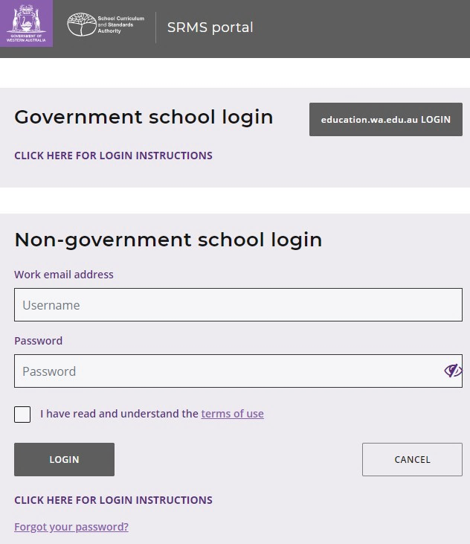
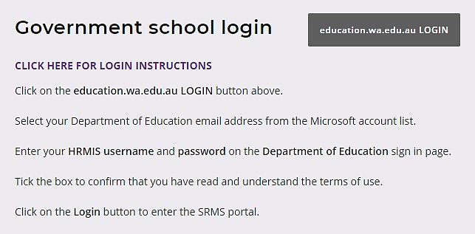
Select your Department of Education email address from the Microsoft account list (shown below).
If you do not see your Department of Education email address, click on Use another account and add your email address, then click on Next to set up this new account.
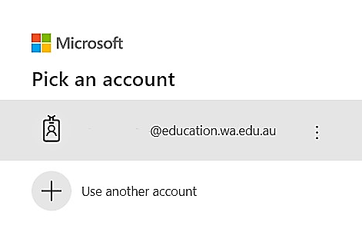
You will be taken to the Department of Education sign in page (shown below).
Enter your HRMIS username and password.
Tick the check box (highlighted below) to confirm that you have read and understand the Appropriate Use of Online Services information.
Click on the Login button (highlighted below) to enter the SRMS portal.
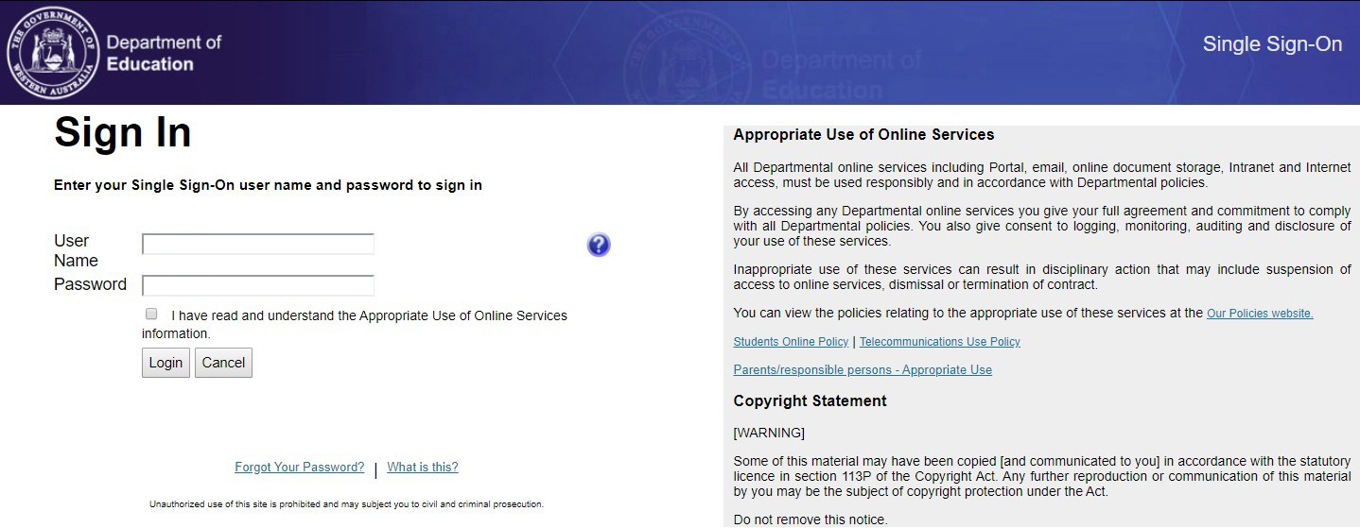

Non-government schools
The first time you log in, click on and read the login instructions (highlighted below). Contact your school administrator if you have not received the email with the link.
Enter your work email address and password in the non-government school login panel.
Tick the check box (highlighted below) to show that you have read and understand the terms of use.
Click on the Login button (highlighted below) to enter the SRMS portal.
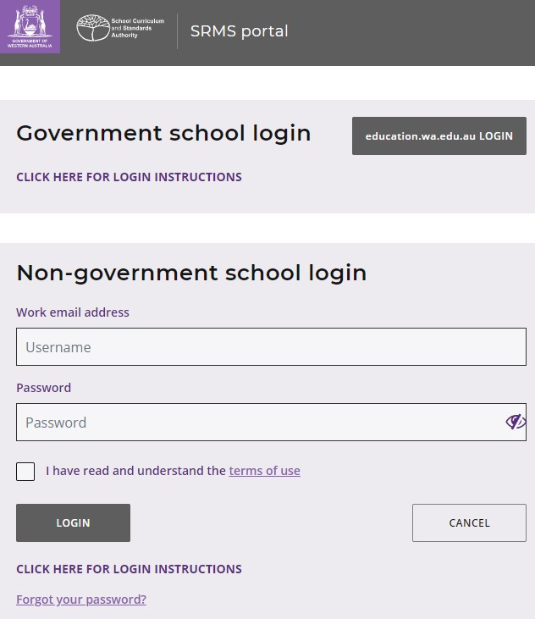

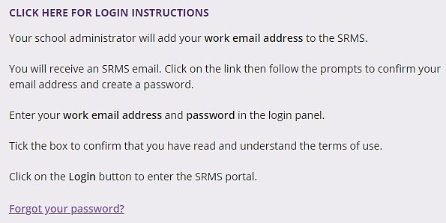
If you forget your password, click on Forgot your password.
Enter your work email address and tick the check box to confirm that you are not a robot. You will be prompted to select images as part of the verification process, then invited to choose another password.

Step 2: Select students’ language applications
Select Language Applications from the Student Applications drop-down list (highlighted below).
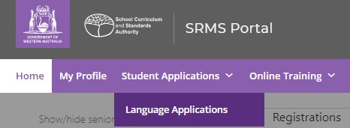
All submitted language applications from students at your school will be displayed on the screen.
You will see the list of all nine WACE languages in the filter section on the left of the screen.
The Status column shows submitted student applications, with a tick and Submitted (highlighted below). The Sub status column shows as Documents (highlighted below), which is the first stage for schools to complete in the WACE language course enrolment process.
The Requires attention by me column shows as Yes (highlighted below), advising you to upload the school documents for each student’s application.
The applications that require your attention will appear at the top of the list.
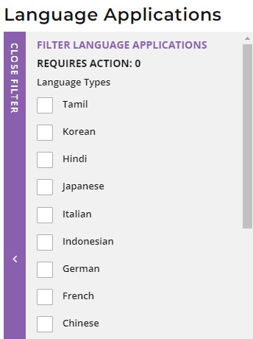
You will see the number of applications that require your attention (highlighted below). This number will update as you complete the required action.

Filter students’ language applications
To retrieve specific applications, you can use the filter options on the left side of the Language Applications screen. For example, tick the German check box (highlighted below) and click on the Search button (highlighted below) to see all submitted German applications.
To retrieve a specific student’s application, type their Given name and/or Family name, or Student number into the search fields, then click on the Search button (all highlighted below).
Click on the Reset button (highlighted below) to reset the filters and view all the applications.
You can choose to display the filter options or not by clicking on the Close filter/Open filter command on the left side of the Language Applications screen.
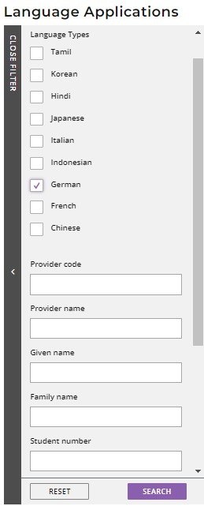
C
Use the Application status check boxes to filter applications by their status. The Submitted and Incomplete check boxes are preselected to show all submitted applications that are at the school stage and those where additional information is required from the student. The In progress check box is also preselected to show applications that are being processed by the Authority (all highlighted below).
Tick the New check box and click on the Search button to see applications that students have started but not submitted.
Tick any of the additional filter check box/es and click on the Search button (both highlighted below) to view other categories of applications.
Click on the Reset button (highlighted below) to reset the filters and view all the applications.
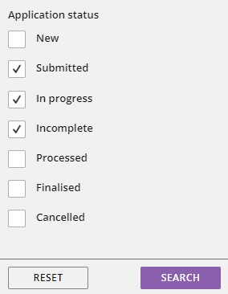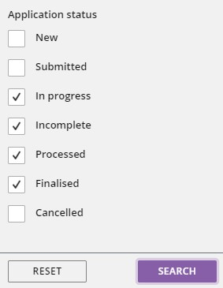

Step 3: View a student’s language application
Click on the View button (highlighted below) to view the details and supporting document/s in that student’s application.
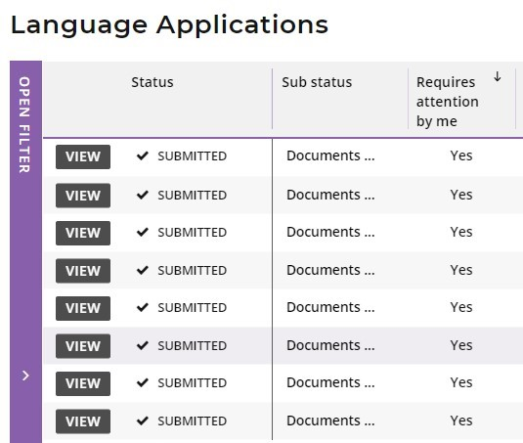

Step 4: Upload school documents
Scroll down to the School support officer section. Click on the Select document type tab to see the list of required school documents:
- School enrolment form
- Year 10 Semester 1 school report
- Ministerial Council on Education, Employment, Training and Youth Affairs (MCEETYA) data collection form.
If your school enrolment form provides information about the language/s spoken at home by the student, parent/guardian 1 and parent/guardian 2, you can upload the school enrolment form twice; i.e. the same document for the school enrolment form, and the MCEETYA data collection form. There is no requirement to add a different file name for this document.
Documents must be saved as .pdf, .jpg, .jpeg or .png files, with a maximum size of 4MB for each file. You will not be able to upload Word documents. Do not use spaces or unrecognisable characters or symbols, such as < > ? ! / \ " * : , # % & ( ) { } + = @ when naming files.
Select the first document from the drop-down list (highlighted below). Click on the Browse button (highlighted below) to select the file from your computer and click on the Open button (Upload button on a Mac) to upload this file. When you have uploaded the first document, the status will show as Saved. Repeat this process for all three documents.
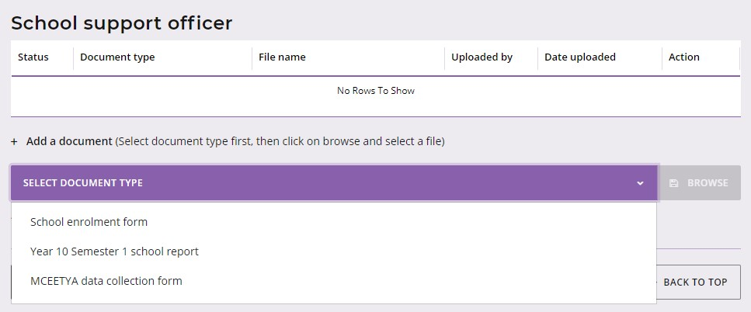
If you upload a document by mistake, click on the Remove button (highlighted below) then upload the correct document. Click on the Submit button (highlighted below) to submit these documents.
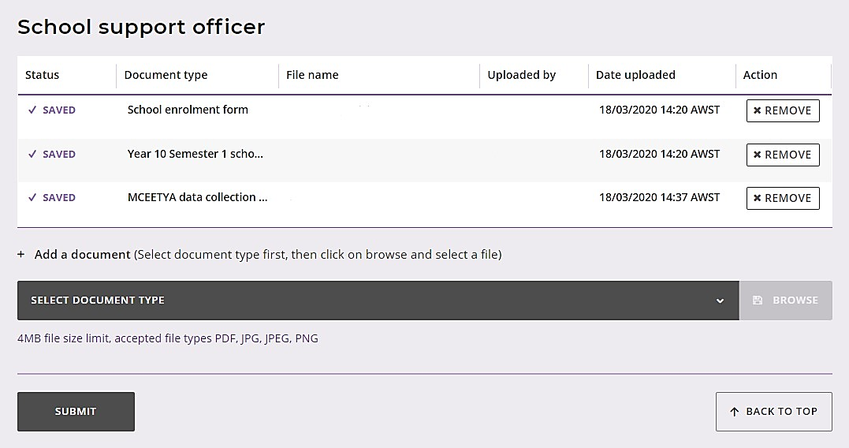
You will return to the Language Applications screen. The Status column will show a tick and Submitted. The Sub status column shows as Teacher (highlighted below), to indicate the application has moved to the teacher declaration stage of the WACE language course enrolment process. The Requires attention by me column will be blank, to show that you have uploaded the required school documentation for that student.
Note: the application that you have just completed will now appear at the bottom of your list.
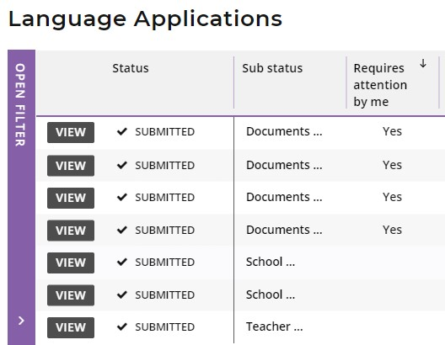
Non-school candidates
If a student has selected Yes to the statement about enrolment as a non-school candidate (NSC) at the start of their language application, this will show as Yes (highlighted below) in the Non School column on the Language Applications screen.
The school support officer does not need to upload any supporting documents for a student’s NSC language application.
The Status column will show a tick and Submitted, but any NSC applications will skip the Documents stage in the Sub status column.
These NSC applications will show as Teacher (highlighted below) in the Sub status column, to indicate the application has moved to the teacher declaration stage.
The Requires attention by me column will be blank for the school support officer, but when the language teacher views this NSC application, they will be prompted to take action and complete their teacher declaration.
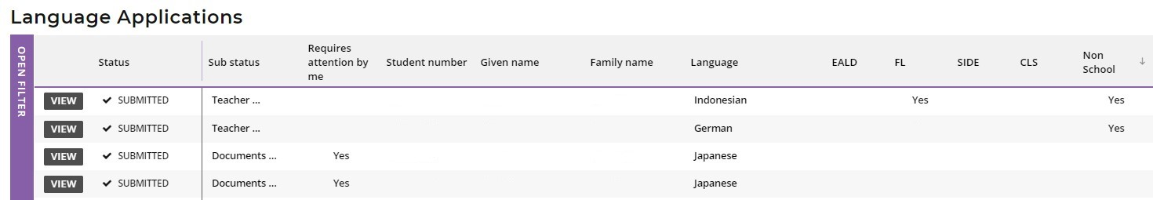

Step 5: Amend a student’s language application
If the Authority requests an amendment/s to a student’s application, you will see this on the Language Applications screen.
The Authority may request an amendment/s if incorrect document/s have been uploaded to a student’s application, if the document/s were blank or could not be opened, or if the document/s do not provide sufficient information about that student’s linguistic background.
The Sub status shows as Documents again and the Requires attention by me column shows as Yes (both highlighted below), prompting you to upload any new or amended document/s, as required.
Click on the View button (highlighted below) to see the change/s for that student’s application.
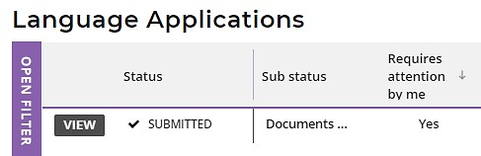
The amendment/s required will be listed.
Repeat the process of uploading the new or amended document/s and click on the Submit button (highlighted below) to submit the amended application.
This student’s application will now proceed to the processing stage with the Authority.
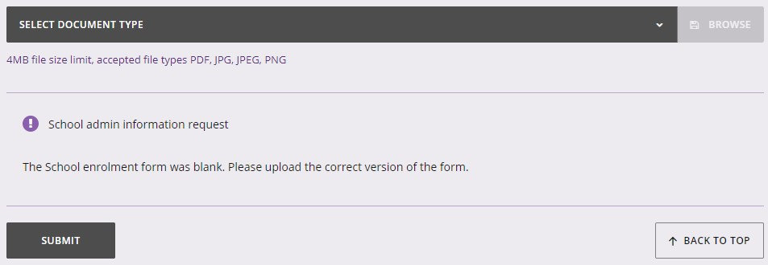

Step 6: Check the SRMS portal for language course enrolment status
At any time, you can check the Language Applications screen in the SRMS portal to monitor the progress of students’ applications.
The Language Applications screen will update whenever an application advances through the stages of the enrolment process.
Below are terms you will see throughout the online WACE language course enrolment process that relate to the status and sub status of students’ applications
Status
New | Language application has been started, but not submitted
Submitted | Language application has been submitted by the student
In progress | Language application is progressing through the processing stages
Incomplete | Language application is being amended by the student
Processed | WACE language course status has been published
Finalised | WACE language course status has been published and accepted by the student
Cancelled | Language application has been cancelled

Sub status
Documents | School support officer to upload new or amended documents
Teacher | Language teacher to complete declaration of language application
School | Principal or deputy principal to complete endorsement of language application
Received | Language application received by the Authority
Languages PC1 | Principal Consultant 1 to determine in which WACE language course the student may enrol
Languages PC2 | Principal Consultant 2 to determine in which WACE language course the student may enrol
Manager | Manager to review Principal Consultants’ determinations
To publish | Principal Consultant 1 or Principal Consultant 2 to publish WACE language course enrolment determination
Language | Publication of Second Language, Background Language or First Language status for WACE language course enrolment
Appeal? | The student may lodge an appeal in the student portal within two weeks of publication of their WACE language course enrolment status
Appeal lodged | The student has lodged an appeal

Five steps for language teacher declaration
A system-generated email will alert the language teacher/s to all applications received for their students on that day and prompt them to complete the teacher declaration in the SRMS portal.

Step 1: Log in to the SRMS portal
Log in to the SRMS portal (https://srms.scsa.wa.edu.au).
Government and non-government schools will see the login screen below.
Government schools
The first time you log in, click on and read the login instructions (highlighted below).
Click on the education.wa.edu.au LOGIN button (highlighted below) in the government school login panel.
Select your Department of Education email address from the Microsoft account list (shown below).
If you do not see your Department of Education email address, click on Use another account and add your email address, then click Next to set up this new account.
You will be taken to the Department of Education sign in page (shown below).
Enter your HRMIS username and password.
Tick the check box (highlighted below) to confirm that you have read and understand the Appropriate Use of Online Services information.
Click on the Login button (highlighted below) to enter the SRMS portal.
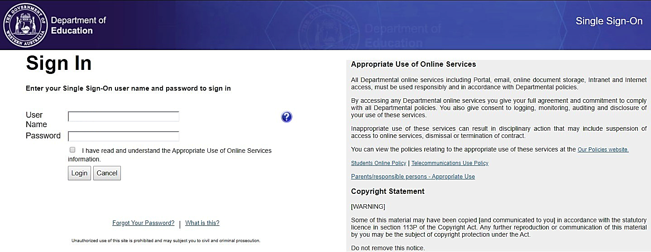

Non-government schools
The first time you log in, click on and read the login instructions (highlighted below). Contact your school administrator if you have not received the email with the link.
Enter your work email address and password in the non-government school login panel.
Tick the check box (highlighted below) to show that you have read and understand the terms of use.
Click on the Login button (highlighted below) to enter the SRMS portal.

If you forget your password, click on Forgot your password.
Enter your work email address and tick the check box to confirm that you are not a robot. You will be prompted to select images as part of the verification process, then invited to choose another password.

Step 2: Select students’ language applications
Select Language Applications from the Student Applications drop-down list (highlighted below).
All submitted language applications from students at your school will be displayed on the screen.
You will see the list of all nine WACE languages in the filter section on the left of the screen.
The Status column shows a tick and Submitted and the Sub status column will say Teacher (both highlighted below) indicating that the application is in the teacher declaration stage. The Requires attention by me column shows as Yes (highlighted below) for any application where the student selected your name as their teacher, advising you to complete your teacher declaration.
You may see other students’ applications, but with no action required by you. Other language teacher/s at your school will be prompted to act, as the students selected their name/s when they completed their application. There may be applications where the student has selected My teacher is not listed here. The Sub status column will show as Teacher, but the Requires attention by me column will be blank. Any teacher may complete the teacher declaration of these applications.
The applications that require your attention will appear at the top of the list.
You will see the total number of applications that require attention by language teacher/s at your school (highlighted below). This number is calculated using the role of language teacher, rather than a named teacher, so the number may be greater than the number of applications that require your attention. This number will update as each teacher completes the required action.
Filter students’ language applications
To retrieve specific applications, you can use the filter options on the left side of the Language Applications screen. For example, tick the Italian check box (highlighted below) and click on the Search button (highlighted below) to see all Italian applications.
To retrieve a specific student’s application, type their Given name and/or Family name or Student number into the search fields, and then click on the Search button (all highlighted below).
Click on the Reset button (highlighted below) to reset the filters and view all the applications.
You can choose to display the filter options or not by clicking on the Close filter/Open filter command on the left side of the Language Applications screen.
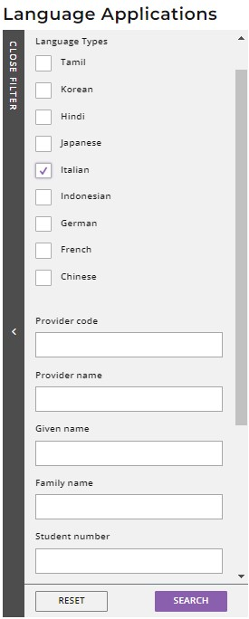
C

Use the Application status check boxes to filter applications by their status. The Submitted and Incomplete check boxes are preselected to show all submitted applications that are at the school stage and those where additional information is required from the student. The In progress check box is also preselected to show applications that are being processed by the Authority (all highlighted below).
Tick the New check box and click on the Search button to see applications that students have started, but not submitted.
Tick any of the additional filter check box/es and click on the Search button (both highlighted below) to view other categories of applications.
Click on the Reset button (highlighted below) to reset the filters and view all the applications.

Step 3: View a student’s language application
Click on the View button (highlighted below) to view the details and supporting documents in that student’s application.
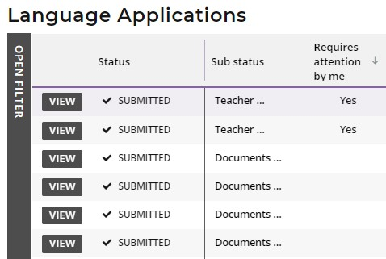

Step 4: Complete language teacher declaration
Scroll down to the bottom of the application to the Teacher declaration section. Select your teacher declaration from the seven options shown below.
If you see any errors in a student’s application, email the Authority so the information can be added to that student’s application; however, you should still complete your declaration.
Click on the Submit button (highlighted below) to submit your declaration.
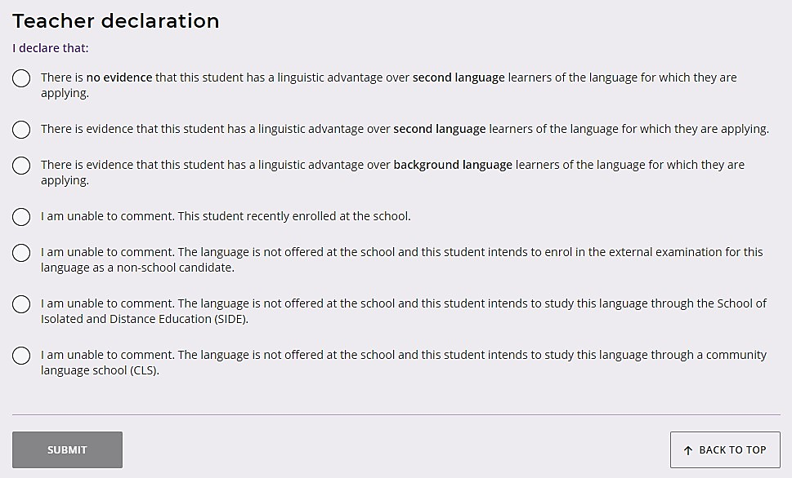
You will return to the Language Applications screen. The Status column will show as Submitted and the Sub status column will show as School (highlighted below), indicating that the application has moved to the principal/deputy principal endorsement stage. The Teacher declaration column will reflect your selection: Second Language (SL), Background Language (BL), First Language (FL), recently enrolled (NEW), non-school candidate (NSC), School of Isolated and Distance Education (SIDE), or community language school (CLS). The Requires attention by me column will be blank, since you have completed your declaration for that student’s application. The application that you have just completed will appear at the bottom of your list.
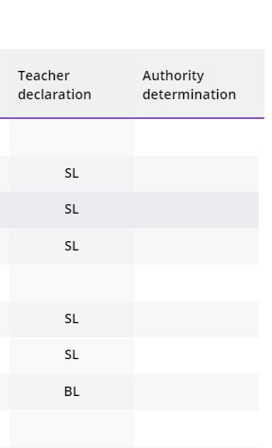
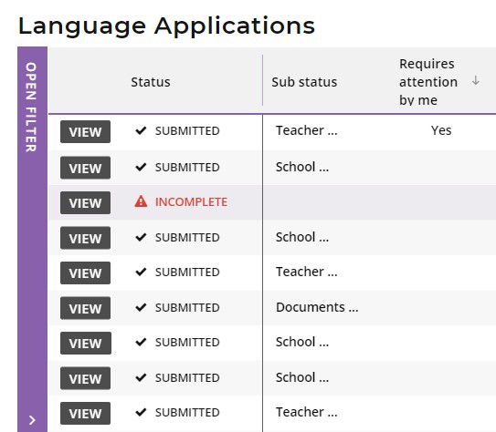

Step 5: Check the SRMS portal for WACE language course enrolment status
Language teachers can check the Language Applications screen in the SRMS portal to monitor the progress of students’ WACE language course enrolment applications at any time.
The Language Applications screen will update whenever an application advances through the stages of the enrolment process.
Below are terms you will see throughout the online WACE language course enrolment process that relate to the status of students’ applications
Status
New | Language application has been started, but not submitted
Submitted | Language application has been submitted by the student
In progress | Language application is progressing through the processing stages
Incomplete | Language application is being amended by the student
Processed | WACE language course status has been published
Finalised | WACE language course status has been published and accepted by the student
Cancelled | Language application has been cancelled

Sub status
Documents | School support officer to upload new or amended documents
Teacher | Language teacher to complete declaration of language application
School | Principal or deputy principal to complete endorsement of language application
Received | Language application received by the Authority
Languages PC1 | Principal Consultant 1 to determine in which WACE language course the student may enrol
Languages PC2 | Principal Consultant 2 to determine in which WACE language course the student may enrol
Manager | Manager to review Principal Consultants’ determinations
To publish | Principal Consultant 1 or Principal Consultant 2 to publish WACE language course enrolment determination
Language | Publication of Second Language, Background Language or First Language status for WACE language course enrolment
Appeal? | The student may lodge an appeal in the student portal within two weeks of publication of their WACE language course enrolment status
Appeal lodged | The student has lodged an appeal

Five steps for principal or deputy principal endorsement
A system-generated email will prompt the principal or deputy principal to endorse a student’s application in the SRMS portal.

Step 1: Log in to the SRMS portal
Log in to the SRMS portal (https://srms.scsa.wa.edu.au).
Government and non-government schools will see the login screen below.
Government schools
The first time you log in, click on and read the login instructions (highlighted below).
Click on the education.wa.edu.au LOGIN button (highlighted below) in the government school login panel.
Select your Department of Education email address from the Microsoft account list (shown below).
If you do not see your Department of Education email address, click on Use another account and add your email address, then click Next to set up this new account.
You will be taken to the Department of Education sign in page (shown below).
Enter your HRMIS username and password.
Tick the check box (highlighted below) to confirm that you have read and understand the Appropriate Use of Online Services information.
Click on the Login button (highlighted below) to enter the SRMS portal.

Non-government schools
The first time you log in, click on and read the login instructions (highlighted below). Contact your school administrator if you have not received the email with the link.
Enter your work email address and password in the non-government school login panel.
Tick the check box (highlighted below) to show that you have read and understand the terms of use.
Click on the Login button (highlighted below) to enter the SRMS portal.

If you forget your password, click on Forgot your password.
Enter your work email address and tick the check box to confirm that you are not a robot. You will be prompted to select images as part of the verification process, then invited to choose another password.

Step 2: Select students’ language applications
Select Language Applications from the Student Applications drop-down list (highlighted below).
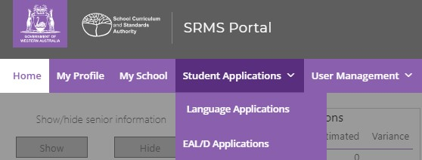
All submitted language applications from students at your school will be displayed on the screen.
You will see the list of all nine WACE languages in the filter section on the left of the screen.
The Status column shows submitted language applications, with a tick and Submitted and the Sub status column shows as School (both highlighted below).
The Requires attention by me column shows as Yes (highlighted below), advising you to certify each student’s application.
The applications that require your attention will appear at the top of the list.
You will see the number of applications that require your attention (highlighted below). This number will update as you complete the required action.
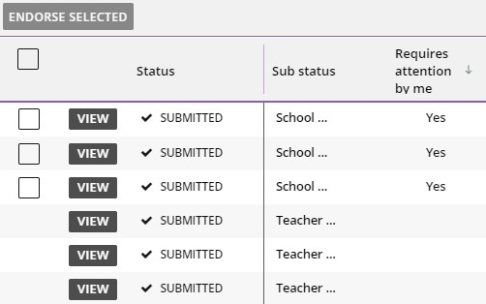

Filter students’ language applications
To retrieve specific applications, use the filter options on the left side of the Language Applications screen. For example, tick the Tamil check box (highlighted below) and click on the Search button (highlighted below) to see all Tamil applications.
To retrieve a specific student’s application, type their Given name and/or Family name, or Student number into the search fields, and then click on the Search button (all highlighted below).
Click on the Reset button (highlighted below) to reset the filters and view all the applications.
You can choose to display the filter options or not by clicking on the Close filter/Open filter command on the left side of the Language Applications screen.
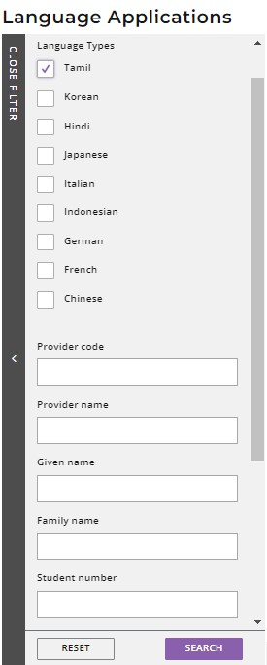
C
Use the Application status check boxes to filter applications by their status. The Submitted and Incomplete check boxes are preselected to show all submitted applications that are at the school stage and those where additional information is required from the student. The In progress check box is also preselected to show applications that are being processed by the Authority (all highlighted below).
Tick the New check box and click on the Search button to see applications that students have started, but not submitted.
Tick any of the additional filter check box/es and click on the Search button (both highlighted below) to view other categories of applications.
Click on the Reset button (highlighted below) to reset the filters and view all the applications.

Step 3: View a student’s language application
Click on the View button (highlighted below) to view the details and supporting documents in that student’s application.
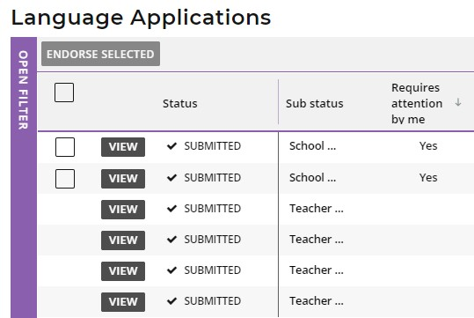

Step 4: Complete principal or deputy principal endorsement
Scroll down to the bottom of the application to the Declaration by the Principal section.
Select either I endorse this application or I am unable to endorse this application.
It is optional to add a reason if you endorse the student’s application, but you must provide an explanation if you are unable to endorse the application. If you are unable to endorse a student’s application and have not provided a comment, you will not be able to submit your endorsement.
Click on the Submit button (highlighted below) to submit your declaration.
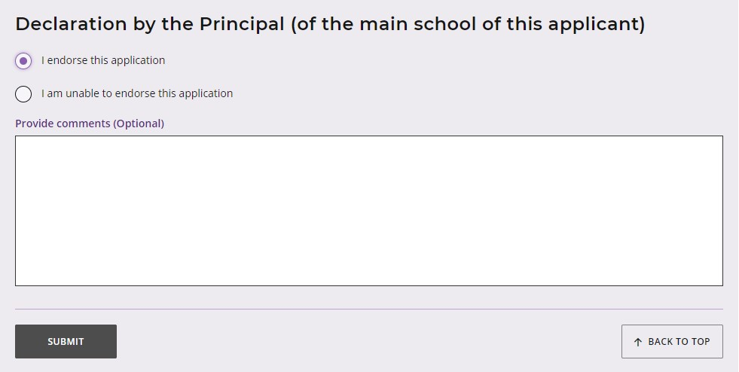
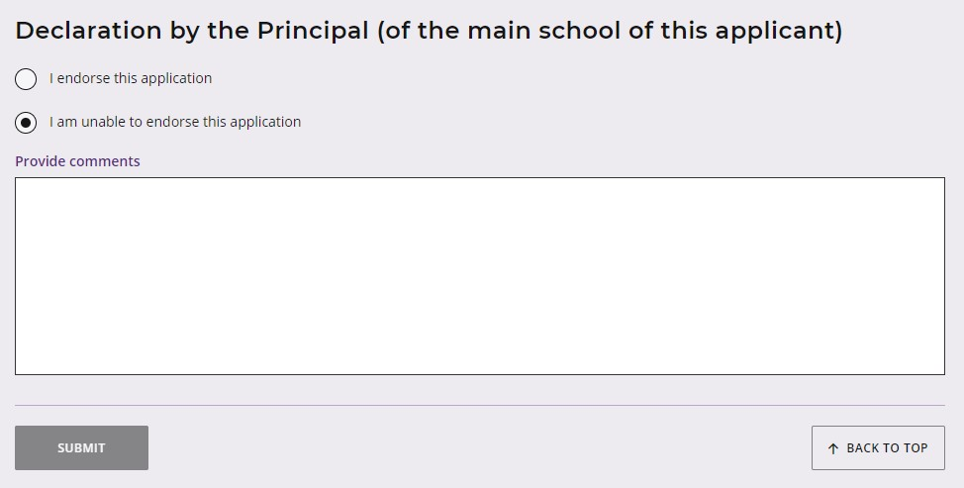

Multiple endorsements
After viewing the applications, if you wish to endorse multiple applications, tick the check box (highlighted below) underneath the Endorse selected button to select multiple applications.
Click on the Endorse selected button (highlighted below). A warning will appear, asking if you wish to endorse the applications of the selected students. Click on the Endorse button (highlighted below) to endorse the selected applications. Alternatively, click on the Cancel button (highlighted below) to cancel this multiple endorsement and endorse the applications individually.
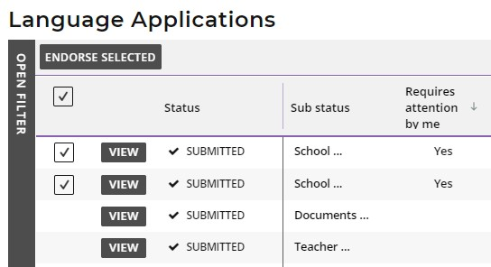
C
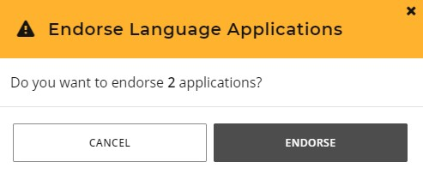
You will return to the Language Applications screen. The Status will show as In progress (highlighted below) and the Sub status will show as Received (highlighted below) to show that this application has been received by the Authority. The Requires attention by me column will be blank, indicating that you have endorsed your school’s applications.
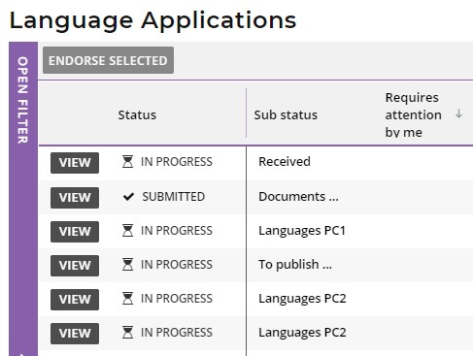
When a student’s application has been received by the Authority, it will be processed. If the Authority requires any further information, or amendments to be made, students will receive an email notifying them of this. They can also see this notification in the student portal.

Step 5: Check the SRMS portal for WACE language course enrolment status
Principals or deputy principals can check the Language Applications screen in the SRMS portal to monitor the progress of their students’ WACE language course enrolment applications at any time.
The Language Applications screen will update whenever an application advances through the stages of the enrolment process.
Below are terms you will see throughout the online WACE language course enrolment process that relate to the status of students’ applications
Status
New | Language application has been started, but not submitted
Submitted | Language application has been submitted by the student
In progress | Language application is progressing through the processing stages
Incomplete | Language application is being amended by the student
Processed | WACE language course status has been published
Finalised | WACE language course status has been published and accepted by the student
Cancelled | Language application has been cancelled

Sub status
Documents | School support officer to upload new or amended documents
Teacher | Language teacher to complete declaration of language application
School | Principal or deputy principal to complete endorsement of language application
Received | Language application received by the Authority
Languages PC1 | Principal Consultant 1 to determine in which WACE language course the student may enrol
Languages PC2 | Principal Consultant 2 to determine in which WACE language course the student may enrol
Manager | Manager to review Principal Consultants’ determinations
To publish | Principal Consultant 1 or Principal Consultant 2 to publish WACE language course enrolment determination
Language | Publication of Second Language, Background Language or First Language status for WACE language course enrolment
Appeal? | The student may lodge an appeal in the student portal within two weeks of publication of their WACE language course enrolment status
Appeal lodged | The student has lodged an appeal

Appeal process
Should the Authority determine that a student does not meet the enrolment criteria for a course and is therefore not permitted to enrol in a Second or Background Language course, this will be shown in the student portal (highlighted below). The student can view the application by clicking on the View [language] application button (highlighted below).
If a student has evidence that shows they do meet the enrolment criteria for the Second or Background Language course, they can request an appeal. The Authority’s Languages Enrolment Determinations Appeals Committee will then review their application. A student must do this within two weeks of their WACE language course enrolment notification in the student portal.
To request an appeal, the student should click on the Lodge appeal button (highlighted below).
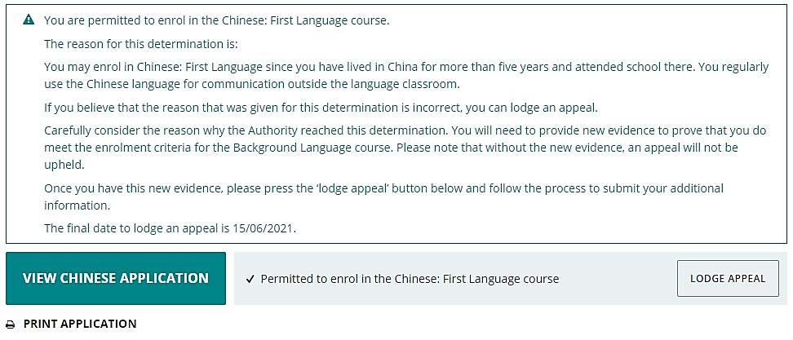
The student needs to provide additional evidence by photographing or scanning one or more documents not previously submitted, uploading it/them and/or typing additional information to demonstrate that they meet the enrolment criteria. The student should check their document/s and/or comments that they provide because, after they have lodged their appeal, they will not be able to upload further documents or make any changes. They can still view them in read-only mode.
Once all supporting documents have been uploaded, the student should click on the Submit button. If they have not attached at least one additional document, or provided a comment, the request for an appeal cannot be submitted.
Note: a student can only lodge one appeal for each WACE language course enrolment application they submit.
The Languages Enrolment Determinations Appeals Committee will review the student’s appeal and the additional document/s and/or supporting evidence provided for the appeal. After the appeal has been completed, the Authority will notify the student, their parents and the school by email, stating the outcome of the appeal. The student will see the appeal determination and any change to their enrolment status in the student portal.
At this point, the Authority recommends that the student contact their school to discuss their study options.

