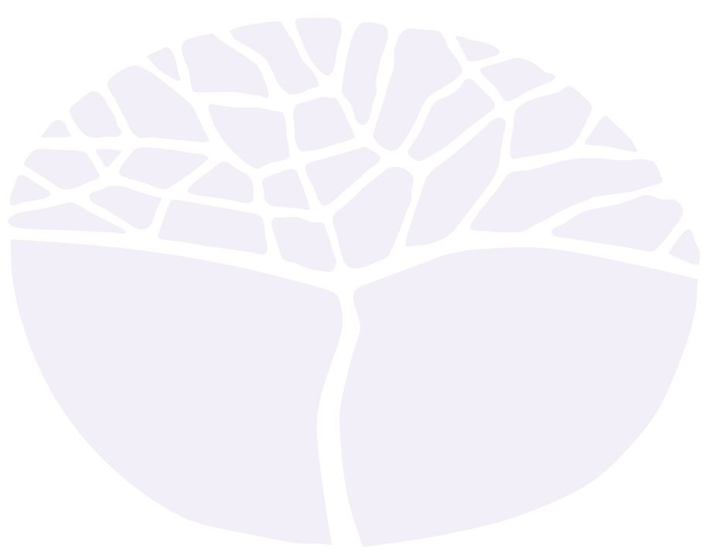
English as and Additional Language or Dialect
ATAR course
Year 11 | Modified Assessment Table | 2023

Acknowledgement of Country
Kaya. The School Curriculum and Standards Authority (the Authority) acknowledges that our offices are on Whadjuk Noongar boodjar and that we deliver our services on the country of many traditional custodians and language groups throughout Western Australia. The Authority acknowledges the traditional custodians throughout Western Australia and their continuing connection to land, waters and community. We offer our respect to Elders past and present.
IMPORTANT INFORMATION
Users of this section of the syllabus are responsible for checking its currency. It should be used in conjunction with the full syllabus.
Syllabuses are formally reviewed by the School Curriculum and Standards Authority on a cyclical basis, typically every five years.
Copyright
© School Curriculum and Standards Authority, 2022.
This document – apart from any third party copyright material contained in it – may be freely copied, or communicated on an intranet, for non-commercial purposes in educational institutions, provided that the School Curriculum and Standards Authority is acknowledged as the copyright owner, and that the Authority’s moral rights are not infringed.
Copying or communication for any other purpose can be done only within the terms of the Copyright Act 1968 or with prior written permission of the School Curriculum and Standards Authority. Copying or communication of any third party copyright material can be done only within the terms of the Copyright Act 1968 or with permission of the copyright owners.
Any content in this document that has been derived from the Australian Curriculum may be used under the terms of the Creative Commons Attribution 4.0 International licence.

Assessment Table – Modified for use in 2023
Where the number of tasks for assessment types with specified focuses must be reduced, teachers should ensure that the assessments provide students the opportunity to demonstrate a representative sampling of the skills in the syllabus content.
All the following assessment types must be assessed once. The weighting provided is the weighting for each assessment.
Type of assessment | Weighting
Investigation  Framing of questions, planning, locating sources, identifying information, assessing relevance, note-taking, interacting with others, synthesising, evaluating, reflecting and producing an oral proposal.  Part A: Semester One (recommended 10%)  Investigate an issue/topic related to Unit 1 and present a research proposal in an oral format.  Investigation – Part B: Semester Two (recommended 10%)  Write a report based on research around a Unit 1 or 2 topic/issue. | 20%
All the following assessment types must be assessed at least once but no more than twice. The weighting provided is the total weighting of the assessment type for the combined pair of units. Where only one task is administered for an assessment type, the weighting of the assessment must match the weighting of the assessment type.
Type of assessment | Weighting
Response  Comprehension, analysis and evaluation of aural, written and printed visual texts.  - One task to focus on the comprehension and analysis of aural texts.  and/or  - One task to focus on the comprehension, analysis and synthesis of written and printed visual texts. | 20%
Written production  Creating texts which use language and structure appropriate to context, genre, purpose and audience.  - One task to focus on the production of a formal essay.  and/or  - One task to focus on the production of a written speech. | 20%
Oral production  Participation in and/or production of group discussions, panel discussions, interviews, debates, conversations, tutorials, speeches | 20%
Written examination  Typically conducted at the end of each semester and/or unit. In preparation for Unit 3 and Unit 4, the examination should reflect the examination design brief included in the Year 12 ATAR syllabus for this course. | 20%
Note: the Assessment Table for this course has been modified for use in 2023. All teachers must adjust their Assessment Outline for this course to reflect the modified Assessment Table. The School Curriculum and Standards Authority will require teachers to revert to using the standard Assessment Table in 2024.

