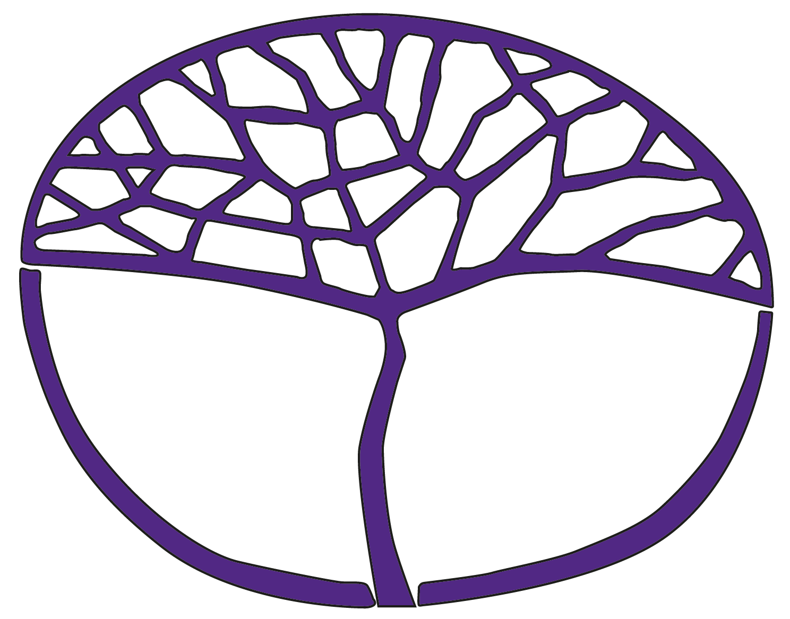
Sample Assessment Outline
Psychology
ATAR Year 12

Acknowledgement of Country
Kaya. The School Curriculum and Standards Authority (the Authority) acknowledges that our offices are on Whadjuk Noongar boodjar and that we deliver our services on the country of many traditional custodians and language groups throughout Western Australia. The Authority acknowledges the traditional custodians throughout Western Australia and their continuing connection to land, waters and community. We offer our respect to Elders past and present.
Copyright
© School Curriculum and Standards Authority, 2022
This document – apart from any third-party copyright material contained in it – may be freely copied, or communicated on an intranet, for non-commercial purposes in educational institutions, provided that the School Curriculum and Standards Authority (the Authority) is acknowledged as the copyright owner, and that the Authority’s moral rights are not infringed.
Copying or communication for any other purpose can be done only within the terms of the Copyright Act 1968 or with prior written permission of the Authority. Copying or communication of any third-party copyright material can be done only within the terms of the Copyright Act 1968 or with permission of the copyright owners.
Any content in this document that has been derived from the Australian Curriculum may be used under the terms of the Creative Commons Attribution 4.0 International licence.
Disclaimer
Any resources such as texts, websites and so on that may be referred to in this document are provided as examples of resources that teachers can use to support their learning programs. Their inclusion does not imply that they are mandatory or that they are the only resources relevant to the course.

Sample assessment outline

Psychology – ATAR Year 12

Units 3 and Unit 4
Assessment type | Assessment type weighting | Assessment task weighting | When | Assessment task
Science inquiry  (practical) | 20% | 12% | Semester 2  Weeks 11–14 | Task 7: Applications of psychology to health – Sleep hygiene  Design a quantitative subjective measure to assess the impact of a technique to improve sleep hygiene on sleep quality, and collect data using the measure. Complete an in-class report to demonstrate processing of data and evaluation of research.
Science inquiry  (research) | 20% | 8% | Semester 1  Weeks 8–9 | Task 2: Memory – Remembering and forgetting  Analyse and evaluate contemporary and seminal research on the process of remembering and forgetting.
Response | 40% | 7% | Semester 1  Week5 | Task 1: Memory and Science inquiry  Short answer test
Response | 40% | 12.5% | Semester 1  Week 14 | Task 3: Learning and Science inquiry  Short answer and extended answer test
Response | 40% | 12.5% | Semester 2  Week 5 | Task 5: Motivation and wellbeing and Science inquiry  Short answer and extended answer test
Response | 40% | 8% | Semester 2  Week 9 | Task 6: Applications of psychology to health and Science inquiry  Extended answer test
Examination | 40% | 15% | Semester 1  Week 16 | Task 4: Semester 1 examination – Unit 3 content (3 hours)  Section One: 5–8 short answer questions (70%)  Section Two: 2 extended answer questions (30%)
Examination | 40% | 25% | Semester 2  Week 16 | Task 8: Semester 2 examination – Unit 3 and Unit 4 content (3 hours)  Section One: 5–8 short answer questions (70%)  Section Two: 2 extended answer questions (30%)  (Content weighting: Unit 3 – 50% and Unit 4 – 50%)
Total | 100% | 100%

